PartyGuard

**Data Services**

Version 0.1

Date: 11/27/2016

Android Nachos

Ashish Peruru

Sridhar Yerasi

Harish Yeddluri

Vinod Kumar Kurma

Harish Reddy Yanala

Rakshith Anand Bootham

Seshu kumar Gandhapuneni

Prepared for

44-696 Computer Science Graduate Directed Project-I

Instructor: Dr. Charles Hoot

Summer 2016

**Revision history:**

|  |  |  |  |
| --- | --- | --- | --- |
| **Date** | **Version** | **Description** | **People** |
| July 11, 2016 | 0.1 | First draft | **Project Owner and Client:** Stansbury, Jacob C  **Faculty Advisor:** Dr. Charles Hoot  **Project Group:**  Seshu Kumar Gandhapuneni,  Rakshith Bhootham,  Harish Yeddluri,  Sridhar Yerasi,  Vinod Kumar Kurma,  Harish Reddy Yanala,  Ashish Peruru |

**Document approval:**

The following Software Requirements Specification has been accepted and approved by the following:

|  |  |  |  |
| --- | --- | --- | --- |
| **Signature** | **Printed Name** | **Title** | **Date** |
|  | Dr. Charles Hoot | Faculty Advisor |  |
|  | Jacob C Stansbury | Project Sponsor |  |
|  |  |  |  |

**Contents**

1. Introduction 4

1.1 Scope 4

2. Architecture 4

3. Data Services 4

# Introduction

## Scope

“PartyGuard” is an Android app that could be used by students of Northwest Missouri State University. Later this app could be implemented across other universities in the Unites States. This document does not include the requirements of Back-end Database, and Services. This document includes the requirements of User Interface and integration of the app with back-end services.

# Architecture

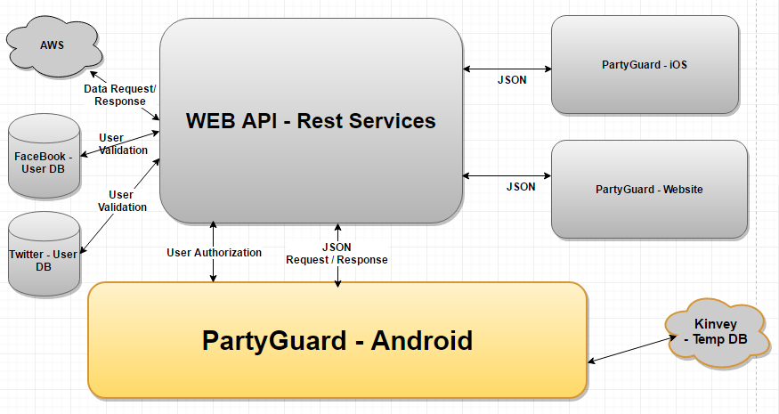

# Data Services

The implementation of android app does not include direct interaction with any database. Android app only consumes (or) posts the data to Data Services as JSON. Below is the list of services that this app integrates with (Screen wise). The services are developed by “Data Services” team, using *“Microsoft ASP.net Web API”*. The Services are deployed to *“Microsoft Azure”*.

**Note:** The Azure URL provided below may change based on the deployment configuration of the Data services team.

|  |  |  |
| --- | --- | --- |
| **Screen Name** | **Service URL** | **Get/Post**  **JSON** |
| Registration Activity | <http://partyguardservices20161110094537.azurewebsites.net/api/Account/Register> | Post |
| Login | <http://partyguardservices20161110094537.azurewebsites.net/token> | Get |
|  | <http://partyguardservices20161110094537.azurewebsites.net/api/Account/UserInfo> | Get |
| FraternityActivity | <http://partyguardservices20161110094537.azurewebsites.net/FraternityList> | Get |
| ChangePasswordActivity | <http://partyguardservices20161110094537.azurewebsites.net/api/Account/NewPasswordSet> | Post |
| Forgot Password | http://partyguardservices20161110094537.azurewebsites.net/api/Account/NewPasswordSet | Post |
| Profile upate | <http://partyguardservices20161110094537.azurewebsites.net/api/Account/UpdateProfile> | Post |
| Submit Issue | <http://partyguardservices20161110094537.azurewebsites.net/api/IssuesModel> | Post |
| Guard Register | <http://partyguardservices20161110094537.azurewebsites.net/api/Account/Register> | Post |
| Issue List –  Guard /Host user | <http://partyguardservices20161110094537.azurewebsites.net//api/IssueList> | Get |
| Claim Alert – Guard /Host user | <http://partyguardservices20161110094537.azurewebsites.net/GuardAlertsClaim> | Post |
| Resolve Alert – Guard /Host user | <http://partyguardservices20161110094537.azurewebsites.net/GuardAlertsResolve> | Post |
| PG Team – Host user | <http://partyguardservices20161110094537.azurewebsites.net/api/HostUserProfile/DisplayGuardDetails> | Get |