**PartyGuard Android App**

User Manual for Basic User

**Android Nachos**

Ashish Peruru

Sridhar Yerasi

Harish Yeddluri

Vinod Kumar Kurma

Harish Reddy Yanala

Rakshith Anand Bootham

Seshu Kumar Gandhapuneni

Date: 11/16/2016

Prepared for

44-696 Computer Science Graduate Directed Project-II

Instructor: Dr. Charles Hoot

Fall 2016

# Introduction

This is an Android application for the safety of women belonging to university fraternities. During a party at a fraternity house, if a woman faces any problem, she can report that issue to the fraternity members. She can report about various problems like fights, someone is too drunk/sick, inappropriate behavior, and assaults of any kind. The fraternity members can view the reported notifications and they will send the rescue team to the spot. In the case of extreme emergency, the user can send an SMS alert to university police. The emergency button feature will have a running timer and if the problem is not solved within 15 minutes, SMS alert will be sent to university police.

# Configuration

This is an android application, which supports for mobile devices having minimum Android version of 4.4 (KitKat).

# Installation instructions

**Step-1:** Download Android Studio IDE from <https://developer.android.com/studio/index.html> into your Windows system. Launch the .exe file you downloaded. Follow the setup wizard to install Android Studio and select Android SDK in SDK tools.

**Step-2:** Our project source code is available on the CD and also in Bitbucket repository, we have given you access to the repository. Clone the code to your system.

**Step-3:** Open the Android Studio IDE and go to the toolbar and click on File -> open the project.

**Step-4:** Wait for some time until the project gets build. Now run the application by clicking on “Run” button in the toolbar. The app runs on the emulator and you can use the app.

**Step-5:** To run the application on a mobile device, go to “Build” option and click on “Generate APK” to generate the APK file. You can see the generated APK file in the explorer. Copy that APK file to an Android device and install the app on the device and use it.

# Basic user

The basic user is a woman attending a party at any fraternity. During the party, if she faces any problem, she can report to the fraternity authority.

## **Registration**

* Firstly, you have to register into the application. After opening the application, initially login screen appears.

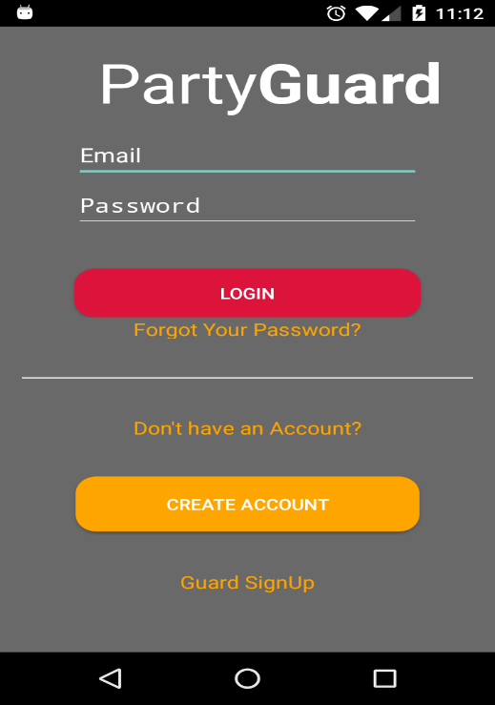

**Fig:4.1.1 Login screen**

* In the login page, click on “Create account” button. This redirects to the Signup page.

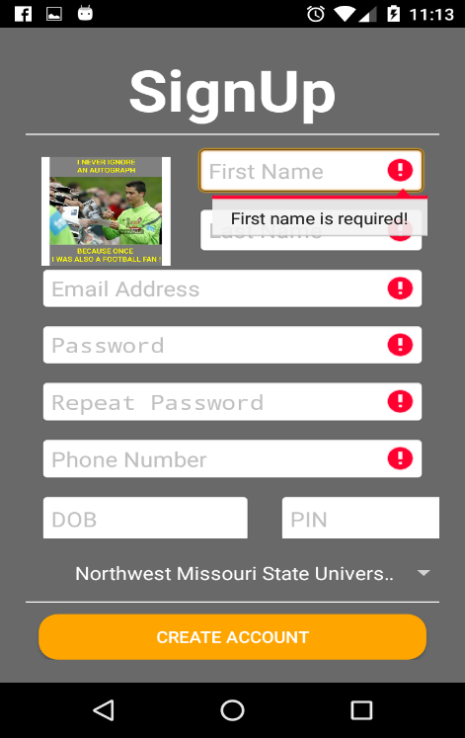

**Fig:4.1.2 Signup screen**

* In the Signup page, you have to provide the details viz. First name, Last name, Email address, Password, Phone number, Date of birth, Zip code and University name.
* You can set your display picture by clicking on the box at the top left corner. You can choose your image from your phone gallery or can take a photo of yours. Setting a display picture is optional. Except for display picture, all other remaining fields are mandatory.
* The password field has certain requirements viz. a minimum of 8 characters, a maximum of 16 characters, at least one capital letter, at least one small letter and at least one special character.
* For selecting the university, there is a drop-down list. You can select the university from that list.
* After entering all the details, click on “Create account” button. Then the registration will be completed successfully and you will be redirected to the login screen.

## **Forgot password**

* If you forget the password, you can reset the password by clicking on “Forgot your password?” button in the login screen.



**Fig:4.2.1 Login screen**

* Then you will get redirected to the Reset password screen, and then enter the email address that is used during your app registration.
* Then you will get an email with a link to reset the password. By clicking on that link, you will be redirected to the PartyGuard website, where you can reset your password.

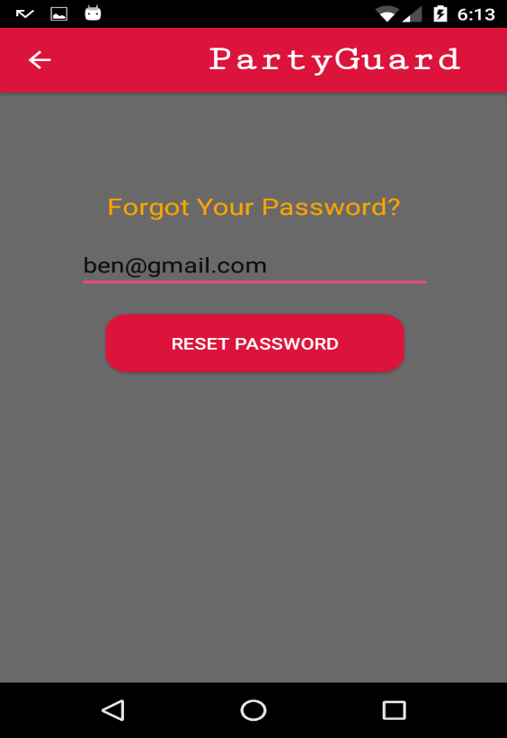

**Fig:4.2.2 Reset password screen**

## **Login**

* After launching the application, firstly login screen appears.



**Fig:4.3.1 Login screen**

* Enter the Email and Password given during the registration and click on the “Login” button.
* If you provide the correct credentials, you will be successfully logged into the application.

## **How to use the app?**

* After logging into the application, you will get to see an image slider describing how to use the app.
* By swiping the image or clicking on “NEXT” button, you can see the next images. When the image slider ends, click on “GOT IT” button and you will be directed to universities list screen. If you don’t wish to see this app information, you can skip it by clicking on “SKIP” button.

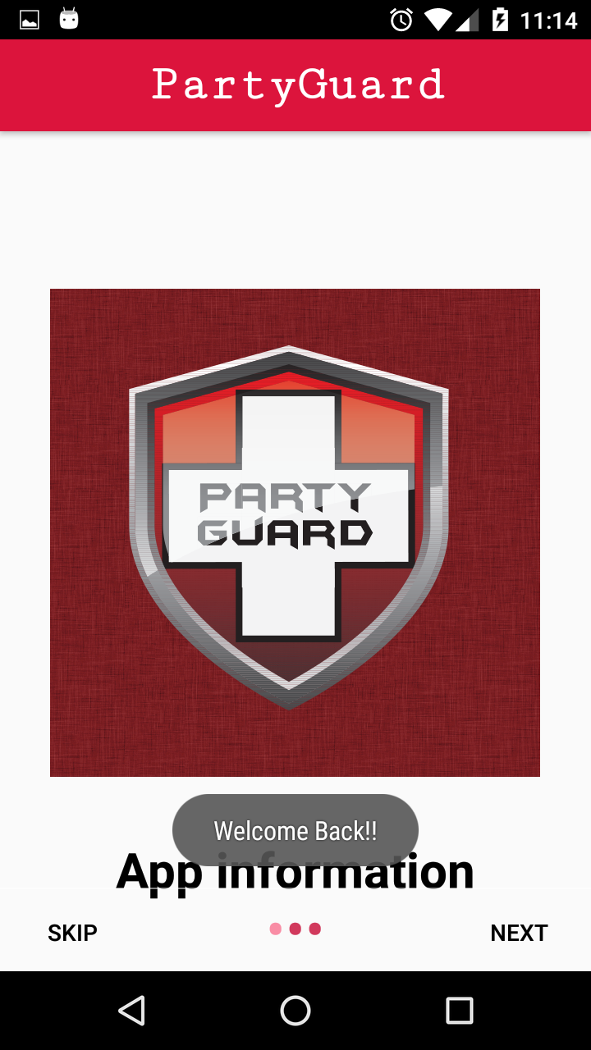

**Fig:4.4.1 How to use app? screen**

## **Submit Alert**

### **Submit alert to fraternity**

* After logging into the application, and viewing the “App information” screen, you will get a screen with a list of universities.
* Select your university from the list of universities.

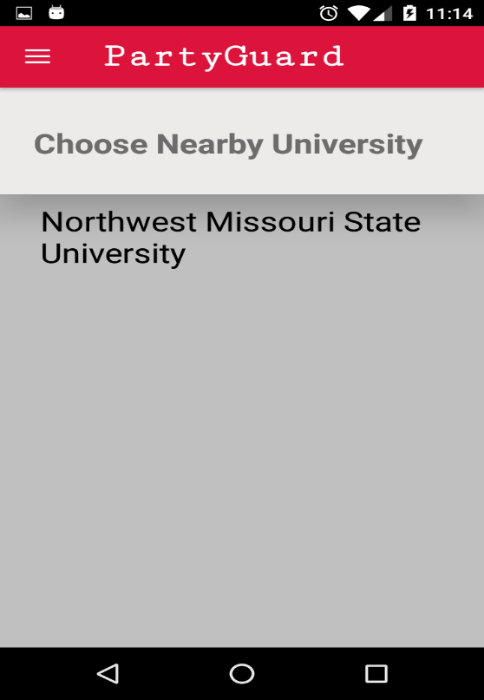

**Fig:4.5.1.1 List of universities screen**

* After selecting the university, a list of fraternities in that particular university will be displayed. Choose your fraternity from the list.

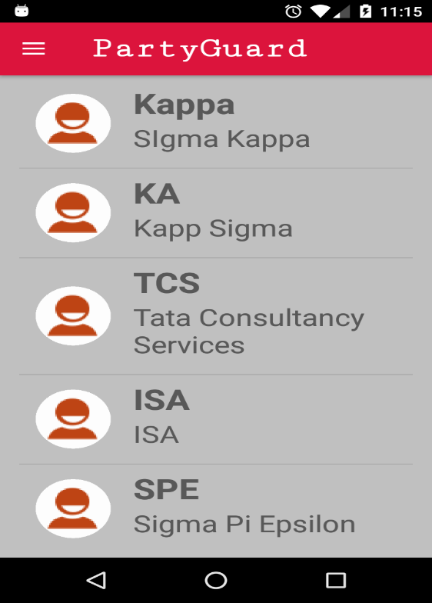

**Fig:4.5.1.2 List of fraternities screen**

* After choosing the fraternity, you will get to see a list of issues like an accident, feeling unsafe, fight etc. as shown below.

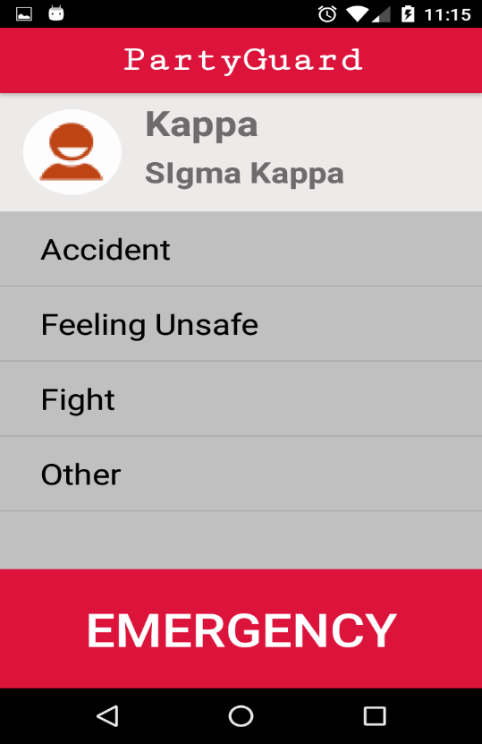

**Fig:4.5.1.3 List of issues screen**

* From the list of issues, select the type of issue you are facing in the party.
* After selecting the type of issue, you have to select your exact location (like upstairs, main floor, basement, deck etc.) in the building.

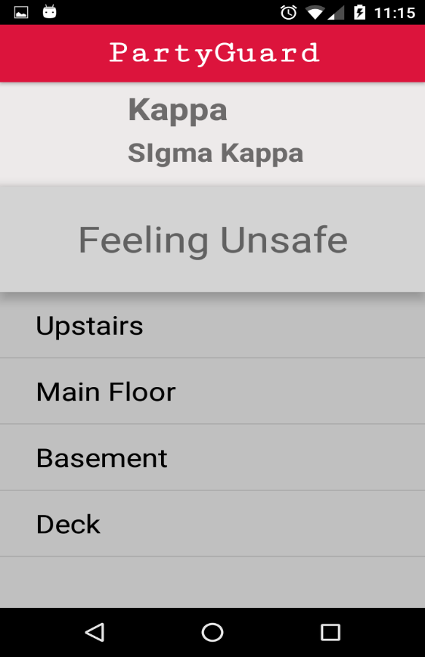

**Fig:4.5.1.4 Exact location screen**

* After selecting the exact location, you will be asked to confirm the sending of alert.
* You will get to see your alert details like issue name and location. You can also give your comments regarding your issue. Giving comments is optional.

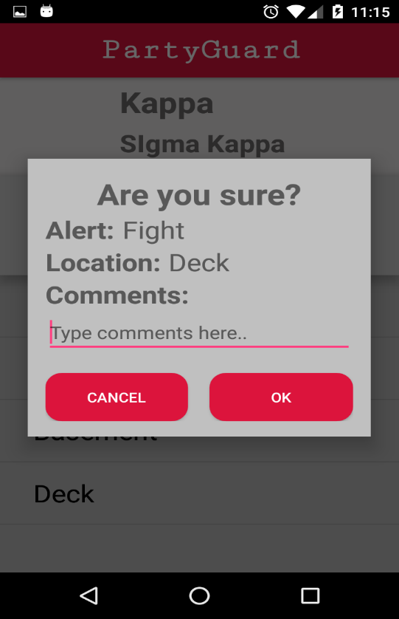

**Fig:4.5.1.5 Sending alert screen**

* By clicking on “OK” button, your alert will be sent to the fraternity authority.
* The fraternity authority will receive your alert and they will send guards to the incident spot. They will reach the spot within few minutes and solve the issue.

### **Send an SMS to university police**

* If there is any delay in the arrival of guards or in a case of extreme emergency, you can send an SMS to university police.
* After selecting the fraternity, you will get a screen with a list of issues. At the bottom of the screen, there is an “Emergency” button.
* Click on the “Emergency” button, the timer starts and after 15 minutes, SMS alert will be sent to the university police. Then the police will come into the scene and they will solve your issue.



**Fig:4.5.1.6 Sending emergency alert screen**

## **View Profile**

* In order to view your profile, you need to be logged into the app and click on the slider menu button on the top left corner of the app and click on the “Profile” tab.

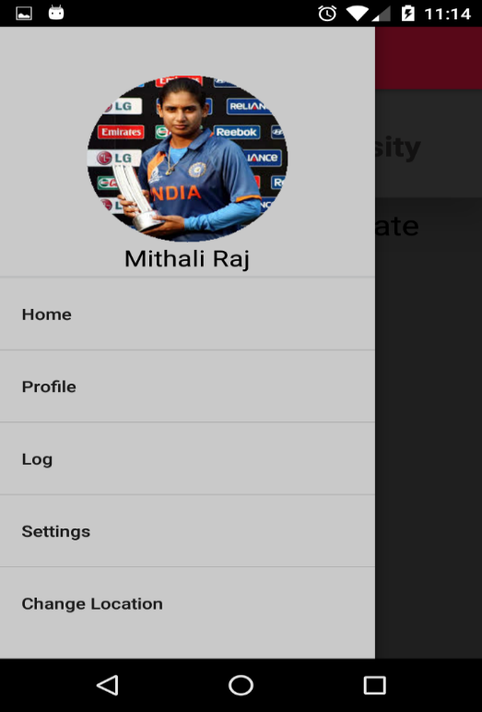

**Fig:4.6.1 Slider menu screen**

* After clicking on “Profile”, you will get to see your details. You can also edit the details by clicking on “Edit” button located on the right side of the screen.

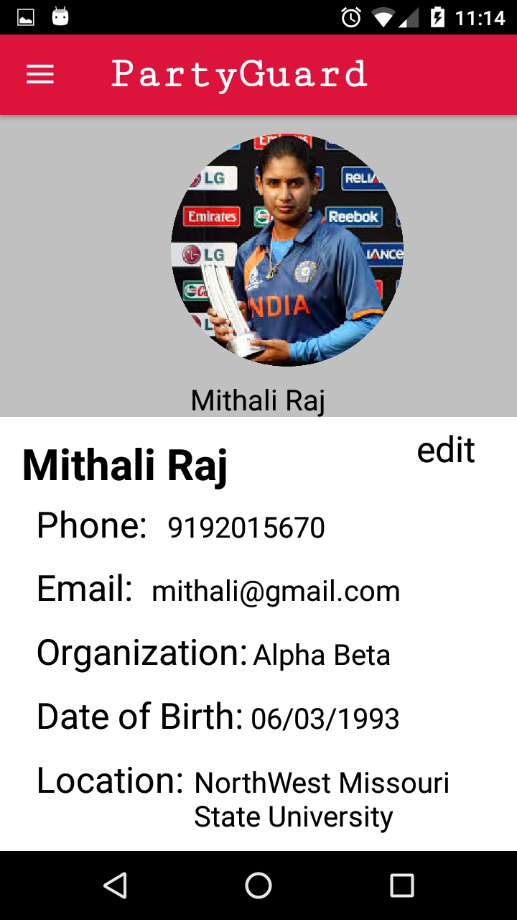

**Fig:4.6.2 Profile screen**

## **View issue log**

* In order to view the issue log, you need to be logged into the app and click on the slider menu button on the top left corner of the app and click on the “Log” tab.



**Fig:4.7.1 Slider menu screen**

* After clicking on “Log”, you can view the list of issues that were previously reported by you like an accident, a fight or feeling unsafe etc.
* Here you can just view the previously reported issues which are added to the log whenever you report an issue.

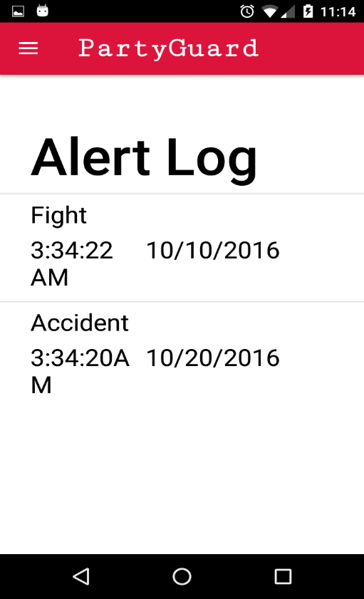

**Fig:4.7.2 View issue log screen**

## **Settings**

* In order to view this screen, you need to be logged into the app and click on the slider menu button on the top left corner of the app and click on the “Settings” tab.



**Fig:4.8.1 Slider menu screen**

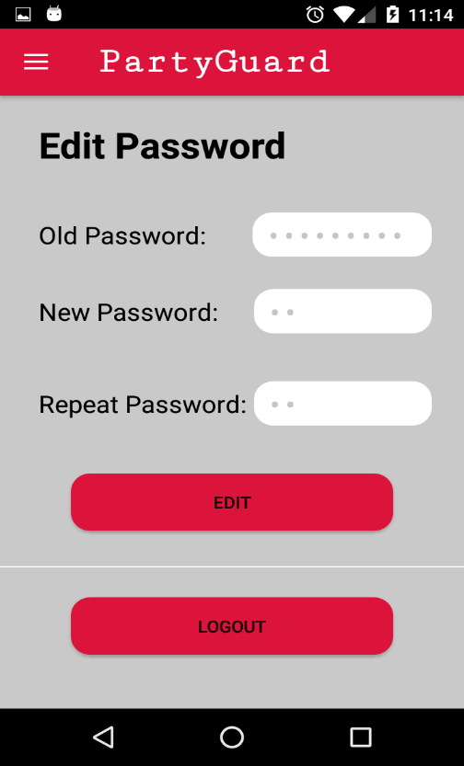

**Fig:4.8.2 Settings screen**

* In this screen, you can update your old password or log out of the app.
* In order to change your password you have to enter the old password, the new password and then the repeat new password again and click on the edit button.
* Once you click on the edit button the new password is updated and you can log in to the app only with the new password.
* You can also log out of the app once you click on the “Logout” button.

## **Change location**

* In order to view this screen, you need to be logged into the app and click on the slider menu button on the top left corner of the app and click on the “Change location” tab.



**Fig:4.9.1 Slider menu screen**

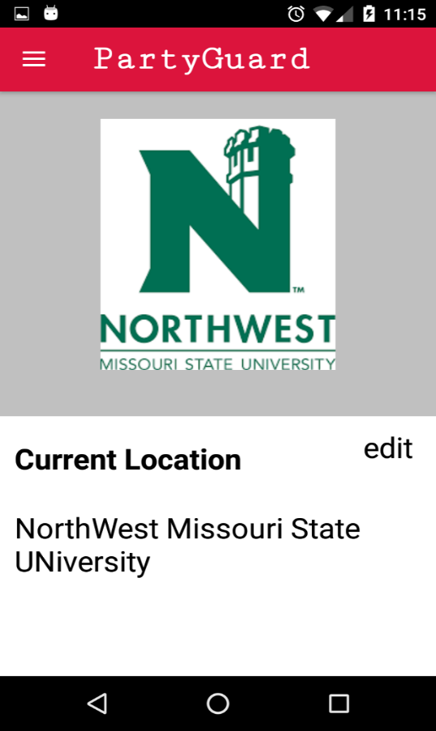

**Fig:4.9.2 Change location screen**

* After clicking on “Change location”, you will get the above screen where you can change your current location by clicking on the edit button.
* Once you click on the edit button you can view the list of universities and then you can select the university which is near to you.
* Once you select a university that particular university is saved.