**PartyGuard Android App**

User Manual for Guard User

**Android Nachos**

Ashish Peruru

Sridhar Yerasi

Harish Yeddluri

Vinod Kumar Kurma

Harish Reddy Yanala

Rakshith Anand Bootham

Seshu Kumar Gandhapuneni

Date: 11/16/2016

Prepared for

44-696 Computer Science Graduate Directed Project-II

Instructor: Dr. Charles Hoot

Fall 2016

# Introduction

This is an android application for the safety of women when she attends a party at a fraternity. During a party at a fraternity house, if a woman faces any problem, she can report that issue to the fraternity members. She can report about various problems like fights, someone is too drunk/sick, inappropriate behavior, and assaults of any kind. The fraternity members can view the reported notifications and they will send the rescue team to the spot. In a case of extreme emergency, the user can send an SMS alert to university police. The emergency button feature will have a running timer and if the problem is not solved within 15 minutes, SMS alert will be sent to university police.

# Configuration

This is an android application, which supports for mobile devices having Android version of minimum 4.4 (KitKat).

# Installation instructions

**Step-1:** Download Android Studio IDE from <https://developer.android.com/studio/index.html> into your Windows system. Launch the .exe file you downloaded. Follow the setup wizard to install Android Studio and select Android SDK in SDK tools.

**Step-2:** Our project source code is available on the CD and also in Bit bucket repository, we have given you access to the repository. Clone the code to your system.

**Step-3:** Open the Android Studio IDE and go to the toolbar and click on File -> open the project.

**Step-4:** Wait for some time until the project gets build. Now run the application by clicking on “Run” button in the toolbar. The app runs on the emulator and you can use the app.

**Step-5:** To run the application on a mobile device, go to “Build” option and click on “Generate APK” to generate the APK file. You can see the generated APK file in the explorer. Copy that APK file to an Android device and install the app on the device and use it.

# Guard user

## **Registration**

* In order to view this screen, you have to open the app by clicking on the app icon button on the home screen of your mobile phone and click on the “Guard Signup” button.

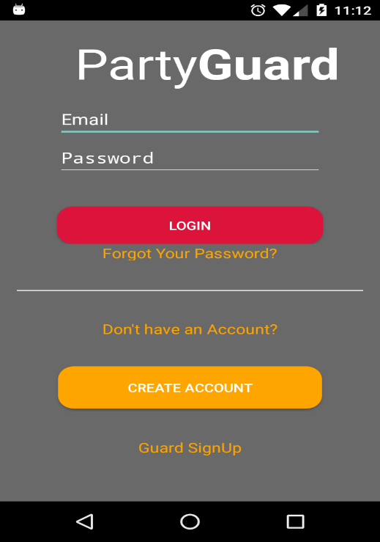

**Fig: 4.1.1 Login screen**

* Once you click on the Guard Signup button you can see the registration screen where you have to enter your first name, last name, email address, password, repeat password, phone number, Date of Birth, Zip code, university and also you can upload your image by clicking on the profile image button.
* When you click on the profile image button you can either upload an image from the gallery or you can take a photograph from your mobile device and upload the image.
* You must enter all the required fields according to the correct format or else you will be asked to re-enter the details and registration fails.
* Once you enter all your details correctly you can click on the create account button and your account gets created and you will be redirected to the login screen.

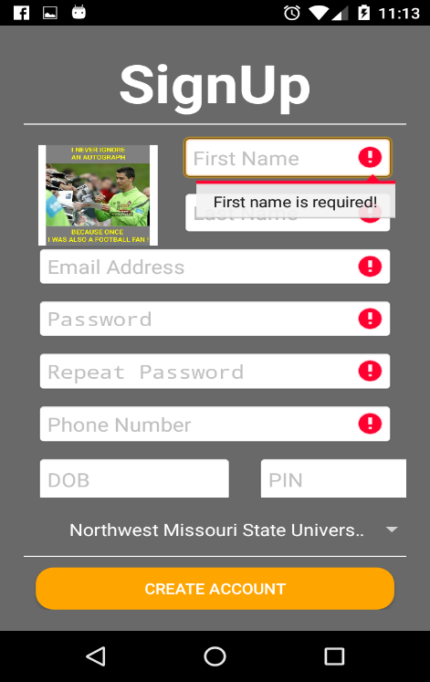

**Fig: 4.1.2 Signup screen**

## **Login**

* In order to view this screen, you have to open the app by clicking on the app icon button on the home screen of your mobile phone.
* Once the app is opened you can view the screen where you have to enter the username and password.
* If you are a new user first you have to register the screen and then you can log in to the app.
* If you are an existing user you can go ahead and enter your username and password that matches with the account.
* Once you finish entering your details you can click on the “Login” button and you will be able to log in to the app.
* If your username and password do not match you cannot login to the app and you can see a message saying the username and password does not match please enter the username and password correctly.



**Fig: 4.2.1 Login screen**

## **View alerts**

* You can view this screen once you log in to the app successfully.
* To view the alerts, click on “Alert” tab at the bottom of the screen.
* You can view all the list of alerts which are not yet resolved.
* For each alert, you can view the image of the user who has reported that alert along with his name and type of the alert.
* You can just view the alerts without making any changes to the alert
* Once you click on an alert you will be redirected to another screen where you can see all the details about the alert.

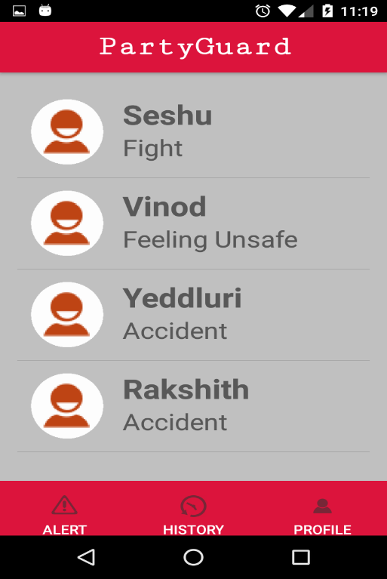

**Fig: 4.3.1 View alerts screen**

## **Claim Alert**

* You can view this screen once you click on a particular issue in the alerts screen
* Here in this screen, you can view the complete details of the issue like the name of the user who reported the issue, fraternity name, age, alert type, location, comments if typed any and the time at which he reported the issue.
* You can also claim the issue by clicking on the claim button and once you claim an issue, it cannot be seen by other fraternity members.
* When you click on the resolve button that means the alert has been resolved and it is stored on the history tab.

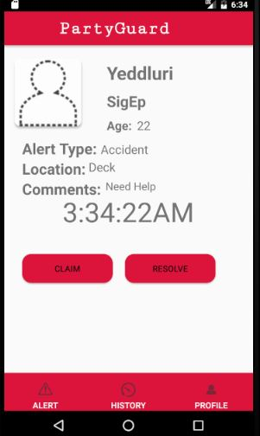

**Fig: 4.4.1 Claim alert screen**

## **View Resolved Alerts**

* You can view this screen when you click on the “History” tab at the bottom of the screen.
* Once you click on the history tab you can view a list of all the issues that were resolved.
* You can view the details of the alert like the user image who has raised an alert, username and the type of the alert.

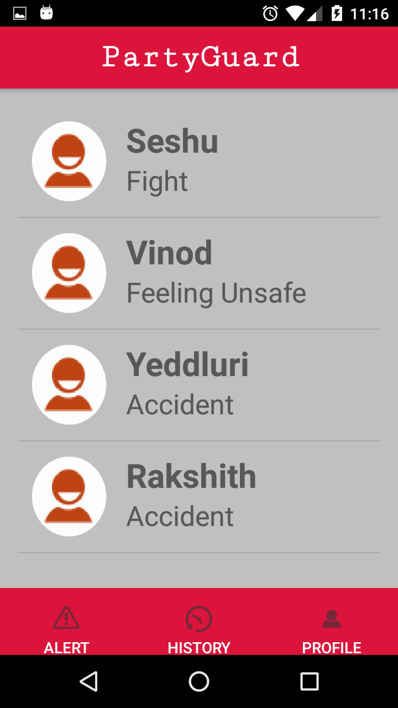

**Fig: 4.5.1 View resolved alerts screen**

## **Profile**

* You can view this screen once you click on the “Profile” tab at the bottom of the screen.
* Here in this screen you can edit the profile or log out of the app.
* You can change the profile image by clicking on the profile image and update the image, change the first name, last name, email address, contact and date of birth.
* After updating the fields you must click on the edit button in order to reflect the change.
* You also have a logout button at the bottom and once you click on the logout button you are logged out of the app.

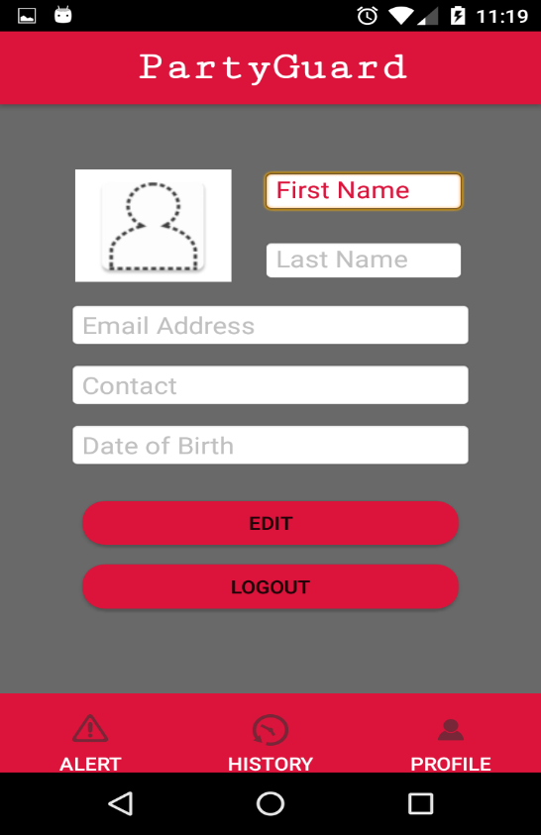

**Fig: 4.6.1 Profile screen**