**PartyGuard Android App**

User Manual for Host User

**Android Nachos**

Ashish Peruru

Sridhar Yerasi

Harish Yeddluri

Vinod Kumar Kurma

Harish Reddy Yanala

Rakshith Anand Bootham

Seshu Kumar Gandhapuneni

Date: 11/15/2016

Prepared for

44-696 Computer Science Graduate Directed Project-II

Instructor: Dr. Charles Hoot

Fall 2016

# Introduction

This is an android application for the safety of women when she attends a party at a fraternity. During a party at a fraternity house, if a woman faces any problem, she can report that issue to the fraternity members. She can report about various problems like fights, someone is too drunk/sick, inappropriate behavior, and assaults of any kind. The fraternity members can view the reported notifications and they will send the rescue team to the spot. In a case of extreme emergency, the user can send an SMS alert to university police. The emergency button feature will have a running timer and if the problem is not solved within 15 minutes, SMS alert will be sent to university police.

# Configuration

This is an android application, which supports for mobile devices having Android version of minimum 4.4 (KitKat).

# Installation instructions

**Step-1:** Download Android Studio IDE from <https://developer.android.com/studio/index.html> into your Windows system. Launch the .exe file you downloaded. Follow the setup wizard to install Android Studio and select Android SDK in SDK tools.

**Step-2:** Our project source code is available on the CD and also in Bit bucket repository, we have given you access to the repository. Clone the code to your system.

**Step-3:** Open the Android Studio IDE and go to the toolbar and click on File -> open the project.

**Step-4:** Wait for some time until the project gets build. Now run the application by clicking on “Run” button in the toolbar. The app runs on the emulator and you can use the app.

**Step-5:** To run the application on a mobile device, go to “Build” option and click on “Generate APK” to generate the APK file. You can see the generated APK file in the explorer. Copy that APK file to an Android device and install the app on the device and use it.

# Host user

## **Login**

* In order to view this screen you have to open the app by clicking on the app icon button on the home screen of your mobile phone.
* In this screen, you can log in as a Host user if you provide the valid username and password.
* First you must enter the username and then enter the correct password.
* Once the username and password matches you are logged into the app.
* If you forget your password you can retrieve your password by clicking on forgot password button.
* Once you click on forgot password button you would be redirected to another screen where you have to enter your email address and click on the “Reset password” button. Then you would receive a mail which shows your password.

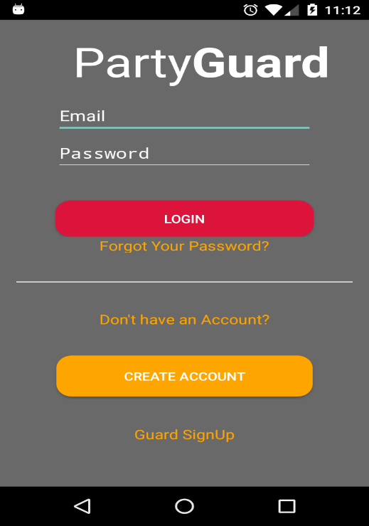

**Fig: 4.1.1 Login screen**

## **View guards**

* In order to view this screen you have to log in to the app as a Host user. Once you login you can see the list of guards with their respective images who belong to that particular fraternity.
* You can view the guard profile by clicking on the “VIEW” button below the profile image of that guard.
* Once you click on the view button you can see the profile of the guard which consists of guard image, email address, and phone number.
* There is also a toggle button on the top of the guard image, once you click on the toggle button green light appears on the bar which means that you have made guards active so that they can receive alerts.
* You can select either a single guard or multiple guards. All the guards who are active can receive alerts.

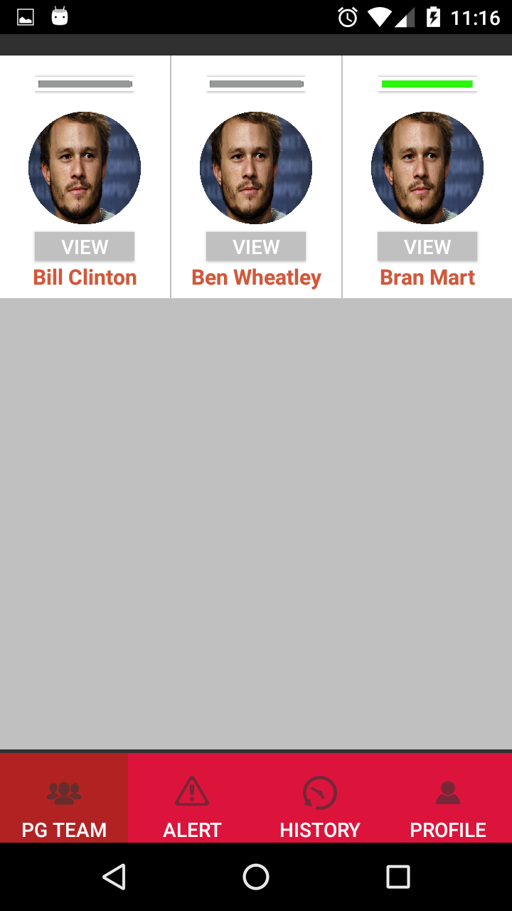

**Fig: 4.2.1 View guards screen**

## **View alerts**

* You can go to this screen by clicking on the “Alert” tab at the bottom of the page.
* In this screen, you can view the list of issues which are yet to be resolved.
* You can view the image of the user who has raised an alert along with his name and type of issue.
* Once you click on a particular issue you can see all the details of that issue.

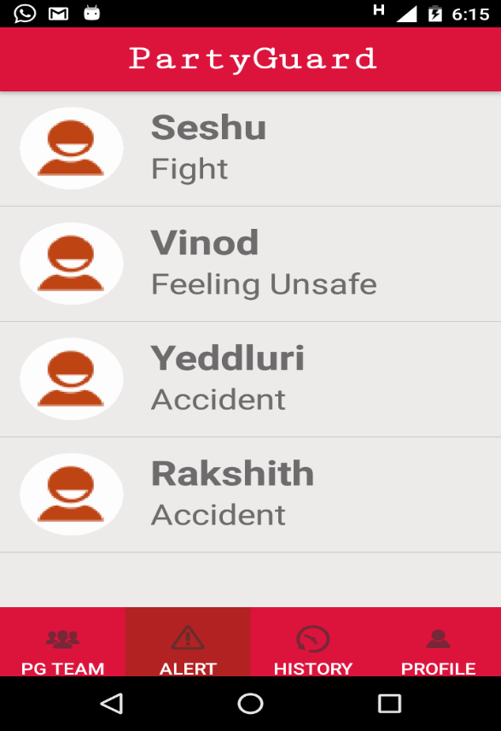

**Fig: 4.3.1 View Alerts screen**

## **Claim Alert**

* You can view this screen once you click on a particular issue in the alerts screen.
* Here in this screen, you can view the complete details of the issue like the name of the user who reported the issue, fraternity name, age, alert type, location, comments if typed any and the time at which he reported the issue.
* You can also claim the issue by clicking on the claim button and once you claim an issue, it cannot be seen by other fraternity members.
* When you click on the resolve button that means the alert has been resolved and it is stored in the history.

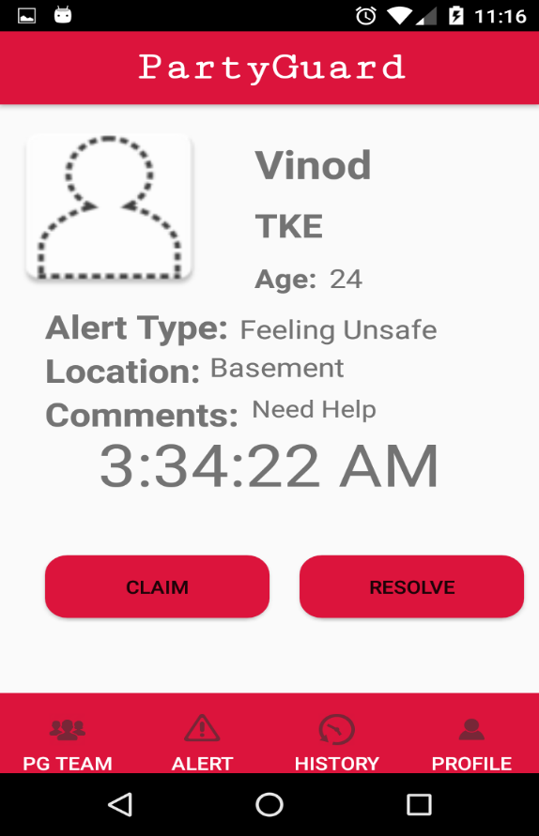

**Fig: 4.4.1 Claim Alert screen**

## **View resolved alerts**

* You can view this screen when you click on the “History” tab at the bottom of the screen.
* Once you click on the history tab you can view a list of all the issues that were resolved.
* You can view the details of the alert like the user image who has raised an alert, username and the type of the alert.

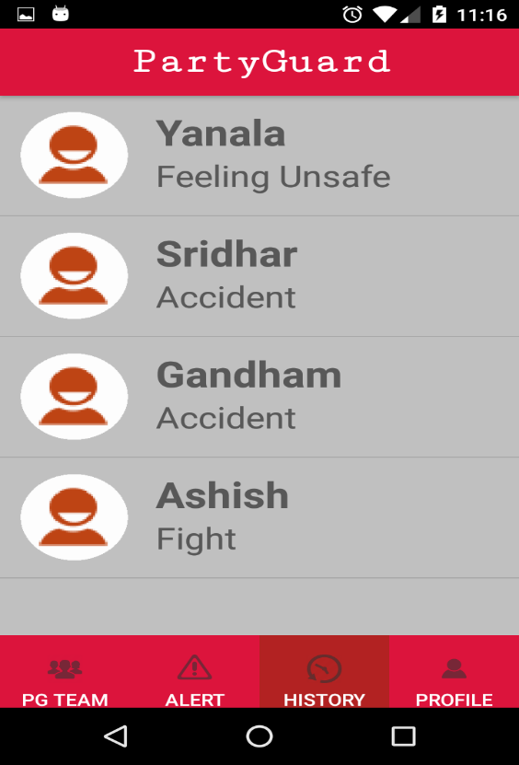

**Fig: 4.5.1 History screen**

## **Profile**

* You can view this screen once you click on the “Profile” tab at the bottom of the screen.
* Here in this screen, you can edit the profile or log out of the app.
* You can change the profile image by clicking on the profile image and update the image, change the first name, last name, email address, contact and date of birth.
* After updating the fields you must click on the edit button in order to reflect the change.
* You also have a logout button at the bottom and once you click on the logout button you are logged out of the app.

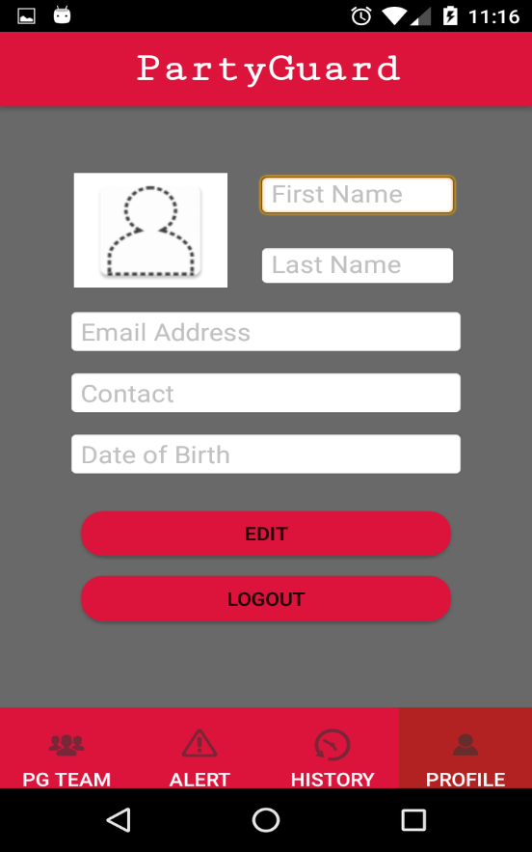

**Fig: 4.6.1 Profile screen**