PartyGuard

Software Requirements Specification

Version 0.3

Date: 07/20/2016

Android Nachos
Ashish Peruru
Sridhar Yerasi
Harish Yeddluri
Vinod Kumar Kurma
Harish Reddy Yanala
Rakshith Anand Bootham
Seshu kumar Gandhapuneni

Prepared for
44-696 Computer Science Graduate Directed Project-I
Instructor: Dr. Dennis Wong
Summer 2016
Revision history:
Date | Version | Description | People
July 11, 2016 | 0.1 | First draft | Project Owner and Client: Stansbury, Jacob C  Faculty Advisor: Dr. Dennis Wong  Project Group:  Seshu Kumar Gandhapuneni,  Rakshith Bhootham,  Harish Yeddluri,  Sridhar Yerasi,  Vinod Kumar Kurma,  Harish Reddy Yanala,  Ashish Peruru
July 17, 2016 | 0.2 | Second Draft  - Two new features are added to the Basic user.  - Features of Host (or) Guard user are introduced in this version.  - Introduced Use case diagram for Host (or) Guard user in this version. | Project Owner and Client: Stansbury, Jacob C  Faculty Advisor: Dr. Dennis Wong
July 20, 2016 | 0.3 | Third Draft  - Modified screenshots & Diagrams based on the review comments of client.  - Incorporated review comments of client.  - Incorporated review comments of Dr. Dennis Wong. | Project Owner and Client: Stansbury, Jacob C  Faculty Advisor: Dr. Dennis Wong

Document approval:
The following Software Requirements Specification has been accepted and approved by the following:
Signature | Printed Name | Title | Date
 | Dr. Dennis Wong | Faculty Advisor
 | Jacob C Stansbury | Project Sponsor
Table of Contents

1. Introduction 1
1.1 Scope 1
1.2 Definitions, Acronyms, and Abbreviations 1
1.3 Overview 1
2. General Description 1
2.1 Product Perspective 1
2.2 Product Functions 2
2.3 User Characteristics 2
2.4 General Constraints 2
2.5 Assumptions and Dependencies 2
3. Basic User - Functional Requirements 3
3.1 Feature 1: User Login 3
3.1.1 Introduction 3
3.1.2 Inputs 3
3.1.3 Processing 3
3.1.4 Outputs 4
3.1.5 Error Handling 4
3.2 Feature 2: Registering User 4
3.2.1 Introduction 4
3.2.2 Inputs 4
3.2.3 Processing 5
3.2.4 Outputs 5
3.2.5 Error Handling 5
3.3 Feature 3: Reset Password 6
3.3.1 Introduction 6
3.3.2 Inputs 6
3.3.3 Processing 6
3.3.4 Outputs 6
3.3.5 Error Handling 6
3.4 Feature 4: How to use this app? 7
3.4.1 Introduction 7
3.4.2 Inputs 7
3.4.3 Processing 7
3.4.4 Outputs 7
3.4.5 Error Handling 7
3.5 Feature 5: Fraternities Screen 8
3.5.1 Introduction 8
3.5.2 Inputs 8
3.5.3 Processing 8
3.5.4 Outputs 8
3.5.5 Error Handling 8
3.6 Feature 6: Report Issue Screen 9
3.6.1 Introduction 9
3.6.2 Inputs 9
3.6.3 Processing 9
3.6.4 Outputs 9
3.6.5 Error Handling 10
3.7 Feature 7: Report Location Screen 10
3.7.1 Introduction 10
3.7.2 Inputs 10
3.7.3 Processing 10
3.7.4 Outputs 11
3.7.5 Error Handling 11
3.8 Feature 8: Resolution Alert 11
3.8.1 Introduction 11
3.8.2 Inputs 11
3.8.3 Processing 11
3.8.4 Outputs 12
3.8.5 Error Handling 12
3.9 Feature 9: Profile Dropdown Menu (or) Swipe Screen 12
3.9.1 Introduction 12
3.9.2 Inputs 12
3.9.3 Processing 13
3.9.4 Outputs 13
3.9.5 Error Handling 13
4. Host (or) Guard User - Functional Requirements 13
4.1 Feature 1: Host User Login 13
4.1.1 Introduction 13
4.1.2 Inputs 13
4.1.3 Processing 13
4.1.4 Outputs 13
4.1.5 Error Handling 13
4.2 Feature 2: PG Team 14
4.2.1 Introduction: 14
4.2.2 Inputs: 14
4.2.3 Processing: 14
4.2.4 Outputs: 14
4.2.5 Error Handling: 15
4.3 Feature 3: Alert Screen 15
4.3.1 Introduction 15
4.3.2 Inputs 15
4.3.3 Processing 15
4.3.4 Output 15
4.3.5 Error Handling 15
4.4 Feature 4: History 16
4.4.1 Introduction 16
4.4.2 Inputs 16
4.4.3 Processing 16
4.4.4 Outputs 16
4.4.5 Error Handling 16
4.5 Feature 5: Host/Guard Profile Screen: 17
4.5.1 Introduction 17
4.5.2 Inputs 17
4.5.3 Processing 17
4.5.4 Outputs 17
4.5.5 Error Handling 18
5. Analysis Models 18
5.1 UML Diagrams 18
5.1.1 Basic User - Use Case Diagram: 18
5.1.2 Host User – Use case diagram: 19
5.1.3 State-Transition Diagrams (STD): 19
5.2 Data Flow Diagrams (DFD): 20
6. Interfaces 21
6.1 Hardware Interfaces 21
6.2 Software Interfaces 21
7. Non-Functional Requirements 22
7.1 Performance 22
The performance of the app will be on par with industry standard. 22
7.2 Availability 22
7.3 Security 22
7.4 Portability 22
8. Change Management Process 22

Introduction

Scope
“PartyGuard” is an Android app that could be used by students of Northwest Missouri State University. Later this app could be implemented across other universities in the Unites States. This document does not include the requirements of Back-end Database, and Services. This document includes the requirements of User Interface and integration of the app with back-end services.

Definitions, Acronyms, and Abbreviations
- Fraternity: A society for male students in a university or college, typically for social purpose.
- Sorority: A society for female students in a university or college, typically for social purposes.
- Basic User: Any student who uses this app is categorized as a basic user.
- Host User: A member of a fraternity house who holds the admin privileges on this app. This user will have a different navigational flow.
- Guard User: This is a regular member of the fraternity without admin privileges, but can still view, claim, and resolve alerts.
- UML: Unified Modelling Language
- UI: User Interface
- KitKat: Android mobile OS version 4.4
- IDE: Integrated Development Environment
- Android Studio: IDE for developing Android apps
- FNF: Functional and Non-Functional requirements

Overview
The SRS document consists of FNF requirements, user interfaces and UML diagrams of PartyGuard app.

General Description

Product Perspective
During a party at a fraternity house, if a woman faces any problem, she can report about that issue to the fraternity members. She can report about various problems like fights, someone is too drunk/sick, inappropriate behavior, and assaults of any kind. The fraternity members can view the reported notifications and they will send the rescue team to the spot. Separate to these other alerts, the emergency button feature will have a running timer and if the problem is not solved within 15 minutes an alert message will be sent to campus police.

Product Functions
- Firstly, there would be a login page, where the existing users can login and there will also be an option for new users to register.
- User can also use Facebook or Twitter credentials to login to the app.
- After login, the first time users will get to see a video of how to use the app.
- In the next screen, the list of fraternities will be populated based on their location to whom they wish to report the problem.
- Once the fraternity is selected, user can choose the type of issue they want to report.
- User can also choose her location (floor) within the house while reporting.
- With the above information, user can send an alert message to the fraternity members.
- The fraternity members will view the notifications and send the rescue team to the spot.
- There will be a confirmation button once the issue is solved by the rescue team that the female user needs to approve of
- There is also an emergency button feature which skips house location selection and comments field. If it is not solved within 15 minutes after reporting, campus police will be notified. There is also a “confirmation” button after they click the emergency button. Which the regular user must confirm and approve that the emergency has been solved.

User Characteristics
There will be three types of users. First type is a basic user, who reports a problem to the fraternity members. The second type is the “Guard” (or) a “Basic Fraternity” user, who views the notifications of problems reported by the basics users via push notifications and responds/resolves them. The third type, called the “Host User,” is going to be exactly the same as the guard user except they will have the permissions to select how many, and which “Guard” users will receive the push notifications at any point.

General Constraints
As of now, no constraints are identified.

Assumptions and Dependencies
- As the backend is not yet finalized for this app, the implementation may change depending on the backend used. We are currently assuming that the app uses Kinvey as the backend database.
- We are assuming Android studio as the IDE for development of the application.

Basic User - Functional Requirements

Feature 1: User Login
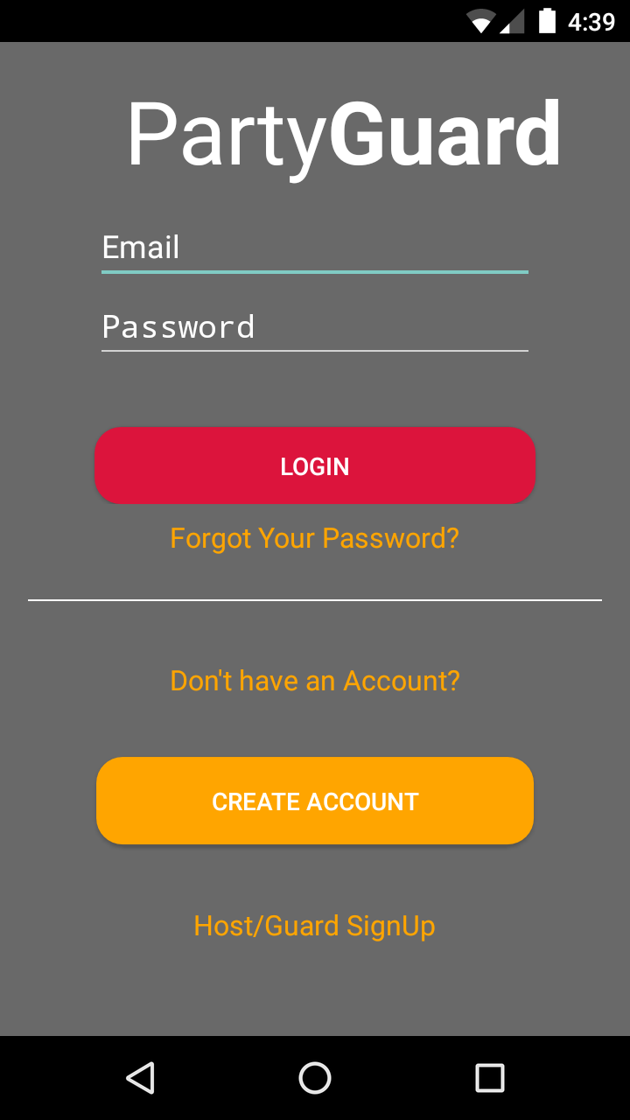

Introduction
- User should be redirected to the login page when he/she opens the app for the first time.
- Basic User should be given option to register as a new user or login through Facebook/Twitter accounts.
- User will be auto logged in after the first login.

Inputs
User should provide username and password in the respective fields and click on Login.
- Username: The username can consist of small case letters, upper case letters and numbers. It must have a minimum of 3 characters and a maximum length of 15 characters.
- Password: The password must consist of at least one small case, upper case, a number and a special character. The password should be minimum length of 8 and maximum length of 16. Password is encrypted before storing it in Database.

Processing
- If user clicks on Register button, user will be redirected to registration page.
- If user clicks on “Facebook” icon in login page, user will be redirected Facebook authentication page.
- If user clicks on “Twitter” icon in login page, user will be redirected Twitter authentication page.
- User should be validated by the respective authentication server based on the credentials provided.

Outputs
If the login is successful, user should be redirected to “How to use app?” screen. “How to use the app” will be a short video/picture tutorial to help users recognize on how to use the app.

Error Handling
If the user credentials provided are invalid an error should be thrown.

Feature 2: Registering User
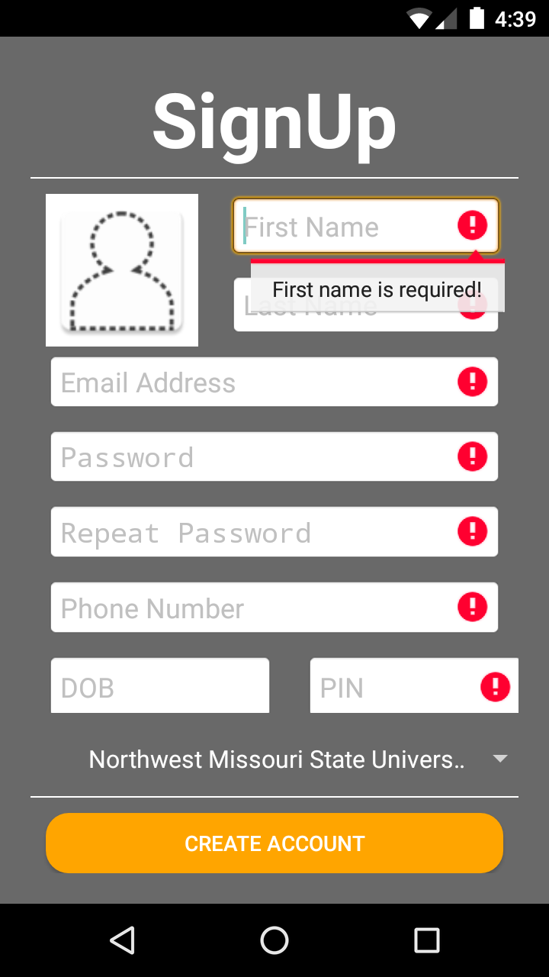

Introduction
Basic User should be redirected to the registration page when he/she clicks on “Register” button in the login page.

Inputs
Basic User should provide the following details to register as a new user
- Choose a Username
The username can consist of small case letters, upper case letters and numbers. It must have a minimum of 3 characters and a maximum length of 15 characters.
- E-mail
The email provided should be in the standard email format.
- Contact number
Should only be numbers with length 10.
- Choose Password
The password must consist of at least one small case, upper case, a number and a special character. The password should be minimum length of 8 and maximum length of 16.
- Re-enter password for confirmation purposes
The entry in this field should match with password entered in the above field.
- Profile Picture
The image will be resized to the predefined resolution.
- Birth date (translated to age in years)
Age of the user is calculated based on the date entered in this field.
- University
This is a dropdown. As of now, this app is available for only Northwest Missouri State University students.
- Greek affiliation if any (optional field)

Processing
- Application checks the availability of the username.
- Applications checks if the passwords match.
- New user details are added to the database.
- App should send a confirmation SMS message to the phone number entered to make sure the correct phone number is linked up to the app.

Outputs
If registration is successful, user should be redirected to “Home” screen.

Error Handling
- If passwords do not match, an error will be thrown.
- If the username is already in use, user will be prompted to re-enter a different username.

Feature 3: Reset Password
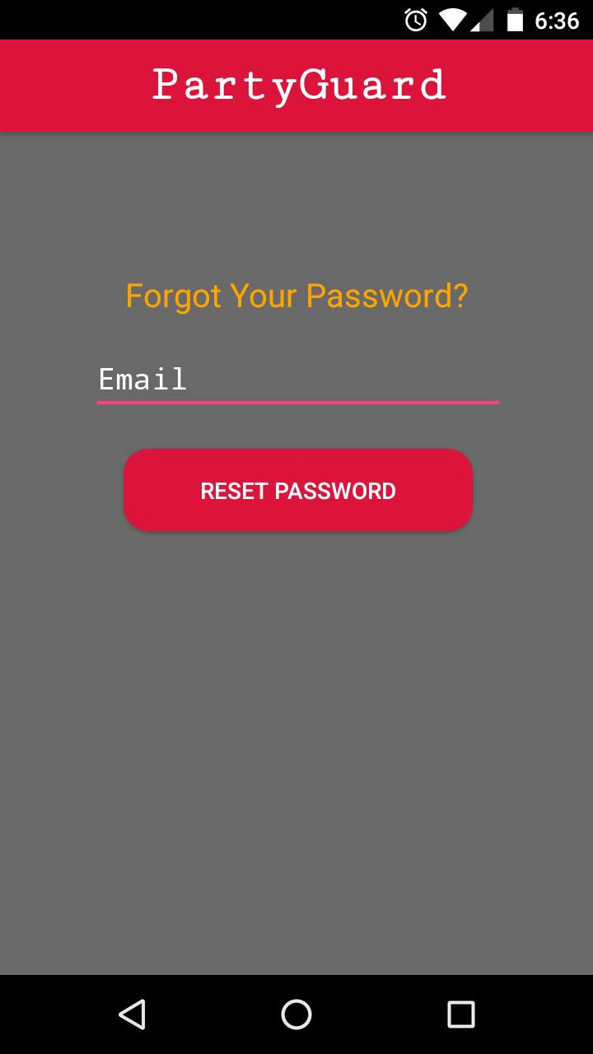

Introduction
User can reset his/her password by providing the user id.

Inputs
User needs to provide “User ID” of his/ her account and click on “Reset” button

Processing
Based on the user id provided by the user, app fetches the corresponding email of the user from database. It is mandatory that every user should provide their email ID during registration.

Outputs
An email is sent to the user with password details.

Error Handling
If the user id provided by the user is invalid, app should show an error message.

Feature 4: How to use this app?
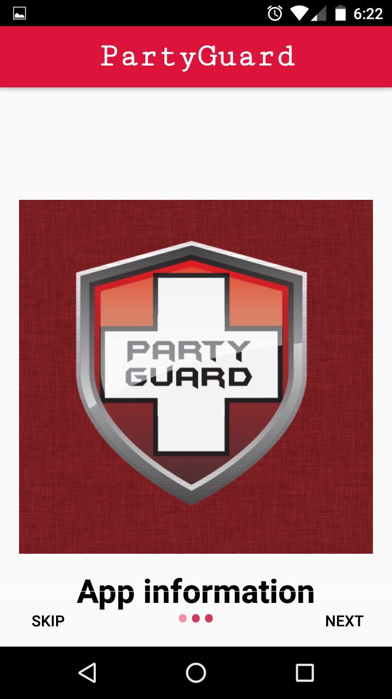

Introduction
User should be redirected to “How to use this app?” screen, when user logins or registers for the first time.

Inputs
User will be provided with a slider that contains images/ Video that instructs user on how to use “PartyGuard” app.

Processing
- Images and Video links are shown on the page in a slider.
- This screen is not shown if the user is not logging in for the first time.

Outputs
User can view Images or Videos provided in this screen.

Error Handling
If the Images and Videos are not loaded from the database, app should not crash.

Feature 5: Universities Screen
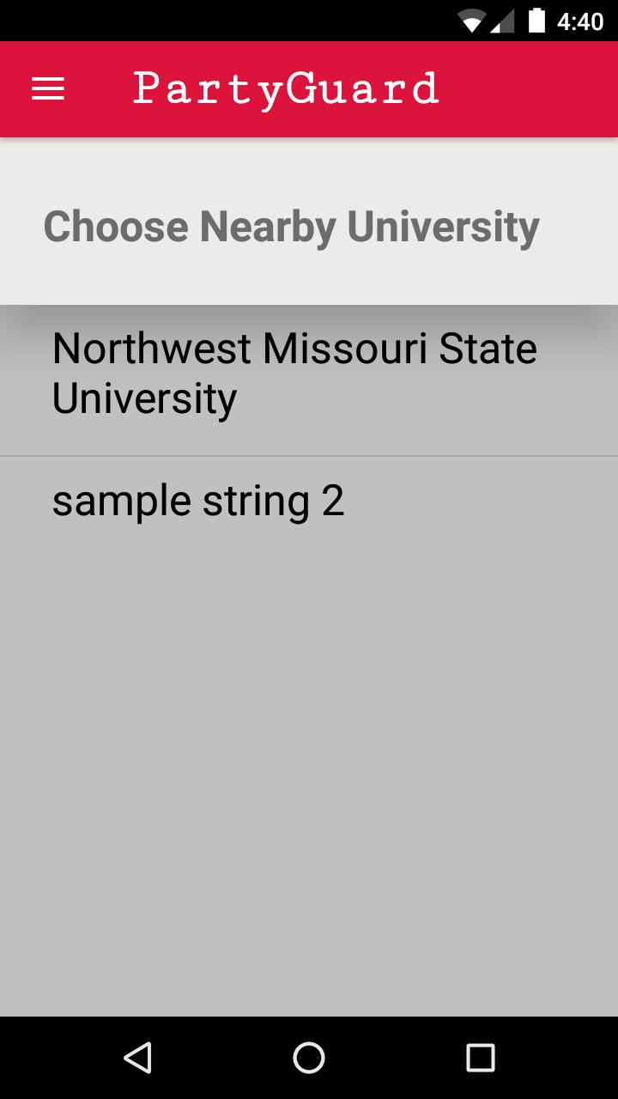

3.5.1 Introduction
User should be redirected to this screen, after the “How to use app” screen when user logins or registers for the first time or when the user auto logs in.

3.5.2 Inputs
User will click on the university in this screen.

3.5.3 Processing
- The university which the user selects in this screen will be sent to the next screen i.e., fraternity screen.

Outputs
The university which the user selects in this screen will be sent to the next screen i.e., fraternity screen

Error Handling
If the universities list is not loaded from the database, app should not crash.

Feature 6: Fraternities Screen
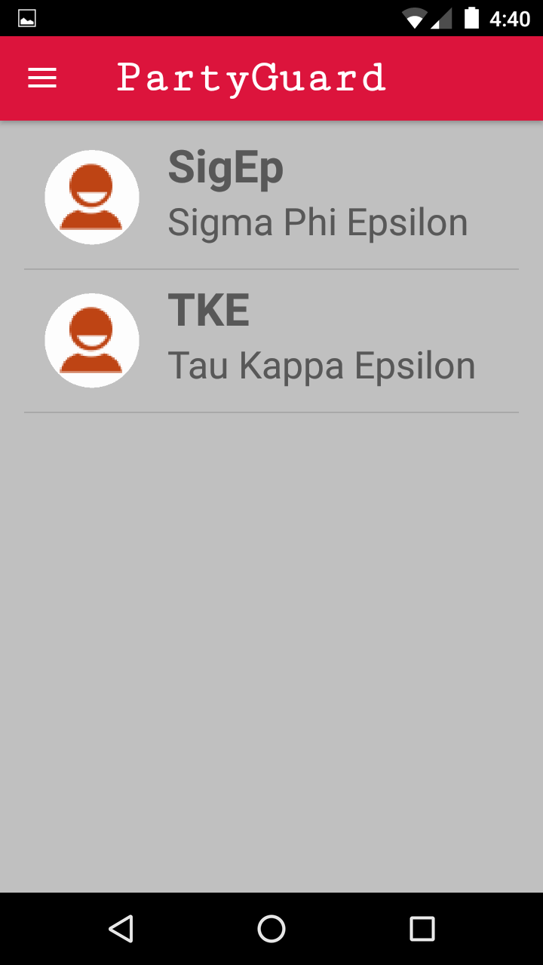

3.6.1 Introduction
The List of fraternities that are available in the user’s location are enabled for user to select. Along next to the names should be a small image of the fraternity house provided by the Host user via the website.

Inputs
Fraternities list in the user’s location are fetched from the database.

Processing
If the fraternity has not paid for the usage of this app, the fraternity option is not enabled in this screen.

Outputs
Fraternities list in the user’s location are fetched from the database. User can select a fraternity to report the issue.

Error Handling
If the fraternity list is not loaded from the database, app should not crash.

Feature 7: Report Issue Screen
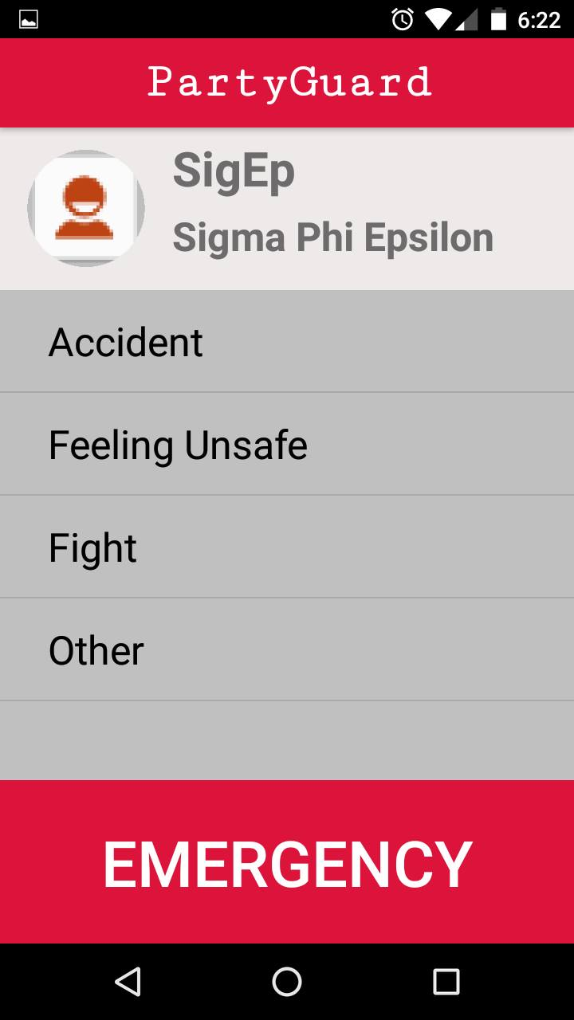

Introduction
User can send an alert using this screen.

Inputs
- User can select from a category of the issue from the list. The issues that are shown in this screen are as below
  - Accident
  - Feeling Unsafe
  - Fight
  - Other

- User can also select emergency button which would then ask the user if they were sure if they wanted to send the alert. If it is confirmed this feature allows the user to skip the location screen in order to send the alert faster. This is the only button that will trigger the University Police alert after 15 minutes.

Processing
A timer is enabled to track if the issue is not resolved for more than 15 minutes, only if the emergency button is clicked.

Outputs
- User can select an issue category to report it to the Fraternity. A confirmation message is shown on the screen triggering a push notification to Guard and Host users
- An emergency alert can be sent only by the EMERGENCY button to “Campus police” if the issue is not resolved by Fraternity within 15 minutes. A confirmation message is shown on the screen.

Error Handling
If the fraternity list is not loaded from the database, app should not crash.

Feature 8: Report Location Screen
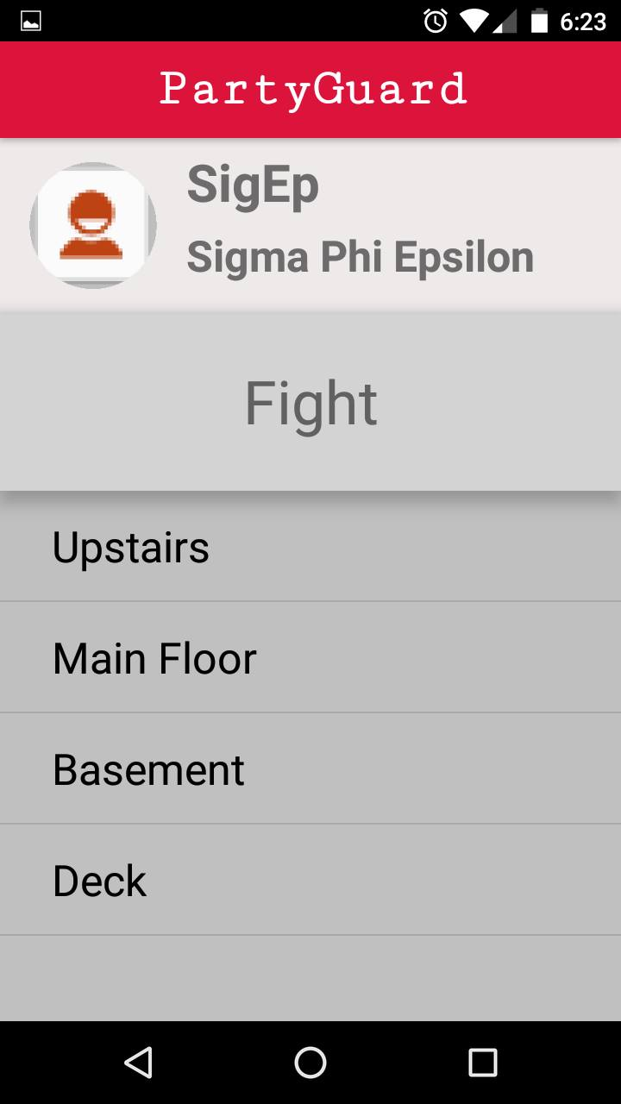

Introduction
User can choose his/ her location in this screen so that Fraternity team can locate the person.

Inputs
User can choose a floor (or) location within the building in this screen.

Processing
- The location (or) floor list in this screen is populated based on the data provided by host user during registration of a Fraternity house.
- The Basic User then is sent to an Alert Summary page. They then have the option to cancel, add optional comments, and/or hit Send.
- A notification is sent to the fraternity member, after selecting this option.

Outputs
The location selected in this screen will be included in the notification that is sent to the respective Fraternity members.

Error Handling
If the location list is not loaded from the database, app should not crash.

Feature 9: Resolution Alert

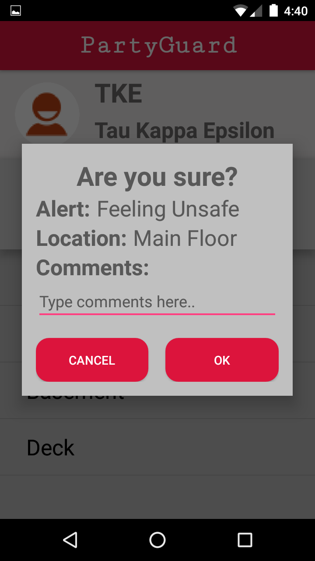

Introduction
Host user can push a notification to the basic user (user who submitted the issue) to confirm if the issue is resolved. A pop-up message is shown on the screen of the basic user to confirm the resolution of the issue.

Inputs
User can either can choose “Accept” or “Decline” option from the pop-up.

Processing
The option chosen by the basic user from the popup (Accept or Decline) is notified to the Host (or) Guard user.

Outputs
Accepted: Issue is marked as resolved
Declined: The issue retains in “Un-resolved” state. Host user can re-notify the user once the issue is resolved.

3.8.5 Error Handling
App should not crash once the user selects the feedback.

Feature 10: Profile Dropdown Menu (or) Swipe Screen

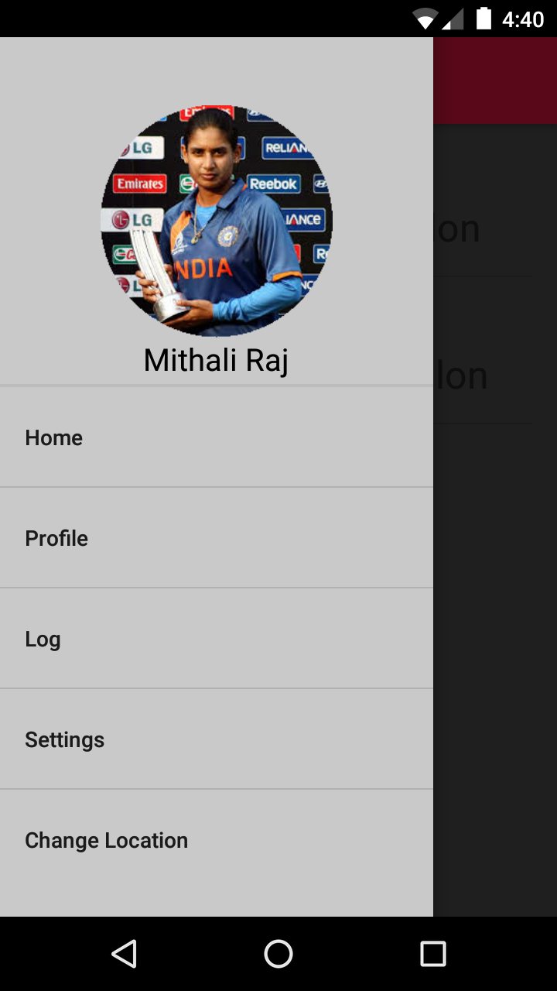

Introduction
This screen can be navigated by swiping from the left end of the screen (or) by clicking the dropdown menu () from the top left end of the screen.

Inputs
User can select one of the below options to view (or) modify the existing settings

- Profile
- My Alerts
- Location Change
- Log Settings
- About PartyGuard

Processing
User can navigate to the respective settings screens by clicking the options provided in the list.

Outputs
User can navigate to the respective settings screens by clicking the options provided in the list.

Error Handling
If the options list is not loaded from the database, app should not crash.

Host (or) Guard User - Functional Requirements

Feature 1: Host/Guard User Signup
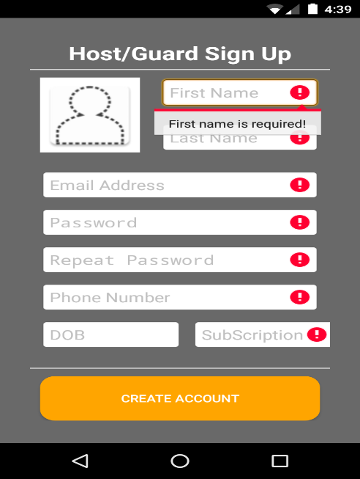

Introduction
- The host user would be redirected to the Signup page when he/she opens the app and clicks on the Host/Guard User Signup.

Inputs
Basic User should provide the following details to register as a new user
- Choose a Username
  - The username can consist of small case letters, upper case letters and numbers. It must have a minimum of 3 characters and a maximum length of 15 characters.
- E-mail
  - The email provided should be in the standard email format.
- Contact number
  - Should only be numbers with length 10.
- Choose Password
  - The password must consist of at least one small case, upper case, a number and a special character. The password should be minimum length of 8 and maximum length of 16.
  - Re-enter password for confirmation purposes
- The entry in this field should match with password entered in the above field.
- Profile Picture
- The image will be resized to the predefined resolution.
- Birth date (translated to age in years)
- Age of the user is calculated based on the date entered in this field.
- University
  - This is a dropdown. As of now, this app is available for only Northwest Missouri State University students.
- Greek affiliation if any (optional field)

Processing
- After the user enters the username and password and clicks on login button, he will be redirected to the PG Team Tab.
- User should be validated by the respective authentication server based on the credentials provided.

Outputs
- If the login is successful, user will be redirected to PG Team Tab.

Error Handling
- If the user credentials provided are invalid an error should be thrown.

Feature 2: PG Team

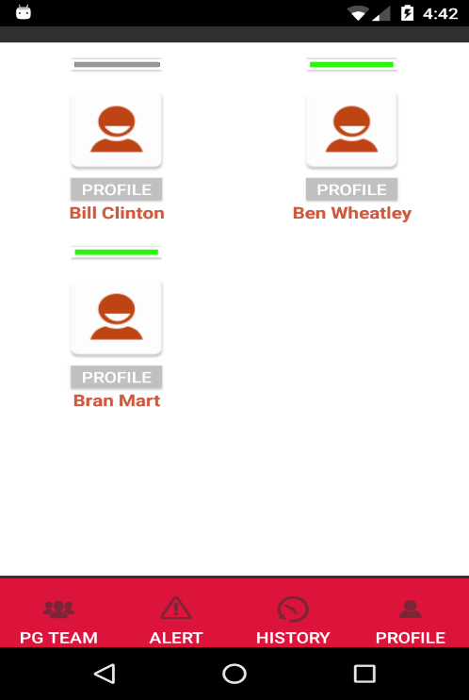

Introduction:
- This screen will be the host landing screen, when the host user logs into the account he/she will be able to see this screen.
- This screen shows the guard members who are in that fraternity.
- When the host user clicks on a member, his/her profile will be displayed.
- The “green” circle on the image indicates the members who will receive alerts.
- The members who are not in green in this screen will not receive any alerts.
- The user can select other tabs like alerts, history, and profile.

Inputs:
- The user just needs to click on a member to view his/her profile. Host user can switch on/off the option of receiving the notifications for this user. Rest of the profile changes can be done only from the website.
- As mentioned earlier, the “green” circled members are those who receive alerts. The assignment to the members will be done by the host user in the website or using app.

Processing:
- When the user clicks on the members, their profile will be displayed.

Outputs:
- The profiles of the guard members will be displayed when the host user clicks on the image.

Error Handling:
- When this page is loaded, only the guard members of that fraternity should be displayed.

Feature 3: Alert Screen

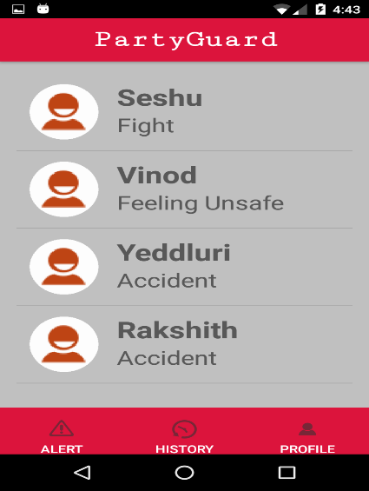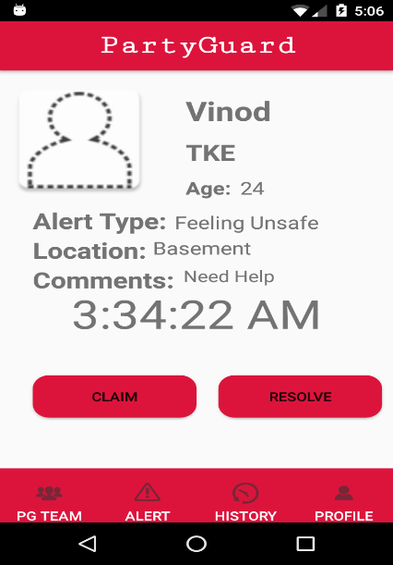

Introduction
Host user should be redirected to the alerts page when he/she clicks on “Alerts” tab.

Inputs
List of all unresolved alerts reported to the fraternity are shown in this screen. Host can select an alert from this screen. Once an alert is resolved and the resolution is confirmed by the basic user the alert information is moved to the history page.

Processing
- The information regarding the alert, will be populated. The time elapsed after submitting the issue will be shown on the screen.
- If no one is handling that particular alert, “claim” button will be enabled. Any fraternity guard member on duty can claim the alert and confirm the claim.
- The name of the person who claimed the alert will be sent to the basic user. To all the other guard members “Claim” button in the screen will be replaced by the name of person who claimed the alert.
- After claiming the alert, any guard user who receives the alert can send the resolution confirmation request to the basic user by clicking on “Resolve” button.
- The basic user can accept (or) reject the request from the fraternity guard member that is on duty.

Output
The fraternity member will get the confirmation message once the basic user accepts the resolution request from the fraternity member. This sends the alert to the history page.

Error Handling
The app should not crash if the alert information is not loaded on to the screen.

Feature 4: History

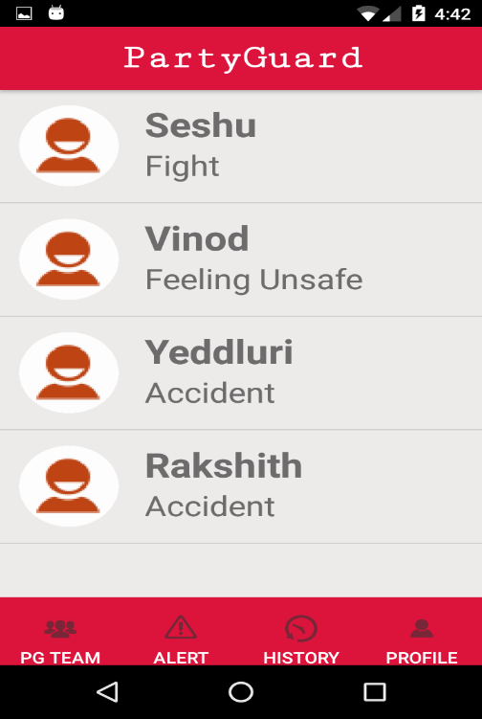

Introduction
The host user can be able to see issues that were resolved from the past few days when he clicks on the “History” tab. All the issues will have the time it was solved, the amount of time it took to solve, and all the information about the issue such as the user and the type of issue.

Inputs
A click on the “History” tab. Also, a click on each alert will load and show all of that information regarding that alert for a quick view.

Processing
When the basic user confirms that the issue was resolved, only then that issue will be displayed under “History” tab.

Outputs
A list of resolved issues will be displayed with the name of the person and location.

Error Handling
If there are no previously resolved issues, nothing will be displayed and the app shouldn’t crash.

Feature 5: Host/Guard Profile Screen:

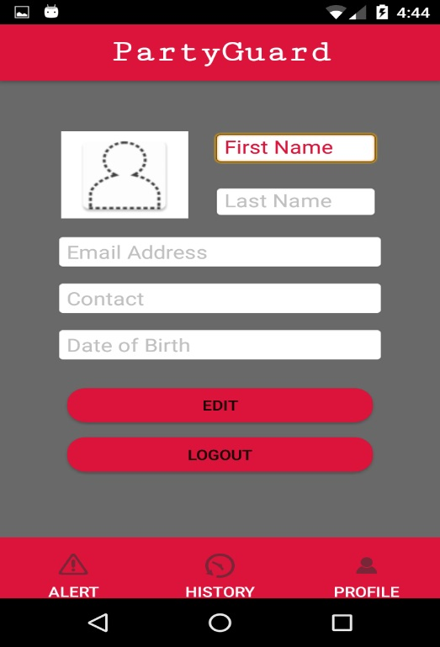

Introduction
Host/Guard User should be re-directed to the profile page when he clicks on “Profile” tab in the Host/Guard landing screen.

Inputs
Host/Guard User could edit his profile by providing any of the following details.
  - First Name
  - Last Name
  - Email Address
  - Phone Number
  - DOB
  - PIN

Processing
- Application directs to the profile screen.
- User can edit and change his (or) her details in the screen.
- New user details are updated to the database.

Outputs
The updated details are shown on the profile screen of Host/Guard user.

Error Handling
The application should not crash, if the page is loaded with new details.

Analysis Models

UML Diagrams

Basic User - Use Case Diagram:
A use case diagram shows interactions among elements of a system. In the diagram, women, fraternity and police are actors whereas Login, Registration etc. are different use cases.
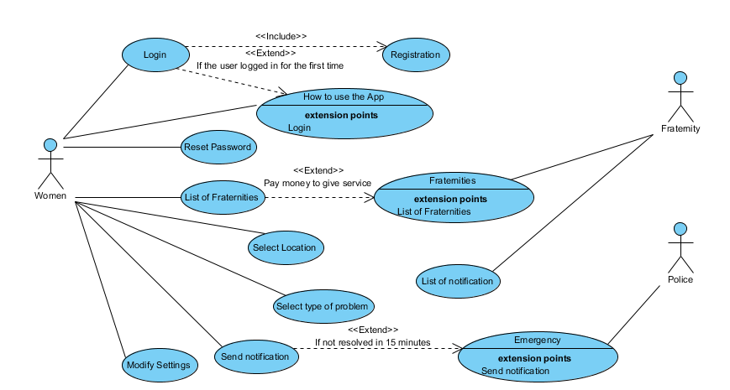

Host User – Use case diagram:
In this diagram host user and basic user are the actors and login, select a member are the uses cases.
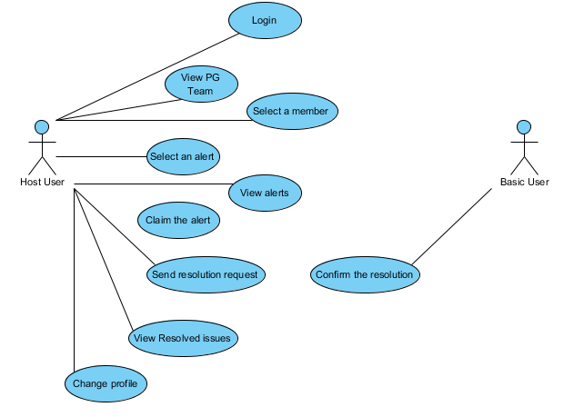

State-Transition Diagrams (STD):
A state transition diagram or state chart diagram, is an illustration of the states an object can attain as well as the transitions between those states. In the diagram Login, Register, Play Video, List of Fraternities etc. are different states.
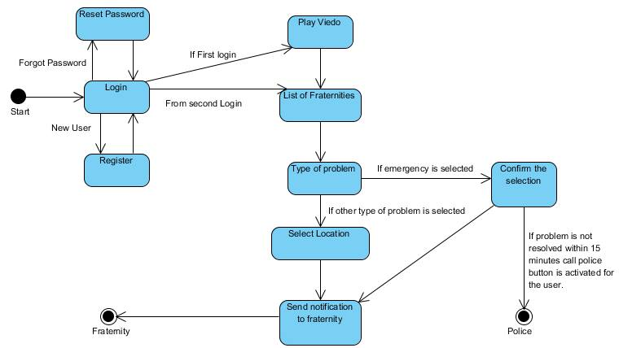

Data Flow Diagrams (DFD):
A data flow diagram is a graphical representation of flow of data through an information system.
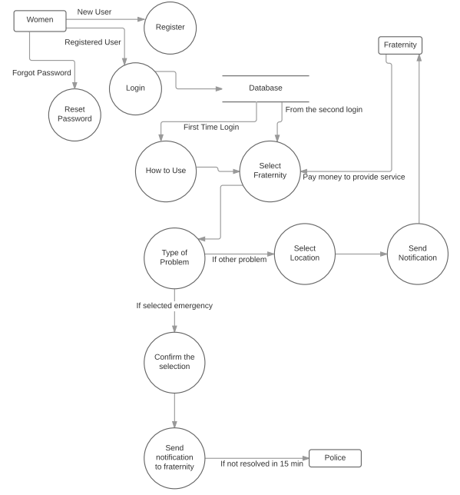

Interfaces

Hardware Interfaces
This application will interact with a centralized database, to store the user, to store the fraternity information, payment information, etc. The connection to the database server is managed by the operating system. This application also uses Location based services to track the fraternities that are in that area, the physical GPS is managed by the GPS application in the mobile phone.

Software Interfaces
This application will be able to run in any mobile phone that uses Android as its operating system and a minimum of Android-4.4 KitKat. The communication with the database will be done in order to authenticate the user and managing the application.

Non-Functional Requirements

Performance

The performance of the app will be on par with industry standard.

Availability
The availability of the app will be 24*7 for 365 days in a year.

Security
All the standard android related security features will be applied to this app.

Portability
This app can be installed and used from the android version KitKat 4.4 and above.

Change Management Process
- All the changes in the requirements will be initially discussed with our instructor and will be documented as a minor version.
- The modified document will be sent to the client for approval.
- This document will be published as a major version only after the approval from the client.

