Abstract: This report develops inclusive user personas, scenarios, and requirements for an accessible international games and sports platform using HCI methods.

1. Introduction
The rise of digital platforms for sports and events requires a user-centred design approach to ensure inclusivity, usability, and satisfaction for a wide range of users. This research explores how personas and scenarios help facilitate the development of products that address the needs of certain user groups. Creating a sports platform that supports local athletic events, makes booking accessible, and fosters a sports-related community is the primary objective.
2. Literature Review
Design is crucial when developing digital gaming platforms that are accessible to all users, according to earlier research. It facilitates designers' comprehension of various users' requirements and expectations. It facilitates the development and accessibility of more beneficial features.
That is, the design that can be accessed by adding simple tools such as a screen reader, clear navigation, and an easy booking system. When the platform includes these features, more people feel comfortable participating in sports events and staying connected to the community. In general, good design improves user satisfaction and supports inclusiveness for all types of users.
3. Methodology
The Safe use of stable sports programs has developed character and orientation. MoSCoW uses its "Favourite, "Required," "Can," and "Not Necessary" study materials. The classifications have been modified. We have ensured that the platform's initial training is based on its products and desires.

User Persona 1

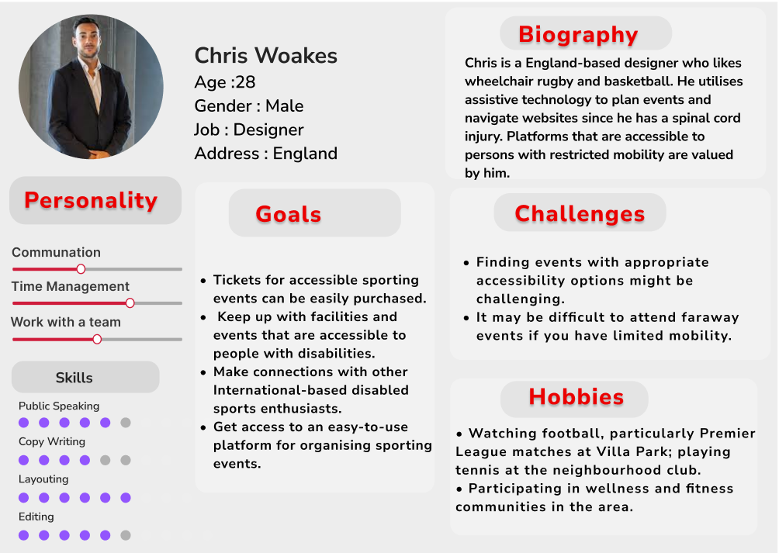

User Persona 2
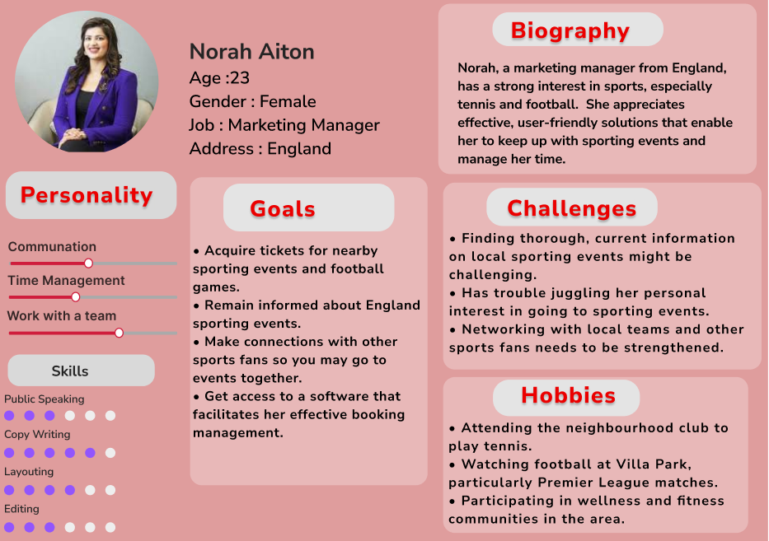

5.User Scenario
Persona 1: Chris Woakes
• Age: 28
• Occupation: Basketball kid and designer
• Benefit: Easy to develop and write good game plans; entertain other athletes; ability to make better suggestions.
• Needs: Good filtering for filters; feedback channel for Sugamita; community health equipment.

Persona 2: Nora Aton
• Age: 23
• Occupation: Marketing Manager
• Goal: Good work for life. Stanford football games entertain and schedule.
• Needs: Instant search, reminders, personal event support.
• Scenario 1 (Chris): Provides access to Chris's game website, good options. It's a filter, makes ticket booking easy, and provides information about other athletes.
• Scenario 2 (Nora): Nora searches for a lunch break during football games; the event is updated on Calendar A, and personal assistance is provided.
• Scenario 3 (Chris): Chris is sent to other athletes to churches online, attachments are provided as part of the review, and opportunities for improvement are provided.

6. Requirements Analysis (MoSCoW)
 | Features
  Priority
 | Sports news, event tracker, accessibility support (screen reader, contrast, font size), premium membership, registration/login
  Must Have
 | User profile management, in-depth event info, search and filter.
  Should Have
 | Discussion forums, interactive sports venue map, personalized recommendations
  Could Have
Won’t Have | Live streaming, detailed player stats, merchandise store

7. Proposed Design
Game news, full programs, ticket sales, the Friend Zone, social media, forum management, and profiles are displayed on the entire platform's homepage. You can easily navigate among invited users through the user interface, and the availability of accessories has been removed.

8. Conclusion
Using personas and scenarios ensures the sports platform is designed for real-world user needs, especially for inclusivity. The MoSCoW analysis prioritizes features to deliver a functional and accessible service that connects local sports communities.

References

