CMP6200/DIG6200
Individual Undergraduate Project (FYP)
Project Interim Report
[Project Title Here]

Student Name: [Harendra Kumar Sah]
Student ID: [24143436]
Course: [Individual Honours Project]
Supervisor: [Shreya Pradhan]
Date: [Date of Submission]

Table of Contents
List of Figures
List of Tables
Contents
1.0 Introduction and Context 3
1.1 Problem Statement 3
2.0 Review of Existing Knowledge 3
2.1 Critical Analysis and Gap Identification 4
2.2 Project Justification 5
3.0 Project Aims, Objectives, and Scope 5
3.1 Project Aim 5
3.2 Project Objectives 5
4.0 Project Design 7
4.1 Design and Methods 7
4.2 Justification of Methods 7
4.3 Project Timeline 8
5.0 Feasibility, Risks, and Ethical Aspects 8
5.1 Feasibility 9
5.2 Risk Analysis and Mitigation 9
5.3 Ethical Considerations 10
References 10

1.0 Introduction and Context
The global education landscape has changed radically over the past decade, with a rapid shift from traditional face-to-face education to e-learning platforms. These changes accelerated during the COVID-19 pandemic as educational institutions were forced to adopt remote learning models (Dhawan, 2020). As a result, e-learning has broadened access to education by removing geographical barriers and providing flexible access to learning resources.
However, there remains a significant gap between effective, active learning and the delivery of essential knowledge, even with increased accessibility. Existing platforms in many developing countries, including Nepal, are often used to organize large groups of pre-recorded video lectures. While user-friendly, these tools often lack important interactive elements such as structured interactions, real-time discussions, and immediate responses to inquiries. Research indicates that while these interactive elements are often absent from traditional asynchronous e-learning systems, they are absolutely essential to the success of comprehensive student engagement and learning outcomes (Barbara Means, 2013).
This project aims to overcome these limitations by creating a structured and traceable Learning Management System (LMS) called the "Informational Learning Pathway". The platform is based on a unique integrated architecture, using Django for backend services and Vue.js/Nuxt.js for frontend development, facilitating a fast and responsive Single Page Application (SPA) experience. In addition to core video content, the platform includes live sessions and interactive help features, providing a comprehensive e-learning experience. The goal is to combine passive content consumption with interactive and structured learning.

1.1 Problem Statement
The e-learning options that local student currently have access to are frequently disjointed. Instructors commonly use email to share PDF notes, Zoom for live online classes, and separate portals to host lectures that have been recorded. Students must navigate several platforms as a result of this lack of integration, which leads to a disjointed educational experience. Additionally, a lot of generic platforms have unclear hierarchies for instructors (content creators) and administrators (system managers), which results in ineffective management and security flaws. By combining all necessary components into a single, cohesive web application with strict Role-Based Access Control (RBAC), Infomatic Education Path resolves these problems by integrating AI-driven chatbot support alongside structured content delivery and live sessions.

2.0 Review of Existing Knowledge
The development of contemporary Learning Management Systems (LMS) necessitates a strong grasp of software engineering concepts, educational structures, and information security factors. Recent studies emphasize that several existing e-learning platforms encounter challenges concerning scalability, learner involvement, and secure access, which can adversely impact the overall educational experience. These obstacles lay the groundwork for creating the Infomatic Education Path platform, which seeks to tackle these shortcomings within a single system.
Traditional LMS systems, like Moodle, utilize Monolithic Architecture, in which the frontend and backend are closely linked. This architecture frequently results in performance constraints and maintenance challenges, particularly as the user count and data volume grow (Richards, 2020).
In contrast, Decoupled Architecture isolates the backend APIs from the frontend clients, resulting in quicker load times, simpler maintenance, and enhanced scalability (Gomes, 2021). This design method is especially appropriate for the delivery of dynamic content and access across multiple devices, which are crucial for contemporary e-learning settings.
E-learning resources are typically offered in two forms: Asynchronous learning, allowing students to view pre-recorded lectures and materials at their convenience (e.g., Coursera), and Synchronous learning, featuring live interactive sessions (e.g., Zoom). Studies show that neither approach by itself completely meets all educational requirements. A Blended Learning strategy that merges asynchronous and synchronous techniques has demonstrated enhancements in engagement, knowledge retention, and overall educational results (D. Randy Garrison, 2008) (Huang, et al., 2019)
The absence of strong access control procedures and distinct hierarchical structures in many current e-learning platforms might lead to administrative inefficiencies and security flaws (Patel & Kumar, 2020). By ensuring that instructors and administrators work within well-defined bounds, Role-Based Access Control (RBAC) improves security and preserves organized workflows (Feng Hao, 2018). This strategy is essential for developing a safe, orderly learning environment, especially for platforms that seek to combine several features into one system.
In addition to content delivery and security, a significant drawback of conventional e-learning is the lag in student assistance. Depending only on asynchronous forums or emails frequently interrupts the learning process because of delayed replies. Recent studies indicate that incorporating Artificial Intelligence, particularly conversational agents (Chatbots), offers immediate answers to common questions and greatly improves learner satisfaction (Pavel Smutny, 2020). The proposed system integrates this AI-based method to provide round-the-clock assistance, closing the interaction void present in traditional LMS models.

2.1 Critical Analysis and Gap Identification
Although Learning Management Systems (LMS) have evolved significantly, key limitations remain. Monolithic architectures frequently encounter issues with scalability and maintainability (Richards, 2020), whereas numerous current platforms function in fragmented settings where live sessions, communication, and content repositories are handled using distinct tools (Huang, et al., 2019). This fragmentation diminishes system integration and makes centralized Role-Based Access Control (RBAC) more complex, heightening risks associated with content security and administrative effectiveness (Feng Hao, 2018)
Furthermore, although AI-based learner support has proven effective in educational settings (Pavel Smutny, 2020) , this functionality is seldom incorporated natively with synchronous and asynchronous learning elements within one modular framework.
These restrictions underscore a distinct deficiency: the lack of a cohesive, scalable, and secure LMS that combines live sessions, organized content distribution, and smart assistance within a unified decoupled framework

2.2 Project Justification
The "Infomatic Education Path" targets shortcomings in current LMS platforms, including disjointed tools, slow student assistance, and ambiguous administrative responsibilities (Smith & Lee, 2021). Integrating a Video/Note repository, Live Class scheduler, and AI chatbots into one SPA with Django, Vue.js, and Decoupled Architecture minimizes cognitive load for students and streamlines management for instructors. Blended education (D. Randy Garrison, 2008) and rigorous RBAC (Patel & Kumar, 2020) improve involvement, safety, and workflow structure. This integrated, scalable approach is particularly important in developing areas such as Nepal, where numerous paid platforms are frequently necessary, providing a functional, contemporary, and unified LMS that current systems do not offer.

3.0 Project Aims, Objectives, and Scope
This section takes the challenges discussed earlier and turns them into an actionable development plan. It defines the main aim of the project and details the specific objectives required to successfully design, develop, and test the new Learning Management System (LMS).

3.1 Project Aim
The overall aim is to design, develop, and test “Infomatic Education Path”, a web app educational platform that facilitates synchronous (Live Classes) and asynchronous (Recorded Videos) learning, supported by automated assessment tools (Quizzes) and an AI Chatbot for 24/7 student assistance.

3.2 Project Objectives
To achieve this aim, the following SMART (Specific, Measurable, Achievable, Relevant, Time-bound) objectives have been defined:
- Objective 1 (Requirement Analysis): To critically analyze existing LMS architectures and define the specific permission sets for Admin, Instructor, and Student roles by Week 4.
- Objective 2 (System Design): To draft the underlying system architecture by Week 8, focusing on planning the relational database schema, establishing the RESTful API flow, and outlining the frontend component structure.
- Objective 3 (Backend & Core API Development): To develop the backend infrastructure using Django, implementing secure Role-Based Access Control (RBAC) and data management APIs by Week 13.
- Objective 4 (Frontend & Interactive Modules): To program the frontend Single Page Application (SPA) with Vue.js by Week 19, actively integrating the recorded video repository, live scheduling features, and automated quiz modules.
- Objective 5 (AI Integration): To configure and integrate an AI-driven Chatbot capable of providing 24/7 automated student assistance within the platform by Week 21.

Objective 6 (Testing, Evaluation & Documentation): To run detailed functional, security, and usability tests to check the platform's overall performance, alongside finalizing all project documentation by Week 25.
3.3 Project Scope
To clearly define the project's boundaries and manage development expectations, the specific inclusions and exclusions of this prototype are outlined below.
In-Scope:
The primary focus of this project is to develop a functional and interactive educational platform. Specifically, the final system will include the following features:
- Secure User Authentication and Role-Based Access Control (RBAC).
- Specific dashboard interfaces for admin and instructors to manage platform.
- Essential learning tools, such as an embedded video player and options to download PDF study materials.
- A built-in quiz module to evaluate student performance automatically.
- A scheduling system to organize and manage live online classes.
- An integrated AI chatbot to answer student queries and provide continuous support.

Out-of-Scope:
Some components are explicitly prohibited in order to give system reliability and essential educational aspects top priority within the allotted time:
- Payment Gateway Integration: Course access will be controlled freely or with human admin approval; the system will not process real-money financial transactions.
- Native Mobile App Development: Although the platform will be a mobile browser-accessible, highly responsive web application, the development of stand-alone, native mobile applications (iOS/Android) is not covered.

4.0 Project Design
This section outlines the practical methods, tools, and timeline used to build the Infomatic Education Path. Rather than a traditional research approach, this project follows a hands-on software development methodology. It combines initial requirement gathering with step-by-step coding and testing to make sure all project objectives are completed on schedule

4.1 Design and Methods
Unlike traditional research that relies on surveys or experiments, this project is entirely focused on practical software development. To manage the build process, I have chosen the Agile methodology. By dividing the workload into short, manageable sprints, Agile allows me to code, test, and refine individual features such as the AI chatbot and the quiz engine one step at a time without breaking the entire system (Sommerville, 2015).
From a technical standpoint, the platform relies on an API-first, decoupled architecture.
I will be using Django to manage the backend database and handle secure API routing, while Vue.js will drive the frontend as a Single Page Application (SPA). This clear separation between the frontend and backend ensures better performance and makes the codebase much easier to maintain (Gomes, 2021). Instead of spending extra time on external wireframing tools like Figma, I plan to design the user interface by prototyping components directly inside Vue. Finally, to ensure everything works as intended, the system will be tested using mock user inputs, sample media files, and functional requirements gathered from analyzing existing educational platforms.

4.2 Justification of Methods
To ensure the successful development of the Infomatic Education Path, I carefully evaluated different approaches before settling on Agile and a decoupled architecture. I selected the Agile methodology instead of the traditional Waterfall model primarily because of its flexibility. The Waterfall approach strictly requires all plans to be finalized before any coding begins, which is highly risky when trying to integrate advanced, unpredictable features like an AI chatbot (Sommerville, 2015). If an unexpected technical issue occurs, it can delay the entire timeline. Agile solves this by letting me work in small, manageable sprints, adapting to challenges as I build and test each module.
Similarly, for the system design, I chose a decoupled architecture using Django and Vue.js rather than a standard monolithic setup. Many older educational platforms use a monolithic design where the user interface and database are tightly tied together. The major drawback there is that a simple update to the student dashboard can accidentally break the server logic (Richards, 2020). A decoupled approach completely separates the frontend from the backend. This setup makes the application run much faster and handle video content efficiently, while keeping the system highly secure and much easier to update in the future.

4.3 Project Timeline
Planning my time carefully is important for a project of this size. The Gantt chart below shows the complete schedule for the Infomatic Education Path. Because I am following the Agile method, I divided the main tasks into two-week sprints. The chart highlights exactly when I will work on specific technical parts, like the backend database, frontend UI, and the AI chatbot. Along with the software development, I have also included the university's deadlines for the interim report, presentations, final repot and viva. Keeping both the coding tasks and academic milestones in one place helps me make sure everything gets done before the final submission date.
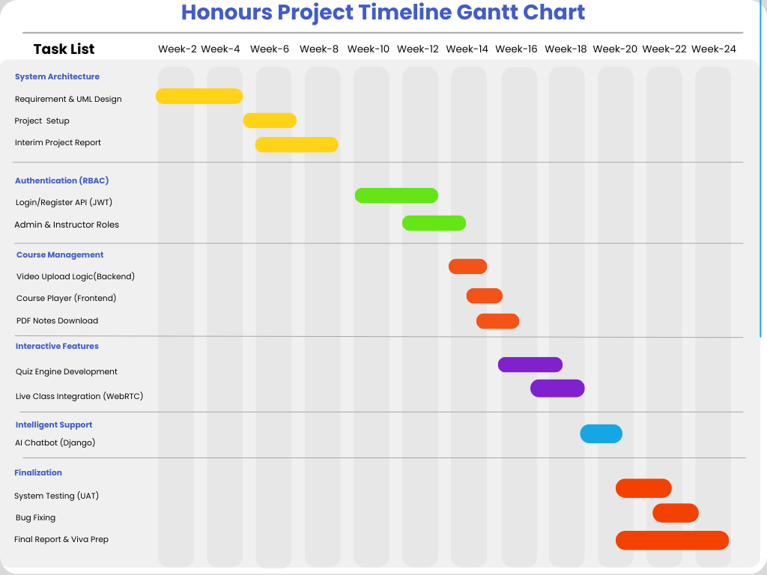

5.0 Feasibility, Risks, and Ethical Aspects
In this chapter, I will look at whether building the Infomatic Education Path is actually possible within the given time and resources. I will also identify any potential problems or risks that might come up during the development process and explain how I plan to handle them. Finally, I will discuss the ethical rules and legal guidelines I need to follow, especially concerning student data privacy and the responsible use of AI features.

5.1 Feasibility
Before fully committing to the Infomatic Education Path, I needed to make sure the project was actually doable from a technical, financial, and scheduling standpoint. On the technical side, I am building the system using Django for the backend and Vue.js for the frontend. Both frameworks have huge online communities, so finding help will be easy if I get stuck. I already have a solid understanding of Python, which makes adding the AI chatbot and database logic much smoother, and using WebRTC means live classes will work directly in standard browsers without students needing to install heavy software. Economically, since this is a university project, my budget is basically zero. Fortunately, my entire tech stack, including PostgreSQL, is open-source and completely free to use. I will handle all the coding and testing on my personal laptop and use free API tiers for the AI features, meaning the project will not cost me anything to build. Finally, looking at the time constraints, the Gantt chart from the previous chapter shows I have until early May 2026 to finish everything. By breaking the work down into two-week Agile sprints, I have created a realistic schedule that lets me build the core features first while leaving enough room at the end for testing, fixing bugs, and writing the final report before the viva.

5.2 Risk Analysis and Mitigation
Since the Infomatic Education Path has a lot of moving parts, things might not go exactly as planned. To make sure I actually finish on time and hand in a working project, I thought about the biggest risks that could mess up my schedule. Table 5.2 below lists four main problems that could happen during development and exactly what I will do to fix or avoid them.

Potential Risk | Likelihood (Low/Med/High) | Impact (Low/Med/High) | Mitigation Strategy
1. Getting stuck while coding the WebRTC live classes or the AI chatbot | High | High | Spend extra time early on watching tutorials. If WebRTC gets too hard and eats up my time, my backup plan is to just let teachers upload pre-recorded videos instead.
2. Running out of time because of other university assignments | Medium | High | Stick strictly to my two-week Agile sprints. I also kept my last month completely free just for fixing bugs and getting ready for the viva.
3. Losing all my project files and database if my laptop crashes | Low | High | Push all my code to a private GitHub repo every single day. I will also keep a local backup of the database on an external drive or pen drive.
4. The Vue.js video player lagging when loading large video files | Medium | Medium | Test the frontend with very small video clips first. If it still lags, I will try to add a simple compression logic in the Django backend.
Table 5.2: Risk Assessment and Mitigation

5.3 Ethical Considerations
Furthermore, the integration of an AI-driven chatbot introduces specific ethical challenges regarding data privacy and algorithmic bias. To mitigate these risks, the system will ensure that all user prompts and interactions with the AI remain strictly confidential. These interactions will be explicitly excluded from being used to train external or public Large Language Models (LLMs), aligning with global ethical guidelines for AI in education that emphasize transparency and the strict protection of student data (UNESCO, 2021).
Looking at the broader social influence, the primary goal of this project is to democratize learning. Therefore, proactive measures will be taken to ensure the AI provides fair, unbiased, and standardized academic assistance. Maintaining this algorithmic fairness is a critical ethical requirement to ensure that every student, regardless of their background, receives equitable support from the platform (Holmes, 2019).

References
Barbara Means, Y. T. R. M. a. M. B., 2013. The Effectiveness of Online and Blended Learning: A Meta-Analysis of the Empirical Literature. Teachers College Record, pp. 1-47.
D. Randy Garrison, N. D. V., 2008. Blended learning in higher education: Framework, principles, and guidelines. San Francisco: John Wiley & Sons.
Dhawan, S., 2020. Online Learning: A Panacea in the Time of COVID-19 Crisis. Journal of Educational Technology Systems, pp. 5-22.
Feng Hao, D. C. B. R. S. F. S., 2018. Role-based access control: Evolution and future directions. IEEE Security & Privacy, 16(1), pp. 11-18.
Gomes, H. Z. A. D. ,. G. P. a. M. F., 2021. The transition to headless LMS: Evaluating decoupled architectures in e-learning. Journal of Web Engineering, 20(4), pp. 450-468.
Holmes, W. B. M. &. F. C., 2019. Artificial Intelligence in Education. [Online]
Available at: https://curriculumredesign.org/our-work/artificial-intelligence-in-education/
[Accessed 27 Feb 2026].
Huang, R., Spector, J. & Yang, J., 2019. Educational technology: A primer for the 21st century. Computers & Education, Volume 128, pp. 25-37.
Patel, M. & Kumar, S., 2020. Security challenges and access control in modern Learning Management Systems. Information Security Journal: A Global Perspective, pp. 245-259.
Pavel Smutny, P. S., 2020. Chatbots for learning: A review of educational chatbots for the Facebook Messenger. Computers & Education, p. 103862.
Pavel Smutny, P. S., 2020. Chatbots for learning: A review of educational chatbots for the Facebook Messenger. Computers & Education, p. 103862.
Richards, M., 2020. Software Architecture Patterns. Sebastopol: O'Reilly Media.
Smith, J. & Lee, C., 2021. The transition to headless LMS: Evaluating decoupled architectures in e-learning. Web Engineering, pp. 450-468.
Sommerville, I., 2015. Software Engineering, 10th Edition. [Online]
Available at: https://www.google.com/search?q=https://www.pearson.com/en-us/subject-catalog/p/software-engineering/P200000003254/9780133943030
[Accessed 26 Feb 2026].
UNESCO, 2021. AI and education: guidance for policy-makers. [Online]
Available at: https://unesdoc.unesco.org/ark:/48223/pf0000376709
[Accessed 27 Feb 2026].

Appendices (Optional)
Include any additional material here, such as review steps, specifications, and methodoloies.

