**GLOBAL ECONOMIC AND DEMOGRAPHIC ANALYSIS**

Milestone 2 Project Documentation

Prepared by: Harene K

Batch: DA-DS March 2025

# Objective

The objective of this project is to analyze and derive insights from global data covering population, GDP, country characteristics, and health-related indicators from multiple sources.

# Datasets Used

The following datasets were used in this project:

1. Population_Pre_country.xlsx - Country-wise population data

2. MetaData_Country.csv - Metadata about countries and attributes

3. GDP_by_country_1960-2016.xlsx - GDP trends over decades

4. CountriesWorld.sql - SQL schema and raw data for countries

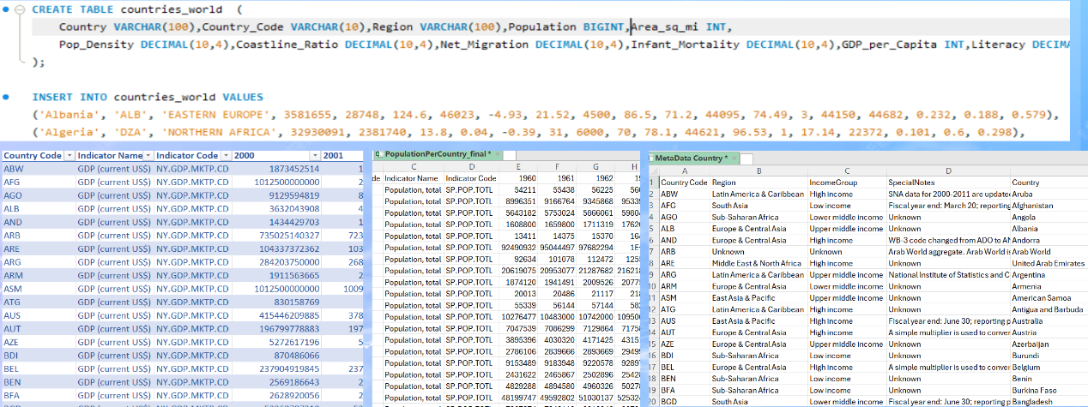

# Data Cleaning & Importing Steps

• Removed null values and filled blanks  
• Formatted columns consistently  
• Imported SQL dataset using MySQL connector  
• Imported CSV and Excel files via Power BI 'Get Data' option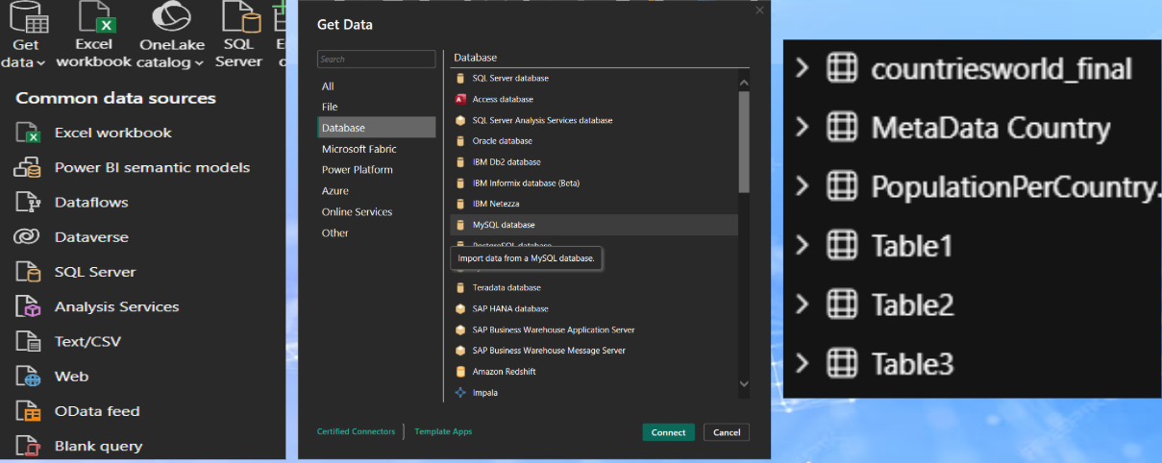

# Data Modelling

Built relationships between tables, established schema joins, and linked datasets for integrated analysis.

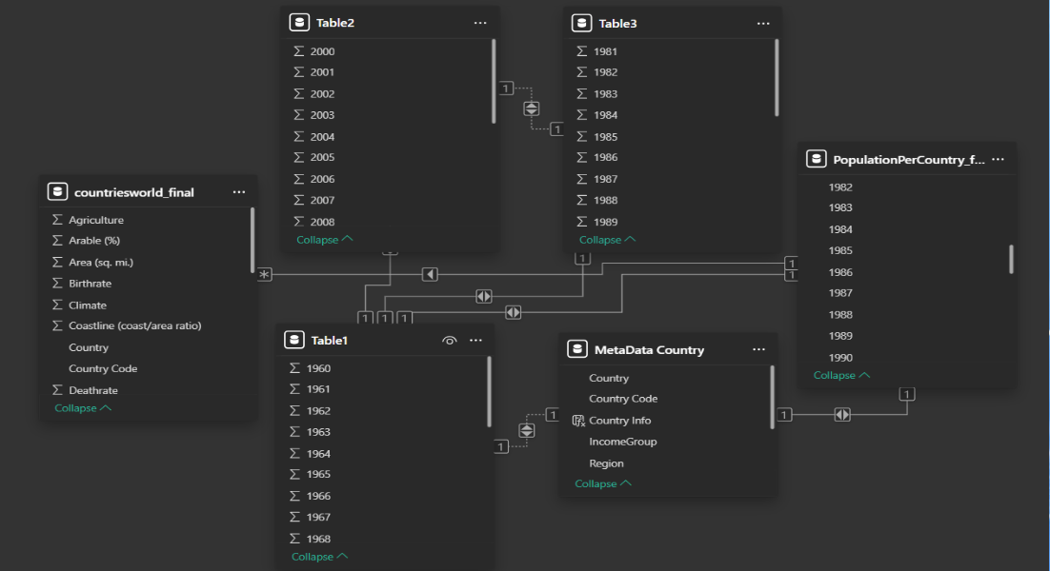

# DAX Functions Used

Created measures and calculated columns using DAX for aggregations, ratios, and trend analysis.

1. Tot_Coun_By_Incomegrp = DISTINCTCOUNT MetaData Country' [Country])
2. Country Count by Region = CALCULATE(DISTINCTCOUNT('MetaData Country [Country]), ALLEXCEPT (MetaData Country', 'MetaData Country Region])
3. Income Level = SWITCH(TRUE(),

*countriesworld_final [GDP ($ per capita)] < 1000, "Low Income",

'countriesworld_final [GDP ($ per capita)] < 4000, "Lower-Middle Income",

*countriesworld_Final [GDP ($ per capita)] < 12000,

"Upper Middle Income, "High Income")

1. Country Info = MetaData Country [Country] && 'MetaData Country' [Region] &" ("& 'MetaData Country [IncomeGroup] & ")"
2. Avg GDP per Capita AVERAGE('countriesworld_final [GDP ($ per capita)])
3. Total_Population = SUM(countriesworld_final [Population])
4. Avg Literacy Rate = AVERAGE('countriesworld_final [Literacy (%)])
5. Infant Mortality = StdDev STDEV.P('countriesworld_final' [Infant mortality (per 1000 births)])
6. Max GDP per Capita = MAX('countriesworld_final' [GDP ($ per capita)])
7. Avg Agriculture % - AVERAGE('countriesworld_final [Agriculture])

# Global Economic and Demographic Analysis

The following aspects were analyzed using Power BI:

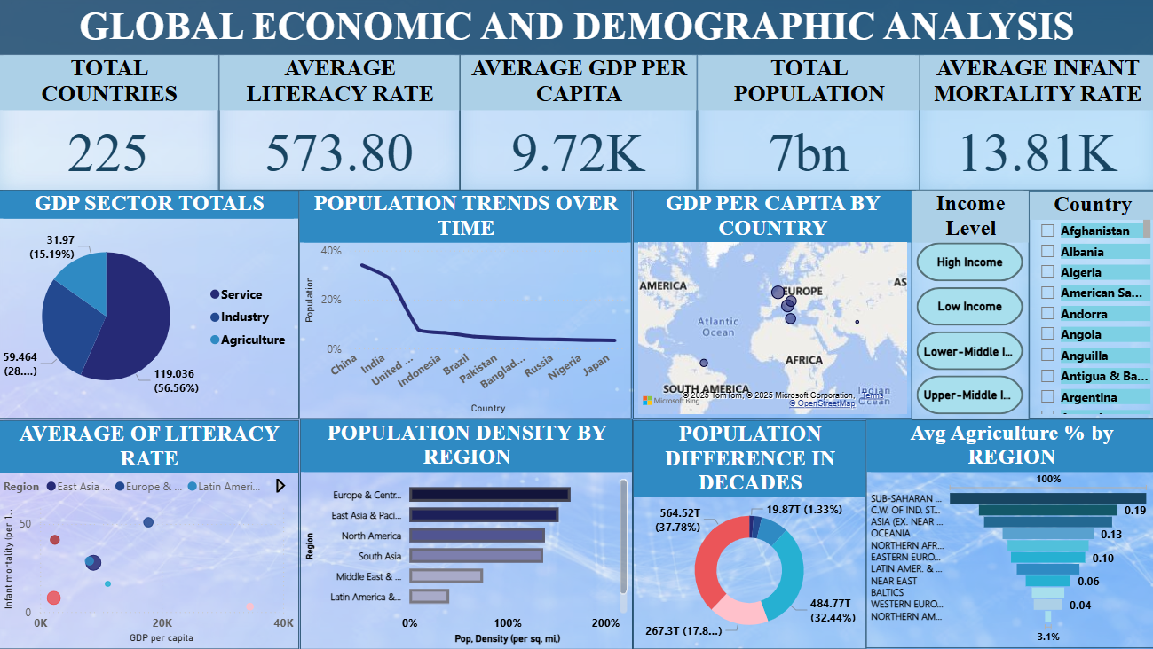

• GDP Sector Totals (Service, Industry, Agriculture)

• Population Density by Region

• Population Trends Over Time (China, India, US, etc.)

• GDP per Capita by Country

• Average Literacy Rate vs Infant Mortality

• Population Difference Across Decades

# Key Insights

• Population: Fastest growth in Africa and South Asia  
• Economy: High GDP in wealthy nations; lowest in Sub-Saharan Africa  
• Sectors: Rich nations → Service-based, Poor nations → Agriculture-based  
• Education: Higher literacy boosts GDP & health  
• Health: Infant mortality high in low-income countries  
• Regional Trends: Middle East (Oil-driven growth), Europe (Stable), Asia (Rapid expansion)

# Recommendations & Conclusion

• Educate & Empower → Boost literacy, GDP, and health  
• Strengthen Healthcare → Lower infant mortality  
• Build & Diversify Economies → Service-driven stability  
• Plan for Growth → Manage population and infrastructure development