**Website amendments**



Contact form error fixed

**Language**- Please change it from flag icons to text ENG and 中文

**Photos-** Please create a hyperlink on the product photos so visitors can enter page by clicking on photos



**Gallery**- Please create three subsections for Shop, Exhibition and Special Photos

**Testimonials-** It is moving very fast, please slow down the slide so it’s easy to read



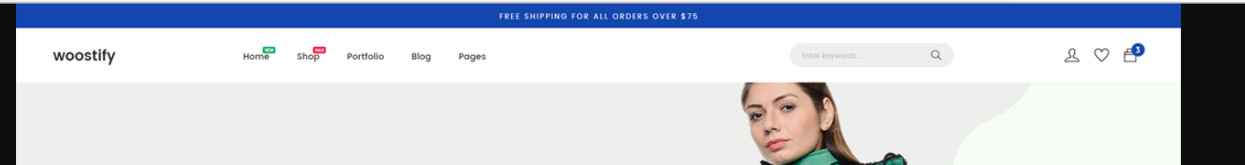**Head information-** Like this

**Video-** Please suggest a way to keep videos in our website