**The below steps are required to be executed one time for setting up the environment for API**

**Step1:** Please Open Anaconda Prompt or Command Prompt and check on the version using command

* *python --version*

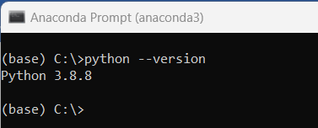

Please ensure the system already has Python > = 3.8

**Step2:** Please place the requirements.txt file in the current directory and execute the below command

If it is personal laptop:

* *pip install -r requirements.txt*

If it is ANZ laptop:

* *pip install --index-url=https://artifactory.gcp.anz/artifactory/api/pypi/simple –trusted-host=artifactory.gcp.anz -r requirements.txt*

Path of requirements.txt : Operations_Risk_Control_Obligations\setup\requirement.txt

Please check if there no errors while installation.

**The below steps are required to start the Operations_Risk_Control_Obligations solution**

**Step 1 :**  Please export/clone the source code from Github repo : <https://github.com/Haresh555/Operations_Risk_Control_Obligations.git>

**Step 2 :**  Please open the file in path Operations_Risk_Control_Obligations*\Request_handler\Llama_Index\ChatGPTRequestHandler_API/* *Ops_Risk_Obligation.ini*

And add the open API key in the variable ‘api_key’

**Step 3:** Open the command prompt/Anaconda prompt and navigate to the path of the checked-out repository

* *cd Operations_Risk_Control_Obligations\Request_handler\Llama_Index\ChatGPTRequestHandler_API*

**Step 4*:*** *Please execute the below command to start the API in the command prompt*

* *python Ops_Risk_Obligation.py*

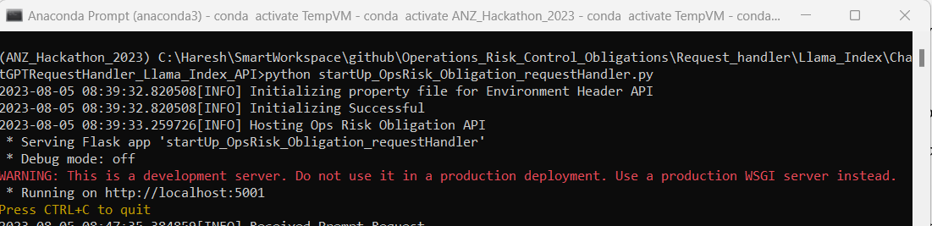

**Step 5:** Open the command prompt/Anaconda prompt and navigate to the path of the checked-out repository

* *cd C:\Haresh\SmartWorkspace\github\Operations_Risk_Control_Obligations\UI_Layer*

**Step 6*:*** *Please execute the below command to start the UI layer in the command prompt*

* *python app.py*

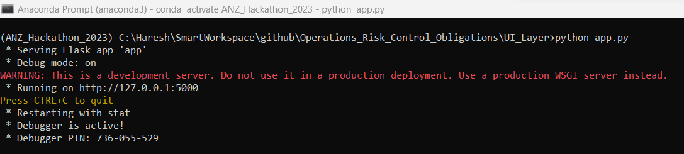

**Step 6*:*** *Please open Google Chrome Browser and navigate to below url to start conversation with chatbot*

*URL :* [*http://localhost:5000*](http://localhost:5000)

