PROJECT REPORT
MediChain
Secure & Performance-Optimized Distributed
Healthcare Records System
Distributed Systems and Applications · Software Testing
Submitted by
N. Sankkarshana | CH.EN.U4CCE23023
Ganesan P.V | CH.EN.U4CCE23008
Hemanth S | CH.EN.U4CCE23013

B.Tech Computer & Communication Engineering
Amrita Vishwa Vidyapeetham, Chennai
October 2026

Contents
Abstract 3
1. Introduction 3
1.1 Problem statement 3
1.2 Objectives 3
1.3 Scope 3
2. Existing system and proposed system 4
3. System architecture 4
3.1 Data placement 5
4. Distributed systems design 5
4.1 Raft consensus 6
4.2 Sharding with consistent hashing 6
4.3 Consistency model 6
4.4 Fault tolerance at the gateway 7
4.5 Asynchronous messaging 7
5. Security design 7
6. Implementation 8
6.1 Technology mapping 8
6.2 Modules 9
6.3 Web portals 9
7. Software testing 9
7.1 Test levels 9
7.2 Test design techniques 10
7.3 Test environment 10
8. Results 11
8.1 Mutation testing 11
8.2 Chaos test 12
8.3 Performance 12
9. Defects found and fixed 12
10. Conclusion and future work 14
References 14
Appendix: running the project 15

Abstract
MediChain is a working distributed electronic health record (EHR) system that keeps serving doctors and patients when servers crash or the network splits. Patient data is sharded across two groups of three replicas, and each group agrees on every write using the Raft consensus algorithm. Around this core sit an API gateway, an identity service, a Kafka-style event bus, a tamper-evident audit ledger and a real-time notification service: 11 operating-system processes started by one command.
Access is controlled by role and by patient consent, with an audited emergency "break-glass" override. Identifiers and clinical notes are encrypted with AES-256-GCM before they are replicated. Three web portals (clinician, patient and operations) expose the system, and the operations console can kill or partition nodes live.
The project was verified with 281 automated tests across unit, integration, security, chaos, end-to-end and load levels. They reach 98.4% line coverage and a 96.5% mutation score. A Jepsen-style chaos test acknowledged 75 of 75 writes with none lost or duplicated, across three forced leader elections. Testing found 14 defects, all fixed.

1. Introduction
Health records must be available in an emergency, correct after a failure, and private at all times. A single hospital database cannot guarantee all three. It is one point of failure, one bottleneck and one target for attackers.

1.1 Problem statement
Design and build a system that stores, secures and serves patient records across many hospitals in real time. It must stay available when a server fails, never lose or duplicate an acknowledged write, and give patients control and visibility over who reads their data.

1.2 Objectives
- Replicate every record so the loss of any one server per shard causes no downtime and no data loss.
- Scale out by sharding patients across independent groups of servers.
- Enforce role-based and consent-based access, with an audited emergency override.
- Encrypt sensitive fields at rest and record every access in a tamper-evident log.
- Keep reads fast through caching while writes stay strongly consistent.
- Prove all of the above with a systematic, multi-level test suite.

1.3 Scope
The project implements the full architecture from the project proposal as runnable software on a single machine, with no external infrastructure. Every component runs as a separate process communicating over HTTP, so crashes and partitions are real rather than simulated in one program. Production concerns such as TLS termination, multi-host deployment and log compaction are out of scope and listed as future work.

2. Existing system and proposed system
The existing model routes every hospital, clinic and app through one application server and one central database. MediChain replaces each weakness of that model with a specific distributed mechanism.
Concern | Centralized system | MediChain
Server failure | Total downtime | Raft elects a new leader in about 1–2 s; writes continue
Data durability | Lost if the disk fails before backup | Each write stored on a majority of replicas before it is acknowledged
Scaling | Vertical only, capped by one machine | Horizontal: patients sharded by consistent hashing
Network partition | Undefined behaviour | Minority side refuses writes; no split-brain
Access control | Often role-only | Role + patient consent + time-limited emergency override
Data at rest | Plaintext identifiers | AES-256-GCM field-level encryption
Auditing | Editable logs | SHA-256 hash-chained ledger; edits are detected
Slow downstream service | Blocks every request | Circuit breakers fail fast; audit events buffered asynchronously

3. System architecture
MediChain runs as 11 operating-system processes that communicate only over HTTP, so a crash of any one is a real process death. Clients reach everything through the API gateway, which authenticates the request, checks policy and routes it to the patient's home shard.
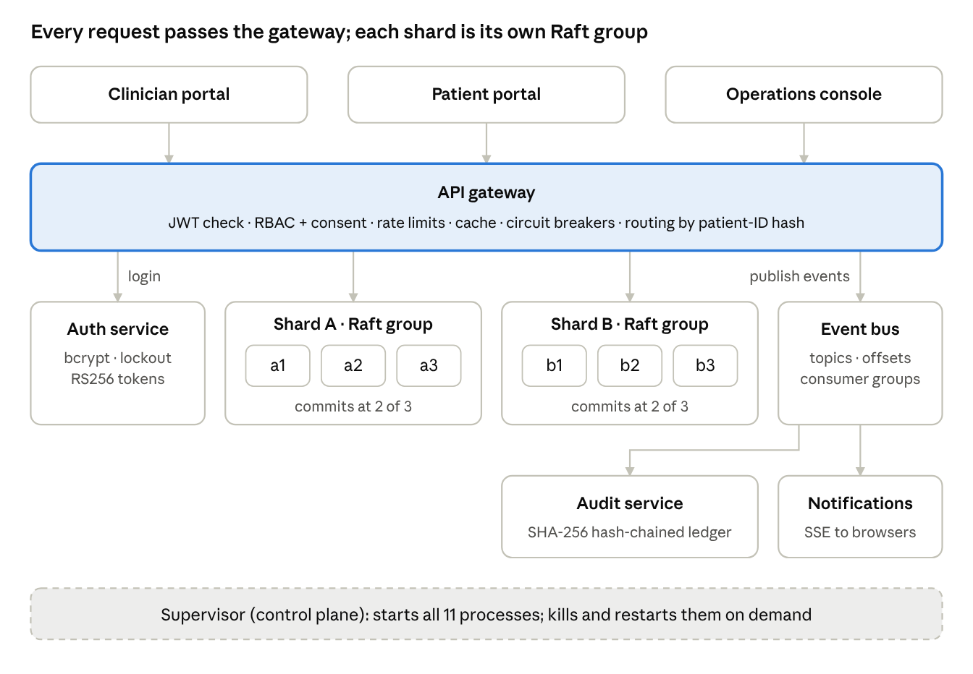
Figure 1. System architecture: 11 processes
The gateway publishes every security-relevant event to the event bus; the audit and notification services consume it independently.

3.1 Data placement
Each patient lives on exactly one shard, chosen by hashing the patient ID. Three keys hold a patient's data, and all three hash to the same shard:
Key | Holds | Encrypted fields
patient:<id> | Demographics, allergies | Phone, ABHA ID
records:<id> | Notes, labs, prescriptions, vitals (append-only) | Free-text content
consent:<id> | Which doctors may read, and on what terms | —

Each shard keeps three full replicas. A write is acknowledged only after two of the three have stored it on disk.

4. Distributed systems design
The core guarantee is that an acknowledged write survives the crash of any single replica in its shard. Raft consensus provides it, sharding provides scale, and the gateway hides failovers from clients.

4.1 Raft consensus
Each shard is a Raft group of three replicas, implemented from the Ongaro & Ousterhout paper (about 500 lines of JavaScript).
Mechanism | What it guarantees
Randomized election timeouts (1.2–2.4 s) | Avoids split votes; one leader per term
Election restriction | Only a candidate with an up-to-date log can win, so committed data is never lost
PreVote | A node returning from a partition cannot force a needless election
Log matching with fast backtracking | Followers repair divergent logs quickly
Commit only current-term entries, no-op on election | Prevents the known "Figure 8" anomaly
Write-ahead log, persisted before replying | Term, vote and log survive crashes; a torn final write is discarded
Check-quorum | An isolated leader steps down instead of serving stale data
Lease reads | Strong reads are linearizable without an extra log round
Request deduplication | A retried client write is applied exactly once

A write follows four steps:
- The gateway sends the command to the shard leader.
- The leader appends it to its write-ahead log and replicates it to the followers.
- Once a majority has stored it, the leader advances the commit index.
- Every replica applies it to its state machine deterministically, using the timestamp stamped by the leader.

4.2 Sharding with consistent hashing
Patient IDs are placed on a hash ring with 150 virtual nodes per shard. All keys of one patient (demographics, records, consents) hash to the same shard, so each request touches one Raft group. Growing from 4 to 5 shards moves about 20% of keys, compared with about 80% for hash mod N (measured in test TC-HASH-10).

4.3 Consistency model
Operation | Consistency | Served by
Read a patient record or consents | Linearizable, or cached | Shard leader, or gateway cache
Patient directory (names, demographics) | Eventual | Any follower (read replicas)
All writes | Linearizable | Leader plus a majority

Each shard is CP in CAP terms: without a majority it refuses writes rather than diverging. The system as a whole degrades gracefully. If an entire shard is down, the other keeps serving and cross-shard queries return partial results flagged as degraded.

4.4 Fault tolerance at the gateway
- Leader tracking: followers answer "not leader" with a hint, and the client follows it immediately.
- Retry with backoff: on failure the client tries other replicas with exponential backoff and jitter until a new leader exists. Callers see a slower request, not an error.
- Circuit breakers: one per replica. After two failures a dead replica is skipped for 2.5 s, then probed with a single trial call.
- Failure detector: the cluster monitor polls every replica each second and publishes node-down, node-up and leader-elected events.

4.5 Asynchronous messaging
The event bus behaves like a small Kafka: append-only topics, offsets, and consumer groups that each receive every message. Offsets are committed after processing, giving at-least-once delivery, and consumers deduplicate by event ID. The gateway publishes through an in-memory outbox, so clinical requests never fail because the audit pipeline is briefly down.

5. Security design
Every request must prove who it is, be allowed by policy for that specific patient, and leave an audit entry. Admins operate the platform but cannot read clinical data.
Layer | Control
Authentication | bcrypt password hashes; lockout after 5 failed attempts; the same error for an unknown user and a wrong password
Tokens | RS256 JWTs. Only the auth service holds the private key; every service verifies locally with the public key
Authorization | RBAC (role) plus ABAC (consent, ownership, expiry), in one pure function covered by a 28-row decision table
Least privilege | Admins manage the cluster but are denied all patient data
Emergency access | Break-glass needs a reason of at least 10 characters, lasts 30 minutes, and alerts the patient in real time
Encryption at rest | AES-256-GCM per field (phone, ABHA ID, note text) before replication; storage nodes only see ciphertext
Integrity | SHA-256 hash chain over the audit log detects edited, deleted or reordered entries
Zero trust | Internal endpoints require a service token even on the private network
Abuse protection | Token-bucket rate limits per user and per IP; 200 kB request body limit
Browser | Content Security Policy, frame denial, no MIME sniffing; all output escaped against XSS

Patients manage consent themselves: they grant or revoke a doctor's access, and see a history of every read, write, denial and emergency access, backed by the verified ledger.

6. Implementation
The system is about 8,100 lines of JavaScript on Node.js 22: 3,350 lines of backend, 2,000 of frontend and 2,700 of tests. It needs no database server, Docker or message broker; npm start launches everything.

6.1 Technology mapping
The proposal named production tools. Each is implemented in miniature with the same semantics, so every mechanism is visible and testable on a laptop.
Proposal | Implemented as | Same core idea
Apache Kafka | Event bus service | Append-only topics, offsets, consumer groups, at-least-once delivery
Redis cache | Gateway LRU cache | Cache-aside, TTL, invalidation on write
Sharded, replicated PostgreSQL | Raft-replicated key-value shards | Consistent-hash sharding, majority replication, failover
etcd / ZooKeeper | Own Raft implementation | The consensus algorithm etcd itself uses
Keycloak (OAuth2/OIDC) | Auth service | RS256 JWTs verified by every service
Kubernetes | Supervisor process | Process lifecycle, health checks, kill and restart on demand
Prometheus + Grafana | /metrics endpoint + Ops Console | Prometheus text format, live dashboard

6.2 Modules
Module | Responsibility
src/raft | Raft node, write-ahead log storage, key-value state machine, storage-node HTTP API
src/gateway | API gateway, shard client with leader tracking, cluster monitor, data access layer
src/auth | Login, lockout, token issuing, patient accounts
src/eventbus | Topics, offsets, consumer groups, long polling
src/audit | Hash-chained ledger, verification, tamper demo
src/notify | Server-Sent Events push to browsers
src/common | Consistent hashing, circuit breaker, rate limiter, cache, crypto, RBAC policy, validation, metrics
src/supervisor | Launches all 11 processes, control-plane API, demo data seeding

6.3 Web portals
The frontend is framework-free HTML, CSS and JavaScript with a minimalist "liquid glass" design: translucent frosted panels over a soft colour field.
- Clinician portal: patient directory gathered from both shards in parallel, record timeline (notes, labs, prescriptions, vitals), add records, register patients, break-glass. A request inspector shows which shard and replica served each read, cache hit or miss, and latency.
- Patient portal: own records, consent management, and an access history backed by the verified ledger, with live alerts.
- Operations console: live cluster topology with animated heartbeats, kill / restart / partition controls per node, a chaos lab that writes continuously during failures, the consistent-hash ring, circuit breakers, event-bus lag, a live event stream and the audit ledger with tamper detection.

7. Software testing
The test strategy follows IEEE 829 and checks every requirement at two or more test levels. The full test plan, the 184-entry test-case catalogue and the traceability matrix are in the repository's docs/ folder.

7.1 Test levels
Level | Scope | Tools | Tests
Unit | Pure modules; injected clocks; in-memory Raft network with fault injection | Vitest, fast-check | 197
Integration | Each service over real HTTP; 3 Raft replicas with on-disk logs | Vitest, Supertest | 28
System and security | The whole cluster in-process; OWASP API Top 10 checks | Vitest, Supertest | 41
Chaos | Crashes and partitions while clients write (Jepsen-style) | Vitest | 3
End-to-end | Real browser against the real 11-process cluster, Page Object Model | Playwright | 12
Performance | Throughput and latency, including failover under load | autocannon | 5 scenarios
Mutation | Whether the tests catch injected bugs | Stryker | 7 modules

7.2 Test design techniques
Technique | Applied to
Equivalence partitioning | Phone numbers, ABHA IDs, blood groups, record types
Boundary value analysis | Name length 2/80, age 0/130, heart rate 20/250, note 5,000 chars, prescription 1–365 days, lockout at attempt N−1/N, cache expiry, break-glass reason 9/10 chars
Decision table | The access policy: role × action × consent × expiry × reason, 28 rules
State transition | Circuit breaker (closed, open, half-open); Raft (follower, candidate, leader)
Property-based | Consistent-hashing invariants; encryption round-trip over arbitrary Unicode
Fault injection | Crashes, partitions, one-way link cuts, 20% message loss, majority loss, whole-shard loss
Security testing | Forged and alg:none tokens, insecure direct object references, injection, prototype pollution, oversized bodies, brute force, stored XSS
Mutation testing | Measures test strength; surviving mutants drove 15 new tests

7.3 Test environment
Tests stay deterministic by injecting clocks and running Raft on an in-memory network whose partitions and message loss the test controls. Each integration file boots its own cluster on random ports with temporary data. The end-to-end run boots a separate real cluster on ports offset by 1000, so it can run beside a development instance. A full-suite pass must succeed three times in a row before a change is accepted, to catch flaky timing-dependent tests.

8. Results
All 281 automated tests pass, and every exit criterion of the test plan is met.
Metric | Result | Target
Automated tests | 281 of 281 passing | 100%
Stability | 3 consecutive full green runs, also beside a live cluster | 3
Statement and line coverage | 98.4% | at least 80%
Branch coverage | 89.0% | at least 70%
Function coverage | 99.5% | at least 80%
Mutation score | 96.5% | at least 85%
Chaos test: writes lost / duplicated | 0 / 0 of 75 | 0 / 0
Client errors during leader failover | 0 | 0

8.1 Mutation testing
Coverage only shows that code ran; mutation testing shows whether the tests notice a bug. Stryker made 486 small changes to the core modules, such as < to <= or deleting a statement, and counted how many the tests caught.
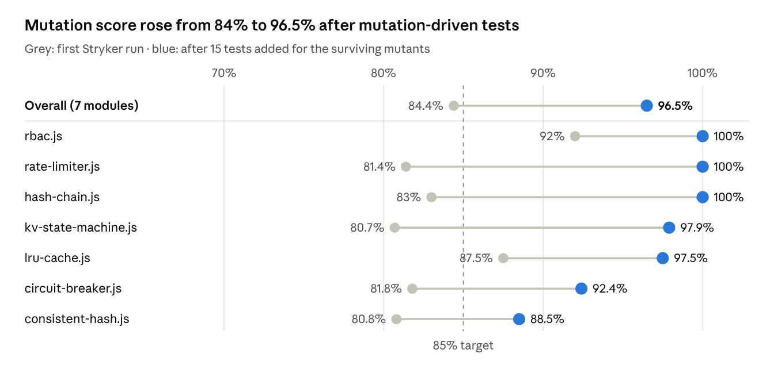
Figure 2. Mutation score per module, first run versus after hardening (Stryker 10, 486 mutants)
The first run scored 84.4% despite 98% line coverage. The survivors exposed a property test that passed even when node removal did nothing, tests whose clocks started at zero and hid arithmetic errors, and untested exact boundaries. Fifteen targeted tests raised the score to 96.5%; the remaining survivors are equivalent mutants that cannot change behaviour.

8.2 Chaos test
Three clients each wrote 25 records while a "nemesis" crashed and restarted the shard leader three times, then partitioned a follower:
[chaos] acked=75 stored=75 attempts=75 retries=0 terms=1,2,3,4 lost=0 dupes=0
Leadership moved through four terms, so the faults were real. All 75 writes were acknowledged, none were lost or duplicated, and the replicas ended byte-identical. The clients needed no retries, because the gateway followed each new leader on their behalf. With two of three replicas down, writes were refused with HTTP 503 rather than accepted by a minority.

8.3 Performance
Measured with autocannon at 20 concurrent connections for 6 s per scenario, on one laptop:
Scenario | Requests/s | Median latency (ms) | p99 latency (ms) | Errors
Read a patient record (cache hit) | 319 | 59 | 282 | 0
Read many patients across 2 shards | 251 | 78 | 263 | 0
Patient directory (both shards in parallel) | 114 | 169 | 344 | 0
Add a clinical note (majority commit) | 87 | 231 | 314 | 0
Add notes while the leader is killed | 66 | 291 | 1,041 | 0

Cached reads run 3.7 times faster than writes, which wait for a majority. A leader crash costs about one election timeout of extra tail latency and no failed requests. In this harness all services share one Node.js event loop, so the absolute numbers are a lower bound.

9. Defects found and fixed
Testing found 14 defects: 10 in the product, 3 in the tests themselves, and 1 tooling incompatibility. All are fixed. The most serious would have blocked real users: patient names in Indian scripts were rejected at registration.
ID | Found by | Severity | Defect | Fix
DEF-01 | Boundary value test with a Tamil name | High | Names in Indic scripts were rejected: the pattern allowed letters but not combining vowel signs | Allow Unicode combining marks
DEF-02 | First system start | High | Every service crashed at start-up: the validation library cannot nest a refined schema in a union | Moved the blood-pressure rule to the union level
DEF-03 | Exploratory UI testing | Medium | Directory showed "No access" right after break-glass, because consent was read from a lagging follower | Consent is now read with linearizable consistency
DEF-04 | API test of idempotency | Medium | A retried request reported a different record ID than the original | State machine returns the original item ID on a duplicate
DEF-05 | Test-run hygiene | Medium | Killing the supervisor left orphaned processes holding ports | Child processes exit when the supervisor disconnects
DEF-06 | End-to-end test E2E-03 | Low | A patient opening the admin page was bounced through the sign-in page | Redirect straight to the user's own portal
DEF-07 | Exploratory UI testing | Low | CSS class collisions broke the sign-in button and squashed vitals cards | Renamed the classes
DEF-08 | Mutation testing | Medium | A half-open circuit breaker relied on a stale failure count to re-open | Reset the count on entering half-open
DEF-09 | Mutation testing | Test defect | A property test passed even when node removal did nothing | Strengthened with an explicit assertion
DEF-10 | Three-run stability check | Test defect | Raft HTTP tests failed about 1 run in 6 when a leader changed mid-test | Tests follow the current leader like a real client
DEF-11 | Code review | Low | Login audit events lost the client IP address | Fixed how the request object is passed
DEF-12 | Tooling | Tooling | Stryker activated no mutants under Vitest 5 | Pinned Vitest 3.2
DEF-13 | End-to-end test after the redesign | Medium | Chaos-lab buttons were rebuilt 5 times a second, so clicks could be lost | Panel now updates in place
DEF-14 | Full suite beside a live cluster | Test defect | Tight 15 ms Raft test timings caused rare leader changes under CPU load | Leader-following writes; relaxed timings

10. Conclusion and future work
MediChain shows that a health-record system can stay available, correct and private under real failures. Killing a shard leader stalls writes for about one election timeout and loses nothing. A partitioned minority refuses writes instead of diverging. Every access is authorized against patient consent and sealed in a verifiable ledger.
The testing work shows that line coverage alone overstates test quality. At 98% coverage, mutation testing still exposed a test that verified nothing and a real flaw in the circuit breaker. Fault injection exposed timing assumptions that only fail under load.
Future work:
- Raft log compaction and snapshots, so the write-ahead log stops growing without bound.
- Dynamic cluster membership, to add or remove replicas without downtime.
- Several gateway instances, with cache invalidation shared over publish/subscribe.
- Multi-factor authentication and an OpenID Connect identity provider.
- Anchoring the audit chain's head in a public blockchain.
- Anomaly detection on access patterns, and FHIR / ABDM interoperability.
- Container images and Kubernetes manifests for multi-host deployment.

References
- D. Ongaro and J. Ousterhout, "In Search of an Understandable Consensus Algorithm," USENIX Annual Technical Conference, 2014.
- D. Ongaro, "Consensus: Bridging Theory and Practice," PhD thesis, Stanford University, 2014 (PreVote, check-quorum, lease reads).
- D. Karger et al., "Consistent Hashing and Random Trees," ACM Symposium on Theory of Computing, 1997.
- M. Nygard, Release It! Design and Deploy Production-Ready Software, Pragmatic Bookshelf (circuit breaker pattern).
- J. Kreps, N. Narkhede and J. Rao, "Kafka: a Distributed Messaging System for Log Processing," NetDB Workshop, 2011.
- K. Kingsbury, Jepsen analyses of distributed databases (methodology for the chaos test).
- OWASP Foundation, API Security Top 10, 2023.
- IEEE Std 829, Standard for Software and System Test Documentation.
- NIST SP 800-38D, Recommendation for Block Cipher Modes of Operation: Galois/Counter Mode (GCM).
- IETF RFC 7519, JSON Web Token (JWT).

Appendix: running the project
Requires Node.js 20 or newer. Run npm install, then npm start, and open http://127.0.0.1:8080. npm run reset wipes all data; the next start re-seeds the demo.
Login | Password | Portal
dr.rohit | Doctor@123 | Clinician: Dr. Rohit, treating doctor
dr.varun | Doctor@123 | Clinician: Dr. Varun, emergency doctor (break-glass demo)
dr.nikhil | Doctor@123 | Clinician: Dr. Nikhil
hemanth, sanku | Patient@123 | Patient portal
admin | Admin@123 | Operations console

Command | Runs
npm test | 269 unit, integration, security and chaos tests
npm run test:coverage | The same with a coverage report
npm run test:e2e | 12 browser end-to-end tests
npm run test:mutation | Mutation testing
npm run test:load | Load test, writes reports/load-test.md

