PROJECT REPORT
MediChain
Secure & Performance-Optimized Distributed
Healthcare Records System
Distributed Systems and Applications · Software Testing
Submitted by
N. Sankkarshana | CH.EN.U4CCE23023
Ganesan P.V | CH.EN.U4CCE23008
Hemanth S | CH.EN.U4CCE23013

B.Tech Computer & Communication Engineering
Amrita Vishwa Vidyapeetham, Chennai
October 2026

Contents
Abstract 3
1. Introduction 3
1.1 Scope 3
1.2 Organisation of the report 3
2. Objectives 4
3. Project Problem Statement 4
3.1 Limitations of the existing system 4
4. System Architecture 5
4.1 Data placement 6
4.2 Security architecture 6
5. Distributed Systems Concepts Used 7
5.1 Raft consensus 7
5.2 Sharding with consistent hashing 8
5.3 Consistency model 8
5.4 Fault tolerance at the gateway 9
5.5 Asynchronous messaging 9
5.6 Caching 9
6. Technology 9
6.1 Mapping to the proposed technologies 10
7. Implementation 10
7.1 Modules 11
7.2 Request flow: a doctor adds a clinical note 11
7.3 Web portals 11
8. Working / Demo 12
8.1 Treating doctor reads a record 12
8.2 Access denied without consent 13
8.3 Emergency break-glass 13
8.4 The patient is alerted in real time 14
8.5 Leader crash and network partition 15
8.6 Encryption at rest and tamper detection 16
8.7 Testing demo in the QA Lab 17
9. Testing Results 17
9.1 Test levels 17
9.2 Test design techniques 18
9.3 Summary of results 18
9.4 Mutation testing 19
9.5 Chaos test 20
9.6 Performance 20
9.7 Defects found and fixed 20
9.8 Fault seeding 22
10. Individual Student Contribution 23
11. Conclusion 23
12. Annexures 24
Annexure A: REST API summary 24
Annexure B: Source code layout 25
Annexure C: Commands 25
Annexure D: References 26

Abstract
MediChain is a working distributed electronic health record (EHR) system that keeps serving doctors and patients when servers crash or the network splits. Patient data is sharded across two groups of three replicas, and each group agrees on every write using the Raft consensus algorithm. Around this core sit an API gateway, an identity service, a Kafka-style event bus, a tamper-evident audit ledger and a real-time notification service: 11 operating-system processes started by one command.
Access is controlled by role and by patient consent, with an audited emergency "break-glass" override. Identifiers and clinical notes are encrypted with AES-256-GCM before they are replicated. Three web portals (clinician, patient and operations) expose the system, and the operations console can kill or partition nodes live.
The project was verified with 281 automated tests across unit, integration, security, chaos, end-to-end and load levels. They reach 98.4% line coverage and a 96.5% mutation score. A Jepsen-style chaos test acknowledged 75 of 75 writes with none lost or duplicated, across three forced leader elections. A QA Lab injects 14 realistic seeded faults into a sandbox copy of the code, and the tests catch all 14. Testing found 14 defects, all fixed.

1. Introduction
Health records must be available in an emergency, correct after a failure, and private at all times. A single hospital database cannot guarantee all three. It is one point of failure, one bottleneck and one target for attackers.
MediChain spreads patient records across several servers that agree on every change, so no single crash can stop the system or lose data. Every read is checked against the patient's consent, every sensitive field is encrypted before it leaves the gateway, and every access is written to a log that cannot be edited without detection.

1.1 Scope
The project implements the full architecture from the project proposal as runnable software on a single machine, with no external infrastructure. Every component runs as a separate process communicating over HTTP, so crashes and partitions are real rather than simulated in one program. Production concerns such as TLS termination, multi-host deployment and log compaction are out of scope and listed as future work.

1.2 Organisation of the report
Sections 2 and 3 state the objectives and the problem. Sections 4 to 7 describe the architecture, the distributed systems concepts, the technology and the implementation. Section 8 walks through the working system, Section 9 presents the testing results, Section 10 lists each member's contribution, and Section 11 concludes. The annexures hold the API summary, source layout, commands and references.

2. Objectives
- Replicate every record so the loss of any one server per shard causes no downtime and no data loss.
- Scale out by sharding patients across independent groups of servers.
- Keep writes strongly consistent while serving reads fast through caching and read replicas.
- Enforce role-based and consent-based access, with an audited emergency override.
- Encrypt sensitive fields at rest and record every access in a tamper-evident log.
- Let operators observe the cluster and inject failures live, to demonstrate fault tolerance.
- Prove all of the above with a systematic, multi-level test suite: unit, integration, security, chaos, end-to-end, performance and mutation testing.

3. Project Problem Statement
Design and build a system that stores, secures and serves patient records across many hospitals in real time. It must stay available when a server fails, never lose or duplicate an acknowledged write, and give patients control and visibility over who reads their data.

3.1 Limitations of the existing system
The existing model routes every hospital, clinic and app through one application server and one central database. MediChain replaces each weakness of that model with a specific distributed mechanism.
Concern | Centralized system | MediChain
Server failure | Total downtime | Raft elects a new leader in about 1–2 s; writes continue
Data durability | Lost if the disk fails before backup | Each write stored on a majority of replicas before it is acknowledged
Scaling | Vertical only, capped by one machine | Horizontal: patients sharded by consistent hashing
Network partition | Undefined behaviour | Minority side refuses writes; no split-brain
Access control | Often role-only | Role + patient consent + time-limited emergency override
Data at rest | Plaintext identifiers | AES-256-GCM field-level encryption
Auditing | Editable logs | SHA-256 hash-chained ledger; edits are detected
Slow downstream service | Blocks every request | Circuit breakers fail fast; audit events buffered asynchronously

4. System Architecture
MediChain runs as 11 operating-system processes that communicate only over HTTP, so a crash of any one is a real process death. Clients reach everything through the API gateway, which authenticates the request, checks policy and routes it to the patient's home shard.
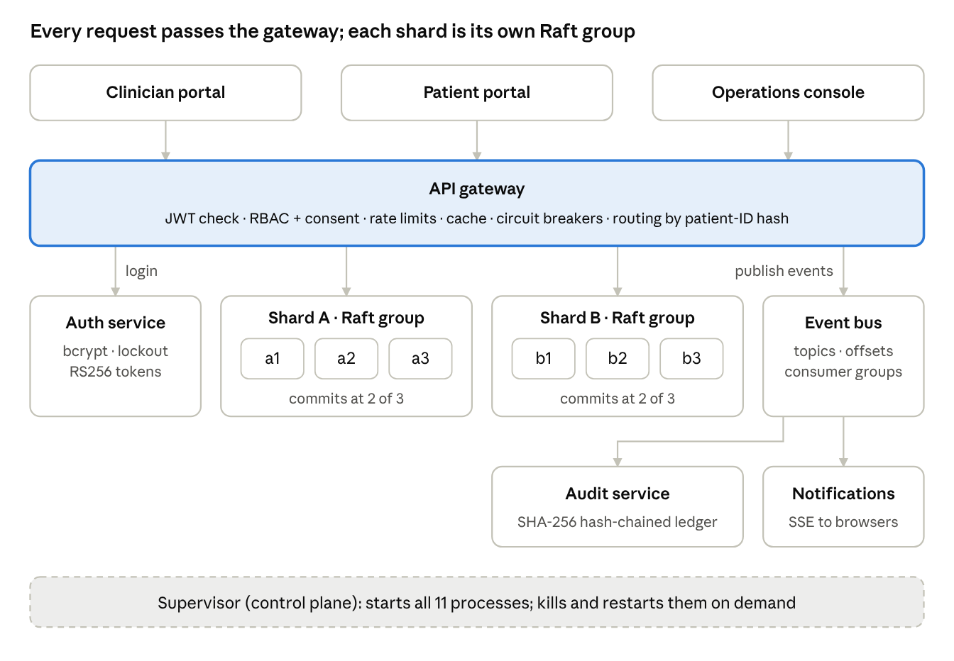
Figure 1. System architecture: 11 processes
Component | Processes | Role
API gateway | 1 | Authentication, rate limiting, policy checks, routing, caching, encryption
Storage shards | 2 × 3 replicas | Raft-replicated key-value stores holding all patient data
Auth service | 1 | Login, account lockout, RS256 token issuing
Event bus | 1 | Kafka-style topics carrying security and cluster events
Audit service | 1 | Consumes events into a hash-chained ledger
Notification service | 1 | Pushes live alerts to browsers over Server-Sent Events
Supervisor | 1 | Starts every process; kill, restart and partition control plane

The gateway publishes every security-relevant event to the event bus; the audit and notification services consume it independently.

4.1 Data placement
Each patient lives on exactly one shard, chosen by hashing the patient ID. Three keys hold a patient's data, and all three hash to the same shard:
Key | Holds | Encrypted fields
patient:<id> | Demographics, allergies | Phone, ABHA ID
records:<id> | Notes, labs, prescriptions, vitals (append-only) | Free-text content
consent:<id> | Which doctors may read, and on what terms | —

Each shard keeps three full replicas. A write is acknowledged only after two of the three have stored it on disk.

4.2 Security architecture
Every request must prove who it is, be allowed by policy for that specific patient, and leave an audit entry. Admins operate the platform but cannot read clinical data.
Layer | Control
Authentication | bcrypt password hashes; lockout after 5 failed attempts; the same error for an unknown user and a wrong password
Tokens | RS256 JWTs. Only the auth service holds the private key; every service verifies locally with the public key
Authorization | RBAC (role) plus ABAC (consent, ownership, expiry), in one pure function covered by a 28-row decision table
Least privilege | Admins manage the cluster but are denied all patient data
Emergency access | Break-glass needs a reason of at least 10 characters, lasts 30 minutes, and alerts the patient in real time
Encryption at rest | AES-256-GCM per field (phone, ABHA ID, note text) before replication; storage nodes only see ciphertext
Integrity | SHA-256 hash chain over the audit log detects edited, deleted or reordered entries
Zero trust | Internal endpoints require a service token even on the private network
Abuse protection | Token-bucket rate limits per user and per IP; 200 kB request body limit
Browser | Content Security Policy, frame denial, no MIME sniffing; all output escaped against XSS

5. Distributed Systems Concepts Used
The core guarantee is that an acknowledged write survives the crash of any single replica in its shard. Raft consensus provides it, sharding provides scale, and the gateway hides failovers from clients.
Concept | How MediChain uses it | Source
Consensus (Raft) | Leader election and log replication in every shard | src/raft/raft-node.js
Replication | 3 replicas per shard; majority commit | src/raft
Sharding / partitioning | Consistent hashing, 150 virtual nodes per shard | src/common/consistent-hash.js
Consistency models | Linearizable writes and reads; eventual reads from followers | src/gateway/ehr-repository.js
CAP trade-off | Each shard is CP: no majority, no writes | src/raft/raft-node.js
Fault tolerance | Leader tracking, retry with backoff and jitter, circuit breakers | src/gateway/shard-client.js
Failure detection | Heartbeats, election timeouts, cluster monitor | src/gateway/cluster-monitor.js
Durability and recovery | Write-ahead log persisted before replying | src/raft/storage.js
Message-oriented middleware | Event bus with topics, offsets, consumer groups | src/eventbus/event-bus.js
Idempotency | Request IDs deduplicate retried writes | src/raft/kv-state-machine.js
Logical time | Raft terms and log indexes order every event | src/raft/raft-node.js
Microservices and API gateway | 6 services behind one entry point | src/gateway/gateway.js
Distributed security | Public-key tokens verified by every service; service-to-service tokens | src/auth, src/common/security.js

5.1 Raft consensus
Each shard is a Raft group of three replicas, implemented from the Ongaro & Ousterhout paper (about 500 lines of JavaScript).
Mechanism | What it guarantees
Randomized election timeouts (1.2–2.4 s) | Avoids split votes; one leader per term
Election restriction | Only a candidate with an up-to-date log can win, so committed data is never lost
PreVote | A node returning from a partition cannot force a needless election
Log matching with fast backtracking | Followers repair divergent logs quickly
Commit only current-term entries, no-op on election | Prevents the known "Figure 8" anomaly
Write-ahead log, persisted before replying | Term, vote and log survive crashes; a torn final write is discarded
Check-quorum | An isolated leader steps down instead of serving stale data
Lease reads | Strong reads are linearizable without an extra log round
Request deduplication | A retried client write is applied exactly once

A write follows four steps:
- The gateway sends the command to the shard leader.
- The leader appends it to its write-ahead log and replicates it to the followers.
- Once a majority has stored it, the leader advances the commit index.
- Every replica applies it to its state machine deterministically, using the timestamp stamped by the leader.

5.2 Sharding with consistent hashing
Patient IDs are placed on a hash ring with 150 virtual nodes per shard. All keys of one patient (demographics, records, consents) hash to the same shard, so each request touches one Raft group. Growing from 4 to 5 shards moves about 20% of keys, compared with about 80% for hash mod N (measured in test TC-HASH-10).

5.3 Consistency model
Operation | Consistency | Served by
Read a patient record or consents | Linearizable, or cached | Shard leader, or gateway cache
Patient directory (names, demographics) | Eventual | Any follower (read replicas)
All writes | Linearizable | Leader plus a majority

Each shard is CP in CAP terms: without a majority it refuses writes rather than diverging. The system as a whole degrades gracefully. If an entire shard is down, the other keeps serving and cross-shard queries return partial results flagged as degraded.

5.4 Fault tolerance at the gateway
- Leader tracking: followers answer "not leader" with a hint, and the client follows it immediately.
- Retry with backoff: on failure the client tries other replicas with exponential backoff and jitter until a new leader exists. Callers see a slower request, not an error.
- Circuit breakers: one per replica. After two failures a dead replica is skipped for 2.5 s, then probed with a single trial call.
- Failure detector: the cluster monitor polls every replica each second and publishes node-down, node-up and leader-elected events.

5.5 Asynchronous messaging
The event bus behaves like a small Kafka: append-only topics, offsets, and consumer groups that each receive every message. Offsets are committed after processing, giving at-least-once delivery, and consumers deduplicate by event ID. The gateway publishes through an in-memory outbox, so clinical requests never fail because the audit pipeline is briefly down.

5.6 Caching
The gateway keeps a cache-aside LRU cache with a time-to-live for patient records. Any write to a patient invalidates that patient's entries, so a cached read never outlives a change made through the gateway. Cached reads run 3.7 times faster than writes (Section 9.6).

6. Technology
The whole system is JavaScript on Node.js 22. It needs no database server, Docker or message broker, so it runs on any laptop with one command.
Layer | Technology | Purpose
Runtime | Node.js 22 (ES modules) | All 11 services
Web framework | Express 5 | HTTP APIs of every service
Security | jsonwebtoken (RS256), bcryptjs, Node crypto (AES-256-GCM, SHA-256) | Tokens, password hashing, encryption, hash chain
Validation | Zod 3 | Schema validation of every request body
Frontend | HTML, CSS, vanilla JavaScript, Server-Sent Events | Three portals, no build step
Unit and integration tests | Vitest 3, Supertest, fast-check | Test runner, HTTP assertions, property-based tests
Coverage | V8 coverage (@vitest/coverage-v8) | Statement, branch and function coverage
End-to-end tests | Playwright 1.63 (Chromium) | Real browser against the real cluster
Mutation testing | Stryker 10 | Measures test strength
Load testing | autocannon | Throughput and latency
Continuous integration | GitHub Actions workflow | Coverage, end-to-end and mutation runs on every push
Test demonstration | QA Lab: Express, Server-Sent Events, custom Vitest and Playwright reporters | Live test runs, fault seeding, quality dashboard

6.1 Mapping to the proposed technologies
The proposal named production tools. Each is implemented in miniature with the same semantics, so every mechanism is visible and testable on a laptop.
Proposal | Implemented as | Same core idea
Apache Kafka | Event bus service | Append-only topics, offsets, consumer groups, at-least-once delivery
Redis cache | Gateway LRU cache | Cache-aside, TTL, invalidation on write
Sharded, replicated PostgreSQL | Raft-replicated key-value shards | Consistent-hash sharding, majority replication, failover
etcd / ZooKeeper | Own Raft implementation | The consensus algorithm etcd itself uses
Keycloak (OAuth2/OIDC) | Auth service | RS256 JWTs verified by every service
Kubernetes | Supervisor process | Process lifecycle, health checks, kill and restart on demand
Prometheus + Grafana | /metrics endpoint + Ops Console | Prometheus text format, live dashboard

7. Implementation
The system is about 8,100 lines of JavaScript: 3,350 lines of backend, 2,000 of frontend and 2,700 of tests. npm start launches the supervisor, which starts every service as its own operating-system process, waits for leaders to be elected and seeds demo data through the public API.

7.1 Modules
Module | Responsibility
src/raft | Raft node, write-ahead log storage, key-value state machine, storage-node HTTP API
src/gateway | API gateway, shard client with leader tracking, cluster monitor, data access layer
src/auth | Login, lockout, token issuing, patient accounts
src/eventbus | Topics, offsets, consumer groups, long polling
src/audit | Hash-chained ledger, verification, tamper demo
src/notify | Server-Sent Events push to browsers
src/common | Consistent hashing, circuit breaker, rate limiter, cache, crypto, RBAC policy, validation, metrics
src/supervisor | Launches all 11 processes, control-plane API, demo data seeding
qa-lab | QA Lab testing console: live test runner, fault-seeding sandbox, quality dashboard (kept outside the product)

7.2 Request flow: a doctor adds a clinical note
- The browser sends the note with the doctor's token to the gateway.
- The gateway verifies the token, applies the rate limit, validates the body and checks the access policy against the patient's consents.
- It encrypts the note text, hashes the patient ID to find the home shard, and sends the write to that shard's leader with a request ID.
- The leader replicates the entry; once two of three replicas have stored it, the write commits and the gateway invalidates the patient's cache entries.
- The gateway replies to the browser and publishes a RECORD_CREATED event. The audit service seals it into the ledger, and the notification service alerts the patient's open portal.

7.3 Web portals
The frontend is framework-free HTML, CSS and JavaScript with a minimalist "liquid glass" design: translucent frosted panels over a soft colour field.
- Clinician portal: patient directory gathered from both shards in parallel, record timeline (notes, labs, prescriptions, vitals), add records, register patients, break-glass. A request inspector shows which shard and replica served each read, cache hit or miss, and latency.
- Patient portal: own records, consent management, and an access history backed by the verified ledger, with live alerts.
- Operations console: live cluster topology with animated heartbeats, kill / restart / partition controls per node, a chaos lab that writes continuously during failures, the consistent-hash ring, circuit breakers, event-bus lag, a live event stream and the audit ledger with tamper detection.

8. Working / Demo
The system starts with npm install followed by npm start, and is opened at http://127.0.0.1:8080. On start-up the supervisor launches all 11 processes, waits for both shards to elect leaders and seeds eight demo patients. npm run reset wipes all data before a fresh demo.
Login | Password | Portal
dr.rohit | Doctor@123 | Clinician: Dr. Rohit, treating cardiologist
dr.varun | Doctor@123 | Clinician: Dr. Varun, emergency doctor (break-glass demo)
dr.nikhil | Doctor@123 | Clinician: Dr. Nikhil, general medicine
hemanth, sanku | Patient@123 | Patient portal
admin | Admin@123 | Operations console

8.1 Treating doctor reads a record
Dr. Rohit has Hemanth's consent. The directory lists all eight patients, fetched from both shards in parallel. Opening Hemanth shows his timeline, and the request inspector shows the serving shard, replica, cache result and latency.
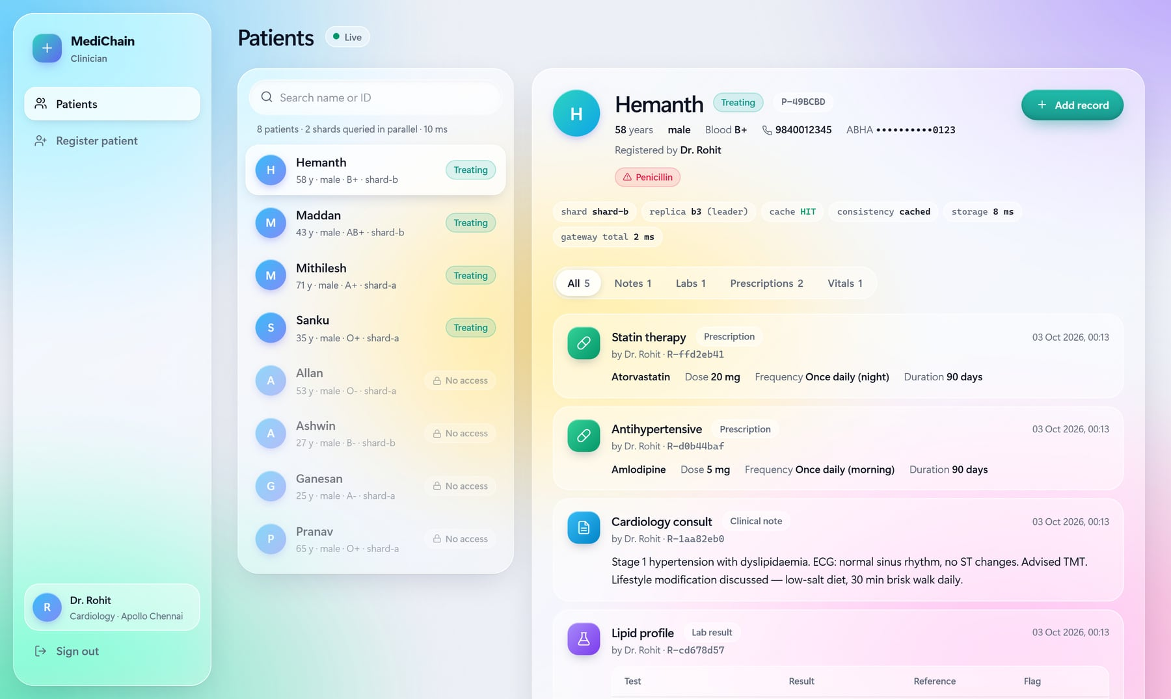
Figure 2. Clinician portal: Dr. Rohit viewing Hemanth's record with the request inspector

8.2 Access denied without consent
Dr. Varun has no consent for Hemanth. The gateway refuses the read and writes a NO_ACTIVE_CONSENT denial to the audit ledger.
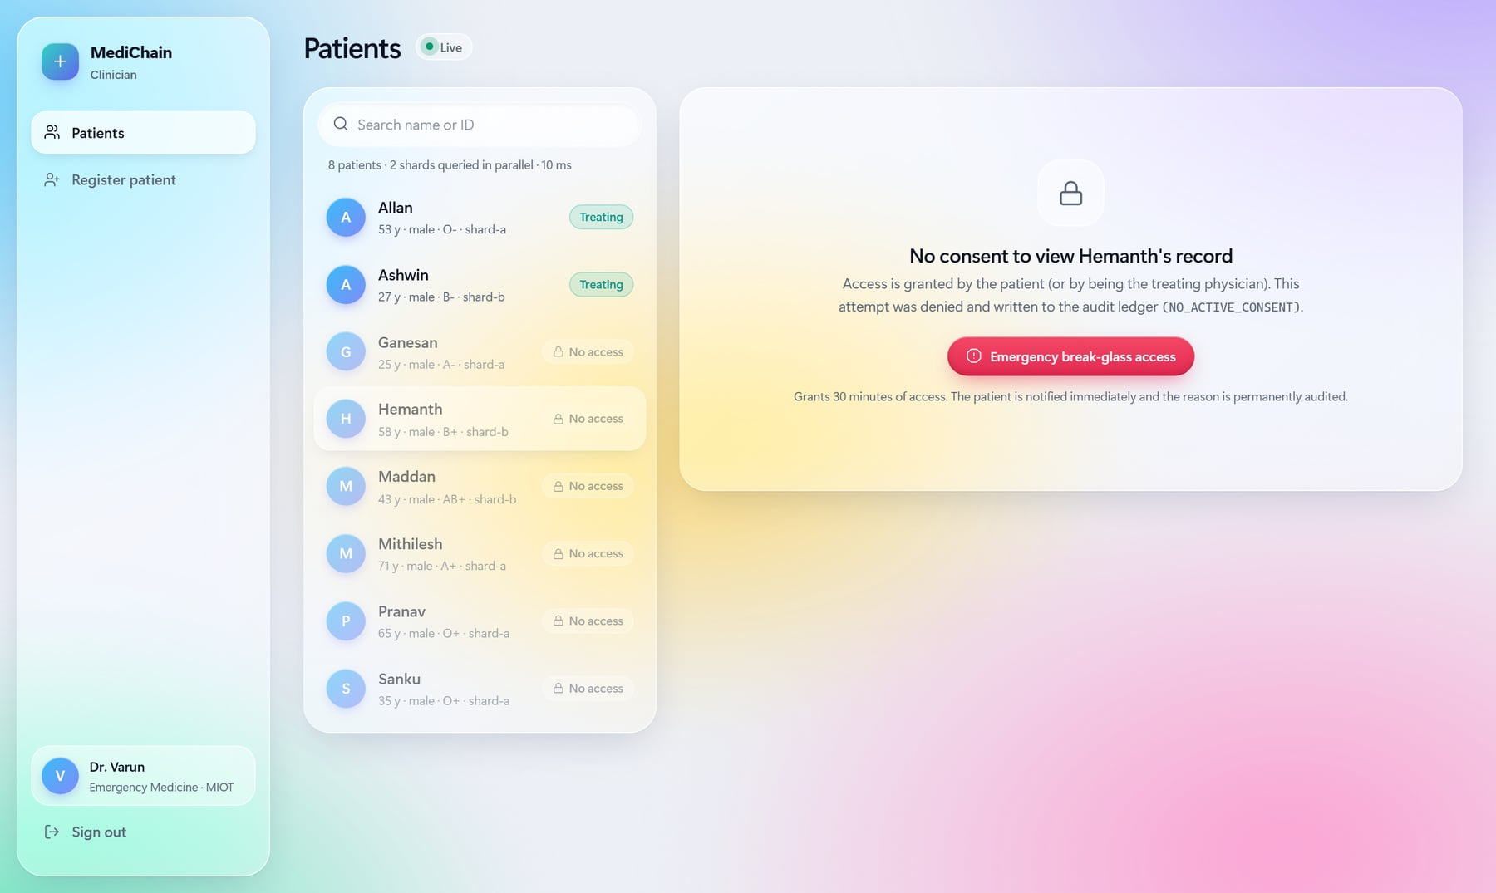
Figure 3. Dr. Varun is denied access; the denial is audited

8.3 Emergency break-glass
Dr. Varun enters a reason and uses break-glass. Access opens for 30 minutes, the record shows an "Emergency" badge, and the action is sealed in the ledger.
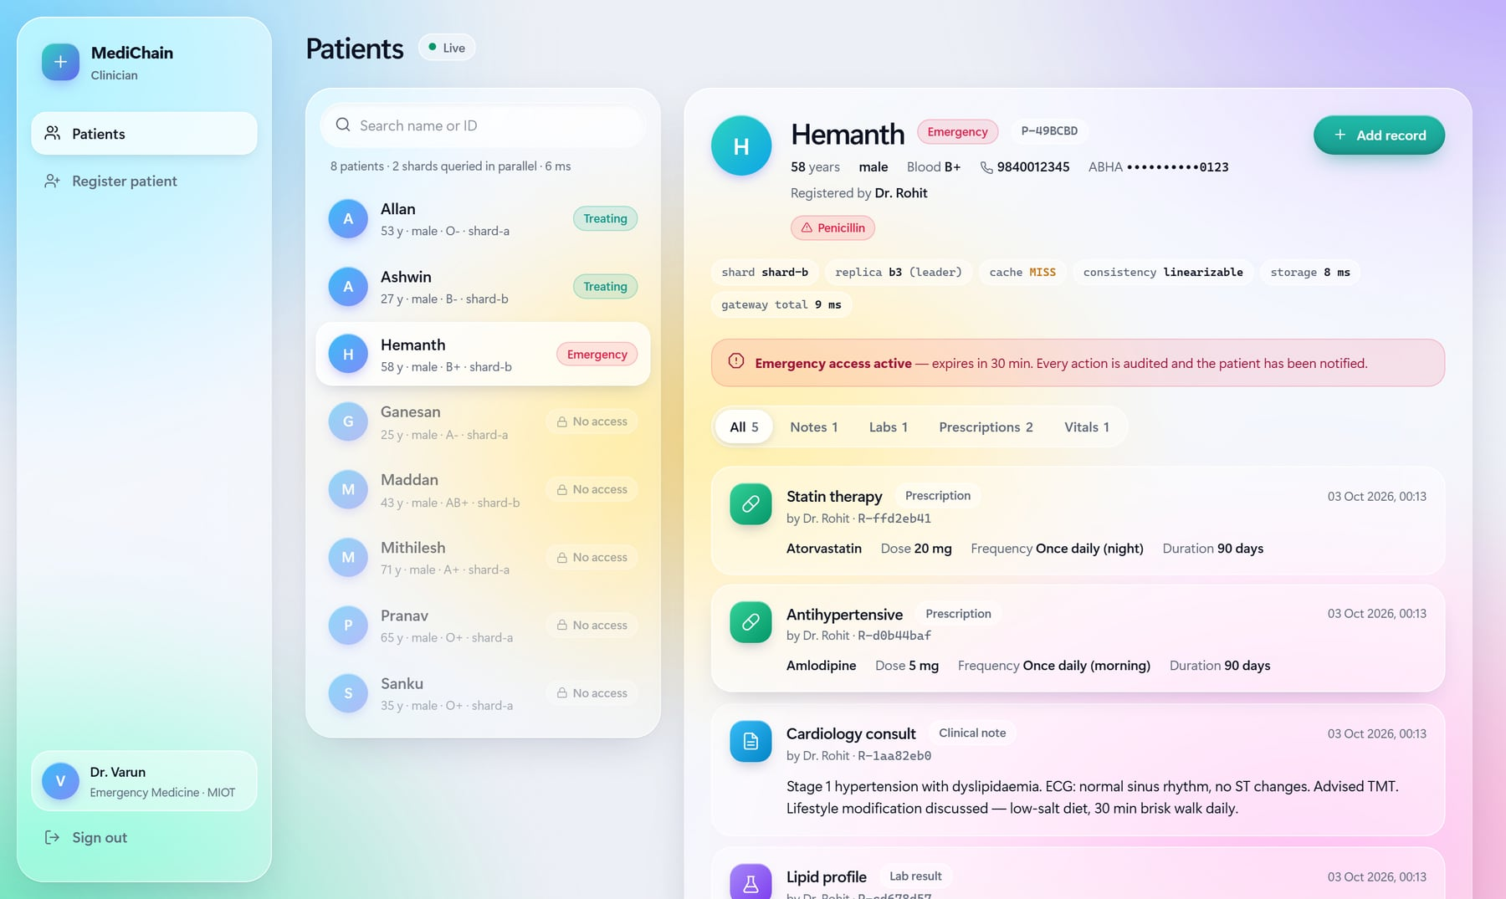
Figure 4. Break-glass access granted for 30 minutes

8.4 The patient is alerted in real time
Hemanth's portal shows a red alert within a second, pushed over Server-Sent Events. From the same portal the patient can revoke any doctor's access and see every read, write, denial and emergency access in the verified history.
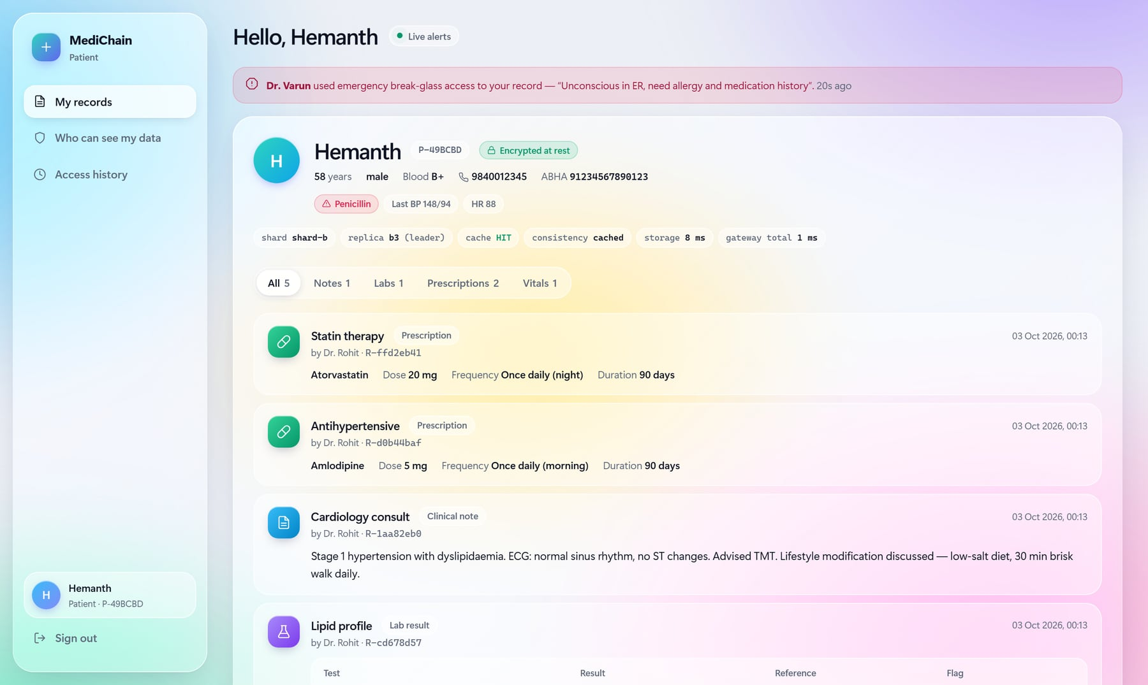
Figure 5. Patient portal: live break-glass alert
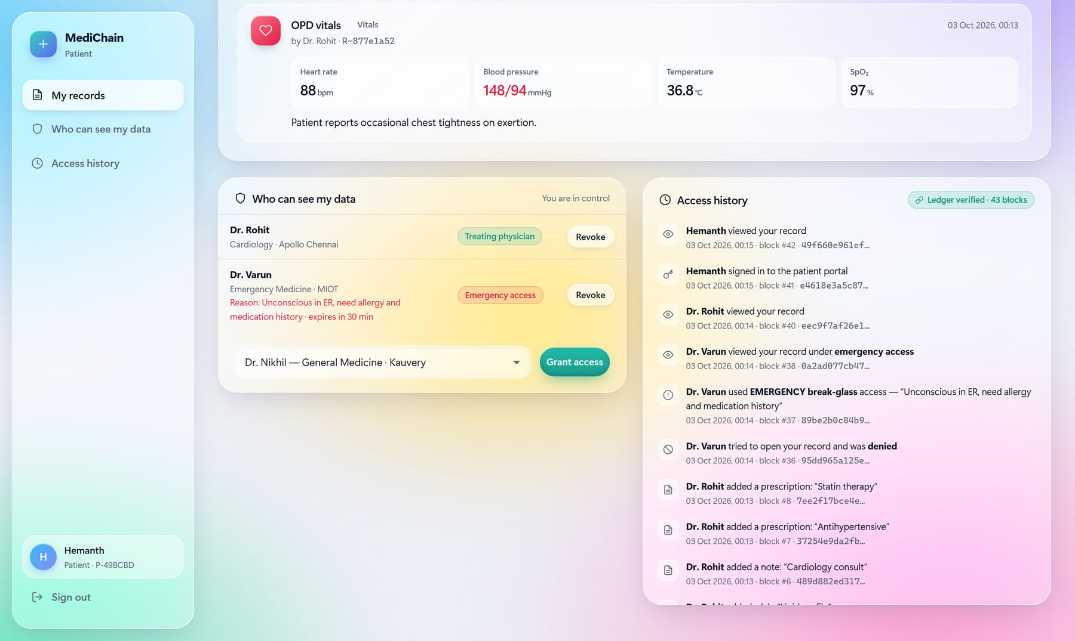
Figure 6. Consent management and the verified access history

8.5 Leader crash and network partition
In the operations console the admin starts write traffic in the chaos lab, then kills a shard leader. The remaining replicas elect a new leader within about two seconds, and the chart shows zero failed writes. Partitioning a leader has the same effect; after healing it rejoins as a follower, and PreVote stops it from disrupting the new term.
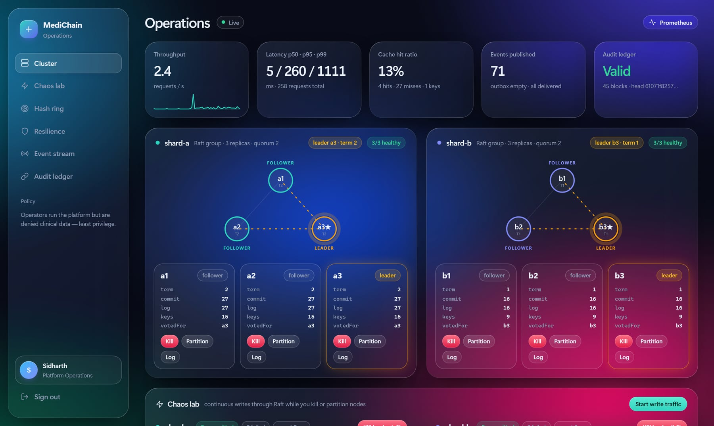
Figure 7. Operations console: both shards, their leaders and replica state
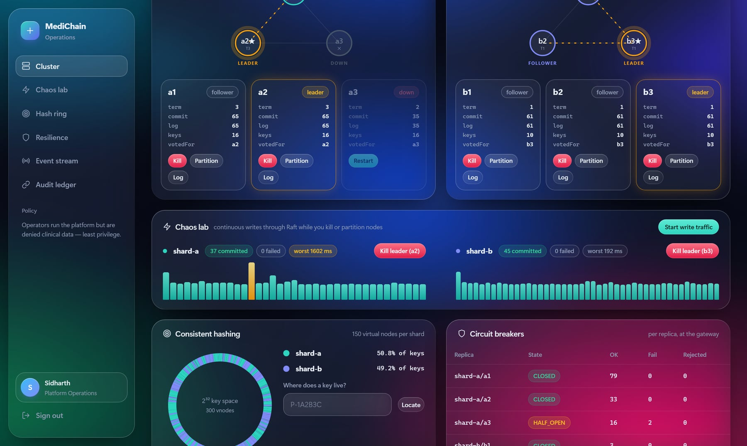
Figure 8. Chaos lab: writes continue through a killed leader with 0 failures

8.6 Encryption at rest and tamper detection
Opening a replica's raw log shows phone numbers, ABHA IDs and notes stored only as ciphertext. In the audit ledger the admin tampers with one block and clicks Verify chain; the ledger reports the exact block whose hash no longer matches.
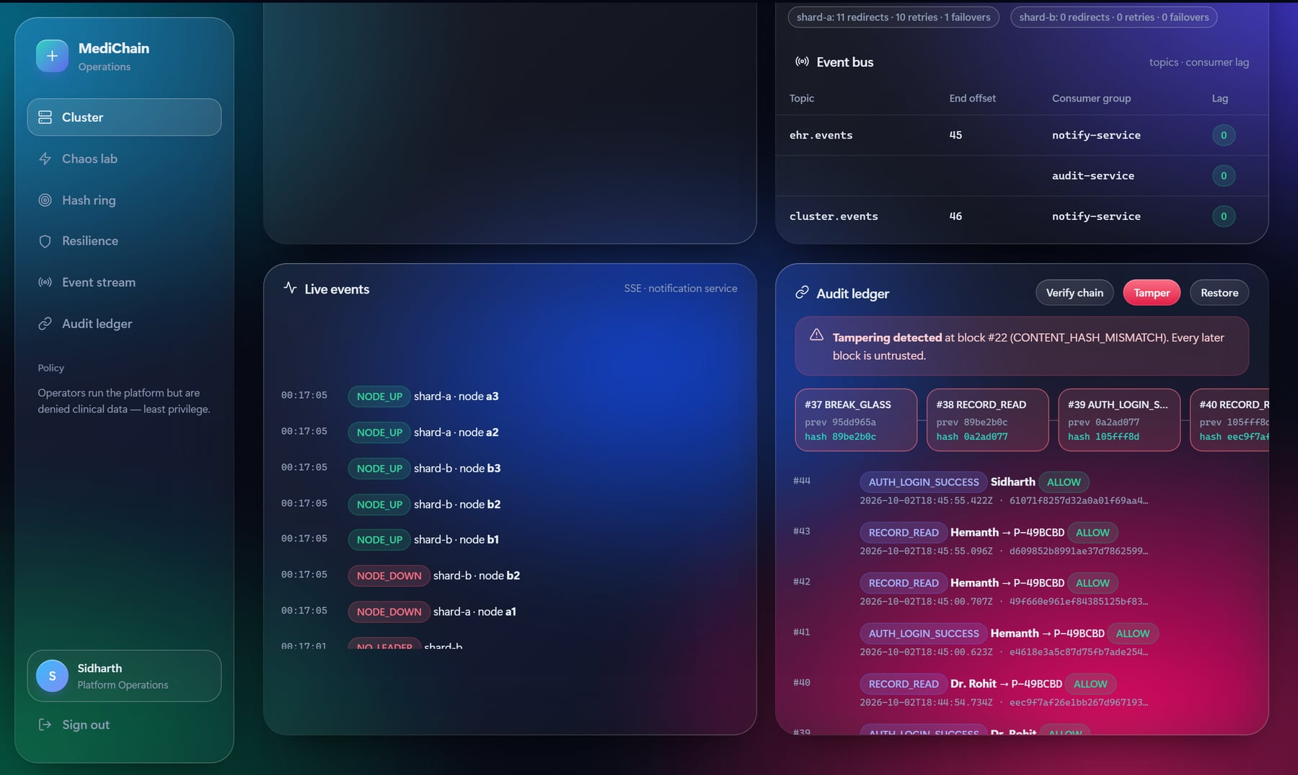
Figure 9. Audit ledger: tampering detected at a specific block

8.7 Testing demo in the QA Lab
npm run lab opens a separate console on port 9000 for the Software Testing demonstration. It runs the real Vitest suites and draws each test case as a square that turns green or red as it finishes. It launches the 12 browser tests in a visible, slowed-down window, and it injects seeded faults (Section 9.8). The lab reads the coverage, mutation, JUnit and load-test reports the tools write, and links every requirement to its latest test results.
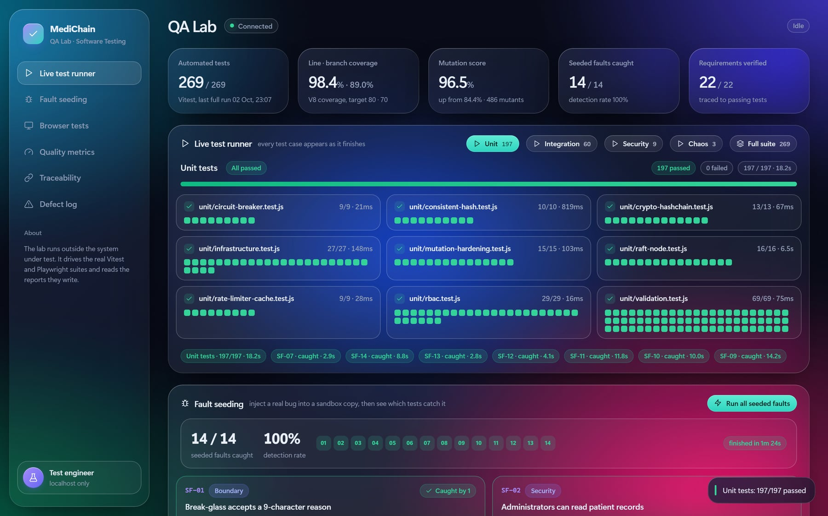
Figure 10. QA Lab: the unit suite running live, one square per test case

9. Testing Results
The test strategy follows IEEE 829 and checks every requirement at two or more test levels. All 281 automated tests pass, and every exit criterion of the test plan is met. The full test plan, the 184-entry test-case catalogue and the traceability matrix are in the repository's docs/ folder.

9.1 Test levels
Level | Scope | Tools | Tests
Unit | Pure modules; injected clocks; in-memory Raft network with fault injection | Vitest, fast-check | 197
Integration | Each service over real HTTP; 3 Raft replicas with on-disk logs | Vitest, Supertest | 28
System and security | The whole cluster in-process; OWASP API Top 10 checks | Vitest, Supertest | 41
Chaos | Crashes and partitions while clients write (Jepsen-style) | Vitest | 3
End-to-end | Real browser against the real 11-process cluster, Page Object Model | Playwright | 12
Performance | Throughput and latency, including failover under load | autocannon | 5 scenarios
Mutation | Whether the tests catch injected bugs | Stryker | 7 modules

9.2 Test design techniques
Technique | Applied to
Equivalence partitioning | Phone numbers, ABHA IDs, blood groups, record types
Boundary value analysis | Name length 2/80, age 0/130, heart rate 20/250, note 5,000 chars, prescription 1–365 days, lockout at attempt N−1/N, cache expiry, break-glass reason 9/10 chars
Decision table | The access policy: role × action × consent × expiry × reason, 28 rules
State transition | Circuit breaker (closed, open, half-open); Raft (follower, candidate, leader)
Property-based | Consistent-hashing invariants; encryption round-trip over arbitrary Unicode
Fault injection | Crashes, partitions, one-way link cuts, 20% message loss, majority loss, whole-shard loss
Security testing | Forged and alg:none tokens, insecure direct object references, injection, prototype pollution, oversized bodies, brute force, stored XSS
Mutation testing | Measures test strength; surviving mutants drove 15 new tests

Tests stay deterministic by injecting clocks and running Raft on an in-memory network whose partitions and message loss the test controls. Each integration file boots its own cluster on random ports with temporary data. The end-to-end run boots a separate real cluster on ports offset by 1000, so it can run beside a development instance.

9.3 Summary of results
Metric | Result | Target
Automated tests | 281 of 281 passing | 100%
Stability | 3 consecutive full green runs, also beside a live cluster | 3
Statement and line coverage | 98.4% | at least 80%
Branch coverage | 89.0% | at least 70%
Function coverage | 99.5% | at least 80%
Mutation score | 96.5% | at least 85%
Seeded faults detected (Section 9.8) | 14 of 14 | all
Chaos test: writes lost / duplicated | 0 / 0 of 75 | 0 / 0
Client errors during leader failover | 0 | 0

9.4 Mutation testing
Coverage only shows that code ran; mutation testing shows whether the tests notice a bug. Stryker made 486 small changes to the core modules, such as < to <= or deleting a statement, and counted how many the tests caught.
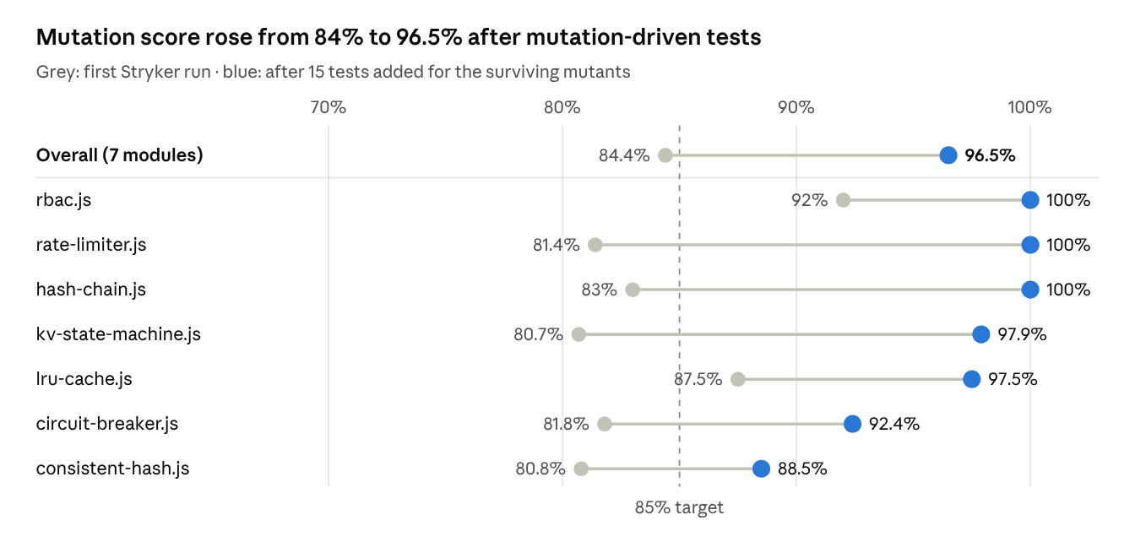
Figure 11. Mutation score per module, first run versus after hardening (Stryker 10, 486 mutants)
The first run scored 84.4% despite 98% line coverage. The survivors exposed a property test that passed even when node removal did nothing, tests whose clocks started at zero and hid arithmetic errors, and untested exact boundaries. Fifteen targeted tests raised the score to 96.5%; the remaining survivors are equivalent mutants that cannot change behaviour.

9.5 Chaos test
Three clients each wrote 25 records while a "nemesis" crashed and restarted the shard leader three times, then partitioned a follower:
[chaos] acked=75 stored=75 attempts=75 retries=0 terms=1,2,3,4 lost=0 dupes=0
Leadership moved through four terms, so the faults were real. All 75 writes were acknowledged, none were lost or duplicated, and the replicas ended byte-identical. The clients needed no retries, because the gateway followed each new leader on their behalf. With two of three replicas down, writes were refused with HTTP 503 rather than accepted by a minority.

9.6 Performance
Measured with autocannon at 20 concurrent connections for 6 s per scenario, on one laptop:
Scenario | Requests/s | Median latency (ms) | p99 latency (ms) | Errors
Read a patient record (cache hit) | 319 | 59 | 282 | 0
Read many patients across 2 shards | 251 | 78 | 263 | 0
Patient directory (both shards in parallel) | 114 | 169 | 344 | 0
Add a clinical note (majority commit) | 87 | 231 | 314 | 0
Add notes while the leader is killed | 66 | 291 | 1,041 | 0

Cached reads run 3.7 times faster than writes, which wait for a majority. A leader crash costs about one election timeout of extra tail latency and no failed requests. In this harness all services share one Node.js event loop, so the absolute numbers are a lower bound.

9.7 Defects found and fixed
Testing found 14 defects: 10 in the product, 3 in the tests themselves, and 1 tooling incompatibility. All are fixed. The most serious would have blocked real users: patient names in Indian scripts were rejected at registration.
ID | Found by | Severity | Defect | Fix
DEF-01 | Boundary value test with a Tamil name | High | Names in Indic scripts were rejected: the pattern allowed letters but not combining vowel signs | Allow Unicode combining marks
DEF-02 | First system start | High | Every service crashed at start-up: the validation library cannot nest a refined schema in a union | Moved the blood-pressure rule to the union level
DEF-03 | Exploratory UI testing | Medium | Directory showed "No access" right after break-glass, because consent was read from a lagging follower | Consent is now read with linearizable consistency
DEF-04 | API test of idempotency | Medium | A retried request reported a different record ID than the original | State machine returns the original item ID on a duplicate
DEF-05 | Test-run hygiene | Medium | Killing the supervisor left orphaned processes holding ports | Child processes exit when the supervisor disconnects
DEF-06 | End-to-end test E2E-03 | Low | A patient opening the admin page was bounced through the sign-in page | Redirect straight to the user's own portal
DEF-07 | Exploratory UI testing | Low | CSS class collisions broke the sign-in button and squashed vitals cards | Renamed the classes
DEF-08 | Mutation testing | Medium | A half-open circuit breaker relied on a stale failure count to re-open | Reset the count on entering half-open
DEF-09 | Mutation testing | Test defect | A property test passed even when node removal did nothing | Strengthened with an explicit assertion
DEF-10 | Three-run stability check | Test defect | Raft HTTP tests failed about 1 run in 6 when a leader changed mid-test | Tests follow the current leader like a real client
DEF-11 | Code review | Low | Login audit events lost the client IP address | Fixed how the request object is passed
DEF-12 | Tooling | Tooling | Stryker activated no mutants under Vitest 5 | Pinned Vitest 3.2
DEF-13 | End-to-end test after the redesign | Medium | Chaos-lab buttons were rebuilt 5 times a second, so clicks could be lost | Panel now updates in place
DEF-14 | Full suite beside a live cluster | Test defect | Tight 15 ms Raft test timings caused rare leader changes under CPU load | Leader-following writes; relaxed timings

9.8 Fault seeding
Mutation testing changes code mechanically. Fault seeding complements it with realistic bugs written by hand, one for each kind of defect that matters in this system. The QA Lab copies the source and tests into a sandbox, applies one fault, runs only the tests for that module, and records which test cases fail. The real source is never modified.
ID | Seeded fault | Caught by
SF-01 | Break-glass accepts a 9-character reason | TC-RBAC DT-15 (boundary value)
SF-02 | Administrators can read patient records | TC-RBAC DT-03 (decision table)
SF-03 | A patient can open another patient's data | TC-RBAC DT-21, 23, 28
SF-04 | Expired consent and break-glass never end | TC-RBAC DT-10, TC-RBAC-29
SF-05 | Circuit breaker opens one failure too late | TC-CB-02, 04, 05, 08 (state transition)
SF-06 | Cache ignores expiry and serves stale data | TC-CACHE-03, TC-MUT-10
SF-07 | AES-GCM reuses the same nonce | TC-CRYPTO-02
SF-08 | Audit ledger stops checking content hashes | TC-CHAIN-03
SF-09 | Raft commits a write without a majority | TC-RAFT-09, 11, 12 (fault injection)
SF-10 | Raft votes for a candidate with an old log | TC-RAFT-04
SF-11 | Retried writes are applied twice | TC-SM-05, TC-MUT-14, TC-RAFT-16
SF-12 | Hash ring wraps around to the wrong shard | TC-HASH-06
SF-13 | Registration accepts a 140-year-old patient | TC-VAL-DOB 130 years + 1 day
SF-14 | Phone numbers stored in plaintext | TC-API-21 (every replica's raw storage)

All 14 seeded faults are detected, and the whole campaign takes about 75 seconds. Two results stand out. SF-07 and SF-14 leave the application working and returning correct data, so only security properties catch them. SF-03 is caught by the policy unit tests, while the API test still passes because the gateway checks ownership a second time: defense in depth.
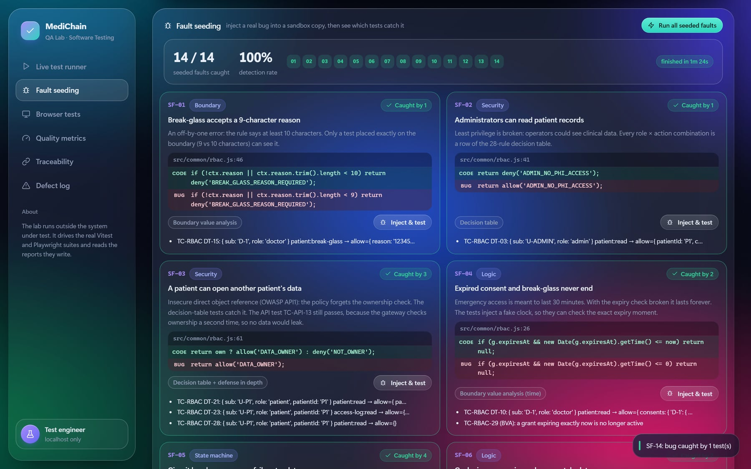
Figure 12. QA Lab: 14 of 14 seeded faults caught, with the correct and faulty line of each

10. Individual Student Contribution
All three members took part in the design, the integration of the services, the demo and this report. Primary ownership was divided as follows.
Member | Roll number | Primary contribution
N. Sankkarshana | CH.EN.U4CCE23023 | Raft consensus (leader election, log replication, PreVote, write-ahead log), consistent-hash sharding, shard-client failover and circuit breakers, chaos (Jepsen-style) testing
Ganesan P.V | CH.EN.U4CCE23008 | API gateway, authentication and the RBAC/ABAC consent policy, break-glass, AES-256-GCM encryption, event bus, audit ledger and notification service, security testing
Hemanth S | CH.EN.U4CCE23013 | Web portals and liquid-glass design, operations console, test plan and test-case catalogue, unit, integration, end-to-end, mutation and load testing, QA Lab and fault seeding, test report

11. Conclusion
MediChain shows that a health-record system can stay available, correct and private under real failures. Killing a shard leader stalls writes for about one election timeout and loses nothing. A partitioned minority refuses writes instead of diverging. Every access is authorized against patient consent and sealed in a verifiable ledger.
The testing work shows that line coverage alone overstates test quality. At 98% coverage, mutation testing still exposed a test that verified nothing and a real flaw in the circuit breaker. Fault injection exposed timing assumptions that only fail under load. Fault seeding gave a second, independent measure: the tests caught all 14 realistic bugs, including two that leave the application working normally.
Future work:
- Raft log compaction and snapshots, so the write-ahead log stops growing without bound.
- Dynamic cluster membership, to add or remove replicas without downtime.
- Several gateway instances, with cache invalidation shared over publish/subscribe.
- Multi-factor authentication and an OpenID Connect identity provider.
- Anchoring the audit chain's head in a public blockchain.
- Anomaly detection on access patterns, and FHIR / ABDM interoperability.
- Container images and Kubernetes manifests for multi-host deployment.

12. Annexures

Annexure A: REST API summary
All endpoints are served by the gateway under /api and need a bearer token, except sign-in.
Method | Endpoint | Purpose | Allowed roles
POST | /api/auth/login | Sign in; returns a token | Everyone
GET | /api/patients | Directory of both shards | Doctor
POST | /api/patients | Register a patient | Doctor
GET | /api/patients/:id | Patient record and timeline | Consented doctor, patient
POST | /api/patients/:id/records | Add a clinical record | Consented doctor
POST | /api/patients/:id/break-glass | 30-minute emergency access | Doctor
GET, POST | /api/patients/:id/consents | View or grant consent | The patient
DELETE | /api/patients/:id/consents/:doctorId | Revoke consent | The patient
GET | /api/patients/:id/access-log | Who accessed the record | The patient
GET | /api/notifications/stream | Live alerts (SSE) | Signed-in users
GET | /api/admin/cluster | Shards and leaders | Admin
POST | /api/admin/nodes/:nodeId/:action | Kill, restart, isolate, heal | Admin
GET | /api/admin/audit/verify | Verify the audit hash chain | Admin
GET | /metrics | Prometheus metrics | Operations

Annexure B: Source code layout
Path | Contents
cluster.config.js | Topology and ports, the single source of service discovery
src/ | Raft, gateway, auth, event bus, audit, notify, common libraries, supervisor
public/ | Login page and the clinician, patient and operations portals
tests/unit, tests/integration, tests/chaos | Vitest suites
tests/e2e, tests/perf | Playwright tests and the autocannon load test
qa-lab/ | QA Lab server, live reporters, seeded-fault catalogue, self-tests
docs/ | Architecture, test plan, test cases, test report, demo script

Annexure C: Commands
Command | Runs
npm start | The full 11-process cluster on port 8080
npm run reset | Wipes all data; the next start re-seeds the demo
npm test | 269 unit, integration, security and chaos tests
npm run test:coverage | The same with a coverage report
npm run test:e2e | 12 browser end-to-end tests
npm run test:mutation | Mutation testing
npm run test:load | Load test, writes reports/load-test.md
npm run lab | QA Lab testing console on port 9000
npm run test:e2e:demo | Browser tests in a visible, slowed-down window
npm run test:ui | Vitest's interactive test UI
npm run test:lab | 22 self-tests for the QA Lab

Annexure D: References
- D. Ongaro and J. Ousterhout, "In Search of an Understandable Consensus Algorithm," USENIX Annual Technical Conference, 2014.
- D. Ongaro, "Consensus: Bridging Theory and Practice," PhD thesis, Stanford University, 2014 (PreVote, check-quorum, lease reads).
- D. Karger et al., "Consistent Hashing and Random Trees," ACM Symposium on Theory of Computing, 1997.
- M. Nygard, Release It! Design and Deploy Production-Ready Software, Pragmatic Bookshelf (circuit breaker pattern).
- J. Kreps, N. Narkhede and J. Rao, "Kafka: a Distributed Messaging System for Log Processing," NetDB Workshop, 2011.
- K. Kingsbury, Jepsen analyses of distributed databases (methodology for the chaos test).
- OWASP Foundation, API Security Top 10, 2023.
- IEEE Std 829, Standard for Software and System Test Documentation.
- NIST SP 800-38D, Recommendation for Block Cipher Modes of Operation: Galois/Counter Mode (GCM).
- IETF RFC 7519, JSON Web Token (JWT).

