MediChain
Software Testing demo guide: the QA Lab
What to open, what to click, what to say, and the questions to expect
N. Sankkarshana · Ganesan P.V · Hemanth S

1. The idea in one paragraph
For the Software Testing demo you do not show the hospital app. You show the tests working. The QA Lab is a web page that runs our real test suites live, then plants a real bug on purpose in a copy of the code and shows exactly which test catches it. That proves the tests are not just numerous: they actually find bugs.
Section of the QA Lab | What it proves
Live test runner | The 269 automated tests really run and pass. Each square on screen is one test case.
Fault seeding | If someone breaks the code, a test fails. 14 of 14 planted bugs are caught.
Browser tests | The whole system works end to end through a real browser.
Quality metrics | Coverage 98.4%, mutation score 96.5%, and performance with 0 errors.
Traceability and defects | Every requirement is linked to the tests that verify it; 14 defects were found and fixed.

2. Before the examiners arrive
- Open a terminal in the project folder and run npm run lab.
- Open http://127.0.0.1:9000 in the browser.
- Click Unit once and let it finish. The first run of the day is slower; the second run is fast.
- Keep a second terminal ready. If they also want to see the hospital app, run npm start and open http://127.0.0.1:8080.
Do not run npm start and the browser tests at the same moment on a slow laptop: both start 11 processes.

3. The demo, step by step (about 10 minutes)

Step 1: The numbers at the top (1 minute)
Point at the five cards: 269 tests passing, 98.4% line and 89.0% branch coverage, 96.5% mutation score, 14 / 14 seeded faults caught, 22 / 22 requirements verified.
Say: Our plan follows IEEE 829. Every requirement is tested at two or more levels: unit, integration, security, chaos, end-to-end and performance. This lab is outside the system under test. It drives the real Vitest and Playwright tools and reads the reports they produce.

Step 2: Run the tests live (1.5 minutes)
- Click Unit. 197 tests run in about 15 seconds. Each square turns green as its test finishes.
- Click the validation.test.js card. It opens the list of test names. Point at boundary tests such as "130 years + 1 day".
- Click Security: 9 tests based on the OWASP API Top 10 (forged tokens, injection, brute force, oversized requests).
- Optional: click Chaos. The console shows acked=75 … lost=0 dupes=0, the result of crashing Raft leaders while clients write.
Say: These are not screenshots. The lab starts the real test runner and streams each result into the page as it happens.
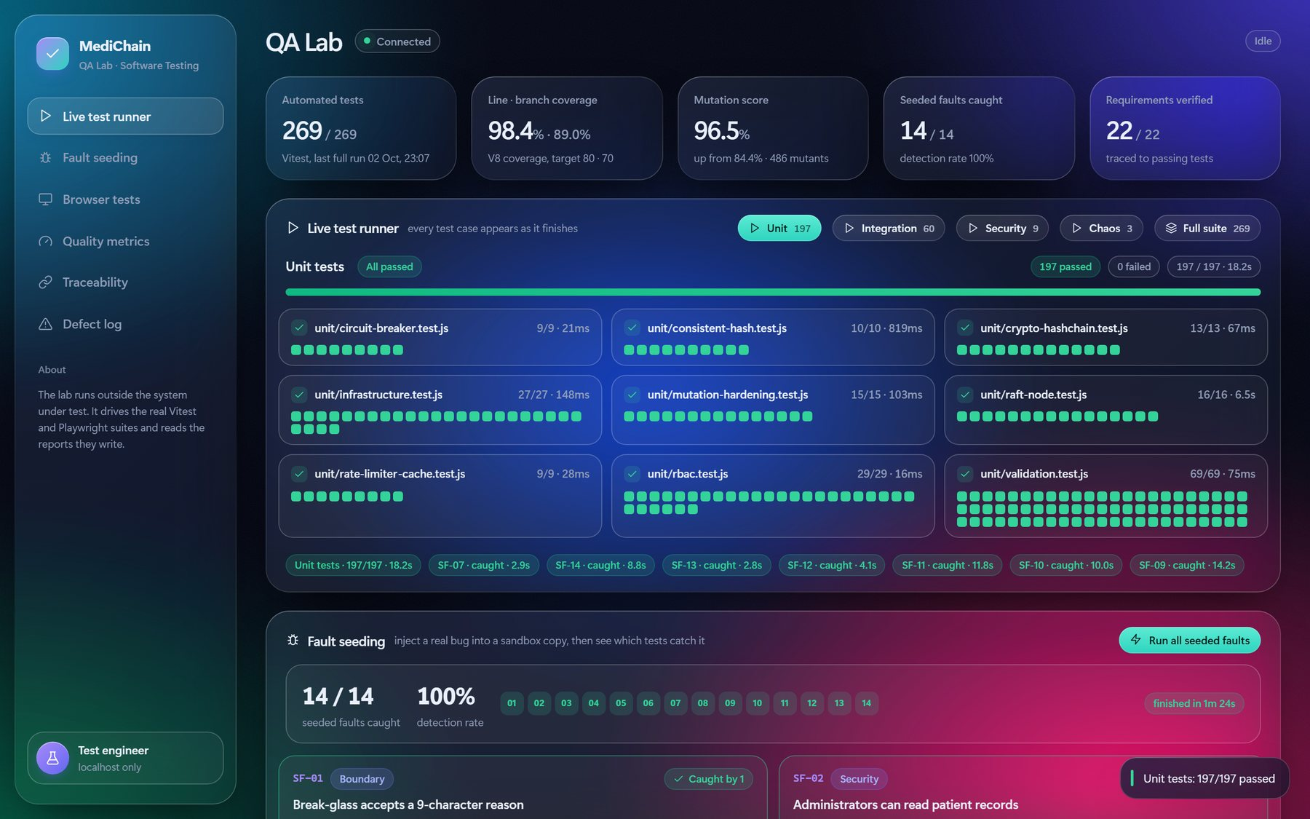
The live runner after the unit suite: 197 of 197 passed, one square per test

Step 3: Plant bugs and watch the tests catch them (3 minutes)
Say: Coverage only tells us code ran. It does not tell us a test would notice a bug. So we wrote 14 realistic bugs. The lab copies the code into a sandbox, puts one bug in, runs only the tests for that part, and shows which test caught it. The real code is never touched.
Scroll to Fault seeding. Each card shows the correct line (CODE) and the bug (BUG). Click Inject & test on these four, one at a time:
- SF-01, break-glass accepts a 9-character reason. Caught by TC-RBAC DT-15. Say: "An off-by-one bug. Only a test exactly on the boundary, 9 versus 10 characters, can catch it. That is boundary value analysis."
- SF-07, encryption reuses the same nonce. Caught by TC-CRYPTO-02. Point at the error: the ciphertext starts with "AAAAAAAA", an all-zero nonce. Say: "Decryption still works, so a normal test would pass. Only the security property, same input gives different ciphertext, catches it."
- SF-09, Raft commits without a majority. Caught by TC-RAFT-09, 11 and 12. Say: "This bug would lose acknowledged medical records after a crash. Our fault-injection tests cut the leader off from the others and check it cannot commit."
- SF-03, a patient can open another patient's data. Caught by the decision-table tests. Say: "The API test still passes, because the gateway checks ownership a second time. Defense in depth: even with this bug no data leaks."
Then click Run all seeded faults. It takes about 75 seconds and ends at 14 / 14 caught, 100%. While it runs, explain the difference from mutation testing (see the questions in section 5).
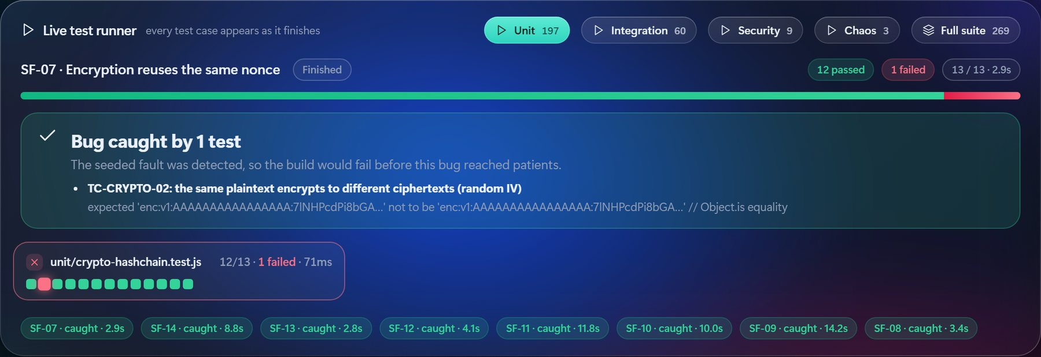
A planted bug caught: SF-07, the reused nonce, detected by TC-CRYPTO-02

Step 4: Browser tests in a visible window (2 minutes)
- Click Run in a visible browser in the Browser tests section.
- Playwright starts its own copy of MediChain on different ports, so it never touches your demo data. About 20 seconds later a Microsoft Edge window opens.
- The browser logs in as doctors, patients and the admin by itself, in slow motion. The results appear in the live runner: 12 / 12.
Say: The browser tests use the Page Object Model, so a change to the user interface only touches one file. Test E2E-10 kills a Raft leader from the admin console and checks that no write fails.

Step 5: The evidence (2 minutes)
- Coverage by module. Every module is above the white 80% target line.
- Mutation score. The yellow mark is our first run, 84.4%, even though line coverage was already 98%. The surviving mutants showed a test that checked nothing and a real circuit-breaker bug (DEF-08). After 15 new tests: 96.5%.
- Traceability. Each requirement, the test IDs at every level, and their latest result.
- Defect log. 14 defects found by testing, all fixed. DEF-01: Tamil names were rejected at registration.
- Open Coverage report or Mutation report under Generated reports to show the tools' own detailed pages.

4. The 14 planted bugs
The four in bold are the ones to show live.
ID | Planted bug | Caught by
SF-01 | Break-glass accepts a 9-character reason | TC-RBAC DT-15 (boundary)
SF-02 | Administrators can read patient records | TC-RBAC DT-03 (decision table)
SF-03 | A patient can open another patient's data | TC-RBAC DT-21, 23, 28
SF-04 | Expired consent and break-glass never end | TC-RBAC DT-10, TC-RBAC-29
SF-05 | Circuit breaker opens one failure too late | TC-CB-02, 04, 05, 08 (state transition)
SF-06 | Cache ignores expiry and serves stale data | TC-CACHE-03, TC-MUT-10
SF-07 | Encryption reuses the same nonce | TC-CRYPTO-02
SF-08 | Audit ledger stops checking content hashes | TC-CHAIN-03
SF-09 | Raft commits a write without a majority | TC-RAFT-09, 11, 12 (fault injection)
SF-10 | Raft votes for a candidate with an old log | TC-RAFT-04
SF-11 | Retried writes are applied twice | TC-SM-05, TC-MUT-14, TC-RAFT-16
SF-12 | Hash ring wraps around to the wrong shard | TC-HASH-06
SF-13 | Registration accepts a 140-year-old patient | TC-VAL-DOB 130 years + 1 day
SF-14 | Phone numbers stored in plaintext | TC-API-21 (raw storage of every replica)

5. Questions the examiners may ask
Question | Short answer
What is fault seeding? | Planting known bugs on purpose to measure how good the tests are. If the tests catch most planted bugs, they are likely to catch real bugs of the same kind.
How is it different from mutation testing? | Mutation testing makes hundreds of tiny automatic changes (Stryker made 486) and gives a score. Fault seeding uses a few realistic bugs, written by hand, one per type of risk.
Can you estimate remaining bugs? | Yes, with Mills' seeding model: if tests find s of S planted bugs and n real ones, there were roughly n × S / s real bugs in total.
Why a sandbox copy? | An experiment must never risk the real code. Stryker uses the same approach.
Does 100% detection mean no bugs? | No. It shows the tests catch these kinds of bugs. Testing can show bugs are present, never that they are absent.
Why is coverage not enough? | Our coverage was 98% while the mutation score was only 84%. Code that runs is not the same as code whose result is checked.
Name the test design techniques you used. | Equivalence partitioning, boundary value analysis, decision table (28 rules), state transition, property-based, fault injection, security testing, mutation testing.
How do you avoid flaky tests? | Fake clocks, an in-memory network the test controls, random ports, and three full green runs in a row before accepting a change.
What is the test oracle in the chaos test? | Every write the system acknowledged must exist exactly once on every replica after the faults heal.
What are your exit criteria? | All tests pass, at least 80% line and 70% branch coverage, at least 85% mutation score, 0 lost or duplicated writes, no open High defects.
Is the QA Lab itself tested? | Yes, 22 self-tests (npm run test:lab). One checks that every planted bug still matches the code, so the list cannot go stale.

6. If something goes wrong
Problem | Fix
"Address already in use" for port 9000 | Another copy of the lab is running. Close the other terminal, or use that browser tab.
A button does nothing | A run is already in progress (the top-right badge says so). Wait, or click Stop.
The browser window does not open | Click Run headless instead. The same 12 tests run without a window.
Browser tests fail at the start | Something else is using ports 8000 to 9080. Stop other MediChain or E2E runs and try again.
The first run is slow | Normal: Vitest warms its cache. That is why you run Unit once before the demo.
No internet | Everything runs locally. Nothing needs the network.
Command-line backups: npm test (all 269 tests), npm run test:e2e:demo (visible browser tests), npm run test:ui (Vitest's own test explorer).

