**PROBABILITY AND STATISTICS**

**PROJECT DETAILS**

*First Page:*

**Netflix Content Analysis: Trends & Preferences**

**1. Problem Statement**

The goal is to study the Netflix dataset to understand what users like and how they behave. Then, use this knowledge to suggest movies or TV shows that users are more likely to enjoy, making them happier with the service.

**2. Objective**

To gain insights into the content and user preferences of Netflix to improve user engagement and satisfaction and to identify trends in user preferences and behavior, specifically related to movies and TV shows.

**3. Data Description**

[Netflix Dataset Link](https://www.kaggle.com/datasets/shivamb/netflix-shows?resource=download)

Netflix is one of the most popular media and video streaming platforms. This tabular dataset consists of listings of all the movies and tv shows available on Netflix, along with details such as - cast, directors, ratings, release year, duration, etc.

**4. Results**

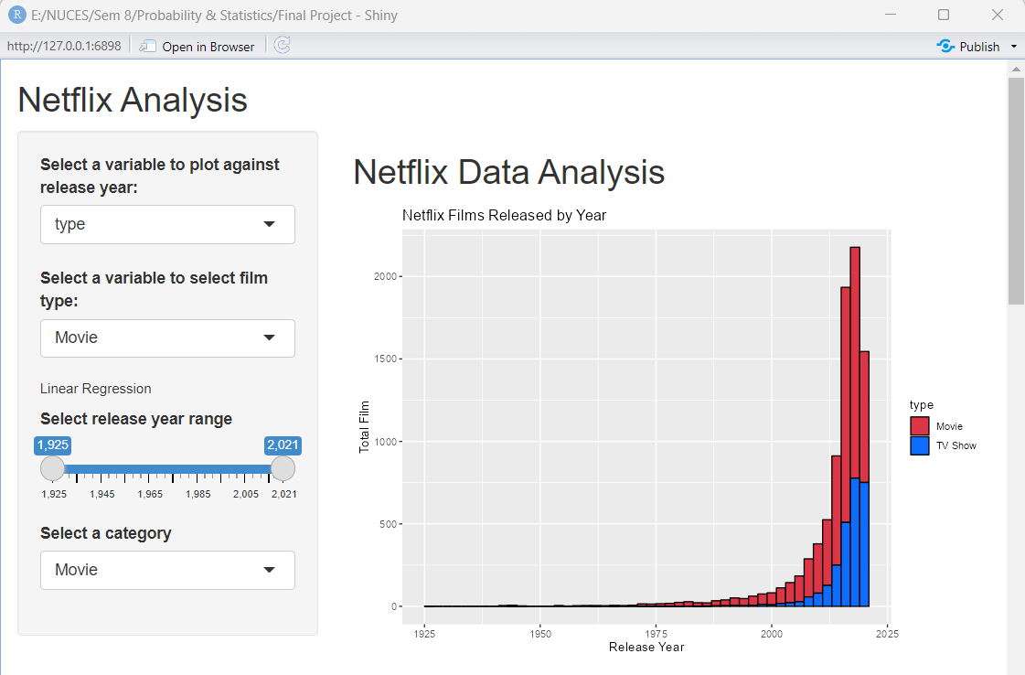

**6. Conclusion**

After analyzing the Netflix dataset, we found that most of the content on Netflix consists of movies, followed by TV shows. We also saw that the number of movie releases is higher than TV shows every year. The United States is the largest producer of movies on Netflix, followed by India and the United Kingdom. The linear regression shows that as the years have progressed, movies have tended to become longer in duration. This trend can be seen in the scatterplot generated by the model, which shows a general upward trend in duration as the years increase. These insights can help us understand user preferences on Netflix and improve user satisfaction by developing a better recommendation system.