**FOUNDAMENTALS OF COMPUTING**

**NAME:- C.Bhargav Reddy**

**REGNO:- 192211758**

**SERIAL NO:- 09**

**COURSE NAME:- Fundamentals of Computing**

**COURSE CODE:- csa5779**

**SLOT NAME:- d**

**FACULTY:- Mr. Arul Raj A M**

**EXPERIMENT.NO:-** 01

**EXPERIMENT NAME :-**

**NUMBER SERIES 1,2,3,4,…. n**

**PROGRAM:-**

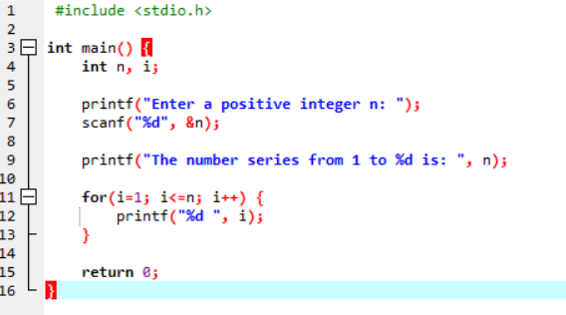

**OUTPUT:-**

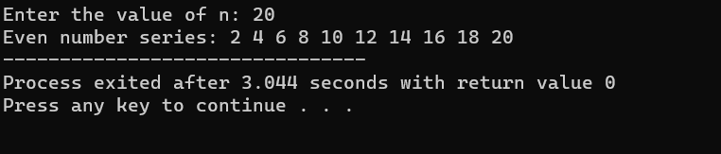

Experiment.no:- 02

Experiment name:-

**EVEN NUMBER SERIES 2,4,6,….. n**

Program:

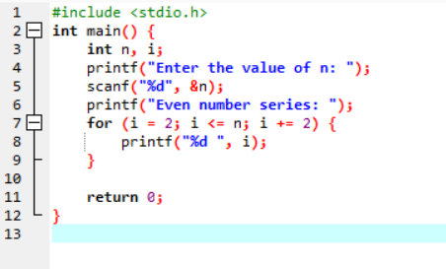

Output:-

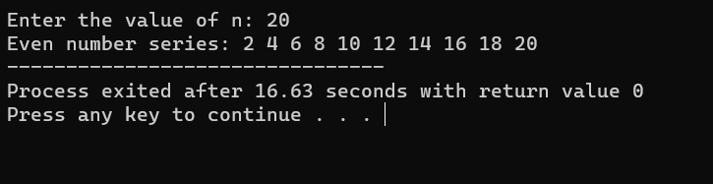

Experiment.no:- 03

Experiment name:-

**ODD NUMBER SERIES 1,3,5,….. n**

Program:-

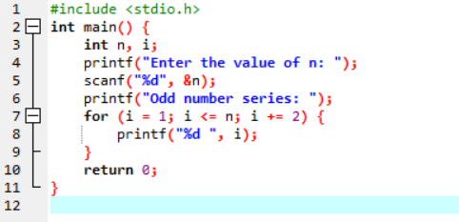

Output:-

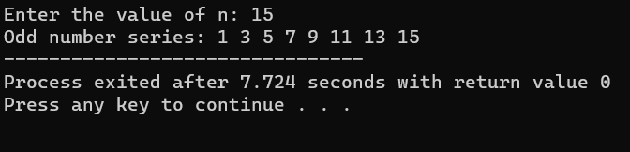

Experiment.no:- 04

Experiment name:-

**FIBONACCI SERIES 0,1,1,2,3,5,8,…. N**

Program:-

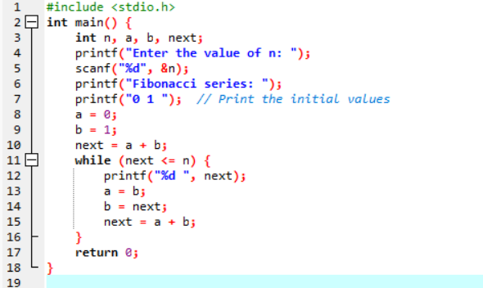

Output:-

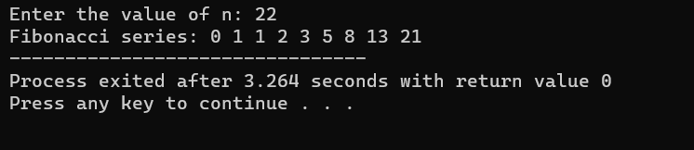

Experiment.no:- 05

Experiment name:-

**SUMMING UP SERIES 1+2+3+4+…..+n**

Program:-

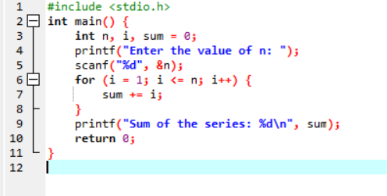

Output:-

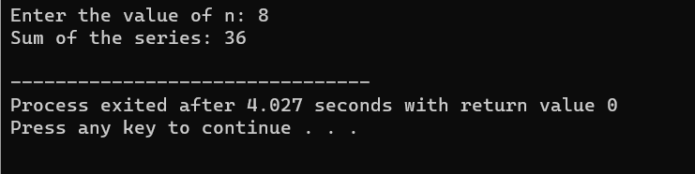

Experiment.no:- 06

Experiment name:-

**SUM OF EVEN NUMBER SERIES**

Program:-

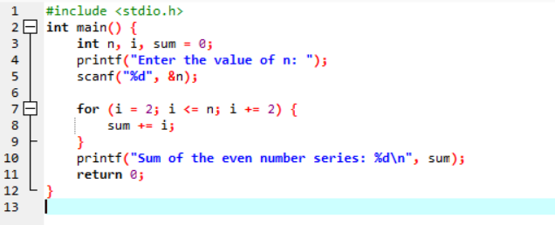

Output:-

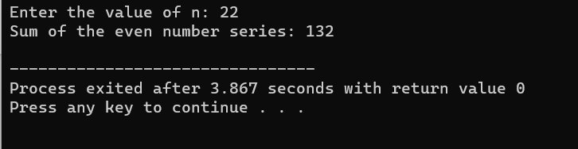

EXPERIMENT.NO:- 07

EXPERIMENT NAME:-

**SUM OF ODD NUMBER SERIES**

PROGRAM:-

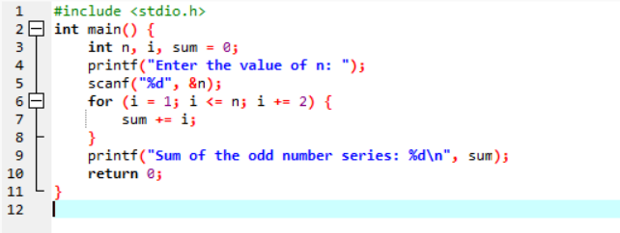

OUTPUT:-

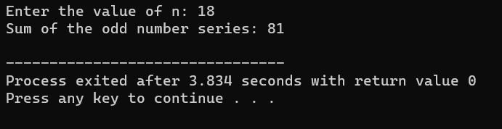

EXPERIMENT.NO:- 08

EXPERIMENT NAME:-

**SUMMING UP 1-2+3-4+5…N**

PROGRAM:-

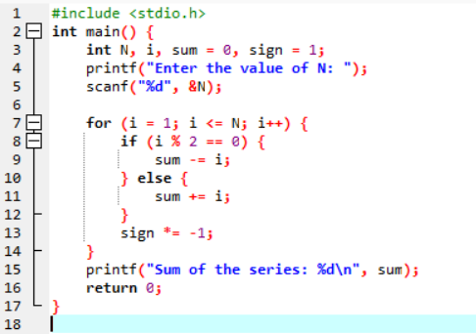

OUTPUT:-

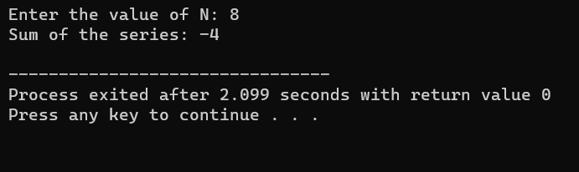

EXPERIMENT.NO:- 09

EXPERIMENT NAME:-

**SUMMING UP 12 + 22 + 32 + 42….. +n**

Program:-

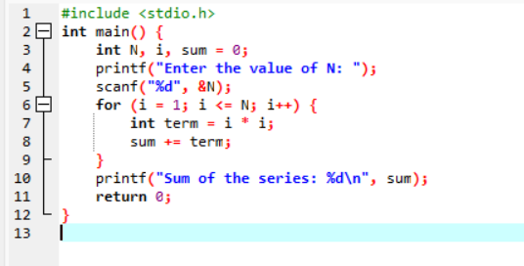

Output:-

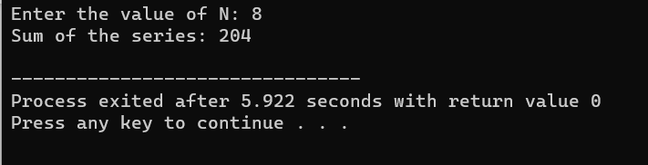

EXPERIMENT.NO:- 10

EXPERIMENT NAME:-

**SUMMING UP 22 + 42 + 62 + 82 + ….. n2**

Program:-

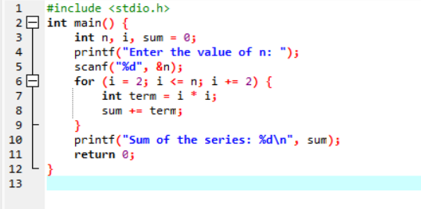

Output:-

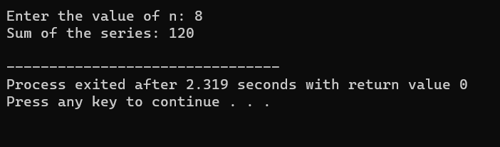

Experiment.no:- 11

Experiment name:-

**SUMMING UP 11+22+33+44+ …. nn**

Program:-

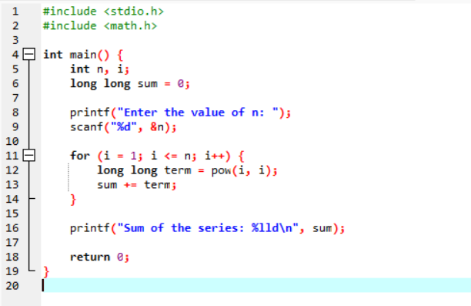

Output:-

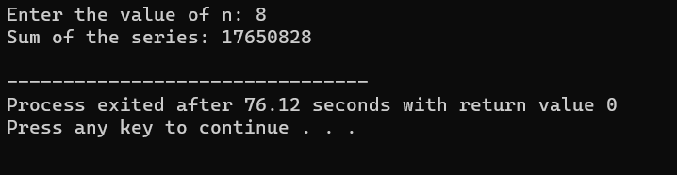

Experiment.no:- 12

Experiment name:-

**SUMMING UP SQUARES OF ODD NUMBERS**

Program:-

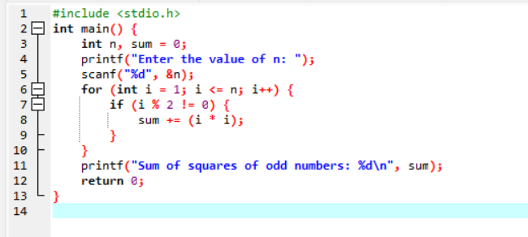

Output:-

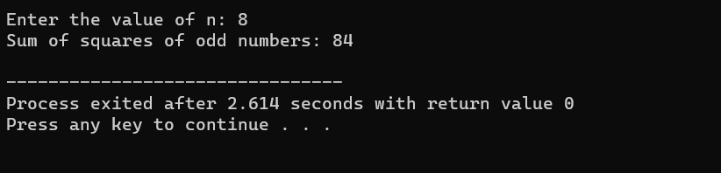

EXPERIMENT.NO:-13

EXPERIMENT NAME:-

**SUMMING UP CUBES OF n NUMBERS**

PROGRAM:-

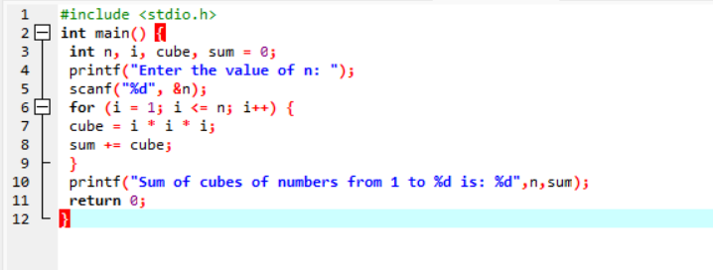

Output:-

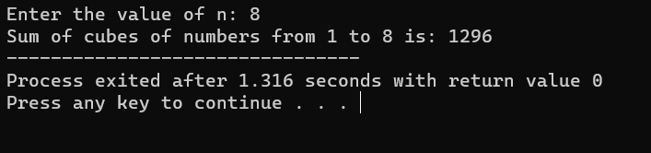

Experiment.no:-14

Experiment name:-

**PRODUCT SERIES**

**-FACTORIAL OF NUMBER**

PROGRAM:-

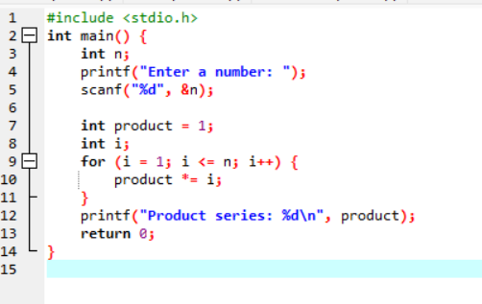

Output:-

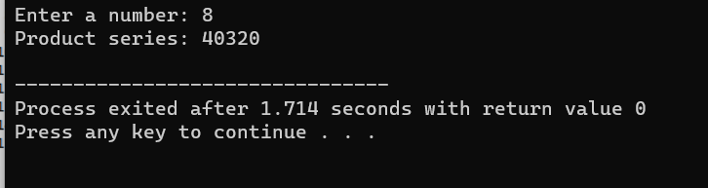

Experiment.no:-15

Experiment name:-

**ARMSTRONG NUMBER**

PROGRAM:-

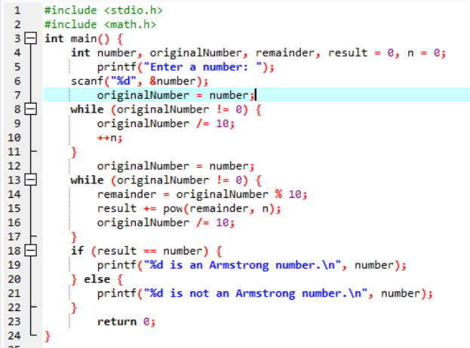

Output:-

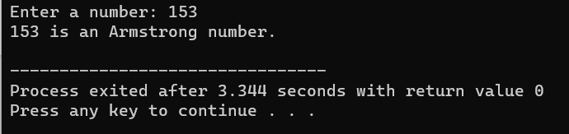

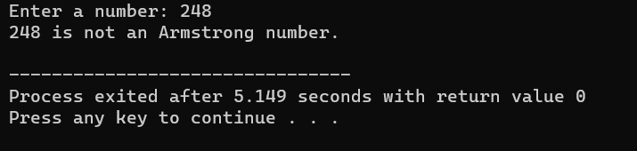

Experiment.no:-16

Experiment name:-

**SUMMING UP ANY N NUMBERS AND FINDING AVERAGE**

PROGRAM:-

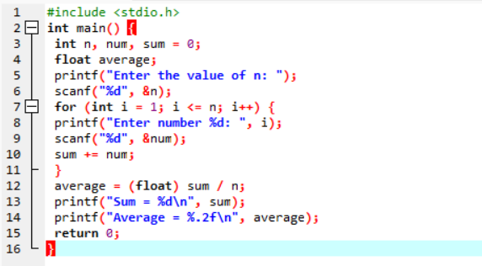

Output:-

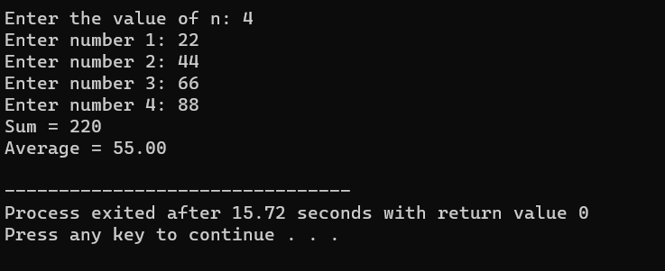

Experiment.no:-17

Experiment name:-

**PRINTING DIGITS OF AN INTERGER NUMBER**

PROGRAM:-

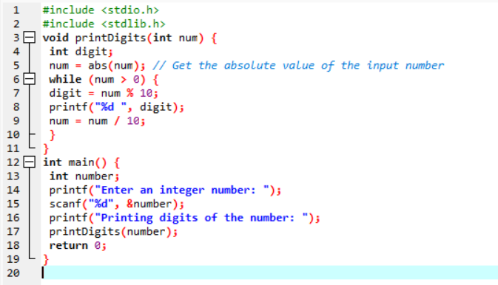

Output:-

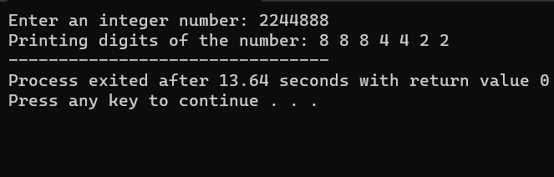

Experiment.no:-18

Experiment name:-

**SUMMING UP THE DIGITS OF AN INTEGER NUMBER**

PROGRAM:-

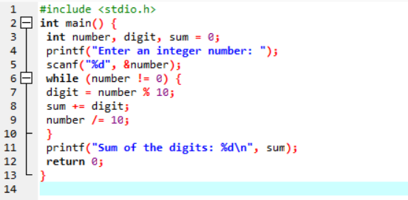

Output:-

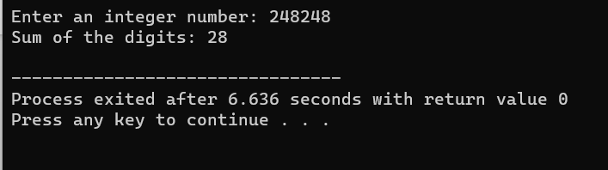

Experiment.no:-19

Experiment name:-

**REVERSING THE DIGITS OF AN INTEGER NUMBER**

PROGRAM:-

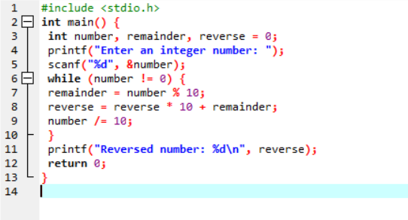

Output:-

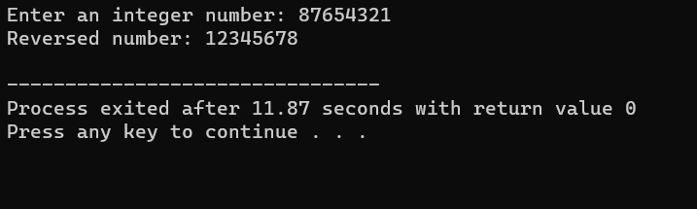

Experiment.no:-20

Experiment name:-

**FINDING WHETHER THE GIVEN ONTEGER IS ODD OR EVEN..**

PROGRAM:-

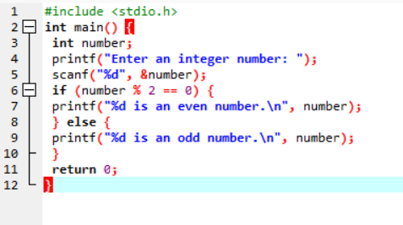

Output:-  
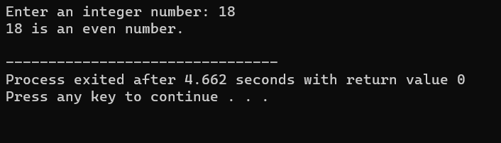

Experiment.no:-21

Experiment name:-

**FINDING THE GIVEN INTEGER IS POSITIVE OR NEGATIVE..**

PROGRAM:-

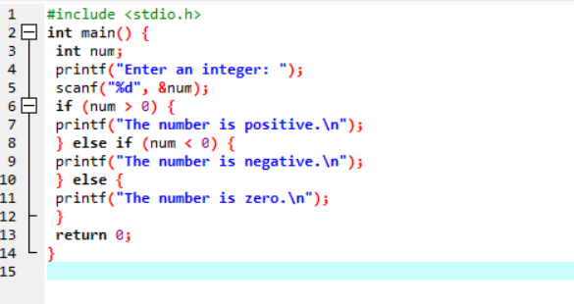

Output:-

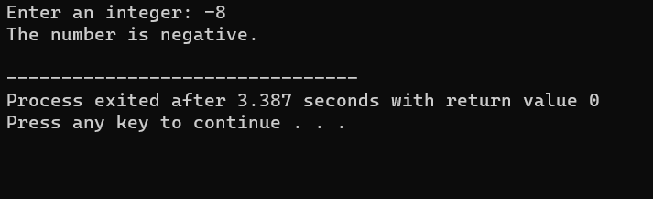

Experiment.no:-22

Experiment name:-

**SWAPPING TWO NUMBERS WITH A TEMPORARY VARIABLE..**

PROGRAM:-

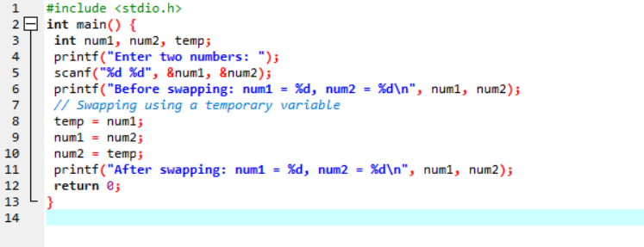

Output:-

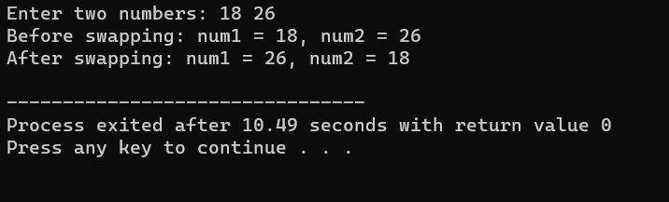

Experiment.no:-23

Experiment name:-

**SWAPPING TWO NUMBERS WITHOUT A TEMPORARY VARIABLE..**

PROGRAM:-

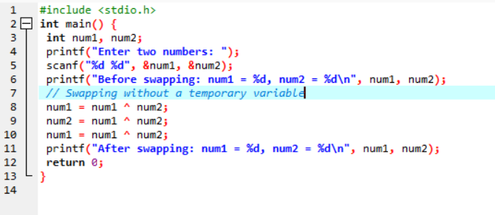

OUTPUT:-

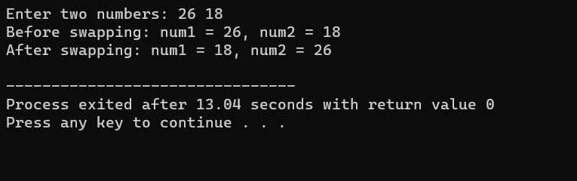

EXPERIMENT.NO:-24

EXPERIMENT NAME:-

**SWAP 3 NUMBERS a TO b , b TO c AND c TO a..**

PROGRAM:-

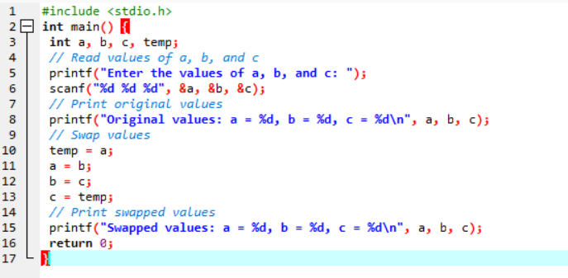

Output:-

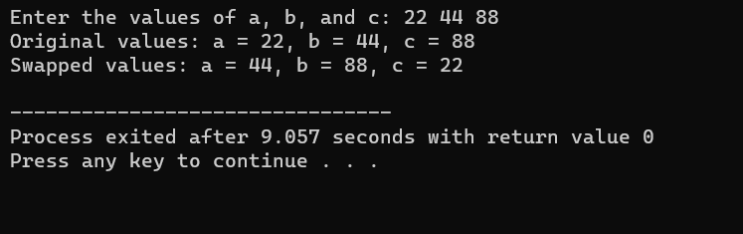

Experiment.no:-25

Experiment name:-

**FINDING THE BIGGEST OUT OF 2 INTEGER NUMBERS**

PROGRAM:-

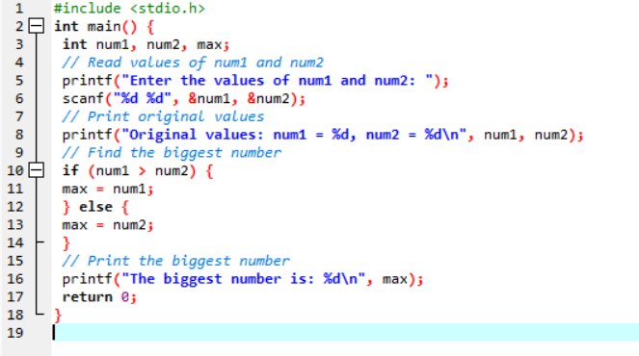

Output:-

