An Explainable Campus Cleanliness Scoring System Using YOLOv8n-Based Litter Detection
Arya Mohod¹, Darsh Kadu², Hargun Singh Jaggi³, Ayaan Ahmed⁴
Department of Electronics Engineering, Ramdeobaba University, Nagpur, India
Deep Learning Lab Capstone, Semester V, Academic Session 2026–27 • Supervisor: Prof. V. R. Gupta

Abstract
Routine campus cleanliness monitoring depends on visual inspection, yet observations can be intermittent and difficult to compare consistently. This paper presents a student-built computer-vision decision-support prototype that accepts a campus photograph, detects visible litter with a fine-tuned single-class YOLOv8n model, and converts predicted object count and bounding-box footprint into an interpretable cleanliness score from 0 to 100. The pipeline covers COCO-to-YOLO annotation conversion, deterministic 70/15/15 data splitting, label validation, transfer-learning-based training, inference, score computation, an interactive Flask application, and a persistent community photo gallery. The working subset contains 100 images and 302 annotated boxes (70 training, 15 validation, and 15 test images). The repository's held-out evaluation report records precision 0.7840, recall 0.6364, F1 0.7025, mAP@0.50 0.6149, and mAP@0.50:0.95 0.4385. A separate project-reported campus pilot covers four images and has a mean heuristic score of 74.25; one nominally clean canteen scene receives a low score because a single large-area detection dominates the area penalty. These findings demonstrate end-to-end feasibility, not deployment readiness: the labeled dataset and campus pilot are small, human-rated score ground truth is unavailable, and evaluation metadata in the saved report is not fully consistent with the current evaluation script. The prototype therefore exposes annotated evidence and treats its score as a review aid rather than a certified cleanliness measurement.
Index Terms—litter detection, YOLOv8n, object detection, campus monitoring, explainable scoring, TACO, Flask.

I. Introduction
Clean public spaces contribute to campus usability, safety, and institutional image. Periodic manual inspection is straightforward but provides only snapshots; written observations may vary across inspectors, and a large campus can make frequent coverage difficult. Camera-based object detection offers a way to turn photographs into consistent, reviewable evidence. Single-stage detectors predict object locations and classes directly from image features, enabling a compact inference pipeline [2].
This work implements a campus cleanliness scoring prototype around one target class, “litter.” A photograph is validated, passed to a fine-tuned YOLOv8n model, and represented as a list of detection boxes and confidence values. A separate deterministic scoring module combines the number of detected objects with the union area of their boxes. The web interface renders the original and annotated images, score components, and a detailed detection inventory. A community gallery extends the interaction: submitted photographs are persisted locally, automatically analyzed when possible, and can be re-analyzed from their gallery cards.
The contribution is an integrated and inspectable prototype rather than a new detector architecture. Specifically, the project contributes: (1) a reproducible single-class preparation pipeline for a 100-image working subset; (2) a YOLOv8n litter-detection inference wrapper; (3) a bounded count-plus-area cleanliness heuristic with visible parameters; (4) a Flask workflow for image analysis and persistent community submissions; and (5) an initial evaluation on a held-out split plus a four-image campus pilot.
The paper is organized as follows. Section II reviews related datasets and detection approaches. Section III describes the data, model, scoring algorithm, and software. Section IV reports the evaluation protocol and results. Sections V and VI discuss interpretation, limitations, ethics, and future work.

II. Related Work

A. Litter datasets and contextual detection
Trash Annotations in Context (TACO) is an open image dataset designed for litter detection and segmentation. Its original paper describes a growing, crowdsourced dataset and reports 1,500 images with 4,784 annotations in the version studied; the authors also emphasize that more manual annotation is needed for reliable deployment in the wild [1]. This project uses a small 100-image working subset and maps valid source categories to one target class. The subset is therefore not equivalent to the full TACO dataset.

B. One-stage object detection
YOLO framed detection as direct prediction of bounding boxes and class probabilities from the complete image in one network evaluation [2]. The project uses Ultralytics YOLOv8n as an implementation and training framework, initializing from pretrained weights and fine-tuning for one litter class [4]. YOLOv8 is identified here as the software model family used by the project; the classic YOLO paper is cited for the broader single-stage detection paradigm, not as the original YOLOv8 specification.

C. Evaluation and score interpretation
Object-detection metrics such as precision, recall, and mean average precision quantify different aspects of predictions. They do not directly measure the operational cleanliness of a location. This project therefore defines a separate heuristic whose inputs are model detections and image geometry. The score is a designed indicator and has not been calibrated against independent human ratings; it should not be confused with a validated environmental quality measure.

III. Materials and Methods

A. System overview
The application is organized as a sequential pipeline. The user uploads an image or chooses a stored sample; the server checks the filename extension and verifies image bytes using Pillow; inference decodes the image and invokes YOLOv8n; detections feed the scoring module; and the application returns a result page or stores the analysis with a community submission. Uploaded images are limited by the Flask request-size configuration (16 MiB by default), and supported extensions are JPG, JPEG, PNG, and WEBP.
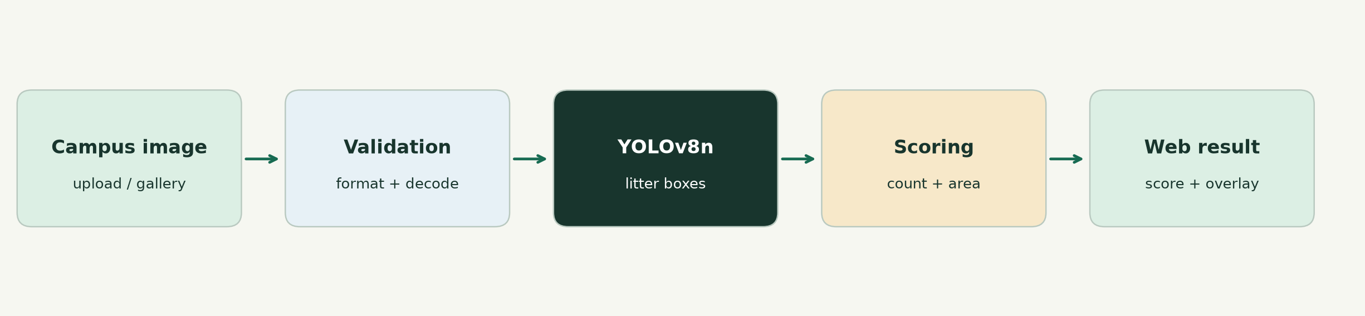
Fig. 1. End-to-end processing path implemented by the prototype.

B. Dataset and annotation preparation
The source project identifies TACO as the annotation source [1]. The local working dataset contains 100 images, 302 labeled boxes, and a single class (class 0: litter). The split manifests record 70 training images/204 boxes, 15 validation images/54 boxes, and 15 test images/44 boxes. Split generation uses seed 42. The preparation scripts convert COCO-format boxes [x_min, y_min, width, height] to normalized YOLO coordinates [x_center, y_center, width, height], clip boxes to image boundaries, reject degenerate boxes, and preserve negative images through empty label files. A validator checks that each image can be decoded, labels exist, class identifiers are valid, and normalized coordinates fall in [0, 1].
Partition | Images | Boxes | Share
Training | 70 | 204 | 70%
Validation | 15 | 54 | 15%
Test | 15 | 44 | 15%
Total | 100 | 302 | 100%

TABLE I. Local working-subset counts taken from the project manifests.
The split unit is an image. The repository documentation states that the split process prevents multi-crop leakage; this manuscript does not independently verify source-image grouping or near-duplicate leakage. Because only 15 images are in the test partition, reported metrics are sensitive to individual examples and should be treated as preliminary.

C. Detector and training configuration
The detector is YOLOv8n with a one-class output head. Training code initializes from the local COCO-pretrained YOLOv8n checkpoint when present, trains at 640-pixel image size, uses Adam with initial learning rate 0.001, freezes the first 10 layers, and configures early-stopping patience 10 and seed 42. The recorded training run completed 10 epochs with batch size 8 on CPU; its epoch log shows training losses and validation curves in the run artifacts. The application loads `models/best.pt` for inference and defaults to CPU. The web interface supplies confidence threshold (default 0.25); inference uses IoU threshold 0.45 by default.
Setting | Project value
Model family / scale | Ultralytics YOLOv8n; single class
Initialization | COCO-pretrained YOLOv8n checkpoint
Input image size | 640 × 640
Optimizer / initial LR | Adam / 0.001
Frozen layers / patience | 10 / 10 epochs
Recorded run | 10 epochs; batch size 8; CPU
Inference defaults | confidence 0.25; IoU 0.45

TABLE II. Training and inference settings documented in project configuration and run artifacts.

D. Count-plus-area scoring
Let N be the number of detections, H and W the image dimensions, and B_i the pixel set covered by detection i. The implementation uses the union of clipped bounding boxes, which avoids double-counting overlapping pixels:
r = min(1, |∪ᵢ Bᵢ| / (H × W))
S = round{100 × [1 − (w_c(1 − e^(−αN)) + w_a min(1, r / s))]}
The default parameters are α = 0.35, area scale s = 0.15, count weight w_c = 0.50, and area weight w_a = 0.50. The configuration enforces positive α and s, non-negative weights, and weights summing to one. The score is clipped to [0, 100]. With no detections, the implementation returns 100. A count-only baseline is also calculated using baseline α = 0.25 in the scoring configuration; the main composite score uses the configured composite α. Ratings are mapped to four descriptive bands: Excellent/Clean (90–100), Good/Satisfactory (70–89), Fair/Needs Attention (45–69), and Poor/High Litter Density (0–44).
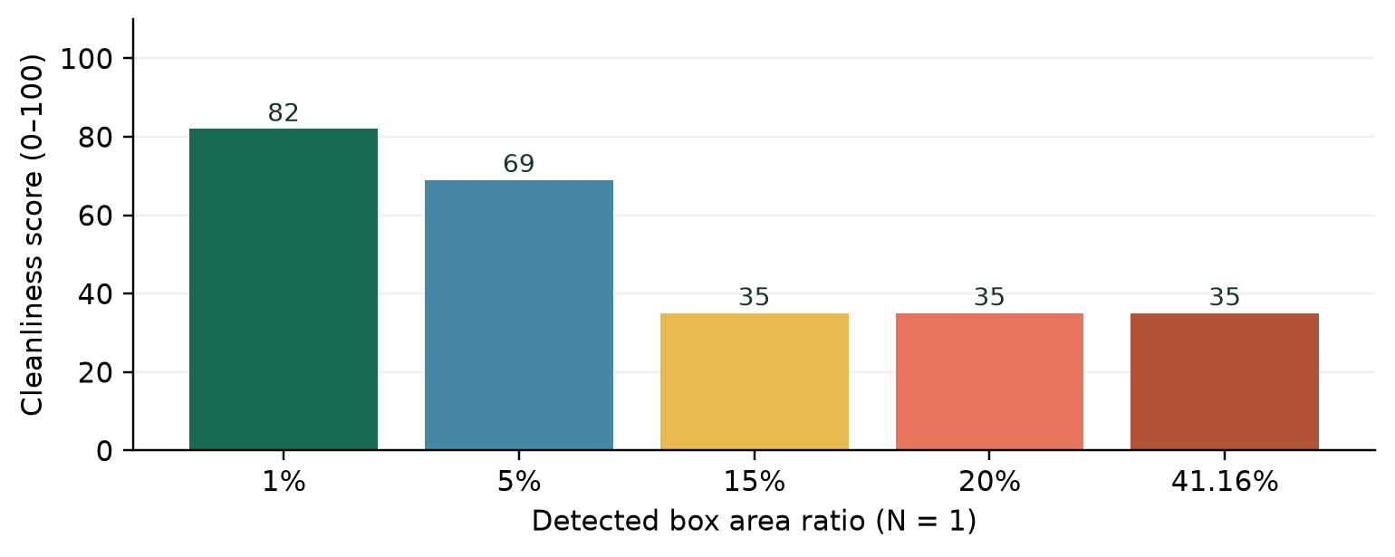
Fig. 2. Illustrative score sensitivity to box-area ratio for one detection; these values are formula examples, not measured model outcomes.
The score intentionally penalizes both frequency and footprint. At N = 1 and r = 0.01, the formula gives approximately 82; when r reaches the saturation scale 0.15, it gives approximately 35. This behavior explains why one incorrectly large detection can dominate a result, as observed in the small campus pilot.

E. Web application and community gallery
The Flask application uses an application factory, a blueprint for web routes, Jinja templates, static CSS/JavaScript, and a service layer that validates uploads and invokes the detector. The standard analysis route returns a score report with the original image, annotated image, object count, dimensions, model metadata, and per-detection class, confidence, box coordinates, and relative area. Health and metrics endpoints expose model-file availability and saved evaluation metrics.
Community submissions are stored as uniquely named image files, with filename, local submission time, and serialized analysis JSON in SQLite. A new post is saved to the gallery even if automatic analysis fails; each gallery card offers Analyze Photo or Analyze Again. Analysis calls the same detector/scoring service and updates the database on success. Storage is local to the host computer, not a cloud service. The gallery is public to anyone who can reach the server; a production deployment would require access control, moderation, retention policies, persistent storage, and privacy review.

IV. Experimental Protocol

A. Detection metrics
The project report exports precision, recall, F1, mAP at IoU 0.50, and mAP averaged over IoU thresholds 0.50–0.95. Precision is the fraction of predicted positive detections that are correct; recall is the fraction of ground-truth litter instances recovered. F1 is the harmonic mean of precision and recall: F1 = 2PR/(P + R). Average precision summarizes a precision–recall curve; mAP averages AP across the evaluated class or classes. IoU is the intersection-over-union of predicted and ground-truth boxes. The single-class setting means class-averaging is over one foreground category.

B. Report and implementation reproducibility caveat
The numeric values below are transcribed from `reports/evaluation_metrics_test.json`. The saved JSON labels its split as test and records confidence 0.25 and IoU 0.45. However, the current `evaluate.py` implementation validates the validation split to derive a recommended confidence threshold, then evaluates the target split using the Ultralytics full precision–recall curve; the visible code does not pass a confidence argument to `model.val`, and when IoU is omitted it documents the Ultralytics default 0.7. The JSON also lacks the evaluated image/instance counts and the recommended threshold described by that code. Consequently, the saved report and current evaluation implementation do not fully establish the precise operating protocol for the reported metrics. The metrics are reported as project results, not claimed as independently reproduced measurements. Before formal submission, regenerate the evaluation report from the final checkpoint and preserve the exact command, library versions, evaluated counts, and thresholds.

C. Campus pilot
A separate project JSON report summarizes four images stored under the project campus-test workflow. The source report gives filenames and outputs but does not independently establish collection protocol, capture dates, location sampling, or annotator ground truth. These results are therefore described as a project-reported four-image pilot, not a statistically representative campus survey.

V. Results

A. Held-out litter-detection metrics
The current saved test report gives precision 0.7840, recall 0.6364, and F1 0.7025. The detection quality measures are mAP@0.50 = 0.6149 and mAP@0.50:0.95 = 0.4385. The gap between mAP@0.50 and the stricter multi-IoU metric is consistent with the latter penalizing less precise box localization. Since the test set contains only 15 images and 44 labeled boxes, the values should be interpreted as a small-sample estimate.
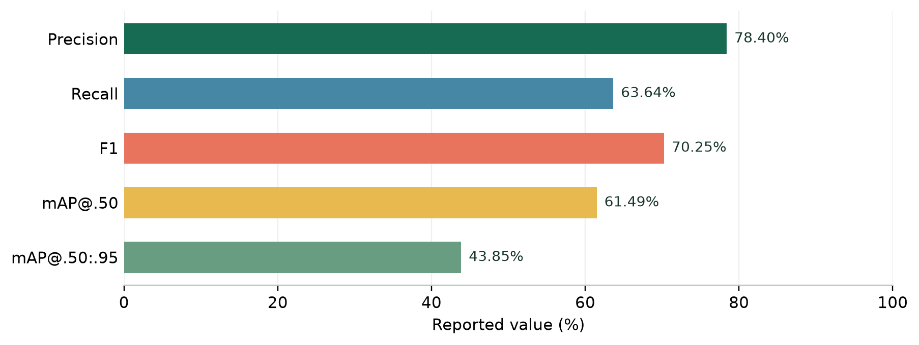
Fig. 3. Metrics transcribed from the saved test report; percentage display does not imply statistical confidence bounds.
Metric | Reported value | Interpretation
Precision | 0.7840 | Predicted litter detections that are correct
Recall | 0.6364 | Ground-truth litter instances recovered
F1 | 0.7025 | Harmonic mean of precision and recall
mAP@0.50 | 0.6149 | Average precision at IoU 0.50
mAP@0.50:0.95 | 0.4385 | Average AP across IoU 0.50–0.95

TABLE III. Test metrics as recorded in `reports/evaluation_metrics_test.json`.

B. Count-only versus count-plus-area score
The saved `model_comparison.json` reports a mean count-only score of 55.67 and a mean count-plus-area score of 42.40 over 15 sampled images, a difference of 13.27 points between those two means. This supports the design rationale that footprint can alter the count-only estimate when boxes cover a large fraction of an image. The value 13.27 is the absolute difference between reported means; it is not a reported mean absolute per-image difference.
The same comparison artifact has a provenance inconsistency: its JSON and model README describe a pretrained COCO baseline, while the current `compare_models.py` code describes and evaluates a scratch-trained baseline. The top-level README also gives different comparison figures. Because model identity and metrics cannot be reconciled from these artifacts alone, this paper does not treat the reported baseline comparison as a valid controlled experiment.

C. Four-image campus pilot
Project image | Detections | Area ratio | Score | Reported rating
campus_corridor_clean.jpg | 0 | 0.0000 | 100 | Excellent / Spotless
campus_canteen_clean.jpg | 1 | 0.4116 | 35 | Poor / High Litter
campus_garden_littered.jpg | 1 | 0.0124 | 81 | Good / Satisfactory
campus_pathway_bottles.jpg | 1 | 0.0134 | 81 | Good / Satisfactory

TABLE IV. Campus pilot records in `reports/campus_test_results.json`.
The four scores average to 74.25, matching the report. The canteen example is especially informative: one predicted box covers 41.16% of the image and yields score 35, although the file name contains “clean.” The report does not include independent ground-truth litter annotations for these four images; the filename is not a verified label. This case should therefore be described as a likely false-positive/oversized-box failure requiring human review, not as a definitive false-positive rate.

VI. Discussion
The results show that a lightweight detector and explicit scoring layer can be integrated into a usable end-to-end workflow. The held-out metrics indicate that the model can identify a meaningful portion of the one-class test annotations, while recall below precision suggests that missed litter remains a material concern. The lower mAP@0.50:0.95 value underscores box-localization sensitivity. Neither issue is hidden by the web UI: detections are presented as boxes with confidence, and the original image remains available for inspection.
The score adds area as a second factor, making the result more sensitive to large visible litter accumulation than a count-only heuristic. However, a bounding rectangle is only a coarse proxy for object footprint; it can include background and its area can be distorted by a localization error. The campus pilot demonstrates this risk directly. The score is therefore best interpreted as an explainable prioritization cue, accompanied by the annotated image and detection list.
The product contribution is operational rather than algorithmic novelty: users can upload an image, adjust confidence, inspect an analysis report, and share campus photos in a persistent gallery. SQLite metadata and local image files preserve posts across app restarts. The local-network configuration enables a classroom or trusted-LAN demonstration, but the current configuration is not a public Internet deployment.

VII. Limitations, Ethics, and Threats to Validity
- Small labeled sample: only 100 images and 302 boxes are documented; the 15-image test split has high sampling uncertainty.
- Single-class labels: the model reports “litter,” not material type, hazard level, or waste category.
- Domain shift: training images may not represent campus camera angles, lighting, surfaces, weather, or local waste.
- Detection errors: small objects, occlusion, motion blur, shadows, and textured backgrounds can cause misses or false detections.
- Uncalibrated score: no independent human rating dataset or score-error analysis is available; score bands are heuristic.
- Pilot limitations: four images do not constitute a representative field study; provenance and sampling protocol are not fully documented.
- Reproducibility: the saved evaluation JSON and current evaluator disagree on some settings/metadata; model-comparison provenance is also inconsistent.
- Privacy and governance: shared images are public to site visitors and stored on the host's local disk; users should avoid faces, license plates, and sensitive scenes. Moderation, consent, deletion, retention, access control, and secure production hosting are not yet implemented.
- Operational scope: the prototype does not dispatch cleaning staff, verify that an area is safe, or replace human inspection.
These limitations constrain external validity. Performance on a small, single-class TACO subset cannot establish generalization across campuses or deployment conditions. In addition, errors in an automated cleanliness indicator could lead to unnecessary work or missed sanitation needs; all consequential decisions should be verified by a person.

VIII. Conclusion and Future Work
This paper described a complete campus cleanliness scoring prototype that links image validation, YOLOv8n litter detection, union-area-aware scoring, annotated visualization, and a persistent Flask community gallery. On the repository's 15-image held-out split, the saved report records precision 0.7840, recall 0.6364, F1 0.7025, mAP@0.50 0.6149, and mAP@0.50:0.95 0.4385. A separate four-image campus pilot has a reported mean score of 74.25 and exposes a major failure mode: an oversized false detection can dominate the area penalty. The prototype demonstrates engineering feasibility, but its data scale, evaluation-protocol inconsistencies, and lack of human score calibration prevent claims of validated campus-wide performance.
Next work should first regenerate and version a fully reproducible evaluation report, expand the campus dataset across locations and conditions, independently annotate false positives and missed objects, and collect multiple human cleanliness ratings per image. The score should then be calibrated and evaluated against human consensus, including error intervals and sensitivity analysis. Additional model classes, segmentation, CCTV integration, or facilities dashboards should follow only after privacy governance, representative validation, and deployment security are addressed.

Acknowledgment
The authors thank Prof. V. R. Gupta for academic supervision and the Department of Electronics Engineering, Ramdeobaba University, Nagpur, for the Deep Learning Lab capstone setting. The project work is attributed to the student team listed above.

Author Contributions
Author | Project contribution
Arya Mohod | Dataset preparation, annotation conversion, preprocessing, dataset organization
Darsh Kadu | YOLOv8n setup, transfer learning, training and experiment tracking
Hargun Singh Jaggi | Model evaluation, metrics, error analysis and comparisons
Ayaan Ahmed | Cleanliness score algorithm, Flask prototype, integration and testing

Data and Code Availability
The manuscript describes the project workspace artifacts, including scripts under `src/`, the 100-image processed subset manifests, model checkpoints, evaluation JSON, campus pilot report, and Flask application. Public release location, dataset redistribution permissions, and long-term artifact hosting have not been specified. Before submission, the authors should confirm TACO terms, identify the exact dataset subset/version, publish or archive the code and configuration at an approved repository, and avoid distributing campus/community photographs without appropriate consent.

Conflict of Interest
The authors declare no competing financial interests in this student project.

References
[1] P. F. Proença and P. Simões, “TACO: Trash Annotations in Context for Litter Detection,” arXiv:2003.06975, 2020. [Online]. Available: https://arxiv.org/abs/2003.06975
[2] J. Redmon, S. Divvala, R. Girshick, and A. Farhadi, “You Only Look Once: Unified, Real-Time Object Detection,” in Proc. IEEE Conf. Computer Vision and Pattern Recognition (CVPR), 2016, pp. 779–788. [Online]. Available: https://arxiv.org/abs/1506.02640
[3] T.-Y. Lin et al., “Microsoft COCO: Common Objects in Context,” in Proc. European Conf. Computer Vision (ECCV), 2014, pp. 740–755. [Online]. Available: https://arxiv.org/abs/1405.0312
[4] Ultralytics, “Explore Ultralytics YOLOv8,” Ultralytics Documentation. [Online]. Available: https://docs.ultralytics.com/models/yolov8/ (accessed: Oct. 27, 2026).
[5] Pallets Projects, “Welcome to Flask,” Flask Documentation, version 3.1.x. [Online]. Available: https://flask.palletsprojects.com/en/stable/ (accessed: Oct. 27, 2026).

Appendix A. Reproduction Commands
The following commands reflect the project documentation and are intended to be run from the project root after dependencies and model weights are installed:
python src/data/convert_annotations.py
python src/data/split_dataset.py --train-ratio 0.70 --val-ratio 0.15 --test-ratio 0.15 --seed 42
python src/data/validate_dataset.py
python src/model/train.py --epochs 10 --batch-size 8
python src/model/evaluate.py --split test
python src/model/batch_test_campus.py --images-dir data/campus_test
python -m pytest tests/ -q
python app.py
The test suite was run during preparation of this manuscript and reported 32 passing tests. Re-running model training or evaluation may produce different results depending on software versions, hardware, random seeds, and the exact checkpoint.

Appendix B. Submission Checklist
- Select the target conference and apply its official template, page limit, reference style, and anonymization rules.
- Confirm author order, names, institutional affiliation, supervisor acknowledgment, and all permissions.
- Regenerate evaluation metrics from the final checkpoint; reconcile confidence/IoU settings and record evaluated image/box counts.
- Reconcile the model-comparison baseline identity and remove or regenerate inconsistent comparison results.
- Document the exact TACO subset, annotation provenance, dataset terms, and duplicate/group leakage checks.
- Collect a larger campus test set and human ratings before claiming score validity or campus-wide generalization.
- Review all photos for privacy/consent and define gallery moderation, retention, deletion, and deployment security.
This manuscript is a detailed conference-style draft, not an accepted or venue-compliant paper. Its claims and numbers should be reviewed by the supervisor and authors before submission.

