**Final-Exam**

**Hargun Pal Singh Jassal**

**8671597**

**GRDN 2200 – 19 F**

**Submitted to: Mr Randall Kozak**

Image-01 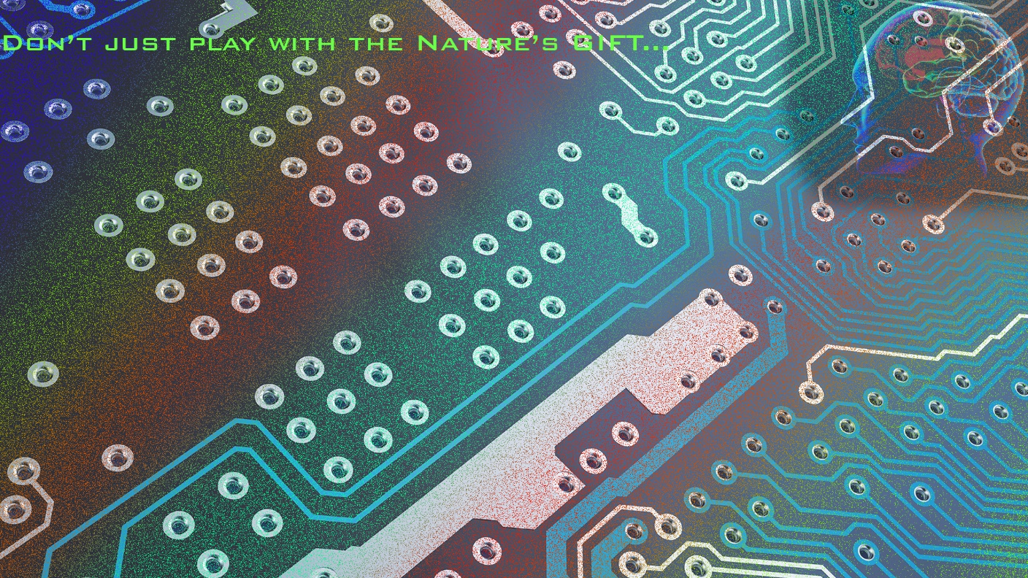

In the above picture, most significantly Brush effects as well as “Dissolve”- Filter had been used, in order to relate it with the human brain. The brain is been shown on right hand corner in a smaller size, As if new generation is not using this particular gift of God, and just like to depend over the Artificial Intelligence.

Image-02 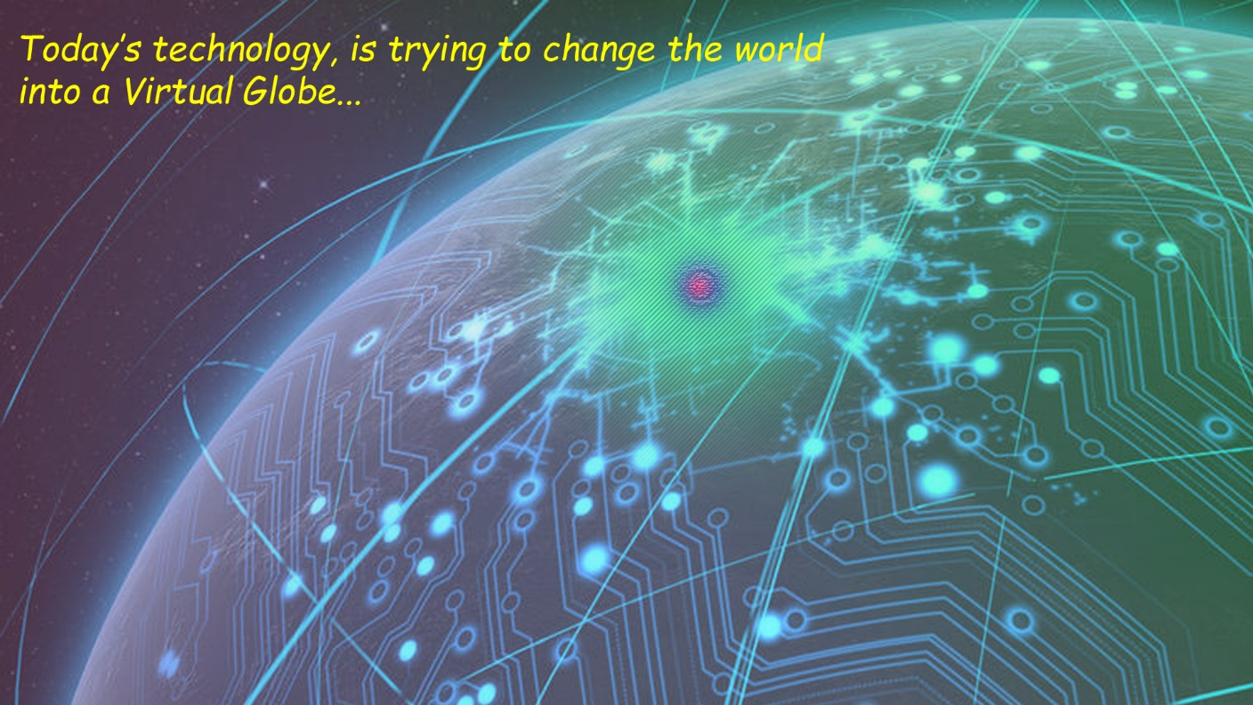

Here the gradient feature is being highlighted, as if there was a missing mood in the picture. Apparently, the use of multilayers with help of three brush-spots (at the centre of picture), makes it as a centripetal point. However, the colour of text in the picture is appearing pretty highlighted, in order to seek a way out of the problem  
(Over-usage of Technology), from the viewer(Audience).

Image-03 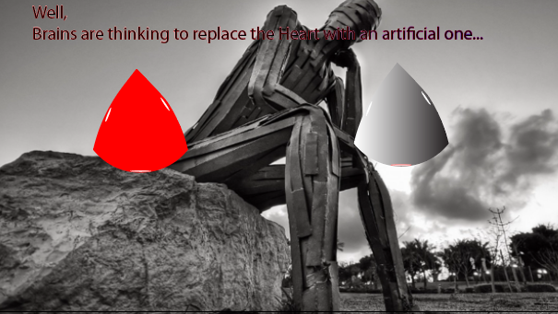

In this Image I used Adobe Illustrator, in order to draw the blood drop, converting into a blood drop, with changing colour, due to excess usage of machines. The drops had been drawn with help of a pen tool, making it much realistic.

Image-04 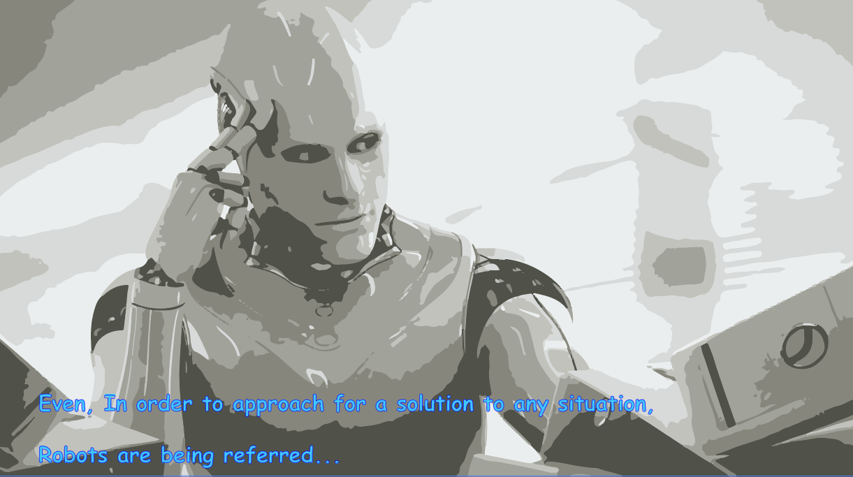

Over here, I took an advantage of Image Tracing technique. Where I preferred to use 6 Colour Technique. So as to give it an innovative approach to the main thought. The text here is an advantage for user to read.