**Project-05**

**Hargun Pal Singh Jassal**

**8671597**

**GRDN 2200 – 19 F**

**Submitted to: Mr Randall Kozak**

Part-A

Here it was supposed to portray hand written text, with some gradient/brush strokes. 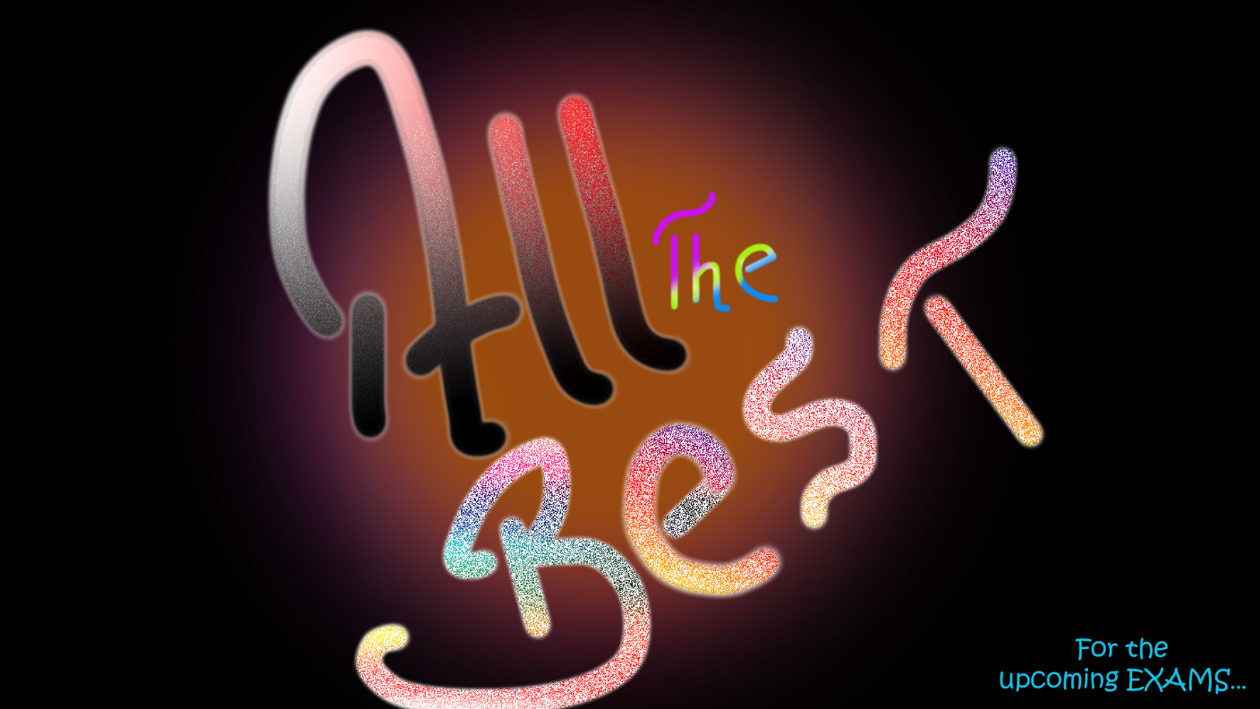

Over here, background consists of two colours of brush strokes and on top of it the text “All the Best” had been written freely with help of brush. Then after creating clipping mask for each of the letters, the gradient, texture and some brush strokes had been used. To give it such an extra ordinary look.

Part-B

As all of the brains in this world have their own goal, but a few of them are really able to achieve it, where some are not able to reach till their goals. So, the theme of my book is “Dedication” towards one’s own motive. The book consists of 8 pages, where there is a single concept of dealing with life, is being dedicated to each page. Where the pictures have been used in order to link it fundamentally with the provided quote on each page.

Q.1)



In this picture, as the quote states that superior brains just stop indulging into cat-race. Which is apparently being matched with the background and had been edited with colorful brush strokes representing that a wonderful as well as fruitful thoughts towards the World.

Q.2)

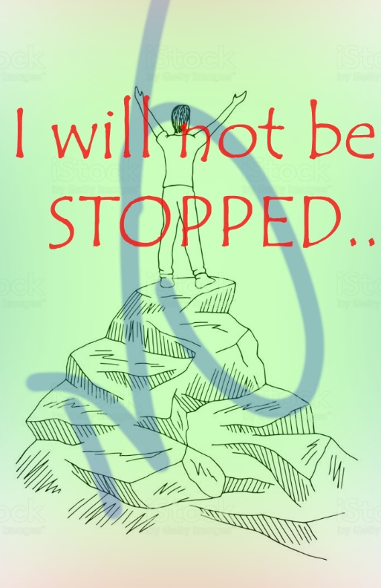

This particular page portrays the dedication and willingness along with the freedom from any sought of fear, and going against all odds. This image had been created brush strokes, depicting with some gradient touch. It even involves “NO” which appears to be engraved into the image, but actually I decreased the opacity.

Q.3)

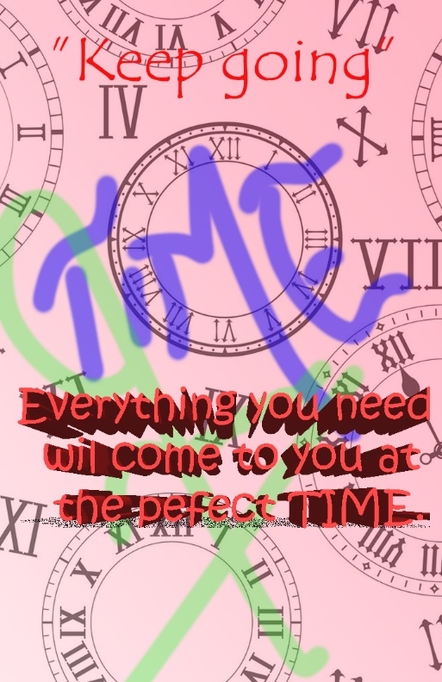

In order to attain real success, one needs to handle time accurately. So, this page is particularly dedicated towards time-management. Where the background image consists of clocks. Moreover, the strokes used, looks to be melting into the back ground. However, the text grabs the spot of viewer as it had been written in 3D, putting an appropriate impression.

Q.4)

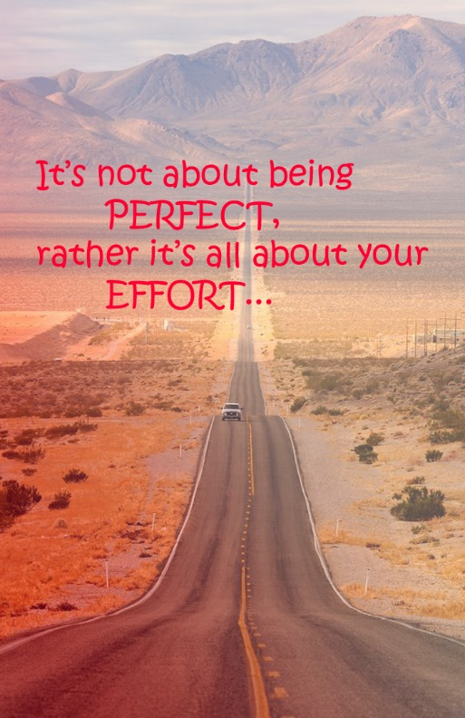

Here, talking about the efforts, again symbolizes with the dedication towards work. So is the image in saturation with redness, showing a long road, using gradient and blur effect. Where the value being depicted is that any one must not leave any task by just looking how long/lengthy it is.

Q.5)

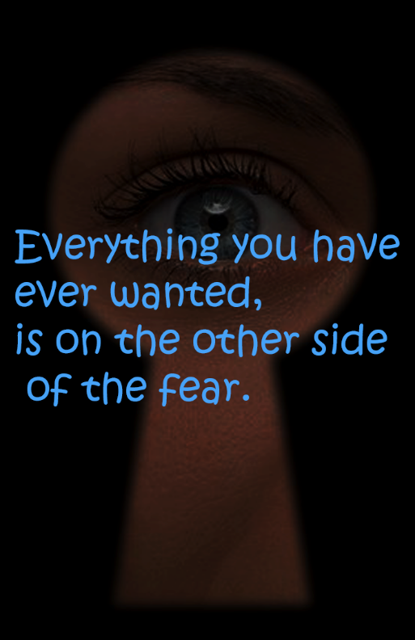

This picture portrays, how to just overcoming the fear. So is the image here, an eye looking beyond a keyhole. Where I just used a couple of things to balance in respective of the text stated like, saturation, hue, blur, and so on. But using a bright color, in order to highlight it for the viewers.

Q.6)

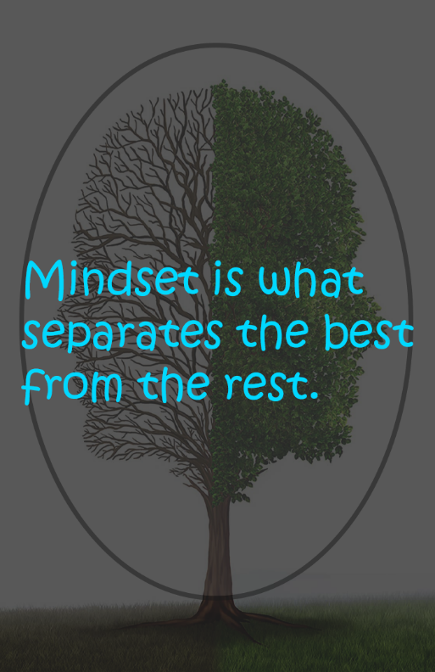

This page specifically shows a tree, depicting human’s mind. That compares two similar appearing brains, gifted from the almighty. But it all depends on the person, how he/she uses it. So, it is being compared with the text that mindset has a lot to do in one’s life. I have been encircled the image along the quote give it an appropriate match. While the filters built by me are just like using new layers and playing with paints.

Q.7)

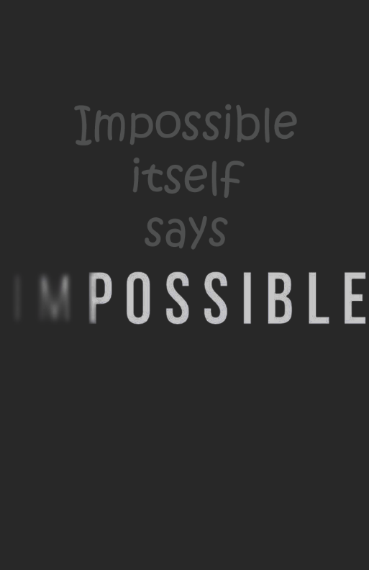

In this side of the page, it appears to be pretty simple. But the “IM” portion of the “Impossible” had been controlled and using a few effects. Giving it a bit of fade as well as fascinating look. So that we must ignore that “IM” in any of the impossible thing and must give it a try.

Q.8)

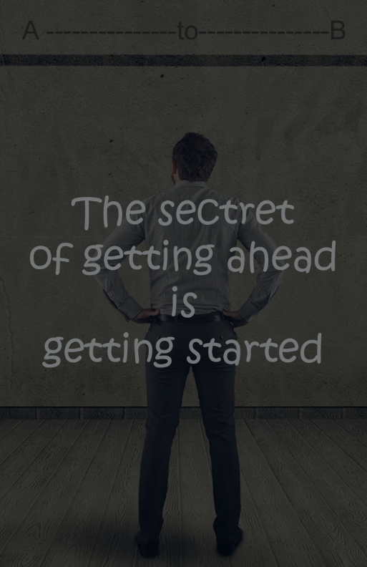

Over here, the top layer acts as a filter. Beyond that a person had been shown looking upwards. Where I engraved a path “A to B”. Where the man believes in planning prior to initiate any work, knowing a blueprint on the starting and finishing point. Eventually knowing, how to actually give it an appropriate start.

References

These all of the Quotes and the background images had been pulled out of Google search engine.

(<https://www.google.com/search?rlz=1C1CHBF_enIN861IN861&biw=1536&bih=706&tbm=isch&sxsrf=ACYBGNSpy_BuH0A1hX2j05YtJHiueNWSCQ%3A1575348778635&sa=1&ei=KurlXcKtJoTl5gKHpp2ACA&q=640-Landscapes-Nature1-l&oq=640-Landscapes-Nature1-l&gs_l=img.3...12600.12600..12760...0.0..0.79.232.3......0....2j1..gws-wiz-img.......35i39.C5jnRw7eVLM&ved=0ahUKEwjC6uPC15jmAhWEslkKHQdTB4AQ4dUDCAc&uact=5#imgrc=4U9akAq7ZdnVvM:>)