EWB CLOUD LABS
STUDENT PROJECT REPORT
BUILD / TEST / EXPLAIN

AWS
VPC Peering
Connect two VPCs.
Prove private connectivity.
EC2, custom route tables, security groups and a bastion host.
 | VPC A  10.10.0.0/16  PRIVATE WORKLOAD | pcx-068f93b98df2751e8 | VPC B  10.20.0.0/16  PRIVATE WORKLOAD
2 VPCS / 3 EC2 INSTANCES / 1 PRIVATE CONNECTION

AWS ARCHITECT ASSOCIATE
Name | Harikishore Manday
Batch | 1
Project | Project 01 - AWS VPC Peering
Region | Asia Pacific (Sydney) / ap-southeast-2
Completion date | 25 October 2026

LEARN. ELEVATE. EMPOWER. PROJECT 01 / OCT 2026
01 / PROJECT OVERVIEW

Project summary
Objective. Build a working private network connection between two VPCs, keep both application servers private, administer them through one public bastion host, and prove with real terminal output that traffic flows only when peering, routes and security rules are all correct.
What was built. Two VPCs (10.10.0.0/16 and 10.20.0.0/16), three /24 subnets, one internet gateway, three custom route tables, three security groups, three t3.micro Amazon Linux 2023 instances, one VPC peering connection with routes on both sides, and SSH access through the bastion using ProxyJump. Every resource carries the tags Project = EWB-VPC-Peering and Student = Harikishore. All lab resources were deleted at the end (Section 11).

Results in one view
- Baseline: before peering, App-A could not reach App-B (4 sent, 0 received, 100% loss).
- After peering and routes: App-A to App-B and App-B to App-A both returned 4 of 4 replies (0% loss). App-B was reached through the bastion with ssh ewb-app-b.
- Isolation: neither App-A nor App-B has a public IPv4 address.
- Controlled failure: removing only the Echo Request rule on ewb-sg-app-b gave 100% loss; restoring the exact rule brought replies back (0% loss).

Deviations from the workbook (both allowed by the workbook)
1. Region: the lab account is limited to Asia Pacific (Sydney) / ap-southeast-2, so Sydney was used instead of the example Region (Mumbai). All resources stay in one account and one Region. 2. App-A private IP: App-A launched with the AWS-assigned address 10.10.2.39 instead of 10.10.2.10. As the workbook instructs, every rule that used it was updated: the ICMP rule on ewb-sg-app-b and the HostName in the SSH config. The bastion (10.10.1.10) and App-B (10.20.1.10) use the workbook addresses.

Workbook submission checklist: where each item is covered
Checklist item (workbook page 13) | Where in this report
Cover: name, batch, project title, Region and completion date | Cover page
Architecture diagram and inventory with actual resource IDs and private IPs | Section 02, Figure 1 and the inventory table
Subnet CIDRs and all three route tables, including their subnet associations | Section 03 (Figures 2 to 5) and Section 06 (Figures 13 to 15)
Active peering connection and inbound rules for each security group | Section 04 (Figures 6 to 8) and Section 06 (Figure 12)
Baseline failure, forward and reverse ping success, and App-B SSH proof | Section 07 (Figures 16 to 18)
Controlled ICMP failure and recovery, with a short explanation | Section 08 (Figures 21 and 22)
Forward path and return path explanation | Section 09
Cleanup evidence plus a short note on what you learned | Section 10 (note) and Section 11 (Figures 23 to 30)
02 / ARCHITECTURE

Architecture and resource inventory
One internet entry point, two private workloads and a direct peering connection between their VPCs.
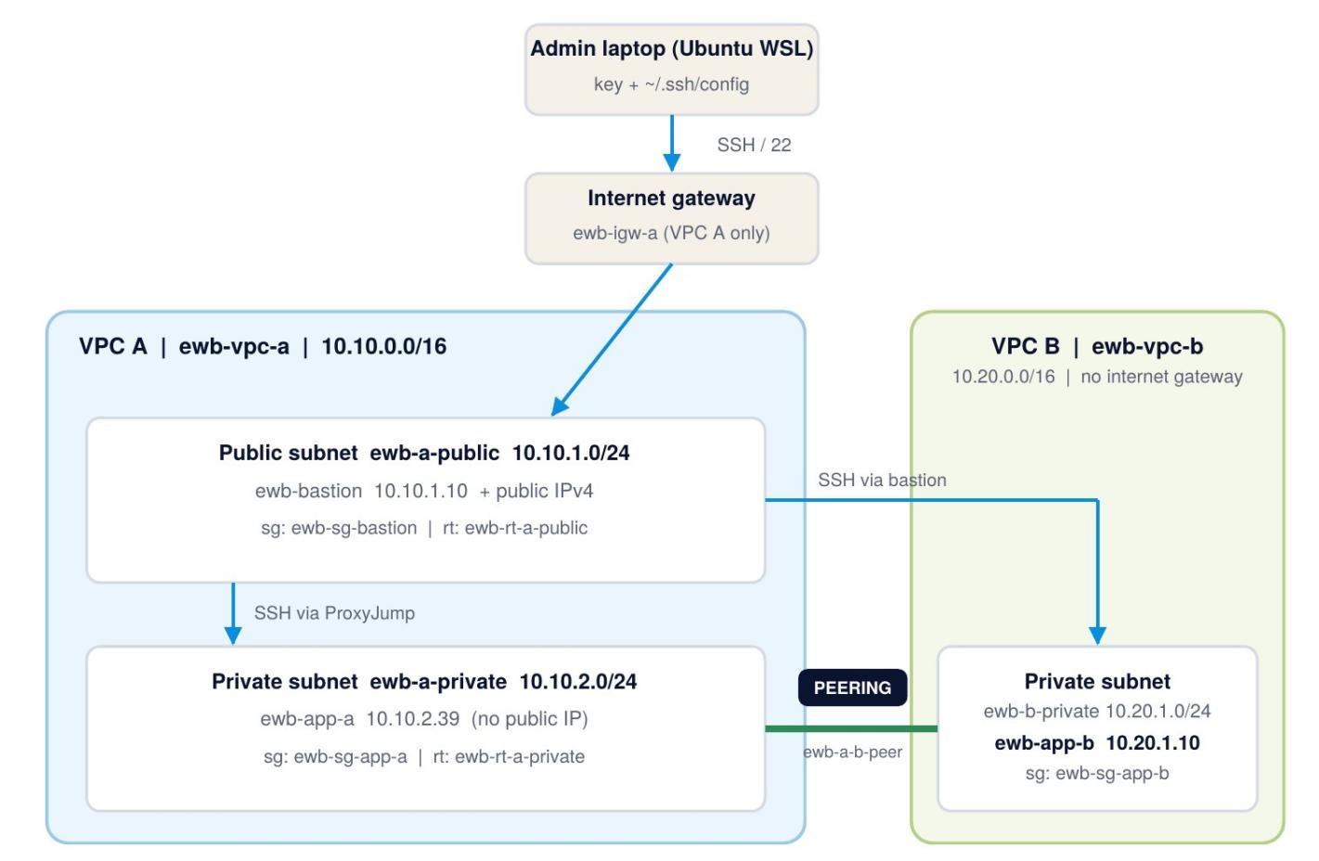
Figure 1. Architecture as built. Administration: laptop to bastion to App-A or App-B (SSH ProxyJump). Project traffic: App-A and App-B over private IPs and the peering connection. Peering does not give VPC B internet access.

Resource inventory (actual IDs)
Resource | Name tag | ID | CIDR / address
VPC A | ewb-vpc-a | vpc-0ecd84d60487b5d08 | 10.10.0.0/16
VPC B | ewb-vpc-b | vpc-024d55d6dc61ec628 | 10.20.0.0/16
Subnet | ewb-a-public | subnet-072c132d8f008f368 | 10.10.1.0/24
Subnet | ewb-a-private | subnet-0cf9d7ba46c93ff50 | 10.10.2.0/24
Subnet | ewb-b-private | subnet-01604c6e6d8b01602 | 10.20.1.0/24
Internet gateway | ewb-igw-a | igw-032b3dccc9c95666a | Attached to ewb-vpc-a
Route table | ewb-rt-a-public | rtb-0816486b30d9396e7 | Associated: ewb-a-public
Route table | ewb-rt-a-private | rtb-0815f76742c290247 | Associated: ewb-a-private
Route table | ewb-rt-b-private | rtb-0bfae5de401c03e6a | Associated: ewb-b-private
Peering connection | ewb-a-b-peer | pcx-068f93b98df2751e8 | Requester VPC A, accepter VPC B, Active
Security group | ewb-sg-bastion | sg-097ad7a4c011f011d | VPC A
Security group | ewb-sg-app-a | sg-012453ea4466f00d3 | VPC A
Security group | ewb-sg-app-b | sg-058259ce20812f9f5 | VPC B
EC2 instance | ewb-bastion | i-0e3c48d6c34cb1a2c | 10.10.1.10 + public IPv4 54.253.46.171
EC2 instance | ewb-app-a | i-0efc8ce8aba077e46 | 10.10.2.39 / no public IP
EC2 instance | ewb-app-b | i-0a51c71ec97154dc3 | 10.20.1.10 / no public IP
Key pair | ewb-lab | RSA; .pem kept only on my laptop | Not included in this report

Why these CIDRs? 10.10.0.0/16 and 10.20.0.0/16 do not overlap, and each /24 subnet sits inside its own VPC range. Peering needs non-overlapping VPC CIDRs: different subnet ranges alone would not fix overlapping VPCs.
03 / BUILD THE NETWORK

Subnets and route tables (Checkpoint 01)
VPC A has a public and a private subnet; VPC B has one private subnet. Every subnet is explicitly associated with its own route table.
Subnet | VPC | CIDR | Route table (explicit association) | Public IP auto-assign
ewb-a-public | ewb-vpc-a | 10.10.1.0/24 | ewb-rt-a-public | Off (bastion gets one at launch)
ewb-a-private | ewb-vpc-a | 10.10.2.0/24 | ewb-rt-a-private | Off
ewb-b-private | ewb-vpc-b | 10.20.1.0/24 | ewb-rt-b-private | Off

Public vs private. A subnet is public only because its route table has 0.0.0.0/0 pointing at the internet gateway (ewb-rt-a-public). ewb-rt-a-private and ewb-rt-b-private have no internet route, so those subnets stay private.
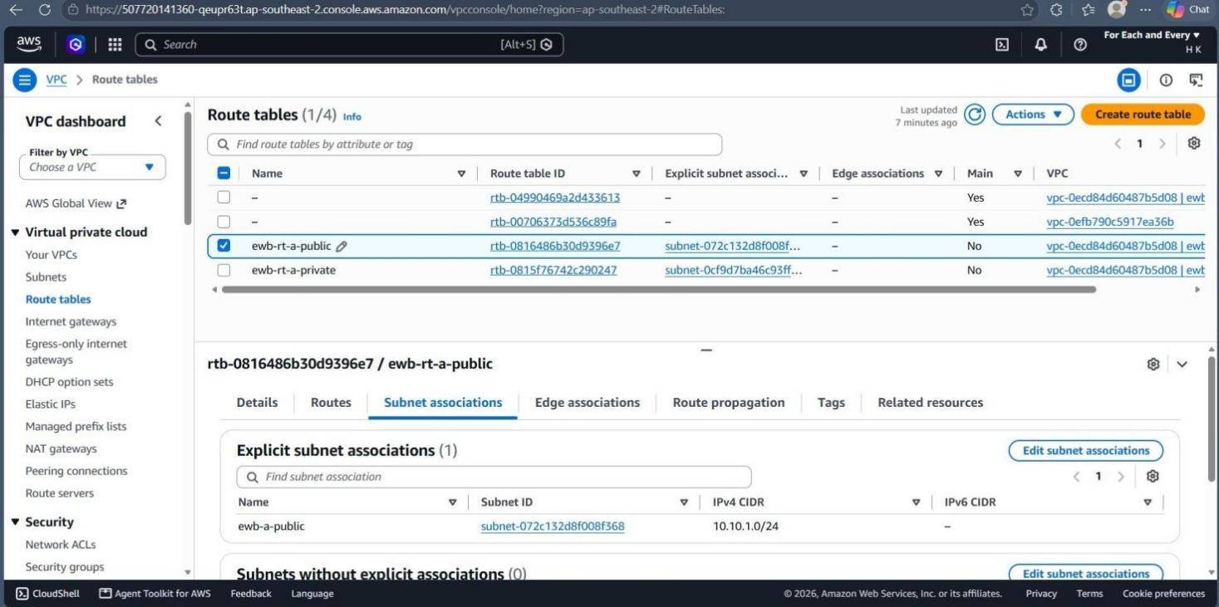
Figure 2. Host: VPC console | Checkpoint 01 | ewb-rt-a-public is explicitly associated with ewb-a-public (10.10.1.0/24).
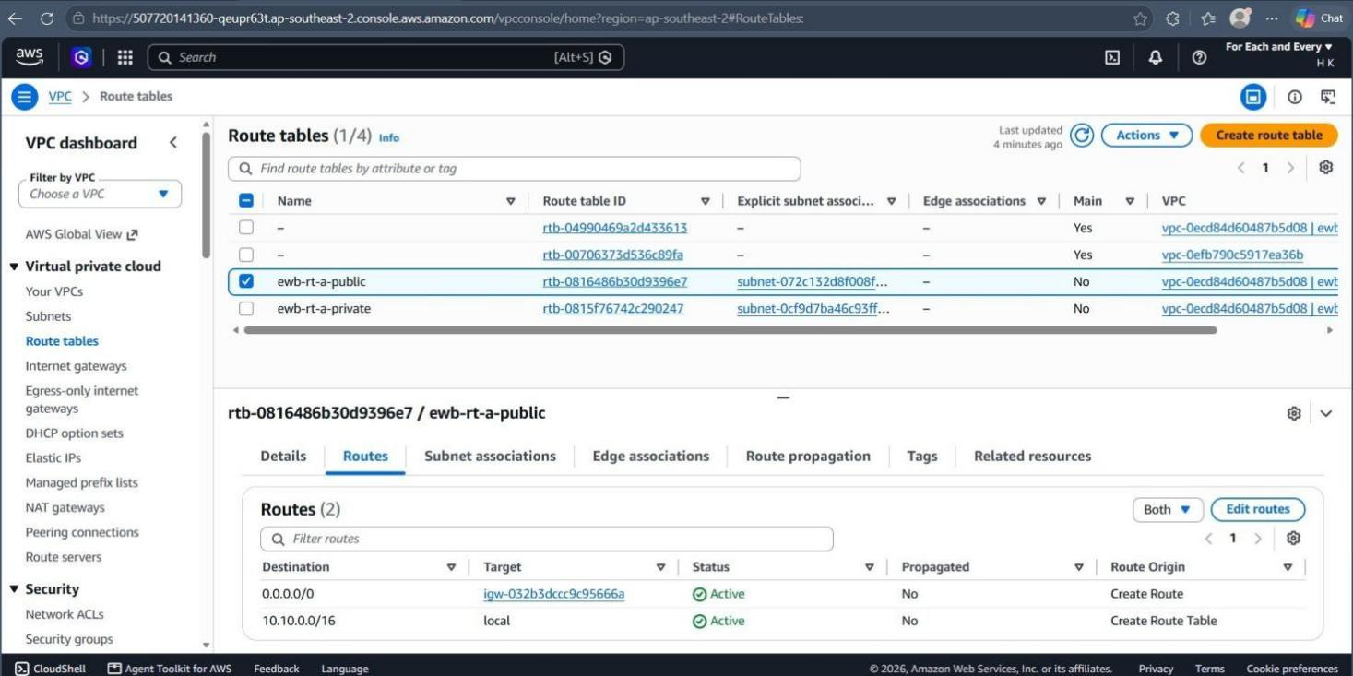
Figure 3. Host: VPC console | Checkpoint 01 | ewb-rt-a-public has 0.0.0.0/0 to igw-032b3dccc9c95666a plus the local route (before peering).
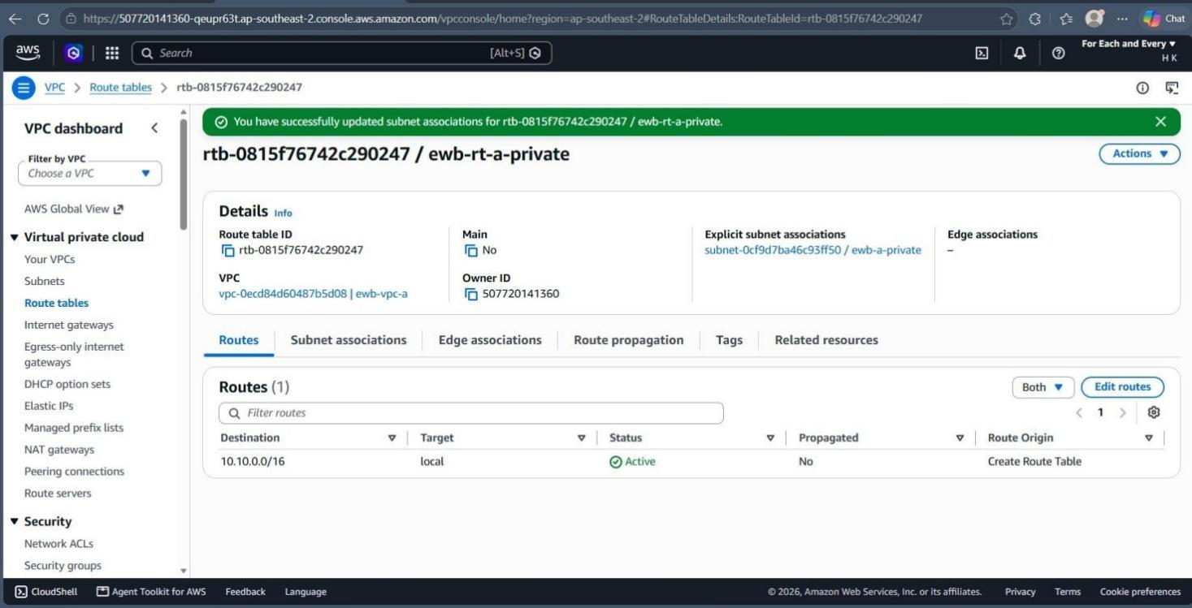
Figure 4. Host: VPC console | Checkpoint 01 | ewb-rt-a-private is associated with ewb-a-private and contains only the local route (before peering).
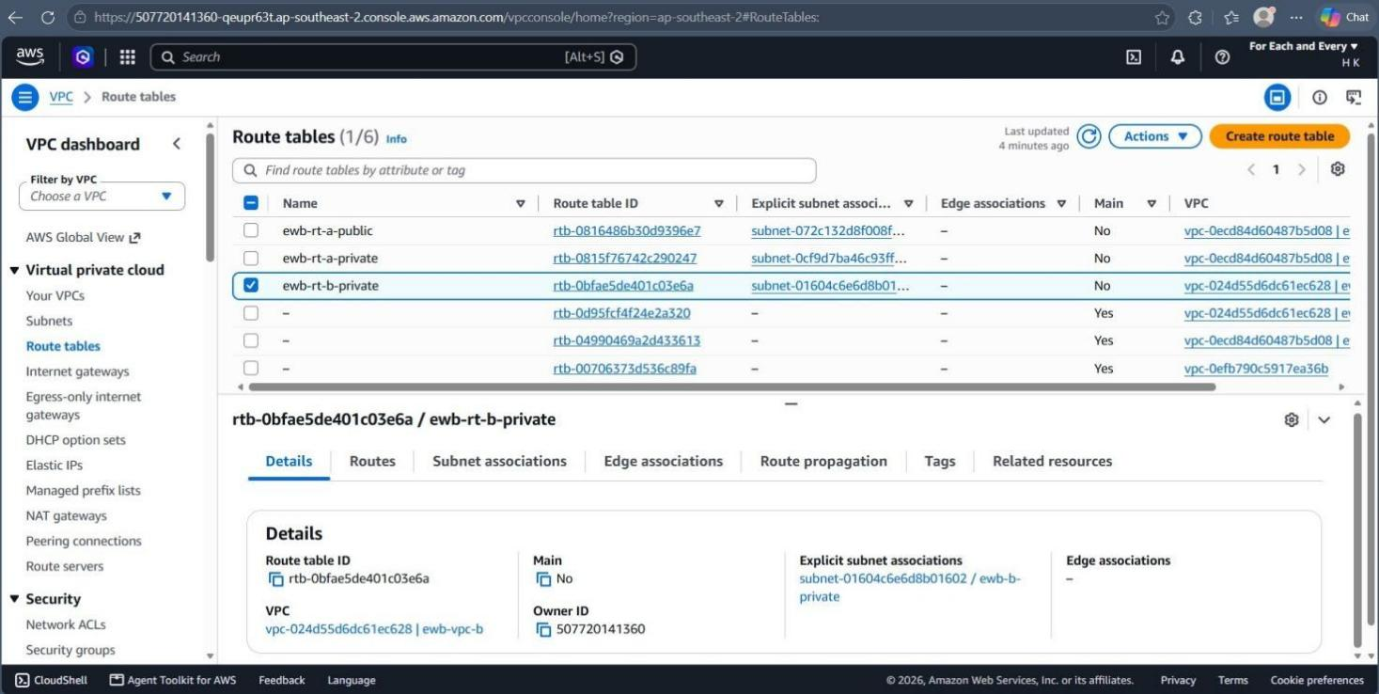
Figure 5. Host: VPC console | ewb-rt-b-private (VPC B) is explicitly associated with ewb-b-private (subnet-01604c6e6d8b01602).
Checkpoint 01
Both VPC A subnet associations and the public default route are captured (Figures 2 to 3). The private route table contains only its local VPC route (Figure 4).

04 / SECURITY AND COMPUTE

Security groups and instances (Checkpoint 02)
Both application servers stay private. Inbound access is scoped to individual lab hosts with /32 rules.
Security group | Type / port | Source | Why it is needed
ewb-sg-bastion (VPC A) | SSH / TCP 22 | My public IPv4 /32 | Only my laptop can reach the bastion
ewb-sg-app-a (VPC A) | SSH / TCP 22 | 10.10.1.10/32 (bastion) | Admin access through the bastion only
ewb-sg-app-a (VPC A) | Custom ICMP, Echo Request | 10.20.1.10/32 (App-B) | Allow ping from App-B (reverse path test)
ewb-sg-app-b (VPC B) | SSH / TCP 22 | 10.10.1.10/32 (bastion) | App-B sees the bastion private IP as the source
ewb-sg-app-b (VPC B) | Custom ICMP, Echo Request | 10.10.2.39/32 (App-A) | Allow ping from App-A (forward path test). Workbook value 10.10.2.10, updated to the actual IP

Outbound rules stay at the default allow-all. Security groups are stateful, so replies to permitted traffic are allowed automatically. Network ACLs are the default allow-all.
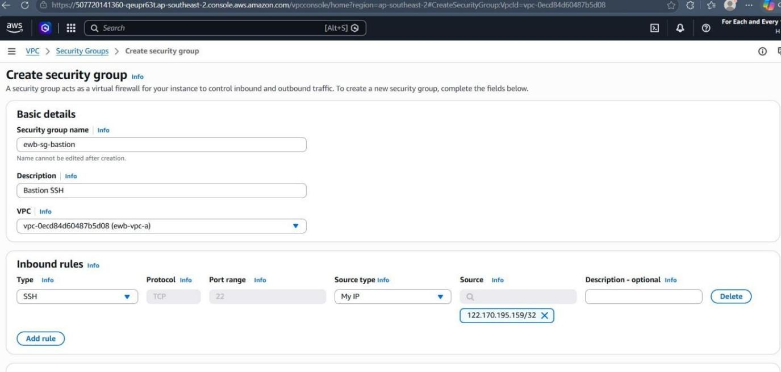
Figure 6. Host: EC2 console | ewb-sg-bastion in ewb-vpc-a | Result: one inbound rule, SSH (TCP 22) from my current public IPv4 /32 (rule as created).
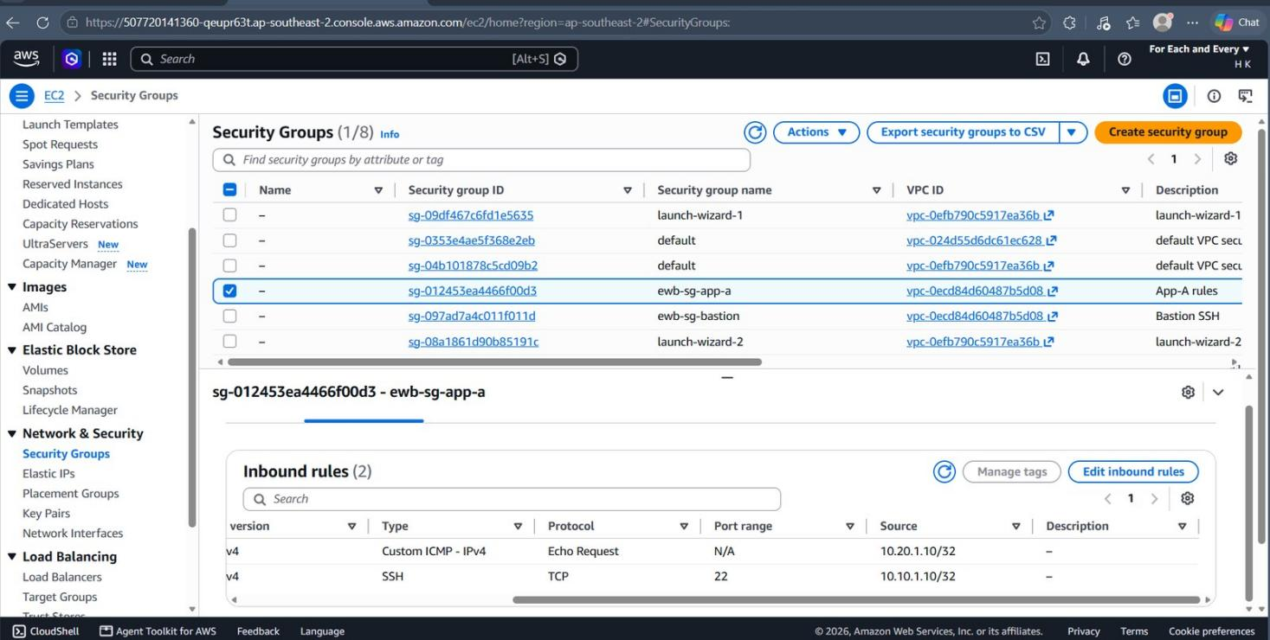
Figure 7. Host: EC2 console | ewb-sg-app-a (VPC A) inbound rules | Result: Echo Request from 10.20.1.10/32 (App-B) and SSH (TCP 22) from 10.10.1.10/32 (bastion).
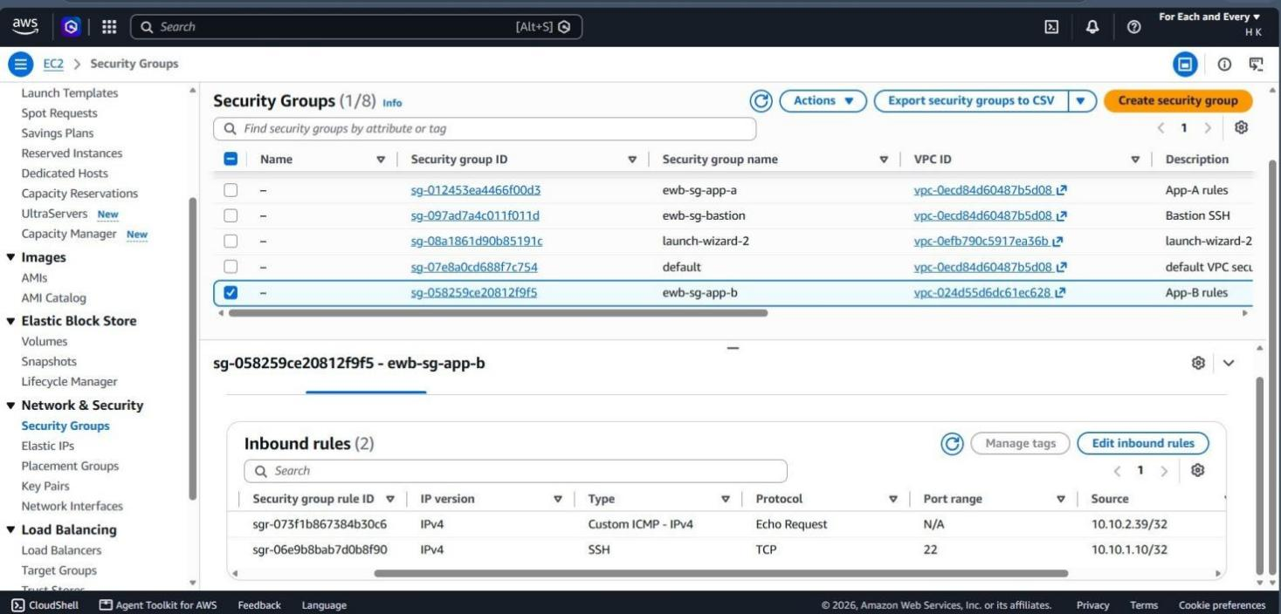
Figure 8. Host: EC2 console | ewb-sg-app-b (VPC B) inbound rules, after the controlled failure test | Result: Echo Request from 10.10.2.39/32 (App-A) and SSH from 10.10.1.10/32 (bastion), both rules in place.

Instances
Instance | Network settings | Security group | Public IPv4
ewb-bastion | ewb-vpc-a / ewb-a-public / 10.10.1.10 | ewb-sg-bastion | 54.253.46.171
ewb-app-a | ewb-vpc-a / ewb-a-private / 10.10.2.39 | ewb-sg-app-a | None
ewb-app-b | ewb-vpc-b / ewb-b-private / 10.20.1.10 | ewb-sg-app-b | None

All three instances are t3.micro, Amazon Linux 2023, in ap-southeast-2a, using key pair ewb-lab, with an 8 GiB root volume set to delete on termination.
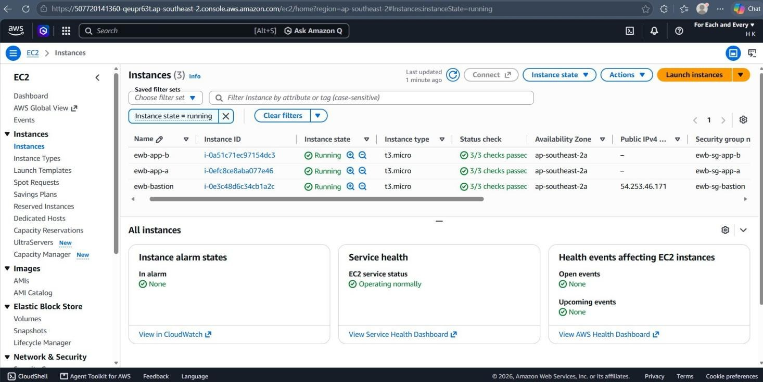
Figure 9. Host: EC2 console | Checkpoint 02 | Instance IDs, running state, 3/3 status checks, and Public IPv4: only the bastion (54.253.46.171) has one.
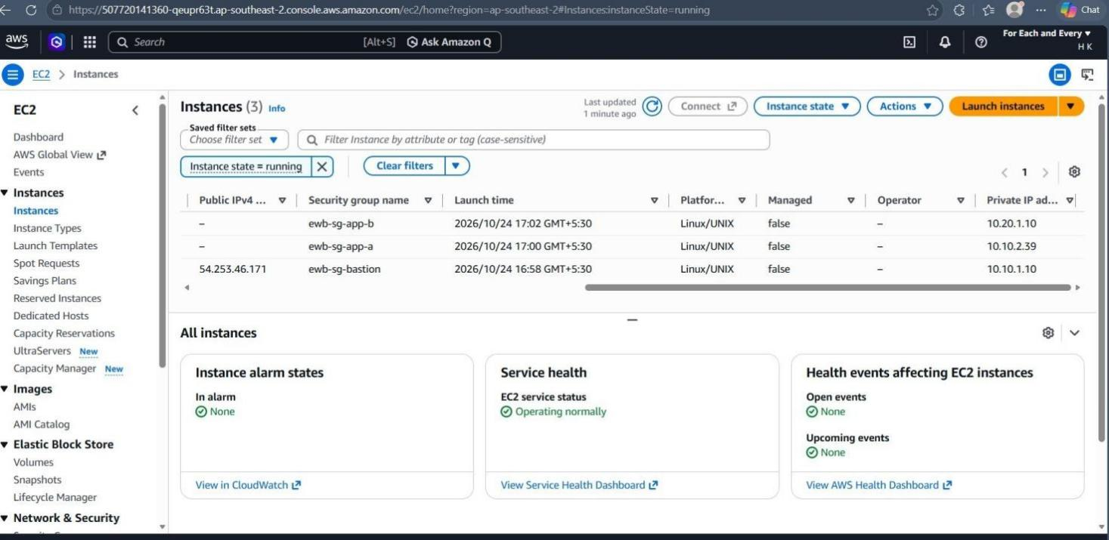
Figure 10. Host: EC2 console | Checkpoint 02 | Private IPs: ewb-app-b 10.20.1.10, ewb-app-a 10.10.2.39, ewb-bastion 10.10.1.10; security group per instance.
Checkpoint 02
All three instance IDs and private IPs are recorded, together with the bastion public IPv4 (Figures 9 and 10). The Public IPv4 field is empty for App-A and App-B.

05 / ADMINISTRATION

SSH access without copying keys
All SSH commands run on my laptop (Ubuntu on WSL). ProxyJump uses the bastion as the connection path, so the private key never leaves the laptop.
The key was copied into WSL as ~/.ssh/ewb-lab.pem and locked with chmod 400. ~/.ssh/config contains one entry per host. Before peering, ssh ewb-bastion and ssh ewb-app-a both connected using VPC A's local route; ssh ewb-app-b works only after the peering routes are in place.
LOCAL FILE / ~/.SSH/CONFIG
Host ewb-bastion
HostName 54.253.46.171
User ec2-user
IdentityFile ~/.ssh/ewb-lab.pem
IdentitiesOnly yes

Host ewb-app-a
HostName 10.10.2.39
User ec2-user
IdentityFile ~/.ssh/ewb-lab.pem
IdentitiesOnly yes
ProxyJump ewb-bastion

Host ewb-app-b
HostName 10.20.1.10
User ec2-user
IdentityFile ~/.ssh/ewb-lab.pem
IdentitiesOnly yes
ProxyJump ewb-bastion

Laptop file ~/.ssh/config. No key material is stored in it, only the path to the key.
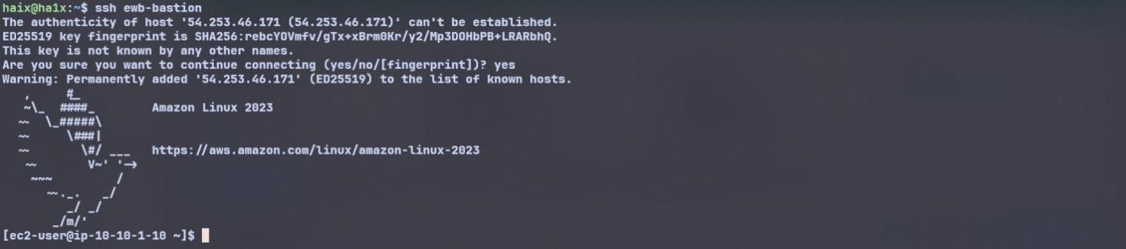
Figure 11. Host: laptop (WSL) to ewb-bastion | Test: ssh ewb-bastion | Result: connected, prompt ec2-user@ip-10-10-1-10 (bastion private IP 10.10.1.10).
06 / PEERING AND ROUTING

Request, accept, activate, then route (Checkpoints 03 and 04)
The peering connection is the link. Route tables and security groups decide whether traffic can use it.
ewb-a-b-peer was requested from VPC A (requester) to VPC B (accepter) in the same account and Region, then accepted. Status is Active.
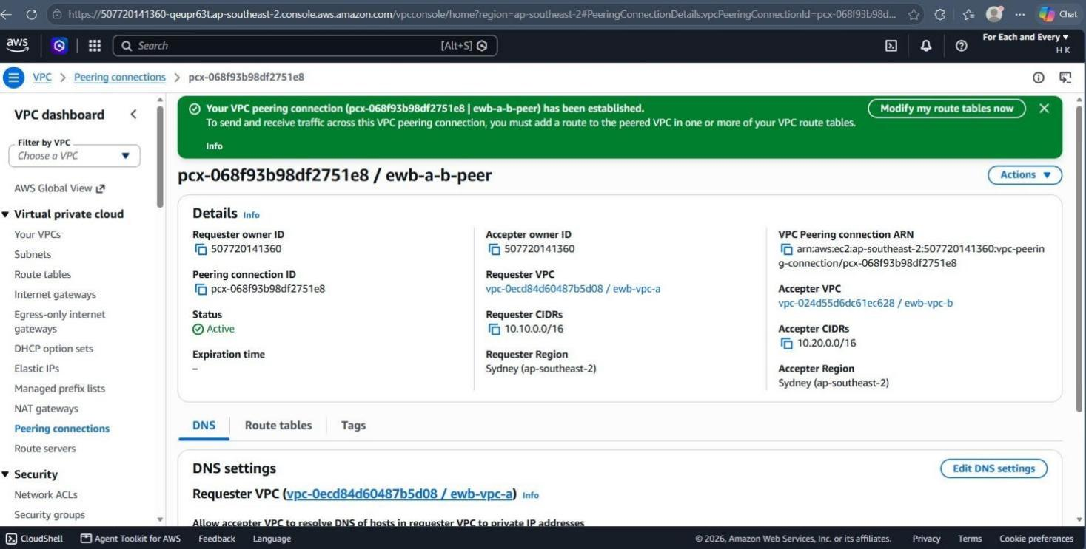
Figure 12. Host: VPC console | Checkpoint 03 | pcx-068f93b98df2751e8 / ewb-a-b-peer is Active. Requester vpc-0ecd84d60487b5d08 (ewb-vpc-a, 10.10.0.0/16); accepter vpc-024d55d6dc61ec628 (ewb-vpc-b, 10.20.0.0/16).
Checkpoint 03
Connection name, Active status and both VPC IDs are shown in Figure 12. Peering alone does not make ping or SSH succeed; the routes below are also needed.

Routes added on both sides (pcx = pcx-068f93b98df2751e8)
Route table | Destination | Target | Purpose
ewb-rt-a-private | 10.10.0.0/16 | local | Existing VPC A route
ewb-rt-a-private | 10.20.0.0/16 | pcx | App-A to VPC B (forward path)
ewb-rt-b-private | 10.20.0.0/16 | local | Existing VPC B route
ewb-rt-b-private | 10.10.0.0/16 | pcx | Return path to VPC A
ewb-rt-a-public | 10.10.0.0/16 | local | Bastion to App-A
ewb-rt-a-public | 0.0.0.0/0 | igw-032b3dccc9c95666a | Bastion internet access
ewb-rt-a-public | 10.20.0.0/16 | pcx | Bastion SSH to App-B (ProxyJump)

Why does the public subnet need a peering route?
ProxyJump makes the bastion open its own connection to App-B, so the bastion's subnet must know how to reach VPC B. The more specific 10.20.0.0/16 route wins over the 0.0.0.0/0 internet route.

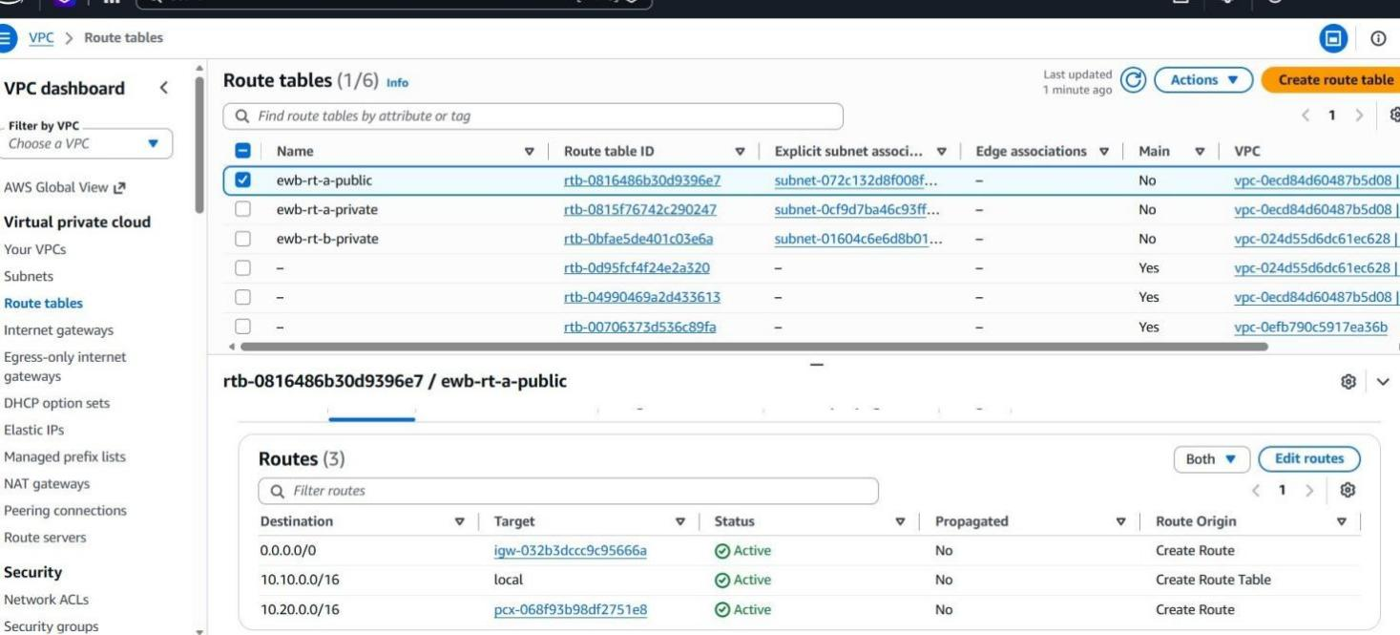
Figure 13. Host: VPC console | Checkpoint 04 | ewb-rt-a-public now has 3 active routes: 0.0.0.0/0 to the internet gateway, 10.10.0.0/16 local, 10.20.0.0/16 to pcx-068f93b98df2751e8.
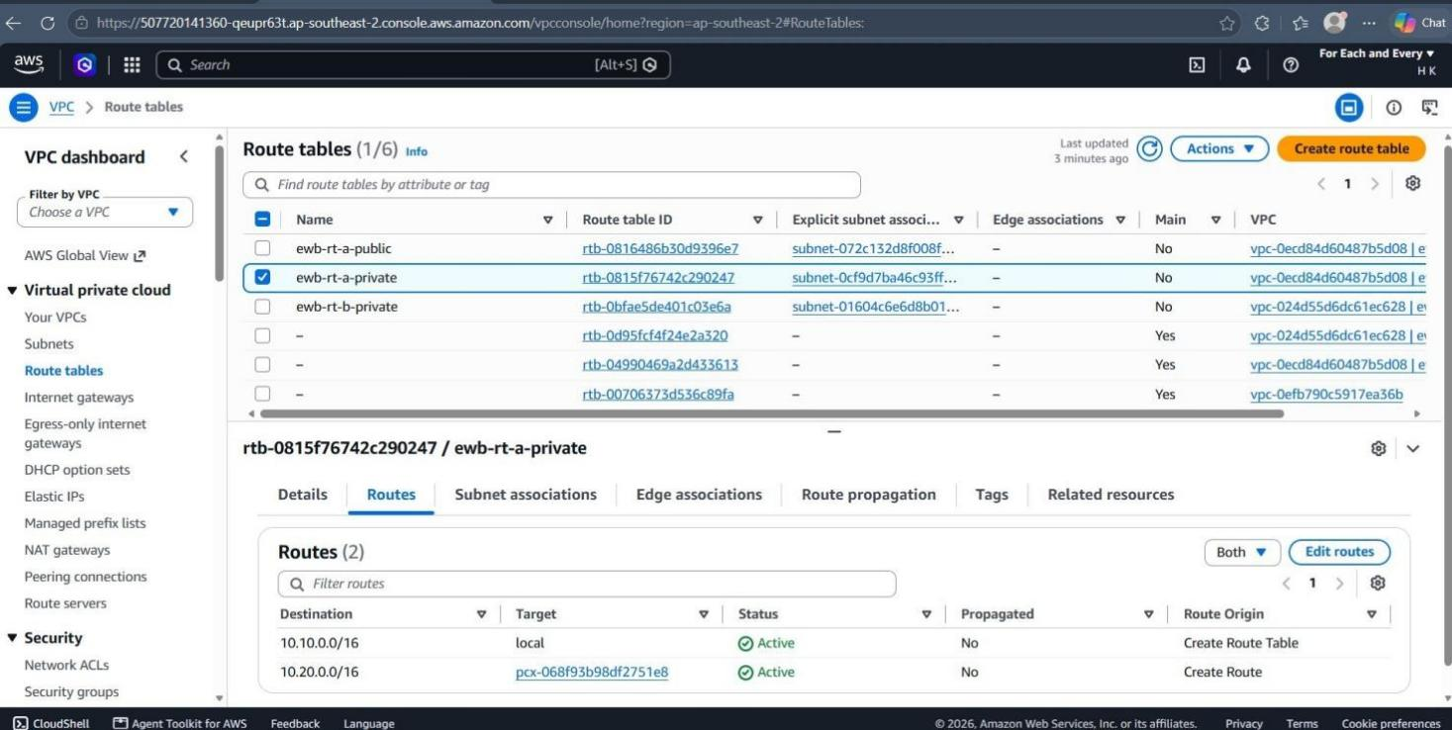
Figure 14. Host: VPC console | Checkpoint 04 | ewb-rt-a-private: 10.10.0.0/16 local and 10.20.0.0/16 to pcx-068f93b98df2751e8 (App-A to VPC B).
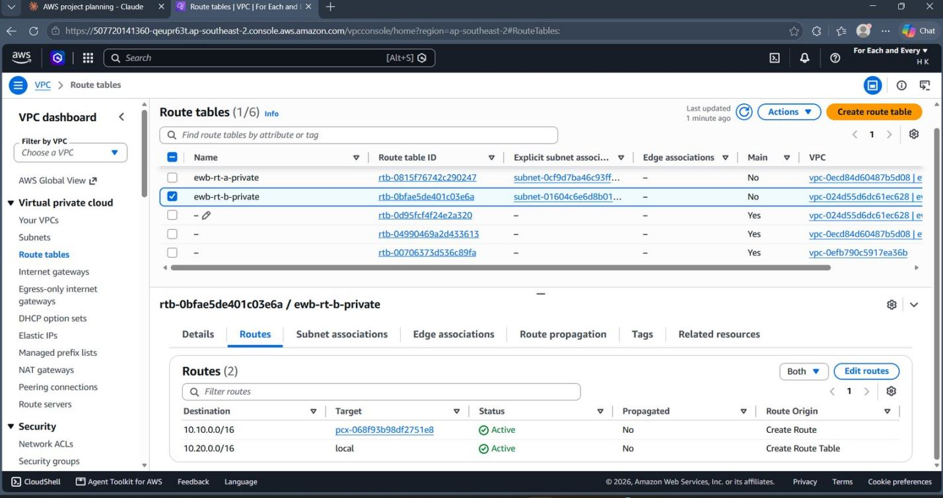
Figure 15. Host: VPC console | Checkpoint 04 | ewb-rt-b-private: 10.20.0.0/16 local and 10.10.0.0/16 to pcx-068f93b98df2751e8 (return path to VPC A), both Active.
Checkpoint 04
Routes and subnet associations are saved for all three tables (Figures 2, 4, 5 and 13 to 15). A one-way route is not enough: replies also need the route back.

07 / VERIFICATION

Prove the project works
Real terminal output from my own run. A screenshot of Active peering alone does not prove reachability.
Test | Where / command | Expected | Actual result | Result
01 Baseline | App-A (10.10.2.39), before peering: ping -c 4 10.20.1.10 | No replies | 4 transmitted, 0 received, 100% packet loss | PASS
02 Forward path | App-A, after routes: ping -c 4 10.20.1.10 | 4 replies, 0% loss | 4 transmitted, 4 received, 0% loss, avg 0.249 ms | PASS
03 Reverse path | App-B (10.20.1.10): ping -c 4 10.10.2.39 | 4 replies, 0% loss | 4 transmitted, 4 received, 0% loss, avg 0.175 ms | PASS
04 Private SSH | Laptop: ssh ewb-app-b | Shell on App-B through bastion | Logged in, prompt ec2-user@ip-10-20-1-10 | PASS
05 Isolation | EC2 instance details: App-A and App-B | No public IPv4 on either host | Public IPv4 address empty on both | PASS

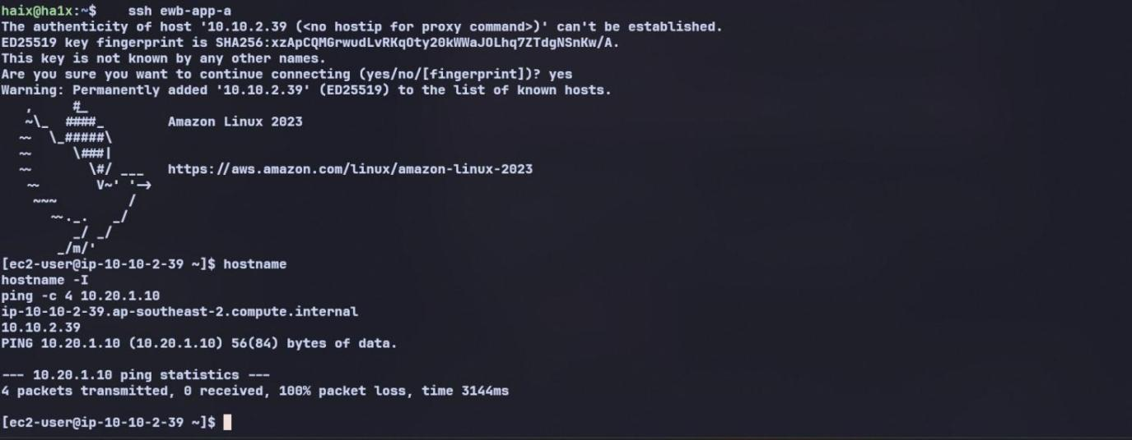
Figure 16. Host: App-A (ip-10-10-2-39) | Test 01 Baseline | ping -c 4 10.20.1.10 before peering | Result: 4 transmitted, 0 received, 100% packet loss (expected failure).
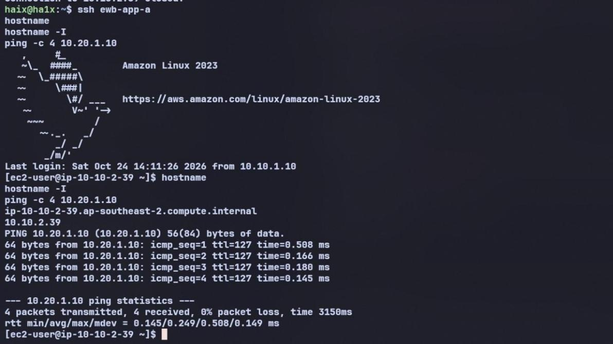
Figure 17. Host: App-A (ip-10-10-2-39) | Test 02 Forward path | ping -c 4 10.20.1.10 after peering and routes | Result: 4 received, 0% packet loss.
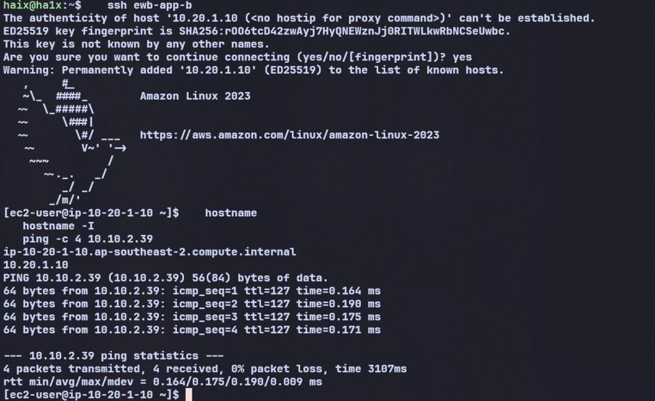
Figure 18. Host: laptop to App-B (ip-10-20-1-10) | Tests 03 and 04 | ssh ewb-app-b through the bastion, then ping -c 4 10.10.2.39 | Result: shell on App-B and 4 received, 0% packet loss.
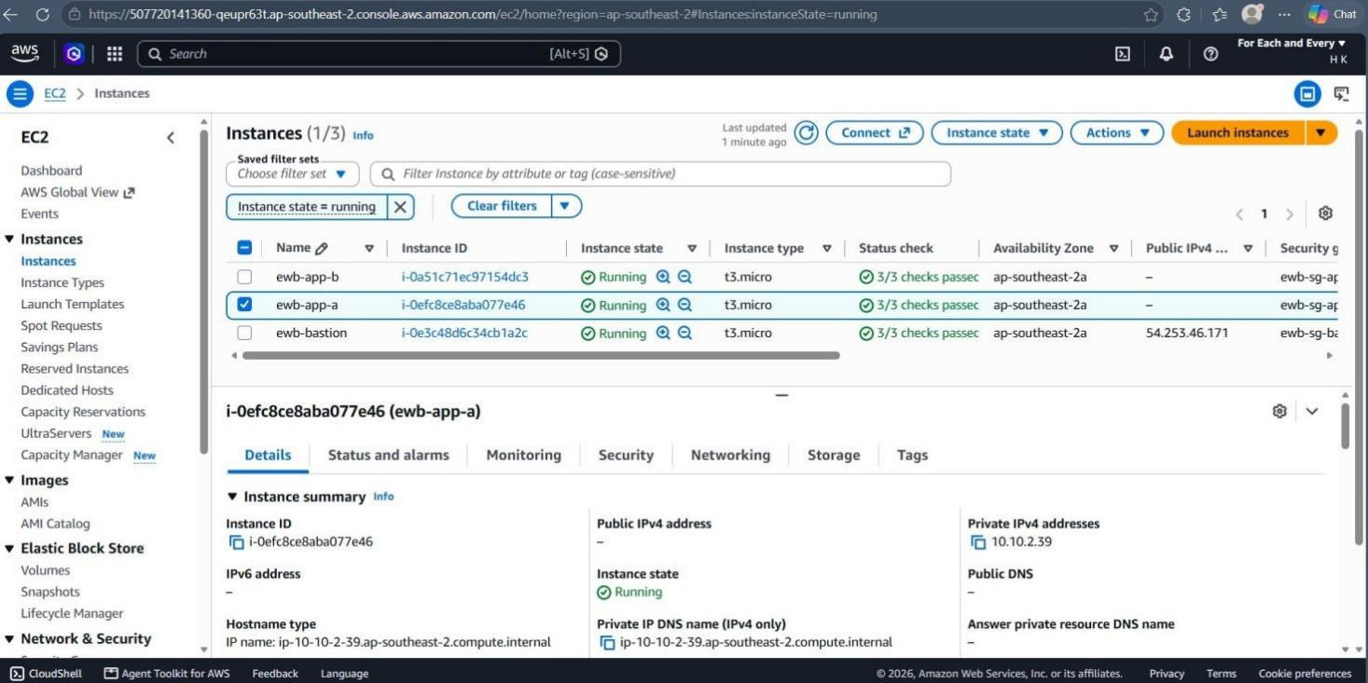
Figure 19. Host: EC2 console | Test 05 Isolation | ewb-app-a (i-0efc8ce8aba077e46): Public IPv4 address empty, private IP 10.10.2.39.
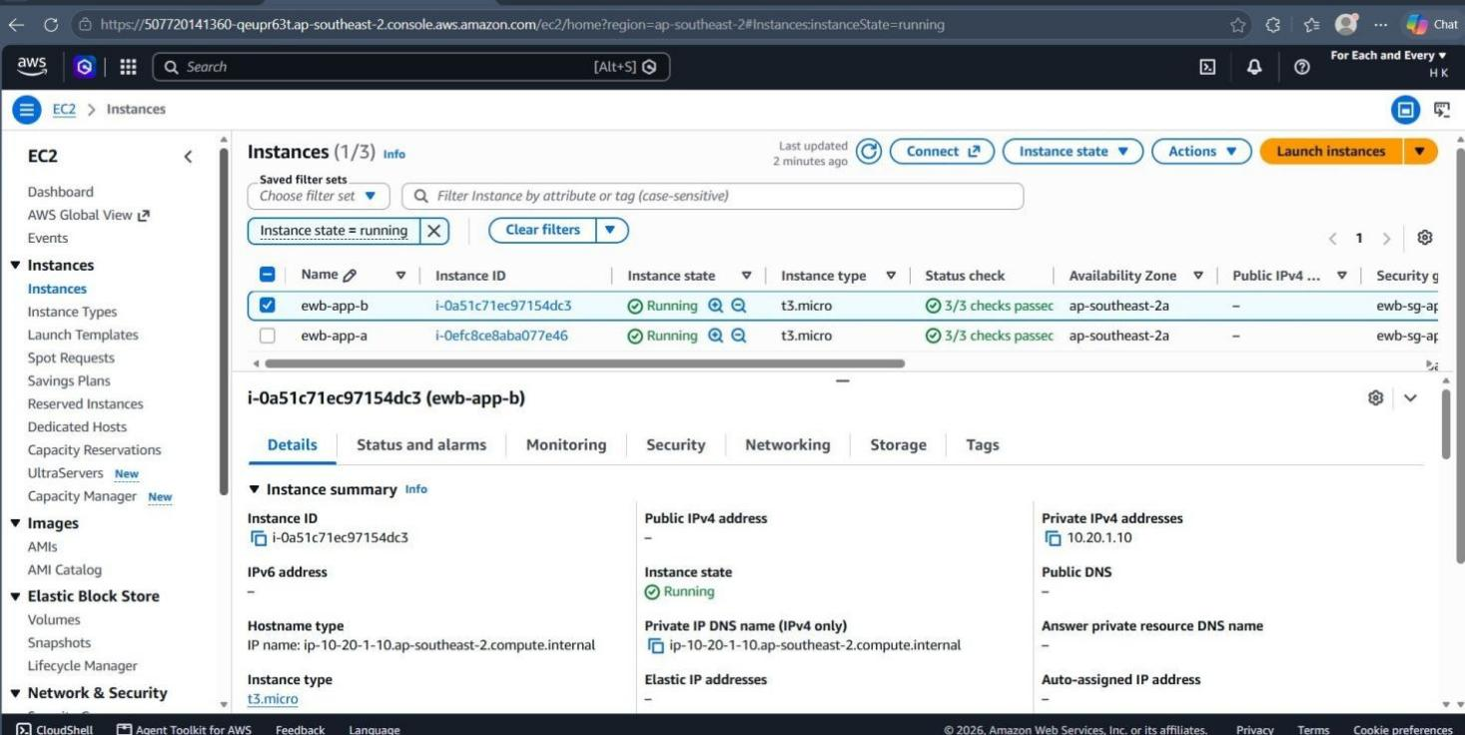
Figure 20. Host: EC2 console | Test 05 Isolation | ewb-app-b (i-0a51c71ec97154dc3): Public IPv4 address empty, private IP 10.20.1.10.
08 / CONTROLLED FAILURE

Break it on purpose, then fix it
Peering and routes stay unchanged. Only one security group rule changes.
Steps. (1) Removed only the Echo Request rule (source 10.10.2.39/32) from ewb-sg-app-b and kept the SSH rule. (2) Pinged App-B from App-A: no replies. (3) Restored the exact rule: Custom ICMP - IPv4, Echo Request, source 10.10.2.39/32. (4) Pinged again: replies resumed.
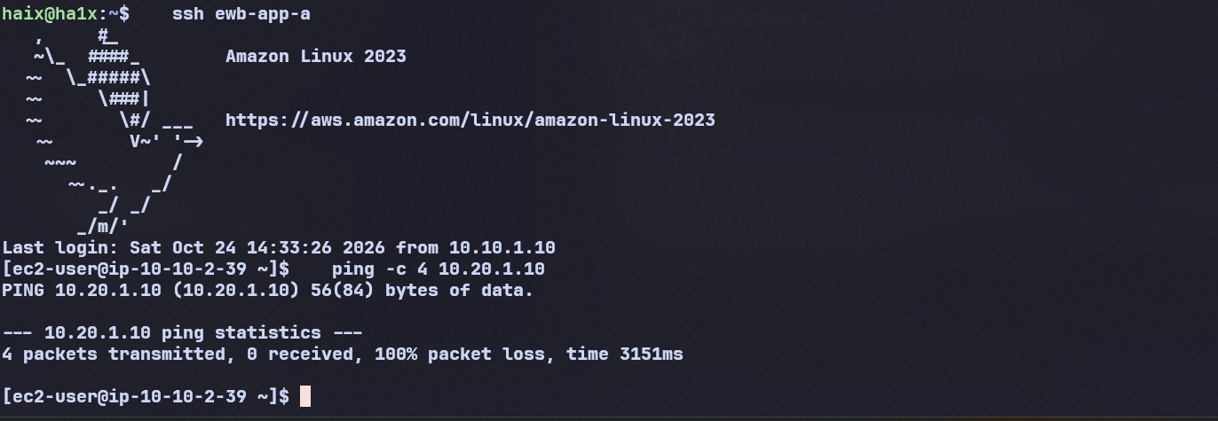
Figure 21. Host: App-A (ip-10-10-2-39) | Controlled failure | Echo Request rule removed from ewb-sg-app-b | ping -c 4 10.20.1.10 | Result: 4 transmitted, 0 received, 100% packet loss.
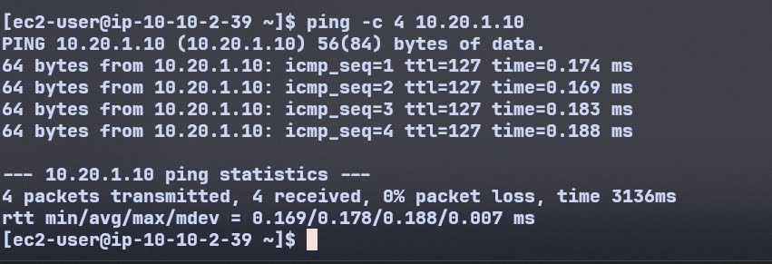
Figure 22. Host: App-A (ip-10-10-2-39) | Recovery | Echo Request rule restored on ewb-sg-app-b | ping -c 4 10.20.1.10 | Result: 4 transmitted, 4 received, 0% packet loss. The restored rules are shown in Figure 8.

What this proves
 | Baseline failure (Test 01) | Controlled failure
Peering connection | Did not exist yet | Active (unchanged)
Routes | No route to 10.20.0.0/16 and no return route | Both routes in place (unchanged)
Security group rule | Not the cause | Echo Request rule missing on ewb-sg-app-b
Result | 100% packet loss | 100% packet loss, then 0% after restoring the rule

Both tests fail with the same symptom (no replies), but for different reasons. Active peering plus correct routes is not enough: the destination security group must also allow the traffic.
09 / EXPLAIN

Forward path, return path and viva answers

Forward path (App-A to App-B)
- App-A (10.10.2.39) sends an echo request to 10.20.1.10. In ewb-rt-a-private the most specific match is 10.20.0.0/16 to the peering connection (pcx-068f93b98df2751e8).
- The packet crosses the peering connection into VPC B. ewb-sg-app-b checks its inbound rules and allows ICMP Echo Request from 10.10.2.39/32.

Return path (App-B back to App-A)
- App-B sends the echo reply to 10.10.2.39. In ewb-rt-b-private the match is 10.10.0.0/16 to the same peering connection, so the reply crosses back into VPC A.
- Security groups are stateful, so the reply is allowed without a separate inbound rule on ewb-sg-app-a. Without the return route the request would arrive but the reply would have nowhere to go.

SSH path (laptop to App-B)
- Laptop to bastion over the internet gateway (ewb-sg-bastion allows my public IP /32). The bastion then opens a separate SSH connection to App-B using ewb-rt-a-public (10.20.0.0/16 to pcx).
- App-B sees the bastion's private IP 10.10.1.10 as the source, which ewb-sg-app-b allows on port 22.

Be ready to explain
Question | Answer
1. Why is the return route needed? | Routing is per direction. The request needs a route from A to B, and the reply needs a route from B back to A. A one-way route gives a timeout.
2. Why is the App-B SSH source the bastion private IP? | ProxyJump makes the bastion open its own SSH connection to App-B. App-B therefore sees 10.10.1.10, not my laptop's public IP.
3. Why does Active peering not guarantee a successful ping? | Active only means the link exists. Traffic also needs routes on both sides and a security group rule on the destination (and permissive network ACLs). The controlled failure shows this: peering and routes were fine, but removing one rule gave 100% loss.
4. Can VPC B use VPC A's internet gateway over peering? | No. Peering is one-to-one and non-transitive, and it does not provide internet access through the peer's gateway. VPC B has no internet gateway and stays private.
10 / REVIEW

Issues I hit and what I learned
Issue | How it was found | Fix
App-A got 10.10.2.39, not 10.10.2.10 | Private IP column on the instance list after launch | Updated the Echo Request rule on ewb-sg-app-b and the HostName in ~/.ssh/config; used 10.10.2.39 in all tests.
Peering CIDR typed over the internet-gateway route when editing ewb-rt-a-public | Row 2 showed 10.20.0.0/16 to Internet Gateway before saving | Restored 0.0.0.0/0 to the IGW and put 10.20.0.0/16 on its own row targeting the peering connection; confirmed 3 active routes after saving.
ssh ewb-app-a failed with "Could not resolve hostname" | Command was typed inside the bastion | The SSH config lives on the laptop; exited and ran it from WSL.
Commands pasted during login were lost | No output after the banner | Waited for the prompt, then ran hostname, hostname -I and ping.

What I learned
Peering on its own does nothing: traffic only flows once both route tables point at the peering connection and the destination security group allows it. Comparing the baseline failure (missing routes and peering) with the controlled failure (one missing security group rule) made the layers clear. ProxyJump makes the bastion open a second SSH connection, which is why App-B sees the bastion's private IP and why the bastion's subnet needs the peering route. I also learned to preview route edits before saving and to record the real IP addresses instead of assuming the workbook values.
11 / FINISH RESPONSIBLY

Cleanup evidence
Evidence was captured while the resources were removed. Only resources created for this project were deleted; the default VPC was left alone.
Order | Action | Evidence
1 | Terminate ewb-bastion, ewb-app-a and ewb-app-b; confirm their EBS volumes are deleted | Figures 23 and 24
2 | Delete the peering connection ewb-a-b-peer and the peer routes | Figure 25
3 | Delete the 3 lab security groups, 3 subnets and 3 custom route tables | Figures 26 to 28
4 | Detach and delete ewb-igw-a; delete ewb-vpc-a and ewb-vpc-b | Figure 29
5 | Delete key pair ewb-lab and the local .pem key | Figure 30
6 | Verify only default-VPC resources remain (no ewb- resources, no volumes) | Figures 24 to 30

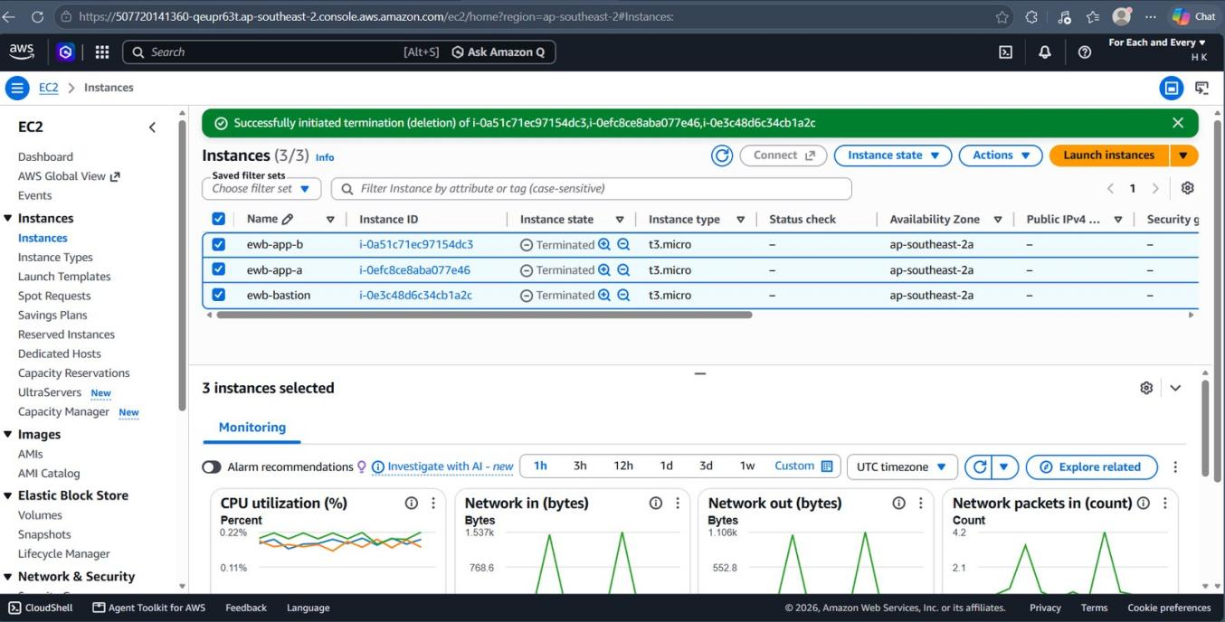
Figure 23. Host: EC2 console | Cleanup step 1 | Result: ewb-bastion, ewb-app-a and ewb-app-b all show Terminated.
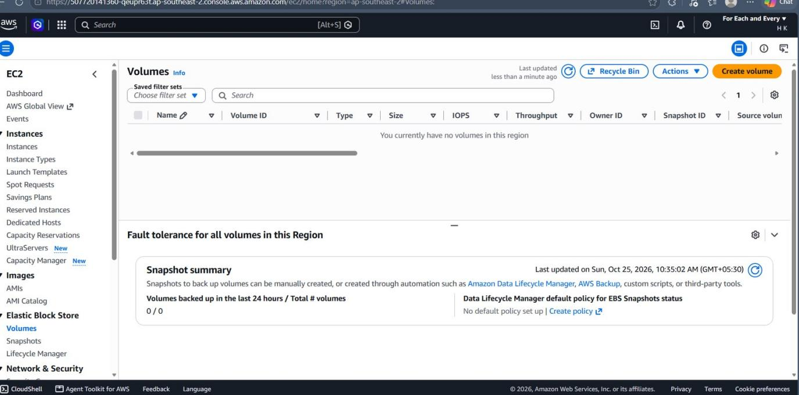
Figure 24. Host: EC2 console | Cleanup step 1 | Result: Volumes list is empty ("no volumes in this region") and the snapshot summary shows 0 / 0.
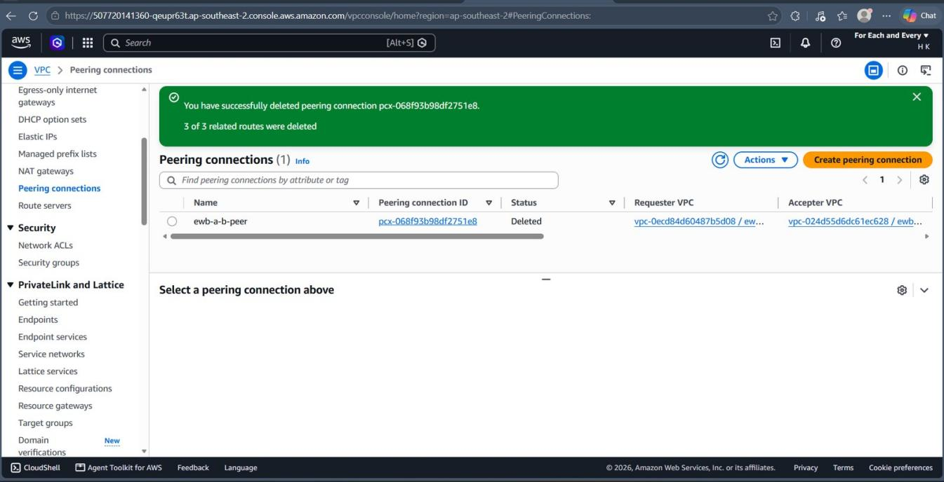
Figure 25. Host: VPC console | Cleanup step 2 | Result: peering connection pcx-068f93b98df2751e8 (ewb-a-b-peer) is Deleted; 3 of 3 related routes were deleted.
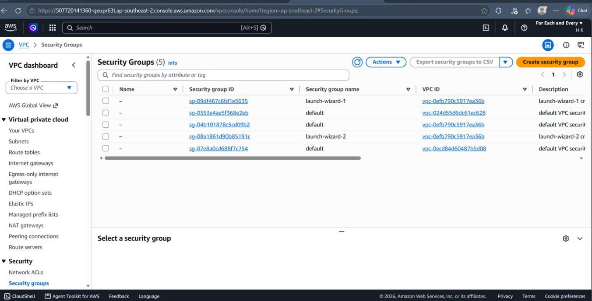
Figure 26. Host: VPC console | Cleanup step 3 | Result: no ewb-sg-* groups remain. The default groups left at this point are created automatically with each VPC and go when the VPC is deleted.
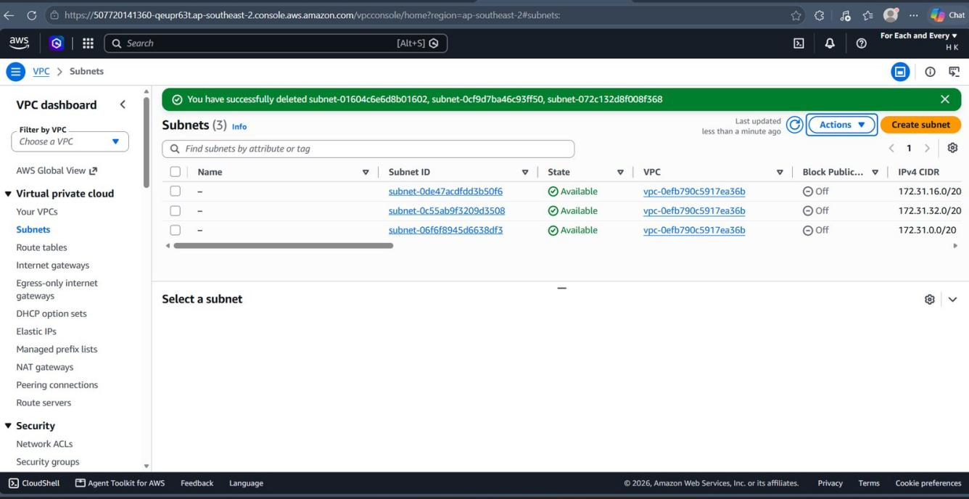
Figure 27. Host: VPC console | Cleanup step 3 | Result: the three lab subnets are deleted; only the default VPC's 172.31.x.x subnets remain.
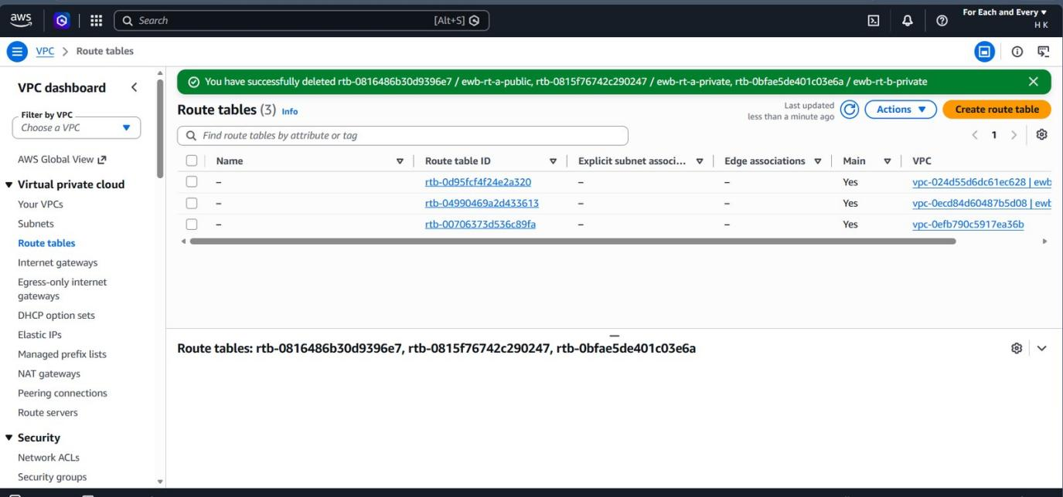
Figure 28. Host: VPC console | Cleanup step 3 | Result: the three lab route tables are deleted; only the automatic main route tables remain.
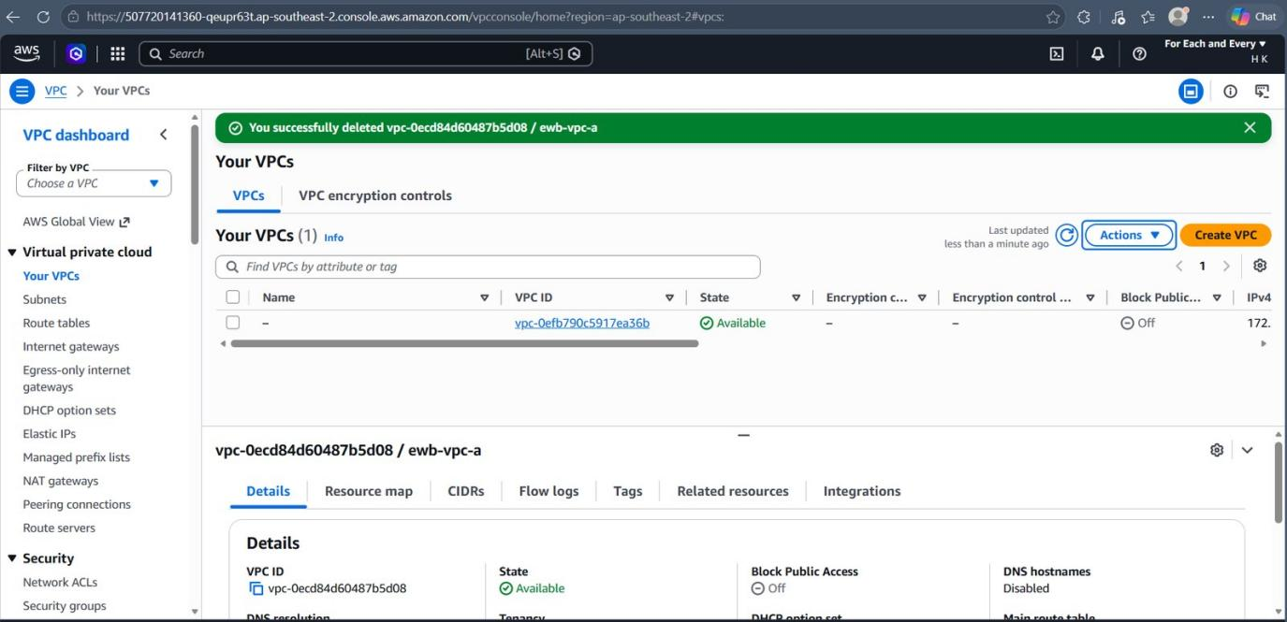
Figure 29. Host: VPC console | Cleanup step 4 | Result: ewb-vpc-a deleted; Your VPCs shows only the default VPC.
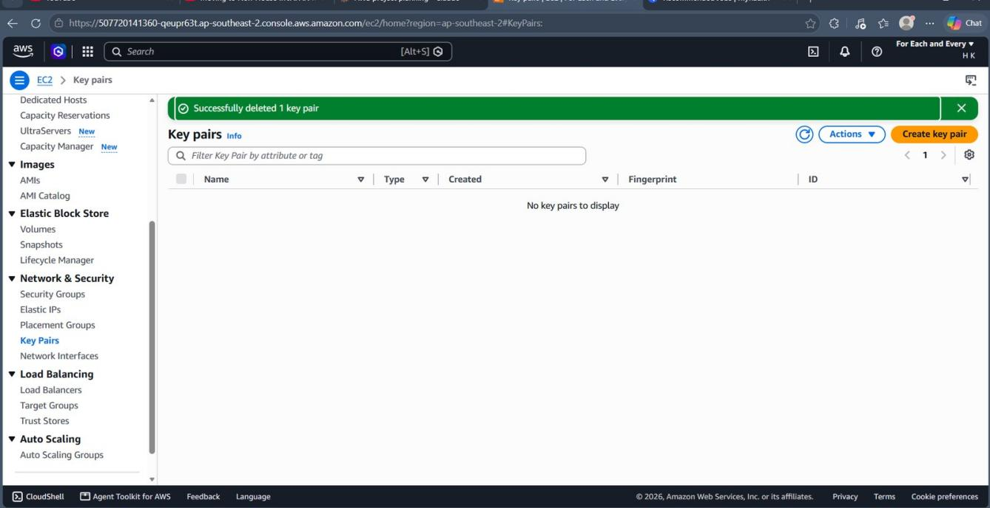
Figure 30. Host: EC2 console | Cleanup step 5 | Result: key pair ewb-lab deleted; "No key pairs to display".
No private keys, passwords or access tokens are included in this report.

