**Database Tables**

**1. stocks:**

To store the stock ids and ticker symbols. The columns in the Stocks table are columns as sid(int) and ticker(varchar(10)).

Primary Key: sid

**2. historical**

To store the historical data for all the stocks present in stocks table. The columns in the historical table are sid (int), dat(date), open_value(float), low(float), high(float), close_value(float) and volume(int).

Primary Key: {sid, dat}

**3. real_time**

To store the real-time data for all the stocks present in stocks table. The columns in this table are the same as the historical table and an additional tim(time) column.

Primary Key: {sid, dat, tim}

Note: The schema for the above three tables is given in the Report.

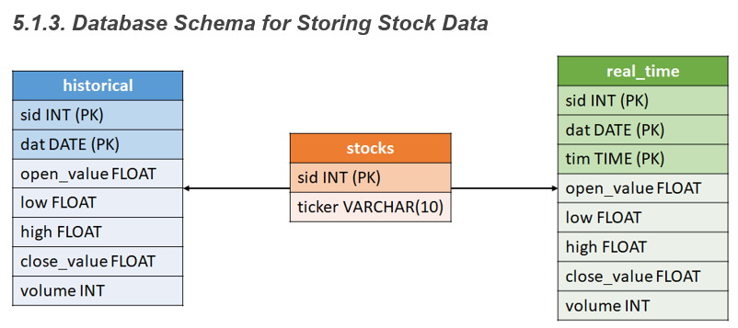

**4. thresholds**

To store the price percentages set by the Users on the user interface using the NotifyMe tab. The columns in the threshold table are username (varchar(20), ticker(varchar(10)), price(float), threshold(float) and satisfied(int).

Primary Key: {username, ticker}

The other tables which were created by default by Django were:

* auth_data
* auth_group_permission
* auth_permission
* auth_user
* auth_user_groups
* auth_user_user_permission
* django_admin_log
* django_content_type
* django_migrations

These tables are updated by Django depending on the operations performed by the admin and users on the application interface. The main table which is used by Django to store the Admin and Users details is the auth_user table.

The columns in the auth_user are id,password,last_login,is_superuser,username,first_name,last_name,email,is_staff,is_active,date_joined.