Project Report

.NET

SecureShare .NET
An Encrypted, Self-Destructing File Sharing System



Registration  No | Section | Name of Students | Roll No
12309768 | 9P192 | Hariharan S | R9P192A14

Submitted To Raushan Raj
Lovely Professional University Jalandhar, Punjab, India.

1. Abstract
In an increasingly digital world, the secure transmission of sensitive data remains a critical vulnerability. Standard file-sharing methods—such as email attachments or instant messaging—often leave permanent, unencrypted traces on third-party servers. SecureShare .NET addresses this vulnerability by providing a robust, web-based utility for the secure, ephemeral transfer of files.
Built using the .NET 9 framework and ASP.NET Core Web API, this system implements military-grade AES-256 end-to-end server-side encryption. The application utilizes an unpredictable, GUID-based routing mechanism to prevent insecure direct object reference (IDOR) attacks. Furthermore, SecureShare introduces a deterministic "self-destruct" protocol, invalidating file access based on strict expiration timestamps or maximum download thresholds. By leveraging Clean Architecture principles and Entity Framework Core, the system is highly modular, scalable, and fully prepared for enterprise cloud deployment.

2. Introduction
2.1 Problem Statement
Individuals and organizations frequently need to share highly sensitive information, such as financial records, cryptographic keys, or proprietary source code. When shared via traditional channels, the sender loses control over the file's lifecycle. The file persists indefinitely in the recipient's inbox or the service provider's data centers, creating a lingering attack surface. Furthermore, many consumer-grade file-sharing links are predictable, allowing malicious actors to enumerate URLs and access unauthorized files.
2.2 Proposed Solution
SecureShare is developed as a zero-persistence file-sharing platform. It allows a sender to upload a document, which is instantly encrypted in transit before being written to the storage medium. The system generates a unique, cryptographically secure one-time link. Once the recipient downloads the file, or the predefined time-to-live (TTL) expires, the system permanently locks the database record, rendering the ciphertext useless and ensuring the data cannot be compromised retroactively.
2.3 Project Objectives
- Data Confidentiality: Ensure files are encrypted at rest using industry-standard symmetric encryption algorithms.
- Access Control: Implement rigid expiration logic (time-based and access-count-based) to enforce data ephemerality.
- Security by Design: Utilize anti-enumeration routing and generic error handling to obscure system state from potential attackers.
- Scalable Architecture: Construct the application utilizing the Repository Pattern and Dependency Injection to allow seamless future migration from local hardware to cloud infrastructure.

3. Technology Stack & Tools
To achieve high performance and security, a modern, enterprise-grade technology stack was selected:
- Backend Framework: .NET 9 (ASP.NET Core Web API). Chosen for its high performance, built-in dependency injection, and asynchronous programming model.
- Programming Language: C# 13. Utilized for strongly typed, object-oriented backend logic.
- Database Engine: Microsoft SQL Server Express. A lightweight, reliable relational database for storing file metadata and encryption keys.
- ORM (Object-Relational Mapper): Entity Framework Core. Allowed for a Code-First approach, translating C# entity classes directly into SQL schemas.
- Security Library: System.Security.Cryptography. Provided the underlying algorithms for AES-256 encryption.
- Frontend UI: HTML5, CSS3, and Vanilla JavaScript. Kept lightweight and decoupled, utilizing the Fetch API to communicate asynchronously with the backend REST endpoints.
- Development Environment: Visual Studio 2022 Community / Developer PowerShell.

4. System Architecture & Design
4.1 Clean Architecture Implementation
The application strictly separates business rules from infrastructure concerns.
- The Core Layer (SecureShare.Core): This class library holds the domain entities (FileRecord, AccessLog) and interfaces (IFileEncryptionService, IFileStorageService). It acts as the contract for the application and is completely agnostic of databases or HTTP protocols.
- The API Layer (SecureShare.API): This layer implements the interfaces defined in the Core. It houses the REST Controllers, the database context, and the actual read/write logic for the file system.
4.2 Database Schema
The database, named SecureShareDb, consists of two primary tables mapped via Entity Framework Core.
Table 1: FileRecords
| Column Name | Data Type | Description |
| :--- | :--- | :--- |
| Id | uniqueidentifier (GUID) | Primary Key. Secure, unpredictable routing ID. |
| OriginalFilename | nvarchar(max) | The original name of the uploaded file. |
| StoredFilename | nvarchar(max) | The randomized name of the encrypted blob on disk. |
| EncryptionKey | varbinary(max) | The 256-bit AES key used to lock this specific file. |
| IV | varbinary(max) | The 16-byte Initialization Vector for cryptographic randomness. |
| UploadedAt | datetime2 | UTC timestamp of upload. |
| ExpiresAt | datetime2 (Nullable) | UTC timestamp of expiration. |
| MaxDownloads | int (Nullable) | Maximum allowed successful GET requests. |
| DownloadCount | int | Current tracking of successful GET requests. |
| IsActive | bit | Soft-delete flag controlling current access status. |
Table 2: AccessLogs
| Column Name | Data Type | Description |
| :--- | :--- | :--- |
| Id | int | Primary Key. |
| FileRecordId | uniqueidentifier | Foreign Key linking to FileRecords. |
| AccessedAt | datetime2 | UTC timestamp of the request. |
| IpAddress | nvarchar(max) | Network origin of the request for auditing. |
| UserAgent | nvarchar(max) | Browser/Client details of the request. |

5. Security Implementation (Deep Dive)
Security is the foundational pillar of SecureShare. The system mitigates multiple vectors of attack through the following mechanisms:
5.1 AES-256 Encryption & Stream Processing
The system utilizes the Advanced Encryption Standard (AES) with a 256-bit key size. Rather than loading large files entirely into RAM—which risks memory overflow—the system utilizes CryptoStream. As the IFormFile is received via the HTTP POST request, it is piped directly through the CryptoStream and written to the hard drive in real-time. The plaintext file is never saved to the physical disk.
5.2 Cryptographic Uniqueness (The IV)
A critical security flaw in basic encryption is deterministic output (encrypting two identical files yields identical encrypted files). SecureShare mitigates this by generating a cryptographically secure, random 16-byte Initialization Vector (IV) for every single upload. Even if two users upload the exact same document, the resulting files on the server will look completely different to a malicious actor.
5.3 Anti-Enumeration and Zero-Knowledge Responses
To prevent Insecure Direct Object Reference (IDOR) attacks, the application completely abandons integer-based primary keys for public routing. URLs are generated using Guid.NewGuid(), creating an address space of $3.4 \times 10^ {38} $ possibilities.
Furthermore, if a malicious user attempts to guess a GUID, or attempts to access a file that has expired, the API deliberately returns a generic 404 Not Found. It does not return "403 Forbidden" or "File Expired", as doing so would leak information confirming that a file did previously exist at that location.

6. Implementation Details & Technical Challenges
6.1 Overcoming Memory Stream Premature Closure
During development, a significant technical hurdle was encountered during the encryption phase. The application threw a System.ObjectDisposedException: Cannot access a closed Stream.
This occurred because the CryptoStream inherently takes ownership of the underlying MemoryStream. Upon completion of the encryption cycle, the CryptoStream automatically disposed of the memory stream before the application could extract the encrypted byte array to save to the database.
Resolution: This was resolved by utilizing an advanced constructor overload for the CryptoStream, specifically passing the leaveOpen: true parameter. This instructed the cryptography class to perform its duties without destroying the underlying stream, allowing the application to successfully commit the data.

6.2 REST API Endpoints
The backend exposes two highly optimized endpoints:
- POST /api/files/upload: Receives multipart/form-data. Orchestrates the encryption service, generates the database metadata, and returns a JSON payload containing the secure URL.
- GET /api/files/{id}: Validates the GUID against the database. Evaluates the expiration logic. If valid, increments the DownloadCount, logs the access event, pipes the encrypted file through the decryption stream, and returns it as an application/octet-stream.

7. User Interface & Workflow
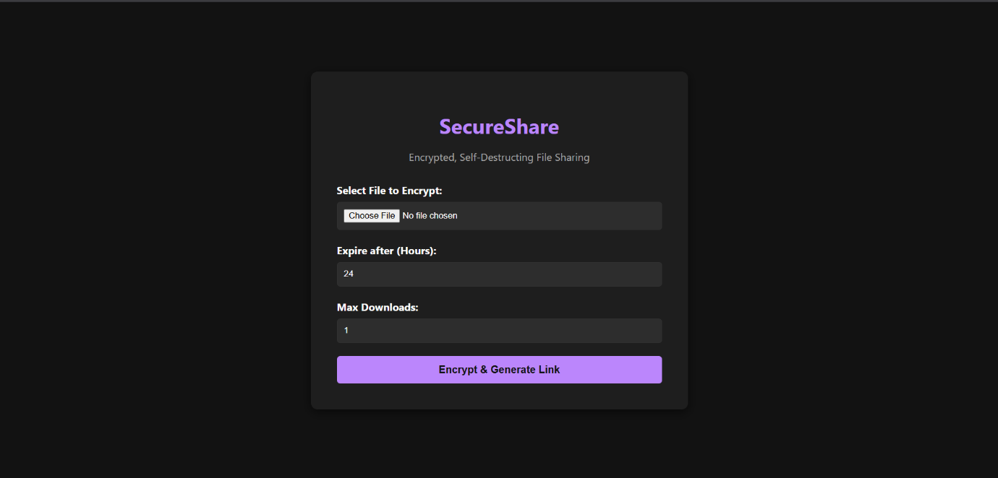
The frontend was designed with minimal friction in mind. Served natively from the .NET wwwroot folder, it provides a responsive, dark-themed dashboard.

Workflow:
- The user selects a file and defines the security parameters (e.g., Expire in 24 hours, Max Downloads: 1).
- The asynchronous JavaScript fetch() API transmits the payload to the server.
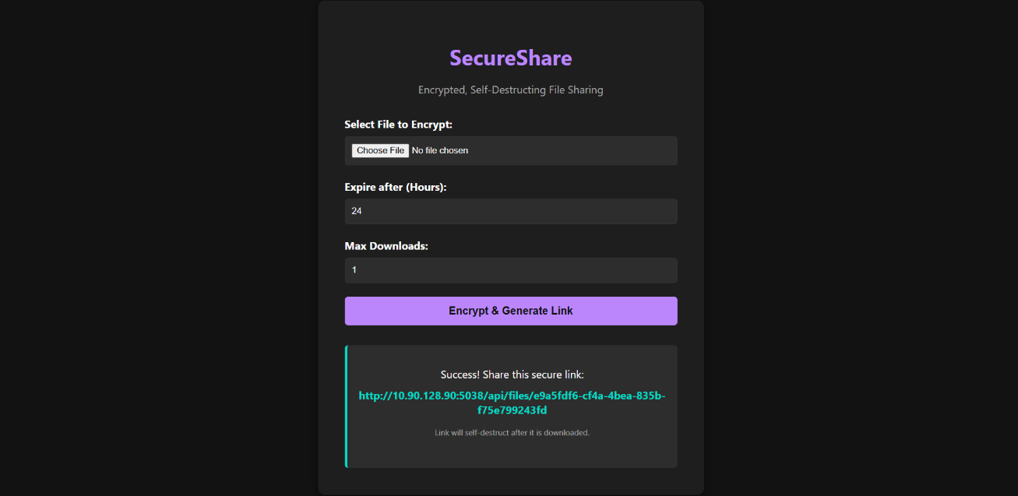
- Upon successful encryption, the UI presents the secure URL, which the user can copy to their clipboard.

8. Testing & Validation
The system underwent rigorous manual testing to ensure edge cases were handled gracefully:
- Validation Testing: Submitting invalid data types (e.g., decimal values for hours) correctly triggers a 400 Bad Request prior to backend processing.
- Expiration Testing: A file set to 1 maximum download was accessed. The first request yielded a 200 OK and successfully decrypted the file. A subsequent request made 1 second later yielded a 404 Not Found, verifying the self-destruct logic.
- Data Integrity: Files of various formats (.txt, .pdf, .png) were uploaded and downloaded to ensure the CryptoStream did not corrupt file encoding during the encryption/decryption cycle.

9. Future Scope & Azure Cloud Integration
While the current iteration of SecureShare operates highly efficiently on a local server environment, the Clean Architecture design perfectly positions the application for enterprise scalability. Future enhancements will focus on Microsoft Azure integration:
- Azure Blob Storage: Because the storage logic is abstracted behind the IFileStorageService interface, the local hard drive storage can be replaced with an AzureBlobStorageService. This will allow the system to handle massive, concurrent file uploads globally.
- Azure Key Vault: To achieve a strict Zero-Trust security model, the AES-256 keys and Initialization Vectors can be decoupled from the SQL Database and moved into Azure Key Vault, ensuring the encrypted data and the keys to unlock them are stored in entirely different physical architectures.
- Automated Physical Deletion: Implementation of a background worker service (e.g., .NET IHostedService or Hangfire) to periodically scan the database for expired FileRecords and permanently purge the physical encrypted blobs from the storage medium, optimizing server costs.

10. Conclusion
SecureShare .NET successfully demonstrates the integration of advanced cryptographic principles within a modern web framework. By prioritizing data ephemerality, unpredictable routing, and decoupled architecture, the project provides a highly secure alternative to traditional file sharing. The development of this application proved that complex security requirements, such as real-time stream encryption and deterministic self-destruction, can be implemented efficiently without compromising system performance or user experience.

