**30 EPOCHES TRAINED WITH 25 SEQUENCE LENGTH AND SPLIT 10**

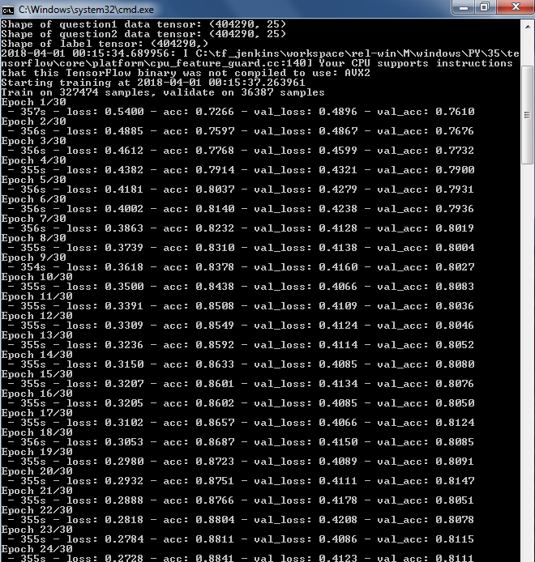

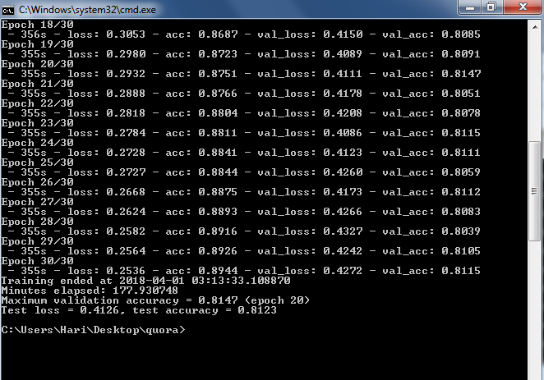

OUTPUT.CSV

