**EX:No.4 221501034**

**04/03/25**

**IMPLEMENT AN PYTHON PROGRAM TO CHECK STATIONARY OF TIME SERIES DATA**

**AIM:**

To implement linear regression model using time series dataset.

**PROCESS:**

import pandas as pd

import numpy as np

import matplotlib.pyplot as plt

from statsmodels.tsa.stattools import adfuller

# Load the dataset

file_path = 'AAPL.csv'

data = pd.read_csv(file_path)

# Ensure column names are clean

data.columns = data.columns.str.strip()

# Convert 'Date' to datetime and set it as index

data['Date'] = pd.to_datetime(data['Date'])

data.set_index('Date', inplace=True)

# Check for 'Adj Close' column

if 'Adj Close' not in data.columns:

raise KeyError("'Adj Close' column not found in the dataset.")

# Access the 'Adj Close' column

price_data = data['Adj Close']

# Handle missing values

price_data.fillna(price_data.mean(), inplace=True)

# Handle outliers using IQR

Q1 = price_data.quantile(0.25)

Q3 = price_data.quantile(0.75)

IQR = Q3 - Q1

lower_bound = Q1 - 1.5 * IQR

upper_bound = Q3 + 1.5 * IQR

filtered_data = price_data[(price_data >= lower_bound) & (price_data <= upper_bound)]

# Plot the time series

plt.figure(figsize=(10, 6))

plt.plot(filtered_data)

plt.title('AAPL Adjusted Close Price (Filtered)')

plt.xlabel('Date')

plt.ylabel('Price')

plt.grid(True)

plt.show()

# Perform ADF Test

result = adfuller(filtered_data)

# Print results

print("ADF Test Results:")

print(f"ADF Statistic: {result[0]}")

print(f"p-value: {result[1]}")

print(f"Critical Values: {result[4]}")

# Interpretation

if result[1] <= 0.05:

print("The series is likely stationary (p-value <= 0.05).")

else:

print("The series is likely non-stationary (p-value > 0.05).")

**OUTPUT:**

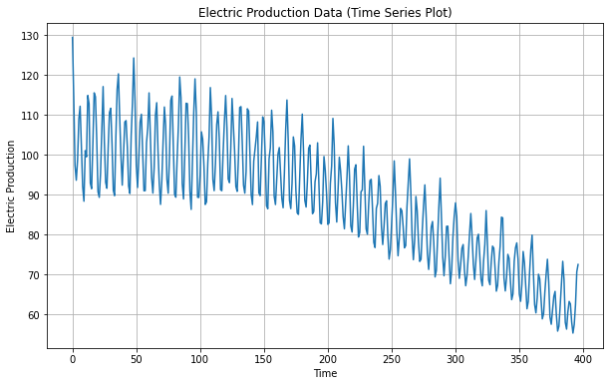

**RESULT:**

The program to implement of program to check stationary or not is created and executed successfully.