**EX:No.6 221501034**

**15/04/25**

**IMPLEMENT PROGRAM TO APPLY MOVING AVERAGE SMOOTHING FOR DATA PREPARATION AND TIME SERIES FORCASTING.**

**AIM:**

To Implement programs for Implement program to apply moving average smoothing for data preparation and time series forecasting

**ALGORITHM:**

OBJECTIVE: Smooth the electric production data to reduce noise, highlight trends, and prepare for forecasting.

BACKGROUND:

1.Time series data has short-term fluctuations.

2.Moving average reduces noise and clarifies trends.

3.Smoothed data improves forecast accuracy and interpretability.

SCOPE OF THE PROGRAM:

1.Load and clean dataset

2.Convert date column to datetime

3.Aggregate data monthly and yearly

4.Apply 3-month and 12-month moving averages

5.Plot original vs smoothed data

ALGORITHM:

1.Import libraries

2.Load dataset

3.Preprocess and set datetime index

4.Resample data (monthly, yearly)

5.Apply 3-month & 12-month smoothing

6.Visualize results

**.**

**PROCESS:**

import pandas as pd

import matplotlib.pyplot as plt

**# Load the dataset**

df = pd.read_csv("/mnt/data/Electric_Production.csv")

**# Display first few rows**

print("First 5 rows of dataset:")

print(df.head())

**# Convert 'DATE' column to datetime format**

df['DATE'] = pd.to_datetime(df['DATE'])

**# Set 'DATE' as the index**

df.set_index('DATE', inplace=True)

**# Rename column if needed**

df.rename(columns={df.columns[0]: 'Electric_Production'}, inplace=True)

**# Resample the data to monthly (if needed; currently weekly/monthly)**

df_monthly = df['Electric_Production'].resample('M').mean()

**# Apply Moving Average Smoothing (e.g., 12-month window)**

window_size = 12

df_smooth = df_monthly.to_frame(name='Electric_Production')

df_smooth['Moving_Avg'] = df_smooth['Electric_Production'].rolling(window=window_size).mean()

**# Plot the original and smoothed series**

plt.figure(figsize=(14, 6))

plt.plot(df_smooth['Electric_Production'], label='Original Electric Production', alpha=0.4)

plt.plot(df_smooth['Moving_Avg'], label=f'{window_size}-Month Moving Average', color='red')

plt.xlabel("Date")

plt.ylabel("Electric Production")

plt.title("Electric Production Trend Estimation using Moving Average Smoothing")

plt.legend()

plt.tight_layout()

plt.show()

**OUTPUT:**

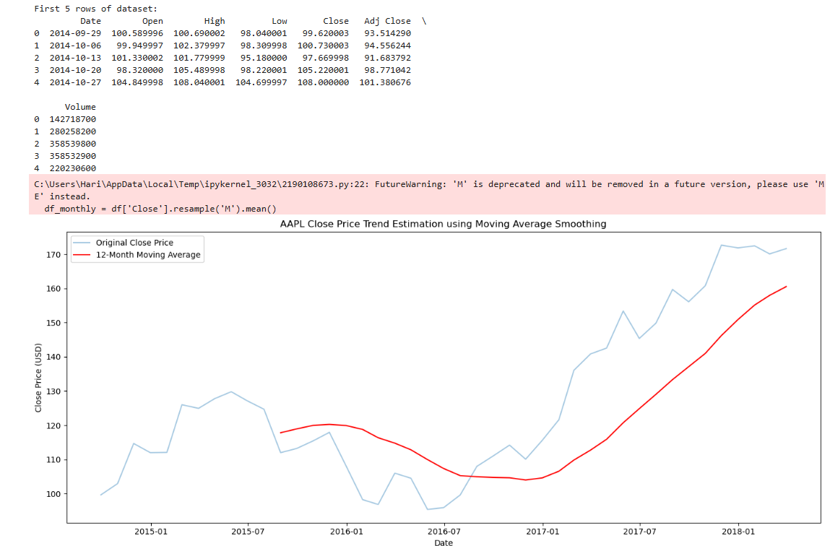

**RESULT:**

The program to Implement program to apply moving average smoothing for data preparation and time series forecasting is implemented successfully.