This is a great idea. Documentation is the backbone of any engineering project, especially before you start testing.
Here is your Phase 1 Completion Report & Testing Guide. You can save this as PHASE_1_REPORT.md in your project root.

📋 Phase 1 Completion Report: Observability & Detection Framework
Project: Anomaly Detection Agent POC
Status: Phase 1 (Data & Detection) - COMPLETE
Architecture Pattern: Sidecar Observability (Medallion Architecture)
1. Architecture Overview
We successfully implemented a Separation of Concerns architecture. The Data Ingestion (ETL) is now completely decoupled from Data Monitoring (Detection).
- Old Flow: ETL Script $\rightarrow$ Injects Data $\rightarrow$ ETL Script Logs Error (Bad Practice)
- New Flow: ETL Script $\rightarrow$ Injects Data $\rightarrow$ Trigger calls Detector $\rightarrow$ Detector Logs Error (Best Practice)
2. Directory Structure (Final State)
This is the layout of your project as of now:
project_root/
├── db/
│ ├── connection.py # Robust, absolute-path SQLite connection
│ ├── init_db.py # Creates 'anomaly_audit_log' table
│ └── utils.py # Utility function 'log_anomaly' (The writer)
│
├── etl/ # [THE CHAOS LAYER] - Pure Ingestion
│ ├── load_spike_volume.py # Scenario: 50x traffic spike
│ ├── load_drop_volume.py # Scenario: 99% traffic drop
│ ├── load_null_injection.py # Scenario: 40% NULLs (DQ)
│ ├── load_duplicates.py # Scenario: Double payments (DQ)
│ ├── load_late_data.py # Scenario: 3-day lag (SLA)
│ ├── load_outlier_value.py # Scenario: $1M Price + JOIN Logic
│ ├── load_deletion.py # Scenario: Accidental Data Loss (New)
│ └── load_trend_shift.py # Scenario: Sustained 5x baseline (New)
│
├── anomaly/ # [THE POLICE LAYER] - Detection
│ ├── rules.py # Configuration file (Thresholds & Limits)
│ └── detector.py # Logic that scans Bronze & logs violations
│
├── scripts/
│ └── trigger.py # Orchestrator (Runs ETL -> Then runs Detector)
│
├── olist.sqlite # The Database
├── .env # Config (DB_PATH)
└── README.md

3. Key Technical Achievements
A. Infrastructure & Connectivity
- Robust Paths: Modified db/connection.py using sys.path and os.path to ensure scripts run correctly from any directory.
- Centralized Logging: Created db/utils.py. The detector uses this standardized function to write to SQLite, ensuring the schema (source, category, severity, meta_data) is always respected.
B. ETL Refactoring (The Cleanup)
- Removed Inline Logging: We went through the original 6 scripts and removed log_anomaly(). They now purely focus on data manipulation.
- Implemented Complexity (JOIN): Updated load_outlier_value.py to JOIN order_items with products. The outlier ($1M price) is now conditionally injected only for the 'beleza_saude' category.
C. Scope Expansion (New Anomalies)
We added two sophisticated scenarios suggested by your lead:
- Deletion (Data Loss): load_deletion.py deletes 40% of bronze_payments.
- Trend Shift: load_trend_shift.py creates a sustained 5x volume increase (not a spike, but a "new normal").
D. The Rule Engine
- anomaly/rules.py: A dictionary-based configuration. If you need to change a threshold (e.g., max price from 50k to 100k), you edit this file, not the code.
- anomaly/detector.py: A unified script that runs 3 types of checks:
  - Volume: Spikes, Drops, Deletions, Trend Shifts.
  - Data Quality: Nulls, Duplicates, Outliers.
  - SLA: Data Latency / Freshness.
What is the use of Trigger
- You type: python etl/load_spike_volume.py (Wait for it to finish...)
- Then you type: python anomaly/detector.py (To catch the spike)
- Then you type: python etl/load_deletion.py (Wait...)
- Then you type: python anomaly/detector.py (To catch the deletion)
With Trigger (The Easy Way):
- You type: python scripts/trigger.py --scenario all
The script automatically runs the specific ETL you asked for, waits for it to finish, and automatically runs the detector right after to capture the result.

Manual Execution (Without Trigger)
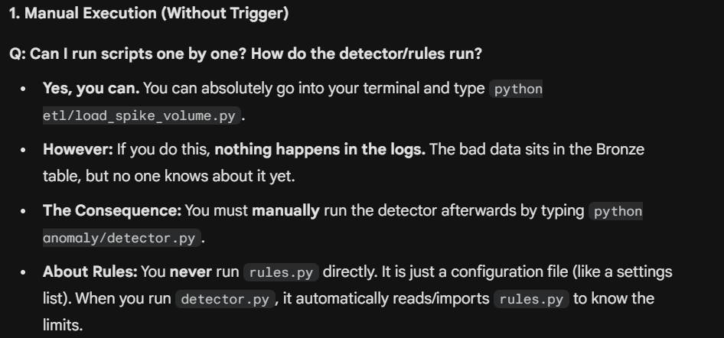
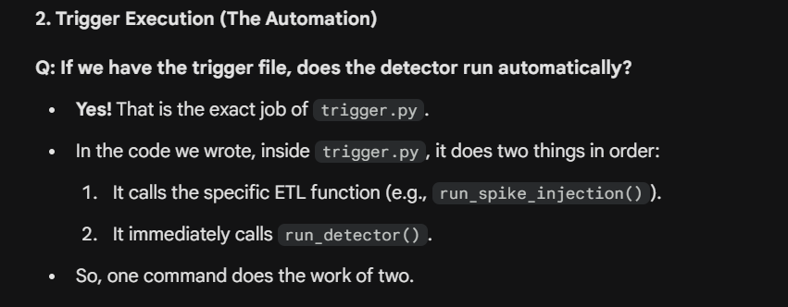
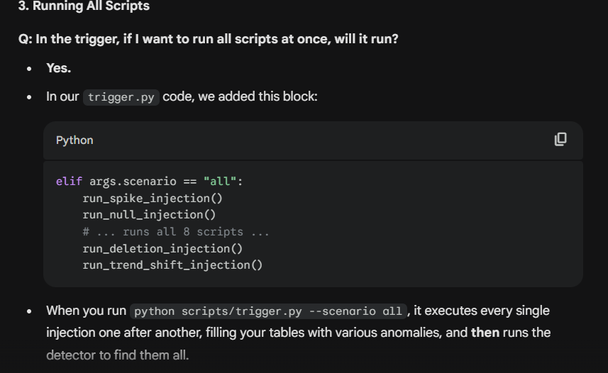
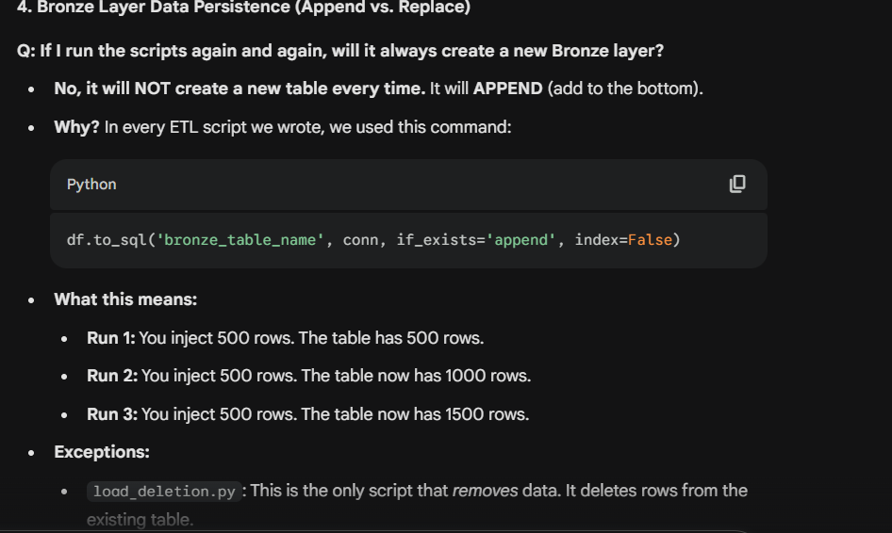

ETL codes buddy
Phase 1 Reference Guide: Data & Detection
1. The ETL Layer (The Chaos Generators)
Location: etl/ Purpose: These scripts inject specific "Bad Data" scenarios into the Bronze Layer to simulate real-world data engineering failures.
# | Script Name | Anomaly Type | Target Table | Description of Logic
1 | load_spike_volume.py | Volume (Spike) | bronze_order_items | Reads source, duplicates data 50x, and appends. Simulates a "Black Friday" traffic burst or infinite loop bug.
2 | load_drop_volume.py | Volume (Drop) | bronze_customers | Reads source, keeps only top 5 rows, discards the rest. Simulates a network timeout or ingestion failure.
3 | load_null_injection.py | Data Quality | bronze_products | Randomly sets 40% of product_category_name to NULL. Simulates a broken upstream mapping or schema change.
4 | load_duplicates.py | Data Quality | bronze_order_payments | Reads source, creates copies of rows, and appends both original and copies. Simulates a "Retry Error" processing the same file twice.
5 | load_late_data.py | SLA (Latency) | bronze_orders | Manipulates timestamps to be 3 days old, then loads them as "new". Simulates a stuck pipeline processing old logs.
6 | load_outlier_value.py | Data Quality | bronze_order_items | Complex: Joins order_items + products. Finds "health/beauty" items and sets price to $1,000,000. Simulates a decimal point error ("Fat Finger").
7 | load_deletion.py | Volume (Loss) | bronze_order_payments | Destructive: Deletes 40% of existing rows in the table. Simulates an accidental DELETE or bad merge strategy.
8 | load_trend_shift.py | Volume (Trend) | bronze_order_items | Multiplies volume 5x (sustained). Not enough to be a spike, but enough to shift the baseline. Simulates organic growth or bot traffic.

2. The Detection Layer (The Police)
Location: anomaly/ Purpose: Scans the Bronze tables immediately after ingestion to catch the issues created above.
A. rules.py (The Law Book)
This file contains static configuration. It defines the "Safe Limits" for your data.
- Volume Rules:
  - Max Rows (Spike): 2000
  - Max Batch (Trend Shift): 200
  - Min Rows (Drop): 10
  - Min Total Rows (Deletion): 1000
- DQ Rules:
  - Max Null %: 5%
  - Max Duplicates: 0
  - Max Price: $50,000
- SLA Rules:
  - Max Latency: 60 minutes
B. detector.py (The Officer)
This is the logic script that enforces the rules.
- Safety Check: It uses table_exists() to ensure it doesn't crash if a table is missing.
- Fetch: It runs SQL queries (e.g., SELECT COUNT(*), SELECT MIN(timestamp)) against Bronze.
- Compare: It compares the SQL result vs. rules.py.
- Log: If a rule is broken, it calls db.utils.log_anomaly to write a record to the database.

3. The Orchestration (The Remote Control)
Location: scripts/trigger.py Purpose: Automates the flow.
- Workflow:
  - User selects scenario (e.g., --scenario all).
  - Trigger runs the specific ETL script(s).
  - Trigger immediately runs detector.py.
- Benefit: Ensures that every time you inject chaos, you immediately detect it.

4. The Storage (The Evidence)
Location: olist.sqlite (Table: anomaly_audit_log) Purpose: A persistent log of every error found.
Schema:
- event_timestamp: When the detection happened.
- source_table: Where the error is.
- anomaly_category: Volume, Data_Quality, or SLA.
- metric_value: The actual number (e.g., 10,000 rows).
- severity: CRITICAL or WARNING.

✅ Phase 1 Status
- Code: Clean, Refactored, Robust.
- Testing: Verified via trigger.py and check_logs.py.
- Ready for Phase 2: Yes.
We are now perfectly positioned to build The Agent. The Agent will simply look at the anomaly_audit_log, read the last few "CRITICAL" entries, and convert them into natural language explanations.
Are you ready to start coding the Agent's Context Fetcher?
To answer your question: We have 3 Phases in total.
- Phase 1: Data & Detection (The Backend Logic) ✅ DONE
  - What we did: Built the plumbing. Bad data flows in, Detector catches it, Logs are written to DB.
- Phase 2: The Agent API (The Brain) 🚧 CURRENT
  - What we will do: Build the Python service that reads the logs, thinks about them (using an LLM), and speaks back.
- Phase 3: The User Interface (The Face) 🔮 NEXT
  - What we will do: Build the Chat UI (Streamlit or Gradio) and the Dashboard (Grafana) so a human can interact with the system.

