Call ai
The call_ai.py file is the central, low-level communication gateway for the entire application. It is the only place in the entire codebase that talks directly to the Azure OpenAI service (GPT-4). Connection Management: It establishes a secure, robust connection to the Azure OpenAI endpoint using stored credentials.
• Request Standardization: It wraps the user's prompt (the question) and the agent's instructions (the system message) into a formal API call.
• Cost and Error Handling: It measures the token usage (for cost tracking) and implements retry logic for API errors like Rate Limits.
---maincode---
• import os: Used to read sensitive keys (like API keys) from the operating system environment.
• import time: Used in the error handling section to make the script "sleep" (wait) before retrying if the API is busy.
• import httpx: This is a robust HTTP client. It is used here specifically to handle custom network settings (like bypassing SSL verification in corporate environments).
• import tiktoken: This is OpenAI's official library for counting tokens. It helps you calculate costs before or during the call.
• from dotenv import load_dotenv: Loads the .env file where your secrets (API Keys) are stored so they aren't hardcoded in the script.
• from openai import AzureOpenAI: The specific class needed to talk to the Azure version of GPT-4, which is different from the standard OpenAI version.
This helper function calculates how "expensive" a request was. Purpose: It takes the text you sent (System + User) and the text the AI replied with (full_response), and converts them into "tokens" (the unit OpenAI charges for).

The Main Function (call_ai)
This is the function that the Agents (Profiler, Validator, etc.) actually call. verify=False: Critical Line. This tells the HTTP client to ignore SSL certificate errors.
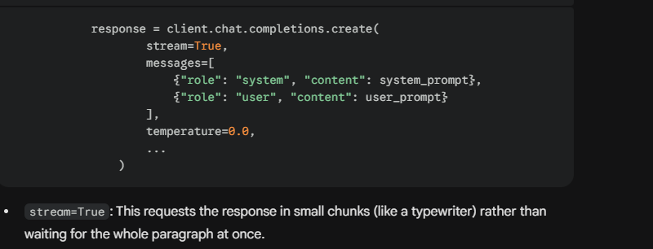
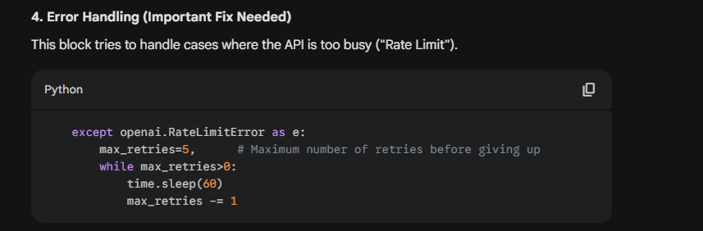

Data Profiler
the Muscle of the operation. It combines strict Python calculation (using Pandas) with AI reasoning (using GPT-4).
---main code---
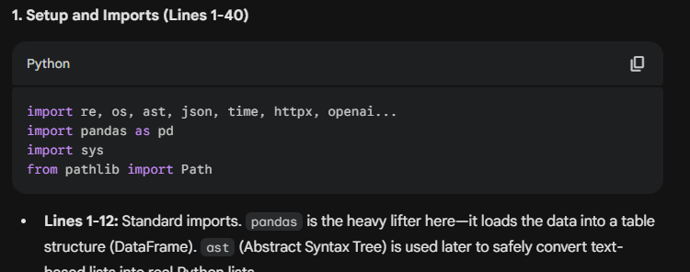
External Imports (Lines 19-24):
- from tools.shared.prompts import *: Imports the text templates we send to the AI.
- from tools.shared.call_ai import call_ai: Imports the connection function we analyzed in the previous file.
- from tools.data_profiler_tool.rules import ...: Imports the strict validation logic (Email regex, Date formats). (We will discuss this in the Loop section).
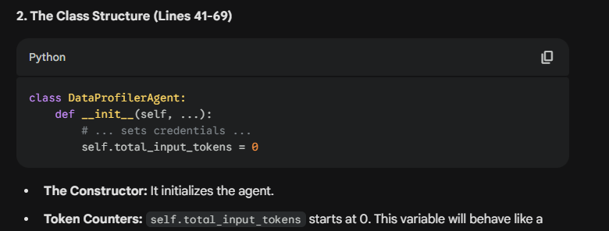
The Helper Functions (Lines 71-129)
These functions act as translators between the raw data and the AI.
_count_tokens (Lines 71-76)
- Calculates the cost of a text string using tiktoken.
call_ai (Lines 79-111)
- Wrapper: This creates a local version of call_ai that adds token tracking.
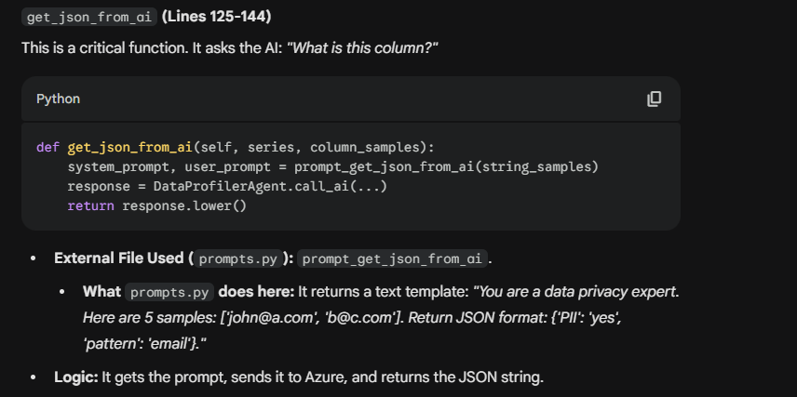
get_data_recommendations (Lines 146-163)
- Similar to above, but this runs at the end. It sends the entire profile summary to the AI and asks for business advice.
- External File Used (prompts.py): prompt_get_data_recommendations.
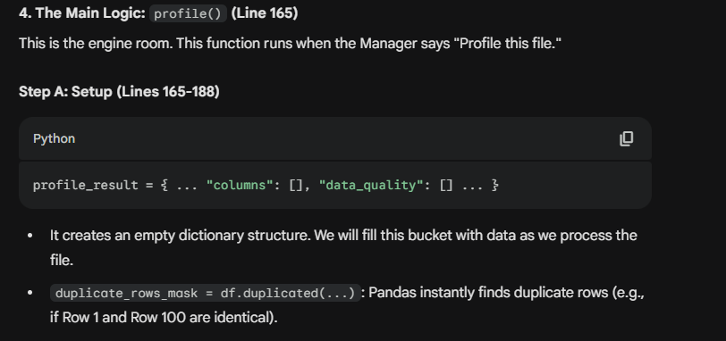
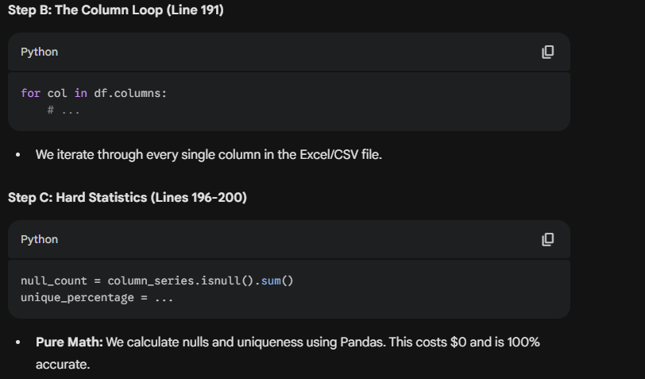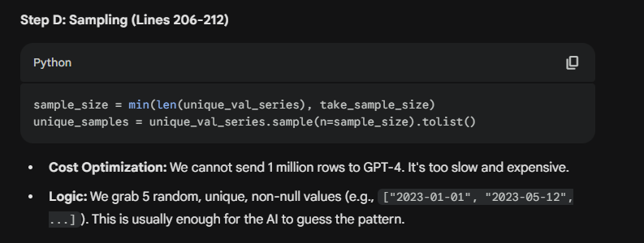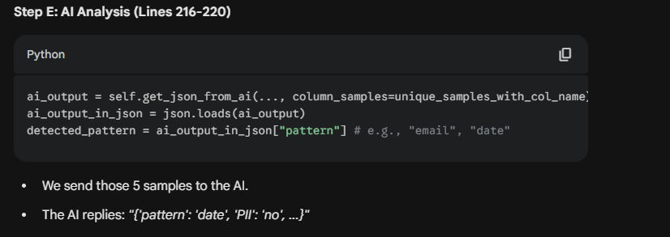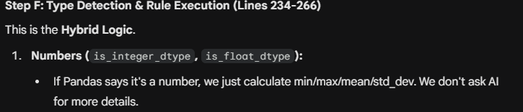
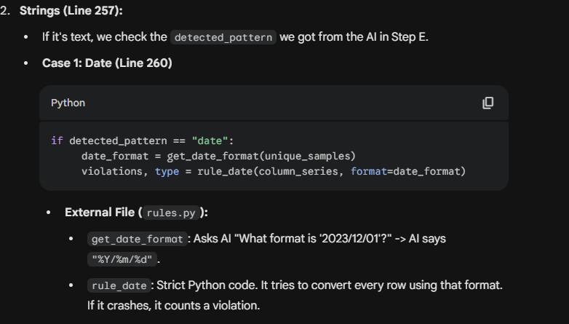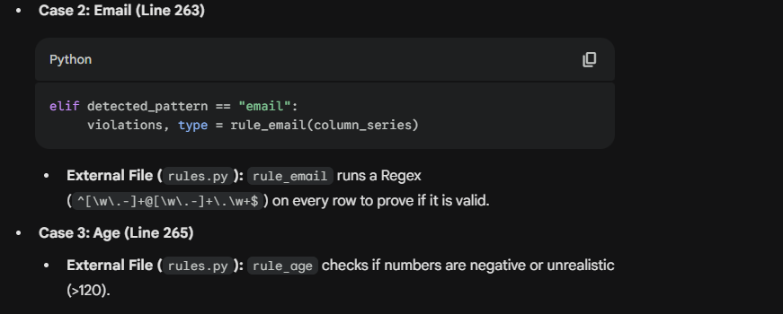
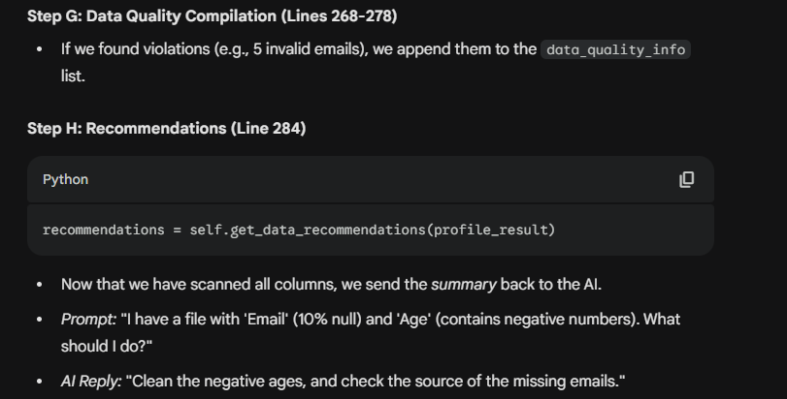
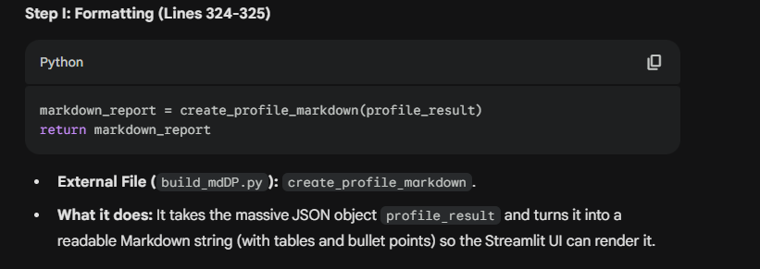

App
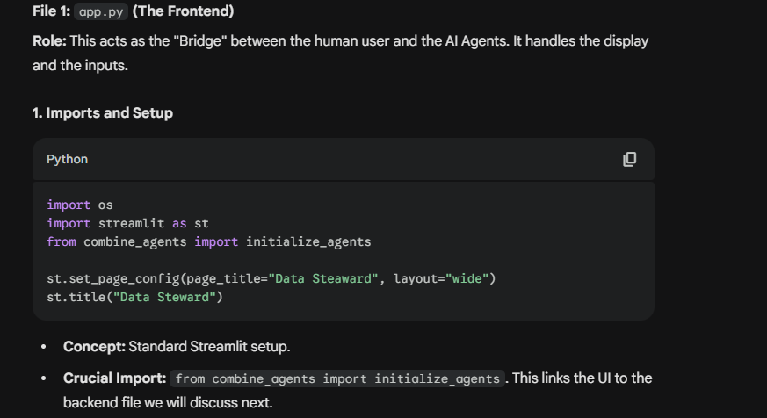
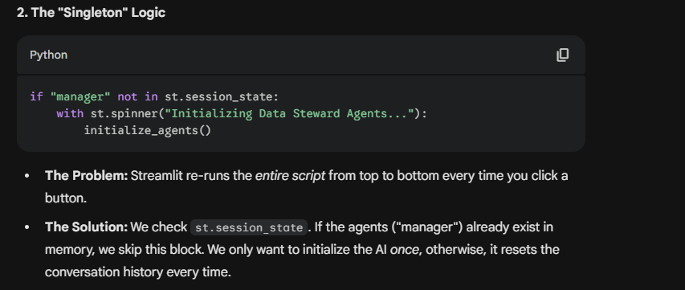
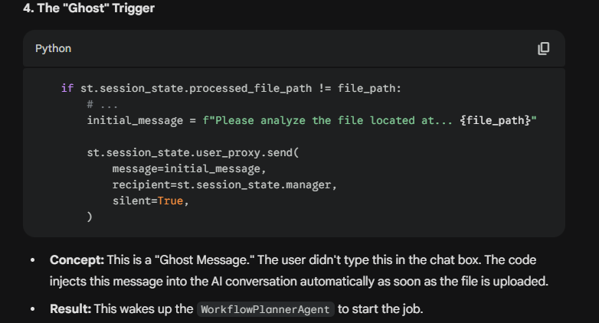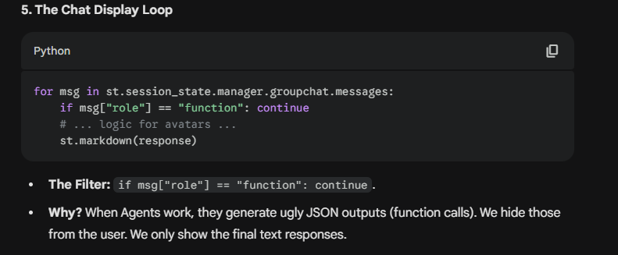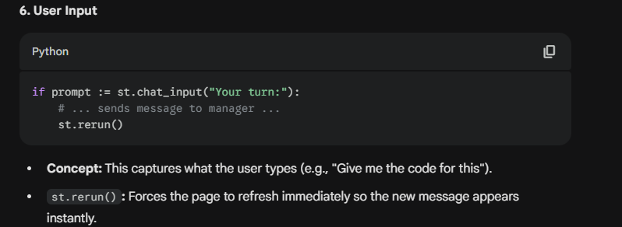

Combine agent
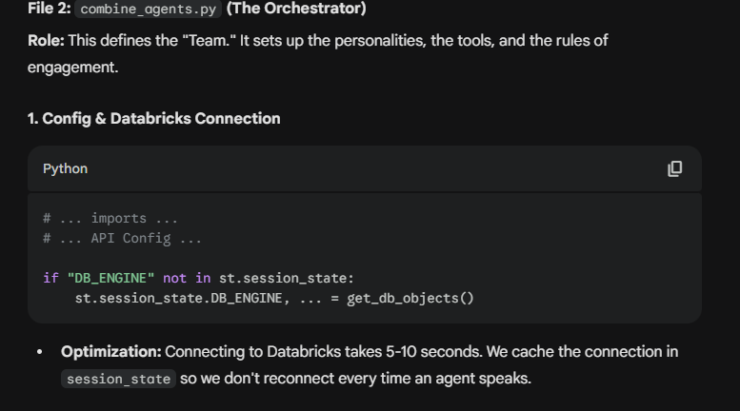
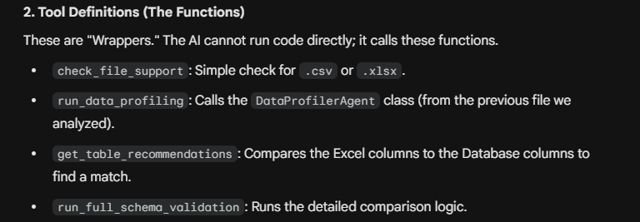
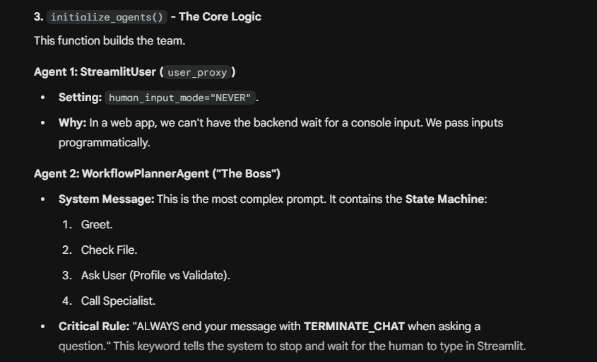
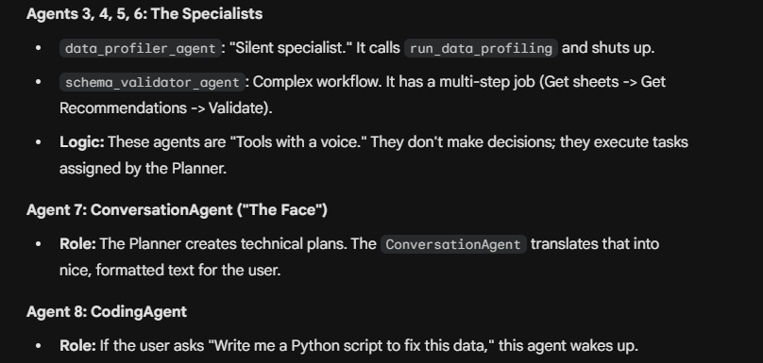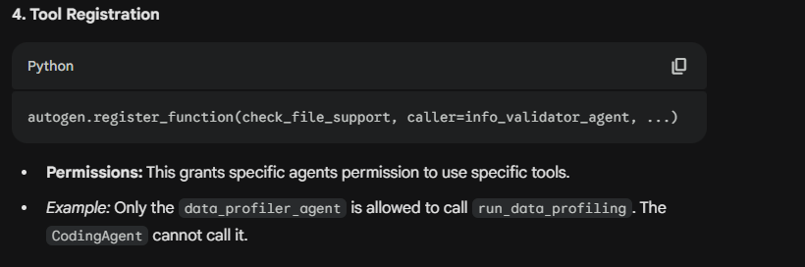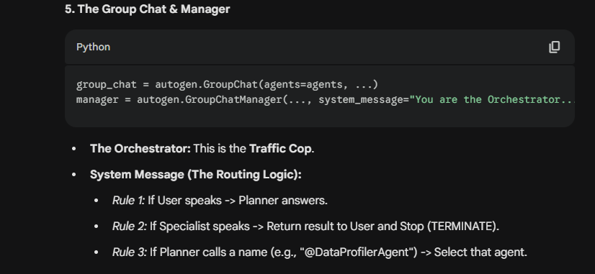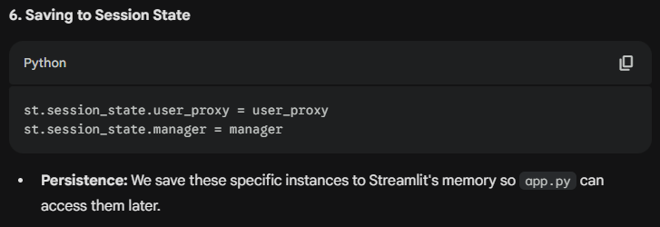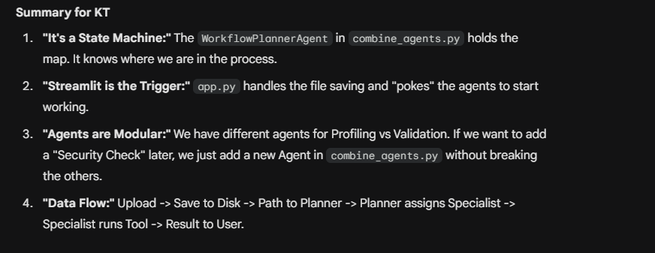

Insight Recommender agent
querying.py
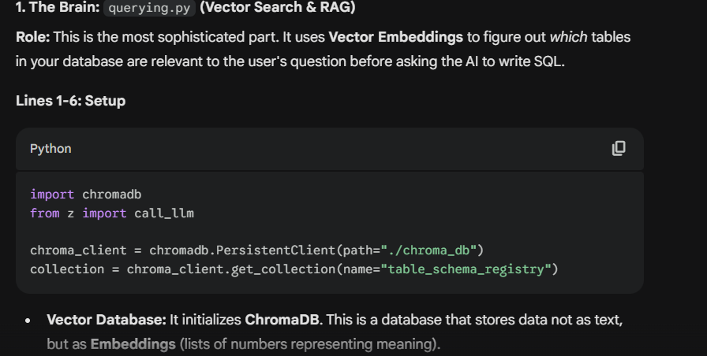
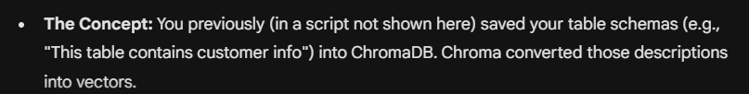
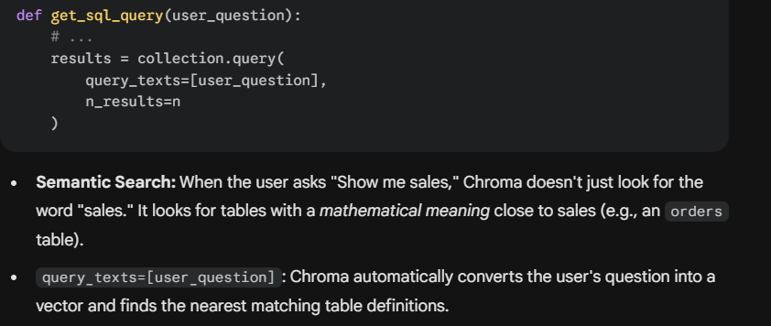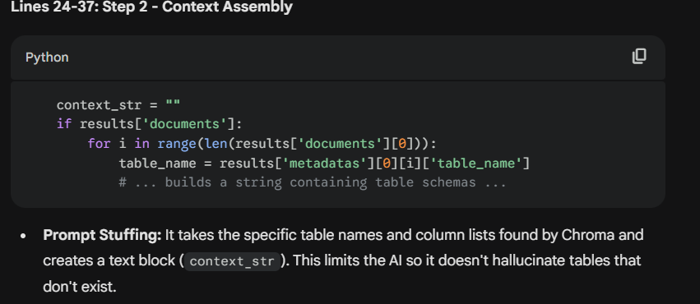
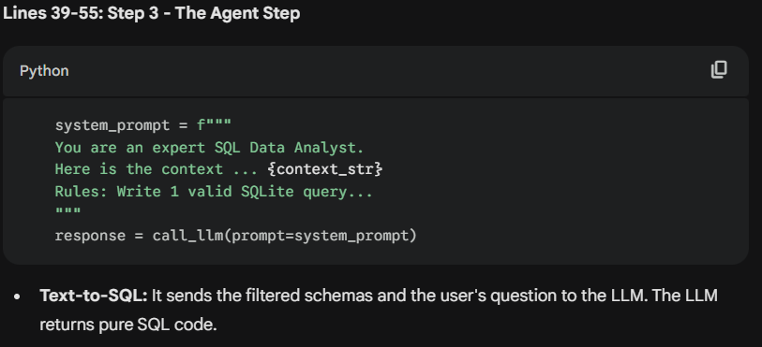

ZZZ
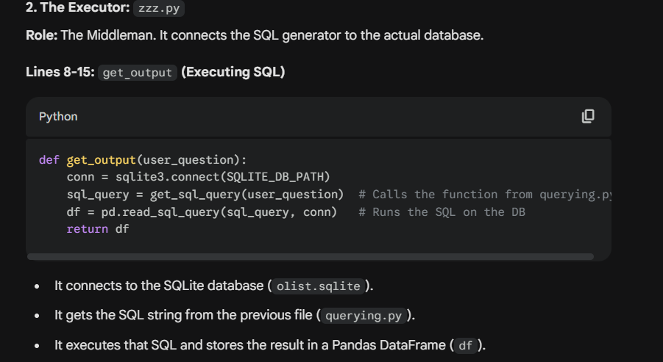
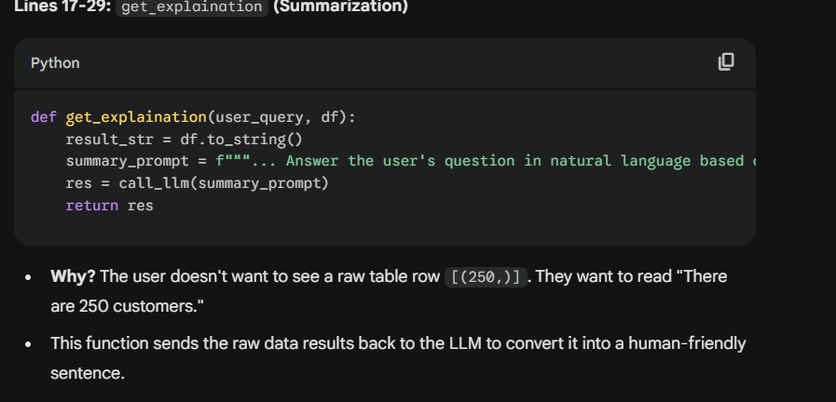
IRA_app.py
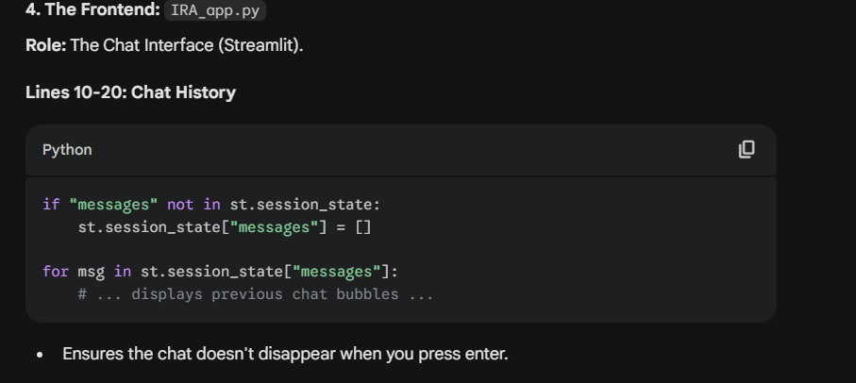
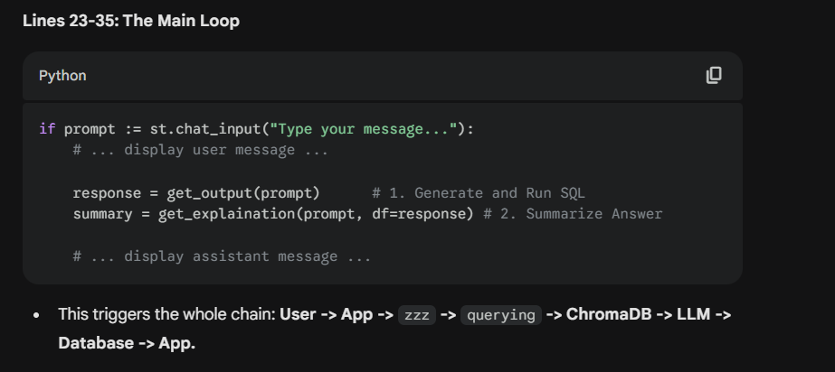
Crawler.py
