Alliance University
Alliance College of Engineering and Design
Micro-project Report
MATLAB-Based Public-Key Cryptography and Secure Communication Using Group Theory and Modular Arithmetic
Sets, Relations and Functions · Graph Theory · Group Theory · Diffie–Hellman Key Exchange · RSA
Team members
Santanu Barua · M Hariharan · Kushi Pathak
P Abdul Wasim · Someshwar A · Adithya Sampath Kumar
Contents
Abstract 3
1 Introduction 4
1.1 Problem and motivation 4
1.2 Objectives 4
1.3 Scope and what is not claimed 4
1.4 Organisation of the report 4
2 Mathematical background 5
2.1 Sets, relations and functions 5
2.2 Graph theory 5
2.3 Modular arithmetic 6
2.4 Group theory 6
2.5 The Diffie–Hellman key exchange 6
2.6 The RSA cryptosystem 7
3 System design 8
3.1 The users and the network 8
3.2 Architecture of the modules 8
4 Implementation 10
4.1 Code organisation and style 10
4.2 The cipher with the key (module sets_relations_functions) 10
4.3 The graph (module graph_network) 10
4.4 Modular arithmetic and the group (module group_theory) 10
4.5 Diffie–Hellman and encryption (modules diffie_hellman, encryption) 11
4.6 The secure network and the routing (module integration) 11
4.7 The eavesdroppers 12
4.8 RSA (module rsa) 12
5 Results and verification 14
5.1 The test suite 14
5.2 The Diffie–Hellman key exchange 14
5.3 Encryption with the shared key 15
5.4 The network at work 16
5.5 Verification by a second method 16
5.6 RSA results 18
5.7 Figures of the network 18
6 Security analysis and limitations 21
7 Conclusion and future work 22
References 22
Appendix A: How to run the project 23
Appendix B: The code, file by file 24

Abstract
This project builds a small but complete simulation of secure communication in MATLAB. A network of six users (Alice, Bob, Carol, Dave, Frank and Grace) is joined by six communication channels. Every channel is protected by its own secret key, and that key is never sent: the two users at the ends of the channel create it with the Diffie–Hellman key exchange in the cyclic group $Z_{97}^{*}$. The key then drives a cipher, and a message travels hop by hop along the shortest path found by breadth-first search. RSA public-key encryption is added as a second use of the same mathematics, including the transport of a cipher key under an RSA public key.
Four areas of discrete mathematics are used as working tools and not only as theory: sets, relations and functions model users, symbols, keys and the cipher; graph theory models and analyses the network; group theory and modular arithmetic give the key exchange and RSA; and number theory (Euclid’s algorithm, fast exponentiation, Lagrange’s theorem) supplies the algorithms. The code has 116 files (about 4,650 lines of base MATLAB with no toolboxes), a test suite of 1,094 automatic checks in 14 test files that all pass in GNU Octave 8.4, and a verification layer that checks every important result a second way with code that shares nothing with the part it checks. Eavesdroppers are simulated on purpose: they break the small examples, which shows why real systems need large numbers. The project is an educational model and not a security product.
Keywords: Diffie–Hellman, RSA, cyclic group, modular arithmetic, graph theory, secure communication, MATLAB.

1 Introduction

1.1 Problem and motivation
Two people who have never met cannot simply agree on a secret key if every message between them can be read by others. This is the key-distribution problem, and the answer of public-key cryptography is surprising: the people can build a shared secret in public, because the operation that makes the secret is easy in one direction and very hard to reverse. Diffie and Hellman showed this for exponentiation in a finite group [1], and Rivest, Shamir and Adleman showed a second way, in which a public key encrypts and only a private key decrypts [2].
Both ideas rest on topics of a course in discrete mathematics. This micro-project connects them. The aim is to see a topic of the course working inside one program, so that a number such as the key 85 can be followed from a group, through an algorithm, to a message that arrives on the other side of a network.

1.2 Objectives
- Model users, messages, keys and the cipher with sets, relations and functions, and test the properties of these objects (reflexive, symmetric, transitive, one-to-one, onto).
- Model the communication network as a graph and analyse it: adjacency matrix and list, connectivity, shortest paths, cycles, bridge channels and cut users.
- Implement modular arithmetic from first principles: fast exponentiation, Euclid’s algorithm, the extended algorithm and the modular inverse.
- Study the group $Z_{97}^{*}$: check the group rules, find orders, generators and cyclic subgroups.
- Implement the Diffie–Hellman key exchange, use the shared key in a cipher, and run a secure network in which every channel has its own key.
- Implement RSA as a second public-key method and compare it with Diffie–Hellman.
- Test and verify the whole system, and simulate eavesdroppers to show what the small numbers do not protect.

1.3 Scope and what is not claimed
All numbers are small (the prime is 97, the RSA modulus is 3233) so that every step can be followed and checked by hand. The cipher $E_{k}\left(m\right)=k⋅m mod 97$ has only 96 keys and is a learning model. RSA is used in its plain “textbook” form without padding, on purpose, so that its weaknesses can be shown. The project does not protect real data and must not be used for that (Section 6).

1.4 Organisation of the report
Section 2 gives the mathematics. Section 3 describes the design of the system and Section 4 its implementation. Section 5 presents the results, the tests and the verification. Section 6 discusses security and the limits of the model, and Section 7 concludes. Appendix A explains how to run the project and Appendix B lists the code.

2 Mathematical background

2.1 Sets, relations and functions
The model starts with four sets. The set of users is $U=\{\text{Alice},\text{Bob},\text{Carol},\text{Dave},\text{Frank},\text{Grace}\}$. The alphabet is the 95 printable ASCII characters (space to ~); a character with code $c$ is the plaintext symbol $c−31$, so the set of plaintext symbols is $P=\{1,…,95\}$. The set of keys is $K=\{1,…,96\}$ and the set of ciphertext values is $C=\{1,…,96\}$. The value 96 belongs to $C$ but is not a plaintext symbol, which is how a wrong key can be noticed (Section 4.2).
A relation $R⊆A×A$ is reflexive if $\left(a,a\right)∈R$ for all $a$, symmetric if $\left(a,b\right)∈R⇒\left(b,a\right)∈R$, antisymmetric if $\left(a,b\right),\left(b,a\right)∈R⇒a=b$ and transitive if $\left(a,b\right),\left(b,c\right)∈R⇒\left(a,c\right)∈R$. Two relations are used. $R_{1}$, “can talk with”, holds for the six channels in both directions; it is symmetric, not reflexive and not transitive, so it is not an equivalence relation (Alice talks with Bob and Bob with Dave, but Alice has no channel to Dave). $R_{2}$, “owns”, pairs each user with one private key.
A function $f:A→B$ is one-to-one if different inputs give different outputs and onto if every element of $B$ is an output. For a key $k∈K$ the encryption $E_{k}\left(m\right)=k⋅m mod 97$ is a function from $P$ to $C$. Because 97 is prime, multiplying by $k$ permutes the non-zero residues, so $E_{k}$ is one-to-one; it is not onto $C$, because $C$ has 96 values and $P$ only 95. Decryption $D_{k}\left(c\right)=j⋅c mod 97$, with $j$ the inverse of $k$ modulo 97, undoes it: $D_{k}\left(E_{k}\left(m\right)\right)=m$.

2.2 Graph theory
A simple undirected graph $G=\left(V,E\right)$ has a set of vertices and a set of edges, each edge a pair of different vertices. Here the vertices are the users and the edges are the channels. The graph is stored as an adjacency matrix $A$ with $A_{ij}=1$ when $i$ and $j$ share a channel, and as an adjacency list. The degree of a vertex is the number of its edges, and the handshake lemma says that
v∈V​degv=2 E.
A path is a sequence of vertices joined by edges, and the distance between two vertices is the number of edges of a shortest path (infinite when there is none). Breadth-first search (BFS) finds shortest paths: it visits the vertices in layers of increasing distance, so the first time it reaches a vertex is by a shortest path. The vertices of one connected piece form a connected component (a “group of users” in the program). A cycle is a closed path, and the number of independent cycles is
$$\text{cycle rank}=\left|E\right|−\left|V\right|+c,$$
where $c$ is the number of components. A bridge is an edge whose removal increases the number of components, and a cut vertex is a vertex with the same property. In a communication network they are the weak points: if a bridge channel breaks, some users can no longer reach each other.
Undirected and directed graphs. A channel carries messages in both directions, and $R_{1}$ is symmetric, so an undirected graph is the right model for this network. A directed graph (with arcs $u→v$) is the right model when traffic or trust goes one way only. The code in this project uses undirected graphs.

2.3 Modular arithmetic
We write $a≡b (mod m)$ when $m$ divides $a−b$. The greatest common divisor is found by Euclid’s algorithm, which repeats $a=qb+r$ and replaces $\left(a,b\right)$ by $\left(b,r\right)$ until $r=0$. The extended algorithm goes back through the steps and produces whole numbers $x,y$ with
$$ax+by=gcd\left(a,b\right).$$
When $gcd\left(a,m\right)=1$ this gives $ax≡1 (mod m)$, so $x mod m$ is the inverse of $a$ modulo $m$; if $gcd\left(a,m\right)≠1$ there is no inverse. For example $gcd\left(85,97\right)=1$ and $85⋅8≡1 (mod 97)$, so the inverse of 85 is 8.
Fast exponentiation. To compute $b^{e} mod m$ the exponent is written in binary and processed from the left: for each bit the running value is squared, and it is multiplied by $b$ when the bit is 1, always reducing mod $m$. For $5^{13} mod 97$ the binary form is 1101 and four squarings give 29, where the plain way needs 12 multiplications. For $5^{96} mod 97$ there are 7 squarings and 2 multiplications instead of 95 multiplications. This makes the large powers of Diffie–Hellman and RSA practical.

2.4 Group theory
A group is a set with an operation that is closed, associative, has an identity and gives every element an inverse. For a prime $p$ the numbers $1,…,p−1$ with multiplication mod $p$ form the group $Z_{p}^{*}$; for $p=97$ it has 96 elements and is commutative. The order of $a$ is the smallest $k≥1$ with $a^{k}≡1$. Lagrange’s theorem says that the order of an element divides the size of the group, so $a^{p−1}≡1$ (Fermat’s little theorem). The order of $a$ is found by starting at $p−1=96=2^{5}⋅3$ and dividing out each prime factor $q$ while $a^{k/q}≡1$ still holds.
An element $g$ is a generator when its order is $p−1$, which holds exactly when $g^{\left(p−1\right)/q}≢1$ for every prime factor $q$ of $p−1$. Then the powers of $g$ run through every element of the group, and the group is cyclic. For $p=97$ the number 5 is a generator, and there are $φ\left(96\right)=32$ generators in all. Every element generates a cyclic subgroup whose size is its order.

2.5 The Diffie–Hellman key exchange
Everybody knows a prime $p$ and a generator $g$. Alice chooses a secret $a$ and sends $A=g^{a} mod p$; Bob chooses $b$ and sends $B=g^{b} mod p$. Alice computes $B^{a}$ and Bob computes $A^{b}$, and
$$B^{a}={\left(g^{b}\right)}^{a}=g^{ab}={\left(g^{a}\right)}^{b}=A^{b} (mod p).$$
Both now hold the key $K=g^{ab} mod p$. An eavesdropper sees $p$, $g$, $A$ and $B$ but not $a$ or $b$. To find $K$ she must find $a$ from $A=g^{a}$, the discrete logarithm problem, for which no fast method is known in large groups. In this project $p=97$ and $g=5$, and the key is a number from 1 to 96, so it is a key of the cipher.

2.6 The RSA cryptosystem
Choose two different primes $p$ and $q$, and put $n=pq$ and $φ\left(n\right)=\left(p−1\right)\left(q−1\right)$. Choose $e$ with $gcd\left(e,φ\left(n\right)\right)=1$ and let $d$ be its inverse modulo $φ\left(n\right)$. The public key is $\left(n,e\right)$ and the private key is $d$; the numbers $p$, $q$ and $φ\left(n\right)$ must also stay secret. Encryption and decryption are
$$c=m^{e} mod n, m=c^{d} mod n.$$
The reason is the group $Z_{n}^{*}$, which has $φ\left(n\right)$ elements. By Lagrange’s theorem $a^{φ\left(n\right)}≡1$ for every $a$ in the group. Since $ed=1+kφ\left(n\right)$, we get ${\left(m^{e}\right)}^{d}=m⋅{\left(m^{φ\left(n\right)}\right)}^{k}≡m$. (The same result holds for the few numbers that share a factor with $n$.) The security rests on the factoring problem: finding $φ\left(n\right)$ from $n$ is as hard as finding $p$ and $q$.

3 System design

3.1 The users and the network
There are six users. The relation $R_{1}$ gives six channels, numbered $e_{1}$ to $e_{6}$ in a fixed order, and the network is connected.
Table 1. The channels of the network and the key of each channel ($p=97$, $g=5$).
Channel | Users | Key (from Diffie–Hellman)
$e_{1}$ | Alice – Bob | 85
$e_{2}$ | Alice – Carol | 12
$e_{3}$ | Bob – Dave | 42
$e_{4}$ | Carol – Dave | 90
$e_{5}$ | Dave – Frank | 32
$e_{6}$ | Frank – Grace | 72
The degrees are 2, 2, 2, 3, 2 and 1 (Alice to Grace), which add up to 12 = 2 × 6, as the handshake lemma requires. The cycle rank is $6−6+1=1$: the only independent cycle is Alice – Bob – Dave – Carol – Alice. The bridge channels are $e_{5}$ (Dave – Frank) and $e_{6}$ (Frank – Grace), and the cut users are Dave and Frank. The shortest route from Alice to Grace is Alice – Bob – Dave – Frank – Grace, with 4 channels.

3.2 Architecture of the modules
The program has seven modules in src/, one folder each. They are built in the order in which the mathematics depends on itself: sets and cipher first, then the graph, then the group theory, then Diffie–Hellman and encryption, and then the integration layer that joins them. RSA is a separate module that reuses the modular arithmetic.
Table 2. The modules of the code (116 files, 4,647 lines in all; the tests add 20 files and 3,654 lines).
Module (folder in src/) | Models | Files | Lines
sets_relations_functions | Users, symbols, keys; $R_{1}$, $R_{2}$; $E_{k}$ and $D_{k}$ | 17 | 434
graph_network | Graph, adjacency matrix and list, BFS, paths, cycles, bridges, pictures | 31 | 931
group_theory | Fast power, gcd, inverse, primes, $Z_{97}^{*}$, orders, generators | 17 | 631
diffie_hellman | Public values, shared keys, key table, eavesdropper on the key exchange | 9 | 225
encryption | Messages with the shared key, eavesdropper on the cipher | 5 | 283
integration | Keys on channels, routing, typed demo, route picture, verification | 17 | 994
rsa | RSA keys, text, users, key transport, eavesdroppers, verification | 20 | 1,149
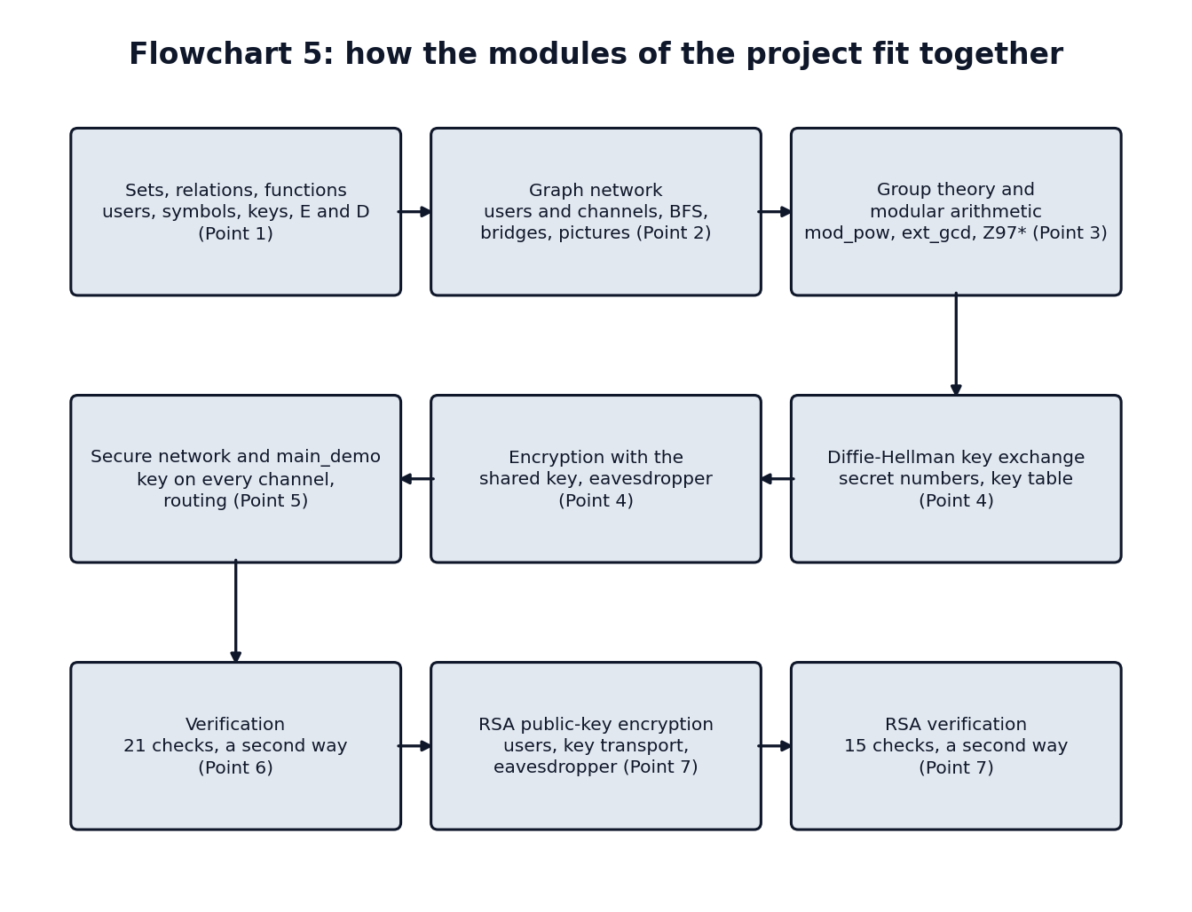
Figure 1. The architecture of the modules and how data moves between them.

4 Implementation

4.1 Code organisation and style
Every function is in its own file, and the file name is the function name. Functions named show_* print a whole part of the result with explanations and a list of self-checks, and each point of the project has a demo_point<N> command that runs these. The code uses only base MATLAB (no toolboxes) and also runs in GNU Octave, with plain ASCII in the files. Pictures are made with base line, fill and text commands. One rule needed care: in MATLAB both operands of && and || must be single true-or-false values, which GNU Octave does not insist on. The first run in MATLAB (R2026b) found one place where all() of a matrix was used as an operand; it was fixed with all(all(...)).

4.2 The cipher with the key (module sets_relations_functions)
encrypt_symbols computes $c=k⋅m mod 97$ and decrypt_symbols computes $m=j⋅c mod 97$ with $j$ from key_inverse. text_to_symbols and symbols_to_text convert between text and symbols. If a decryption gives the value 96 (which is in $C$ but is not a symbol), decrypt_symbols stops with an error. This is what happens with a wrong key, and it lets the program notice a wrong key at once. relation_properties and function_properties test the properties of Section 2.1 from the 0/1 matrix of a relation.

4.3 The graph (module graph_network)
define_graph builds the graph from $R_{1}$ and stores each edge once as $\left[i j\right]$ with $i<j$. bfs_search visits the neighbours of a vertex in increasing order, so the shortest path shown is always the same one. shortest_path, distance_matrix, connected_components, cycle_rank and find_cycle follow the definitions of Section 2.2. bridge_channels and cut_users remove each channel or user in turn and count the components. graph_layout fixes the place of every user (the users are drawn in layers by distance from the first user of a group), so a picture of the same network always looks the same, and draw_network draws the picture. Five pictures are made: the network, the shortest path, a shortest cycle, the weak points (bridges red, cut users orange) and the network after the first bridge is removed.

4.4 Modular arithmetic and the group (module group_theory)
mod_pow is the repeated squaring of Section 2.3. It needs the modulus to be at most $2^{26}$ so that every product stays below $2^{52}$ and the double-precision numbers stay exact. euclid_gcd gives the steps $\left[a b q r\right]$, ext_gcd gives $g$, $x$, $y$ with $ax+by=g$, and mod_inverse uses it and stops with an error when $gcd\left(a,m\right)≠1$. check_group takes any multiplication table and tests closure, identity, inverses, associativity (all triples) and commutativity; applied to $Z_{97}^{*}$ all five rules hold. element_order, is_generator, find_generators and cyclic_subgroup follow Section 2.4. The tests compare the fast method for orders with the plain method of multiplying until the result is 1.

4.5 Diffie–Hellman and encryption (modules diffie_hellman, encryption)
dh_public_value computes $g^{a} mod p$ and dh_shared_key computes $B^{a} mod p$. dh_exchange runs one exchange and checks that both keys agree and equal $g^{ab mod \left(p−1\right)} mod p$. check_dh_setup refuses a $p$ that is not prime and a $g$ that is not a generator. With the default secret numbers (Alice 6, Bob 15, Carol 23, Dave 41, Frank 58, Grace 77) the public values are 8, 46, 82, 80, 44 and 23. send_message lets a sender and a receiver each compute the key from their own secret and the public value of the other, encrypt with one key and decrypt with the other, and report whether the text came back.

4.6 The secure network and the routing (module integration)
define_system joins everything in one structure: the users, the graph, the secrets and the key of every channel (the keys of Table 1). route_message sends a text along the shortest path of the working network, hop by hop; every hop is a send_message with the key of that channel, so a relay decrypts what it gets and encrypts it again with the key of the next channel. If there is no route, the message is not sent, and this is not treated as an error. main_demo is the entry command for the demo: it prints a menu and asks for every answer with typed prompts. The user can send a message (choosing sender, receiver and text), see the key exchange of two users, see the channels and their keys, break a channel, repair the channels, print the whole report, and draw the picture of the network with the route of the last message. The function route_picture_options colours the picture: the route is thick and green, broken channels are dotted and grey, and when the network is split every group of users has its own colour.
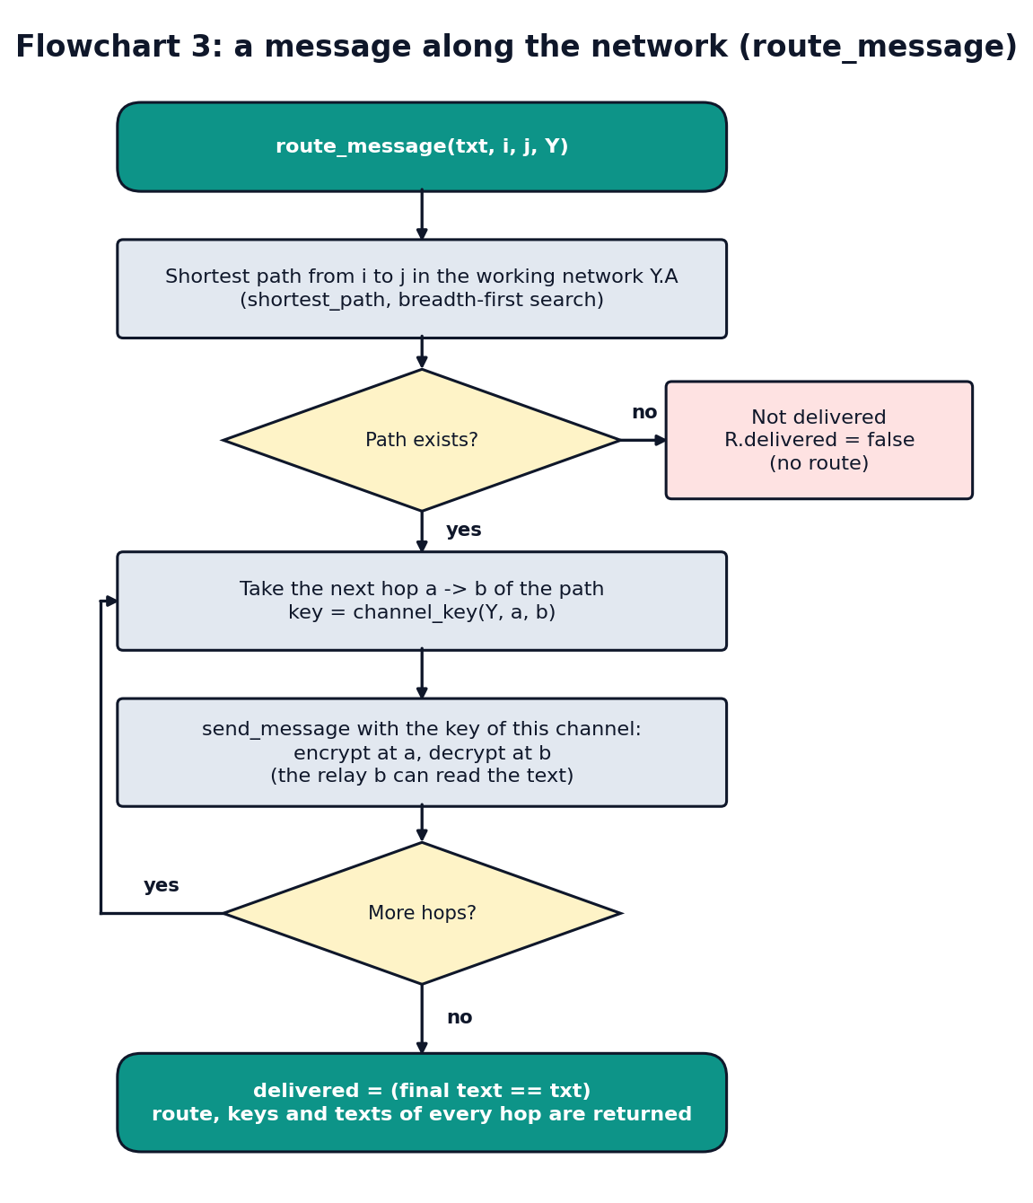
Figure 2. Routing a message along the network: every hop uses the key of its own channel.

4.7 The eavesdroppers
Three attackers are simulated. eavesdrop_dh sees $p$, $g$, $A$ and $B$ and computes $g^{1},g^{2},…$ until she reaches $A$, which gives the secret $a$ and then the key $B^{a}$. try_all_keys decrypts a ciphertext with every one of the 96 keys and keeps those that give readable text. In RSA, eavesdrop_rsa factors $n$ by trial division and builds $φ\left(n\right)$ and $d$, and eavesdrop_codebook encrypts every number from 1 to 96 with the public key and looks the message up in that list. All of them succeed on the small numbers of the project, which is the purpose of the simulation.

4.8 RSA (module rsa)
check_rsa_setup and rsa_make_keys implement Section 2.6: they check that $p$ and $q$ are different primes, that $n$ is larger than 96 (so that every symbol and every key is smaller than $n$) and at most $2^{26}$, and that $gcd\left(e,φ\left(n\right)\right)=1$, and then they find $d$ with the extended Euclid algorithm. rsa_encrypt_number, rsa_decrypt_number, rsa_encrypt_text and rsa_decrypt_text use mod_pow. Text is encrypted one symbol at a time (textbook RSA). define_rsa_users gives each of the six users their own key pair, and rsa_send_message encrypts with the public key of the receiver only, so the sender needs no secret.
Key transport. RSA needs a modular power for every number, which is slow for a long text. rsa_key_transport therefore sends only the cipher key $k$ with RSA, as $k^{e} mod n$, and encrypts the text with the fast cipher $E_{k}$. For Bob (with $d=157$) one RSA decryption takes 8 squarings and 5 multiplications, 13 modular multiplications. For the 36-character demo text, RSA on every number needs $36×13=468$ multiplications, while key transport needs $13+36=49$.
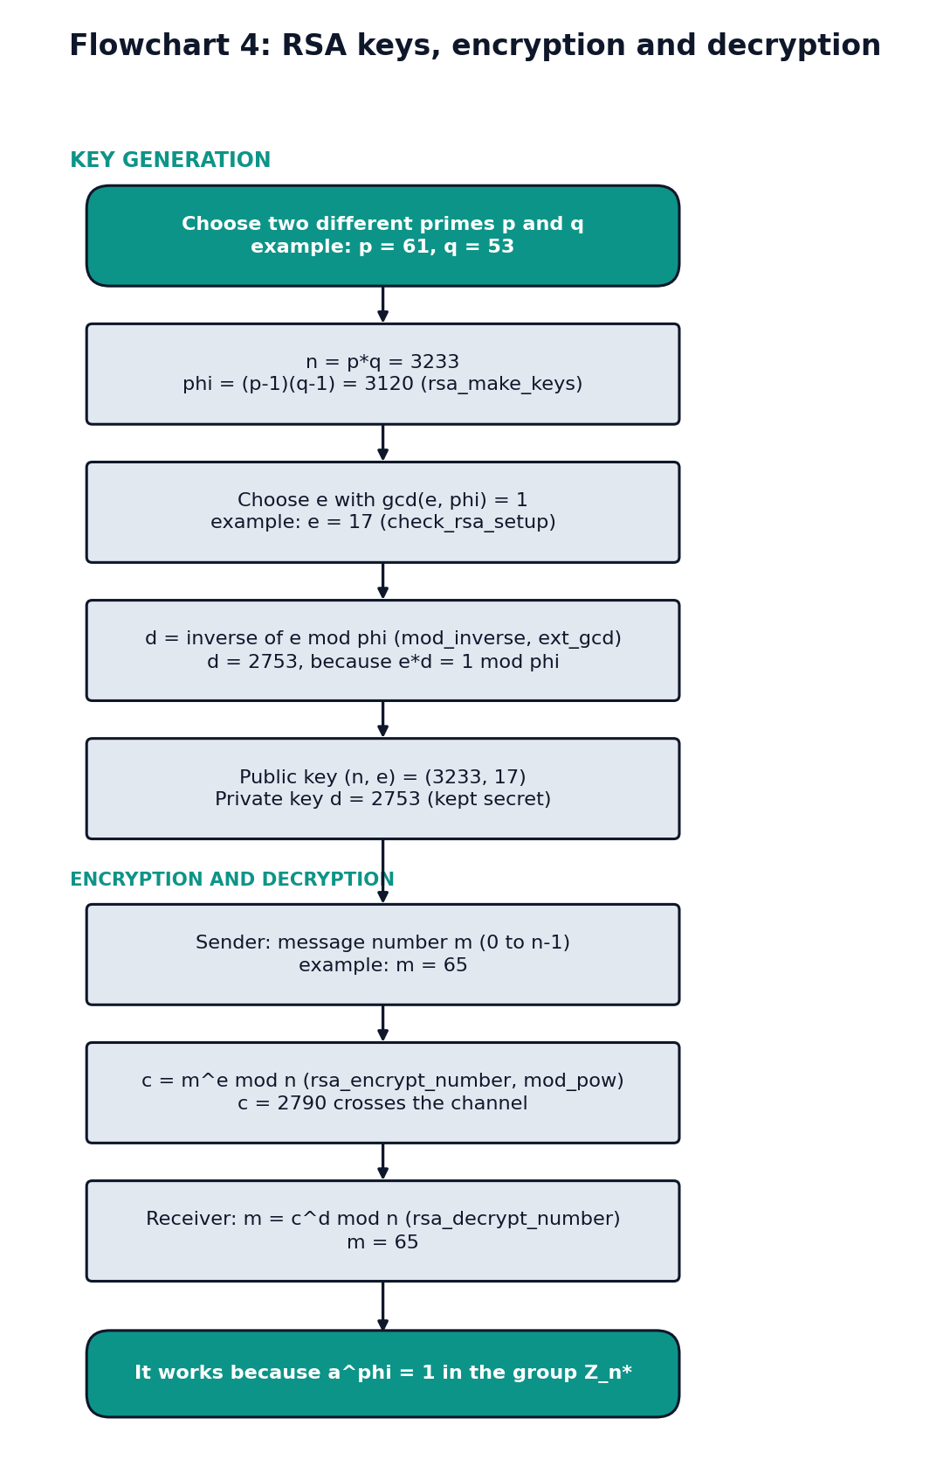
Figure 3. RSA: making the keys, encrypting and decrypting, and the key transport.

5 Results and verification

5.1 The test suite
Every part has a test file of automatic checks that print PASS or FAIL lines. All 14 test files that need no figure window were run in GNU Octave 8.4 and every check passed.
Table 3. Results of the test suite in GNU Octave 8.4.
Test file | Part tested | Checks passed
test_sets | Sets, text conversion | 25 of 25
test_relations | Relations and their properties | 51 of 51
test_cipher | Encryption and decryption as functions | 50 of 50
test_graph | Graph, adjacency matrix and list | 51 of 51
test_modular | Fast power, gcd, inverse | 130 of 130
test_group | Group rules, orders, generators | 131 of 131
test_dh | Diffie–Hellman | 71 of 71
test_encryption | Encryption with the shared key, eavesdroppers | 101 of 101
test_system | Secure network and routing | 69 of 69
test_verification | Verification of key, decryption and graph | 32 of 32
test_rsa | RSA keys, numbers and text | 109 of 109
test_rsa_users | RSA users, key transport, eavesdroppers | 188 of 188
test_rsa_verification | Verification of RSA | 27 of 27
test_main_demo | The typed demo (without the keyboard) | 59 of 59
Total |  | 1,094 of 1,094
Three more test files (test_graph_analysis, test_graph_pictures and test_route_picture) draw figures and are run in MATLAB by the team. The tests never write into the outputs folder: the pictures are drawn with the figure hidden and saved in a temporary folder. The tests also check that bad input is refused, for example a prime $p$ that is not prime, a generator that is not a generator, a secret number out of range, or a text with a character outside the alphabet.

5.2 The Diffie–Hellman key exchange
With $p=97$ and $g=5$, Alice chooses $a=6$ and sends $A=5^{6} mod 97=8$. Bob chooses $b=15$ and sends $B=5^{15} mod 97=46$. Alice computes ${46}^{6} mod 97=85$ and Bob computes $8^{15} mod 97=85$. Both get the key 85, which agrees with $g^{ab}=5^{90} mod 97=85$; only 8 and 46 crossed the channel. Table 4 gives the key of every pair of users. The table is symmetric, so two users always get the same key.
Table 4. The shared Diffie–Hellman key of every pair of users.
 | Alice | Bob | Carol | Dave | Frank | Grace
Alice | – | 85 | 12 | 89 | 33 | 18
Bob | 85 | – | 67 | 42 | 8 | 28
Carol | 12 | 67 | – | 90 | 11 | 60
Dave | 89 | 42 | 90 | – | 32 | 41
Frank | 33 | 8 | 11 | 32 | – | 72
Grace | 18 | 28 | 60 | 41 | 72 | –
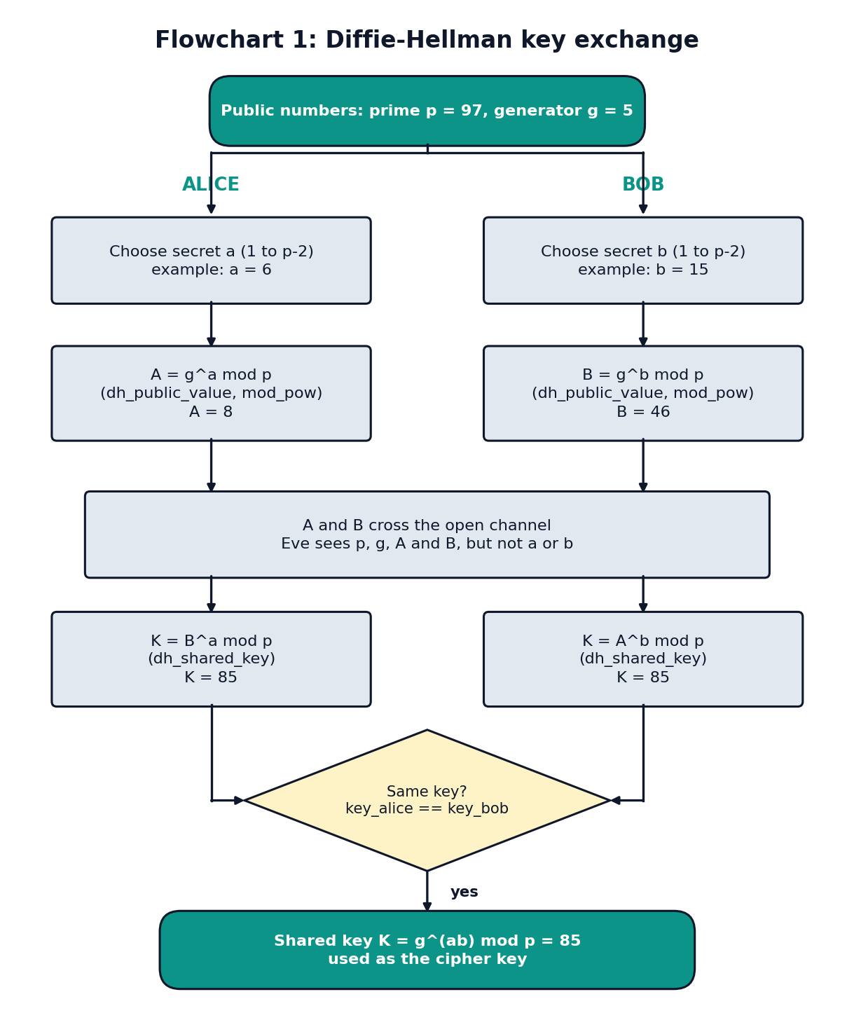
Figure 4. The Diffie–Hellman key exchange step by step.

5.3 Encryption with the shared key
Alice sends Bob the text Meet me at the library at 5 pm, Bob. (36 characters). The first character M is the symbol 46, and it becomes $85⋅46 mod 97=30$. The 36 numbers that cross the channel start 30, 33, 33, 47, 85, 34. Bob finds the inverse key $j=8$ (because $85⋅8 mod 97=1$) and gets the same text back. If Bob uses the key of Alice and Carol (12) instead, the decryption stops, because a value outside the symbols comes out. All 30 ordered pairs of users send and receive the text correctly.
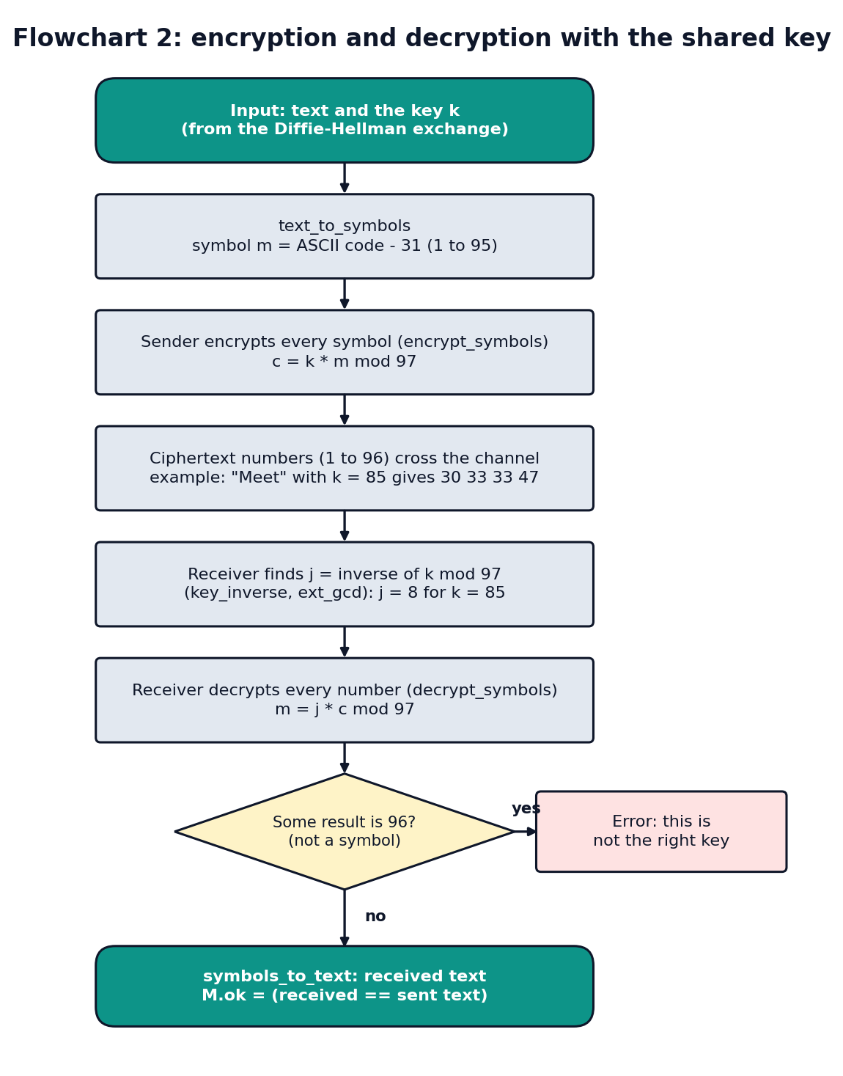
Figure 5. Encryption and decryption with the shared key.

5.4 The network at work
A message from Alice to Grace, Hello Grace, the meeting is at 5 pm., goes along Alice – Bob – Dave – Frank – Grace. The four hops use the keys 85, 42, 32 and 72, and on every hop the numbers are different, because the keys are different (the first hop starts 90, 33, 46, 46, the second 73, 30, 33, 33). Grace gets the text intact, and Carol, who is not on the route, cannot read it. The users in the middle can read the message, because each of them decrypts it before encrypting it again: the encryption protects each channel, not the whole route. When all 30 ordered pairs send a message, the number of messages by route length is 12 (1 channel), 10 (2 channels), 6 (3 channels) and 2 (4 channels), and all 30 arrive.
When the channel Dave – Frank (a bridge) is removed, the network falls apart into the groups {Alice, Bob, Carol, Dave} and {Frank, Grace}. The message from Alice to Grace then has no route and is not sent, and only 14 of the 30 messages still arrive.

5.5 Verification by a second method
A test that uses the same code as the program can repeat the program’s mistake. The verification layer therefore checks each important result a second way, with code that shares nothing with the part it checks. verify_system has 21 checks and verify_rsa has 15, and they are listed in Tables 5 and 6.
Table 5. The 21 checks of verify_system. The same 21 checks also agree on the network after the channel Dave – Frank is removed.
Group | Check (the second method) | Cases | Agree
Shared key | Both users of a pair compute the same key | 15 | yes
 | The key is $g^{ab} mod 97$ by plain repeated multiplication | 15 | yes
 | Every key is a number from 1 to 96 | 15 | yes
 | The key table is symmetric, with 0 on the diagonal | 15 | yes
 | Every channel has the key of its two users | 6 | yes
 | An eavesdropper who tries every secret finds the same key | 15 | yes
Cipher | A text with all 95 characters arrives for every pair | 30 | yes
 | $k⋅m$ and $j⋅c$ worked out by hand ($j$ found by trial) | 15 | yes
 | Every wrong key fails to give the text back (15 keys × 95 wrong keys) | 1,425 | yes
 | A message arrives exactly when there is a route | 30 | yes
 | Every hop uses the key of its channel | 30 | yes
 | Values on a channel are in the ciphertext set (1 to 96) | 30 | yes
Graph | The matrix is symmetric and has no loops | 36 | yes
 | The degrees add up to twice the number of channels | 6 | yes
 | The adjacency list gives back the matrix | 6 | yes
 | Distances are finite exactly where matrix products show a path | 36 | yes
 | Every distance is the smallest power $k$ of the matrix with a path | 36 | yes
 | Every shortest path uses only channels and has the right length | 30 | yes
 | The groups of users equal the groups found with matrix products | 6 | yes
 | A channel is a bridge exactly when removing it makes more groups | 6 | yes
 | A user is a cut user exactly when removing him makes more groups | 6 | yes
The second methods are: repeated multiplication instead of mod_pow; the formulas $k⋅m mod p$ and $j⋅c mod p$ instead of encrypt_symbols and decrypt_symbols; powers of the adjacency matrix instead of breadth-first search (a walk of $k$ channels from $i$ to $j$ exists exactly when entry $\left(i,j\right)$ of the $k$-th power of the matrix is not zero, so the smallest such $k$ is the distance); and removing a channel or a user and counting the groups instead of bridge_channels and cut_users. The test for the verification also checks that the verification finds mistakes: a wrong channel key and a wrong public value are both caught.
For RSA, verify_rsa makes 15 checks in the same three groups (the RSA keys, encryption and decryption, and the key transport with the eavesdropper), with trial division instead of is_prime_number, trying every number instead of mod_inverse, repeated multiplication instead of mod_pow, and counting the numbers with no common divisor with $n$ instead of the formula for $φ\left(n\right)$. One finding is worth noting: the check on $d$ tries every $d$ from 1 to $φ\left(n\right)−1$ and shows that a $d$ works for every number from 0 to $n−1$ exactly when $ed≡1 (mod lcm\left(p−1,q−1\right))$, so a user can have more than one working private key (Alice: 413, 1193, 1973 and 2753). The checks are repeated for a second set of keys.

5.6 RSA results
For $p=61$, $q=53$, $e=17$ the modulus is $n=3233$ and $φ\left(n\right)=3120$. The extended Euclid algorithm gives $17⋅\left(−367\right)+3120⋅2=1$, so $d=−367 mod 3120=2753$. The message $m=65$ gives $c={65}^{17} mod 3233=2790$, and ${2790}^{2753} mod 3233=65$. Counting the numbers with no common factor with 3233 gives exactly 3120, and $a^{3120}≡1$ for all of them. Also $ed=46801=1+15⋅3120$, as the proof in Section 2.6 requires.
The same demo text encrypts to 36 numbers from 0 to 3232, the first being ${46}^{17} mod 3233=2825$. The 8 spaces all become the number 1, because the space is the symbol 1 and $1^{e}=1$: equal characters give equal numbers, which is the weakness of textbook RSA. The six users have the keys of Table 7.
Table 7. The RSA keys of the six users (only $n$ and $e$ are public).
User | $p$ | $q$ | $n$ | $e$ | $d$
Alice | 61 | 53 | 3233 | 17 | 2753
Bob | 47 | 59 | 2773 | 17 | 157
Carol | 43 | 67 | 2881 | 5 | 1109
Dave | 71 | 37 | 2627 | 11 | 2291
Frank | 79 | 31 | 2449 | 7 | 1003
Grace | 73 | 41 | 2993 | 7 | 823

5.7 Figures of the network
Six pictures show the network of the six users. Figures 6 to 10 are made by demo_point2 and Figure 11 by option 7 of main_demo. In every picture the users keep the places that graph_layout gives for the whole network, so only the colors, the line widths, the line styles and the title change from one picture to the next. The channels are numbered e1 to e6 in the order Alice–Bob, Alice–Carol, Bob–Dave, Carol–Dave, Dave–Frank and Frank–Grace.
Note on these figures. The six pictures in this version of the report were not copied from MATLAB windows. A separate plotting script (handoff/make_figures.py) drew them from the places, colors, line widths and titles that the MATLAB functions graph_layout, picture_options and route_picture_options compute (these values were read out with GNU Octave, which cannot open figure windows). They have the layout and the colors of draw_network, and they will be replaced by the PNG files that demo_point2 and main_demo save in MATLAB (same file names) after the run on the demo laptop.
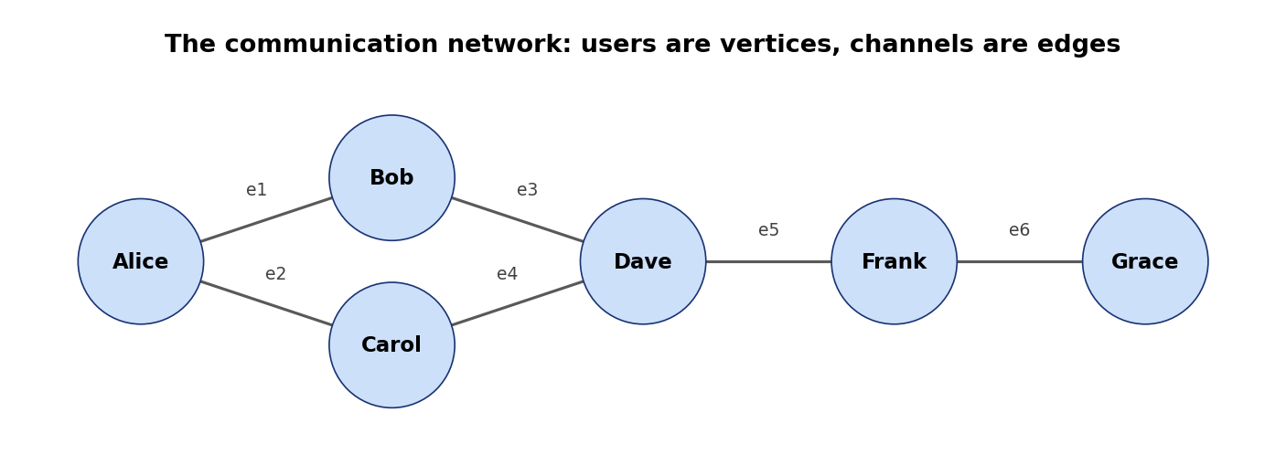
Figure 6. The communication network: the users are the vertices and the six channels are the edges (point2_network.png).
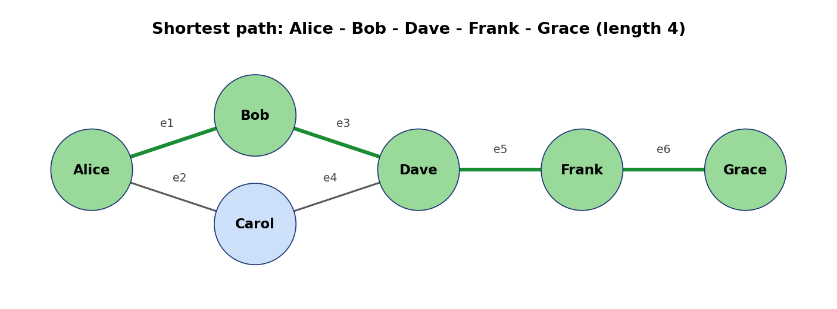
Figure 7. The shortest path from Alice to Grace: Alice – Bob – Dave – Frank – Grace, 4 channels (point2_shortest_path.png).
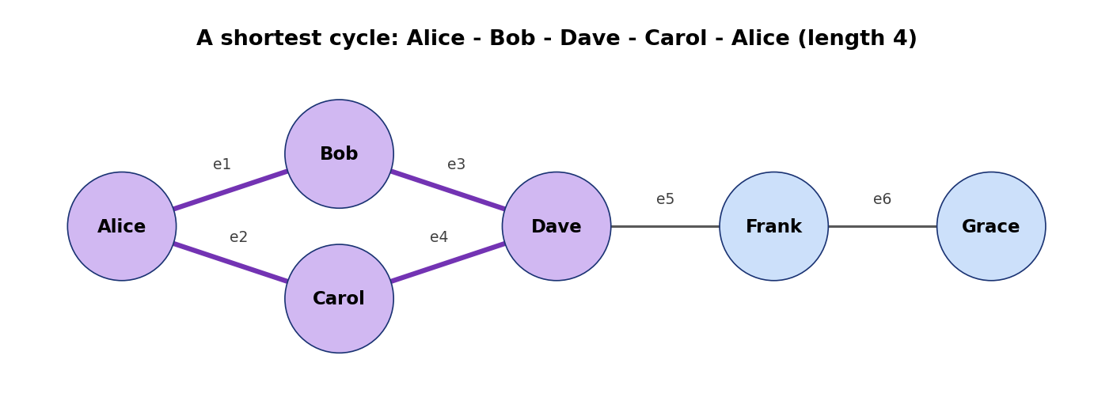
Figure 8. A shortest cycle: Alice – Bob – Dave – Carol – Alice, length 4. The network has exactly one independent cycle, since 6 channels − 6 users + 1 group = 1 (point2_cycle.png).
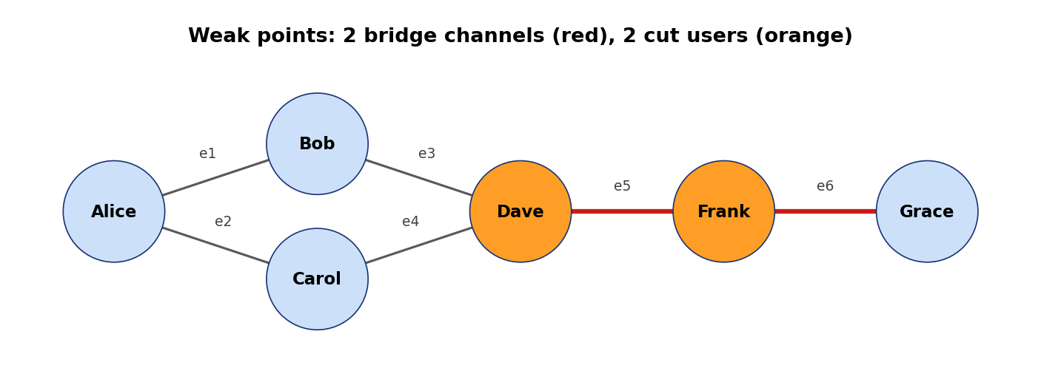
Figure 9. The weak points: the bridge channels Dave – Frank (e5) and Frank – Grace (e6) are red, and the cut users Dave and Frank are orange (point2_weak_points.png).
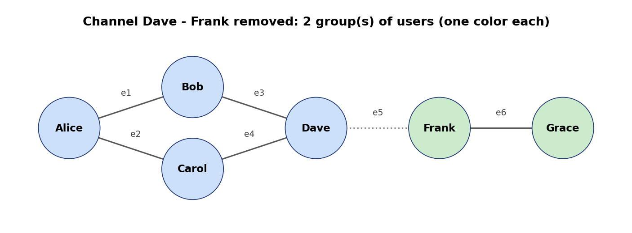
Figure 10. The network after the bridge channel Dave – Frank is removed (dotted): two groups of users, {Alice, Bob, Carol, Dave} and {Frank, Grace}, one color each (point2_split.png).
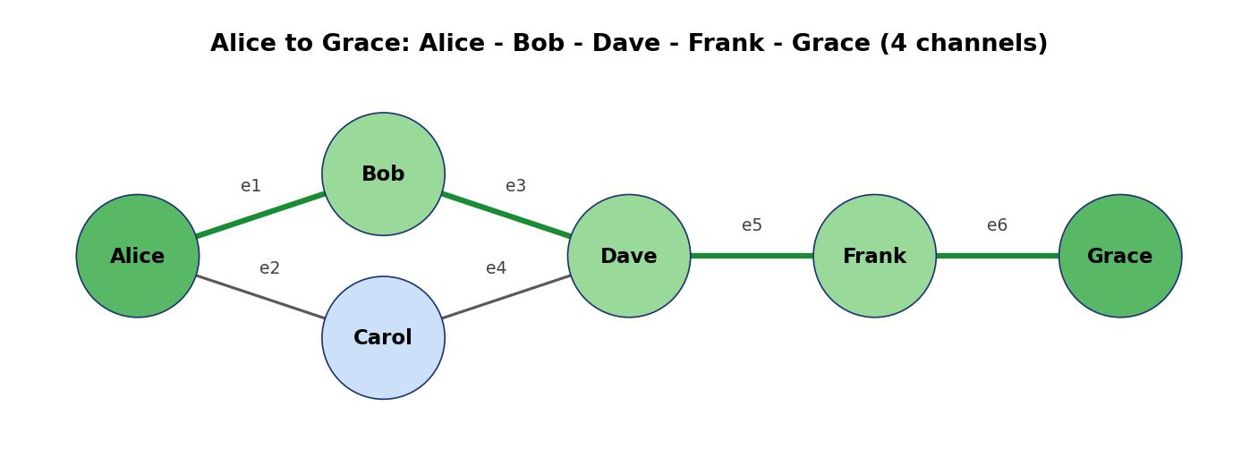
Figure 11. The route of the message from Alice to Grace in main_demo (option 7). The thick green channels e1, e3, e5 and e6 carry it with the keys 85, 42, 32 and 72; Alice and Grace are dark green, Bob, Dave and Frank light green, and Carol is not on the route (point5_route.png).

6 Security analysis and limitations
What the simulation shows. The eavesdropper eavesdrop_dh finds the secret number and the key of Alice and Bob from $A=8$ by trying $g^{1},g^{2},…$, which takes only a few steps because the group has 96 elements. For RSA, trial division finds the primes of $n$ with at most $\sqrt{n}$ tries, and Table 8 shows how the work grows with the size of $n$.
Table 8. Eve factors $n$ by trial division: the number of tries grows with $\sqrt{n}$.
$n$ | Bits | Tries of Eve | Most tries | Eve gets the right $d$
143 | 8 | 10 | 10 | yes
10,403 | 14 | 100 | 100 | yes
1,022,117 | 20 | 1,008 | 1,009 | yes
64,160,099 | 26 | 8,008 | 8,008 | yes
The number of tries grows with the square root of $n$. A modulus of 2048 bits (a number with 617 digits) would need up to $2^{1024}$ tries by this method, which is impossible. Faster factoring methods exist, but they also need a very large amount of work for such a modulus, which is why real systems use numbers of that size.
Why the cipher is weak. The cipher $E_{k}\left(m\right)=k⋅m mod 97$ has only 96 keys, so Eve can try them all: try_all_keys shows that for the demo message only the key 85 gives readable text. Because the cipher is linear, a single known pair of plaintext and ciphertext also reveals $k$. The model is therefore good for learning how a shared key is used, and not for protection.
Other limits.
- Not end-to-end. In the routing, every relay decrypts and re-encrypts, so the users in the middle read the message. A real system would encrypt end to end.
- No authentication. A Diffie–Hellman exchange without signatures or certificates can be attacked by a person in the middle who runs two exchanges. This is not simulated.
- Textbook RSA. The encryption has no padding, so equal characters give equal numbers, and the list of all small numbers (eavesdrop_codebook) reads the message without factoring $n$.
- Small numbers. The prime is limited to $2^{26}$ so that mod_pow stays exact in double-precision arithmetic.
- Undirected graph. All channels are two-way (Section 2.2).

7 Conclusion and future work
The project connects four topics of discrete mathematics in one working program. Sets, relations and functions describe the users and the cipher. Graph theory finds the route of a message and the weak points of the network. Group theory explains why the Diffie–Hellman key is the same on both sides, and why RSA decrypts correctly. Number theory supplies the algorithms that make it fast. The result is a 116-file MATLAB program with 1,094 automatic checks that pass in GNU Octave, and a verification layer that checks the key, the decryption, the graph and RSA a second way. The simulated attackers show that the small numbers give no protection, which is the main lesson of the model.
Possible future work: use a modulus with big integers (so that real sizes can be shown), add padding to RSA, authenticate the Diffie–Hellman exchange with signatures, encrypt end to end instead of hop by hop, use elliptic-curve groups instead of $Z_{p}^{*}$, and add directed channels to the graph model.

References
[1] W. Diffie and M. E. Hellman, “New directions in cryptography,” IEEE Transactions on Information Theory, vol. 22, no. 6, pp. 644–654, 1976.
[2] R. L. Rivest, A. Shamir and L. Adleman, “A method for obtaining digital signatures and public-key cryptosystems,” Communications of the ACM, vol. 21, no. 2, pp. 120–126, 1978.
[3] D. R. Stinson, Cryptography: Theory and Practice, CRC Press.
[4] K. H. Rosen, Discrete Mathematics and Its Applications, McGraw-Hill.
[5] D. B. West, Introduction to Graph Theory, Prentice Hall.
[6] J. A. Gallian, Contemporary Abstract Algebra, Cengage Learning.
[7] D. E. Knuth, The Art of Computer Programming, Volume 2: Seminumerical Algorithms, Addison-Wesley.

Appendix A: How to run the project
- Open MATLAB and set the current folder to the project folder.
- Run setup_project to add the code folders to the MATLAB path.
- Run run_all_tests; it ends with ALL TESTS PASSED when everything is correct.
- Run the demos: demo_point1 (sets, relations, functions), demo_point2 (graph, analysis and 5 pictures, saved in outputs), demo_point3 (modular arithmetic and the group), demo_point4 (Diffie–Hellman, encryption and the eavesdropper), demo_point5 (the secure network), demo_point6 (the verification) and demo_point7 (RSA).
- Run main_demo for the demo with typed prompts. Choose option 1 to send a message, option 4 to break a channel, option 5 to repair, option 7 to draw the picture of the route (saved as outputs/point5_route.png), and option 0 to quit.
The README of the project folder lists the same commands, and PROGRESS.md records every design decision. The seminar slides are in docs/Crypto_Microproject_Presentation.pptx and the flowcharts in docs/flowcharts.

Appendix B: The code, file by file
Each function is one file in src/<module>/, and the file name is the function name. The show_* functions print a whole part of the results with explanations and self-checks, and the demo_point* commands run them.
Table 9. The functions of each module (116 files in src/).
Module | Functions | Printouts and demos
Sets, relations and functions | cipher_relation, decrypt_symbols, decrypt_text, define_relations, define_sets, encrypt_symbols, encrypt_text, function_properties, key_inverse, pairs_to_matrix, relation_properties, symbols_to_text, text_to_symbols | demo_point1, show_cipher, show_relations, show_sets
Graph network | adjacency_to_edges, adjacency_to_list, bfs_search, bridge_channels, check_picture_files, connected_components, cut_users, cycle_rank, define_graph, distance_matrix, draw_network, edges_to_adjacency, find_cycle, format_groups, format_names, graph_layout, is_connected, list_to_adjacency, mark_edges, path_to_edges, picture_options, plural_s, reachable_from, remove_channel, remove_user, save_network_pictures, shortest_path, yes_no | demo_point2, show_analysis, show_graph
Group theory and modular arithmetic | check_group, cyclic_subgroup, element_order, euclid_gcd, ext_gcd, find_generators, group_table, is_generator, is_prime_number, is_whole_number, mod_inverse, mod_pow, prime_factors | demo_point3, show_cyclic, show_group, show_modular
Diffie-Hellman | check_dh_setup, define_secrets, dh_exchange, dh_key_table, dh_public_value, dh_shared_key, eavesdrop_dh | demo_point4, show_dh
Encryption | format_numbers, send_message, try_all_keys | show_eavesdropper, show_encryption
Integration, demo and verification | channel_key, check_system, define_system, draw_route_picture, main_demo, pick_user, reach_by_matrix, read_answer, route_message, route_picture_options, verify_system | demo_point5, demo_point6, show_route, show_route_picture, show_system, show_verification
RSA | check_rsa_setup, check_rsa_users, define_rsa_users, eavesdrop_codebook, eavesdrop_rsa, rsa_decrypt_number, rsa_decrypt_text, rsa_encrypt_number, rsa_encrypt_text, rsa_format_numbers, rsa_key_transport, rsa_make_keys, rsa_send_message, verify_rsa | demo_point7, show_rsa, show_rsa_eavesdropper, show_rsa_transport, show_rsa_users, show_rsa_verification

