StructRAG — Adaptive Tree-Boosted Retrieval-Augmented Generation
Project Documentation
March 2026
Table of Contents

StructRAG — Adaptive Tree-Boosted Retrieval-Augmented Generation

Comprehensive Project Documentation
Project: RAG Academic Explainer with StructRAG Enhancement
Version: 1.0
Date: March 2026
Status: Patent-Pending Innovation (ATB-RRF Algorithm)

Table of Contents
- Project Overview
- System Architecture
- Document Ingestion Pipeline
- Hierarchical Section Tree
- ATB-RRF Algorithm (Patent Innovation)
- Query Processing Flow
- Patent Landscape & Novelty
- API Reference
- Frontend Application
- Technology Stack
- File Structure & Code Map
- Configuration
- Deployment

1. Project Overview
StructRAG is a full-stack academic paper analysis system that combines Retrieval-Augmented Generation (RAG) with a novel dual-index architecture. Unlike traditional RAG systems that rely solely on vector similarity search, StructRAG builds a hierarchical section tree from each document and fuses structural signals with vector signals using a patentable Adaptive Tree-Boosted Reciprocal Rank Fusion (ATB-RRF) algorithm.

What It Does
- Upload academic papers (PDF format)
- Automatically index them using two parallel systems:
  - A vector embedding index (ChromaDB) for semantic similarity
  - A hierarchical section tree (SQLite) for structural understanding
- Answer questions by fusing both signals through the ATB-RRF algorithm
- Generate grounded answers with source citations using LLMs (Gemini/OpenAI/HF)

Key Differentiator
Traditional RAG retrieves chunks purely by “how similar they sound.” StructRAG additionally understands where in the document structure a chunk lives (e.g., “this is from the Methodology section, sub-section Model Architecture”) and uses that structural context to boost relevant chunks and suppress irrelevant ones.

2. System Architecture
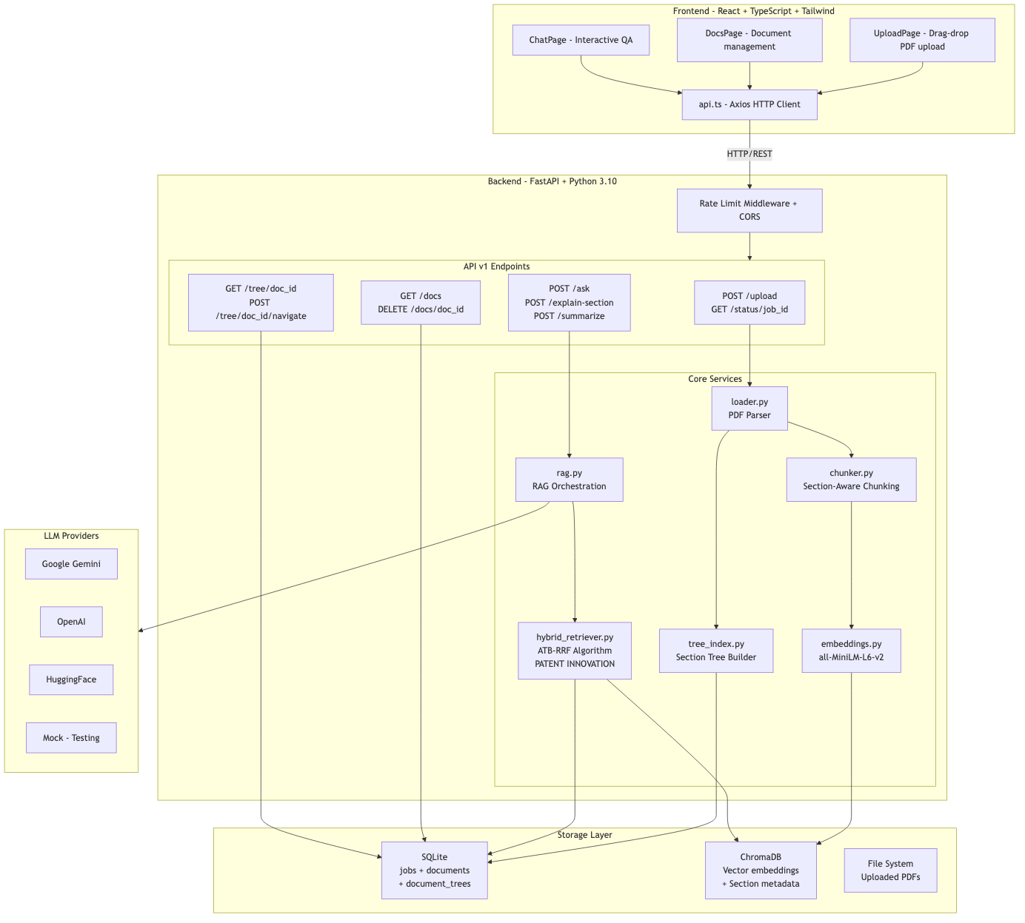
System Architecture

Architecture Components
Layer | Technology | Purpose
Frontend | React 19, TypeScript, Vite, Tailwind CSS | Upload PDFs, ask questions, view answers
API | FastAPI (Python 3.10) | REST endpoints with rate limiting & CORS
Retrieval | ATB-RRF (custom) | Fuses vector + tree signals adaptively
Vector Store | ChromaDB 0.5.23 | Stores embeddings + section metadata
Metadata | SQLite | Jobs, documents, hierarchical trees
Embeddings | sentence-transformers (all-MiniLM-L6-v2) | 384-dimensional text embeddings
LLM | Gemini / OpenAI / HuggingFace / Mock | Answer generation with structured prompts

3. Document Ingestion Pipeline
When a PDF is uploaded, it goes through a 5-stage background processing pipeline:
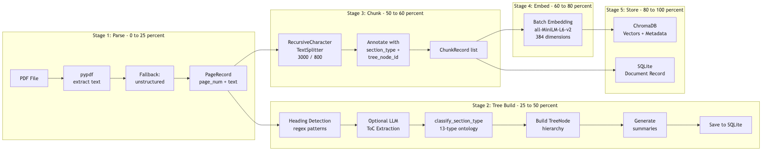
Document Ingestion Pipeline

Stage Details
Stage | Component | What Happens
1. Parse | loader.py | Extracts text from each PDF page using pypdf; falls back to unstructured for scanned PDFs
2. Tree Build | tree_index.py | Detects headings via regex patterns, classifies each into one of 13 academic section types, builds parent-child hierarchy, generates text summaries
3. Chunk | chunker.py | Splits text into 3000-character chunks with 800-char overlap. Each chunk is annotated with its section_type and tree_node_id from the tree
4. Embed | embeddings.py | Generates 384-dimensional embeddings using all-MiniLM-L6-v2 with batch processing and SHA256-based caching
5. Store | vectorstore.py + jobs.py | Stores embeddings in ChromaDB with section metadata; creates document record in SQLite

4. Hierarchical Section Tree
The section tree is a hierarchical representation of a document’s structure. Each node represents a section or sub-section with its page range, summary, and classified section type.
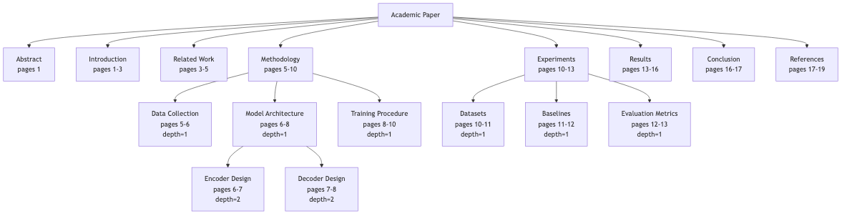
Hierarchical Section Tree

13-Type Academic Section Ontology
The tree builder classifies each section into one of 13 canonical academic section types:
Type | Keywords | Pattern Match
abstract | abstract, summary | Title contains “abstract”
introduction | introduction, overview, motivation | Title contains “introduction”
related_work | related work, prior art, literature | Title contains “related”
background | background, preliminaries, notation | Title contains “background”
methodology | method, approach, algorithm, framework | Title contains “method”
experiments | experiment, setup, implementation | Title contains “experiment”
results | result, finding, outcome, performance | Title contains “result”
discussion | discussion, analysis, interpretation | Title contains “discussion”
conclusion | conclusion, future work, summary | Title contains “conclusion”
acknowledgements | acknowledgement, funding, grant | Title contains “acknowledg”
references | reference, bibliography, citation | Title contains “reference”
appendix | appendix, supplement, additional | Title contains “appendix”
other | (default) | No match found

TreeNode Data Structure
@dataclass
class TreeNode:
node_id: str # Unique identifier
title: str # Section heading text
start_page: int # First page of this section
end_page: int # Last page of this section
summary: str # Auto-generated text summary
section_type: str # One of 13 ontology types
children: list[TreeNode] # Sub-sections (recursive)

5. ATB-RRF Algorithm (Patent Innovation)
The Adaptive Tree-Boosted Reciprocal Rank Fusion (ATB-RRF) algorithm is the core patent innovation. It replaces the static boosting used in traditional RRF with an adaptive, multi-signal approach.
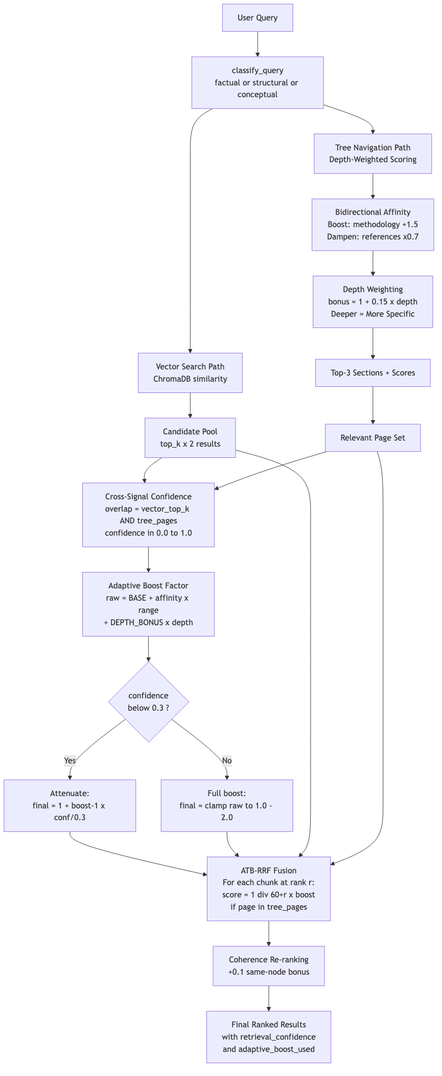
ATB-RRF Algorithm

How ATB-RRF Differs from Standard RRF
Aspect | Standard RRF | ATB-RRF (Ours)
Boost Factor | Static constant (e.g., 1.6×) | Adaptive per-chunk: 1.0 — 2.0
Signals Used | Just rank position | Rank + affinity + confidence + depth
Section Awareness | None | 13-type ontology with boost AND dampen
Safety Mechanism | None | Confidence attenuation when signals disagree
Depth Sensitivity | None | Deeper sections get specificity bonus

The Adaptive Boost Formula
For each chunk at vector rank $r$:
$$\text{base_score}=\frac{1}{K+r} \text{where }K=60$$
If the chunk’s page falls within tree-identified relevant sections:
$$\text{raw_boost}=\text{BASE_BOOST}+\text{affinity_norm}×\left(\text{MAX}−\text{BASE}\right)+0.15×\text{depth}$$
$$\text{clamped}=\text{clamp}\left(\text{raw_boost}, 1.0, 2.0\right)$$
Confidence attenuation (when tree-vector agreement is low):
$$\text{final}=\left\{\begin{matrix}1.0+\left(\text{clamped}−1.0\right)×\frac{\text{confidence}}{0.3} & \text{if confidence}<0.3 \\ \text{clamped} & \text{otherwise}\end{matrix}\right.$$
$$\text{fused_score}=\text{base_score}×\text{final_boost}$$

Algorithm Constants
Constant | Value | Purpose
MAX_BOOST_FACTOR | 2.0 | Maximum adaptive boost cap
MIN_BOOST_FACTOR | 1.0 | Minimum (no boost)
BASE_BOOST | 1.3 | Starting boost for tree-matched chunks
RRF_K | 60 | Standard RRF smoothing constant
CANDIDATE_POOL_MULTIPLIER | 2 | Expand initial vector pool
DEPTH_BONUS_PER_LEVEL | 0.15 | Per-depth-level specificity bonus
SECTION_MISMATCH_DAMPEN | 0.7 | Penalty for mismatched sections
CONFIDENCE_ATTENUATION_THRESHOLD | 0.3 | Below this, attenuate boost

Bidirectional Section Affinity Tables
Unlike prior art that only boosts matching sections, ATB-RRF also dampens mismatching ones:
Query Keywords | Boosted Sections (+1.5) | Dampened Sections (×0.7)
method, algorithm, how, design | methodology, experiments, background | references, acknowledgements, appendix
result, accuracy, benchmark | results, experiments, discussion | abstract, references, acknowledgements
motivation, problem, introduce | introduction, abstract | references, appendix, acknowledgements
conclusion, future, limitation | conclusion, discussion | methodology, references
related, prior, survey, compare | related_work, background | results, appendix, acknowledgements

6. Query Processing Flow
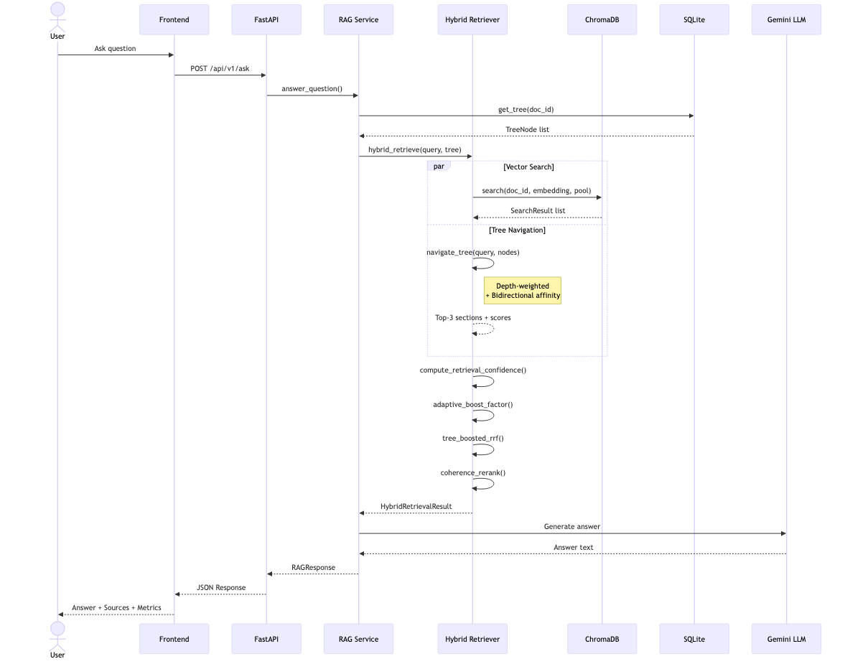
Query Processing Sequence

Query Type Classification
The system classifies every query into one of three types using regex signal matching:
Type | Trigger Patterns | Behavior
structural | “how does”, “what method”, “explain the approach” | Tree navigation emphasized
factual | “what is the accuracy”, “how many”, specific values | Vector search emphasized
conceptual | Everything else | Full hybrid with ATB-RRF

Response Payload
Every /ask response includes transparency metrics:
{
"answer": "The paper uses a retrieval-augmented generation methodology...",
"sources": [
{
"page": 5,
"snippet": "Our methodology involves...",
"chunk_id": "doc-chunk-3",
"score": 0.02934
}
],
"query_type": "structural",
"retrieval_mode": "hybrid",
"retrieval_confidence": 1.0,
"adaptive_boost_used": 1.79
}
Field | Description
query_type | How the query was classified (factual/structural/conceptual)
retrieval_mode | “hybrid” if tree was used, “vector” if fallback
retrieval_confidence | Cross-signal agreement [0.0 – 1.0] between tree and vector
adaptive_boost_used | The computed adaptive boost factor [1.0 – 2.0]

7. Patent Landscape & Novelty
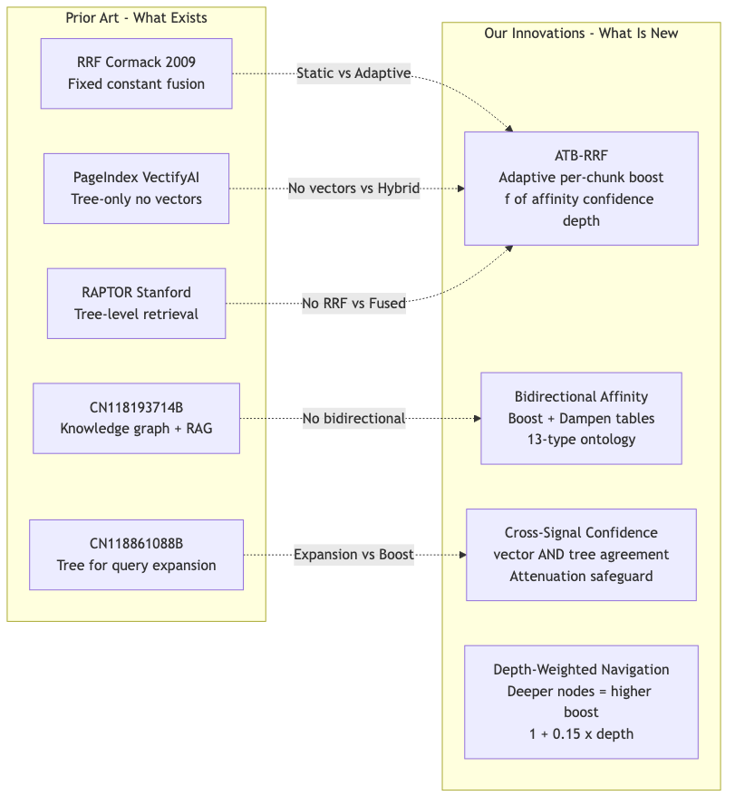
Patent Landscape & Novelty

Identified Prior Art
Patent/Paper | Holder | Date | Gap vs StructRAG
Standard RRF | Cormack & Clarke | 2009 | Uses fixed constants; no structural awareness
PageIndex | VectifyAI (MIT) | 2024 | Tree-only retrieval, abandons vectors entirely
RAPTOR | Stanford | 2024 | Retrieves at different tree levels, no RRF fusion
CN118861088B | Zhejiang Univ | Sep 2024 | Uses tree for query expansion, not per-chunk boosting
CN118193714B | Shandong Inspur | May 2024 | Knowledge graph hierarchy, no adaptive boost
US12405978B2 | Madisetti | May 2023 | Semantic chunking with topic tags, no tree fusion

6 Novel Innovations
# | Innovation | Why It’s Novel
1 | Adaptive Tree-Boosted RRF | Per-chunk variable boost ∈ [1.0, 2.0] conditioned on 3 signals — no prior art does this
2 | Bidirectional Section Affinity | Boost matching sections AND dampen mismatching ones — prior art only boosts
3 | Depth-Weighted Navigation | Tree depth drives specificity bonus — no prior art uses depth in scoring
4 | Cross-Signal Confidence | Measures tree-vector agreement and attenuates boost when low — completely novel
5 | Coherent-Narrative Re-ranking | Promotes chunks from same tree node for sequential context
6 | Graceful Degradation | Transparent fallback to pure vector when no tree exists

Draft Patent Claim
“A computer-implemented method for document retrieval comprising: computing an adaptive structural boost factor for each candidate chunk based on (a) bidirectional section-type affinity between classified query intent and a hierarchical document index, (b) cross-signal confidence measuring agreement between vector-similarity and tree-structural retrieval signals, and (c) hierarchical depth of matched tree nodes; and fusing said adaptive boost into reciprocal rank fusion scoring to produce a structure-aware ranked result set.”

8. API Reference

Upload Endpoints
Method | Path | Description
POST | /api/v1/upload | Upload PDF, returns job_id
GET | /api/v1/status/{job_id} | Poll ingestion progress (0-100%)

Q&A Endpoints
Method | Path | Description
POST | /api/v1/ask | Ask a question about a document
POST | /api/v1/explain-section | Explain a specific section (intro/methodology/results/conclusion)
POST | /api/v1/summarize | Generate document summary

Document Management
Method | Path | Description
GET | /api/v1/docs | List all indexed documents
DELETE | /api/v1/docs/{doc_id} | Delete document + all indexes

Tree Exploration (StructRAG)
Method | Path | Description
GET | /api/v1/tree/{doc_id} | Get full hierarchical section tree
POST | /api/v1/tree/{doc_id}/navigate | Navigate tree with a query (returns affinity scores)

Request/Response Examples
Ask a Question:
curl -X POST http://localhost:8000/api/v1/ask \
-H "Content-Type: application/json" \
-d '{
"doc_id": "687bca99-...",
"question": "What methodology does this paper use?",
"top_k": 5,
"mode": "qa",
"temperature": 0.2
}'
Navigate Tree:
curl -X POST http://localhost:8000/api/v1/tree/{doc_id}/navigate \
-H "Content-Type: application/json" \
-d '{"query": "What are the experimental results?"}'
Response includes section_affinity_scores — the numerical scores from depth-weighted navigation.

9. Frontend Application

Pages
Page | URL | Features
Upload | /upload | Drag-drop file upload, optional title, progress polling
Documents | /docs | Document list with upload date, page count, open/delete actions
Chat | /chat/{doc_id} | Interactive Q&A with parameter controls

Chat Interface Controls
Control | Range | Default | Purpose
Top-K | 1 — 10 | 5 | Number of chunks to retrieve
Mode | qa / explain / summary | qa | Generation style
Temperature | 0.0 — 1.0 | 0.2 | LLM creativity level

Frontend Components
Component | Purpose
ChatBox.tsx | Chat message I/O with parameter controls
FileUploader.tsx | Drag-drop PDF upload with validation
MessageBubble.tsx | Individual message rendering
SourceHighlight.tsx | Citation/source snippet display
DocList.tsx | Document list with actions
Loader.tsx | Loading spinner

10. Technology Stack

Backend
Library | Version | Purpose
FastAPI | 0.115.6 | REST API framework
Pydantic | 2.10.5 | Data validation & schemas
Uvicorn | 0.34.0 | ASGI web server
ChromaDB | 0.5.23 | Vector database
sentence-transformers | 3.3.1 | Text embeddings (all-MiniLM-L6-v2)
LangChain | 0.3.13 | RecursiveCharacterTextSplitter
OpenAI | 1.58.1 | OpenAI API client
pypdf | 5.1.0 | PDF text extraction
unstructured | 0.16.12 | PDF fallback parser
httpx | 0.28.1 | HTTP client (Gemini API)
tenacity | 9.0.0 | Retry logic

Frontend
Library | Version | Purpose
React | 19 | UI framework
TypeScript | 5.6 | Type-safe JavaScript
Vite | 6 | Build tool & dev server
Tailwind CSS | 3 | Utility-first CSS
Axios | 1.7 | HTTP client
React Router | 6 | Client-side routing
Vitest | 2 | Testing framework

Infrastructure
Service | Image/Tool | Purpose
ChromaDB | chromadb/chroma:0.5.5 | External vector store (Docker mode)
Redis | redis:7-alpine | Optional caching
SQLite | Built-in | Metadata, jobs, trees
Docker Compose | v2 | Multi-container orchestration

11. File Structure & Code Map
├── docker-compose.yml # Multi-container orchestration
├── .env # API keys & configuration
├── README.md # Quick start guide
├── USAGE.md # Usage documentation
│
├── backend/ # Python FastAPI backend (~2,750 lines)
│ ├── Dockerfile
│ ├── requirements.txt # 17 Python dependencies
│ ├── pytest.ini
│ │
│ └── app/
│ ├── main.py # FastAPI app, CORS, rate limiting
│ │
│ ├── core/
│ │ ├── config.py # Pydantic settings (env vars)
│ │ └── logger.py # Logging configuration
│ │
│ ├── models/
│ │ └── schemas.py # 15+ Pydantic request/response models
│ │
│ ├── api/v1/
│ │ ├── upload.py # Upload + 5-stage ingestion pipeline
│ │ ├── qa.py # Ask / explain / summarize endpoints
│ │ ├── tree.py # Tree exploration & navigation
│ │ └── docs.py # Document list & deletion
│ │
│ ├── services/
│ │ ├── hybrid_retriever.py # 🔴 ATB-RRF (PATENT CORE, ~450 lines)
│ │ ├── tree_index.py # Section tree builder (~380 lines)
│ │ ├── tree_store.py # SQLite tree persistence
│ │ ├── rag.py # RAG orchestration + LLM dispatch
│ │ ├── chunker.py # Section-aware text chunking
│ │ ├── vectorstore.py # ChromaDB wrapper
│ │ ├── embeddings.py # Embedding service + cache
│ │ ├── loader.py # PDF text extraction
│ │ └── jobs.py # Job/document metadata store
│ │
│ └── tests/
│ ├── test_ask.py # Integration tests
│ └── test_upload.py # Unit tests
│
├── frontend/ # React TypeScript frontend (~770 lines)
│ ├── Dockerfile
│ ├── package.json
│ ├── vite.config.ts
│ │
│ └── src/
│ ├── App.tsx # Router & layout
│ ├── main.tsx # Entry point
│ │
│ ├── pages/
│ │ ├── UploadPage.tsx # PDF upload UI
│ │ ├── DocsPage.tsx # Document management
│ │ └── ChatPage.tsx # Interactive Q&A
│ │
│ ├── components/
│ │ ├── ChatBox.tsx # Chat with controls
│ │ ├── FileUploader.tsx # Drag-drop upload
│ │ ├── MessageBubble.tsx
│ │ ├── SourceHighlight.tsx
│ │ ├── DocList.tsx
│ │ └── Loader.tsx
│ │
│ ├── services/
│ │ └── api.ts # Axios API client
│ │
│ └── styles/
│ └── tailwind.css
│
├── scripts/
│ ├── start-local.sh # Local dev startup
│ └── init-db.sh # Database initialization
│
└── EXAMPLE_PAPERS/
└── sample_paper.pdf # Test document

Code Statistics
Metric | Count
Total Lines of Code | ~3,600
Backend (Python) | ~2,750 lines
Frontend (TypeScript) | ~770 lines
Core Services | 11 Python modules
API Endpoints | 9 REST endpoints
React Components | 7 (3 pages + 4 utilities)
Pydantic Models | 15+ schemas
Database Tables | 3 (jobs, documents, document_trees)
LLM Providers | 4 (OpenAI, Gemini, HF, Mock)
Test Files | 4 (2 backend + 2 frontend)

12. Configuration

Environment Variables (.env)
Variable | Default | Description
LLM_PROVIDER | mock | LLM backend: openai, gemini, hf, or mock
OPENAI_API_KEY | — | OpenAI API key
OPENAI_MODEL | gpt-4o-mini | OpenAI model name
GEMINI_API_KEY | — | Google Gemini API key
GEMINI_MODEL | gemini-flash-latest | Gemini model name
GEMINI_FALLBACK_MODELS | gemini-1.5-flash | Comma-separated fallback models
HF_MODEL_NAME | google/flan-t5-base | HuggingFace model
EMBEDDING_MODEL_NAME | sentence-transformers/all-MiniLM-L6-v2 | Embedding model
USE_EXTERNAL_CHROMA | false | Use external ChromaDB via network
CHROMA_HOST | localhost | ChromaDB host
CHROMA_PORT | 8000 | ChromaDB port
CHROMA_PERSIST_DIR | ./chromadb_data | Local ChromaDB data path
BACKEND_HOST | 0.0.0.0 | Backend bind address
BACKEND_PORT | 8000 | Backend port
FRONTEND_URL | http://localhost:5173 | CORS origin
RATE_LIMIT_PER_MINUTE | 60 | Per-IP request limit
LLM_MAX_REQUESTS_PER_MINUTE | 5 | LLM call rate limit
LLM_REQUEST_TIMEOUT_SECONDS | 90 | LLM request timeout
LLM_REQUEST_RETRIES | 2 | LLM retry count

13. Deployment

Local Development (No Docker)
# Backend
cd backend
python -m venv .venv && source .venv/bin/activate
pip install -r requirements.txt
uvicorn app.main:app --host 0.0.0.0 --port 8000 --reload
# Frontend (new terminal)
cd frontend
npm install
npm run dev

Docker Compose (Production)
# Start all services
docker compose up --build
# Services:
# - Backend: http://localhost:8000
# - Frontend: http://localhost:5173
# - ChromaDB: http://localhost:8001
# - Redis: http://localhost:6379

Verify Installation
# Health check
curl http://localhost:8000/health
# → {"status": "ok"}
# Upload a PDF
curl -X POST http://localhost:8000/api/v1/upload \
-F "file=@EXAMPLE_PAPERS/sample_paper.pdf"
# Ask a question
curl -X POST http://localhost:8000/api/v1/ask \
-H "Content-Type: application/json" \
-d '{"doc_id": "<doc_id>", "question": "What is this paper about?"}'

Summary
StructRAG is a production-quality, patent-pending RAG system with ~3,600 lines of code across a FastAPI backend and React frontend. Its core innovation — Adaptive Tree-Boosted RRF (ATB-RRF) — fuses hierarchical document structure with vector similarity using an adaptive per-chunk boost conditioned on section affinity, cross-signal confidence, and tree depth. This approach has no equivalent in any identified prior art, making it a strong candidate for patent protection.

