Cognitive Agent System to Retrieve Relevant Code Components from a Repository
Almost all types of computer programs logics are readily available and stored at repositories but we don’t have any facility to get required component logic in quick simple search, almost for logic search we need to depend on Google which will fetch required component logic with lots of noisy data and its bit difficult for the programmer to get the required logic from that huge noisy data.
For example if I want to search programs which implements reverse logic then Google will give reverse logic programs with lots of noisy data. To overcome from this issue and to ease relevant code component retrieval process we are introducing a concept called ‘Cognitive Agent System to Obtain Relevant Component from Repository’.
Here Cognitive Agent System is the machine training and learning process which will be train on existing repository code component and then a train model will be generated. Whenever user give any query (to search code component) then Cognitive Agent System will apply train model on that new query to get relevant code component. Always this technique will retrieve only those components which are satisfying query and make developer work easier to get required component logic.
To implement this project we are using following modules
Upload Code Repository: Using this module we will upload a code repository directory which contains multiple programs for different logics. To train this repository we will use program name as training label and program data as train data.
Pre-process Module: Using this module we will scan each program in the repository and remove stopwords from comments to make training size smaller. We will remove all special symbols also.
Code2Vector: Using this module we will convert entire pre-processed data to vector, this vector contains mapping between words and its occurrence in each program. In simple term vector is nothing but a matrix whose column name contains program words and column values contains count of that words.
Query Module: Using this module we will accept query from user and then convert query into test vector. New generated test vector will be applied on train vector to predict all programs which contains that logic. If program contains logic the predict function returns value > 0 and if not contains then it will return value 0.
For example if I give query as ‘valueOf()’ which means I want to retrieve all components which has logic for ‘valueOf()’ code. Similarly you can retrieve code for any logic which is available in train repository.
Graph Module: Using this module we are showing graph which represents total number of predicted components from entire train repository.
Dataset Information
To implement this project we downloaded some java repositories which contains program from different technologies such as HADOOP, Hibernate, apache etc. All this programs are available inside train folder.
Screen shots
To run this project double click on ‘run.bat’ file to get below screen
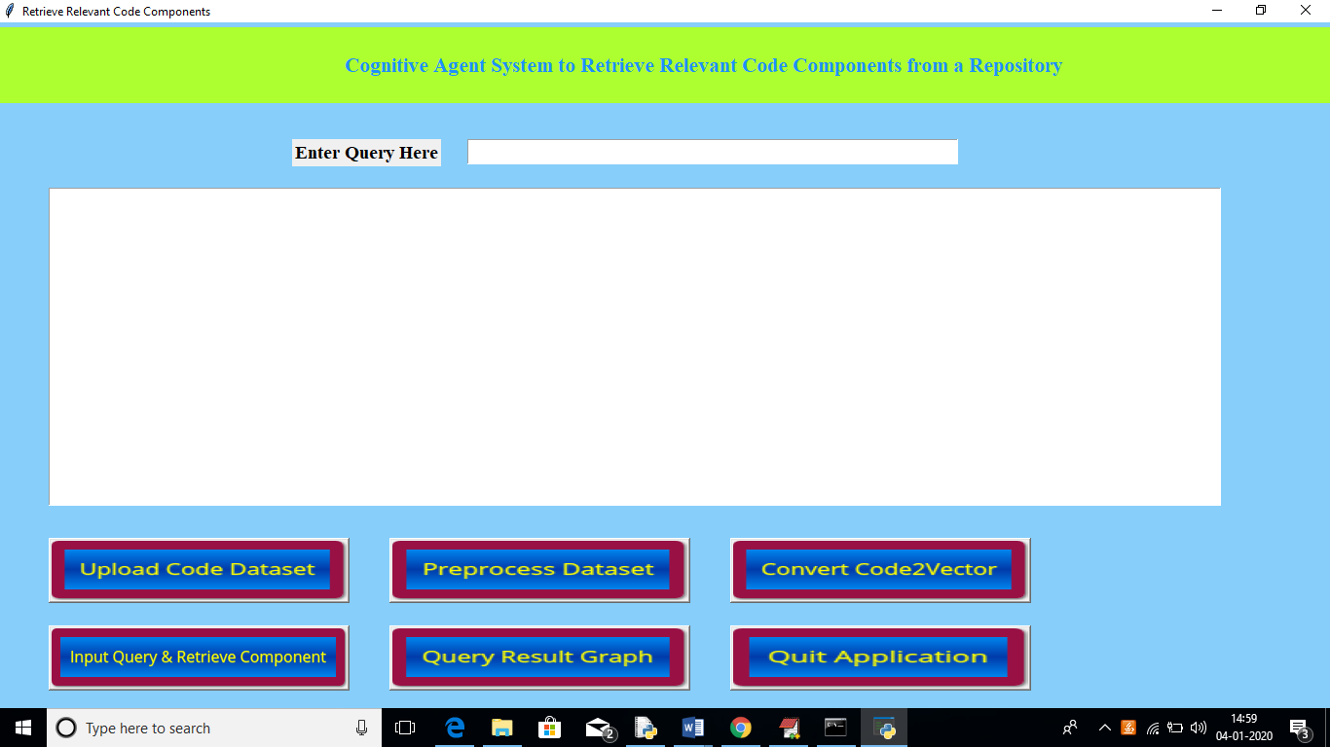
In above screen click on ‘Upload Code Dataset’ button and upload train repository
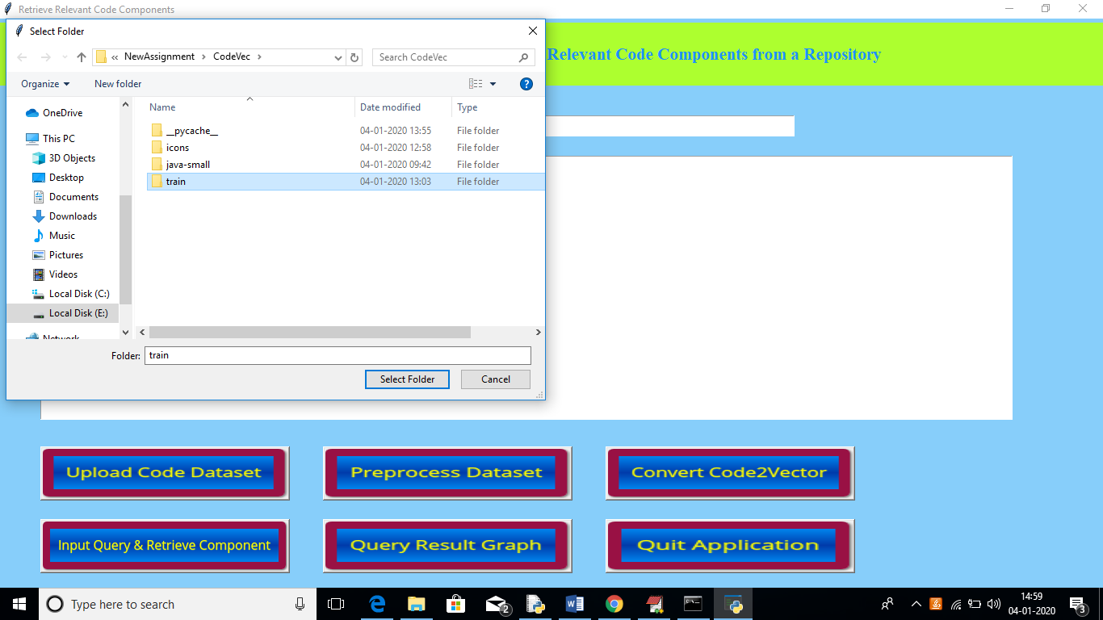
In above screen I am uploading train folder which contains more than 100 programs from different technologies. After uploading dataset will get below screen
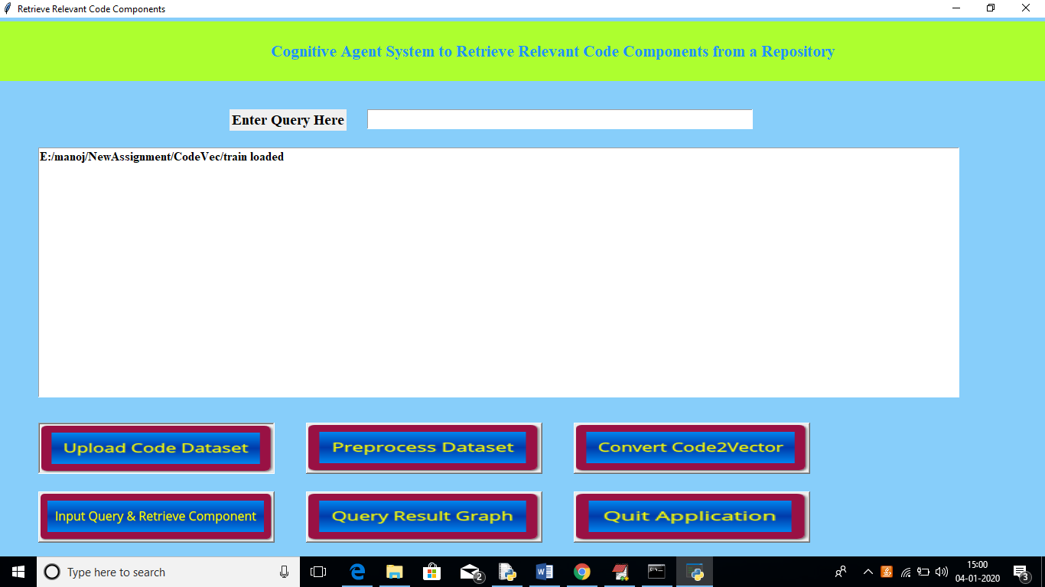
Now click on ‘Preprocess Dataset’ button to read all programs and to clean all programs by removing stop words and special symbols. Will get below screen after preprocessing
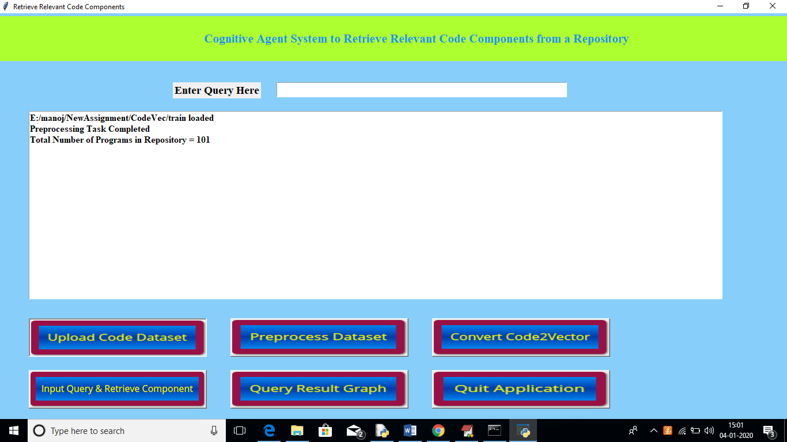
In above screen we can see it process total 101 programs and to see processed program names then see black console. See below screen
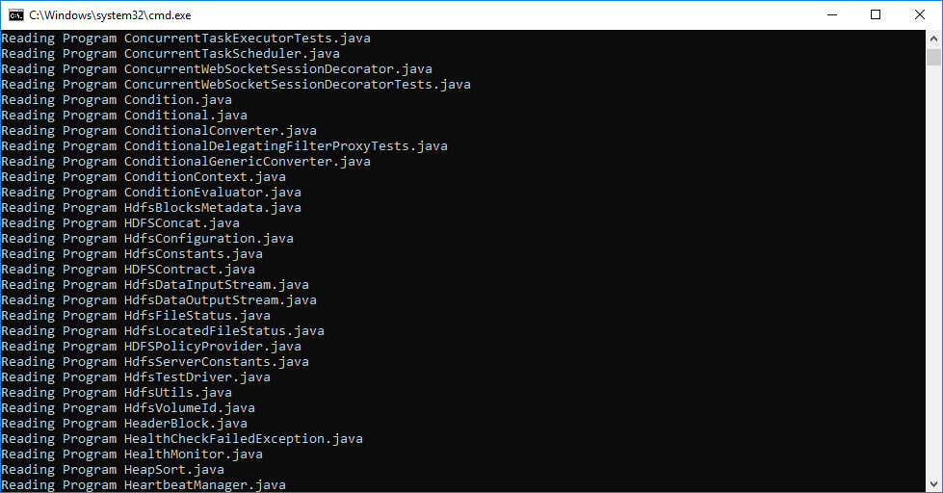
In above screen we can see name of each program which was processed. Now click on ‘Convert Code2Vector’ button to convert all processed program to vector
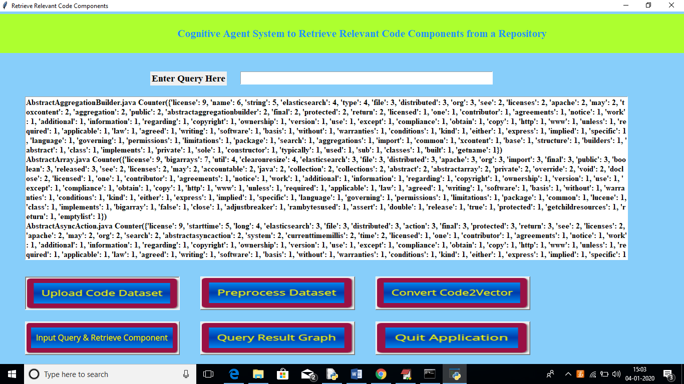
In above screen we can see program name and then its words and its count. Now enter your query in text field and click on ‘Input Query & Retrieve Component’ button to get all programs which implement that query. Once you build model then you can search any number of queries.
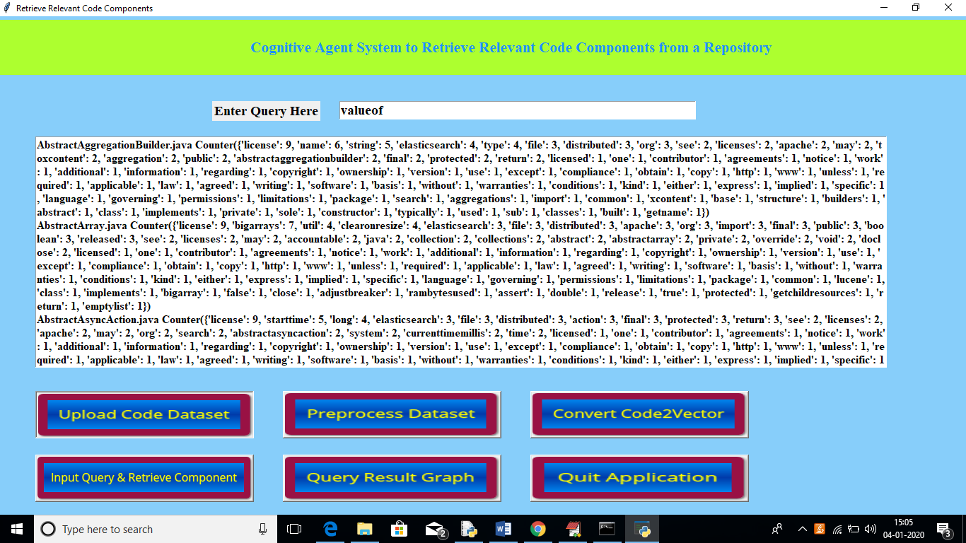
In above screen I entered query as ‘valueof’ which means I want to get all component which used or contains logic for valueof function. Below are the search results
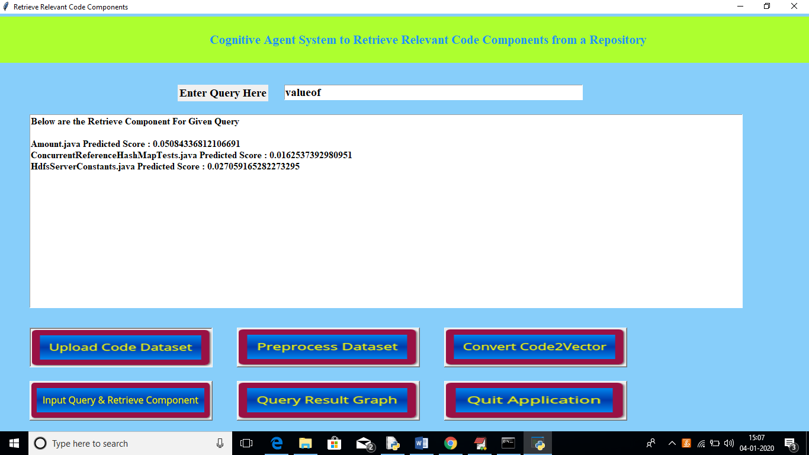
In above screen we can see total 3 programs found (Amount.java, ConcurrentReferenceHashMapTests.java and HdfsServerConstants.java) which used or contains logic for ‘valueof’. Now I will open ‘Amount.java’ program from train folder to see whether it really contains that valueof code or not
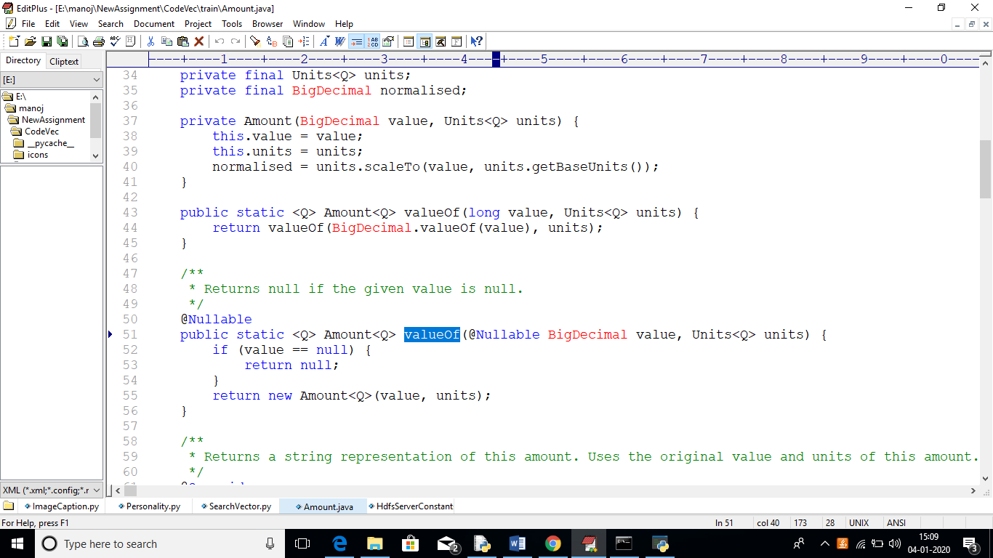
In above ‘Amount.java’ from train repository we can see it contains ‘valueOf’ function. Similarly you can see any query and get component. Now click on ‘Query Result Graph’ button to get below graph
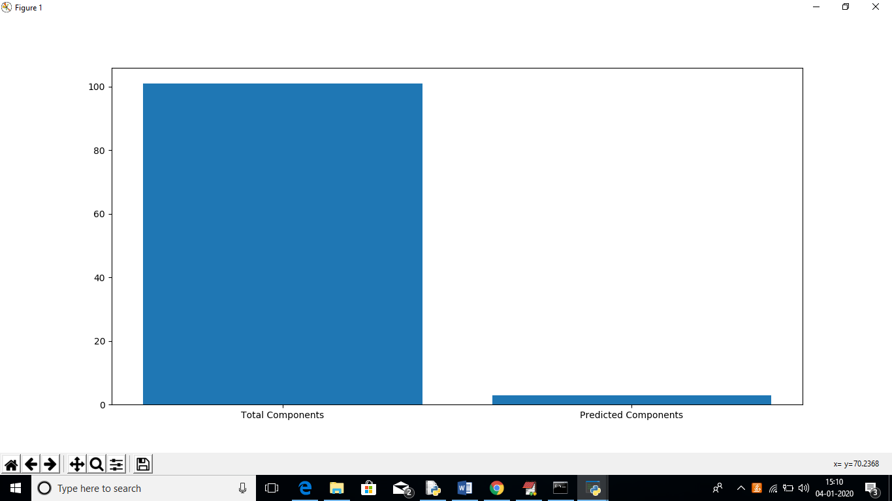
In above graph x-axis represents total components and predicted components and y-axis represents it count.

