Report - Digital E Gram Panchayat

Project Title: Digital E Gram Panchayat
Submitted By: Harikrishna Gangadi
Technologies: HTML, CSS, JavaScript, Firebase

—————————————————————————————————————————————
1. Problem Statement

The major goal of this project is to improve the delivery of citizen services in the village by computerizing applications for gram panchayat services. Gram panchayat is a decentralized institution that manages applications and provides information about gram panchayat services. The suggested system will allow users to submit applications for various services and track their progress. The suggested system E-Services for Gram Panchayat develops a web application with the goal of providing government information about services or schemes, and public users can apply for services using an online application. Admin and staff will manage the application for approval and creation of the scheme.

—————————————————————————————————————————————
2. System Modules
• User (Citizen)
• Staff
• Officer / Admin

—————————————————————————————————————————————

3. Module List
Officer / Admin
• Login
• Create Services
• Update / Delete Services
• Update application status
• Logout

User (Citizen)
• Register
• Login
• Search services
• Apply Services
• My application status
• My profile
• Logout

Staff
• Login
• View services
• Update Application status
• Logout

—————————————————————————————————————————————

4. Project Evaluation Metrics

Code:
• Written in modular fashion (separate JS files: firebase-config.js, navbar.js, logger.js)
• Safe, Testable, Maintainable and Portable
• Public GitHub repository with proper README
• Followed coding standards

Database:
• Used only Firebase (Authentication + Firestore + Hosting)

Logging:
• Custom logging system implemented using logger.js
• Every action (login, register, apply, approve, reject, create/delete service, logout) is logged in Firestore ‘logs’ collection

Deployment:
• Deployed on Firebase Hosting
• Live URL:

—————————————————————————————————————————————
5. Technologies Used

• HTML5, CSS3, JavaScript (ES6)
• Firebase Authentication
• Firebase Firestore (Real-time database)
• Firebase Hosting
• Responsive design (Mobile-friendly)

—————————————————————————————————————————————

6. Screenshots of the Project

6.1 Login & Registration Page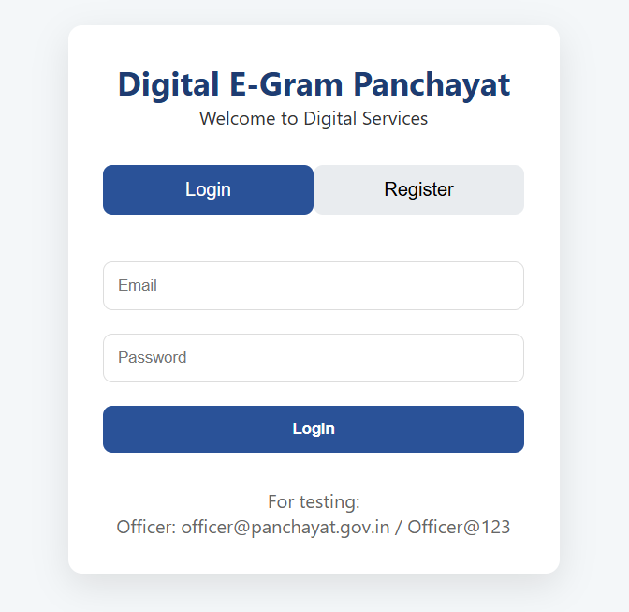

6.2 Officer Dashboard
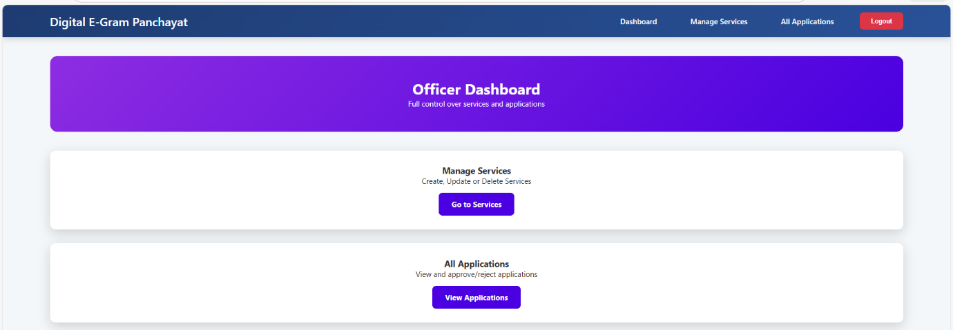

6.3 Manage Services (Officer Panel)
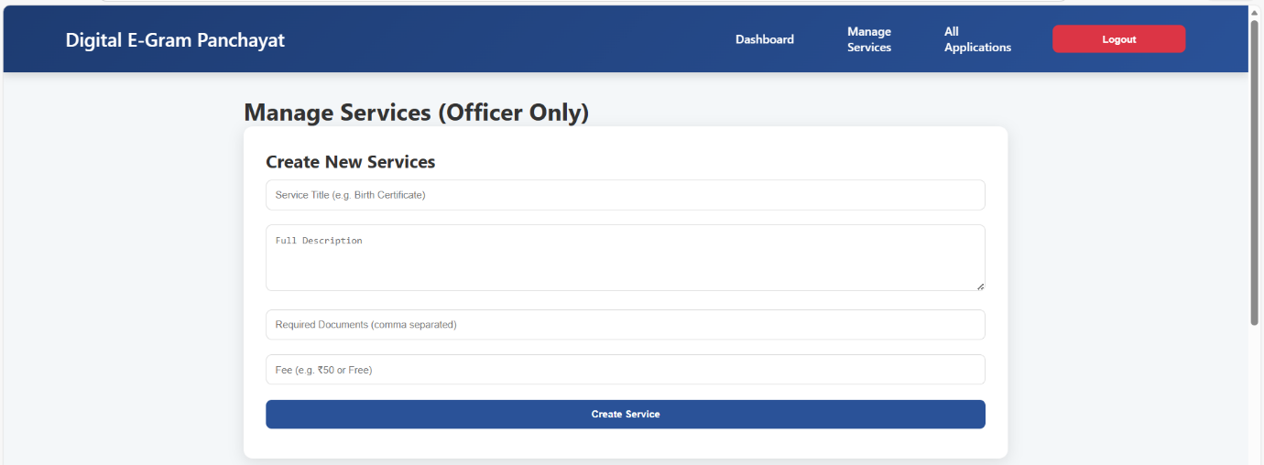

6.4 Add New Service Form
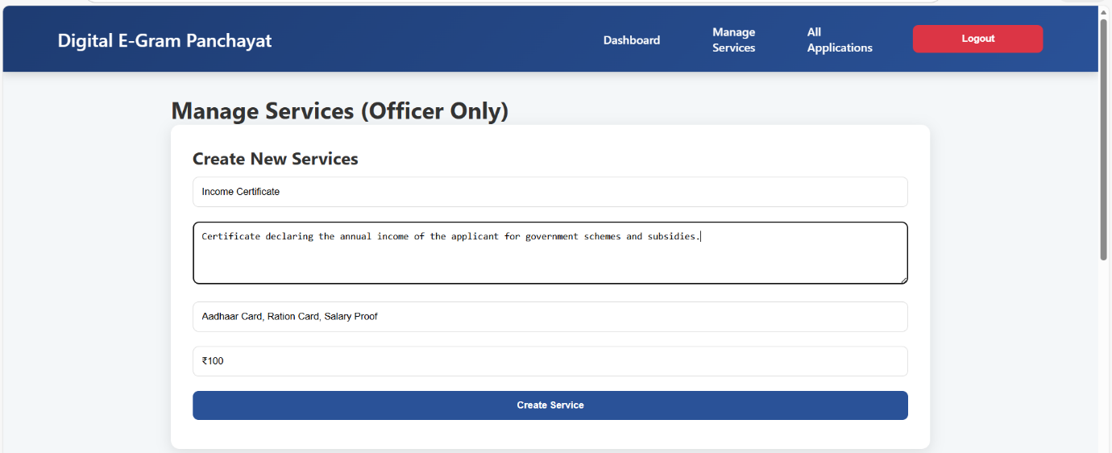

6.5 Service List Visible to Citizens
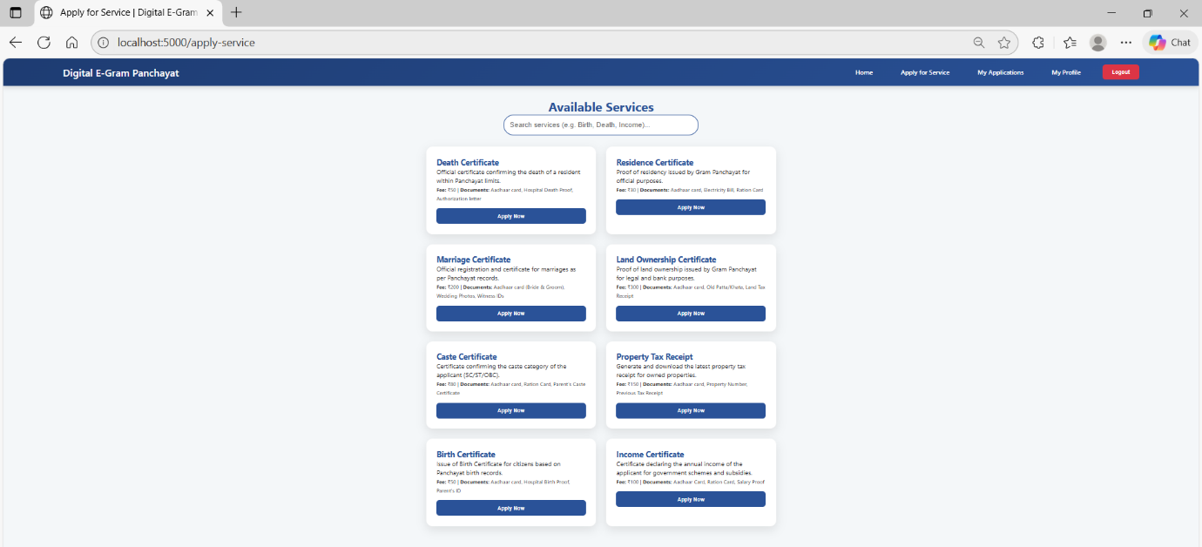
6.6 Citizen Dashboard
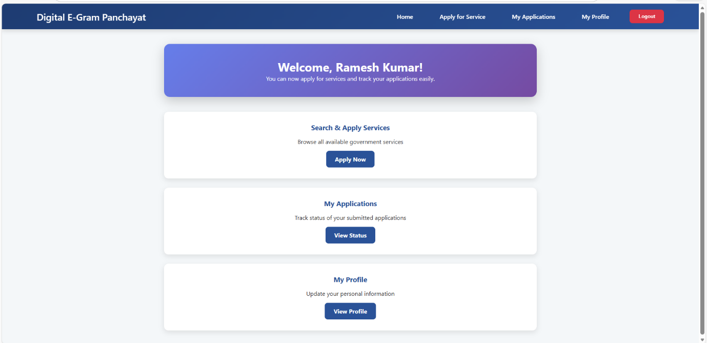

6.7 Citizen – Search & Apply for Service
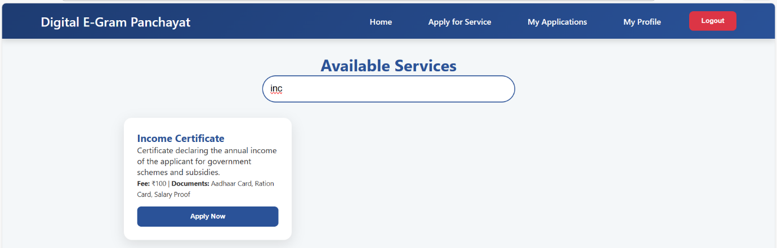
6.8 Application Submission Modal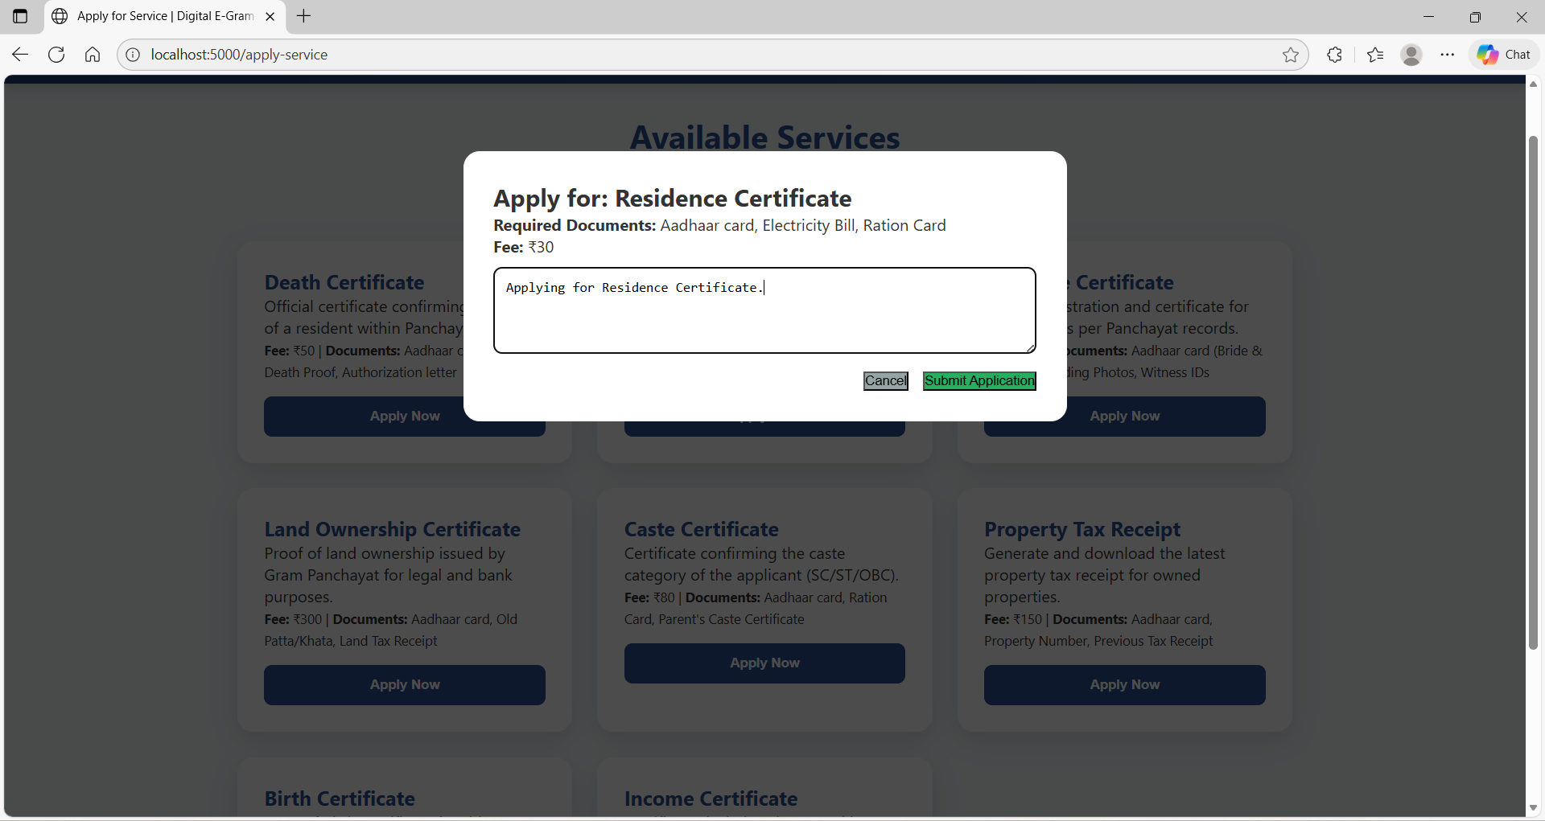

6.9 Success Message After Submission
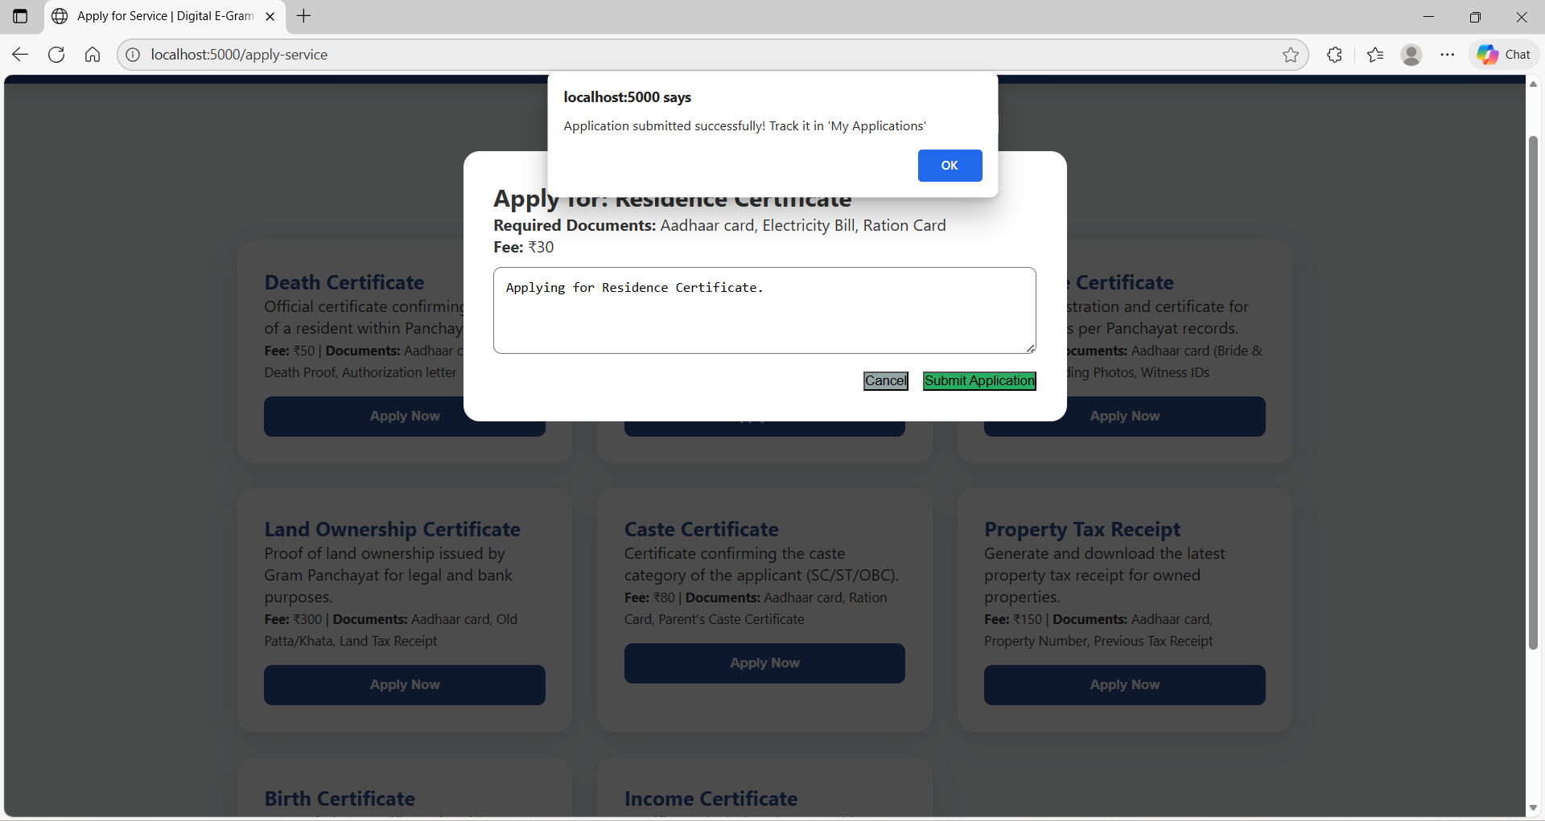

6.10 My Applications – Status Tracking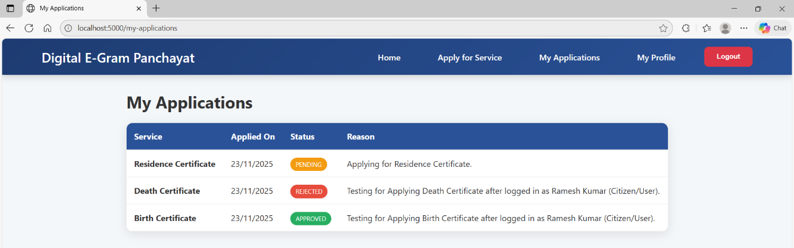

6.11 Citizen Profile Page
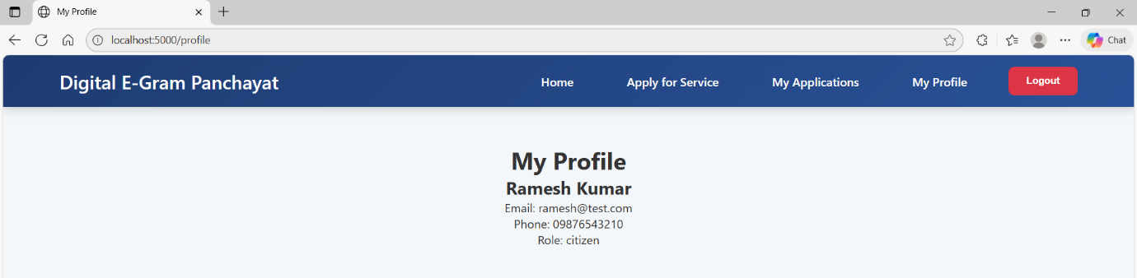

6.12 Staff Dashboard
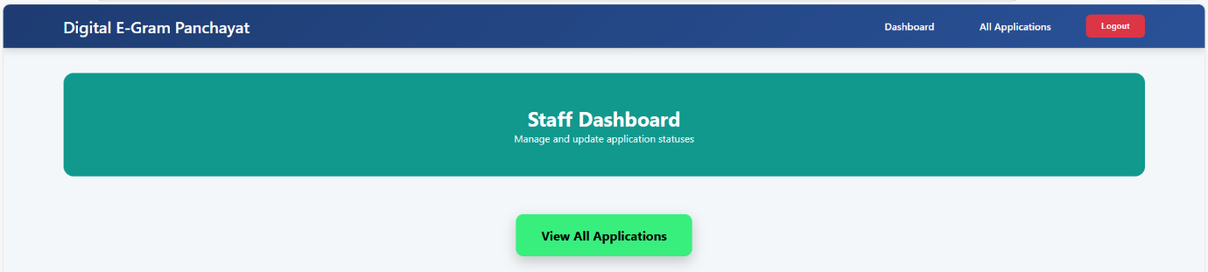

6.13 Staff/Officer – View All Applications
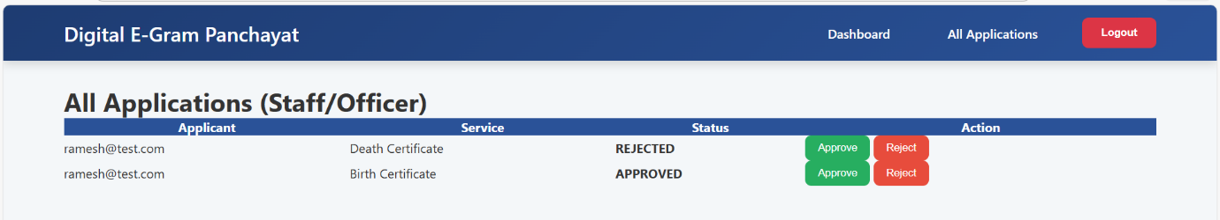

6.14 Approve / Reject Application Buttons
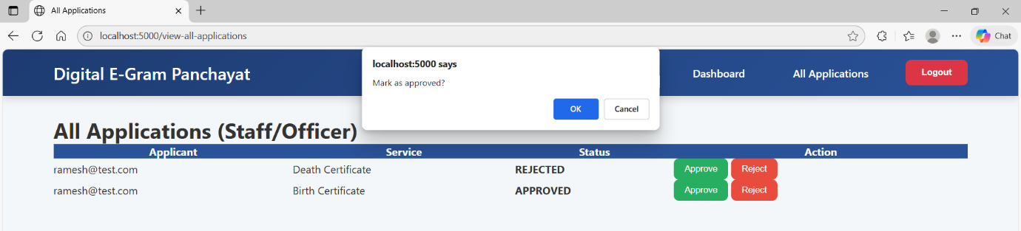
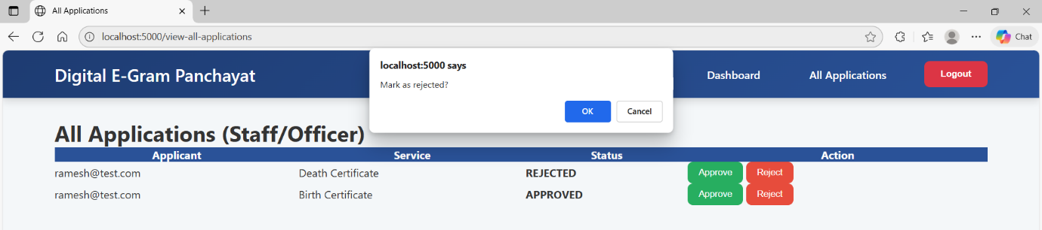

6.15 Updated Status in Real Time
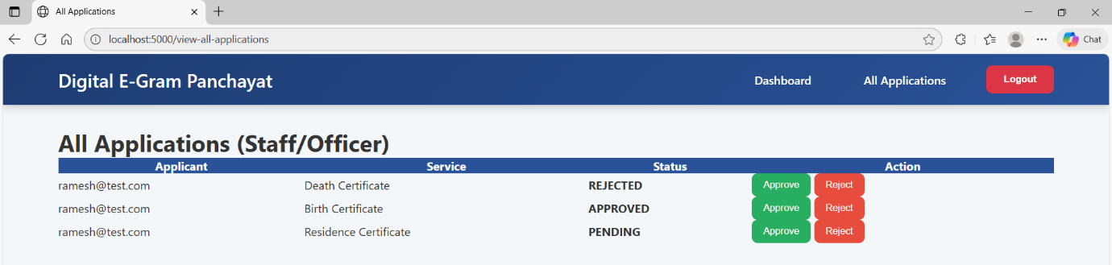

6.16 Delete Service Confirmation
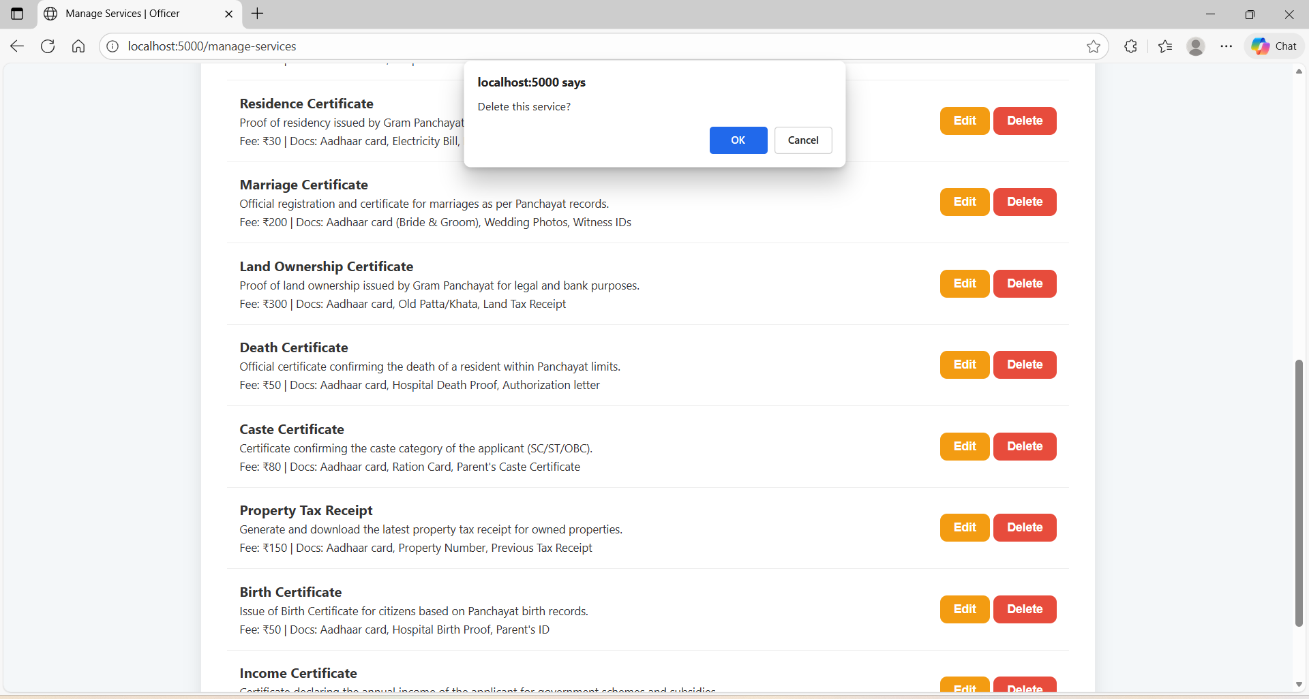
6.17 Firestore – users Collection
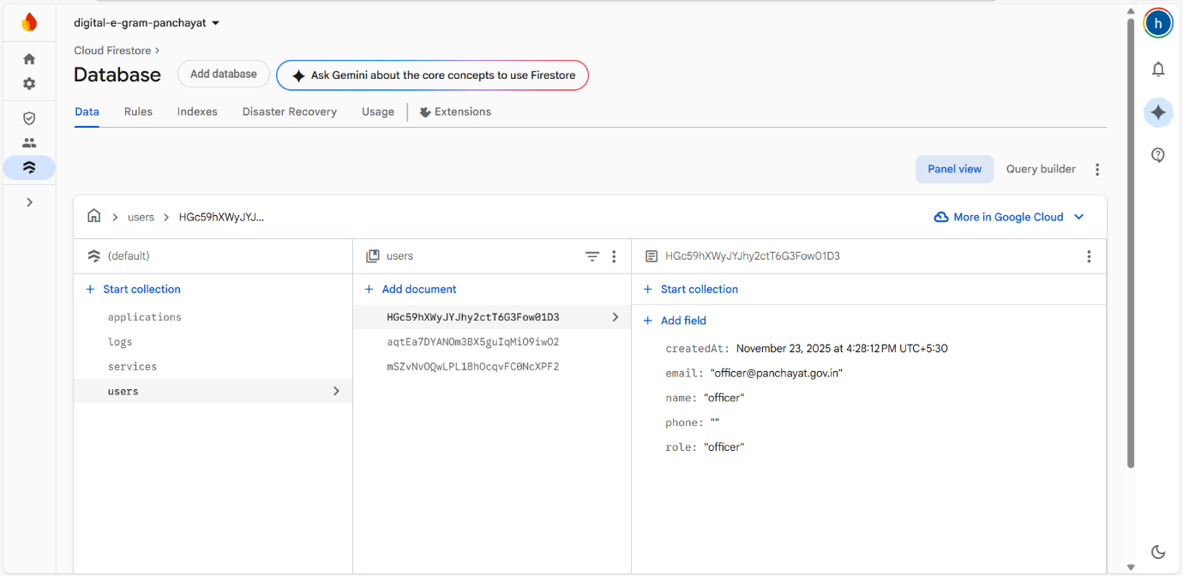

6.18 Firestore – services Collection
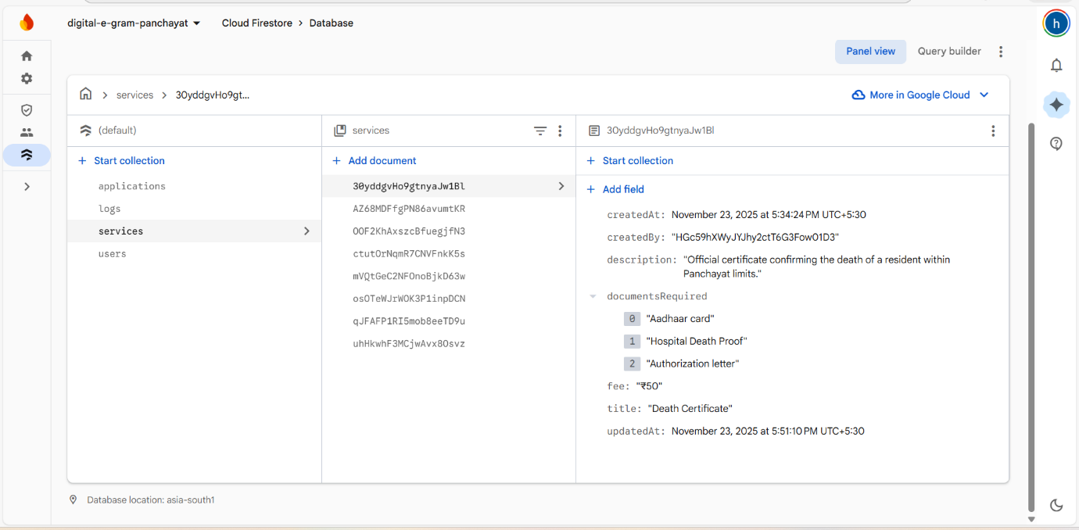

6.19 Firestore – applications Collection
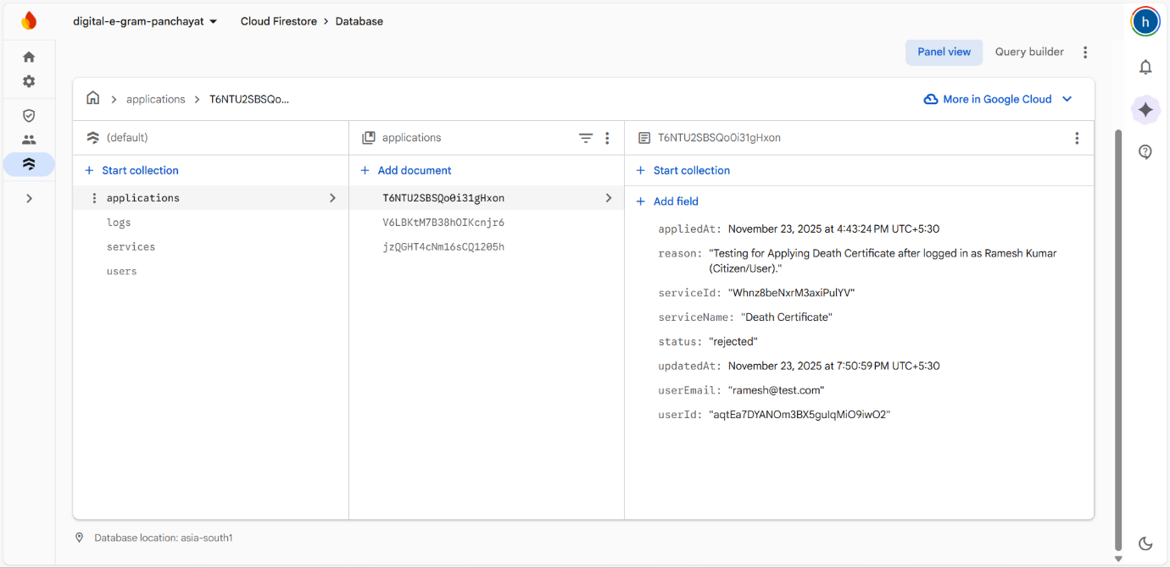

6.20 Firestore – logs Collection
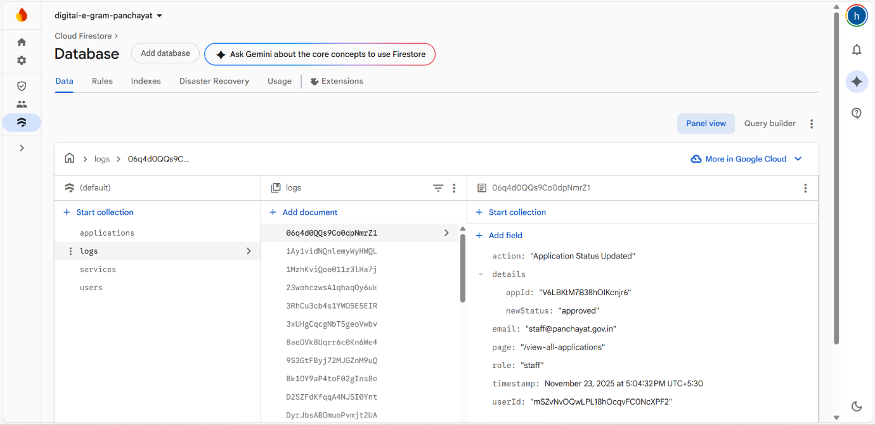

—————————————————————————————————————————————

7. Logging Implementation

A custom logging system has been implemented using logger.js. Every important action performed by any user is logged with the following details:
• User ID & Email
• Role (citizen/staff/officer)
• Action performed
• Details (e.g., service ID, application ID)
• Timestamp
• Page URL

All logs are stored in the Firestore collection named logs.

—————————————————————————————————————————————

8. Test Cases

Citizen Flow:
• Register → Login → Search Service → Apply → View status in My Applications → Logout

Staff Flow:
• Login → View All Applications → Approve/Reject → Status updates instantly

Officer Flow:
• Login → Create Service → Service appears for citizens → Update/Delete service → Manage applications

All functionalities tested and working perfectly.

—————————————————————————————————————————————

9. Deployment & Links

GitHub Repository:
https://github.com/hari612k/digital-e-gram-panchayat

Live Project URL:

Deployment Command:
firebase deploy

10. Conclusion
The Digital E-Gram Panchayat web application has been successfully developed using HTML, CSS, JavaScript and Firebase. All the required modules for Citizen, Staff and Officer have been implemented with proper role-based access control, real-time data synchronization, custom logging system and responsive design.

—————————————————————————————————————————————

