Enterprise Advanced RAG with
Hybrid Search, ReRanking,
CRAG, SRAG, Caching and Guardrails in LangGraph

1. Description
An enterprise-grade conversational AI co-pilot for Site Reliability Engineers SREs and platform engineers. The system routes natural-language questions into a RAG pipeline (for documentation lookup), a Text2SQL pipeline (for operational data queries), or a Hybrid pipeline (when both are needed) — all behind a 9-layer security stack and a 5-tier Redis cache.
Stage | Approx. Time
Native RAG baseline | 1.5 hours
Hybrid Search Dense + Sparse + RRF | 1.5 hours
Cross-Encoder Reranking | 1 hour
HyDE Hypothetical Document Embeddings) | 1 hour
CRAG Corrective RAG Web Fallback) | 1.5 hours
Self-RAG SRAG Reflection Loop | 1.5 hours
TextSQL with LangGraph HITL approval) | 2 hours
5 Tier Caching Layer | 1.5 hours
9 Layer Guardrails & Security | 2 hours
Integration, FastAPI service, Streamlit demo | 1.5 hours
Total | ≈ 15 17 hours

3. Introduction
Retrieval-Augmented Generation RAG) has become the de-facto pattern for grounding Large Language Models in private enterprise knowledge. However, a
naïve RAG pipeline — embed → retrieve top-k → stuff into the prompt → generate —
collapses the moment it meets the real world: noisy corpora, ambiguous queries, latency-sensitive users, prompt-injection attempts, and the need to also consult structured operational data.
This project builds a production-ready RAG copilot for Kubernetes operations that progressively layers in every advanced RAG technique published over the past two years — Hybrid Search, Reranking, HyDE, CRAG, Self-RAG — and combines them with Text2SQL, multi-tier caching, and a 9-layer security pipeline. The knowledge base is deliberately engineered with a 95% noise / 5% signal ratio so each advanced technique has to earn its place. The entire flow is orchestrated as a stateful, resumable LangGraph state machine with human-in-the-loop SQL approval.

4. Aim
Goal: Build a working, end-to-end, production-grade RAG service that an SRE can actually trust with operational queries — accurate, fast, observable, and safe against prompt injection.
Specifically the learner will:
Understand how each advanced RAG technique solves a specific failure mode of naïve RAG.
Implement Dense + Sparse hybrid retrieval with Reciprocal Rank Fusion.
Build a LangGraph state machine with conditional edges, persistence, and interrupts for human approval.
Integrate Text2SQL alongside RAG behind a single intelligent router.
Engineer a 5-tier Redis cache that bounds latency and LLM token spend.
Wire up a 9-layer defensive security pipeline (input validation, prompt-injection scanning, PII redaction, output validation).
Ship the whole thing as a clean, testable FastAPI service with Docker and a Streamlit demo UI.

5. Dataset Used
The knowledge base is assembled by _{scripts/data_pipeline/} and is intentionally adversarial.
Category | Source | Format | Count | Size
Signal  (true_data) | Kubernetes official docs — kubernetes.io | PDF / MD | 50 docs | 30 MB
Noise  (noisy_data) | Random PDFs from github.com/tpn/pdfs | PDF / DOCX /  TXT | 950 docs | 120 MB
Structured Ops  DB | Synthetic K8s operational data | PostgreSQL 7 tables) | 10k rows | 20 MB
Why 95% noise? A 95/5 noise-to-signal ratio guarantees that naïve top-k retrieval will fail — which is exactly the pedagogical point. Each advanced technique then has to demonstrably rescue the signal.
The synthetic SQL operational schema:
clusters(id, name, region, provider, k8s_version, node_count, s tatus, created_at)
nodes(id, cluster_id, name, role, instance_type, cpu_cores, mem ory_gb, status, joined_at)
pods(id, node_id, namespace, name, image, cpu_request, memory_r equest, status, created_at, last_restart)
deployments(id, cluster_id, namespace, name, replicas_desired, replicas_ready, strategy, updated_at) incidents(id, cluster_id, severity, title, status, started_at, resolved_at, mttr_minutes)
alerts(id, cluster_id, node_id, alert_name, severity, fired_at, resolved_at, labels JSONB)
oncall_logs(id, incident_id, engineer, action, notes, logged_a t)

6. Tools & Technologies
Layer | Technology
Language | Python 3.12
API Framework | FastAPI 0.115
Orchestration | LangGraph (with Postgres checkpointer + interrupts)
LLM | OpenAI GPT4o / GPT4o-mini
Embeddings | OpenAI text-embedding-3-small
Vector Store | Qdrant (dense + sparse vectors)
Sparse Encoder | FastEmbed / BM25
Reranker | Local cross-encoder BGE / Voyage AI
Relational DB | PostgreSQL 16
Cache | Upstash Redis (serverless)
Web Search Fallback | Tavily Search API
Security Scanner | llm-guard PromptInjection, Toxicity, BanTopics, Anonymize)
Document Parsing | Docling / pypdf
Auth | JWT PyJWT + sliding-window rate limiter
Demo UI | Streamlit
Container | Docker + Docker Compose
Deployment | AWS ECS Fargate + EFS ALB CloudFormation)
Logging | Loguru (structured JSON
Testing | pytest, Ragas (eval harness)
Tooling | uv (deps), Ruff (lint), Mypy (types)

7. Architecture Diagram

7.1 High-Level System Architecture
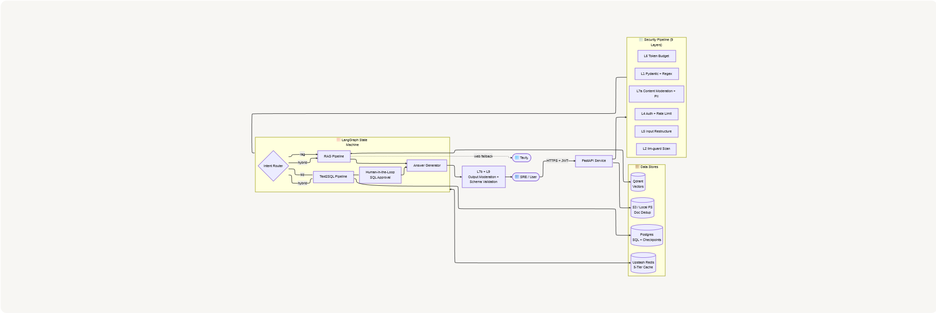

7.2 LangGraph State Machine (the heart of the system)
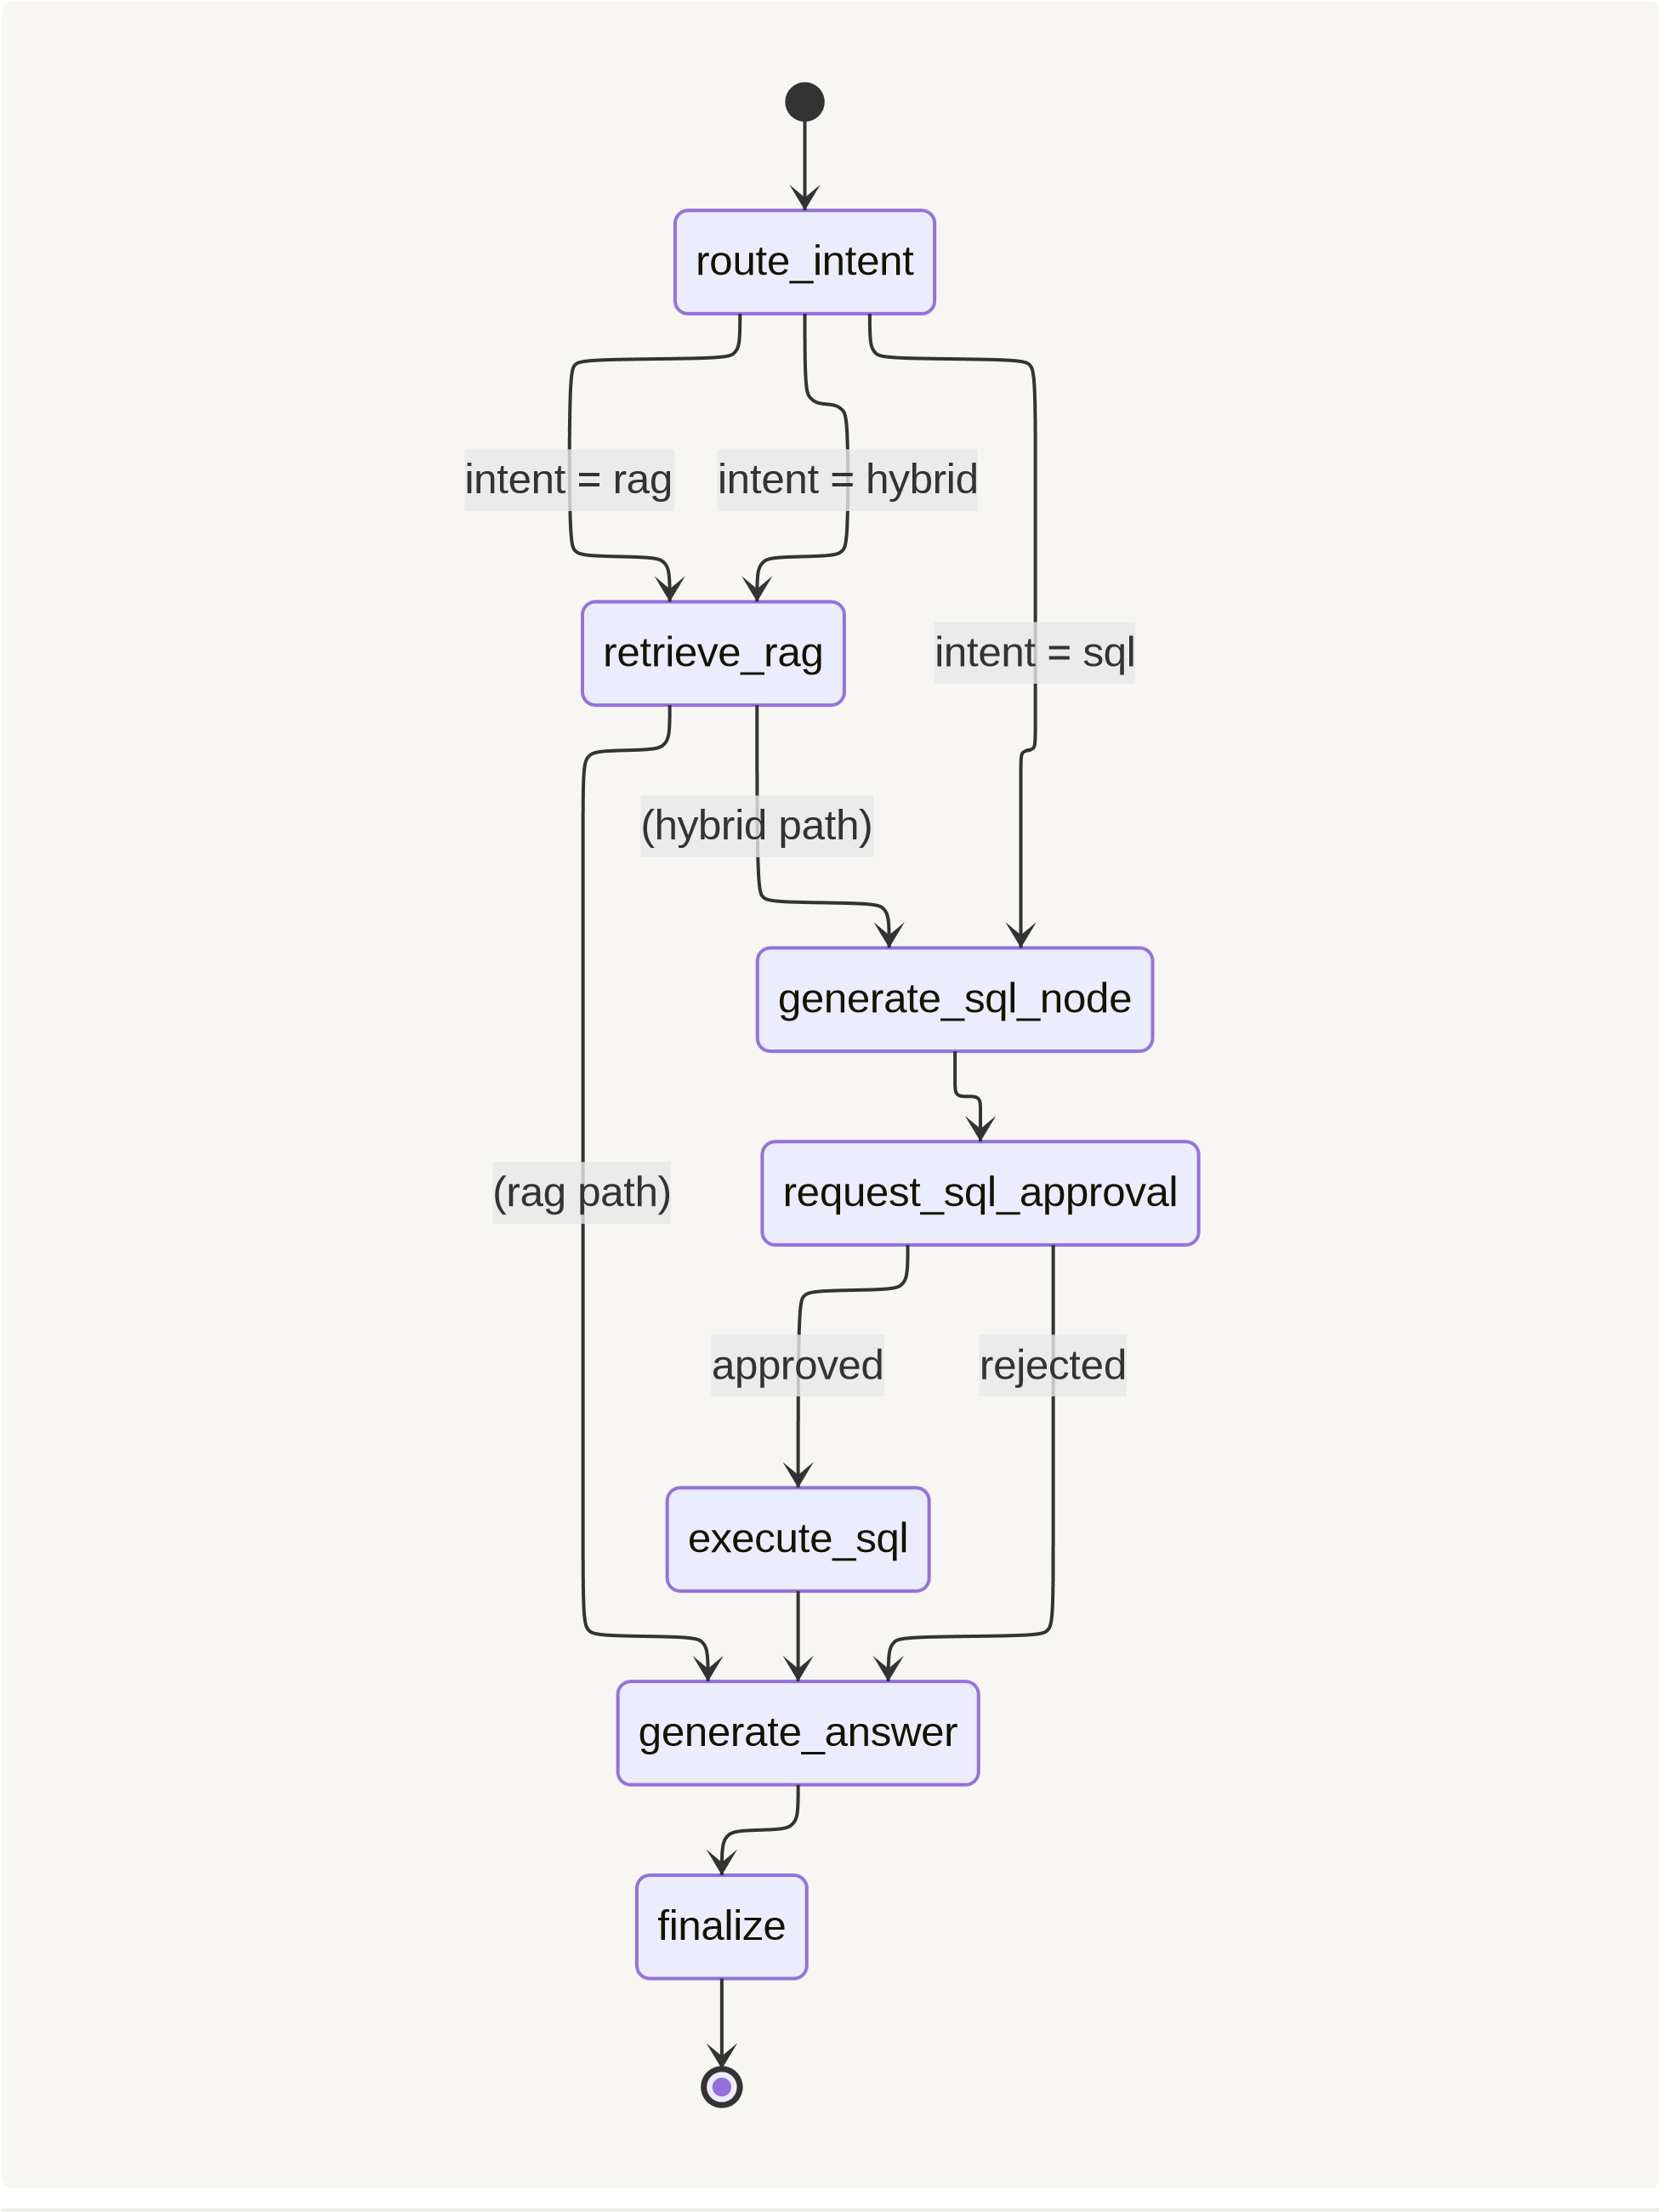
7.3 RAG Retrieval Pipeline (HyDE → Hybrid → Rerank → CRAG →

Spotlight → Generate)
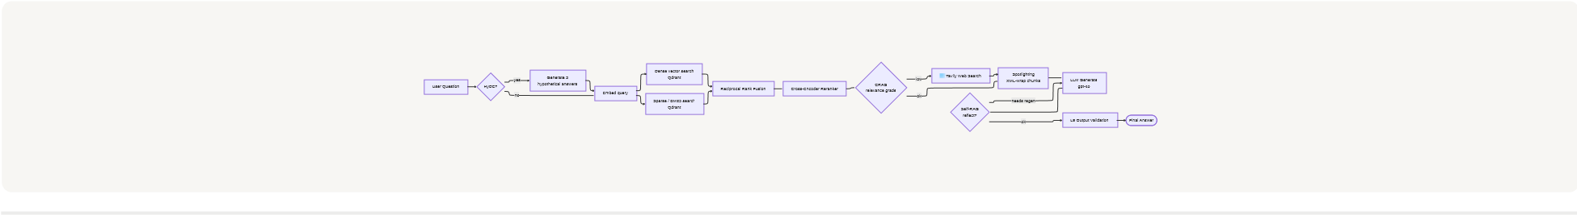

7.4 Caching Topology
Incoming Query
Intent Router Cache
TTL 24h
RAG Answer Cache
TTL 1h
SQL Generation Cache
TTL 24h
SQL Statement
SQL Result Cache
TTL 15m
Text Chunk
Embedding Cache
TTL 7d
Upstash Redis

8. Key Steps / Modules
The project is built incrementally — each commit adds one self-contained advanced technique on top of the previous baseline. Learners can checkout any commit and run that exact stage.

Module 1 — Native (Baseline) RAG
Set up Qdrant, embed the Kubernetes docs, retrieve top-k, stuff into the prompt, generate. The intentional weakness here — naïve dense retrieval drowning in 95% noise — is what motivates everything that follows.

Module 2 — Hybrid Search (Dense + Sparse + RRF)
Add a sparse encoder BM25-style) running side-by-side with dense embeddings inside Qdrant, fused with Reciprocal Rank Fusion. Dense captures semantic
similarity ("rolling update" ≈ "progressive rollout"), sparse rescues exact lexical matches ("kubectl", "CrashLoopBackOff").
Query
Dense Vector Search
Sparse / BM25 Search
Reciprocal Rank Fusion
RRF k=60
Top-k Hybrid Results

Module 3 — Cross-Encoder Reranking
Bi-encoder retrieval is fast but shallow. A cross-encoder re-scores the top-N candidates by jointly encoding the (query, doc) pair — slower per-pair, but dramatically better at separating signal from noise. Pluggable backend: local BGE model or Voyage AI.

Module 4 — HyDE (Hypothetical Document Embeddings)
Short SRE queries like "why is my pod OOMKilled?" lack vocabulary overlap with longer documentation chunks. HyDE asks an LLM to generate 3 hypothetical
answers, embeds those, and uses them as the retrieval query — bridging the
vocabulary gap.

Module 5 — CRAG (Corrective RAG + Web Fallback)
A grader LLM scores each retrieved chunk for relevance. If the average score falls below _{CRAG_RELEVANCE_THRESHOLD = 0.7} , the system falls back to Tavily web search — turning retrieval failure into graceful degradation instead of a hallucination.

Module 6 — Self-RAG (SRAG) Reflection Loop
After the LLM generates an answer, a reflection critic scores it. If the score is below
REFLECTION_MIN_SCORE = 0.8 , the graph loops back and regenerates (max 2 retries). Also
teaches the system when retrieval isn't needed at all — general K8s knowledge bypasses the retriever entirely.

Module 7 — Text2SQL with LangGraph (Human-in-the-Loop)
Not every question is documentation — "Which cluster had the most P1 incidents last month?" needs SQL, not RAG. An LLM generates SQL from the Postgres schema, the LangGraph interrupts to surface the SQL for human approval, then resumes execution via _{Command(resume={approved})} . SELECT-only enforcement + keyword blocklists.
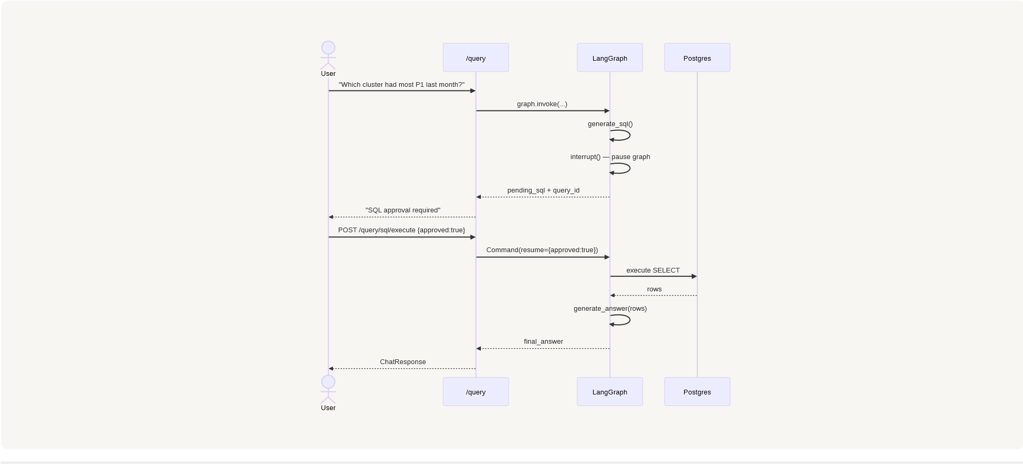

Module 8 — 5-Tier Caching Layer
Every expensive call (embedding, intent classification, SQL generation, SQL execution, final answer) is wrapped with a SHA256-keyed Upstash Redis cache. Cache hits are surfaced in the response metadata for full observability.
Tier | Key | TTL | Saves
embedding | sha256(text) | 7 days | Embedding API calls
intent_router | sha256(question.lower()) | 24 h | Router LLM calls
sql_gen | sha256(question) | 24 h | SQL-generation LLM calls
sql_result | sha256(normalized SQL) | 15 min | Postgres reads
rag_answer | sha256(question + flags) | 1 h | Full pipeline cost

Module 9 — 9-Layer Guardrails & Security
Every request traverses a fixed-order defensive pipeline. Defense in depth — no single layer is trusted to stop everything.

POST /query
L1: Pydantic + Regex
Injection patterns
L4a: JWT Auth
L4b: Rate Limit
req/min
20
L6: Token Budget
100
k/day per user
L5: Input Restructure
tiktoken
truncate/summarize
L2: llm-guard Scan
PromptInjection / Toxicity
L7a: Content Moderation
PII Redaction
+
LangGraph Invoke
L3: Hardened System
Prompt
L8: Spotlighting
XML-delimited chunks
LLM Generation
L7b: Output Moderation
PII Redaction
+
L9: Pydantic Output
Validation + LLM retry
Return ChatResponse

. Duration

