CHAPTER-1
INTRODUCTION

1.1 STATEMENT OF THE PROBLEM

Module description

We can use this application for our state. Or also for a cloud of states within a single web application. The application contains mainly 6 modules

- Admin
- Breeder
- Driver
- Doctor
- Trainer
- Customer
- Boarding

Admin

- Manage breeder
- Manage doctor
- Manage trainer
- Manage customer
- Manage boarding
- View driver details
- Manage product category
- View and manage products such as medicines & accessories
- View request for trainers

Breeder

- Registration
- Manage own profile
- Manage drivers
- Manage pets
- View customer request
- View selling details
- Purchase accessories
- Assign delivery details to drivers
- View selling history
- View & communicate with trainer
- View & communicate with doctor
- Purchase medicine
- Make payment

Driver
- Login
- Manage own profile
- View assigned delivery details
- Update location details in each delivery

Boarding’s

- Registration
- Manage own profile
- View request from owners/customers

Doctor

!) Registration
2) Manage own profile
3) View and reply message from breeder
4) Add prescription

Trainer

1) Registration
2) Manage own profile
3) Add training details
4) View training requests from breeders
5) Can communicate with breeders

Customer

1) Registration
2) Manage own profile
3) View and purchase
4) Can communication with breeders

CHAPTER-2
SYSTEM ANALYSIS

2.1 PRESENT SYSTEM

The pet market was once a very leading online active market. It functions without assuring any kind of documentation, reliability and pet’s safety. After placing orders breeders inadvertently deliver pets without taking necessary precautions or safety measures. As a results, they can have a variety of health problems. Some of them have been reported dead. Pet care industry includes sales of pets and pet food, pet care products and pet accessories as well as services (pet grooming/boarding).pet food is the major segment in India covering more than half of the market revenues and is expected to grow at a CAGR of 13.9%, while pet accessories, grooming and healthcare are growing rapidly in the urban and elite markets. Most popular pets are likely in India dog and cat, but many person also keep house, small pets rabbit, rodents, hamsters, guinea pigs, bird like parakeets, parrots, and fish, gold fish and tropical fishes. The application provides the user to adopt a pet, and purchase the products that are related to pets.

2.2 LIMITATIONS OF PRESENT SYSTEM

- Pets are turned away too soon from their mothers.
- Sold without vaccination.
- Dogs won’t have license which will turn into a crime if it attack folks.
- Breeds aren’t necessarily equipped with license.
- Fraud dealing are easy here.
- fCurrently Doctors consulting availability is too low in present system within required locations
- Training purpose not available at all

2.3 PROPOSED SYSTEM

This web application lets one to track the order they made, which makes this web application different from other. While the existing system compromises the quality of pet accessories they sell. Pet care deals only genuine quality products which does not harm the pets. Life of the pets are the priority of pet care and to strengthen it, delivery is done with atmost care and responsibility, where lives matter. Apart from all these, pets training and veterinary appointments can be done through petcare. The most popular pets are likely in India Dog and cat, but many person also keep house, small pets rabbit, rodents, hamsters, guinea pigs, Birds like parakeets, canaries, parrots, and fish, ornamental fish, tropical fish and more lovely petsThe web application contains pets related products such as Dog food, Dog Treats and Biscuits, Dog Toys, Dog Leases, Collar, Cat food, Cat Treats, Birds Food, Treats for birds, small pet food, fish food and more. The purchase of products is done using cash on delivery.It saves the time, paper work is less, and easy retrieval of records, automating the system reduces the process of middle man who takes commission.

2.4 ADVANTAGES AND FEATURES OF PROPOSED SYSTEM

a) pets with quality exposing doc/certificates are only sold.
b) Breeders are truest worthy, they are equipped with breeder licence.
c) Pets are delivered through secure and healthy measures /methods.
d) Exotic breeds are filtered out.
e) Fraud plays are avoided to max extend.
g) In this system reduces the process of middle man who takes commission.
h) In this proposed system application will be provided medical consultation, training, pharmaceutical and accessory purchase, delivery and boarding facility.

2.5 Feasibility Study
The main aim of the feasibility study activity is to determine. Whether it would be financially and technically feasible to develop the product. The feasibility study activity involves analysis of the problem and collection of all relevant information relating to the product such as the different data items which would be input to the system the processing required to be carried out of these data, the output data required to be carried out of these data, the output data required to be produced by the system, as well as various constraints on the behaviour of the system.
a) Technical Feasibility
b) Economic Feasibility
c) Operational Feasibility

2.5.1 Technical Feasibility
The proposed system uses language PHP. Based n this criteria we can strongly say that it is technically feasible, since there will not be much difficulty n getting required resources for the development and maintain system as well. All the resources needed for the development of the software as well as the maintenance of the same is available in the organisation. Here we are utilizing the resources which are already available so it is technically feasible that we can implement the Pet care system

2.5.2 Operational Feasibility

Proposed system would be beneficial only if they can be turned in to information system that will meet the organization operating requirements. One of the main problems faced during the development of a new system is getting acceptance from user.

2.5.3 Economic Feasibility

Economically, this project doesn’t raise any issue, as the project itself is planned as the website. The resource required for this project is minimum. This system doesn’t demand any additional equipment.

a) The resource required for our project is minimum and the system doesn’t demand any additional equipment so our project is economically feasible

b) It is cost effective as it eliminates the paper works

CHAPTER – 3
SYSTEM SPECIFICATION

3.1 MINIMUM SOFTWARE REQUIREMENTS

1.Operating System : Windows / Mac Os
2.Language : PHP
3.Frontend : HTML, CSS, Javascript, Bootstrap
4.Framework : Codeigniter
5.IDE : Adobe Dream weaver CS3
6.Database : Mysql

3.2 MINIMUM HARDWARE REQUIREMENTS

1.Processor : Intel i5 or AMD Ryzen 3
2.RAM : 3 GB
3.Hard Disk Drive : 300GB
4.Peripherals : Keyboard, Mouse, Camera, Monitor

CHAPTER – 4
SYSTEM DESIGN

4.1 CONTEXT LEVEL DIAGRAM

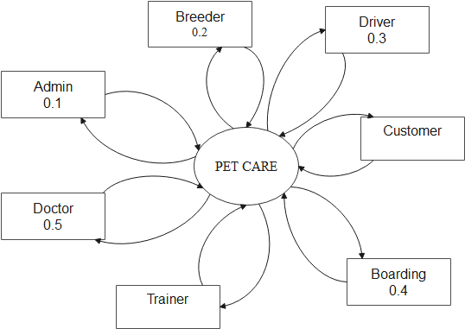

4.2 DATA FLOW DIAGRAM

LEVEL 1: ADMIN

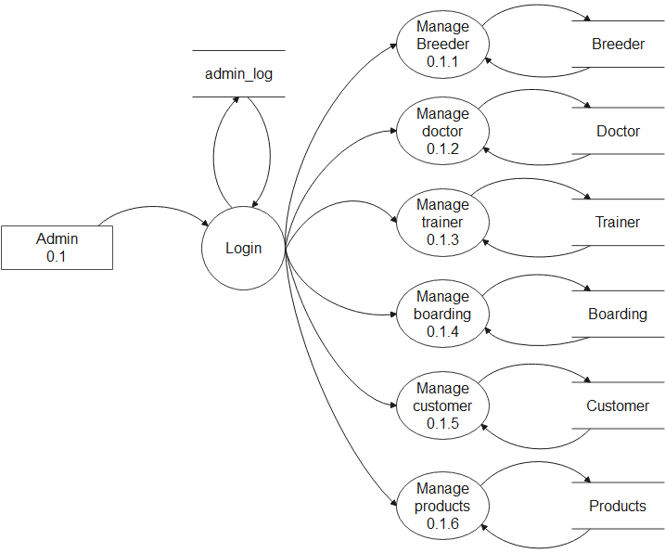

LEVEL 1: BREEDER

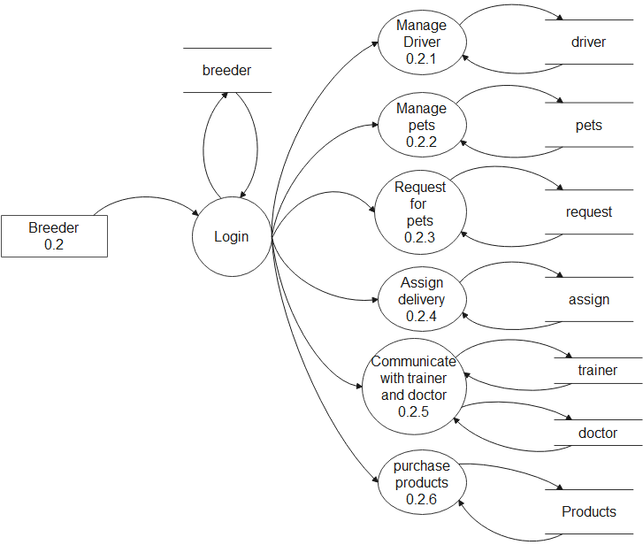

LEVEL 1: DRIVER
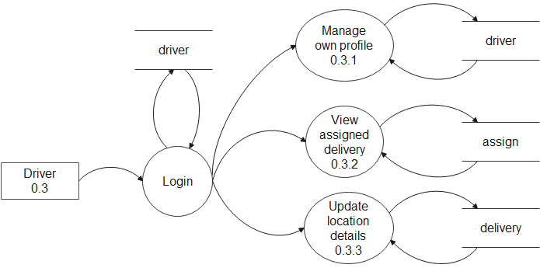

LEVEL 1: BOARDING

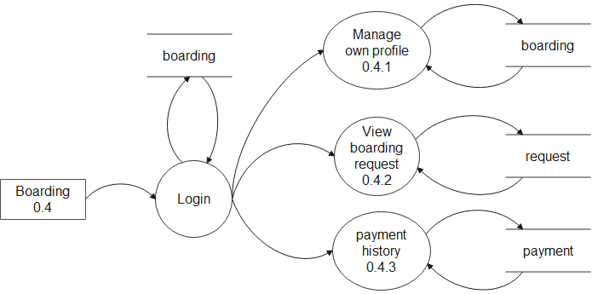

LEVEL 1 : DOCTOR

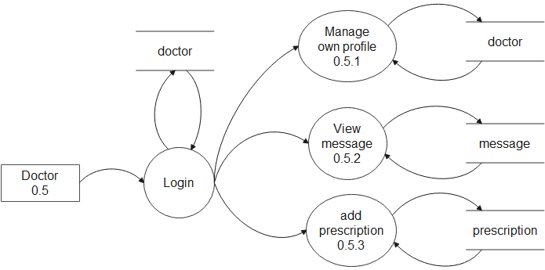

LEVEL 1 : TRAINER
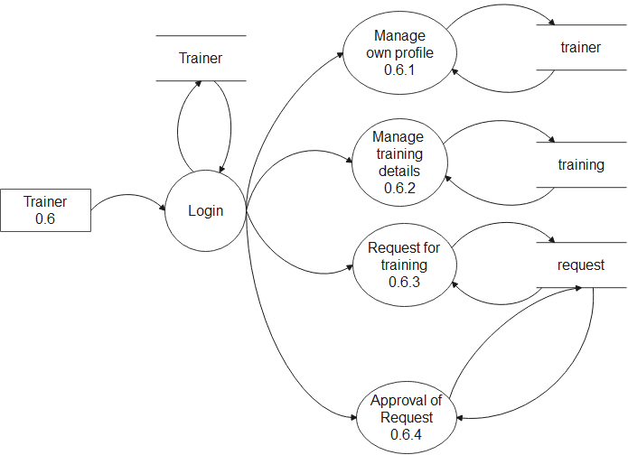

LEVEL 1 : CUSTOMER

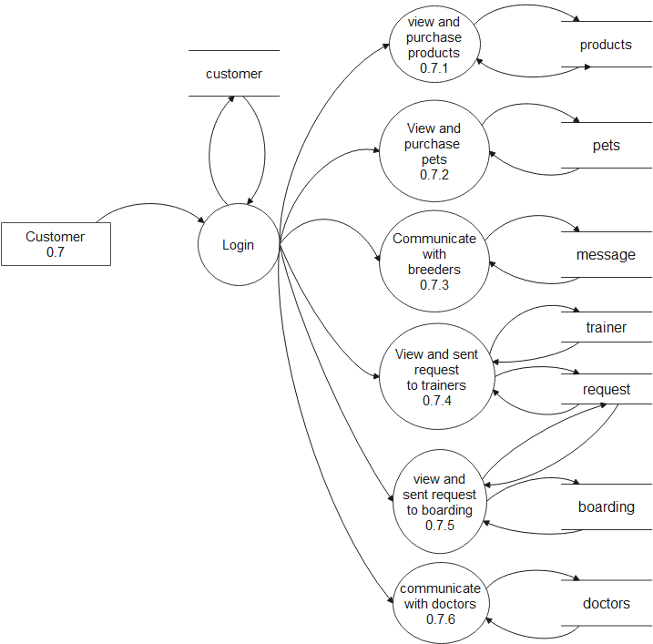

ER DIAGRAM

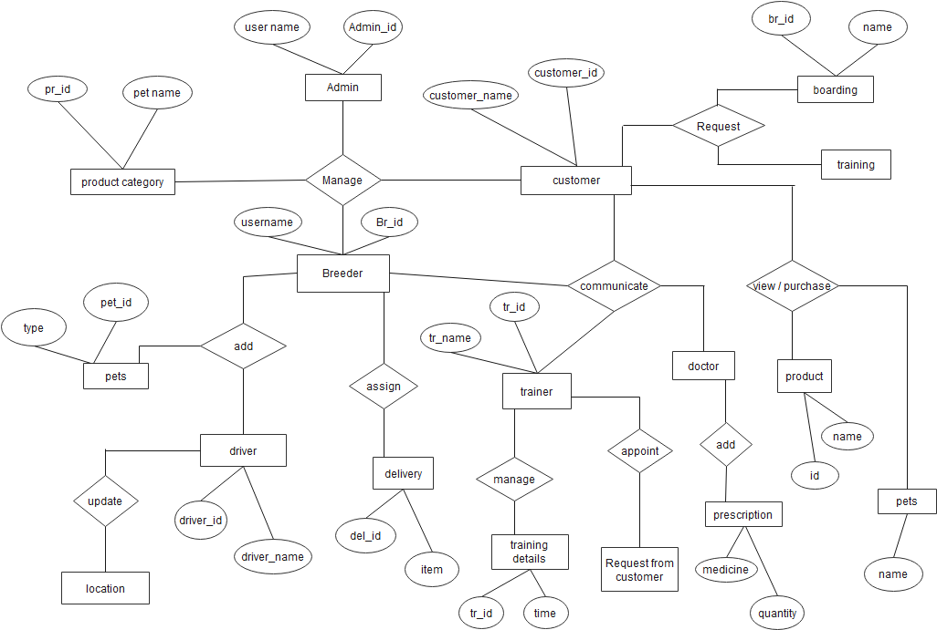

4.3 DATABASE DIAGRAM

TABLE : PAN-CARD DATABASE

FIELD NAME DATATYPE SIZE CONSTRAINTS

Pan Number CharField 100 PrimaryKey
Father Name Char Field 100 Not Null
Name Char Field 100 Not Null
Pan Dob Char Field 100 Not Null
Pan Image Image Field Not Null

TABLE : AADHAR CARD DATABASE

FIELD NAME DATATYPE SIZE CONSTRAINTS

Aadhar Number Char Field 100 PrimaryKey
Aadhar Name Char Field 100 Not Null
Aadhar Birth Char Field 100 Not Null
Aadhar Gender Char Field 100 Not Null
Aadhar Image Image Field Not Null

TABLE: DRIVER LICENCE DATABASE

FIELD NAME DATATYPE SIZE CONSTRAINTS

Driver Licence No Char Field 100 PrimaryKey
Driver Licence Name Char Field 100 Not Null
Driver Licence L name Char Field 100 Not Null
Driver Licence Image Image Field Not Null

TABLE : VOTER ID DATABASE

FIELD NAME DATATYPE SIZE CONSTRAINTS

Voter Father Name Char Field 100 PrimaryKey
Voter Name Char Field 100 Not Null
Voter Image Image Field Not Null

4.4 NORMALIZATION

Designing a data base is a complex task and the normalization theory is a useful and in this design process.
A bad database design may lead to certain undesirable situations such as;
- Repetition of information
- Inability to represent certain information
- Loss of information
To minimize the anomalies, normalization may be used. In construction and system, here
there is only one database named result. There are tables in database.

First Normal form (1 NF)

A relation is in first normal form (1 NF), if and only if all its attributes are based on a single domain. The objective of normalizing a table is to remove its repeating groups and ensure that all entries of the resulting table have at most single value. The objective of 1NF is to divide the database into logical units called tables. When each table has been designed, primary key is assigned to most or all tables.

Second Normal form (2 NF)

A table is said to be in second normal form (2 NF), when it is in 1NF and it satisfies functional dependency. Functional of 2NF is to take data that is partially dependent on the primary key, enter the data into another table. Now consider the data base of the system. In this there are a total of table and all tables are in second normal form. That is all of these tables satisfies second normal form. No repeated information is stored in any table. All of the table. All of the tables have a separate primary key some of all are auto numbers.

Third Normal form (3 NF)

A table is said to be in 3NF, when it is 2NF and every non-key attribute is functionally dependent only on the primary key. The objective of 3NF is to remove data in a table that is not dependent on the primary key.

All our tables are in First normalization form

4.5 DESIGN OF EACH SUB SYSTEM

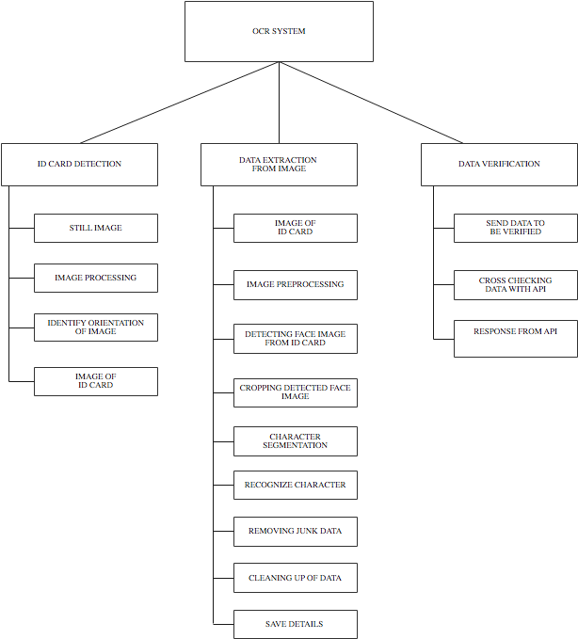

4.6 UML DIAGRAMS

4.6.1 USE CASE DIAGRAM

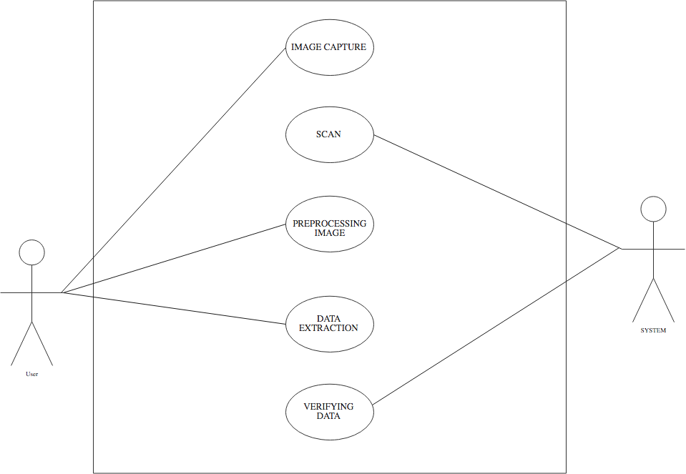

CHAPTER-5
CODING

5.1 FEATURES OF LANGUAGE

Python Overview

Python is a general-purpose, interpreted, high-level programming language which is widely used nowadays .It is an open source language which was developed by Guido Van Rossum in the late 1980s .Python Software Foundation (PSF), a non-profit organization, holds the intellectual property rights of Python. Python was released in 1991 at Centrum Wiskunde & Informatica (CWI) in the Netherlands as a successor to the ABC language. Rossum named this language after a popular comedy show called 'Monty Python's Flying Circus' (and not after Python-the snake).In the last few years, the popularity of python has increased immensely due to its wide applications. According to most of the tech surveys, Python is in the top ten Most Popular Technologies in 2019.

Python Features

Python is an interpreter-based language, which allows execution of one instruction at a time.

- Extensive basic data types are supported e.g. numbers (floating point, complex, and unlimited-length long integers), strings (both ASCII and Unicode), lists, and dictionaries.
- Variables can be strongly typed as well as dynamic typed.
- Supports object-oriented programming concepts such as class, inheritance, objects, module, namespace etc.
- Cleaner exception handling support.
- Supports automatic memory management.

Python Advantages

- Python provides enhanced readability. For that purpose, uniform indents are used to delimit blocks of statements instead of curly brackets, like in many languages such as C, C++ and Java.
- Python is free and distributed as open-source software. A large programming community is actively involved in the development and support of Python libraries for various applications such as web frameworks, mathematical computing and data science.
- Python is a cross-platform language. It works equally on different OS platforms like Windows, Linux, Mac OSX etc. Hence Python applications can be easily ported across OS platforms.
- Python supports multiple programming paradigms including imperative, procedural, object-oriented and functional programming styles.

- Python is an extensible language. Additional functionality (other than what is provided in the core language) can be made available through modules and packages written in other languages (C, C++, Java etc)
- A standard DB-API for database connectivity has been defined in Python. It can be enabled using any data source (Oracle, MySQL, SQLite etc.) as a backend to the Python program for storage, retrieval and processing of data.
- Standard distribution of Python contains the Tkinter GUI toolkit, which is the implementation of popular GUI library called Tcl/Tk. An attractive GUI can be constructed using Tkinter. Many other GUI libraries like Qt, GTK, WxWidgets etc. are also ported to Python.
- Python can be integrated with other popular programming technologies like C, C++, Java, ActiveX and CORBA.

Python Applications
Even though Python started as a general-purpose programming language with no particular application as its focus, over last few years it has emerged as the language of choice for developers in some application areas. Some important applications of Python are summarized below:

Image Processing

The OpenCV library is commonly used for face detection and gesture recognition. OpenCV is a C++ library, but has been ported to Python. Because of the rapid development of this feature, Python is a very popular choice from image processing.

OpenCV

OpenCV is a cross-platform library using which we can develop real-time computer vision applications. It mainly focuses on image processing, video capture and analysis including features like face detection and object detection. Computer Vision can be defined as a discipline that explains how to reconstruct, interrupt, and understand a 3D scene from its 2D images, in terms of the properties of the structure present in the scene. It deals with modeling and replicating human vision using computer software and hardware.

Django

Django is a high-level Python Web framework that encourages rapid development and clean, pragmatic design. Built by experienced developers, it takes care of much of the hassle of Web development, so you can focus on writing your app without needing to reinvent the wheel. It’s free and open source.

Django Features

Ridiculously fast:- Django was designed to help developers take applications from concept to completion as quickly as possible.

Fully loaded:- Django includes dozens of extras you can use to handle common Web development tasks. Django takes care of user authentication, content administration, site maps, RSS feeds, and many more tasks — right out of the box.

Reassuringly secure:- Django takes security seriously and helps developers avoid many common security mistakes, such as SQL injection, cross-site scripting, cross-site request forgery and clickjacking. Its user authentication system provides a secure way to manage user accounts and passwords.

Exceedingly scalable:- Some of the busiest sites on the planet use Django’s ability to quickly and flexibly scale to meet the heaviest traffic demands.

Incredibly versatile:- Companies, organizations and governments have used Django to build all sorts of things — from content management systems to social networks to scientific computing platforms.

5.2 FUNCTIONAL DESCRIPTION

#views.py

import json
from django.http import HttpResponse
from django.shortcuts import render # , redirect
from django.core.files.storage import FileSystemStorage

"""import numpy as np
import urllib
import json
import cv2
import os"""

# import ast
# from django.views.decorators.csrf import csrf_exempt
# from django.http import JsonResponse
from django.conf import settings
from django import db
from .forms import UploadImageForm
from .forms import ImageUploadForm
from .forms import UploadFileForm

from .models import aadhardb, dirverdata, voteriddata, panddata, panapi, aadharapi, drvingapi, voterapi
# import our OCR function
# import pandas as pd
from .ocr import ocr
# import re
from .adhar import adhar
from .voterid import voterid
from .driver import driver_license

# from .bank import bank_details_sbi, bank_details_alla, bank_details_yes
# from .driver import driver_license
# db.connections.close_all()

def home(request):
return render(request, 'pcard/home.html', {})

def Hbase(request):
return render(request, 'pcard/base.html')

def index(request):
return render(request, 'pcard/index.html', {})

def aadhar(request):
if request.method == 'POST':
form = ImageUploadForm(request.POST, request.FILES)
if form.is_valid():
post = form.save(commit=False)
post.save()

imageURL = settings.MEDIA_URL + form.instance.image.name
# print(settings.MEDIA_URL, "cgfcgvhvhvh")
adhar_text = adhar(settings.MEDIA_ROOT_URL + imageURL)
# print(adhar_text, "HHH")
# obj={
# 'form':form, 'post':post, 'adhar_text': adhar_text, 'img_src' : imageURL
# }
# adhar_text=json.loads(json.dumps(adhar_text))
ad_name = adhar_text[0]
ad_dob = adhar_text[2]
ad_gender = adhar_text[3]
ad_num = adhar_text[1]
obj = {
"Name": ad_name,
"DOB": ad_dob,
"Gender": ad_gender,
"Number": ad_num
}
myobj = aadhardb(aadharnumber=ad_num, aadharname=ad_name, aadharbirth=ad_dob, aadhargender=ad_gender, aadharimage=imageURL)
myobj.save()

return render(request, 'pcard/aadhar.html',
{"adhar_text": obj, 'img_src': imageURL, 'adharno': adhar_text[1]})
else:
form = ImageUploadForm()
return render(request, 'pcard/aadhar.html', {'form': form})

def voter_id(request):
if request.method == 'POST':
form = ImageUploadForm(request.POST, request.FILES)
if form.is_valid():
post = form.save(commit=False)
post.save()

imageURL = settings.MEDIA_URL + form.instance.image.name
# print(settings.MEDIA_URL, "cgfcgvhvhvh")
voterid_text = voterid(settings.MEDIA_ROOT_URL + imageURL)
print(voterid_text)
v_name = voterid_text[0]
v_fname = voterid_text[1]

print("voters_name", v_name)
print("voters_father name", v_fname)

# obj={
# 'form':form, 'post':post, 'adhar_text': adhar_text, 'img_src' : imageURL
# }
# adhar_text=json.loads(json.dumps(adhar_text))

vobj = voteriddata(votername=v_name, voterfname=v_fname, voterimage=imageURL)
vobj.save()

return render(request, 'pcard/voterid.html', {"voterid_text": voterid_text, 'img_src': imageURL})

else:
form = ImageUploadForm()
return render(request, 'pcard/voterid.html', {'form': form})

def uimage(request):
if request.method == 'POST':
form = UploadImageForm(request.POST, request.FILES)
if form.is_valid():
myfile = request.FILES['image']
fs = FileSystemStorage()
filename = fs.save(myfile.name, myfile)
uploaded_file_url = fs.url(filename)
return render(request, 'pcard/uimage.html', {'form': form, 'uploaded_file_url': uploaded_file_url})

else:
form = UploadImageForm()
return render(request, 'pcard/uimage.html', {'form': form})

def ocr_core(request):
if request.method == 'POST':
form = ImageUploadForm(request.POST, request.FILES)
if form.is_valid():
post = form.save(commit=False)
post.save()

imageURL = settings.MEDIA_URL + form.instance.image.name
# print(imageURL)
extracted_text = ocr(settings.MEDIA_ROOT_URL + imageURL)

print(extracted_text)
# print(extracted_text[6:24])
# print(extracted_text[39:53])
# print(extracted_text[69:79])
# print(extracted_text[92:101])

fname = extracted_text[0]
fathername = extracted_text[1]
dob = extracted_text[2]
pno = extracted_text[3]

pobj = panddata(panno=pno, fathername=fathername, name=fname, pandob=dob, panimage=imageURL)
pobj.save()

return render(request, 'pcard/pcard.html',
{'form': form, 'post': post, 'extracted_text': extracted_text, 'img_src': imageURL})
else:
form = ImageUploadForm()
return render(request, 'pcard/pcard.html', {'form': form})

def driver_id(request):
if request.method == 'POST':
form = ImageUploadForm(request.POST, request.FILES)
if form.is_valid():
post = form.save(commit=False)
post.save()

imageURL = settings.MEDIA_URL + form.instance.image.name
# print(imageURL)
driver_text = driver_license(settings.MEDIA_ROOT_URL + imageURL)
print(driver_text)
print("name", driver_text[0])
drlicencename = driver_text[0]
drlicencelname = driver_text[1]
drlicenceno = driver_text[2]
print(drlicenceno, drlicencename, drlicencelname)
myobj = dirverdata(drlicenceno=drlicenceno, drlicencename=drlicencename drlicencelname=drlicencelname,drlicenceimage=imageURL)
myobj.save()
return render(request, 'pcard/driver.html',
{'form': form, 'post': post, 'driver_text': driver_text, 'img_src': imageURL})
else:
form = ImageUploadForm()
return render(request, 'pcard/driver.html', {'form': form})

def pandataverification(request):
if request.method == 'POST':

pandate = request.POST.get('pandate')
panid = request.POST.get('panid')
alldata = panapi.objects.filter(uid=panid)

for x in alldata:
if panid != x.uid:
return HttpResponse('not equal')
elif pandate != x.dob:
return HttpResponse('not equal')
else:
return render(request, 'pcard/responseapi.html', {'alldata': alldata})

form = ImageUploadForm()
return render(request, 'pcard/pcard.html', {'form': form})

def drivingdataverification(request):
if request.method == 'POST':

drivingid = request.POST.get('drivingverify')
alldata = drvingapi.objects.filter(uid=drivingid)
try:
data = drvingapi.objects.get(uid=drivingid)
except Exception as e:
data = None

if (data != None):

return render(request, 'pcard/drivingresponse.html', {'alldata': alldata})
# return HttpResponse("success")
else:
return HttpResponse("not in db")

form = ImageUploadForm()
return render(request, 'pcard/driver.html', {'form': form})

def voterdataverification(request):
if request.method == 'POST':

voterid = request.POST.get('voterverify')
alldata = voterapi.objects.filter(voterid=voterid)
try:
data = voterapi.objects.get(voterid=voterid)
except Exception as e:
data = None

if (data != None):

return render(request, 'pcard/voterresponse.html', {'alldata': alldata})
# return HttpResponse("success")
else:
return HttpResponse("not in db")

form = ImageUploadForm()
return render(request, 'pcard/voterid.html', {'form': form})

def aadhardataverification(request):
if request.method == 'POST':
aadhardate = request.POST.get('aadhardate')
aadharid = request.POST.get('aadharid')
alldata = aadharapi.objects.filter(uid=aadharid)

for x in alldata:

if aadharid != x.uid:
return HttpResponse("not equal")
elif aadhardate != x.dob:
return HttpResponse("not equal")
else:
return render(request, 'pcard/aadharresponse.html', {'alldata': alldata})

form = ImageUploadForm
return render(request, 'pcard/aadhar.html', {'form': form})

#pancard.py

# from django.conf import settings

"""try:
from PIL import Image
except ImportError:
import Image"""

import pytesseract
import numpy as np
import cv2
import ftfy
import re
import json
import io
# import os
from PIL import Image

# from scipy.ndimage import rotate
face_classifier = cv2.CascadeClassifier("./haarcascade_frontalface_default.xml")

# filename = cv2.imread("/home/arijit/Documents/PAN-Card-OCR-master/media")

def Convert(a):
it = iter(a)
res_dct = dict(zip(it, it))
return res_dct

def ocr(filename):
"""
This function will handle the core OCR processing of images.
"""
i = cv2.imread(filename)

newdata = pytesseract.image_to_osd(i)
angle = re.search('(?<=Rotate: )\d+', newdata).group(0)
angle = int(angle)
i = Image.open(filename)
if angle != 0:
# with Image.open("ro2.jpg") as i:
rot_angle = 360 - angle
i = i.rotate(rot_angle, expand="True")
i.save(filename)

"""rot = False
if rot:
i = rotate(i, None)
i = rotate(i, None)
i = rotate(i, None)"""
i = cv2.imread(filename)
# Convert to gray
i = cv2.cvtColor(i, cv2.COLOR_BGR2GRAY)

# Apply dilation and erosion to remove some noise
kernel = np.ones((1, 1), np.uint8)
i = cv2.dilate(i, kernel, iterations=1)
i = cv2.erode(i, kernel, iterations=1)

text = pytesseract.image_to_string(i)
# return text

dict = text.split(' ')
# print(dict)

# print('Pan card number is {}.\nDate of Birth is {}.'.format(val[0][0],val[1][0]))
# print('\n')
# Cleaning all the gibberish text
text = ftfy.fix_text(text)
text = ftfy.fix_encoding(text)
new_text = ocr_to_json(text)

# print(type(new_text))
# list_text = new_text.split("\n")
# print(list_text)

face_detect(filename)
return new_text

def ocr_to_json(text):
# Initializing data variable
name = None
fname = None
dob = None
pan = None
nameline = []
dobline = []
panline = []
text0 = []
text1 = []
text2 = []

# Searching for PAN
lines = text.split('\n')
for lin in lines:
s = lin.strip()
s = lin.replace('\n', '')
s = s.rstrip()
s = s.lstrip()
text1.append(s)

text1 = list(filter(None, text1))

# to remove any text read from the image file which lies before the line 'Income Tax Department'

lineno = 0 # to start from the first line of the text file.

for wordline in text1:
xx = wordline.split('\n')
if ([w for w in xx if re.search(
'(INCOMETAXDEPARWENT @|mcommx|INCOME|TAX|GOW|GOVT|GOVERNMENT|OVERNMENT|VERNMENT|DEPARTMENT|EPARTMENT|PARTMENT|ARTMENT|INDIA|NDIA)$',
w)]):
text1 = list(text1)
lineno = text1.index(wordline)
break

text0 = text1[lineno + 1:]

# print(text0) # Contains all the relevant extracted text in form of a list - uncomment to check

def findword(textlist, wordstring):
lineno = -1
for wordline in textlist:
xx = wordline.split()
if ([w for w in xx if re.search(wordstring, w)]):
lineno = textlist.index(wordline)
textlist = textlist[lineno + 1:]
return textlist
return textlist

try:
# Cleaning first names, better accuracy
name = text0[0]
name = name.rstrip()
name = name.lstrip()
name = name.replace("8", "B")
name = name.replace("0", "D")
name = name.replace("6", "G")
name = name.replace("1", "I")
name = re.sub('[^a-zA-Z] +', ' ', name)

# Cleaning Father's name
fname = text0[1]
fname = fname.rstrip()
fname = fname.lstrip()
fname = fname.replace("8", "S")
fname = fname.replace("0", "O")
fname = fname.replace("6", "G")
fname = fname.replace("1", "I")
fname = fname.replace("\"", "A")
fname = re.sub('[^a-zA-Z] +', ' ', fname)

# Cleaning DOB
dob = text0[2]
dob = dob.rstrip()
dob = dob.lstrip()
dob = dob.replace('l', '/')
dob = dob.replace('L', '/')
dob = dob.replace('I', '/')
dob = dob.replace('i', '/')
dob = dob.replace('|', '/')
dob = dob.replace('\"', '/1')
dob = dob.replace(" ", "")

# Cleaning PAN Card details
text0 = findword(text1, '(Pormanam|Number|umber|Account|ccount|count|Permanent|ermanent|manent|wumm)$')
panline = text0[0]
pan = panline.rstrip()
pan = pan.lstrip()
pan = pan.replace(" ", "")
pan = pan.replace("\"", "")
pan = pan.replace(";", "")
pan = pan.replace("%", "L")

except:
pass

# Making tuples of data
data = {}
data['Name'] = name
data['Father Name'] = fname
data['Date of Birth'] = dob
data['PAN'] = pan

# Writing data into JSON
try:
to_unicode = unicode
except NameError:
to_unicode = str

# Reading data back JSON(give correct path where JSON is stored)
with open('data.json', 'r', encoding='utf-8') as f:
ndata = json.load(f)

t = (f"Name: {data['Name']}\n"
f"Father's Name: {data['Father Name']}\n"
f"Date of Birth: {data['Date of Birth']}\n"
f"PAN number: {data['PAN']}\n")

list_data = [data['Name'], data['Father Name'], data['Date of Birth'],data['PAN']]

return list_data
# return Respone({"message":data})

# print(ocr('images/ocr_example_1.png'))

def face_detect(filename):
img = cv2.imread(filename)

gray = cv2.cvtColor(img, cv2.COLOR_BGR2GRAY)

# cv2.imshow('Original image', img)

faces = face_classifier.detectMultiScale(gray, 1.3, 5)

"""
if faces is ():
print("No faces found")"""

# crop_img = 0
for (x, y, w, h) in faces:
x = x - 25
y = y - 40
cv2.rectangle(img, (x, y), (x + w + 50, y + h + 70), (27, 200, 10), 2)
# cv2.imshow('Face Detection', img)
crop_img = img[y: y + h + 70, x: x + w + 50]
cv2.imwrite('./media/Face1.jpg', crop_img)
cv2.waitKey(1000)
cv2.destroyAllWindows()
return crop_img

#aadhar.py

from django.conf import settings

import pytesseract
import cv2
import re

import cv2
import ftfy
from PIL import Image

# from scipy.ndimage import rotate
import numpy as np

face_classifier = cv2.CascadeClassifier("./haarcascade_frontalface_default.xml")

def adhar(filename):
"""
This function will handle the core OCR processing of images.
"""

i = cv2.imread(filename)
newdata = pytesseract.image_to_osd(i)
angle = re.search('(?<=Rotate: )\d+', newdata).group(0)
angle = int(angle)
i = Image.open(filename)
if angle != 0:
# with Image.open("ro2.jpg") as i:
rot_angle = 360 - angle
i = i.rotate(rot_angle, expand="True")
i.save(filename)

i = cv2.imread(filename)
# Convert to gray
i = cv2.cvtColor(i, cv2.COLOR_BGR2GRAY)

# Apply dilation and erosion to remove some noise
kernel = np.ones((1, 1), np.uint8)
i = cv2.dilate(i, kernel, iterations=1)
i = cv2.erode(i, kernel, iterations=1)

text = pytesseract.image_to_string(i)
# return text

dict = text.split(' ')
# print(dict)

# print('Pan card number is {}.\nDate of Birth is {}.'.format(val[0][0],val[1][0]))
# print('\n')
# Cleaning all the gibberish text
text = ftfy.fix_text(text)
text = ftfy.fix_encoding(text)

new_text = clear_text(text)
# print(type(new_text))
face_detect(filename)
return new_text

def clear_text(text):
list_text = []
res = text.split()
split_ocr = text.split('\n')
yob_patn = '[0-9]{4}'
dob_patn = '\d+[-/]\d+[-/]\d+'
adhar_number_patn = '[0-9]{4}\s[0-9]{4}\s[0-9]{4}'
adhar_name_patn = r'\b[A-Z][a-z]+\s[A-Z][a-z]+\s[A-Z][a-z]+$'

# adhar_name_pattrn = r'\b[a-zA-Z0-9._%+-]+@[a-zA-Z0-9.-]+\.[a-zA-Z]{2,}\b'
name = 'NULL'
for ele in split_ocr:
match = re.search(adhar_name_patn, ele)
if match:
name = match.group()
print('name :', name)
list_text.append(name)
if name == 'NULL':
if 'Government' in res:
index = res.index('India')
name = res[index + 3] + " " + res[index + 4]
elif 'GOVERNMENT' in res:
index = res.index('INDIA')
name = res[index + 3] + " " + res[index + 4]
else:
name = split_ocr[1] + " " + split_ocr[2]
print('name :', name)
list_text.append(name)
aadhar_number = ''
for word in res:
if 'yob' in word.lower():
yob = re.findall('d+', word)
if yob:
print('Year of Birth: ' + yob[0])
list_text.append(yob[0])
if len(word) == 4 and word.isdigit():
aadhar_number = aadhar_number + word + ' '
if len(aadhar_number) >= 14:
print("Aadhar number is : " + aadhar_number)
list_text.append(aadhar_number)
else:
aadhar_number = 'NULL'
print("Aadhar number not read")
if aadhar_number == 'NULL':
match = re.search(adhar_number_patn, text)
print(match, 'match --3')
if match:
print(match.group(), 'match.group()')
aadhar_number = match.group()
print("Aadhar number is : " + aadhar_number)
list_text.append(aadhar_number)
if 'DOB' in text:
match = re.search(dob_patn, text)
if match:
DateOfBirth = match.group()
print('DateOfBirth :', DateOfBirth)
list_text.append(DateOfBirth)
elif 'DOB:' in res:
match = re.search(dob_patn, text)
if match:
DateOfBirth = match.group()
print('DateOfBirth :', DateOfBirth)
list_text.append(DateOfBirth)
else:
match = re.search(dob_patn, text)
if match:
DateOfBirth = match.group()
print('DateOfBirth :', DateOfBirth)
list_text.append(DateOfBirth)
if 'Year of Birth' in text:
match = re.search(yob_patn, text)
if match:
DateOfBirth = match.group()
print('DateOfBirth :', DateOfBirth)
list_text.append(DateOfBirth)
if 'Male' in text or 'MALE' in text:
GENDER = 'Male'
elif 'Female' in text or 'FEMALE' in text:
GENDER = 'Female'
else:
GENDER = 'NAN'
print('GENDER :', GENDER)
list_text.append(GENDER)
return list_text

def face_detect(filename):
# print(filename, "XXX")
img = cv2.imread(filename)
gray = cv2.cvtColor(img, cv2.COLOR_BGR2GRAY)

# cv2.imshow('Original image', img)

faces = face_classifier.detectMultiScale(gray, 1.3, 5)

"""if faces is ():
print("No faces found")"""

for (x, y, w, h) in faces:
x = x - 25
y = y - 40
cv2.rectangle(img, (x, y), (x + w + 50, y + h + 70), (27, 200, 10), 2)
# cv2.imshow('Face Detection', img)
crop_img = img[y: y + h + 70, x: x + w + 50]
cv2.imwrite('./media/Face1.jpg', crop_img)

cv2.waitKey(1000)
cv2.destroyAllWindows()
return crop_img

#dirver.py

import pytesseract
import cv2
import re

import cv2

from PIL import Image
import numpy as np
import regex

def Convert(a):
it = iter(a)
res_dct = dict(zip(it, it))
return res_dct

def driver_license(filename):
"""
This function will handle the core OCR processing of images.
"""

i = cv2.imread(filename)
newdata = pytesseract.image_to_osd(i)
angle = re.search('(?<=Rotate: )\d+', newdata).group(0)
angle = int(angle)
i = Image.open(filename)
if angle != 0:
# with Image.open("ro2.jpg") as i:
rot_angle = 360 - angle
i = i.rotate(rot_angle, expand="True")
i.save(filename)

i = cv2.imread(filename)
# Convert to gray
i = cv2.cvtColor(i, cv2.COLOR_BGR2GRAY)

# Apply dilation and erosion to remove some noise
kernel = np.ones((1, 1), np.uint8)
i = cv2.dilate(i, kernel, iterations=1)
i = cv2.erode(i, kernel, iterations=1)

txt = pytesseract.image_to_string(i)
print(txt)
"""
for key in ('Issue Date', 'Licence No\.', 'N', 'Validity\(NT\)'):
print(regex.findall(fr"(?<={'Licence No'}\s*:\s*)\b[^\n]+", txt, regex.IGNORECASE))
"""
text = []
data = {
'firstName': None,
'lastName': None,
'documentNumber': None,
}

c = 0
print(txt)
pattern = "(?<=KEY\s*:\s*)\b[^\n]+"
# Splitting lines
lines = txt.split('\n')

for lin in lines:
c = c + 1
s = lin.strip()
s = s.replace('\n', '')
if s:
s = s.rstrip()
s = s.lstrip()
text.append(s)

try:
if re.match(r".*Name|.*name|.*NAME", s):
name = re.sub('[^a-zA-Z]+', ' ', s)
name = name.replace('Name', '')
name = name.replace('name', '')
name = name.replace('NAME', '')
name = name.replace(':', '')
name = name.rstrip()
name = name.lstrip()
nmlt = name.split(" ")
data['firstName'] = " ".join(nmlt[:len(nmlt) - 1])
data['lastName'] = nmlt[-1]
if re.search(r"[a-zA-Z][a-zA-Z]-\d{13}", s):
data['documentNumber'] = re.search(r'[a-zA-Z][a-zA-Z]-\d{13}', s)
data['documentNumber'] = data['documentNumber'].group().replace('-', '')
if not data['firstName']:
name = lines[c]
name = re.sub('[^a-zA-Z]+', ' ', name)
name = name.rstrip()
name = name.lstrip()
nmlt = name.split(" ")
data['firstName'] = " ".join(nmlt[:len(nmlt) - 1])
data['lastName'] = nmlt[-1]
if re.search(r"[a-zA-Z][a-zA-Z]\d{2} \d{11}", s):
data['documentNumber'] = re.search(r'[a-zA-Z][a-zA-Z]\d{2} \d{11}', s)
data['documentNumber'] = data['documentNumber'].group().replace(' ', '')
if not data['firstName']:
name = lines[c]
name = re.sub('[^a-zA-Z]+', ' ', name)
name = name.rstrip()
name = name.lstrip()
nmlt = name.split(" ")
data['firstName'] = " ".join(nmlt[:len(nmlt) - 1])
data['lastName'] = nmlt[-1]
"""
if re.match(r".*DOB|.*dob|.*Dob", s):
yob = re.sub('[^0-9]+', ' ', s)
yob = re.search(r'\d\d\d\d', yob)
data['age'] = datetime.datetime.now().year - int(yob.group())
"""
except:
pass
# new_data = Convert(data)
# print(new_data)
list_data = [data['firstName'], data['lastName'], data['documentNumber']]
return list_data # data

#voterid.py

from django.conf import settings

"""try:
from PIL import Image
except ImportError:
import Image"""
import pytesseract
import numpy as np
import cv2
# import ftfy
import re

# import json
# import io
# import os

face_classifier = cv2.CascadeClassifier("./haarcascade_frontalface_default.xml")

# filename = cv2.imread("/home/arijitsen/PAN-Card-OCR-master/media")

def Convert(a):
it = iter(a)
res_dct = dict(zip(it, it))
return res_dct

def voterid(filename):
"""
This function will handle the core OCR processing of images.
"""

i = cv2.imread(filename)

# Convert to gray
i = cv2.cvtColor(i, cv2.COLOR_BGR2GRAY)
i = cv2.adaptiveThreshold(i, 255, cv2.ADAPTIVE_THRESH_GAUSSIAN_C, cv2.THRESH_BINARY, 85, 11)

# Apply dilation and erosion to remove some noise
kernel = np.ones((5, 5), np.uint8)
i = cv2.dilate(i, kernel, iterations=1)
i = cv2.erode(i, kernel, iterations=1)

text = pytesseract.image_to_string(i)
# return text
dict = text.split(' ')

# print(dict, "XXX")
# print('Pan card number is {}.\nDate of Birth is {}.'.format(val[0][0],val[1][0]))
# print('\n')
# Cleaning all the gibberish text
# text = ftfy.fix_text(text)
# text = ftfy.fix_encoding(text)
# new_text = ocr_to_json(text)
# face_detect(filename)
# print(type(new_text))
# list_text = new_text.split("\n")
# print(list_text)

new_text = get_name(text)
face_detect(filename)
file = open("../TextExtract.txt", "w")
file.write(text)
file.close()

# new_text = text_process()
return new_text

def get_name(text):
# Initializing data variable
name = None
fname = None
nameline = []
text0 = []
text1 = []
text2 = []

# Searching
lines = text.split('\n')
for lin in lines:
s = lin.strip()
s = s.rstrip()
s = s.lstrip()
text1.append(s)
# print(text1)
text1 = list(
filter(None, text1)) # Attribute has to be converted into a list object before any additional processing
# print(text1) #at this operation the new line strings become a list of strings

lineno = 0 # to start from the first line of the text file.

for wordline in text1:
xx = wordline.split('\n')
if ([w for w in xx if re.search(
'(ELECTOR|PHOTO|IDENTITY|CARD|ELECTION|COMMISSION|INDIA|IND|NDIA)$',
w)]):
text1 = list(text1)
lineno = text1.index(wordline)
break
# text1 = list(text1)
text0 = text1[lineno + 1:]
# print(text0) #Contains all the relevant extracted text in form of a list - uncomment to check
try:
for x in text0:
for y in x.split():
# print(x)
nameline.append(x)
break
except:
pass
# print(nameline)
try:
name = nameline[2].rsplit(':', 1)[1]
fname = nameline[4].rsplit(':', 1)[1]

except:
pass
# Making tuples of data
data = {}
data['Name'] = name
data['Father Name'] = fname

##
def findword(textlist, wordstring):
lineno = -1
for wordline in textlist:
xx = wordline.split()
if ([w for w in xx if re.search(wordstring, w)]):
lineno = textlist.index(wordline)
textlist = textlist[lineno + 1:]
return textlist
return textlist

# Finding the electors number
voter_no = findword(text1, '(ELECTION COMMISSION OF INDIA | ELECTOR PHOTO IDENTITY CARD|CARD|IDENTITY CARD)$')
voter_no = voter_no[0]
epic_no = voter_no.replace(" ", "")
# print('\n')
# print('Epic No:',epic_no)
##print(str(d).replace("{","").replace("}", ""))
print(data['Name'])
print(data['Father Name'])
print(voter_no)
list_data = [data['Name'], data['Father Name']]
return list_data # (str(data).replace("{","").replace("}", ""))

def face_detect(filename):
img = cv2.imread(filename)
gray = cv2.cvtColor(img, cv2.COLOR_BGR2GRAY)

# cv2.imshow('Original image', img)

faces = face_classifier.detectMultiScale(gray, 1.3, 5)

"""if faces is ():
print("No faces found")"""

for (x, y, w, h) in faces:
x = x - 25
y = y - 40
cv2.rectangle(img, (x, y), (x + w + 50, y + h + 70), (27, 200, 10), 2)
# cv2.imshow('Face Detection', img)
crop_img = img[y: y + h + 70, x: x + w + 50]
cv2.imwrite('./media/Face2.jpg', crop_img)

cv2.waitKey(1000)
cv2.destroyAllWindows()
return crop_img

"""
def text_process():

# Open and reading the textfile containing result
filename = open('../TextExtract.txt', 'r')
text = filename.read()

text1 = []

# Splitting the lines to sort the text paragraph wise
lines = text.split('\n')
for lin in lines:
s = lin.strip()
s = s.rstrip()
s = s.lstrip()
text1.append(s)

# Using regex to find the neceesary information
def findword(textlist, wordstring):
lineno = -1
for wordline in textlist:
xx = wordline.split()
if ([w for w in xx if re.search(wordstring, w)]):
lineno = textlist.index(wordline)
textlist = textlist[lineno+1:]
return textlist
return textlist

# Finding the electors number
voter_no = findword(text1, '(ELECTION COMMISSION OF INDIA ELECTORAL PHOTO IDENTITY CARD|CARD|IDENTITY CARD)$')
voter_no = voter_no[0]
epic_no = voter_no.replace(" ", "")
print('\n')
print('Epic No:',epic_no)

# Some voter id's last name is printed on next line hence, it will extract from next line
find_word = "(Elector's Name|NAME|Name)$"
name_end = findword(text1, find_word)
endname = name_end[0]

lines = text
for x in lines.split('\n'):
_ = x.split()
if ([w for w in _ if re.search("(Elector's Name|ELECTOR'S NAME|NAME|Name|name)$", w)]):
person_name = x
person_name = person_name.split(':')[1].strip()

# If voter id's endname is on next line it will join it
if endname:
print("Elector's Name:",person_name + ' ' + endname)
full_name = person_name + ' ' + endname
else:
print(person_name)
full_name = person_name

# Finding the father/husband/mother name
if ([w for w in _ if re.search("(Father's|Mother's|Husband's)$", w)]):
elder_name = x
elder_name = elder_name.split(':')[1].strip()
print("Father's Name:",elder_name)

# Finding the gender of the electoral candidate
if ([w for w in _ if re.search('(sex|SEX|Sex)$', w)]):
gender = x
gender = gender.split('/')
sex = ''.join(gender[2]).strip()
print('Sex:',sex)

# Finding the Date of Birth
if ([w for w in _ if re.search('(Year|Birth|Date of Birth|DATE OF BIRTH|DOB)$', w)]):
year = x
year = year.split(':')
dob = ''.join(year[1:]).strip()
print('Date of Birth:',dob)

# Converting the extracted informaton into json
di = {'Epic No':epic_no,
'Elector Name':full_name,
'Father Name':elder_name
#'Sex':sex,
#'Date of Birth':dob
}

CHAPTER -6
IMPLEMENTATION

Implementation is the stage of the project where theoretical design is turned into a working system. If the implementation is not carefully planned and controlled, it can cause chaos and confusion. Proper implementation is essential to provide a reliable system to meet organization requirements. Successful implementation may not guarantee improvement in the organization using the system, but proper installation will prevent it. The process of putting the developed system in actual use is called system implementation. The system can only be implemented after thorough testing is done and if it is found to be working according to the specifications.

The implementation stage involves following tasks:

1) Investigation of system and constraints.
2) Design of methods to achieve the changeover.
3) Training of the staff in the changeover phase.
4) Careful Planning

In order to have the system running of a specific machine, the following components are needed.
- Python
- A preferable operating system like windows 8 or windows 10
- Pycharm
- Android Phone

Parallel run is done and both the computerized and manual systems are executed in parallel manual result can be compared with the result of computerized system. For the case of demonstration of the success of this system, it was implemented with successfully running; manual systems results are verified.
CHAPTER – 7
CONCLUSION

Through the years, optical character recognition systems have been developed to extract characters from all types of optical documents. Such systems are used in various industries for different purposes. For example, OCR can be used for handwriting recognition, document archiving, and number plate recognition. Using OCR offers numerous great advantages, including higher data processing speed, higher work efficiency, and higher effectiveness.

Our DID system uses OCR as one of the first steps in the identity verification process. This step determines whether the identity data is associated with an individual is valid or forged one. DID developed OCR-system that is able to extract characters from identity documents (e.g. aadharcard, pancard, identity cards, and driver’s licenses). To do so, DID allows the use of the camera in someone’s system, and the use of a scan or photo of an identity document.

Both methods face certain industry-wide constraints that must be overcome. Scene complexity may hinder the recognition process, and the challenge is to separate textual parts from non-textual parts of the image. Bad lighting results in dark OCR conditions, while glare results in excessive brightness spots in the image. The challenge is to make sure the camera captures all necessary details, or that the provided scan has all the necessary details. Blurry text may hinder the recognition process, so blur must be prevented as much as possible. Moreover, web applications allow only the use of a single image, so the input image must meet all mandatory requirements for OCR to work correctly.

To address these constraints and challenges, in our DID system after each of data extracted it will pass through different functions for cleaning up of data .This technology is able to (1) detect and preprocess the identity document (2) extract the different characters in the preprocessed document by segmentation; and (3) extracted data is passed through function for accurate result .This way, DID system ensures identity verification with higher efficiency and effectiveness than traditional OCR systems.

CHAPTER – 8
FUTURE ENHANCEMENT

DID system project has a very vast scope in future.The model may be expanded to add AI powered OCR technology assisted and trained by a neural network. In Future it may add biometric verification and real time face recognition so that the verification process could become more effective and accurate

APPENDIX

PAN CARD UPLOAD PAGE
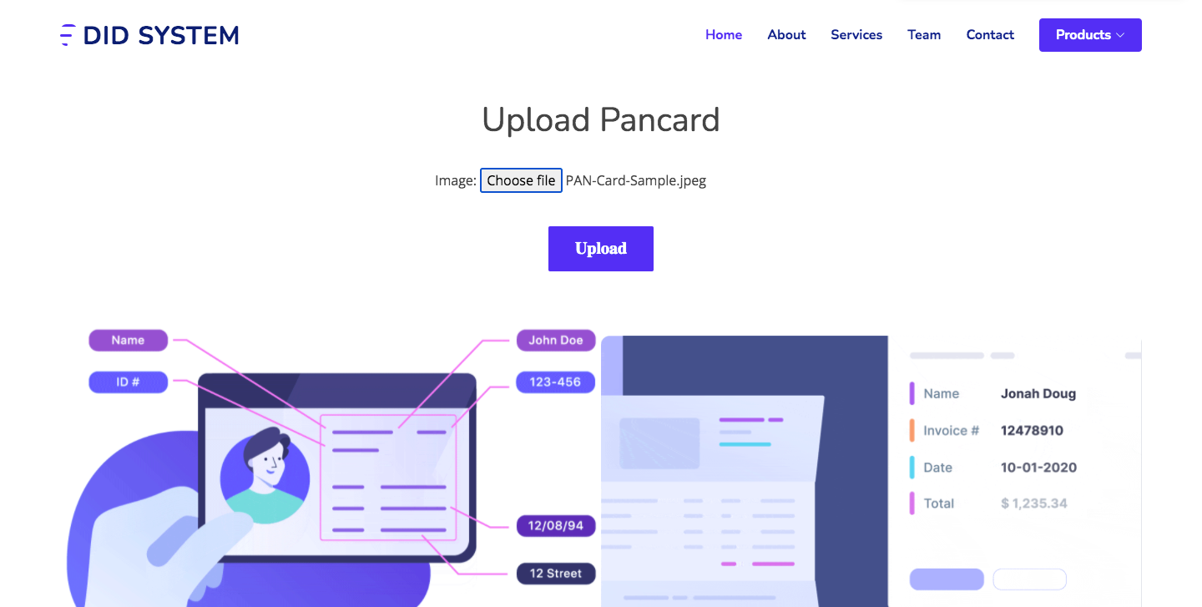

PAN CARD DATA EXTRACT PAGE
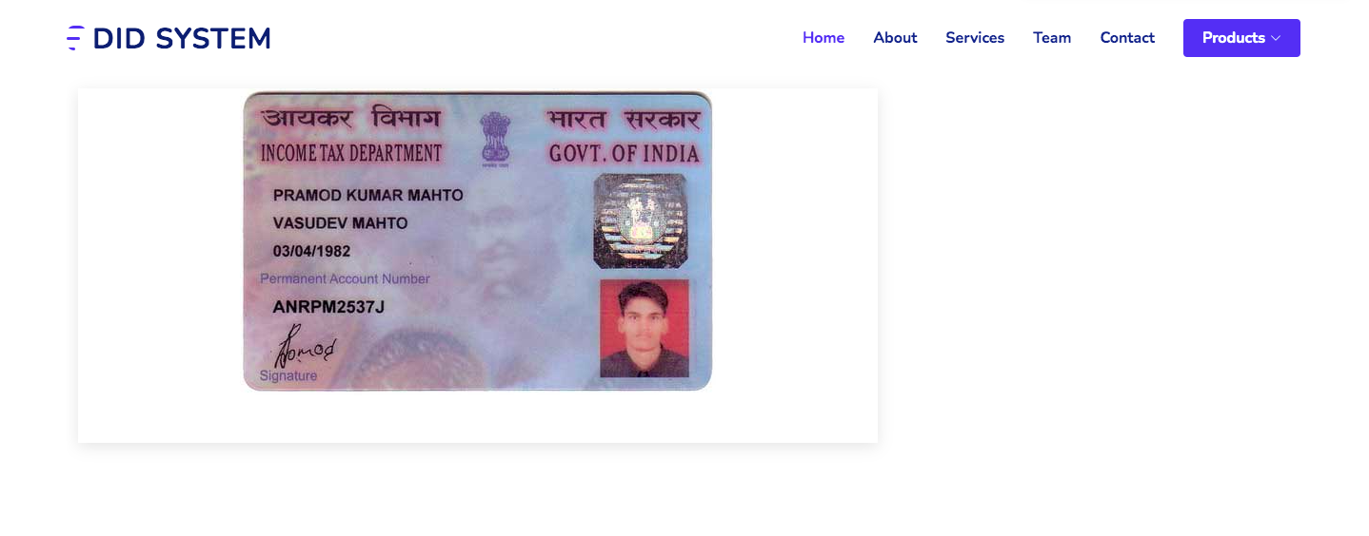

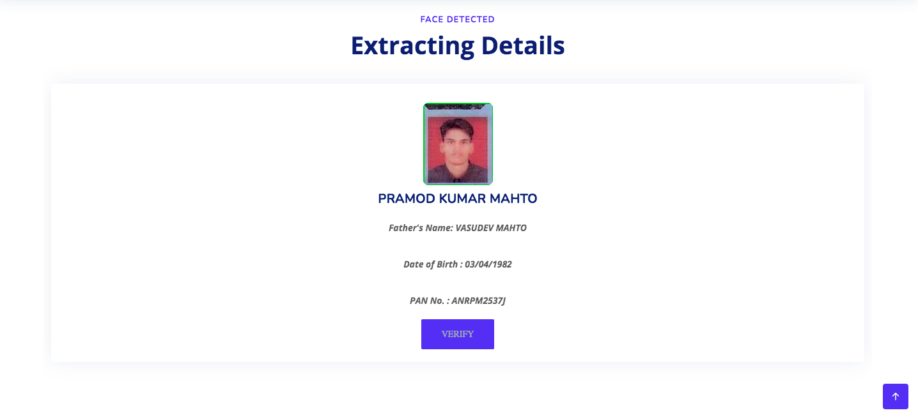
PAN CARD VERIFICATION PAGE

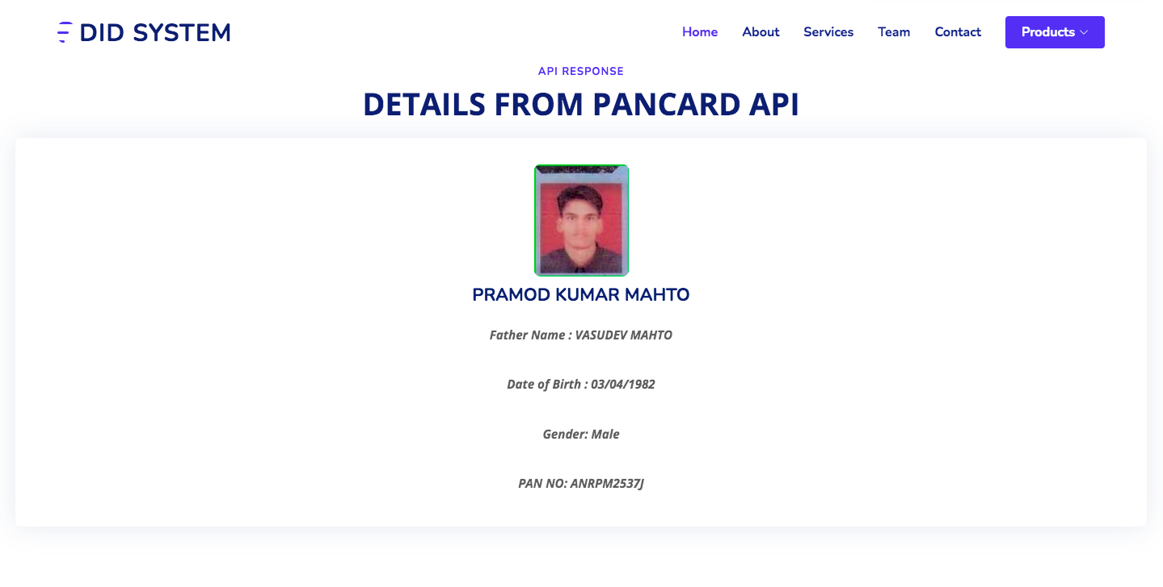

DRIVING LICENCE UPLOAD PAGE
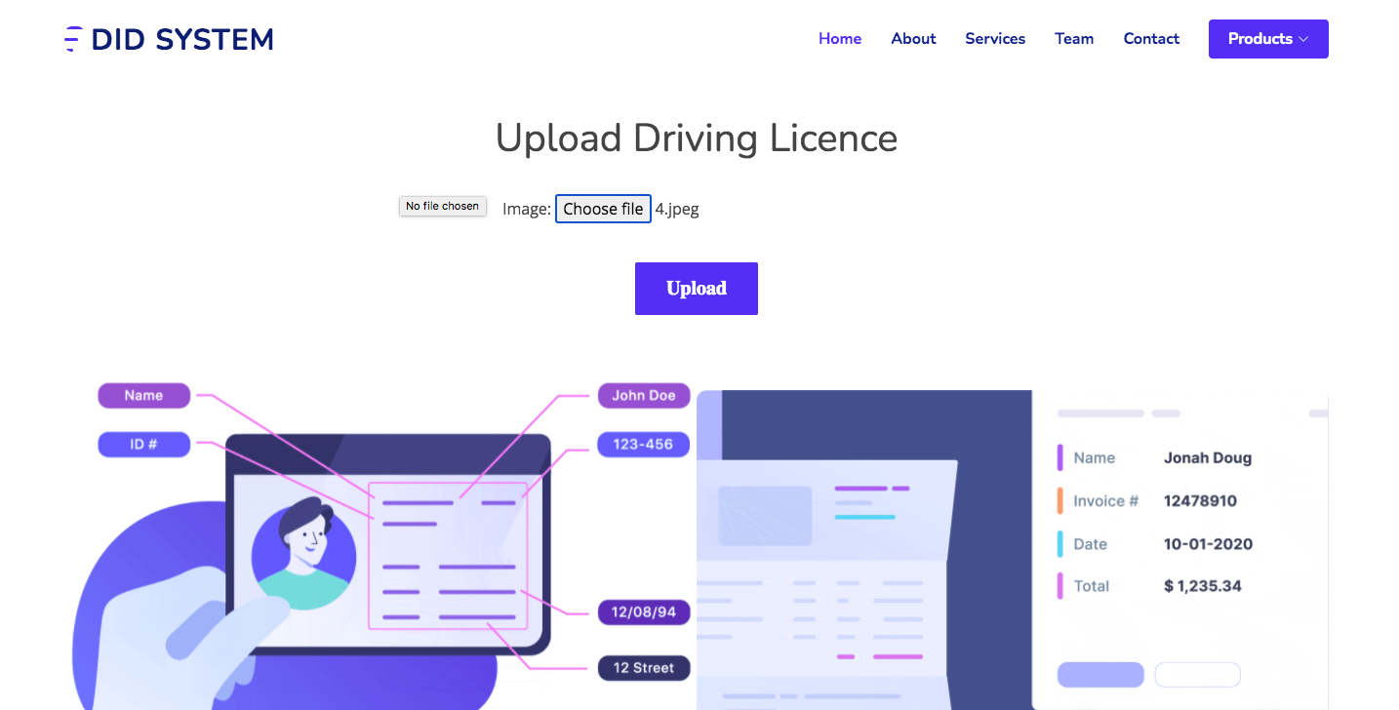
DRIVING LICENCE DATA EXTRACT PAGE

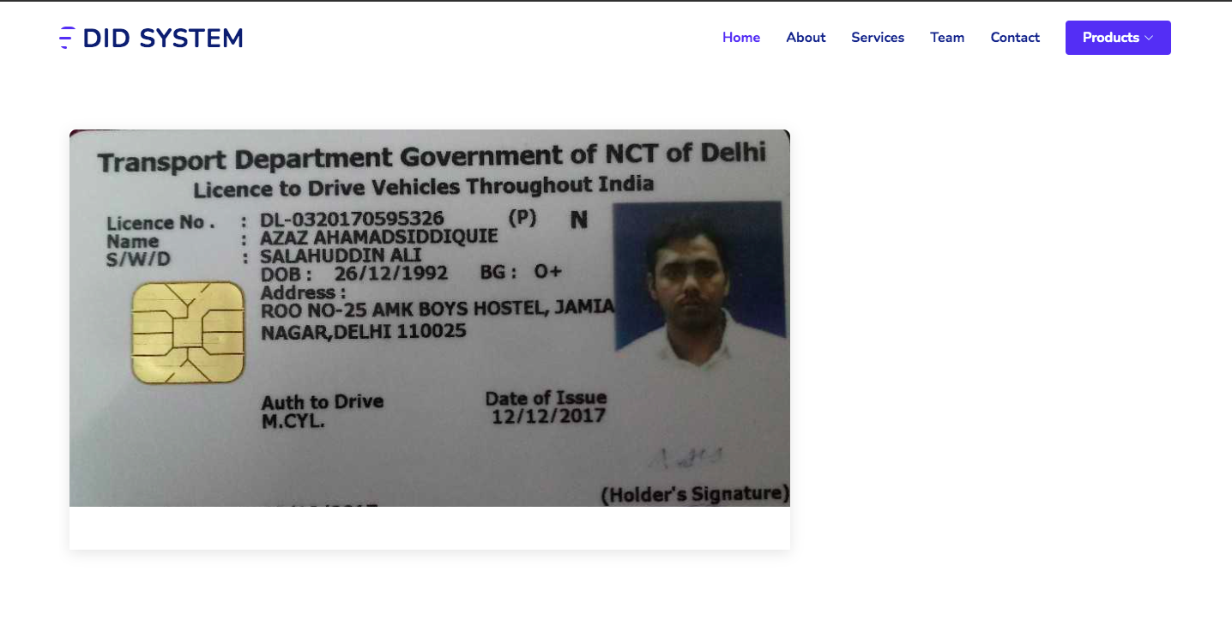

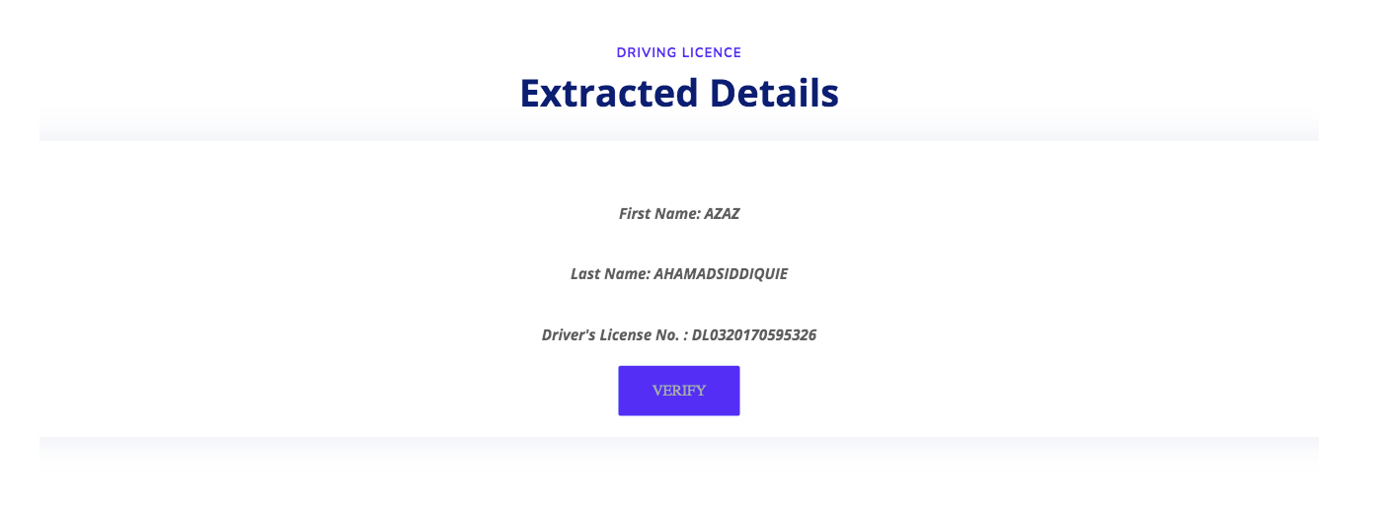
DRIVING LICENCE VERIFICATION PAGE

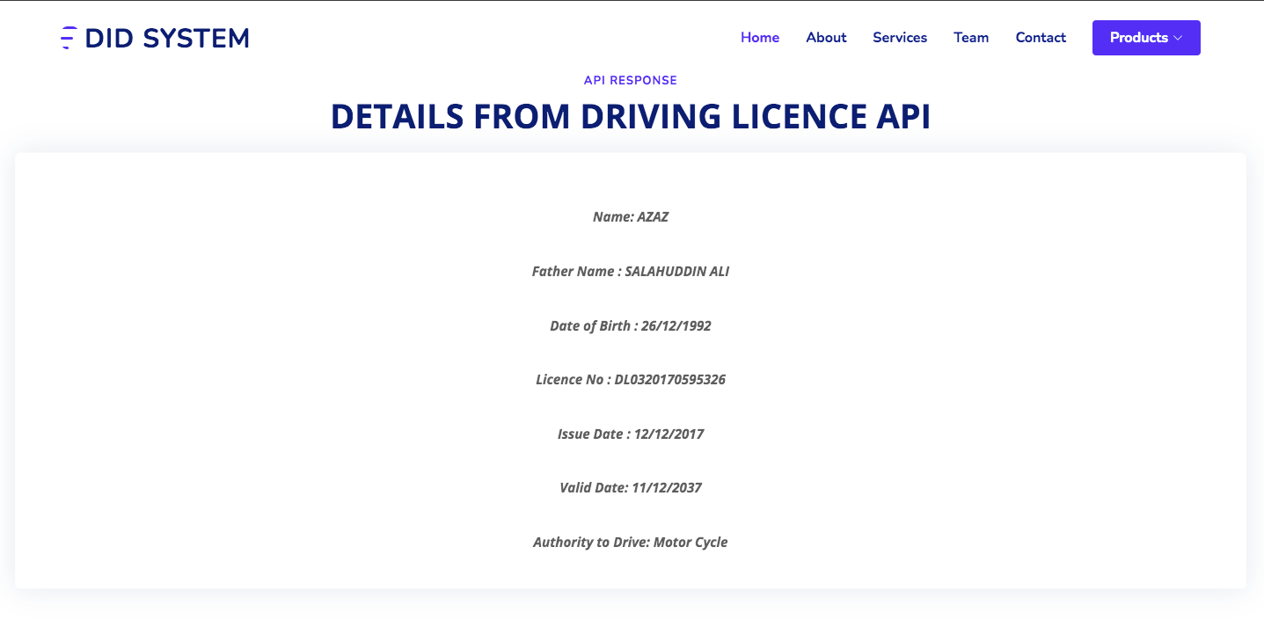

BIBLIOGRAPHY

Internet sites

- https://docs.djangoproject.com/en/3.0/topics/auth/default/#built-in-auth-forms

- https://www.geeksforgeeks.org/django-url-patterns-python/

- https://docs.djangoproject.com/en/3.1/topics/templates/

- https://docs.djangoproject.com/en/3.1/topics/settings/

- https://docs.djangoproject.com/en/3.1/howto/deployment/

- https://docs.djangoproject.com/en/3.1/ref/contrib/staticfiles/

- https://docs.djangoproject.com/en/3.1/topics/migrations/

- https://www.tutorialspoint.com/opencv/index.html

