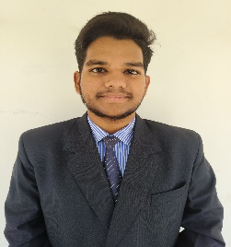**Name:M.HARI HARAN RAO**

**Branch**:Computer Science and Engineering

**Email**: meesalahariharanrao@gmail.com

**Phone**: +91 8260831271

**Career Objective**

Enthusiastic engineer with a passion for programming seeking opportunities as a trainer developer in the IT field. Eager to leverage technical expertise and communication skills to inspire and educate others in a challenging and dynamic environment.

**Educational Qualifications**

|  |  |  |  |
| --- | --- | --- | --- |
| Degree and Year of passing | Institute / University | Board | Percentage / CGPA attained |
| B.tech(CSE) in 2025 | GIET UNIVERSITY,  GUNUPUR | AICTE | 7.5 |
| +2 Science in 2021 | Sri Chaitanya Junior College | SSC | 73 |
| 10th in 2019 | ST.Xavier High School | CBSE | 55 |

**Training / Certification**

* NPTEL – Privacy and Security in Online Social Media
* NPTEL – Joy of Computing with Python

**Achievements and Extracurricular activities**

* Certificate of Participation in Cambridge University
* Successfully Completed Introduction To Java at (SoloLearn) Platform
* Certificate of Completion in Effective Communication
* Certificate of Completion MySql Basics at Great Learning
* Certificate of Completion Introduction To Generative AI Studio

**Technical Skills**

* JAVA
* python
* OPPS in Java
* SQL
* HTML / CSS

**Soft Skills**

* Communication
* Adaptability
* Teamwork
* Problem Solving
* Time Management

**Position of Responsibility**

* Design and develop engineering projects, such as bridges, buildings, and other structures
* Analyze data and create reports to present findings
* Develop and implement engineering plans and strategies
* Develop and test prototypes

**Internship Programs**

* Internship program on “Cyber Security” from Craw Security (17/June/2023 – 20/July/2023)
* Internship program on “Salesforce” from Salesforce Administration(10/November/2023-06/February/2024)

**Internship Project Details**

|  |  |
| --- | --- |
| **Name of the Project** | Basic Network security Assessment |
| **Device used** | KALI LINUX |
| **Description** | Vulnerability testing, reconnaissance, and port scanning on targeted websites to identify potential weaknesses, gather intel on the network, for enhanced protection. |

**Project Details**

|  |  |
| --- | --- |
| **Name of the Project** | Analyzed ecommerce Sales data creative and interactive dashboard using Power bi |
| **Language used** | DAX,Power Query M language |
| **Device used** | Power BI Desktop |
| **Description** | Created interactive dashboards to track and analyze online sales data used complex parameters to drill down in worksheet and customization using filters an slicers used different types of customized visualization(bar chart,pie chart,donut chart,clustered bar chart,scatter chart,line chart,area chart,map,slicers,etc) |

**Personal Details**

|  |  |
| --- | --- |
| Date of Birth | 28/07/2003 |
| Gender | Male |
| Father's Name | M.Bhaskar Rao |
| Address | Roith Colony 6th Line Rayagada Odisha |
| Alternate phone number | 9938496062 |
| Language Known | English / Telugu / Hindi / Odia |
| Interests & Hobbies | Badminton / Swimming |

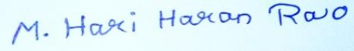

Place: Rayagada, Odisha

Signature