Python_II&III_Assignment1

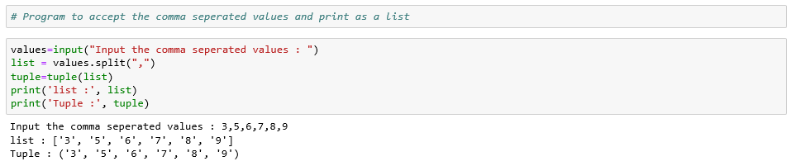

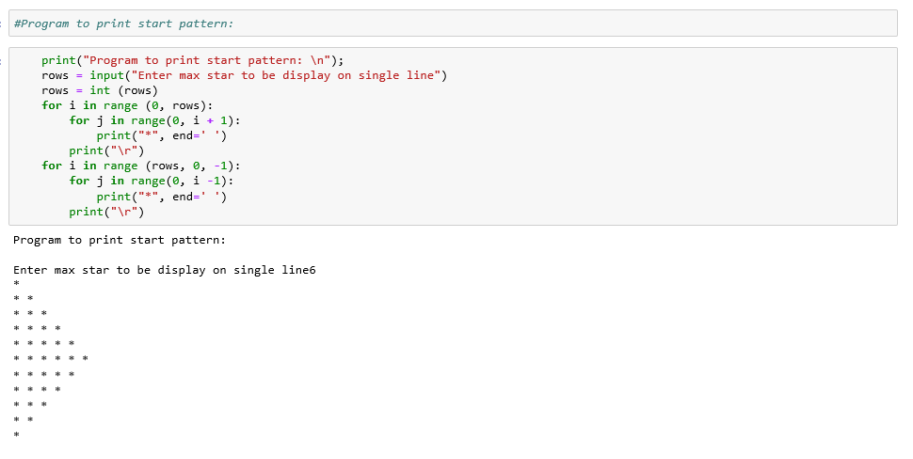

# Input name and print in Reverse order

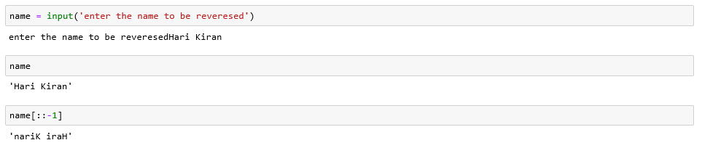

#Program to Print the specified formatted text

