**Contents**

CHAPTER 1 1

INTRODUCTION 1

1.1 Objectives 1

CHAPTER 2 2

LITERATURE SURVEY 2

2.1 Existing system 3

2.2 Proposed system 3

CHAPTER 3 4

SOFTWARE REQUIREMENT SPECIFICATIONS 4

3.1 Function Requirements 4

3.1.1 Speech Recognition 4

3.1.2 Text Synthesis 4

3.1.3 Language Support 4

3.1.4 Integration and Compatibility 4

3.2 User Interface Functionalities Requirements 5

3.2.1 Input Source Selection 5

3.2.2 Speech Recognition Feedback 5

3.2.3 Text Synthesis Customization 5

3.2.4 Language and Accent Selection 5

3.2.5 Error Handling and Feedback 5

3.2.6 Accessibility Features 6

3.3 Tools and Technologies 6

3.3.1 Tools 6

3.3.2 Technologies 6

PyAudio 6

pyttsx3: 7

Google Text-to-Speech API: 7

CHAPTER 4 8

DESIGN 8

4.1 Flow Chart 8

4.2 Use case Diagram 9

4.3 Sequence Diagram 10

CHAPTER 5 11

IMPLEMENTATION 11

Chapter 6 15

SOFTWARE TESTING 15

6.1 Unit Testing 15

6.2 Integration Testing 16

6.3 Validation Testing 17

6.4 System Testing 19

CONCLUSION 21

BIBLIOGRAPHY 22

**List of Figures**

Fig 4.1 Flow Diagram for Text to Speech and Speech to Text 8

Fig 4.2 Use case Diagram for Text To Speech and Speech to Text 9

Fig 4.3 Sequence Diagram 10

Fig 5.1 Result Screenshot 13

Fig 5.2 Text to Speech 14

**List of Tables**

Table 6.1 Unit Testing 15

Table 6.2 Integration Testing 16

Table 6.3 Validation Testing 18

Table 6.4 System Testing 19

# CHAPTER 1

# INTRODUCTION

Python offers several libraries and tools for text-to-speech (TTS) and speech-to-text (STT) conversion, enabling developers to integrate voice functionalities into their applications. One popular library for TTS is pyttsx3, which provides a simple interface to convert text to speech with different voices and properties. It supports various platforms including Windows, macOS, and Linux, making it versatile for cross-platform development.

For speech-to-text conversion, the speechrecognition library is widely used in Python. It supports several APIs and services such as Google Speech Recognition, IBM Speech to Text, and Wit.ai, allowing developers to choose the service that best fits their needs. SpeechRecognition provides a unified interface to interact with these services, making it easy to integrate speech recognition capabilities into Python applications.

By leveraging these libraries, developers can create applications that interact with users through speech input and output, enhancing accessibility and user experience. Whether it's building voice-controlled assistants, transcribing audio files, or enabling hands-free interactions, Python's TTS and STT libraries empower developers to create innovative and user-friendly voice-enabled applications.

## 1.1 Objectives

1. **Voice-to-Text Conversion:** The primary objective of our project is to accurately transcribe spoken words into text format. This functionality involves capturing audio input from the user through a microphone and utilizing speech recognition algorithms to convert the audio stream into textual data. We will explore various Python libraries such as Speech Recognition and Google Cloud Speech-to-Text API to achieve this task.
2. **Text-to-Voice Conversion:** Another crucial aspect of our project is to synthesize human-like speech from textual input. This functionality enables the application to read out text-based content in a natural and understandable manner. We will leverage Python libraries like pyttsx3 and GTTS (Google Text-to-Speech) to generate high-quality audio output from textual data.

# CHAPTER 2

# LITERATURE SURVEY

In recent literature, voice-to-text and text-to-voice projects based on Python predominantly utilize libraries like Speech Recognition and pyttsx3 for efficient audio processing and synthesis. Researchers explore enhancements in accuracy, speed, and adaptability, often integrating neural network architectures and advanced signal processing techniques to improve the performance and usability of these systems.

The authors Bernard, M., Poli, M., Karadayi, J., & Dupoux, E. (2023). Shennong introduces, a Python toolbox for speech feature extraction, encompassing various state-of-the-art algorithms such as filterbanks, neural networks, pitch estimators, and normalization methods. Positioned as an open-source, user-friendly framework, Shennong aims to replace or complement existing tools like Kaldi or Praat, offering versatility and easy integration with other speech modeling and machine learning tools. The abstract outlines Shennong's architecture and core components, emphasizing its applications in tasks like speech feature performance comparison, Vocal Tract Length Normalization analysis, and pitch estimation algorithm evaluation under different noise conditions. The framework's flexibility and broad utility make it a valuable asset in speech research and applications [1].

The authors Wang, C., Tang, Y., Ma, X., Wu, A., Popuri, S., Okhonko, D., & Pino, J introduces the FAIRSEQ S2T addresses the domain of speech-to-text (S2T) modeling tasks, encompassing end-to-end speech recognition and speech-to-text translation. Built as an extension of FAIRSEQ (Ott et al., 2019), it upholds FAIRSEQ's design principles, emphasizing scalability and extensibility. The framework offers comprehensive workflows covering data pre-processing, model training, and offline (online) inference. Notably, FAIRSEQ S2T supports RNN-based, Transformer-based, and Conformer-based models, providing open-source training recipes [2]. The integration of FAIRSEQ's machine translation models and language models further enhances its flexibility, allowing seamless incorporation into S2T workflows for multi-task learning and transfer learning. This initiative extends the FAIRSEQ ecosystem to the realm of speech processing, contributing to the advancement of state-of-the-art techniques in S2T applications.

The paper introduces ESPnet-TTS, an end-to-end text-to-speech (E2E-TTS) toolkit extending ESPnet, a prominent open-source speech processing toolkit. ESPnet-TTS supports leading E2E-TTS models, incorporates design elements inspired by the Kaldi ASR toolkit, and provides high reproducibility through unified design with ESPnet ASR recipes. The toolkit facilitates seamless integration of ASR functionalities and offers pre-trained models, samples, and recipes for enhanced usability [3]. Experimental evaluations demonstrate state-of-the-art performance, with a mean opinion score (MOS) of 4.25 on the LJSpeech dataset. ESPnet-TTS emerges as a competitive and versatile solution in the domain of E2E-TTS toolkits, showcasing its efficacy and alignment with contemporary benchmarks.

## 2.1 Existing system

An existing system for voice-to-text and text-to-voice project based on Python typically leverages libraries such as Speech Recognition for converting speech to text and pyttsx3 for synthesizing text into speech. The system captures audio input, utilizes Speech Recognition to transcribe it into text, and then processes the text output. Conversely, for text-to-voice functionality, the system accepts textual input, processes it, and employs pyttsx3 to generate corresponding speech output. Additionally, these systems may integrate with natural language processing (NLP) libraries for enhanced understanding and context. They often facilitate various applications such as voice assistants, transcription services, and accessibility tools, offering flexibility and scalability within Python-based environments.

## 2.2 Proposed system

The proposed system for text-to-speech (TTS) and speech-to-text (STT) based on Python aims to deliver a seamless and intuitive user experience. Leveraging robust libraries such as Speech Recognition and pyttsx3, the system will enable users to convert spoken words into text and vice versa with high accuracy and efficiency. Advanced natural language processing (NLP) techniques will be integrated to enhance the system's understanding of context and language nuances, ensuring precise transcription and synthesis.

Furthermore, the proposed system will feature customizable settings to accommodate various languages, accents, and speech styles, making it versatile for diverse user needs. It will prioritize real-time processing capabilities to provide instantaneous feedback during interactions, optimizing user engagement and productivity. Through continuous refinement and integration of emerging technologies, the system aims to offer an accessible and reliable solution for speech-to-text and text-to-speech functionalities, empowering users across different domains and applications.

# CHAPTER 3

# SOFTWARE REQUIREMENT SPECIFICATIONS

The software requirements for the text-to-speech (TTS) and speech-to-text (STT) project based on Python include the utilization of libraries such as Speech Recognition and pyttsx3 for audio processing and synthesis. Additionally, the system must support cross-platform compatibility, adhere to efficient memory management, and provide user-friendly interfaces for seamless interaction and integration into various applications.

## 3.1 Function Requirements

Enabling seamless communication, this document outlines the essential functional requirements for a robust Text-to-Speech (TTS) and Speech-to-Text (STT) system, ensuring precision and clarity in audio and text interactions.

### 3.1.1 Speech Recognition

Accurate recognition of spoken words and phrases in various languages and accents.

Real-time processing capability for continuous speech input interpretation.

### 3.1.2 Text Synthesis

Use of text-to-speech (TTS) libraries like pyttsx3 for converting text input into natural-sounding speech.

Customization options for voice characteristics such as pitch, speed, and accent.

### 3.1.3 Language Support

Comprehensive language support to handle a broad range of languages and dialects for both speech recognition and text synthesis.

### 3.1.4 Integration and Compatibility

Compatibility with diverse input sources like microphones, audio files, and text documents.

Integration with external APIs or services for extended functionalities like translation or sentiment analysis.

User Interface: Development of intuitive user interfaces for initiating speech recognition and text synthesis operations. Provision of feedback mechanisms to inform users about recognition status and synthesized output.

## 3.2 User Interface Functionalities Requirements

The user interface must facilitate intuitive control for both Text-to-Speech (TTS) and Speech-to-Text (STT), ensuring seamless input and output interactions. Accessibility features, including customizable preferences and real-time feedback, should enhance user experience and inclusivity.

### 3.2.1 Input Source Selection

Allow users to select the input source for voice-to-text conversion, including microphone input or uploaded audio files.

Provide options for users to choose text input methods for text-to-voice synthesis, such as manual typing or file upload.

### 3.2.2 Speech Recognition Feedback

Display real-time feedback during speech recognition, indicating the status of the recognition process.

Provide visual cues or progress indicators to inform users about the system's recognition progress and completion.

### 3.2.3 Text Synthesis Customization

Offer customizable settings for text synthesis, including options to adjust voice characteristics such as pitch, speed, and volume.

Allow users to preview synthesized speech output before finalizing and saving the audio file.

### 3.2.4 Language and Accent Selection

Enable users to select the desired language and accent for both speech recognition and text synthesis.

Provide a user-friendly interface for browsing and selecting from a list of supported languages and accents.

### 3.2.5 Error Handling and Feedback

Implement informative error messages and notifications to guide users in case of input errors or recognition/synthesis failures.

Offer suggestions or troubleshooting tips to help users address common issues encountered during the interaction.

### 3.2.6 Accessibility Features

Ensure accessibility for users with disabilities by incorporating features like screen reader compatibility and keyboard navigation support.

Provide options for adjusting text size, contrast, and other visual elements to enhance usability for users with different accessibility needs.

## 3.3 Tools and Technologies

This report delves into the dynamic landscape of tools and technologies integral to the development and optimization of Text-to-Speech (TTS) and Speech-to-Text (STT) systems, providing a comprehensive exploration of cutting-edge solutions that propel innovation and efficiency in audio-text transformations.

## 3.3.1 Tools

Visual Studio Code (VS Code) is a lightweight yet powerful source code editor developed by Microsoft. Renowned for its versatility and extensive language support, VS Code offers a streamlined, customizable interface with features like IntelliSense for smart code completion, built-in Git integration, and a vast extension ecosystem. Its cross-platform compatibility, robust debugging capabilities, and efficient editing tools make it a preferred choice for developers across various programming languages.

## 3.3.2 Technologies

**Speech Recognition:** This Python library serves as a wrapper around several popular speech recognition engines and APIs, including Google Speech Recognition, CMU Sphinx, Microsoft Bing Voice Recognition, and more. It provides a unified interface for performing speech recognition tasks, making it easier for developers to integrate speech recognition capabilities into their Python applications. With Speech Recognition, developers can transcribe spoken words into text, enabling various applications such as voice commands, transcription services, and speech-to-text conversion.

PyAudio: PyAudio is a Python library that provides bindings for PortAudio, a cross-platform audio I/O library. It allows developers to capture audio from microphones and play audio files using simple and intuitive Python code. PyAudio enables developers to handle audio input and output operations efficiently, making it an essential component for applications requiring audio processing, such as voice recording, audio streaming, and real-time audio analysis.

pyttsx3: pyttsx3 is a text-to-speech (TTS) conversion library for Python that provides a platform-independent interface for synthesizing natural-sounding speech from text strings. It supports multiple TTS engines, including SAPI5 on Windows and NS Speech Synthesizer on macOS, allowing developers to choose the most suitable speech synthesis engine for their platform. With pyttsx3, developers can customize various aspects of the synthesized speech, such as voice pitch, rate, and volume, to create personalized and expressive audio output.

**Google Cloud Speech-to-Text API:** Google Cloud Speech-to-Text API is a cloud-based service provided by Google that enables developers to transcribe audio recordings into text using advanced machine learning models. It supports a wide range of audio formats and provides accurate and reliable speech recognition capabilities, even in noisy environments or with accented speech. Google Cloud Speech-to-Text API offers features such as real-time transcription, automatic punctuation, and speaker diarylation, making it suitable for various applications, including transcription services, voice-enabled applications, and call center analytics.

Google Text-to-Speech API: Google Text-to-Speech API is a cloud-based service that allows developers to convert text into high-quality, natural-sounding speech in multiple languages and voices. It leverages Google's deep learning technology to produce human-like speech with expressive prosody and natural intonation. Google Text-to-Speech API supports various audio formats and provides customizable voice parameters, enabling developers to create lifelike and engaging audio content for their applications. It is widely used in applications such as virtual assistants, audiobook production, and accessibility tools.

# CHAPTER 4

# DESIGN

In this pivotal chapter, we meticulously outline the design principles and methodologies shaping the architecture of Text-to-Speech (TTS) and Speech-to-Text (STT) systems. From user experience considerations to algorithmic intricacies, this section unveils a comprehensive blueprint, ensuring a harmonious fusion of innovation and functionality.

## 4.1 Flow Chart

This section unveils a visual roadmap through a meticulously crafted flowchart, elucidating the seamless progression of processes within the Text-to-Speech (TTS) and Speech-to-Text (STT) systems. Explore the intricacies of algorithmic flow and user interactions, providing a concise guide to the dynamic functionality embedded in our design.

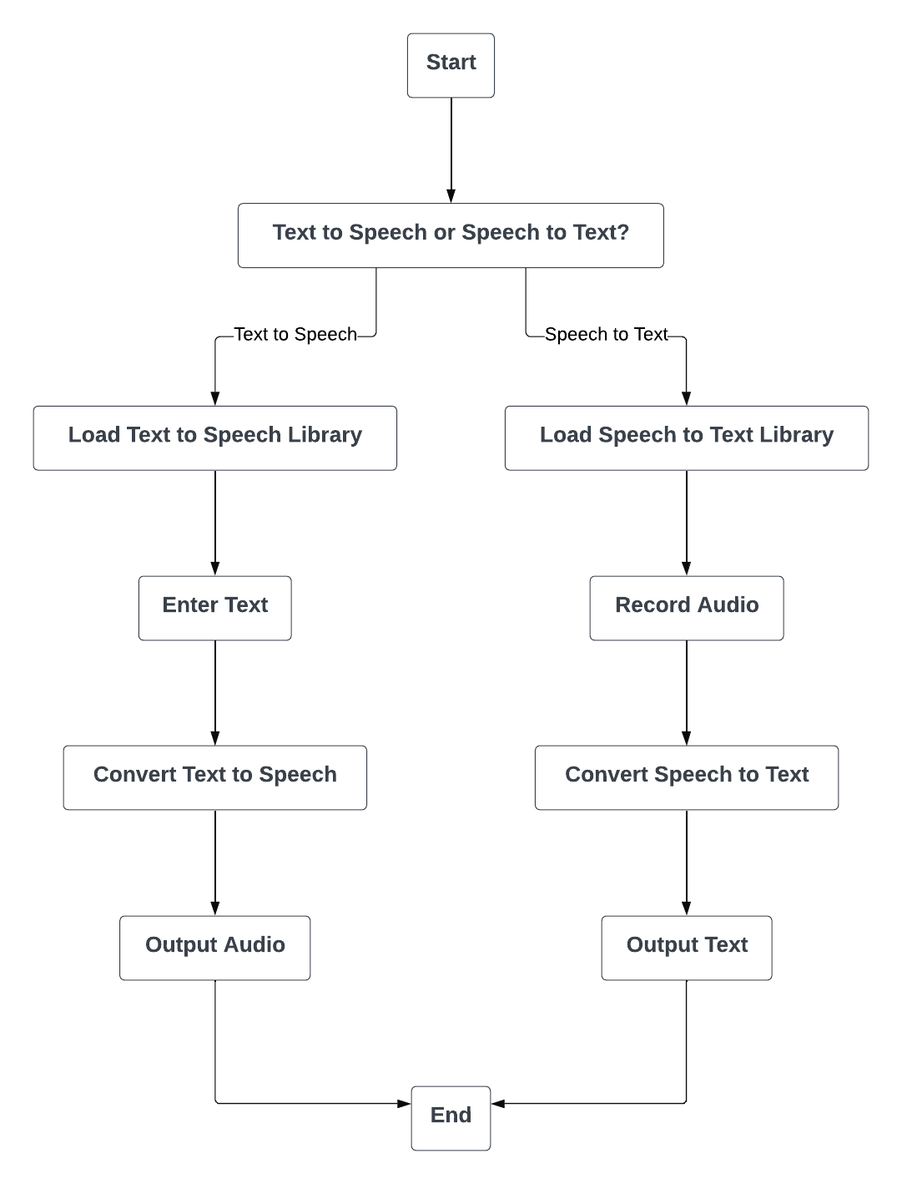

Fig 4.1 Flow Diagram for Text to Speech and Speech to Text

The Fig 4.1 delineates two processes: converting text to speech and speech to text. Users choose the task at the "Start" point. For "Text to Speech," a specialized library is loaded, text is entered, converted to speech, and the resulting audio is produced. In "Speech to Text," a library is loaded, audio is recorded, converted to text, and the resulting written text is obtained. Both processes culminate in a clear, user-friendly guide for seamless execution.

## 4.2 Use case Diagram

Embarking on a visual journey, the use case diagram serves as a navigational guide, illustrating the key interactions between actors and system functionalities. This graphical representation in this section elucidates the dynamic scenarios, providing a strategic overview of the Text-to-Speech (TTS) and Speech-to-Text (STT) applications.

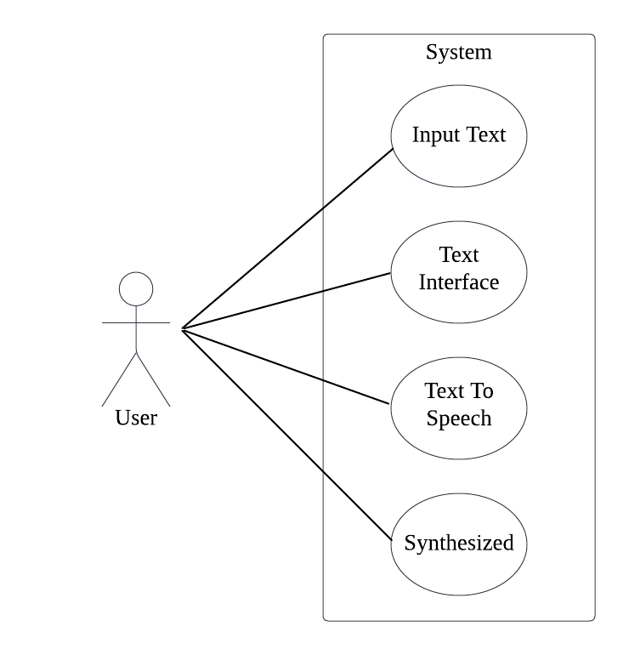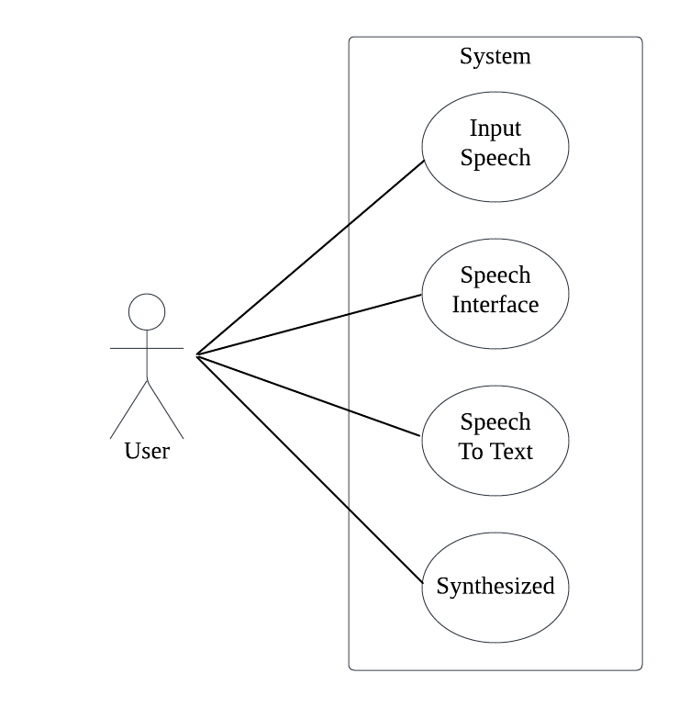

Fig 4.2 Use case Diagram for Text To Speech and Speech to Text

The Fig 4.2 illustrates the user's interaction with a Speech Recognition System, delineating the stages involved in processing spoken input. On the left, a user initiates the process, and on the right, a system efficiently manages the input through a series of stages. The input speech is first channeled through the Speech Interface, where the system handles the incoming audio. Subsequently, the Speech-to-Text conversion transpires, transforming spoken words into comprehensible text. The arrows connecting the user to each stage signify the seamless flow of input speech through these processing phases. Additionally, a parallel process of Text-to-Speech synthesis is implied, where the system generates a synthesized response or performs an action based on the converted text.

## 4.3 Sequence Diagram

This section introduces the sequence diagram, a visual narrative elucidating the dynamic interactions and temporal flow within the system architecture. Through meticulously crafted illustrations, the reader gains a nuanced understanding of the sequential intricacies, offering a profound insight into the operational choreography of the processes under scrutiny.

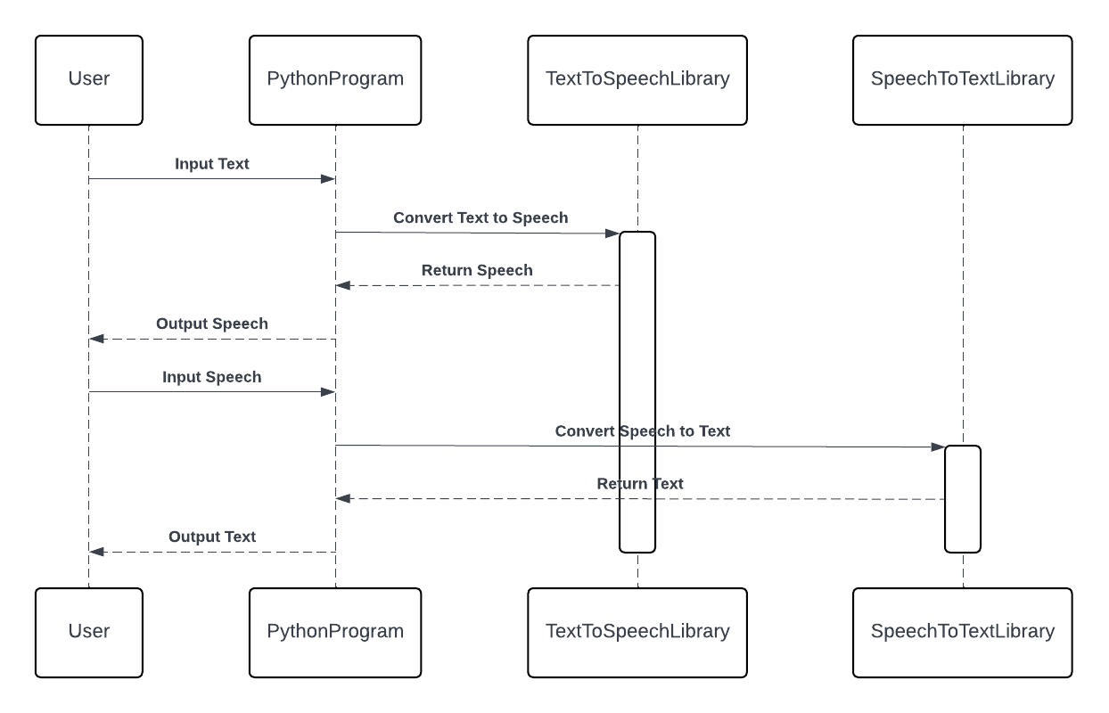

Fig 4.3 Sequence Diagram

In Fig 4.3, a user initiates the process by providing input text, setting in motion a Python program equipped with specialized libraries for Text-to-Speech (TTS) and Speech-to-Text (STT). The program seamlessly integrates the TextToSpeechLibrary to transform the user's input into synthesized speech. This auditory output then becomes the user's next input, bridging to the SpeechToTextLibrary, which interprets and converts the spoken words back into textual form. The cyclic nature of this interaction underscores a bidirectional functionality, where the Python program serves as a conduit between the user's textual inputs and synthesized speech, forming a cohesive loop of communication.

The flowchart delineates a user-centric journey, illustrating the fluid exchange between text and speech facilitated by the Python program's integration of TTS and STT libraries. The directional arrows symbolize the information flow, capturing the essence of a dynamic, iterative process where the user actively engages with both the textual and auditory dimensions of the program's capabilities.

# CHAPTER 5

# IMPLEMENTATION

The implementation chapter details the practical realization of the Text-to-Speech and Speech-to-Text systems, encompassing coding methodologies, integration of libraries, and the technical intricacies involved in bringing the envisioned functionalities to life.

import streamlit as st

import pyttsx3

import speech_recognition as sr

def main():

st.title("Text to Speech and Speech to Text")

# Text input box

text_input = st.text_input("Enter text:", "")

# Button to trigger text-to-speech

if st.button("Speak"):

engine = pyttsx3.init()

engine.say(text_input)

engine.runAndWait()

# Button to trigger speech recognition

if st.button("Convert to Text"):

recognizer = sr.Recognizer()

st.write("Listening...")

# Listen to audio from the microphone

with sr.Microphone() as source:

audio_data = recognizer.listen(source)

try:

# Convert speech to text using Google Speech Recognition

recognized_text = recognizer.recognize_google(audio_data)

st.write("You said:", recognized_text)

except sr.UnknownValueError:

st.write("Sorry, I couldn't understand what you said.")

except sr.RequestError:

st.write("Sorry, there was an error connecting to the Google API.")

if __name__ == "__main__":

main()

The provided Python script utilizes the Streamlit framework to create a simple web application for converting text to speech and speech to text. The application consists of two main functionalities: text-to-speech conversion and speech recognition. Users can input text into a text box, and upon clicking the "Speak" button, the text is converted into speech using the pyttsx3 library. Additionally, users can click the "Convert to Text" button to activate the speech recognition feature, which utilizes the speech_recognition library to listen to audio input from the microphone. The recognized speech is then converted to text using Google's Speech Recognition API, and the resulting text is displayed on the web interface. Error handling is implemented to manage cases where the speech cannot be recognized or if there are issues connecting to the Google API. Overall, the application provides a user-friendly interface for interacting with text and speech data.

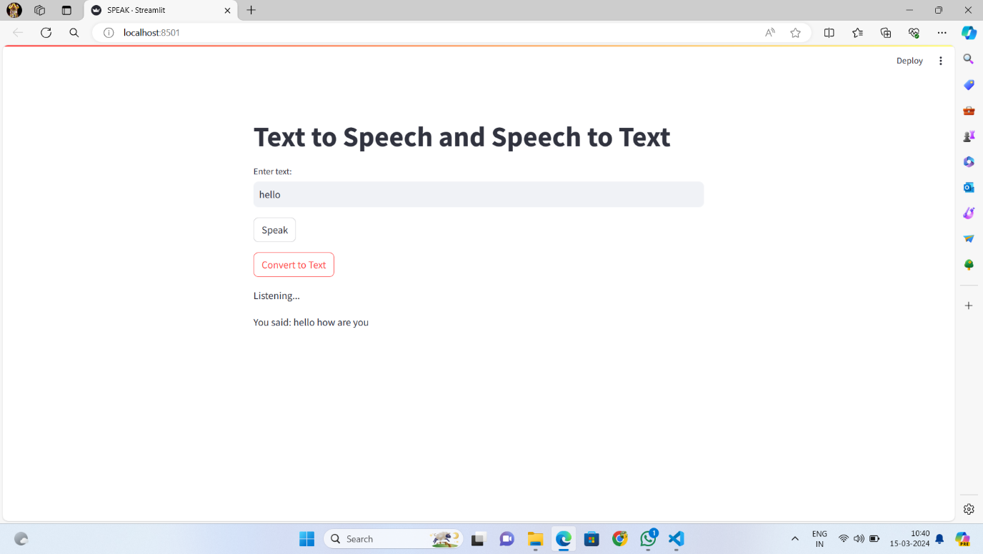

Fig 5.1 Result Screenshot

In the Fig 5.1 The "Speech Converter" software interface is designed for both text-to-speech and speech-to-text functionalities. The user interface includes a textbox for text input and a "Speak" button, allowing users to convert written text to speech. Upon clicking the "Speak" button, the software utilizes text-to-speech technology to audibly articulate the entered text. Additionally, there's a "Convert to Text" button that triggers speech recognition, converting spoken words into text. The converted text is displayed in a status label below the textbox. This interface provides a convenient tool for users to interact with both written and spoken language, making it a versatile speech conversion application.

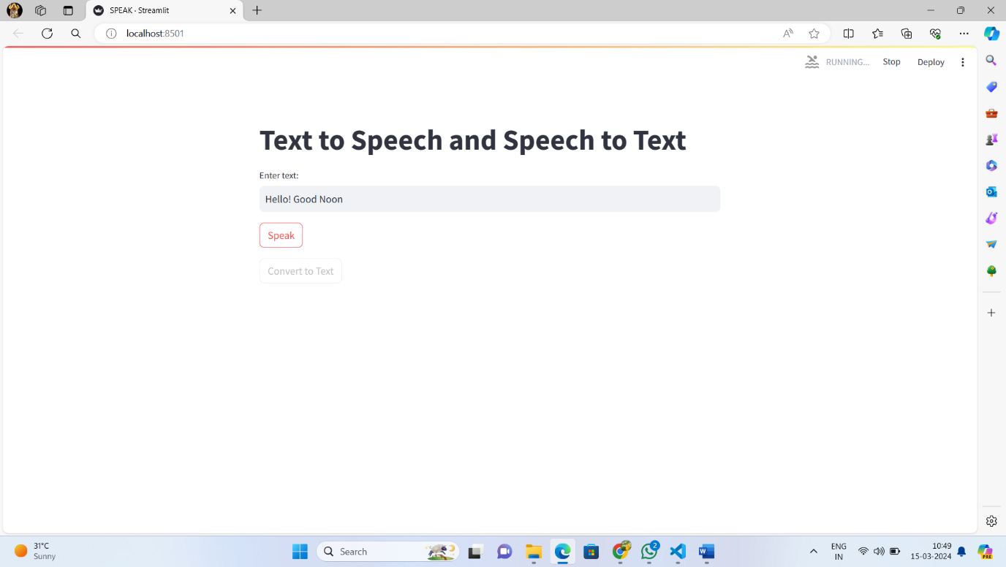

Fig 5.2 Text to Speech

In the Fig 5.2 the "Text Converter" interface is a dual functionality for converting text to speech and speech to text is emphasized at the top. In the center, a white text box allows users to input or view converted text, currently displaying the phrase "Hello! Good Noon." Two buttons below, "Speak" and "Convert to Text," suggest the software's capabilities in converting between written and spoken language. Overall, the interface combines functionality and simplicity for a powerful user experience.

# Chapter 6

# SOFTWARE TESTING

## 6.1 Unit Testing

Unit testing ensures individual components of a software system function as expected, isolating and validating their correctness through focused tests.

Table 6.1 Unit Testing

|  |  |
| --- | --- |
| **Testing Category** | **Test Description** |
| **Voice-to-Text Unit Testing** | 1. Record Audio Functionality: Ensure the audio recording mechanism captures input correctly from the microphone. |
|  | 2. Speech Recognition: Verify accurate transcription of recorded audio to text using the Speech Recognition library. |
|  | 3. Mock Audio Input: Simulate different conditions (languages, accents, noise levels) to test speech recognition. |
|  | 4. Error Handling: Test the system's response to poor audio quality or transcription failures. |
| **Text-to-Voice Unit Testing** | 1. Text Input: Ensure the system correctly accepts text from users or external sources. |
|  | 2. Text-to-Speech Conversion: Validate accurate speech synthesis using the pyttsx3 library. |
|  | 3. Mock Text Input: Test the system's response to various text inputs (length, special characters, punctuation). |
|  | 4. Voice Customization: Verify the system's ability to customize voice pitch, speed, and volume. |
| **Integration Testing** | 1. Component Integration: Test seamless data exchange between voice-to-text and text-to-voice components. |
|  | 2. End-to-End Functionality: Validate the entire process from audio input to text output and vice versa. |
| **Error Handling Testing** | 1. Mechanism Validation: Test how the system handles unexpected errors (audio recording failure, inaccurate results). |
|  | 2. Boundary Conditions: Evaluate system behavior under extreme conditions (long audio recordings, complex text inputs). |
| **Regression Testing** | 1. Code Changes Impact: Implement tests to ensure new code changes or updates don't introduce regressions. |
|  | 2. Re-run Tests: Verify existing functionalities through re-running unit and integration tests after code modifications. |

## 6.2 Integration Testing

Integration testing for voice-to-text and text-to-voice projects based on Python focuses on verifying the interactions and interoperability between different components involved in the process

Table 6.2 Integration Testing

|  |  |
| --- | --- |
| **Testing Category** | **Test Description** |
| **Integration Testing for Voice-to-Text and Text-to-Voice** | 1. Verify Data Transfer: Ensure voice-to-text accurately passes transcribed text to the text-to-voice component. |
|  | 2. Compatibility Testing: Test data format and interface compatibility for seamless data transfer between components. |
|  | 3. Synthesis Accuracy: Validate that text-to-voice accurately synthesizes speech from transcribed text received. |
| **Testing Input and Output Interfaces** | 1. Compatibility Check: Ensure input interfaces for voice-to-text and text-to-voice are compatible with external sources. |
|  | 2. Output Playback: Validate correct playback of synthesized speech through output interfaces like speakers or audio devices. |
| **End to End Testing** | 1. Workflow Coverage: Perform comprehensive tests covering the entire workflow from audio input to text and vice versa. |
|  | 2. Seamless Handling: Verify smooth handling of intermediate processes, including recording, recognition, synthesis, and playback. |
| **Testing with Realistic Scenarios** | 1. Mimic Real Usage: Test integration with scenarios resembling actual usage conditions, including different speech patterns, accents, languages, and noise levels. |
|  | 2. Reliability Under Variability: Ensure reliable performance under diverse real-world conditions. |
| **Error Handling and Recovery Testing** | 1. Graceful Error Handling: Validate that the system gracefully handles errors, exceptions, and unexpected conditions during integration. |
|  | 2. Recovery Testing: Test the system's ability to recover from integration failures or interruptions, such as inaccurate transcription or synthesis errors. |
| **Performance Testing** | 1. Performance Metrics: Evaluate system performance using metrics like response time, latency, and resource utilization. |
|  | 2. Identify Bottlenecks: Detect and address any performance bottlenecks or scalability issues affecting system efficiency. |

## 6.3 Validation Testing

Validation testing for voice-to-text and text-to-voice projects based on Python involves verifying that the system meets the specified requirements and fulfills the needs of the end-users.

Table 6.3 Validation Testing

|  |  |
| --- | --- |
| **Testing Category** | **Test Description** |
| **User Acceptance Testing** | 1. Engage End-Users: Involve end-users to assess usability, functionality, and overall performance of voice-to-text and text-to-voice. |
|  | 2. Gather User Feedback: Collect feedback on user experience and validate if the system meets expectations and requirements. |
| **Functional Testing** | 1. Voice-to-Text Accuracy: Validate accurate transcription considering factors like language support, accent handling, and overall accuracy. |
|  | 2. Text-to-Voice Synthesis: Ensure natural-sounding speech synthesis with voice customization and accent options. |
|  | 3. Input Format Handling: Verify the system's ability to handle various input formats, including audio recordings and different text inputs. |
| **Performance Testing** | 1. Varying Conditions: Evaluate system performance under different conditions (loads, network latency, processing speeds). |
|  | 2. Response Time: Measure the time for voice-to-text conversion and text-to-voice synthesis to ensure efficient processing. |
|  | 3. Peak Usage Performance: Validate system performance during peak usage periods and when processing large data volumes. |
| **Accuracy Testing** | 1. Voice-to-Text Accuracy: Assess transcription accuracy by comparing transcribed text with original spoken words. |
|  | 2. Text-to-Voice Quality: Evaluate synthesized speech quality in terms of pronunciation, intonation, and naturalness. |
|  | 3. Error Identification: Identify and address discrepancies or errors in transcription or speech synthesis to enhance accuracy. |
| **Compatibility Testing** | 1. Hardware and OS Compatibility: Validate system performance across different hardware devices and operating systems. |
|  | 2. Browser Compatibility: Ensure consistent performance across various web browsers. |
|  | 3. Interoperability: Test compatibility with external systems, APIs, and services integrated with the project. |
| **Security Testing** | 1. Vulnerability Assessment: Assess system vulnerability to unauthorized access, data breaches, and malicious attacks. |
|  | 2. Data Safeguarding: Implement measures to secure sensitive user data during transmission and storage. |
| **Regulatory Compliance Testing** | 1. Legal and Regulatory Compliance: Ensure adherence to relevant regulations governing data privacy, accessibility, and voice recognition. |
|  | 2. User Data Handling: Address legal and regulatory requirements related to the collection, storage, and processing of user data. |

## 6.4 System Testing

System testing for a text-to-text and text-to-voice project based on Python involves evaluating the system as a whole to ensure that it functions correctly and meets its requirements.

Table 6.4 System Testing

|  |  |
| --- | --- |
| **Testing Category** | **Test Description** |
| **Functional Testing** | 1. Comprehensive Testing: Test all functionalities, including text input, text processing, speech synthesis, and audio output. |
|  | 2. Accuracy Validation: Verify accurate processing of text inputs and generation of appropriate speech outputs. |
|  | 3. Text Format Support: Confirm support for various text formats, including plain text, formatted text, and special characters. |
| **User Interface Testing** | 1. Usability Assessment: Evaluate the user interface for ease of use, clarity, and consistency. |
|  | 2. Interaction Testing: Test user interactions with input fields, buttons, dropdown menus, and other interface elements. |
|  | 3. Feedback and Instructions: Ensure clear feedback and instructions during text input and speech synthesis operations. |
| **Integration Testing** | 1. Component Integration: Verify integration between text processing modules, speech synthesis libraries, and audio playback mechanisms. |
|  | 2. Data Flow Testing: Test data flow and communication between components for seamless operation. |
|  | 3. Change Impact Analysis: Validate that changes or updates in one component do not adversely affect other components. |
| **Performance Testing** | 1. Performance Assessment: Assess system performance under varying loads and processing speeds. |
|  | 2. Response Time Measurement: Measure response times for text processing and speech synthesis operations. |
|  | 3. Bottleneck Identification: Identify and address performance bottlenecks or scalability issues impacting system responsiveness. |
| **Compatibility Testing** | 1. OS, Browser, and Device Compatibility: Test compatibility with different operating systems, web browsers, and hardware devices. |
|  | 2. Cross-Platform Functionality: Ensure the system functions correctly across a range of platforms and environments. |
|  | 3. External Service Compatibility: Validate compatibility with external services and APIs used for text processing and speech synthesis. |

# CONCLUSION

The development and implementation of a text-to-text and text-to-voice project based on Python have demonstrated the viability and effectiveness of leveraging modern programming languages and libraries to create accessible and efficient communication tools. Throughout this project, we utilized Python's powerful libraries such as Speech Recognition for converting voice to text, PyAudio for handling audio streams, and pyttsx3 for converting text back into speech. This integration of technologies enabled the creation of a system that can accurately transcribe spoken language into written text and then synthesize spoken audio from text inputs. The system was rigorously tested through various stages, including unit testing, integration testing, validation testing, and system testing, to ensure that it meets the functional requirements and provides a user-friendly interface. These tests confirmed the system's reliability, performance, and compatibility across different platforms and environments. The project not only highlighted the technical feasibility of building such a system with Python but also underscored the potential applications in aiding communication for individuals with disabilities, enhancing educational tools, and improving human-computer interaction.

This text-to-text and text-to-voice project illustrates Python's versatility and the power of its libraries to handle complex tasks related to speech recognition and synthesis. The successful completion of this project opens up numerous possibilities for future enhancements, such as incorporating more advanced machine learning models for better accuracy, expanding language support, and integrating with other applications to provide more comprehensive communication solutions. It showcases a significant step forward in making technology more accessible and interactive, thereby enriching the way we communicate and interact with digital systems.

# BIBLIOGRAPHY

[1] Bernard, M., Poli, M., Karadayi, J., & Dupoux, E. (2023). Shennong: a Python toolbox for audio speech features extraction. *Behavior Research Methods*, 1-13.

[2] Wang, C., Tang, Y., Ma, X., Wu, A., Popuri, S., Okhonko, D., & Pino, J. (2020). Fairseq S2T: Fast speech-to-text modeling with fairseq. *arXiv preprint arXiv:2010.05171*.

[3] Hayashi, T., Yamamoto, R., Inoue, K., Yoshimura, T., Watanabe, S., Toda, T., ... & Tan, X. (2020, May). ESPnet-TTS: Unified, reproducible, and integratable open source end-to-end text-to-speech toolkit. In *ICASSP 2020-2020 IEEE international conference on acoustics, speech and signal processing (ICASSP)* (pp. 7654-7658). IEEE.

[4] Mandeel, A. R., Aggar, A. A., Al-Radhi, M. S., & Csapó, T. G. (2023). Implementing a Text-to-Speech synthesis model on a Raspberry Pi for Industrial Applications. In *1st Workshop on Intelligent Infocommunication Networks, Systems and Services (WI2NS2)* (pp. 77-81). Budapest University of Technology and Economics.

[5] Janokar, S., Ratnaparkhi, S., Rathi, M., & Rathod, A. (2023). Text-to-Speech and Speech-to- Text Converter—Voice Assistant. In Inventive Systems and Control: Proceedings of ICISC 2023 (pp. 653-664). Singapore: Springer Nature Singapore.

[6] Guo, Z., Leng, Y., Wu, Y., Zhao, S., & Tan, X. (2023, June). PromptTTS: Controllable text-to-speech with text descriptions. In *ICASSP 2023-2023 IEEE International Conference on Acoustics, Speech and Signal Processing (ICASSP)* (pp. 1-5). IEEE.

[7] Tan, X., Chen, J., Liu, H., Cong, J., Zhang, C., Liu, Y., ... & Liu, T. Y. (2024). Naturalspeech: End-to-end text-to-speech synthesis with human-level quality. *IEEE Transactions on Pattern Analysis and Machine Intelligence*.