**INFOLABZ IT SERVICE PVT. LTD.**

Functions in JavaScript ( Basic )

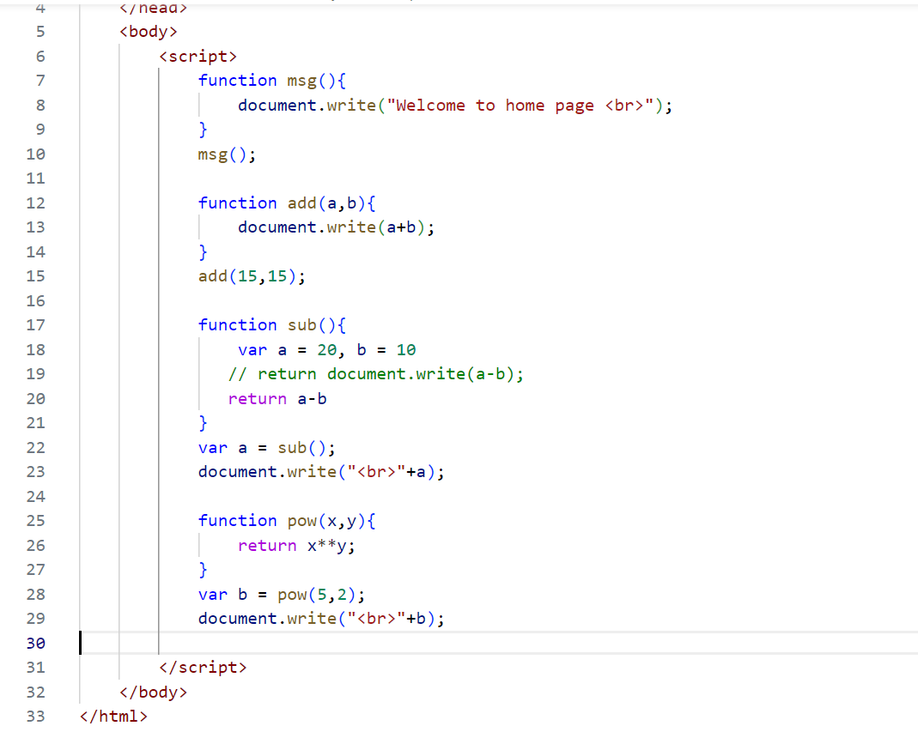

Arrow functions ( ES 6 )

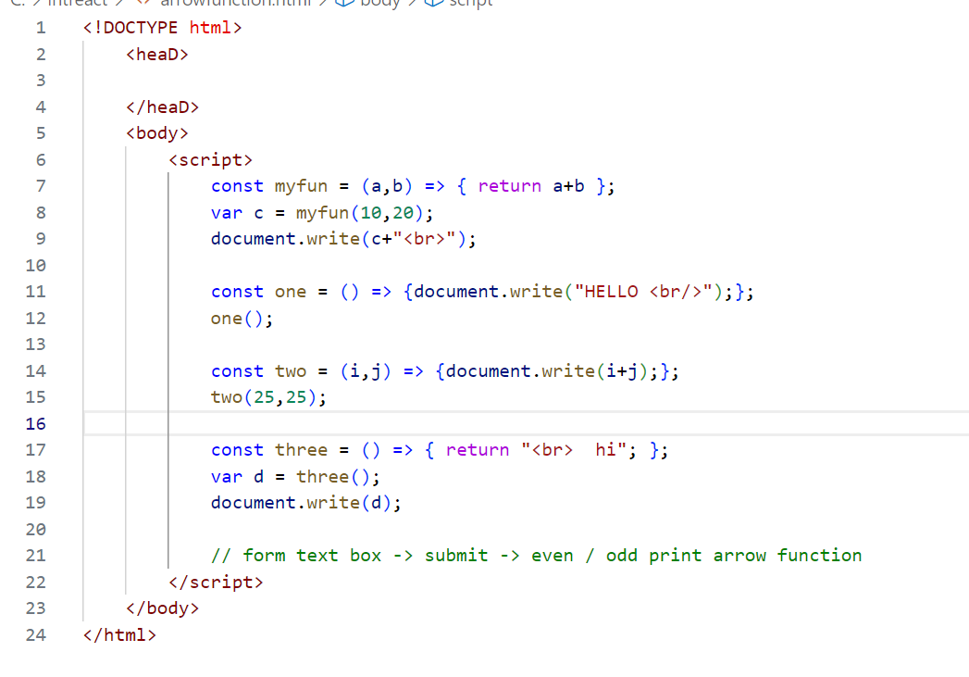

**TASK 1 : ALLOW USER TO INSERT A NUMBER VIA FORM ( HTML FORM ). ENTERED NUMBER SHOULD BE PASSED IN ARROW FUNCTION VIA ARGUMENT AND PRINT / ALERT THAT NUMBER IS EVEN OR ODD.**

**OBJECT DATA TO TABLE : OBJECT.HTML**

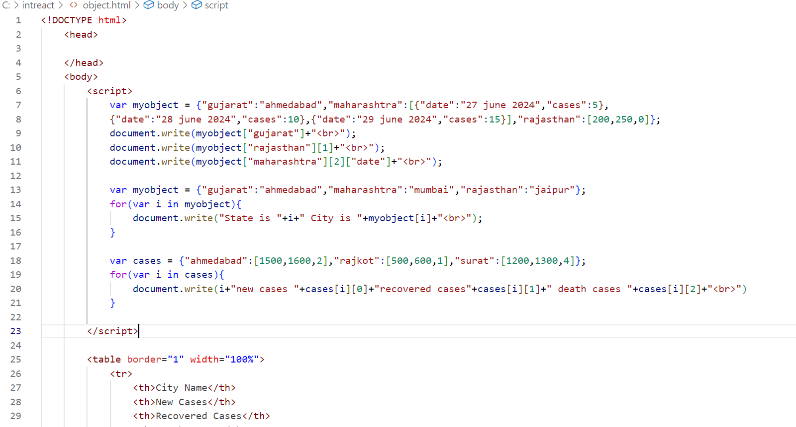

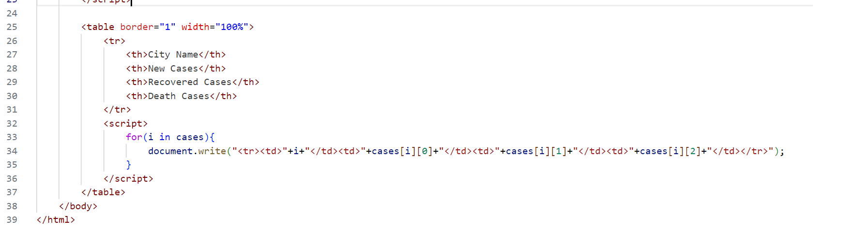

**TASK 2 : SEARCH AND LEARN BASIC ABOUT LITERALS OR TEMPLATE LITERALS FROM NET.**

**FETCHING LIVE DATA : API DATA**

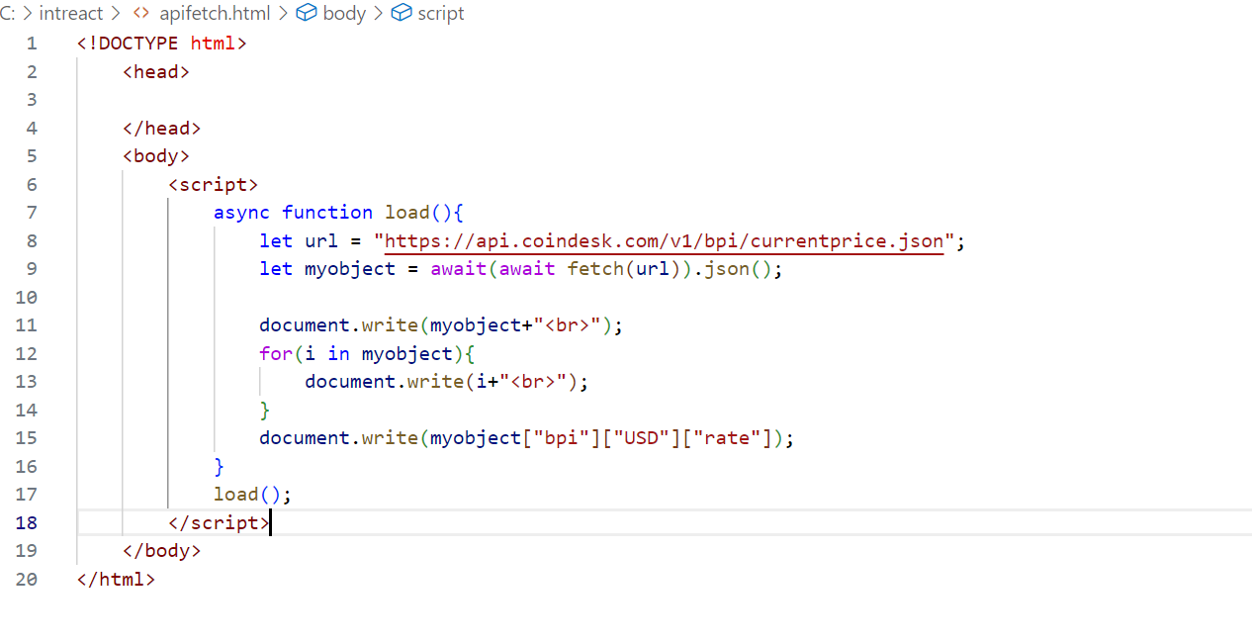

**TASK 3 :**

**API :** [**https://data.covid19india.org/data.json**](https://data.covid19india.org/data.json)

**PRINT DATA FROM ABOVE API IN TABLE FORMAT**

**SR NO | STATE NAME | CONFIRMED CASES | RECOVERED CASES | DEATH CASES**