**INFOLABZ IT SERVICES PVT. LTD.**

WORKING WITH TEMPLATE LITERALS

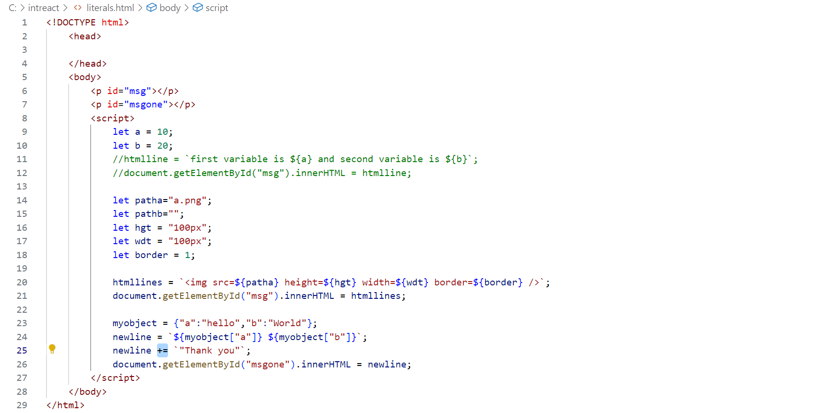

CONDITIONAL DATA FETCHING

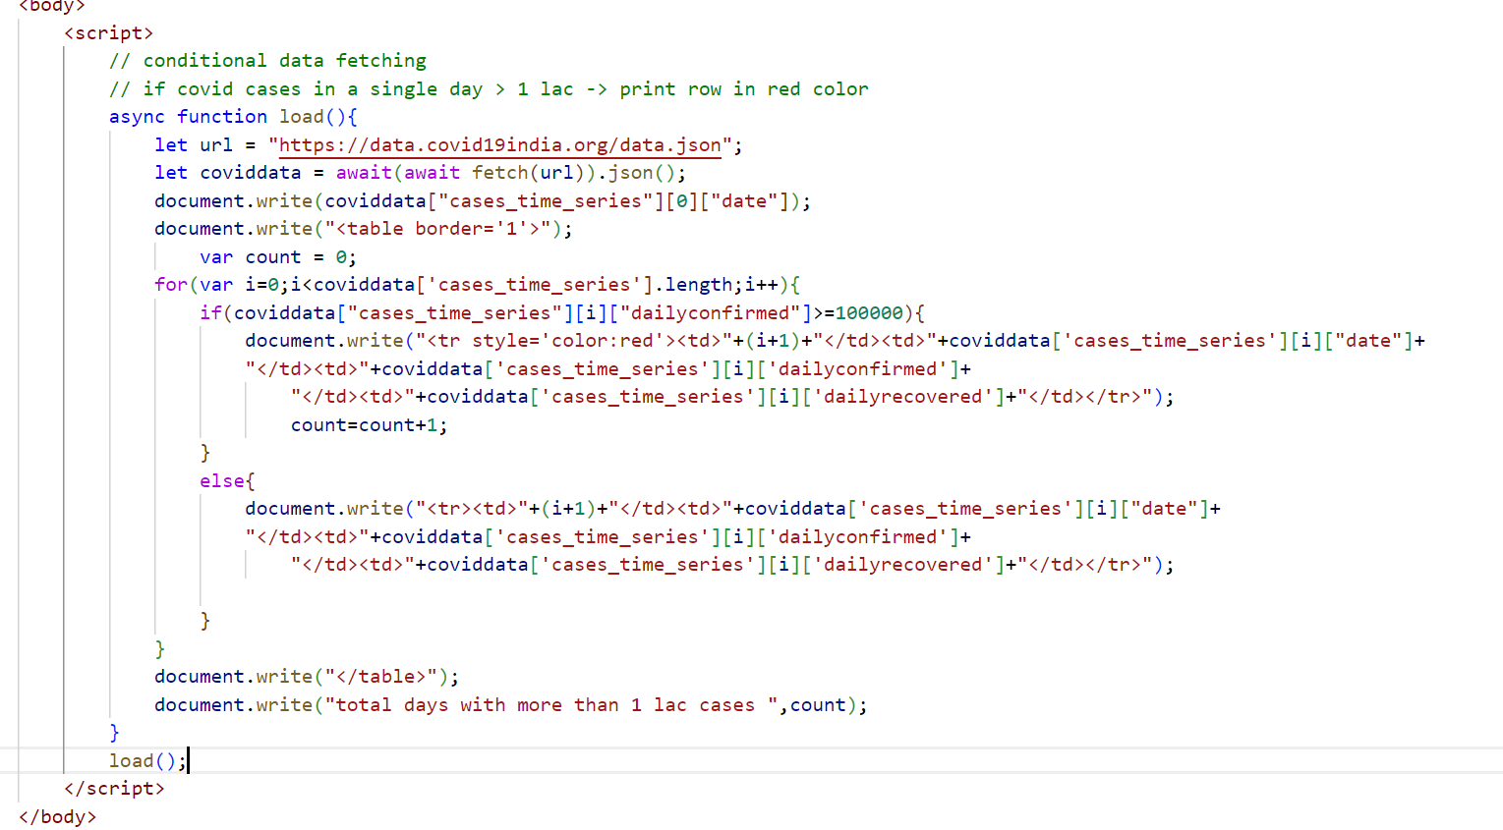

**INFOLABZ IT SERVICES PVT. LTD.**

**TASKS**

**TASK 1 :** Create a simple html form ( registration form ) with name, email, phone ,gender ( radio ) , city ( drop-down) and address (textarea). On submit button print all data in table format. [form data to table]

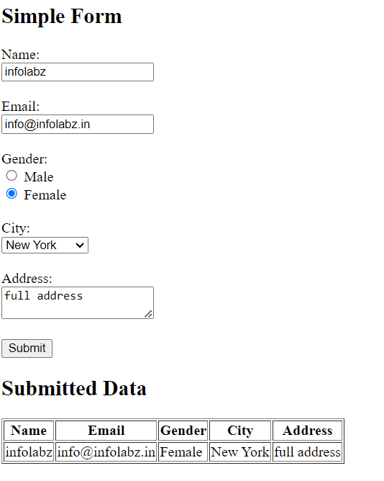

**TASK 2 :** https://data.covid19india.org/data.json

Allow user to insert date in form field. On click of submit print New cases / New deaths in table format as shown in below image .

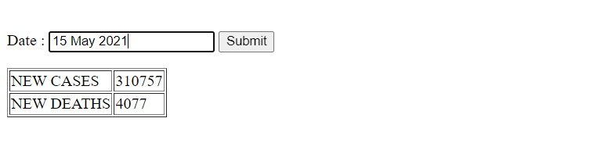

**Task 3 :** Allow user to insert Mutual fund scheme code. If found print scheme name otherwise print scheme not found.

API: https://api.mfapi.in/mf