**INFOLABZ IT SERVICES PVT. LTD.**

**JS FORM TO VARIABLE :**

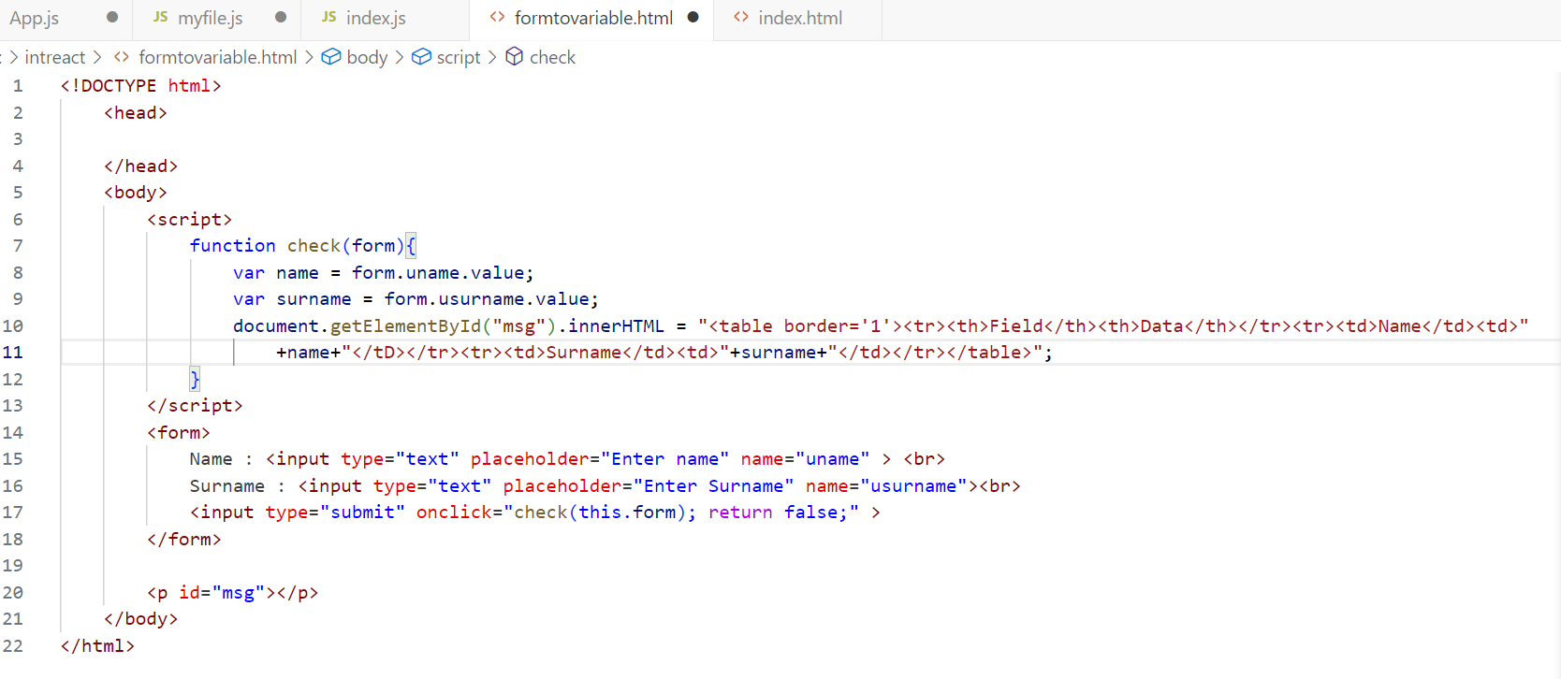

**REACT :**

Create a new react project : functionalcomponent

Steps :

npm init react-app functionalcomponent

cd functionalcomponent

npm start

App.js file :

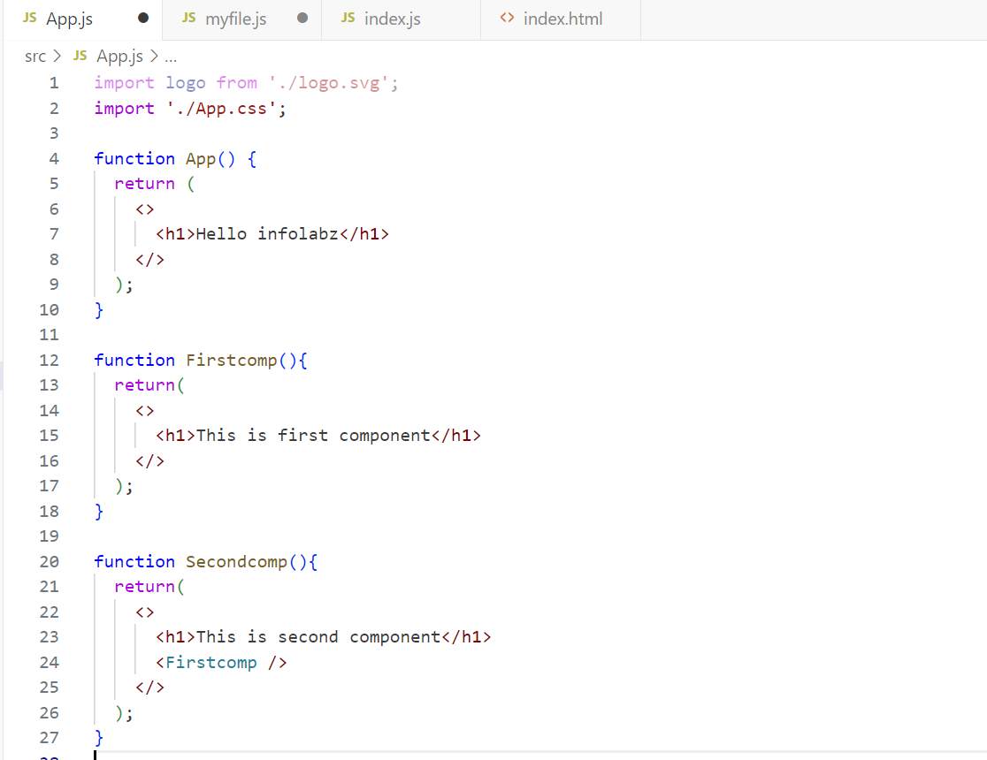

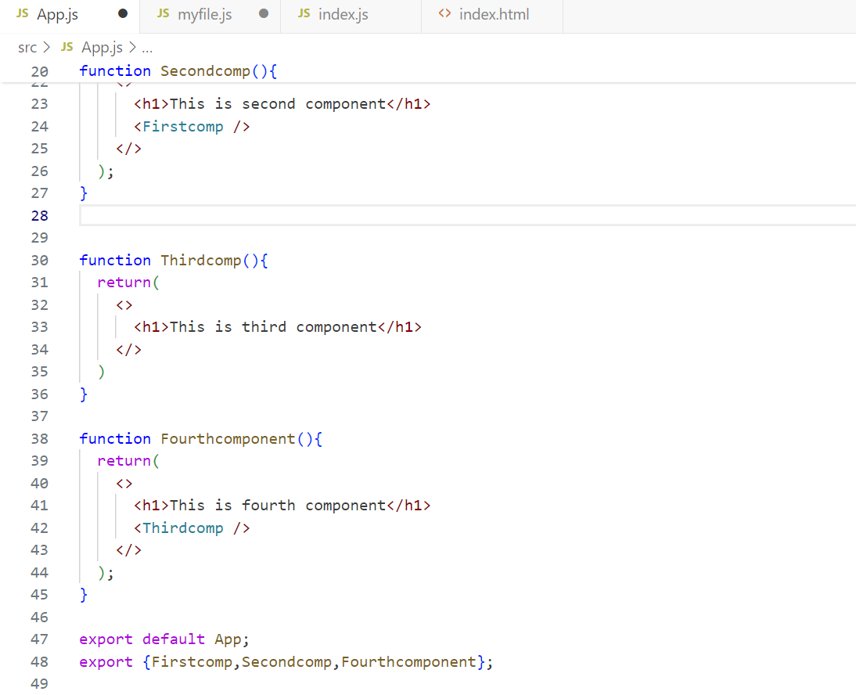

index.js File :

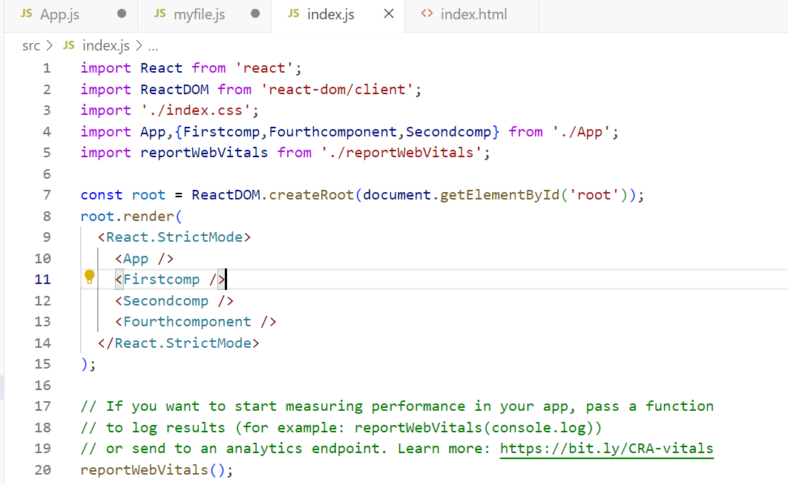

**TASKS**

**TASK 1 : API ACCESS ( PRINT DATA )**

API : <http://universities.hipolabs.com/search?country=india>

Print universities from above API in below table format. ( You can added css/bootstrap as per your requirement )

SR NO | UNIVERSITY NAME | STATE-PROVINCE | WEBSITE LINK

1 Ashoka University Haryana Visit Site

( on click of visit site, website should be open in new tab )

**TASK 2 : API SEARCH OPERATION**

API : <https://isro.vercel.app/api/spacecrafts>

Allow user to insert name of spacecraft in textbox. Print Spacecraft found or not.

**TASK 3 : React component practice task.**

| **Create New react project : componentpractice** | |
| --- | --- |
| **App.js** | App (DE), First (XE), Second [ First, Login ](E) , Third [Fourth,Logout] (E) , Fourth (XE), Buttons [Login,Logout,Addtocart] (E) |
| **Customcomps.js** | Login (DE), Logout (E), Addtocart (E), All (E) [Login, Logout, Addtocart] |
| DE: export default , E : Export, XE : Not Export | |