INFOLABZ IT SERVICES PVT. LTD.

**Js inside react component**

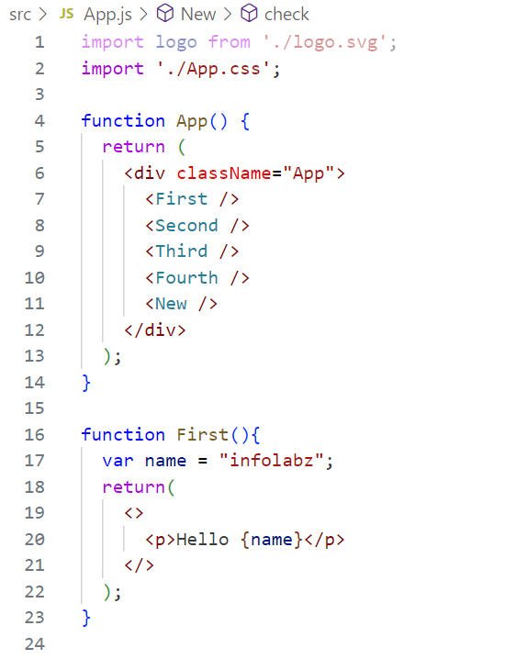

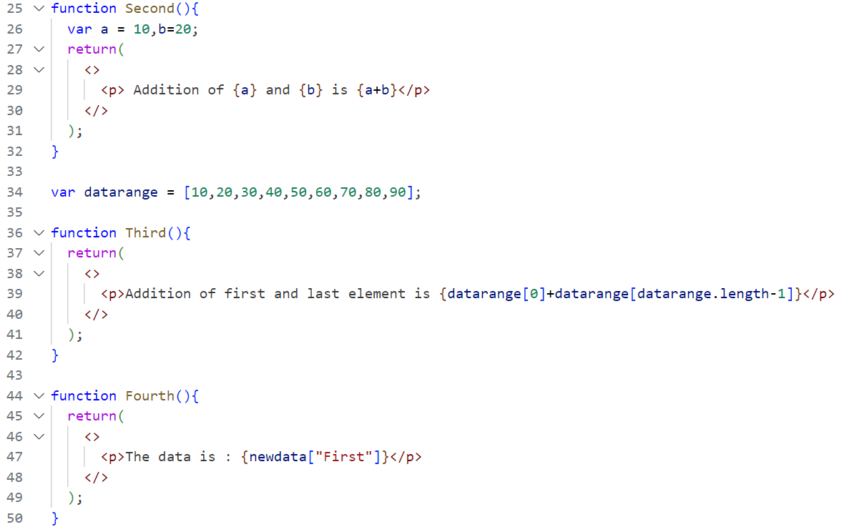

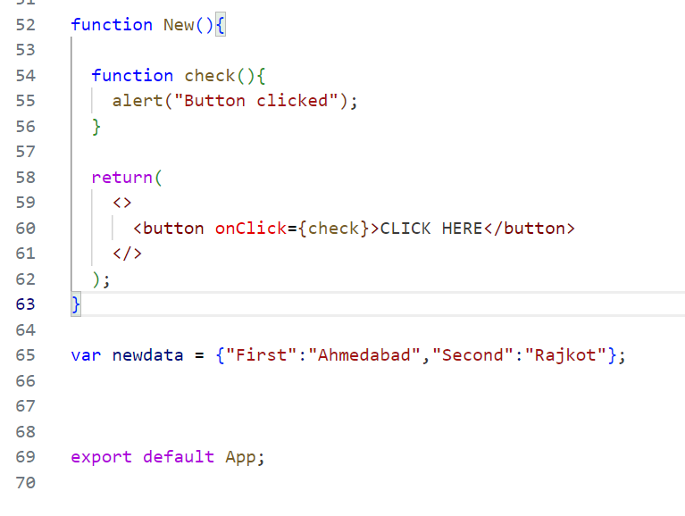

**React Hooks : Fetching bitcoin data from API**

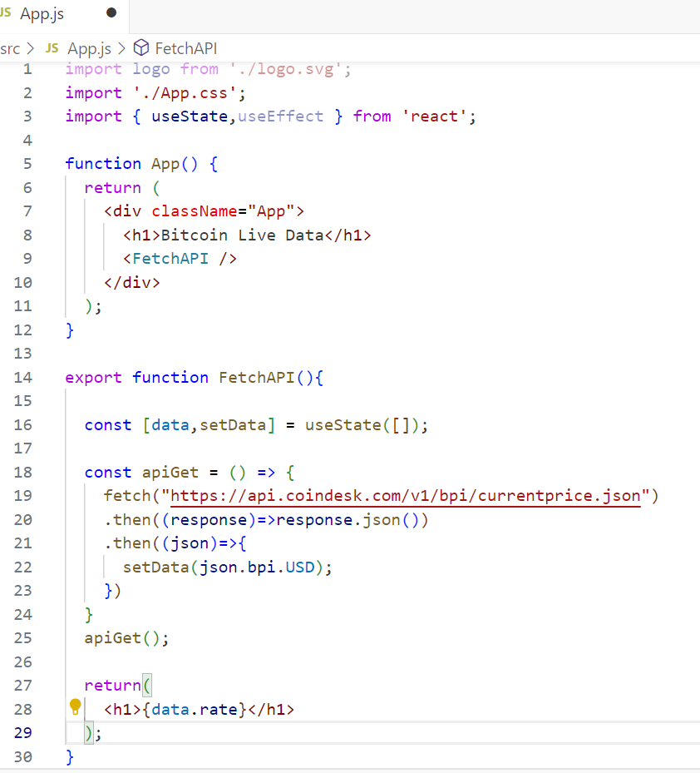

**TASKS**

Task 1 : Use another hook , useEffect in above code.

Task 2 : Print below news api data in table using Hooks. ( Do not use Js, Compulsory react )

API : <https://inshortsapi.vercel.app/news?category=sports>