INFOLABZ IT SERVICES PVT. LTD.

Bitcoin Price :

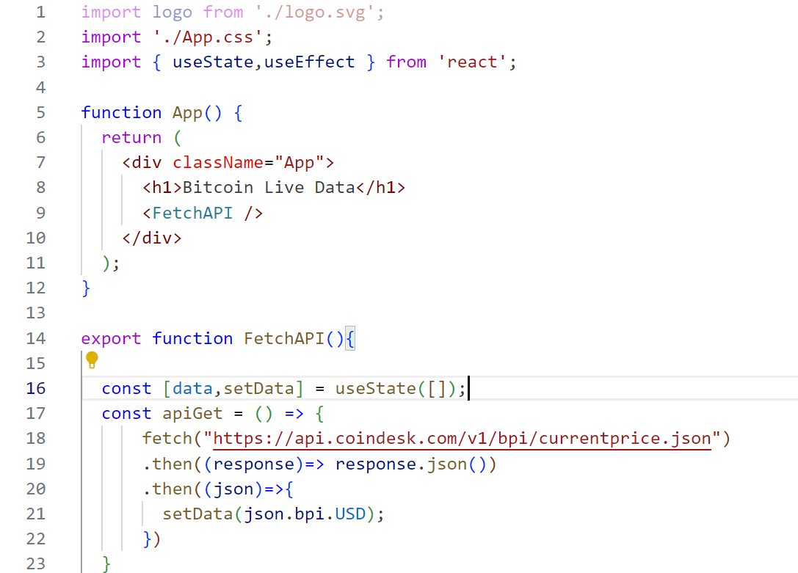

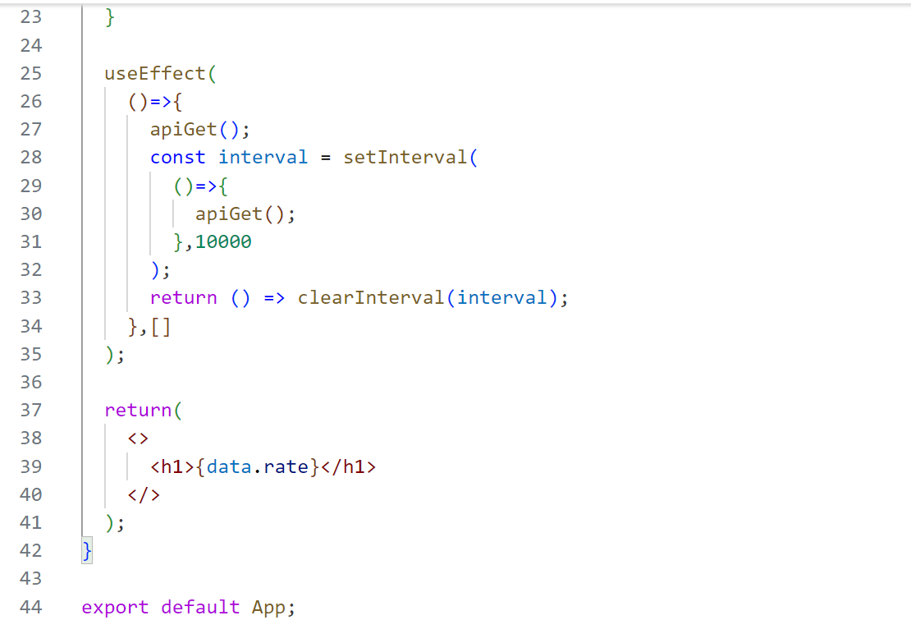

Fetching State wise covid data from API.

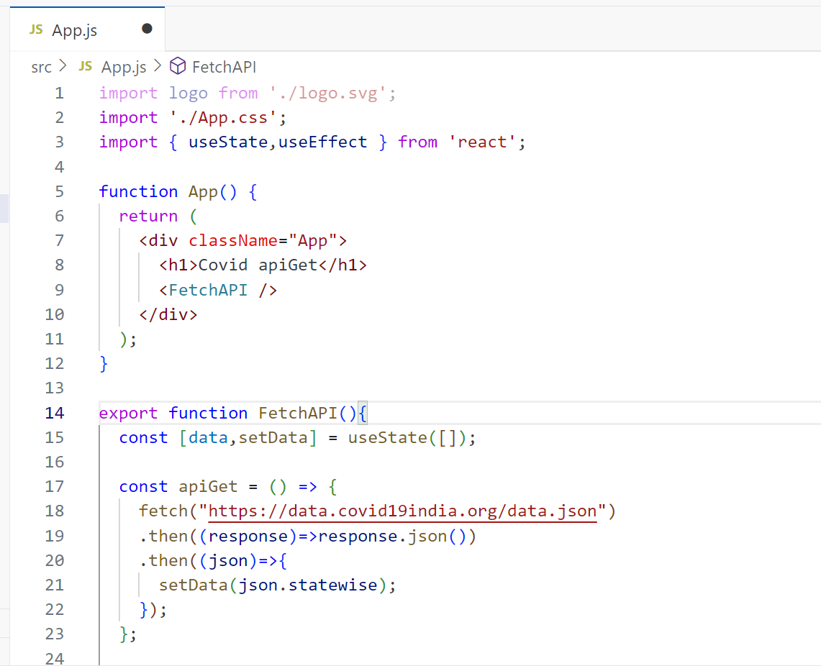

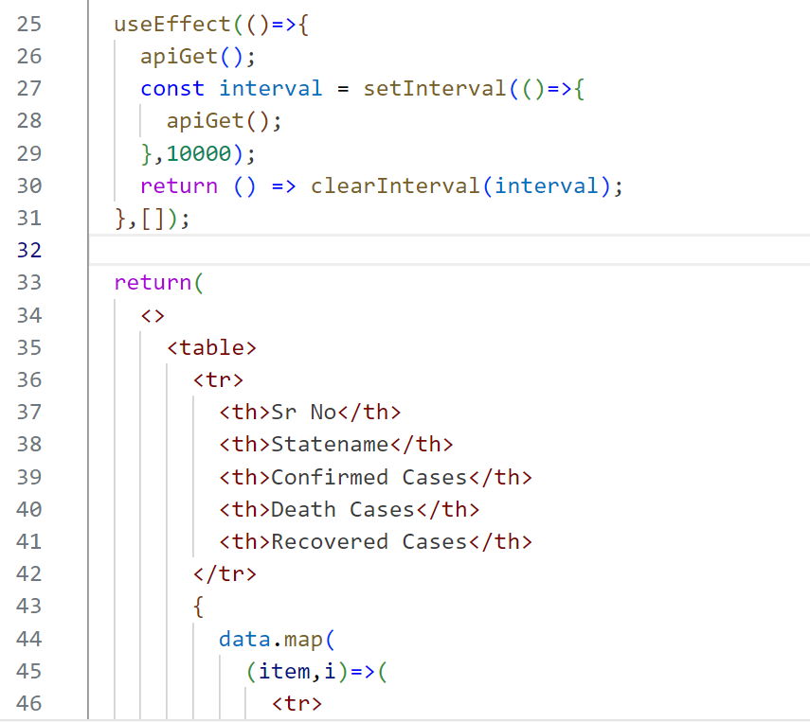

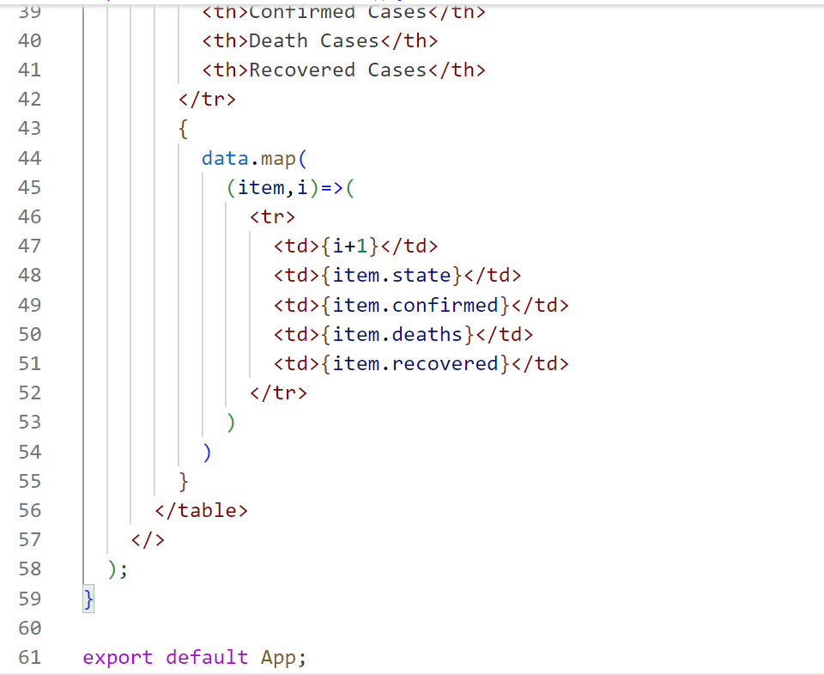

**Tasks**

**Task 1 : ISRO API :** [**https://isro.vercel.app/api/spacecrafts**](https://isro.vercel.app/api/spacecrafts)

Load API data using React JS and print it in bootstrap table.

Applied bootstrap concepts : Container, Row, Bordered table

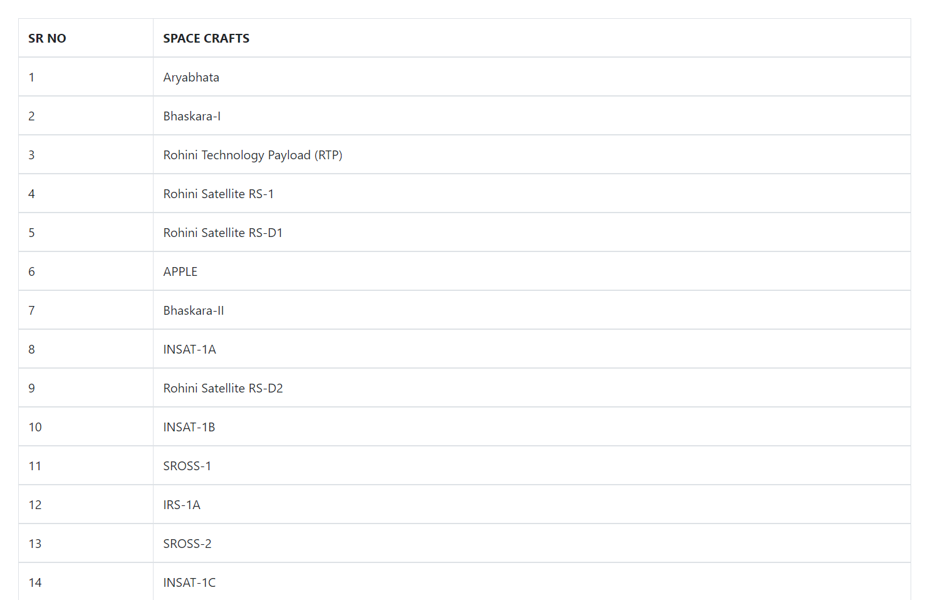

**TASK 2 : News API :** [**https://inshortsapi.vercel.app/news?category=sports**](https://inshortsapi.vercel.app/news?category=sports)

Load data from above API from using React Js and print in Bootstrap table as shown in table below.

