INFOLABZ IT SERVICES PVT. LTD.

Fetching Data from News API ( Bootstrap Cards ) :

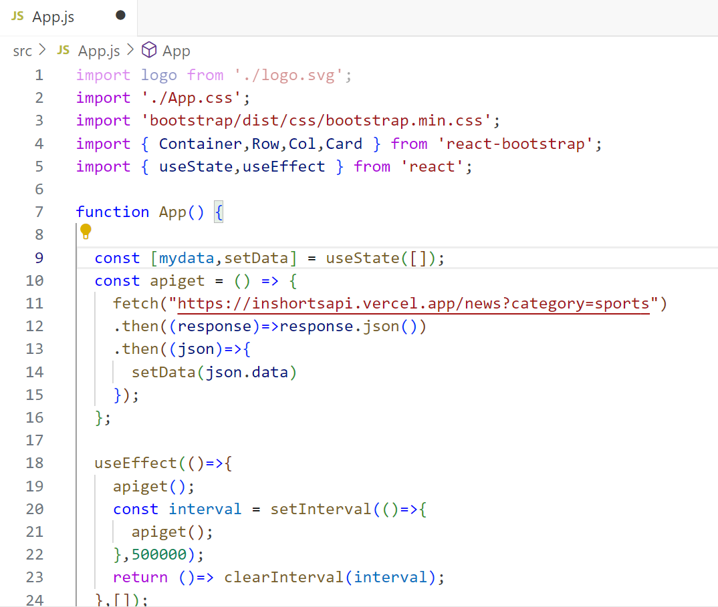

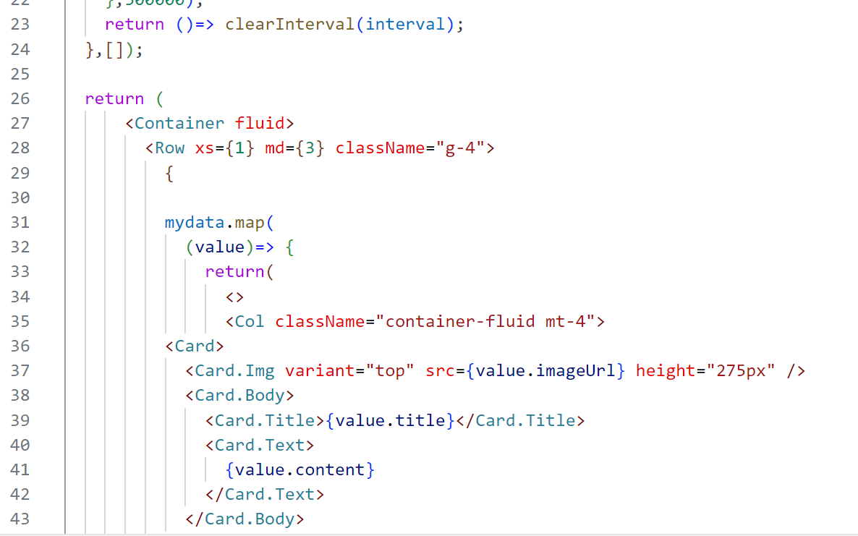

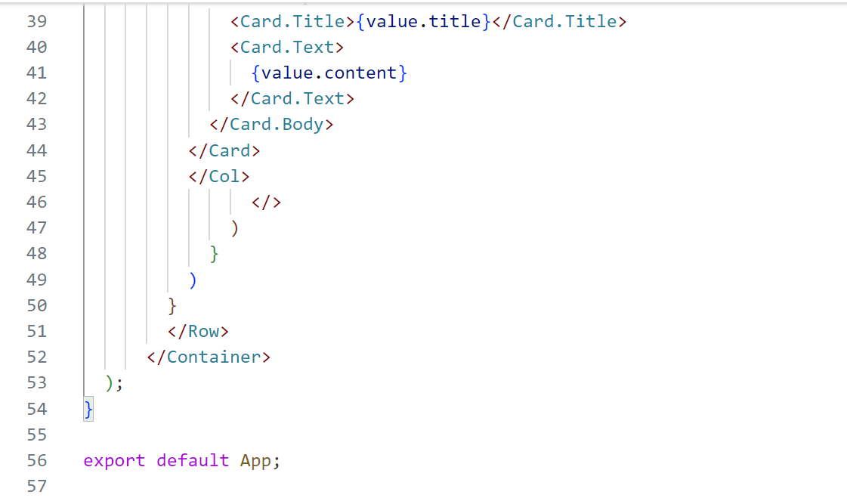

TASKS :

**Project Idea 1 : API baked food recipe portal using React Js**

( VERY POWERFUL - CAN CREATE FULL WEBPAGE )

<https://www.themealdb.com/api/json/v1/1/search.php?s=Arrabiata>

<https://www.themealdb.com/api/json/v1/1/search.php?s=Pizza>

**Project Idea 2 : API baked dynamic real time news portal using react Js**

( Create a website of realtime news from very popular inshorts API )

<https://inshortsapi.vercel.app/news?category=sports>

TASK : Find any five API (except covered api in internship ) using which you can create a mini project in react.

Finding API is important and Time consuming work. Great APIs can reduce lot of work and can pour lot of content. We can create resume oriented awesome small projects too !

**Students have to find and submit API urls in below form.**

[**Click here to submit Task in google form.**](https://docs.google.com/forms/d/e/1FAIpQLSfsvcZuQ2b2N2Sa8gePGGVmQxla9a_GmMU5htawVmRdCtp4fg/viewform)