**INFOLABZ IT SERVICES PVT. LTD.**

**Routing in react : Step by Step**

Create a new react project : reactrouting

Install routing package :

Go to project’s terminal > New Terminal

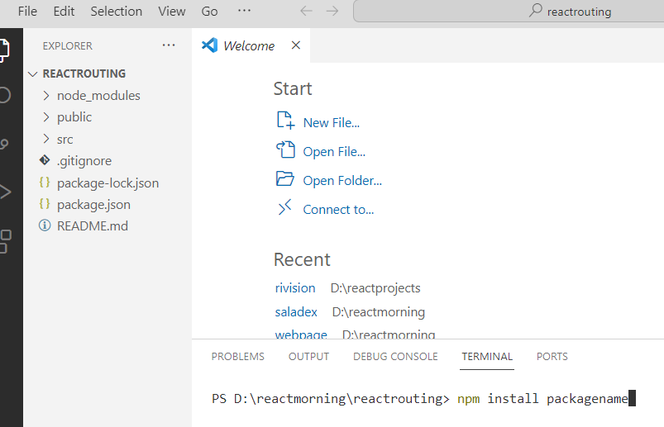

Package Name : react-router-dom

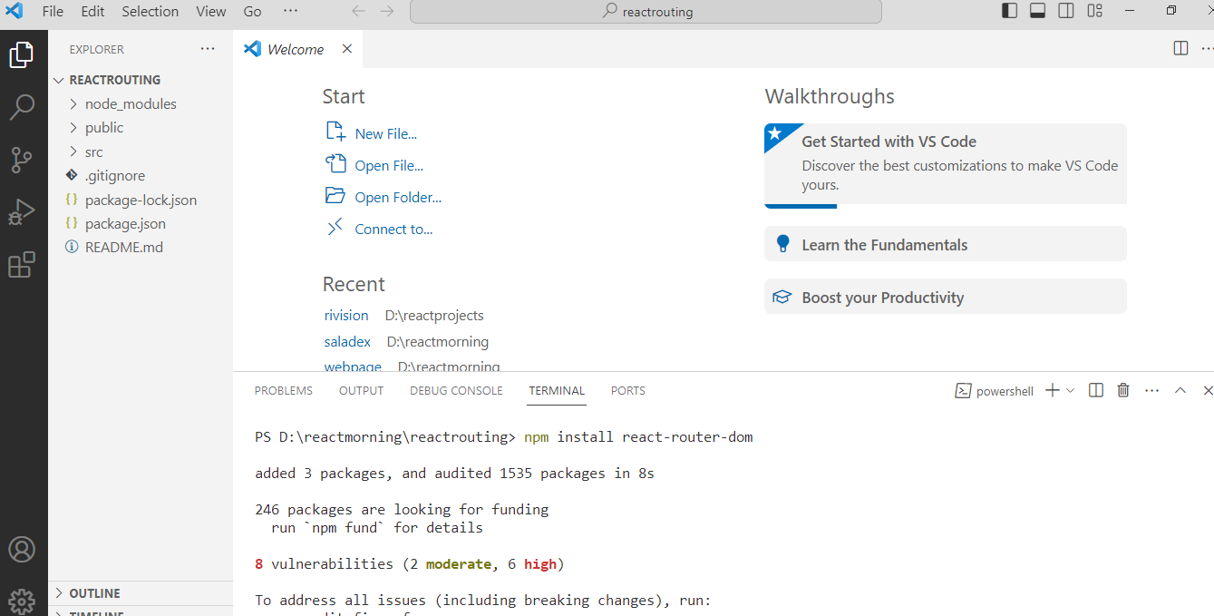

Create a new folder : components

Add sub files for different pages

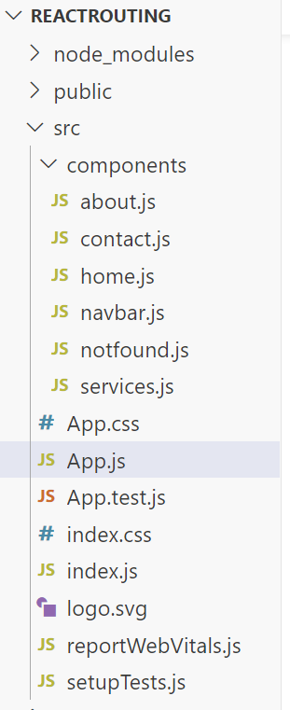

**home.js**

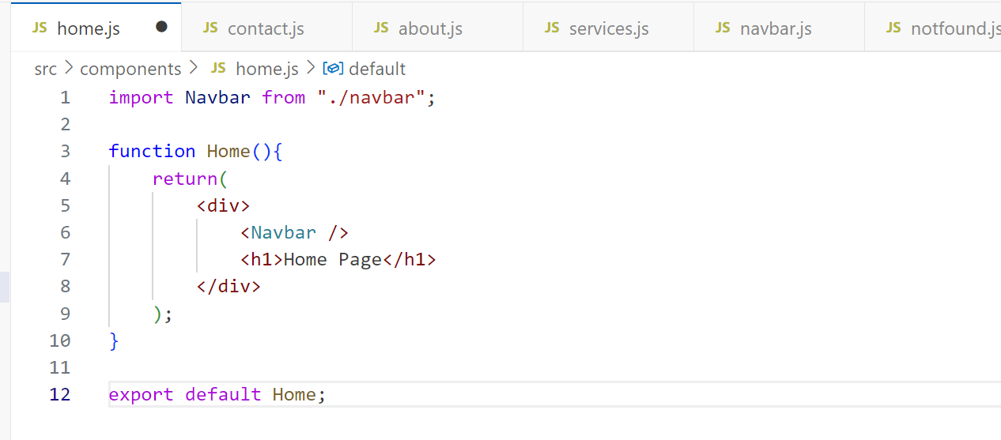

**Services.js**

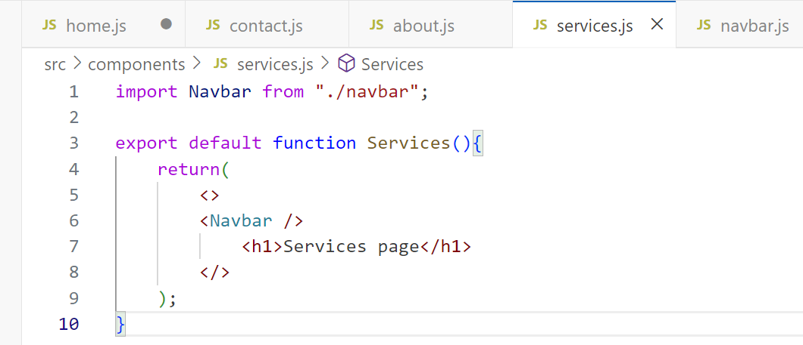

**Contact.js**

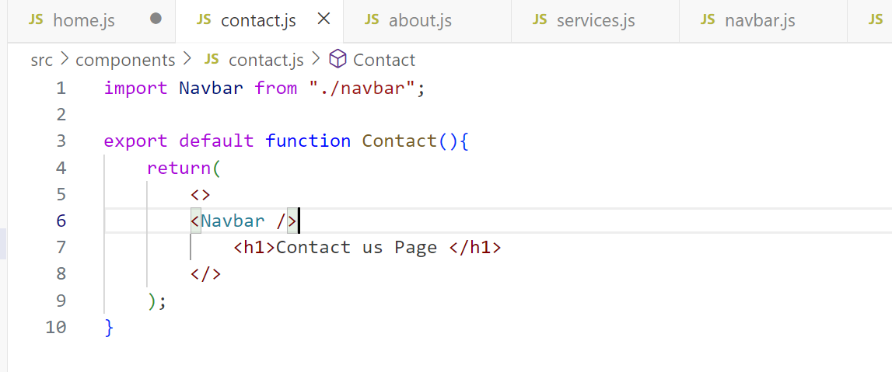

**About.js**

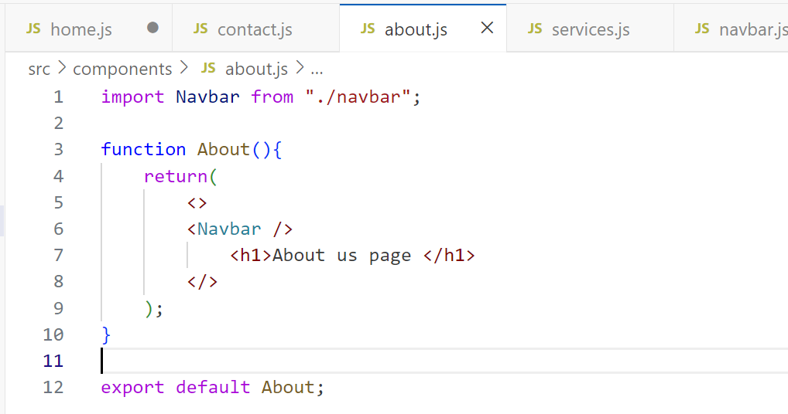

**Navbar.js**

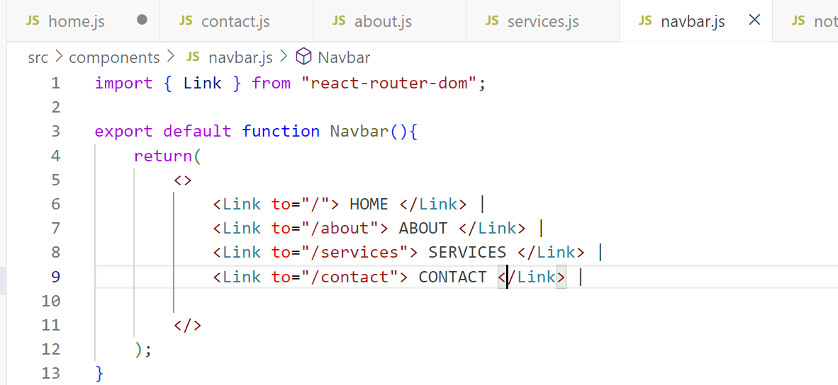

**Notfound.js**

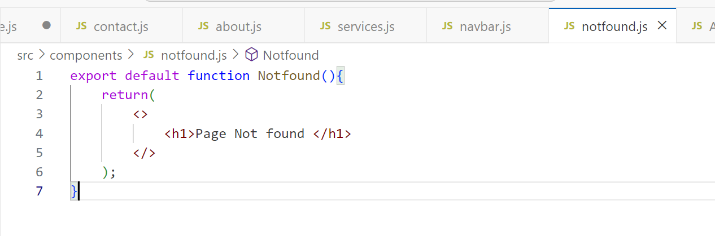

**App.js**

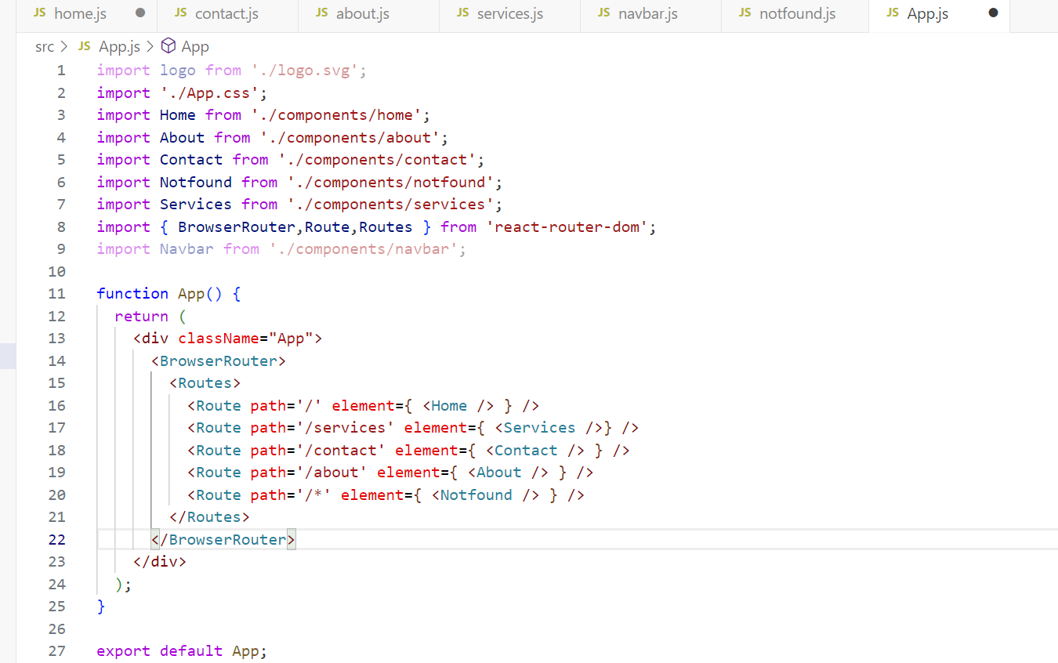

**NEWS API CATEGORIES : ( TO DEVELOP MASTER PROJECT )**

API : <https://inshortsapi.vercel.app/news?category=sports>

1. all

2. national //Indian National News

3. business

4. sports

5. world

6. politics

7. technology

8. startup

9. entertainment

10. miscellaneous

11. hatke // Unconventional

12. science

13. automobile