**INFOLABZ IT SERVICES PVT. LTD.**

1. Create new react project

Name it: reactbootstrap

1. **Official React documentation website**

Link : <https://react-bootstrap.netlify.app/docs/getting-started/introduction>

1. Open project in visual studio code
2. Go to terminal and install react bootstrap

npm install react-bootstrap bootstrap

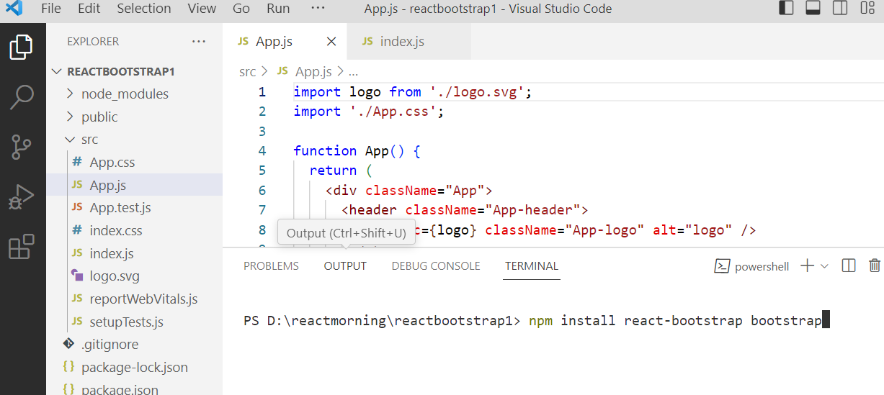

1. Import CSS file in App.js ( where we want to use bootstrap )

import 'bootstrap/dist/css/bootstrap.min.css';

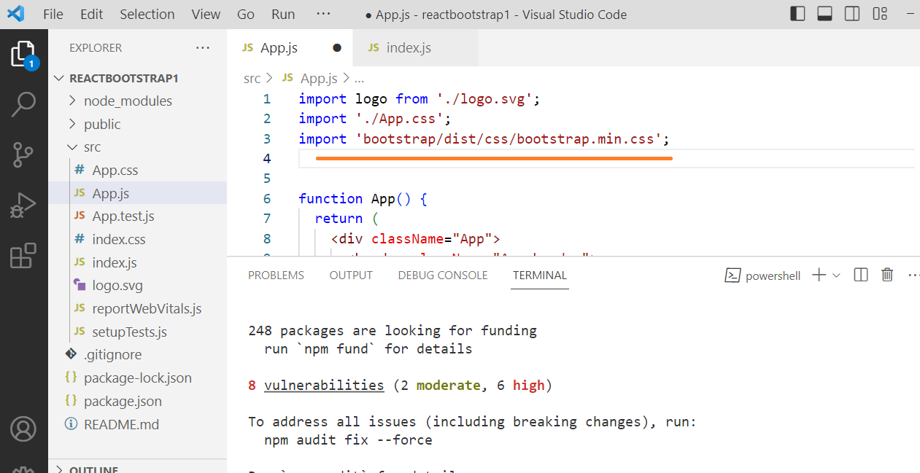

APP.JS

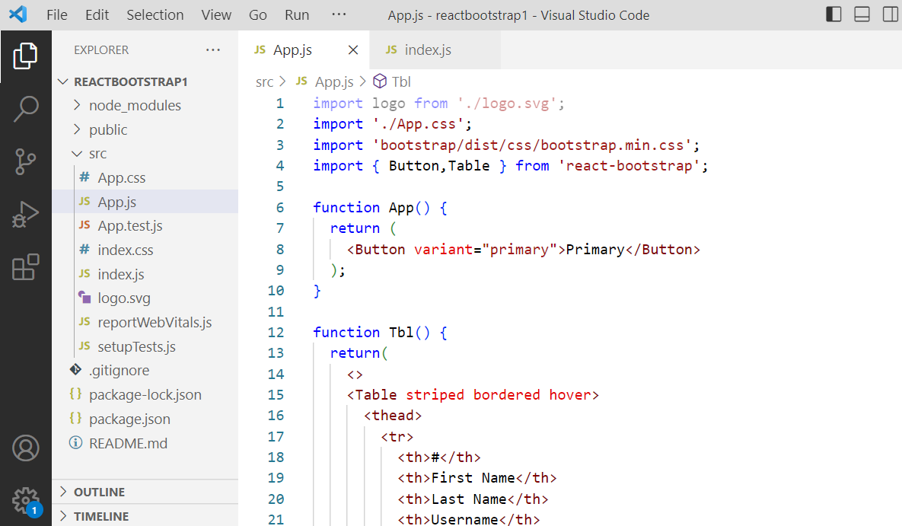

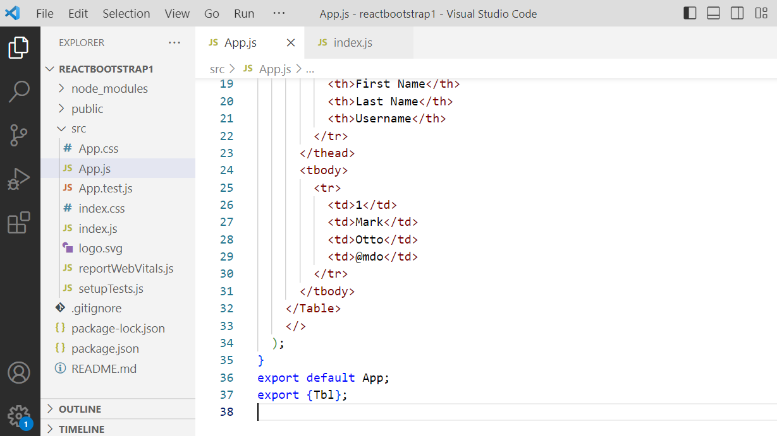

Index.js

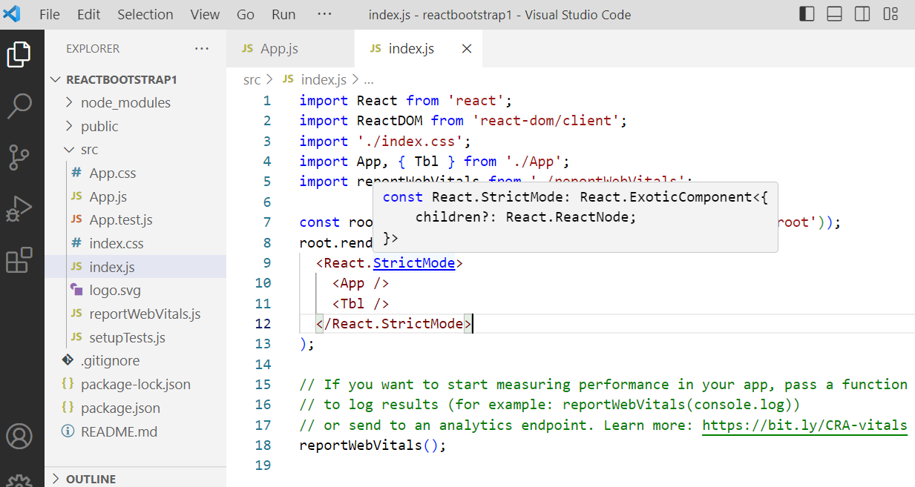

Output :

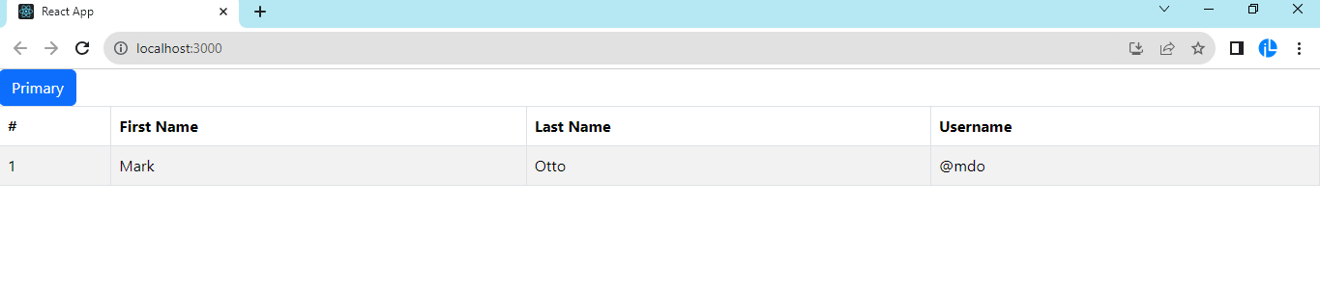

**TASKS**

**Project 1 :**

| **Page Names** | **Project name :** reactbootstrapcomps |
| --- | --- |
| App.js | App (DE), First (XE), Second [Bdgmain] (E) |
| Navbar.js  ( Badges component ) | Bdgmain (primary badge ) (DE) , Btnbadge (E) , Successbagde (XE), Pillsuccessbadge [Successbadge] (E), Passbadge (E) (green), Failbadge (E) (red) |
| Table.js  ( Table component ) | Resulttble (DE)  (Columns : Sr No. | Student Name | Maths Marks | Phy Marks | Chem Marks | Pass / Fail Badge ) |
| Modelspage.js  ( Modelscomponent ) | Mainmodel (DE), Fullscreenmodel (E), Largemodel (E) |

  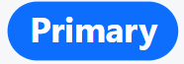

Button Badge Contextual Badge Pill Badge

**Project 2 :**

| **Page Names** | **Project name :** reactbootstrapcomps |
| --- | --- |
| App.js  ( Mix component ) | App (DE), Btngroups(E), Pagination(E) , Breadcrumbs (E), Overlays (E), Toasts (E) |
| Tabs.js  ( Tabs component ) | Controlledtabs (DE), Justifiedtabs (E), Pilltabs (E) |
| Details.js  ( Offcanvas component ) | Companyinfo ( DE ) ( left offcanvas ) , Termsandconditions ( bottom offcanvas ) |