**Analysis of Environmental Changes and Global Impacts**

**Hari Pad Bharti** (ID: 01591571 ; hbharti@umassd.edu)

*Department of Computer & Information Science*

*UMASS Dartmouth*

***Abstract***

Data analysis of environmental changes and the global impacts can be useful to find information’s of the trend that environment have witnessed in recent times and predict the possible future. Today, environmental changes are at alarming rate and needs understanding and attention globally. One of the factor that inversely affect the environment is emitted carbon content in environment. Global warming and pollution are the key effects and need to be studied to reduce its emission in upcoming years. Carbon emission have effects on both, environment and the economy, and further in this paper, techniques to analyze data and possible visualizations will be discussed. Visualization is a technique by which any analysis or result can be drawn, understood and concluded for further understandings. In order to make an understanding of the current trend in environment, analysis of environmental data and the findings of co-related changes, this paper will further explain the information’s through Visualization.

***Introduction***

Environment is always vulnerable to changes and has been changing since ages. But last few decades have witnessed such changes that can threaten the existence of life on earth if not controlled. Green House Gases are one such threat which are being mostly contributed by the carbon emission. Carbon Emission comes from most of the processes that human requires, needs or likes. Whether transportation or manufacturing, burning fossil fuels or refrigerating machine, all produces carbon content and if we closely analyze, most of such production comes from human activities itself. In this paper, taking global carbon emission, GDP income and Forest Cover datasets from the World Bank, analysis have been concluded based on the results to co-relate the carbon content in the environment with the Economy, GDP and Forest Cover. Most of the analytic results can be concluded through visualization results that can be obtained by scalable data analysis using python’s pandas’ library that can help in analyzing big data sets. Taking 258 countries in consideration and analyzing from year 1990 to 2011, different results can be concluded including co-relation of the carbon emission with economy of the region, forest cover depletion and corresponding economic growth etc. Overall, this project gives a path towards Sustainable Development strategies that can be derived through the Visual analysis of trends of environmental changes and its global impacts.

***Description***

Taking world bank dataset and filtering the analysis part, Carbon emission can be derived for each country for the required span of time. Availability of complete data between years 1990 and 2011 can be filtered and can be processed through data cleaning for further analysis. Taking small data frame of countries and its emission, small visual graphs can be generated taking segment of years in analysis. The same method is applied to the data of world forest cover and the GDP. Interesting results can be derived by the analysis of such data.

***Observations***

Firstly, talking about the carbon emission and its corresponding analysis, visuals can be found as described in figure 1.

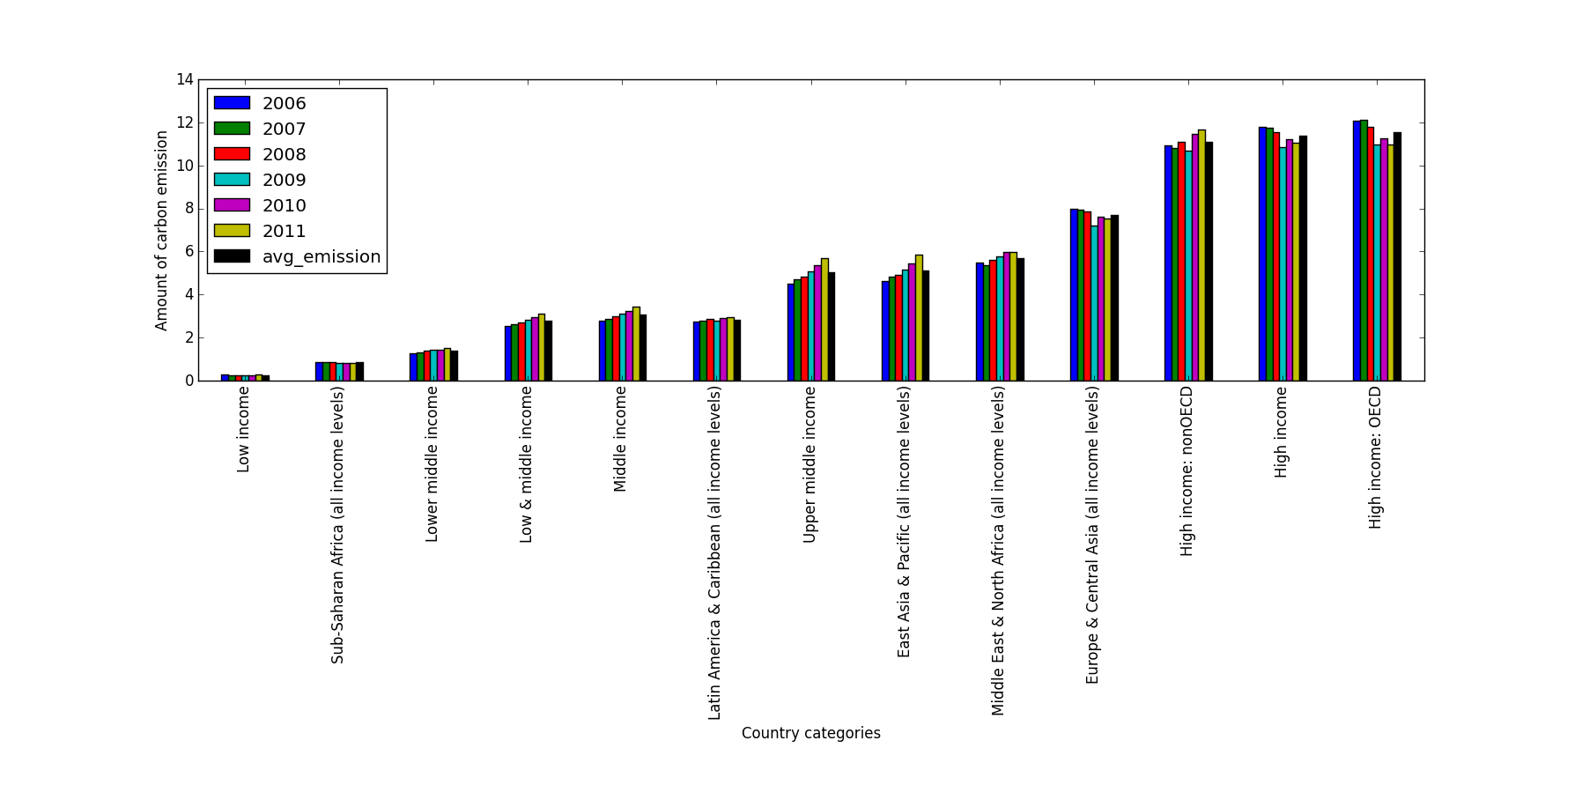

*Figure 1: Bar chart shows the trend of carbon emission by different countries categorized on the basis of United Nations country classification on the basis of their economies.*

Similar analysis can be drawn from year ‘1990’ to ‘2006’ with little difference. One noticeable trend that can be seen in the Figure 1 is that High Income and OECD countries have reduced the carbon emission in past few years while the carbon emission by rest of the countries have been gradually increasing. Another noticeable fact is the amount of emission. High income countries produces almost 30 times more carbon content than the Low income countries while most of the developing countries like population giants ‘India’ and ‘China’ lies in the Middle Income and Upper Middle Income category of countries. More observations can be derived from the data frame (Figure 2) filtered as shown.

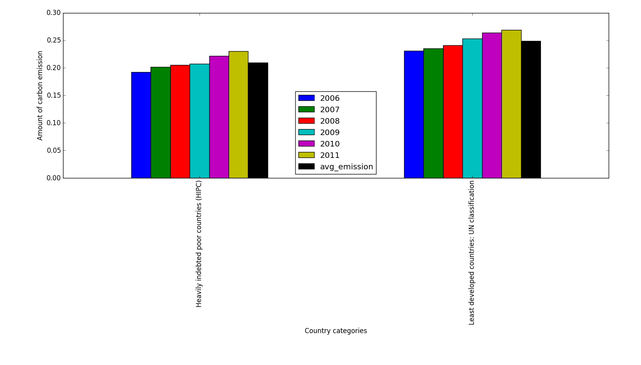

*Figure 2 shows the trend of carbon emission by HIPC and Least Developed Countries*

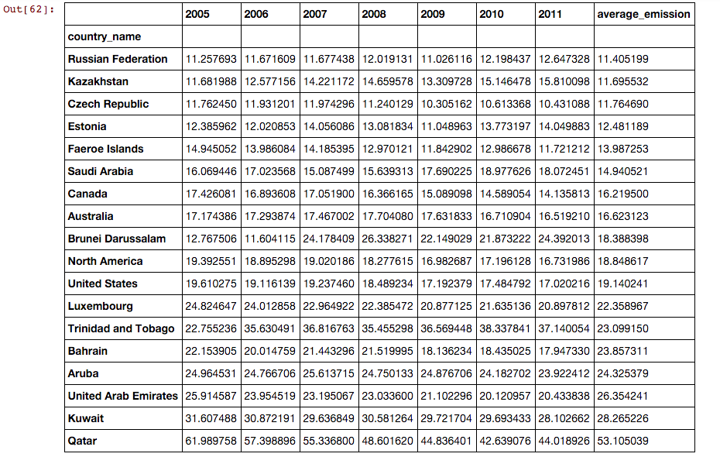

*Figure 3: Shows the derived data frame that shows the list of top 18 carbon emitting countries. Note that the value of carbon emission is in metric tons per capita.*

It can be observed from Figure 3 that Qatar with an average emission of 53.1 *metric tons per capita* tops the list of carbon emitting giants followed by Kuwait with 28.27 *metric tons per capita* while United States stands on 8th position. It can be observed that few of the nations have shown a significant reduction in carbon emission during past few years while the rest of the data suggests that in developing and under developed countries, carbon emission is rising significantly. The overall amount of emitted carbon content is going to be increased in next coming years as observed by the current trends, it can also be inferred that there is alarming need to control carbon emission as if the same trend continues, it can be catastrophic to the mankind and the environment.

Now, in order to understand the distribution of carbon emitting countries globally, a color map visualization is generated using Pandas methods to first transport the data elements of data frame to the excel sheet and then giving output that can fit the analytic software to give the pattern of countries with the amount by colored representation.

*from pandas import ExcelWriter*

*writer = ExcelWriter('output.xlsx')*

*df3.to_excel(writer, 'sheet1')*

*writer.save()*

*The above mentioned code can export the data in excel sheet that can be taken as input by the software to analyze the data.*

Figure 4 represents the global map of the countries with their carbon emission depicted by different colors.

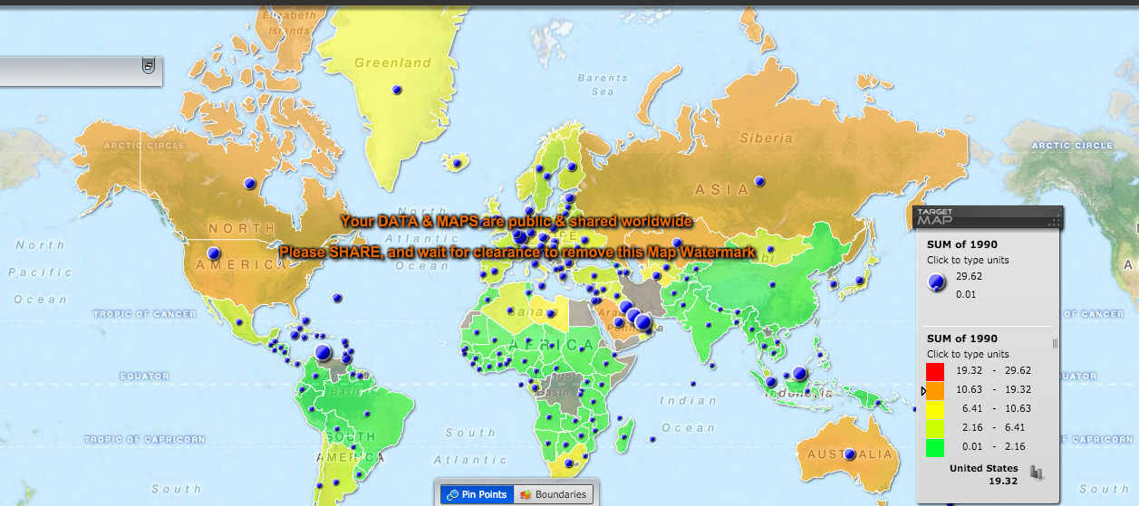

*Figure 4 represents colored map of the regions with its carbon emission depicted by different colors. Note that the unit of carbon emission taken is in metric tons per capita while right hand side of the figure depicts the value differences.*

It can be inferred from the map that most of the green regions represents underdeveloped or developing countries like India, China and central African nations, while red and orange colors are represented by oil producing like Qatar, Kuwait etc. or developed countries like Russia, USA and Australia. This map clearly suggests the existence of relation between the environment and the economy. Another noticeable fact about the map is presence of blue dots, whose size represents the amount of carbon emitted by the region. This figure globally shows the trend of carbon emission and can help in understanding location wise environment trend.

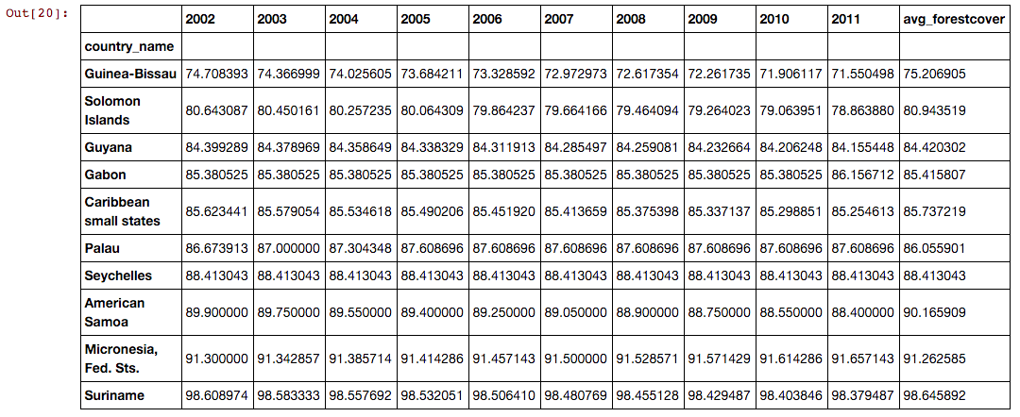

*Figure 5 shows the list of countries having maximum forest cover. Note that value represented denotes the percentage of forest cover of the total land.*

Now, taking forest cover in picture, we can observe that most of the countries having globally maximum forest cover belongs to the lower income and low GDP. Here in Figure 5, list of countries having maximum forest cover do belong to lower income category of the countries. Forest cover deeply affects the economy of the region. Forest not only acts as a habitat to different flora and fauna, it also boost economy of the region with enriched wood products and natural medical products while at the same time hinders the infrastructure construction and the constructions. We can observe that Suriname tops the list of having maximum forest cover with 98.65% of the total land.

Countries that tops the list of being maximum carbon emitters have almost no forest cover.

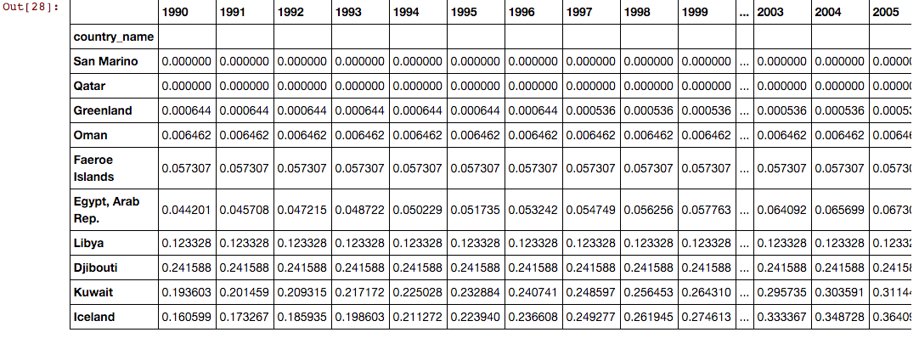

*Figure 6 shows the list of countries having least forest cover.*

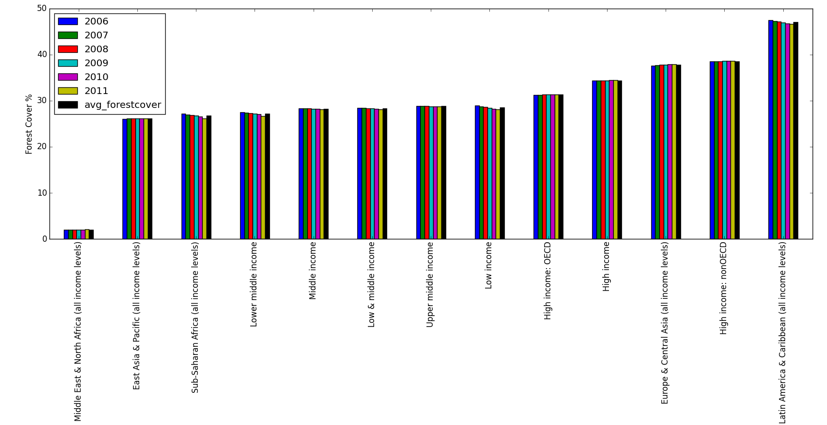*Figure 7 shows the distribution of Forest cover and corresponding country category.*

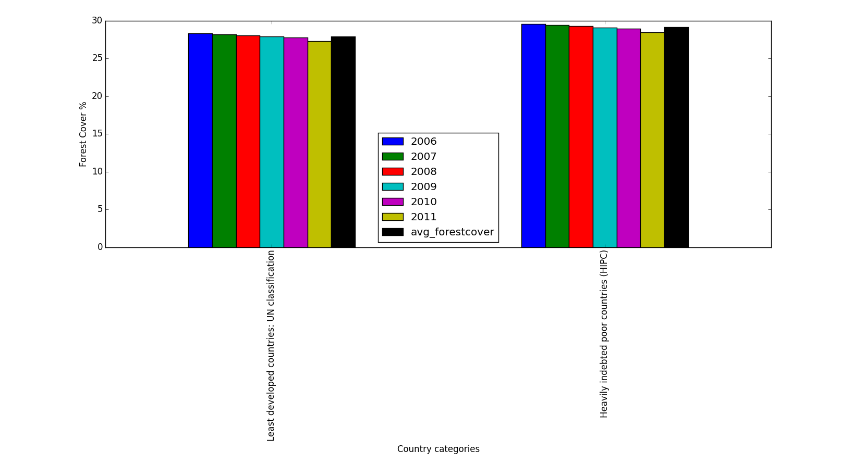

*Figure 8 Shows the distribution of Forest cover among Least developed and HIPC countries.*

We can clearly observe that least developed countries also have no forest cover reflecting the significance of forest cover on the economy of the region.

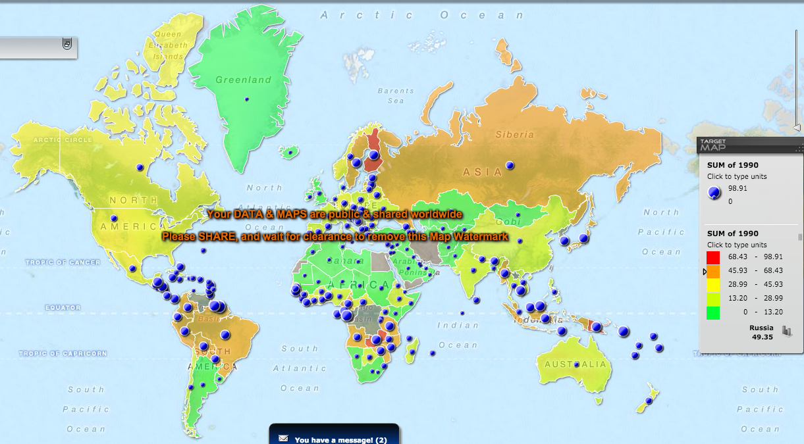

*Figure 9 represents the forest cover of different region across the globe.*

Here, we can observe from Figure 9 that forest cover also helps the country to develop the economy as most of the developed countries have decent forest cover as well.

Now taking GDP in picture, we can get similar findings.

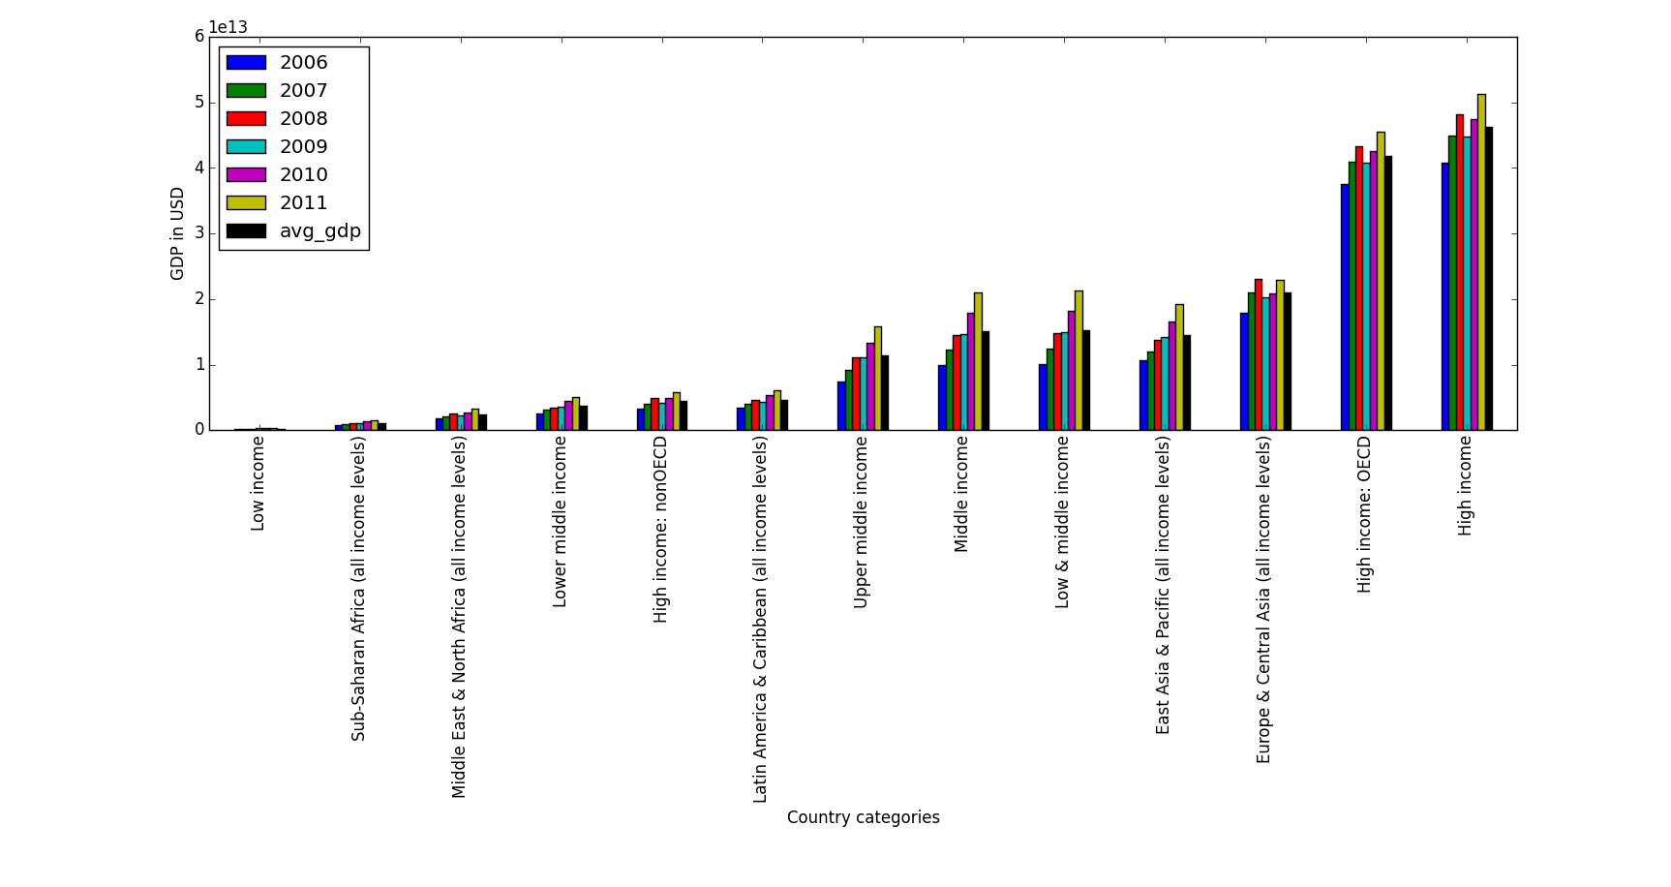*Figure 10 shows the distribution of GDP among different countries based on economy of the region.*

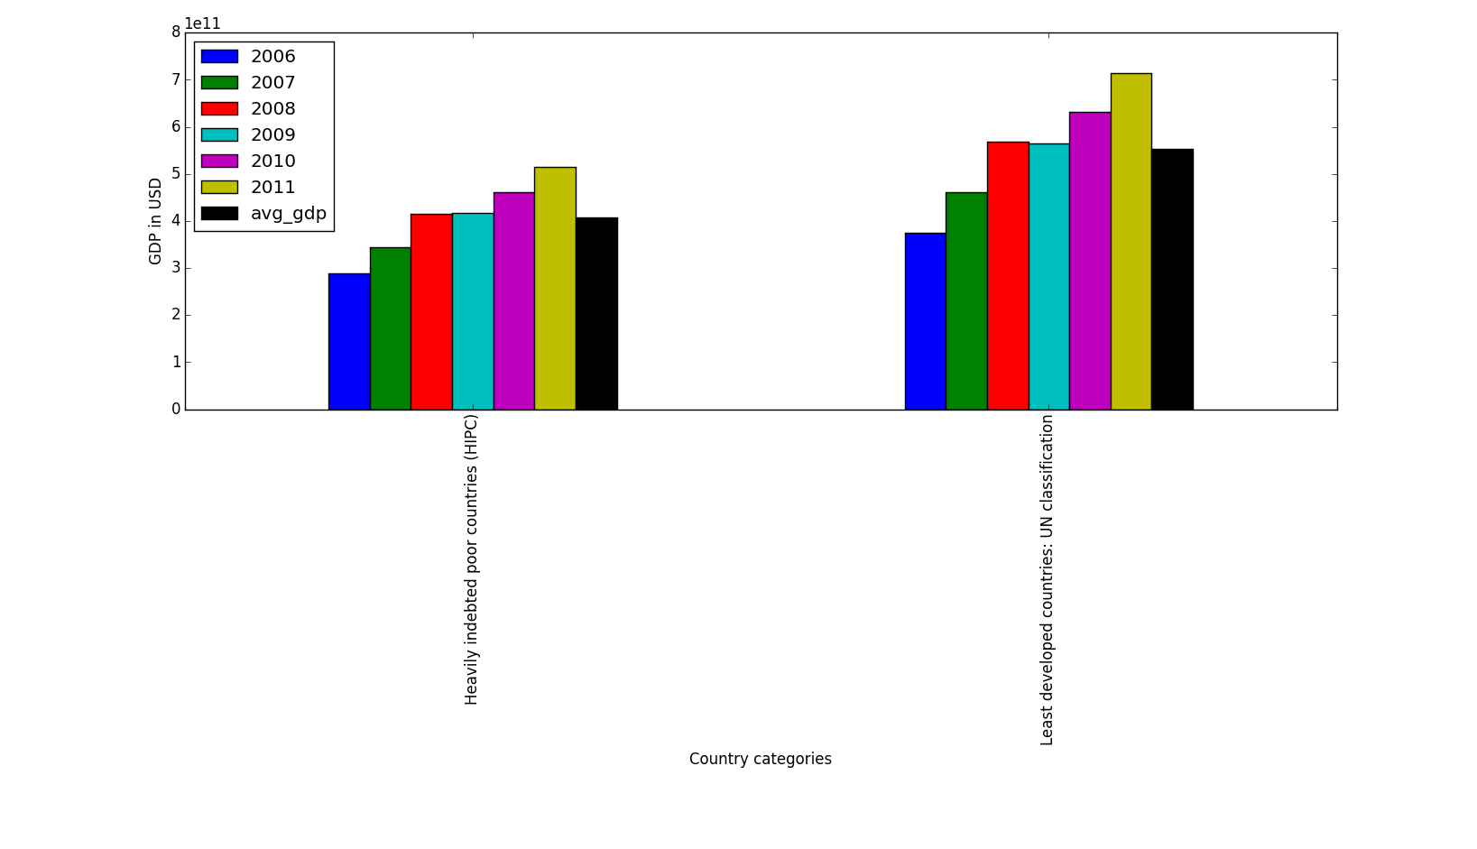

*Figure 11 Shows the distribution of GDP among Least developed and HIPC countries.*

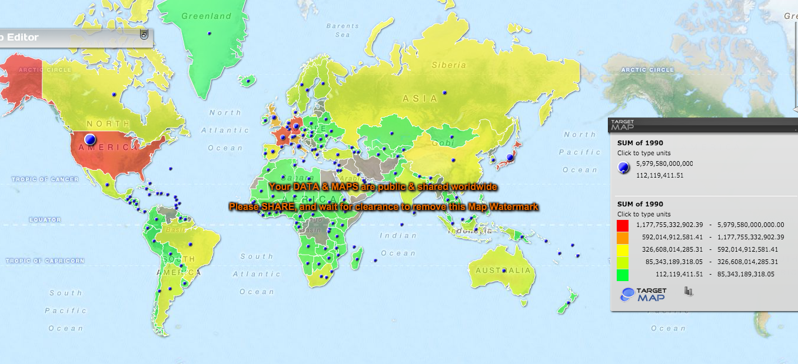

*Figure 12 shows the Global distribution of GDP.*

***Results***

As per the observations, household requirements produce maximum Carbon Emission (~70%). Rest of the development and infrastructure contributes the rest 30% of the total emission. It can also be inferred that there exists direct proportional relation between Economy of the region and its Carbon. Forest cover also contributes to the economy and it completely depends on how the forest cover can be utilized by the region and how useful it is to the nation. Also, It can be observed from visualization that Carbon Emission significantly reduced in past 2-3 years among developed countries while increased in the developing and under developed countries.

Is is noticeable that Forest cover got reduced with the increase in Carbon Emission specially in the developed and developing countries. Developed Countries emitted maximum carbon content to the environment while using exhaustive industrial exploitation of the environment.

There is a rise in Carbon Emission by Developing Countries like India and China, the population giants. Trend also shows overall carbon emission will increase in next coming years mostly contributed by developing nations. Its also noticeable that Qatar, the maximum carbon emitting country, have no forest cover while Kuwait also shares the same story being on 2nd spot. United States stands at 8th position in Carbon Emission with significant reduction in emission during past 5 years.

***Conclusion***

It can be concluded that there is a need of strict control on carbon emission globally in order to save the environment and natural habitat. There are possibilities that controlled use of resources and in a profitable manner can help reduce overall carbon emission and deforestation of forest cover and desertification due to exhaustive use.

Its important that world should now focus on SUSTAINBLE DEVELOPMENT rather than exhaustive development. This project can help us to understand the current trend of environment and the coming time. We may predict the future through observing the present scenario of the environment. Another significant finding of this project is the co-relation of Environment and the Economy and also the overall GDP and Forest Cover.

Overall, this project has a concluding line that can pave the path of Sustainable Growth of the Environment and Economy: -

*“Environmental exploitation is not a right way to grow Economy”.*

***References***

Carbon Footprint of Nations: A Global, Trade-Linked Analysis: <http://pubs.acs.org/doi/abs/10.1021/es803496a>

Economic growth and the environment: Whose growth? Whose environment? <http://www.sciencedirect.com/science/article/pii/0305750X9290038W>

Is Trade Good or Bad for the Environment? Sorting Out the Causality <http://www.mitpressjournals.org/doi/abs/10.1162/0034653053327577#.VjBql36rQdU>

Stack Overflow

<http://stackoverflow.com/users/5661594/hari-pad-bharti>

Pandas Documents

<http://pandas.pydata.org/pandas-docs/>

GooGle

[www.google.com](http://www.google.com)

Wiki

*---------------------------------------------- end----------------------------------------------*