Create a button with "Click me" on click of it render a circle, once circle rendered show "**hello world**" message in the circle.

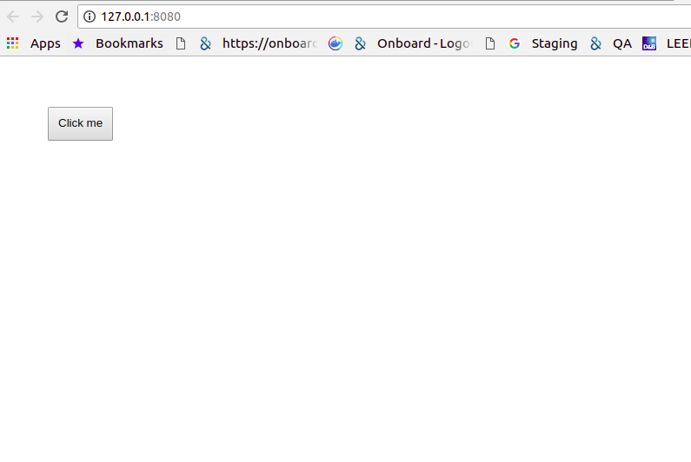

Complete this exercise using callbacks, promises, async / await.

On button click Show a circle like below.

