Day-32 [Python] Coding Challenge
Level 1: Understanding Logic
  - Even or Odd Checker "Even" if divisible by 2
  - "Odd" otherwise
  - Write a program that takes a number and prints:
Concept: if condition 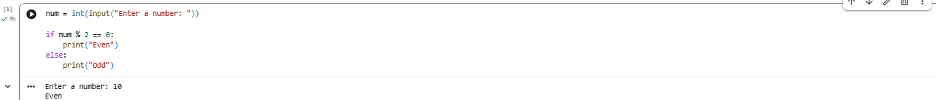
Positive, Negative or Zero "Positive"
  - "Negative"
  - "Zero"
  - Take a number and print:
Concept: multiple if-elif-else 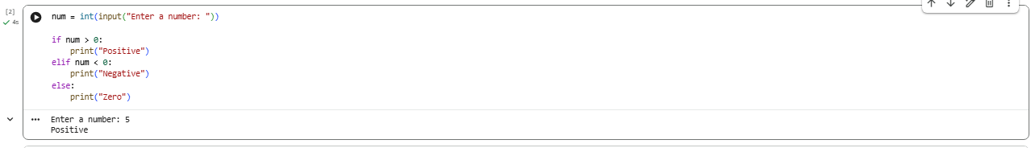

- Print Numbers from 1 to N

Take a number N and print numbers from 1 to N using a while loop. Concept: while loop basics
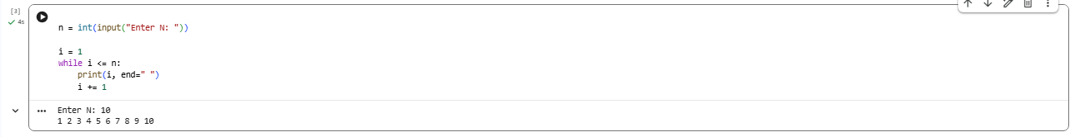

Level 2: Real Thinking

- Sum of First N Numbers

Input: N
Output: sum from 1 + 2 + ... + N
Use while loop 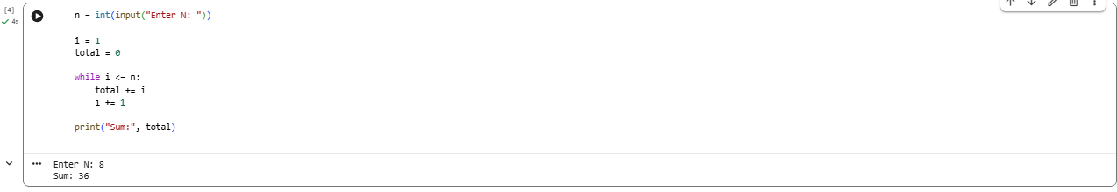
- Password Retry System
Ask user to enter password:
If correct → print "Access Granted"
  - If wrong → ask again
  - Stop after 3 attempts
  - Concept: while + if + counter 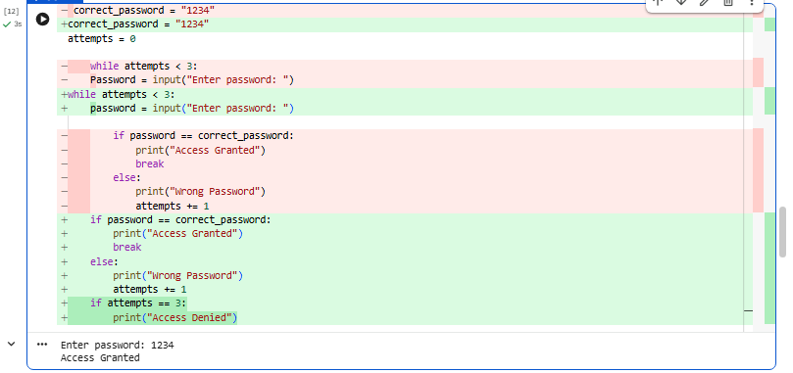

- Multiplication Table

Input: a number
Output: print its table up to 10
Example:
5 x 1 = 5 5 x 2 = 10
...
Concept: loop + formatting 