Comparison of few SKLEARN algorithms

Task 1
- Load the 'cluster_data.npy' data after importing the required libraries.
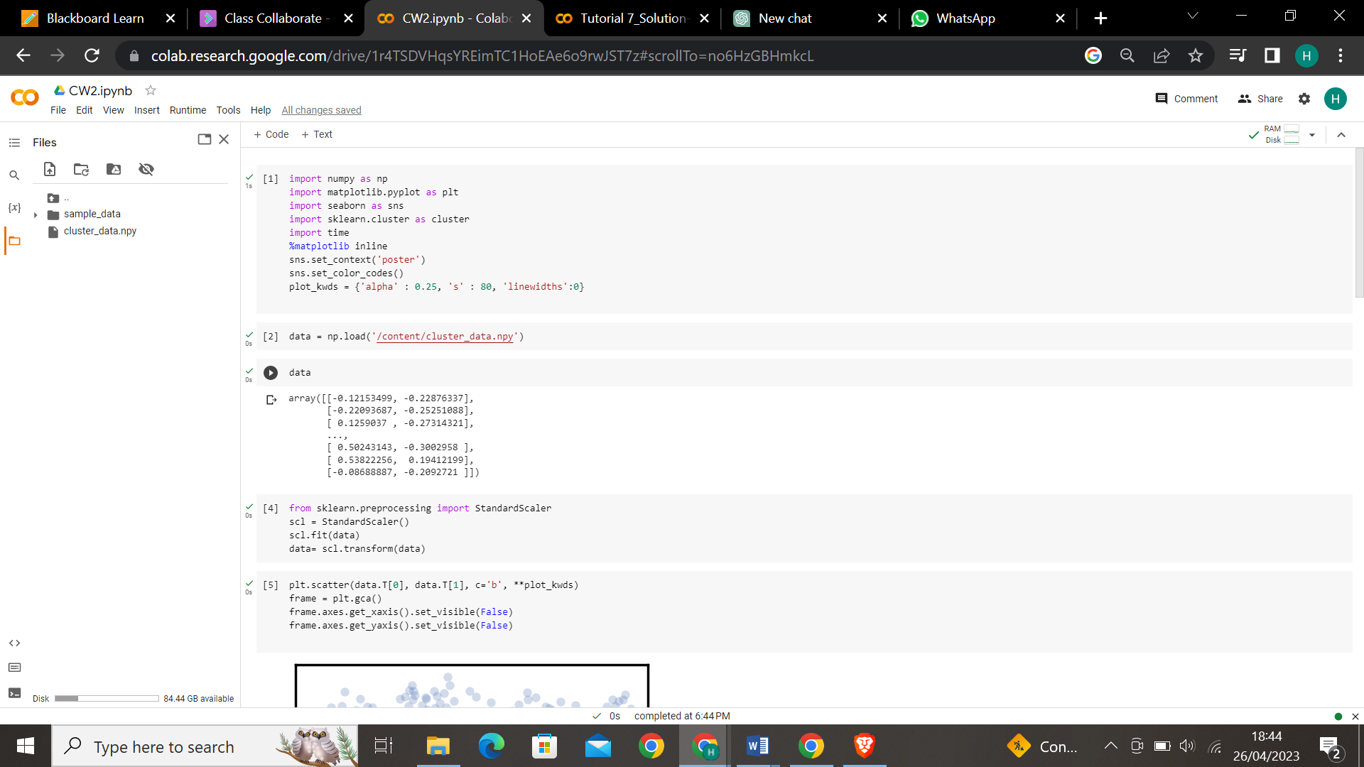
The data has two variables as you can see below.
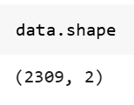

- Used scatterplot to view the data.
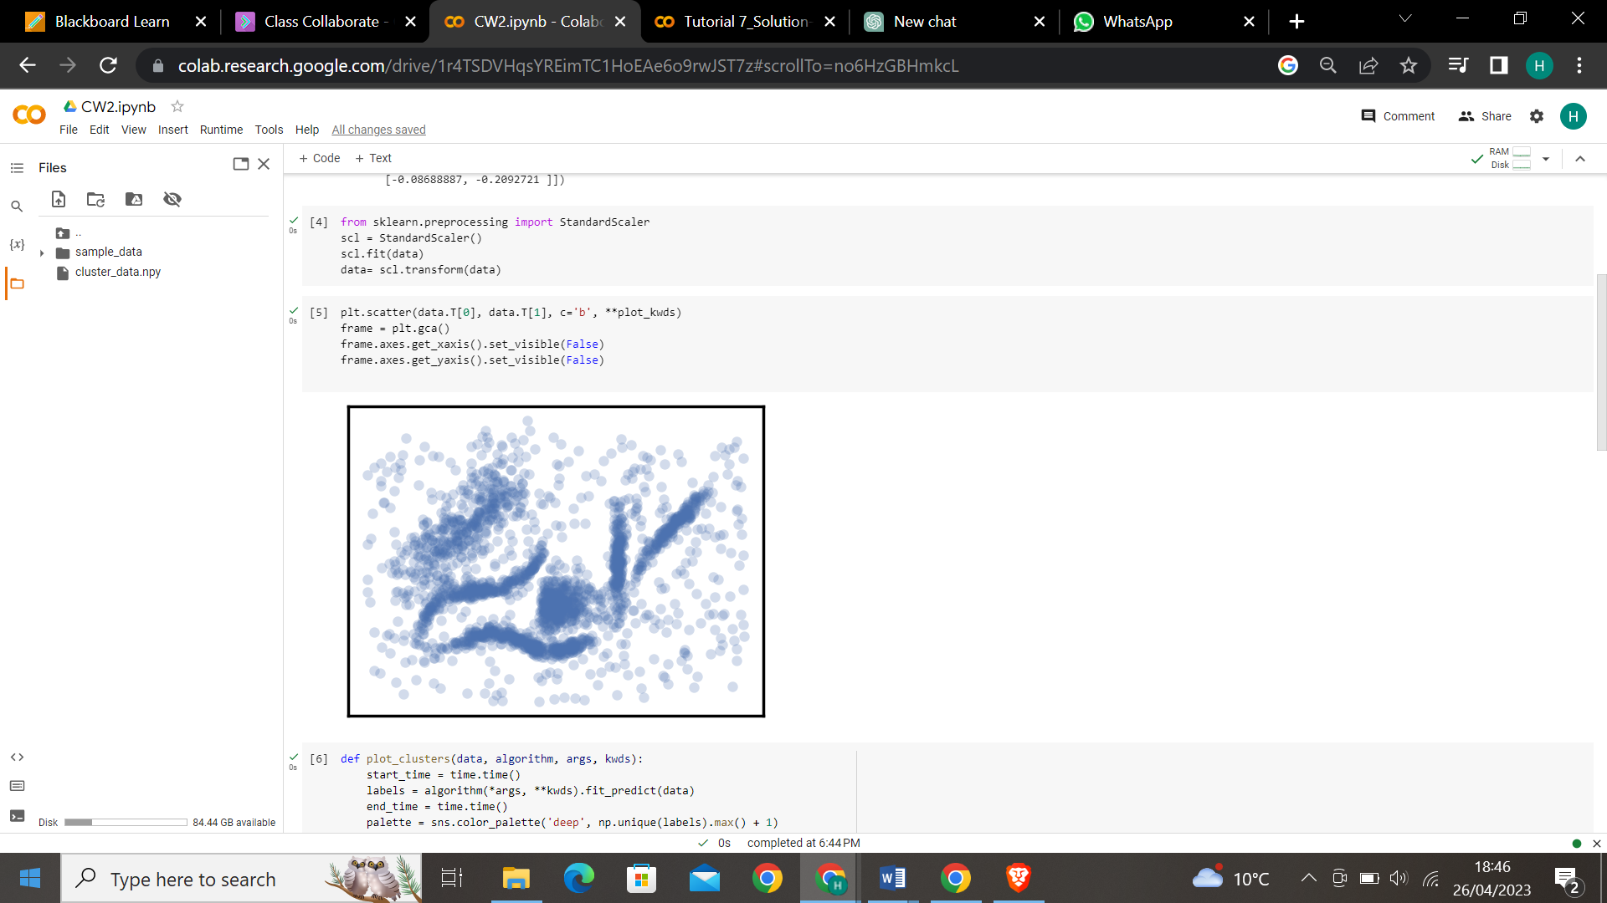

- For testing the algorithms, the utility function will call the algorithms and plot the results. Below is the table which consists intuitive parameters according to the algorithms.
No | Algorithm | Parameters
1 | K-Means | N_clusters  Init  n_init  max_iter
2 | Affinity Propagation | Preference  Damping
3 | Mean Shift | Bandwidth  Bin_seeding  Cluster_all
4 | Spectral Clustering | N_clusters  Eigen_solver  Affinity
5 | Agglomerative Clustering | N_clusters  Linkage
6 | HDBSCAN | min_cluster_size  min_samples

Task 2
Below is the data of the parameters that were adjusted and tested for all the algorithms which can be used for this type of data.
NOTE: Wherever I am using same reference number it means referenced from same website.
- K-Means
No | Parameters | Values | Justification
1 | n_clusters | 6 | Considered n_clusters as 6 for all cases since we can see 6 clusters with our eyes.
2 | init | k-means++(default)  random | To check which initialization works better, k-means++ speeds up convergence, random method initializes centroids randomly. [1]
3 | n_init | 10  30  auto | Initialization of centroids is important. Default would usually provide good results it can be increased to initialize with optimum centroids. [2]
4 | max_iter | 300(default)  600 | It directly affects runtime and scalability, therefore it is used to run faster by decreasing it and for higher accuracy by increasing the value. Here I want to increase the accuracy by taking 600. [2]

- Affinity Propagation
No | Parameters | Values | Justification
1 | preference | -50  -15  -5 | A higher preference parameter value indicates that more exemplars(clusters) will be chosen, while a lower value indicates fewer exemplars. [5]
2 | damping | 0.9  0.5 | Damping factor in the range (0.5-1.0) is the extent to which the current value is maintained relative to incoming values (weighted 1 - damping)

- Mean Shift
No | Parameters | Values | Justification
1 | bandwidth | 0.749(optimum acc. to bandwidth_estimator)  0.7  0.68  0.685 | Depending on bandwidth clusters can look quite different. If we choose a small value it will result each point having own cluster, a high value will result making one cluster. Used estimate_bandwidth [3] to get the optimum bandwidth for the data and tried values around the optimum value of bandwidth. [4]
2 | bin_seeding | True  False(default) | Setting this option to true will speed up the algorithm because fewer seeds will be initialized. [3]
3 | Cluster_all | True(default)  False | It allows us to control whether to include all data points in clustering or only those that are close to the mode. [3]

- Spectral Clustering
No | Parameters | Values | Justification
1 | n_clusters | 6 | Considered n_clusters as 6 for all cases since we can see 6 clusters with our eyes.
2 | affinity | rbf(default)  nearest_neighbors | These are two kernels that produce affinity matrix:  Rbf: using radial basis function  nearest_neighbors: computes graph of nearest neighors[9]
3 | eigen_solver | arpack(default)  lobpcg  amg | These are the three eigen value decomposition strategies.[9]

- Agglomerative Clustering
No | Parameters | Values | Justification
1 | n_clusters | 6 | Considered n_clusters as 6 for all cases since we can see 6 clusters with our eyes.
2 | linkage | Single  Complete  Average  ward | - ‘ward’ minimizes the variance of the clusters being merged.  - ‘average’ uses the average of the distances of each observation of the two sets.  - ‘complete’ or ‘maximum’ linkage uses the maximum distances between all observations of the two sets.  - ‘single’ uses the minimum of the distances between all observations of the two sets. [10]  To check which type measuring inter cluster distance is better

- HDBSCAN
No | Parameters | Values | Justification
1 | min_cluster_size | 5  15  30  90 | Start initialization with small number of minimum size of a cluster should contain and increase it to have less number of clusters.[11]
2 | min_samples | 15  1 | Larger the value, more conservative clustering – more points will be declared as noise. If we assign small value it considers less denser clustering and less data points will be declared as noise. [11]

Task 3
Following is the data of the values of parameters that I tested.
- K-Means
Considered n_clusters as 6 for all cases since we can see 6 clusters with our eyes in scatter plot.
Cases | Parameters | Values
1 | n_init | 10
2 | n_init | 10
 | init | random
3 | n_init | auto
4 | n_init | Auto
 | init | random
5 | n_init | 30
6 | n_init | 30
 | init | random
7 | n_init | auto
 | Max_iter | 600
8 | n_init | random
 | init | Auto
 | Max_iter | 600

Case1:
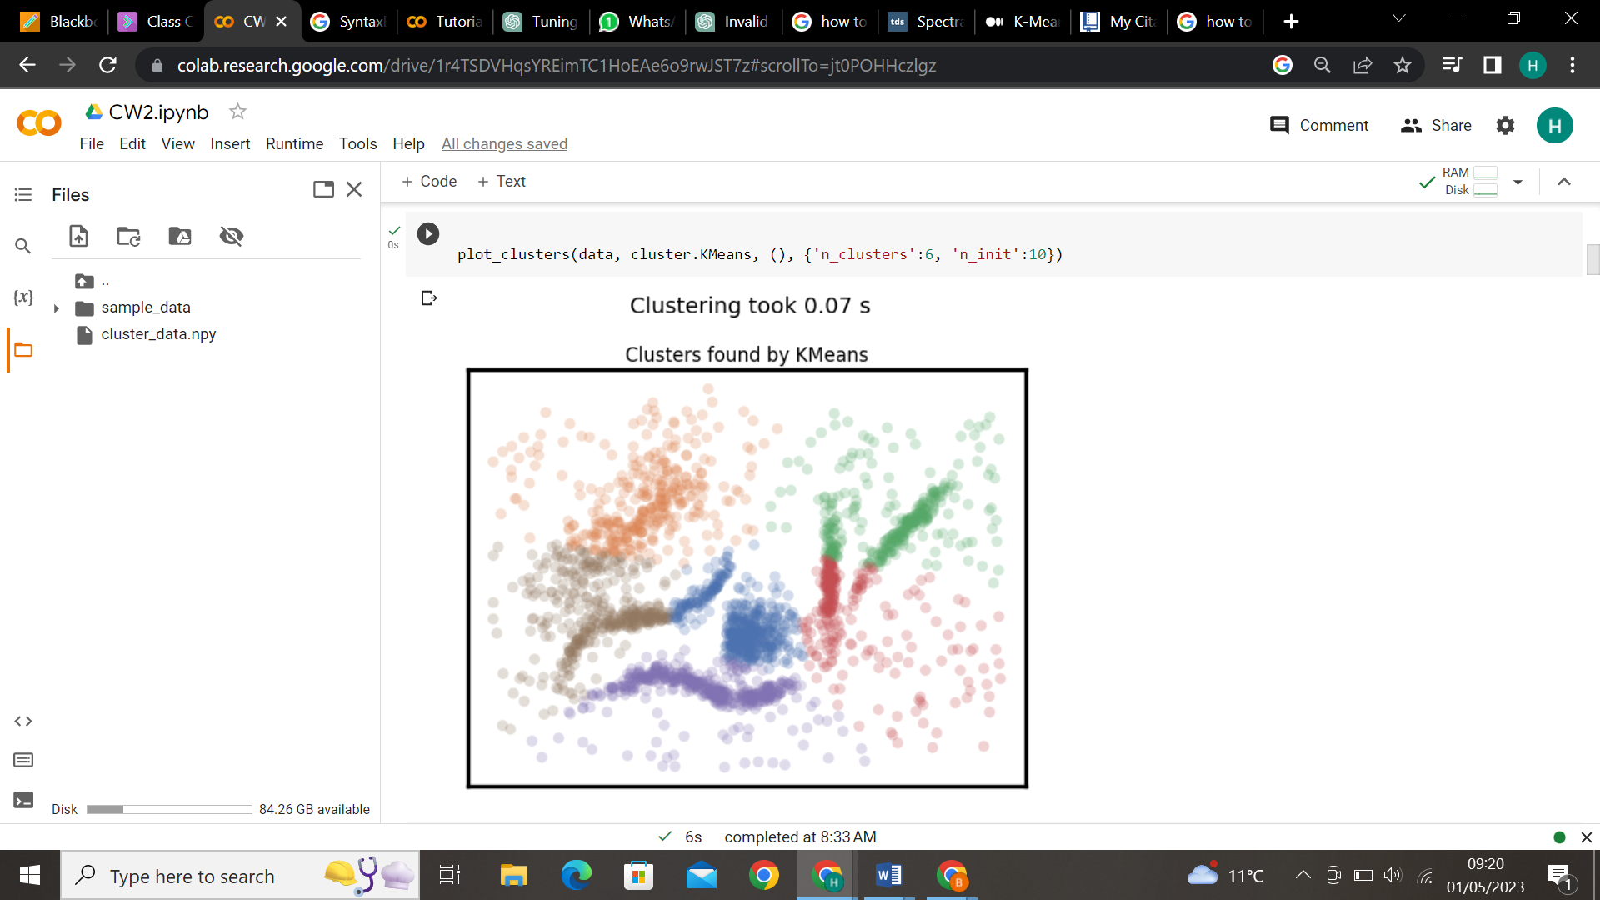
Case2:
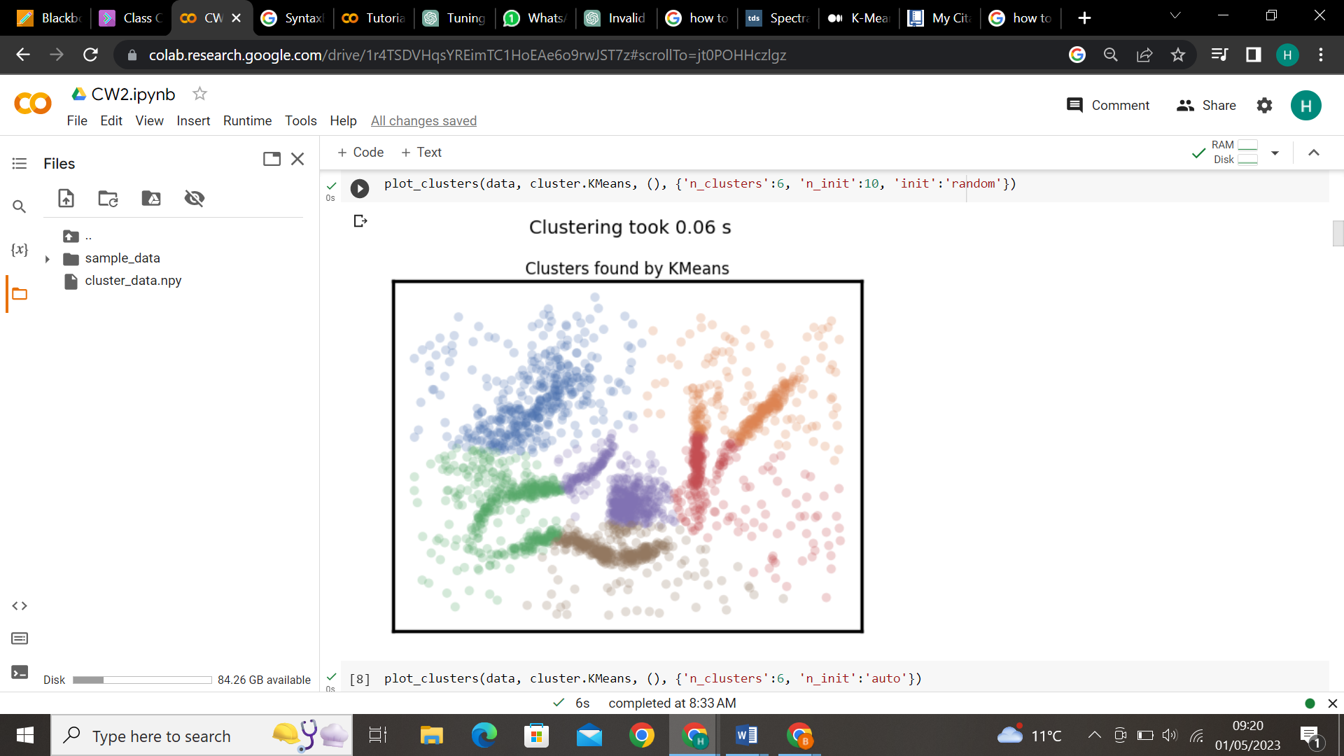
Case3:
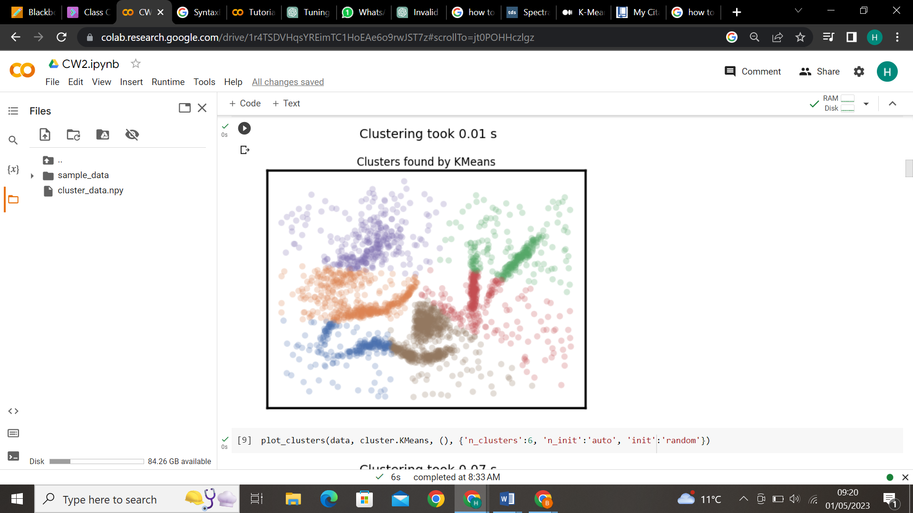
Case4:
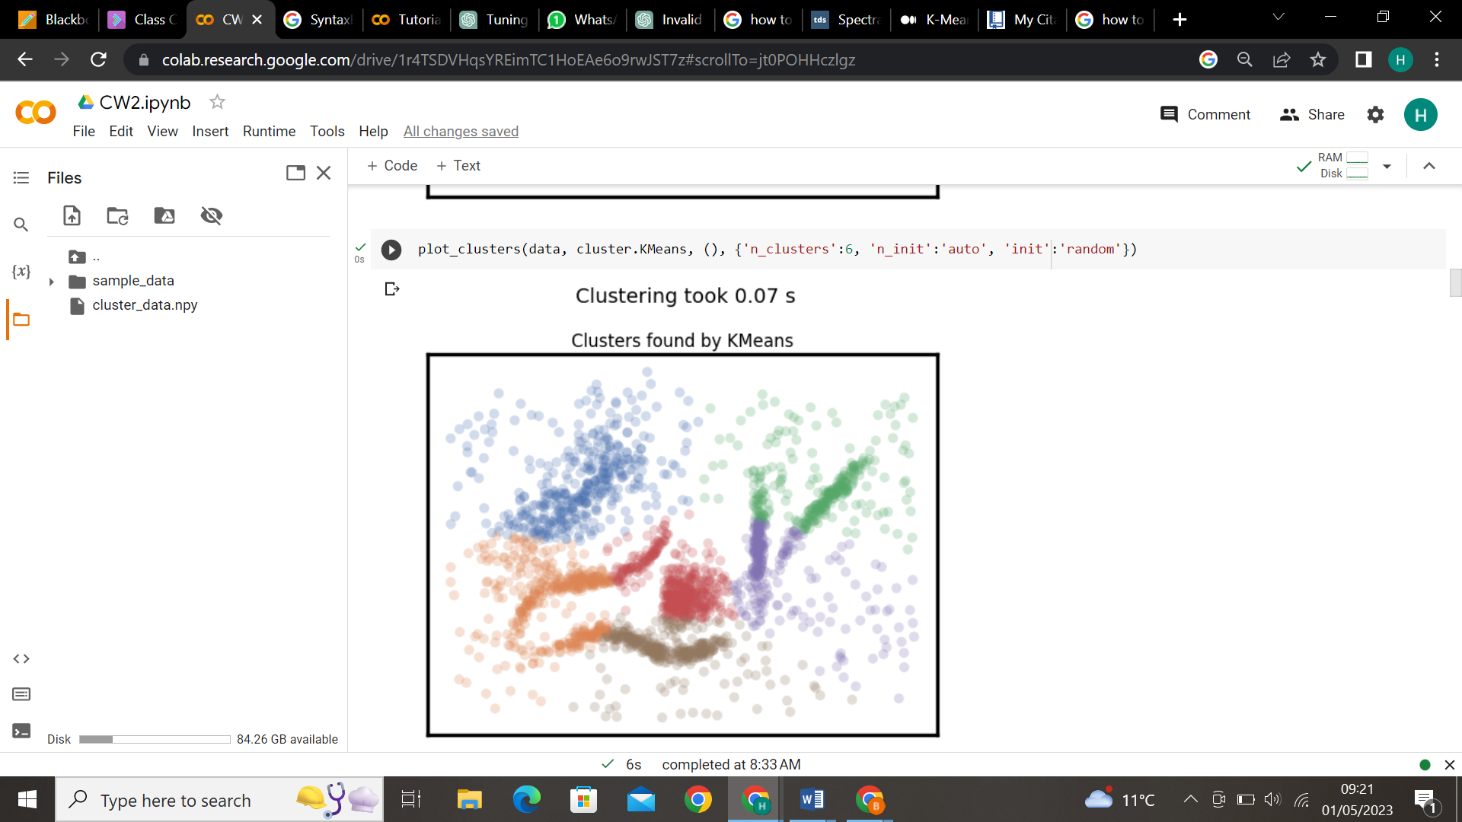
Case5:
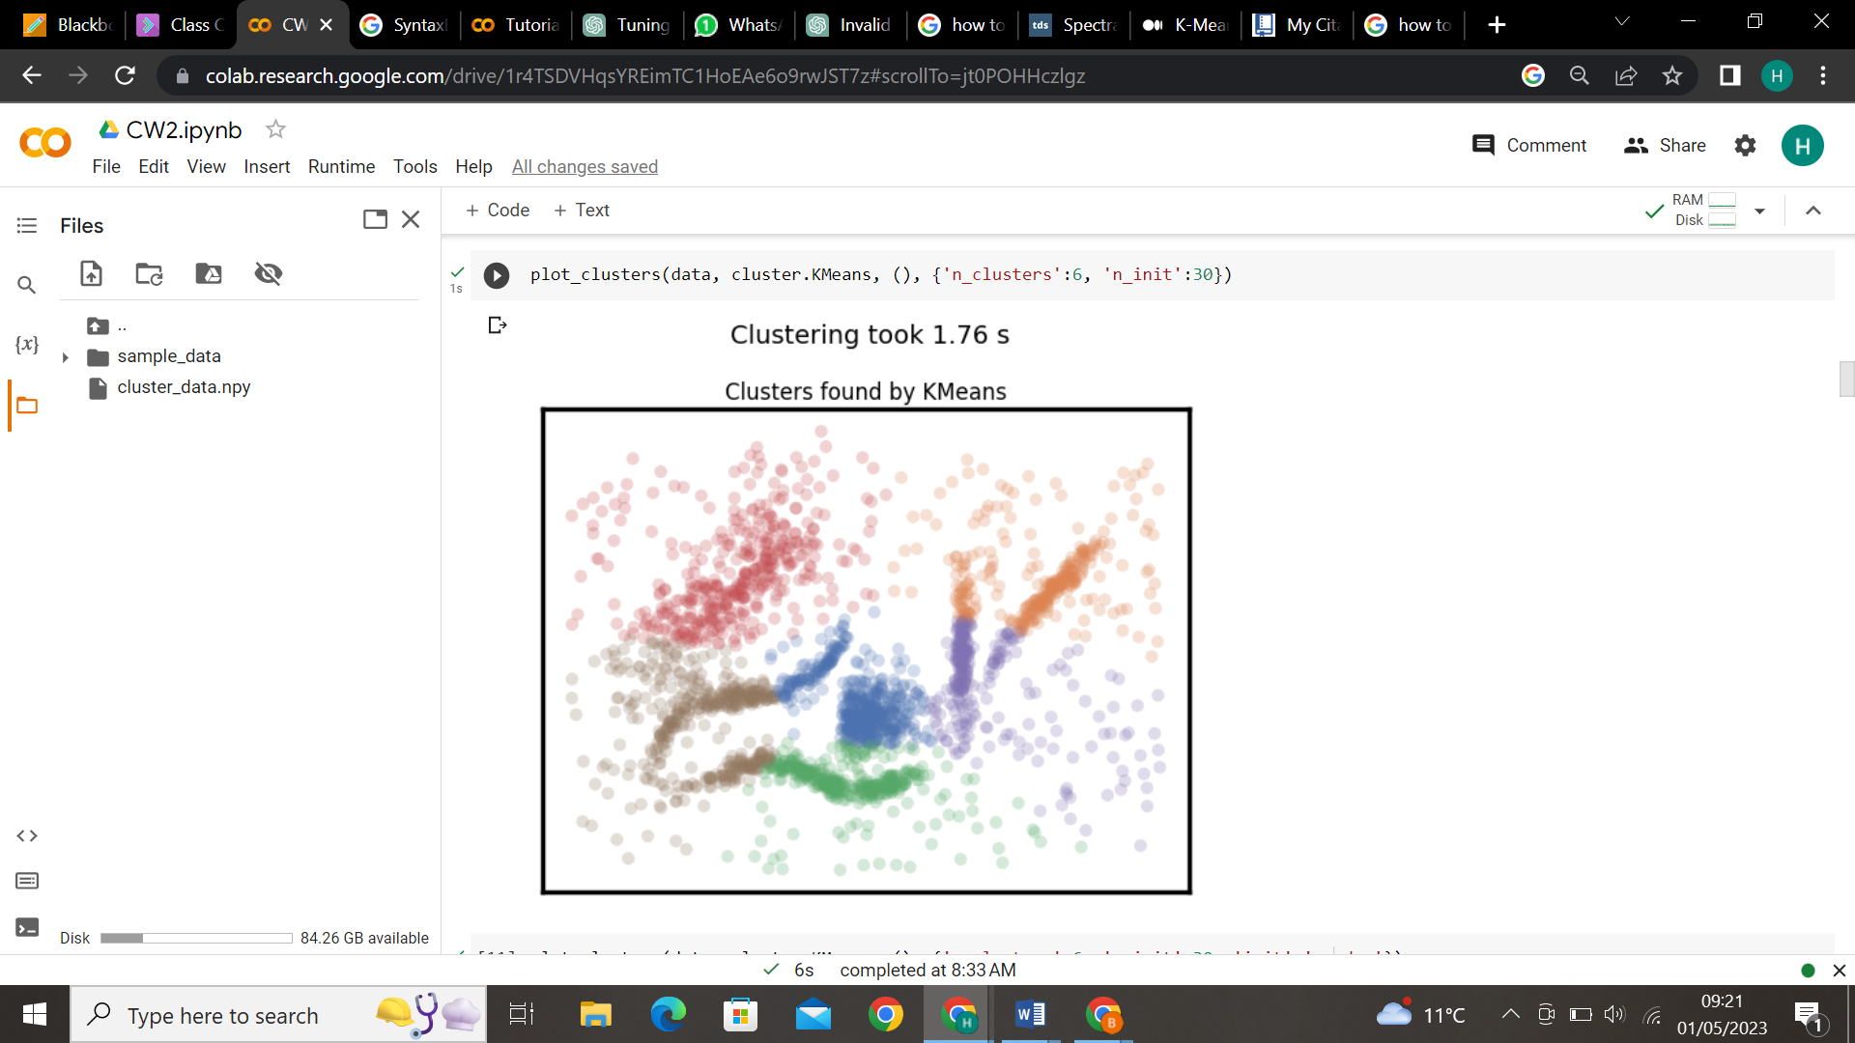
Case6:
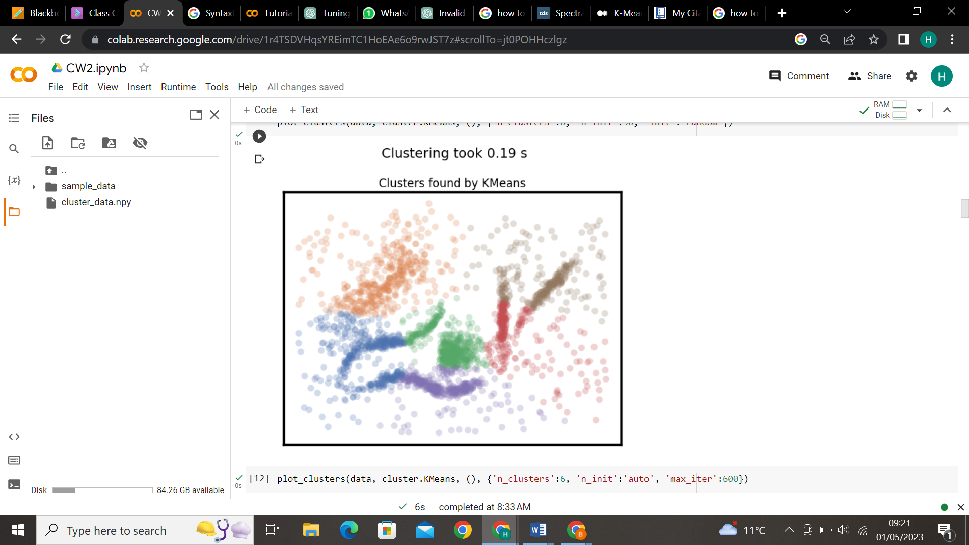
Case7:
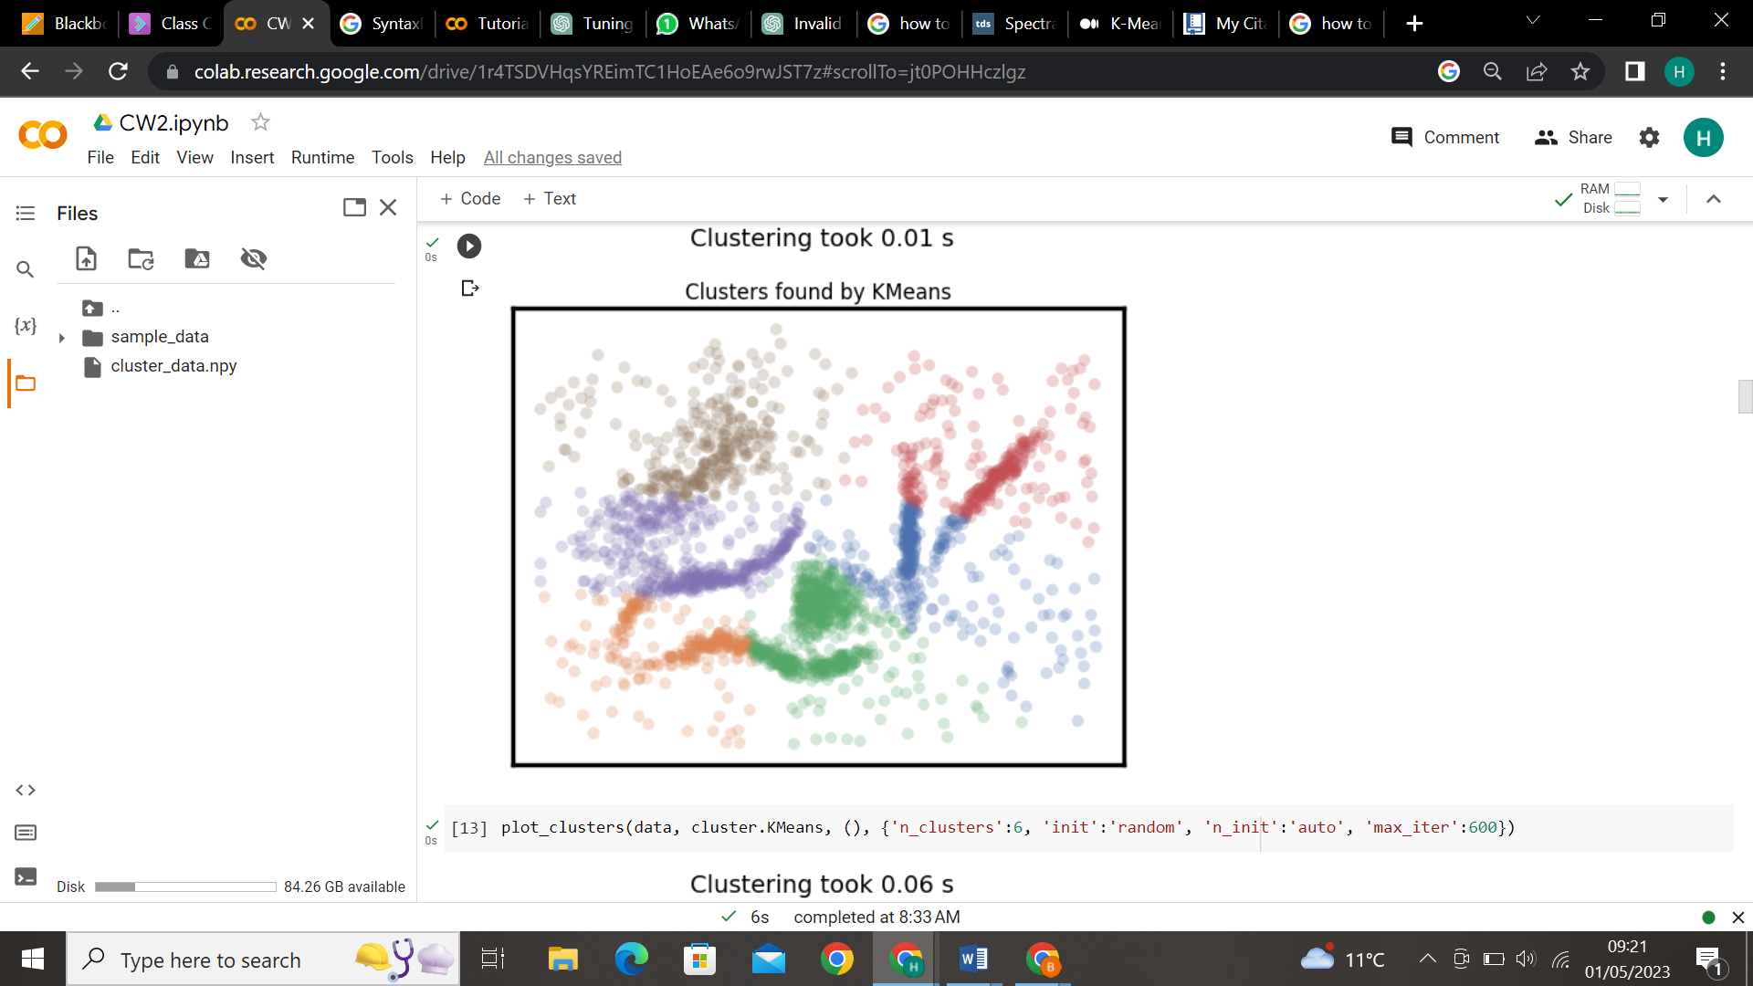
Case8:
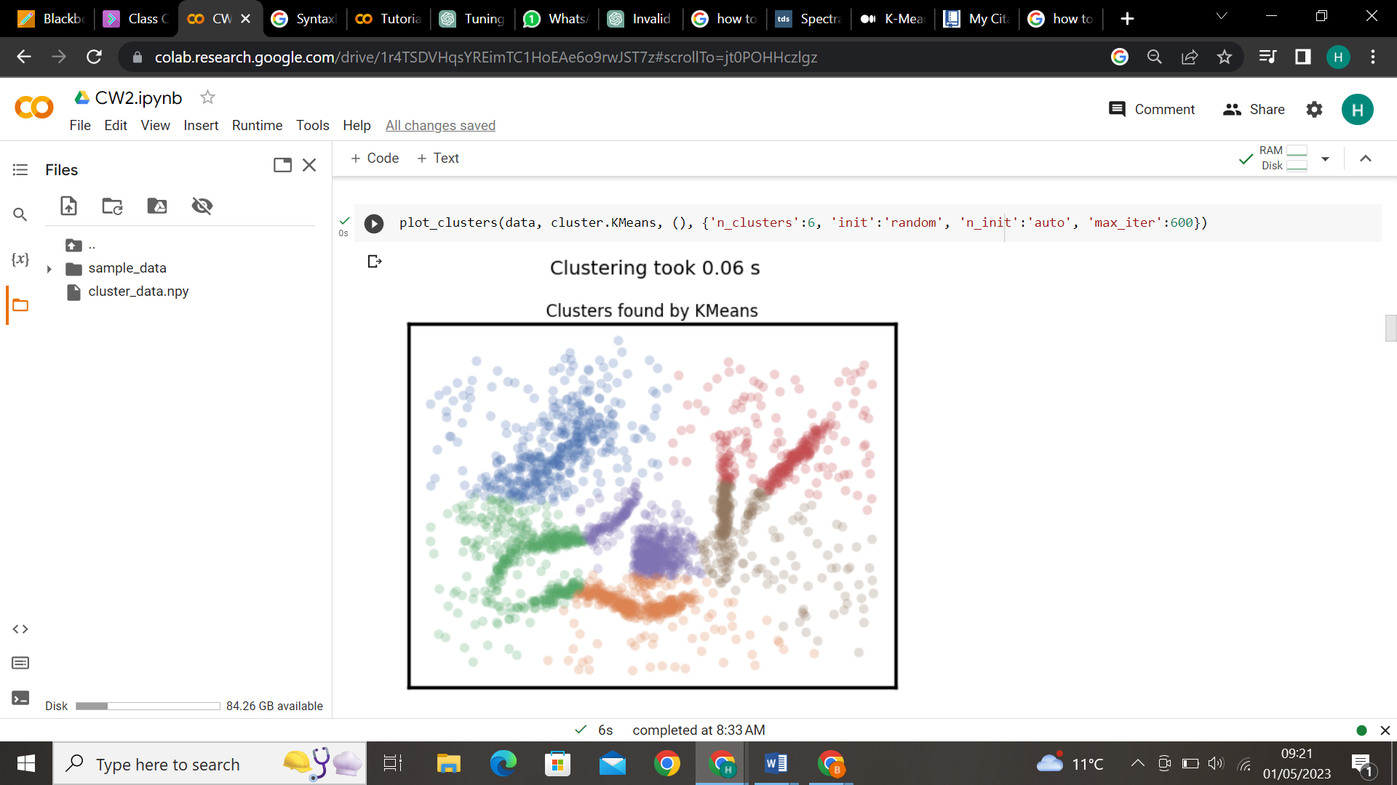

    - Affinity Propagation:
Cases | Parameters | Values
1 | preference | -30
 | damping | 0.9
2 | preference | -15
 | damping | 0.9
3 | preference | -15
 | damping | 0.5
4 | preference | -5.0
 | damping | 0.9

Case1:
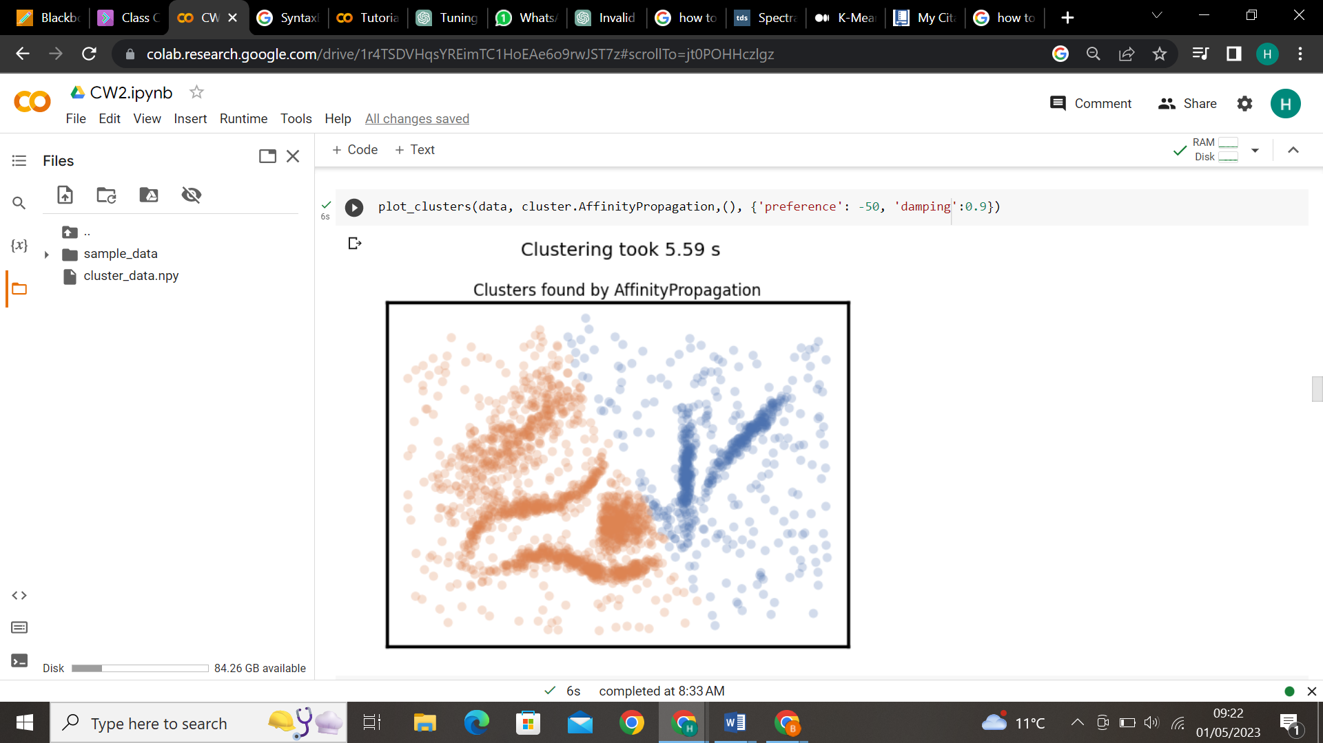
Case2:
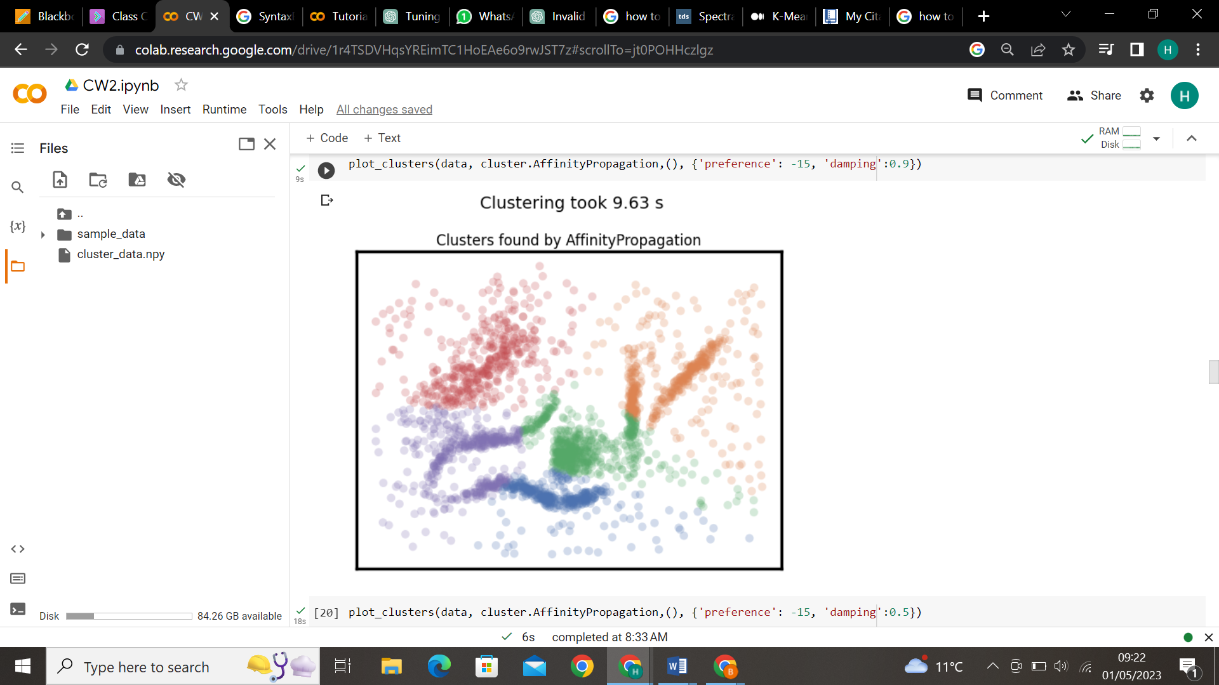
Case3:
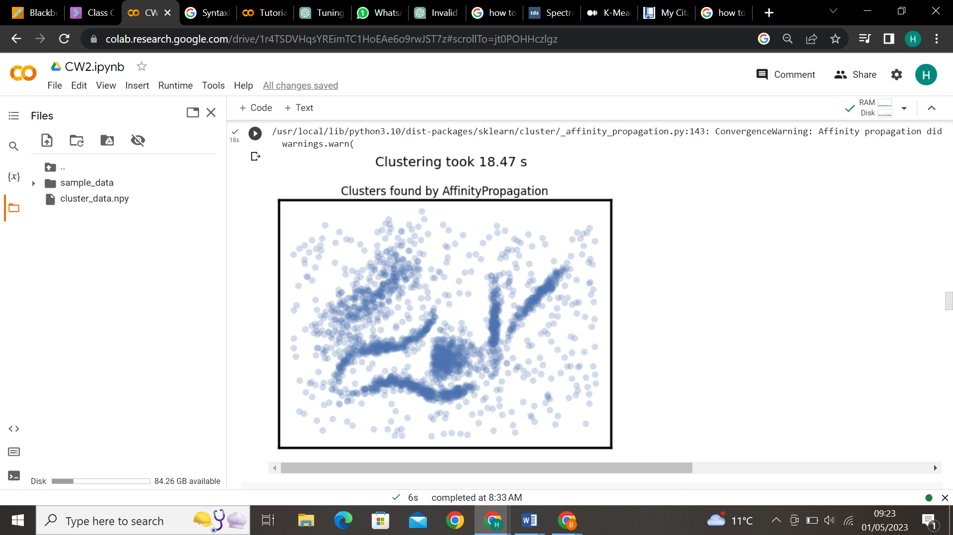
Case4:
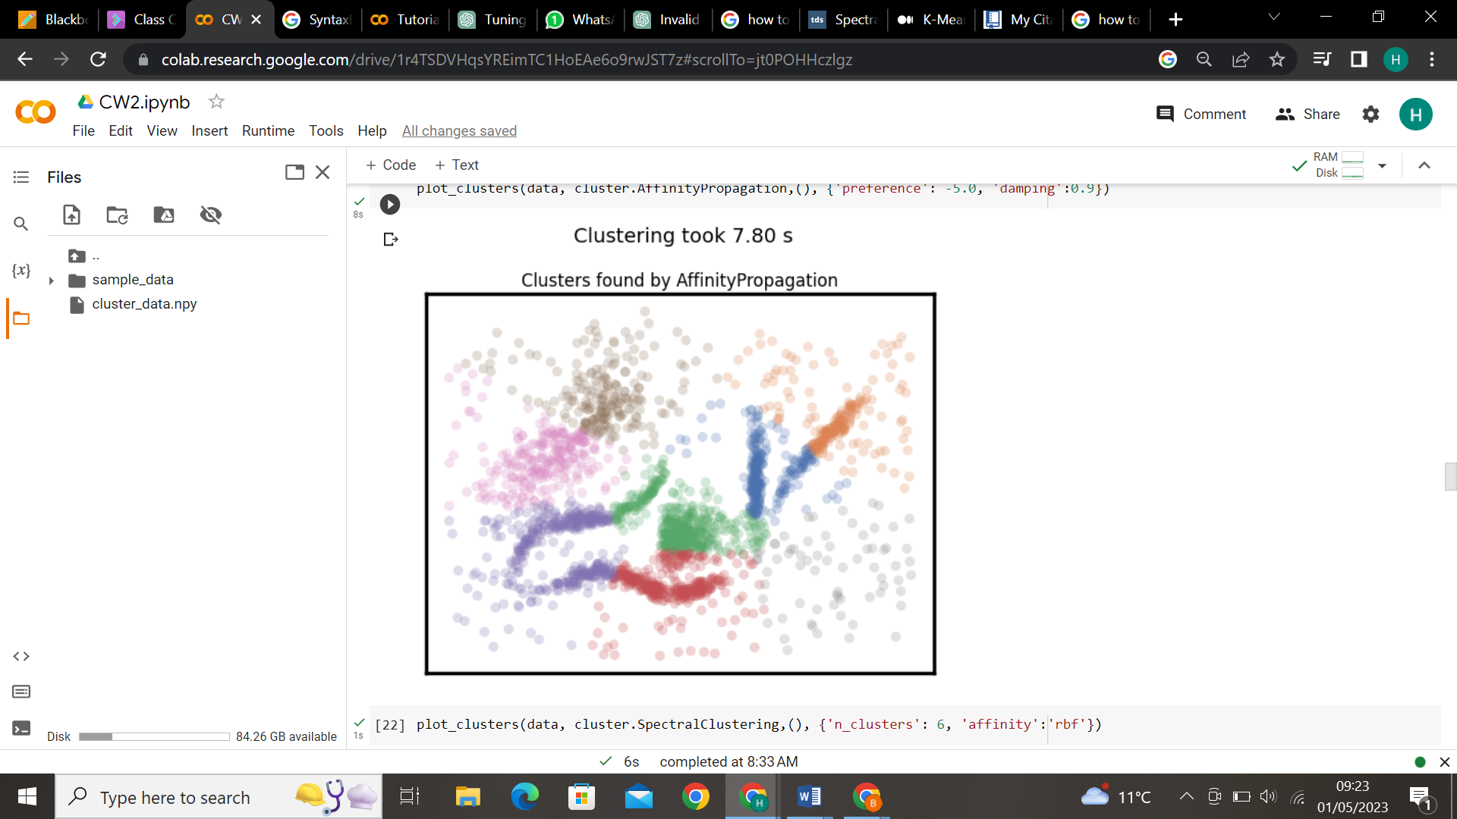

    - Mean Shift:
Cases | Parameters | Values
1 | Bandwidth | Bandwidth(best)
 | Bin_seeding | True
2 | Bandwidth | 0.1
 | Bin_seeding | True
3 | Bandwidth | 0.3
 | Bin_seeding | False
4 | Bandwidth | 0.18
 | Bin_seeding | True
 | Cluster_all | False

Case1:
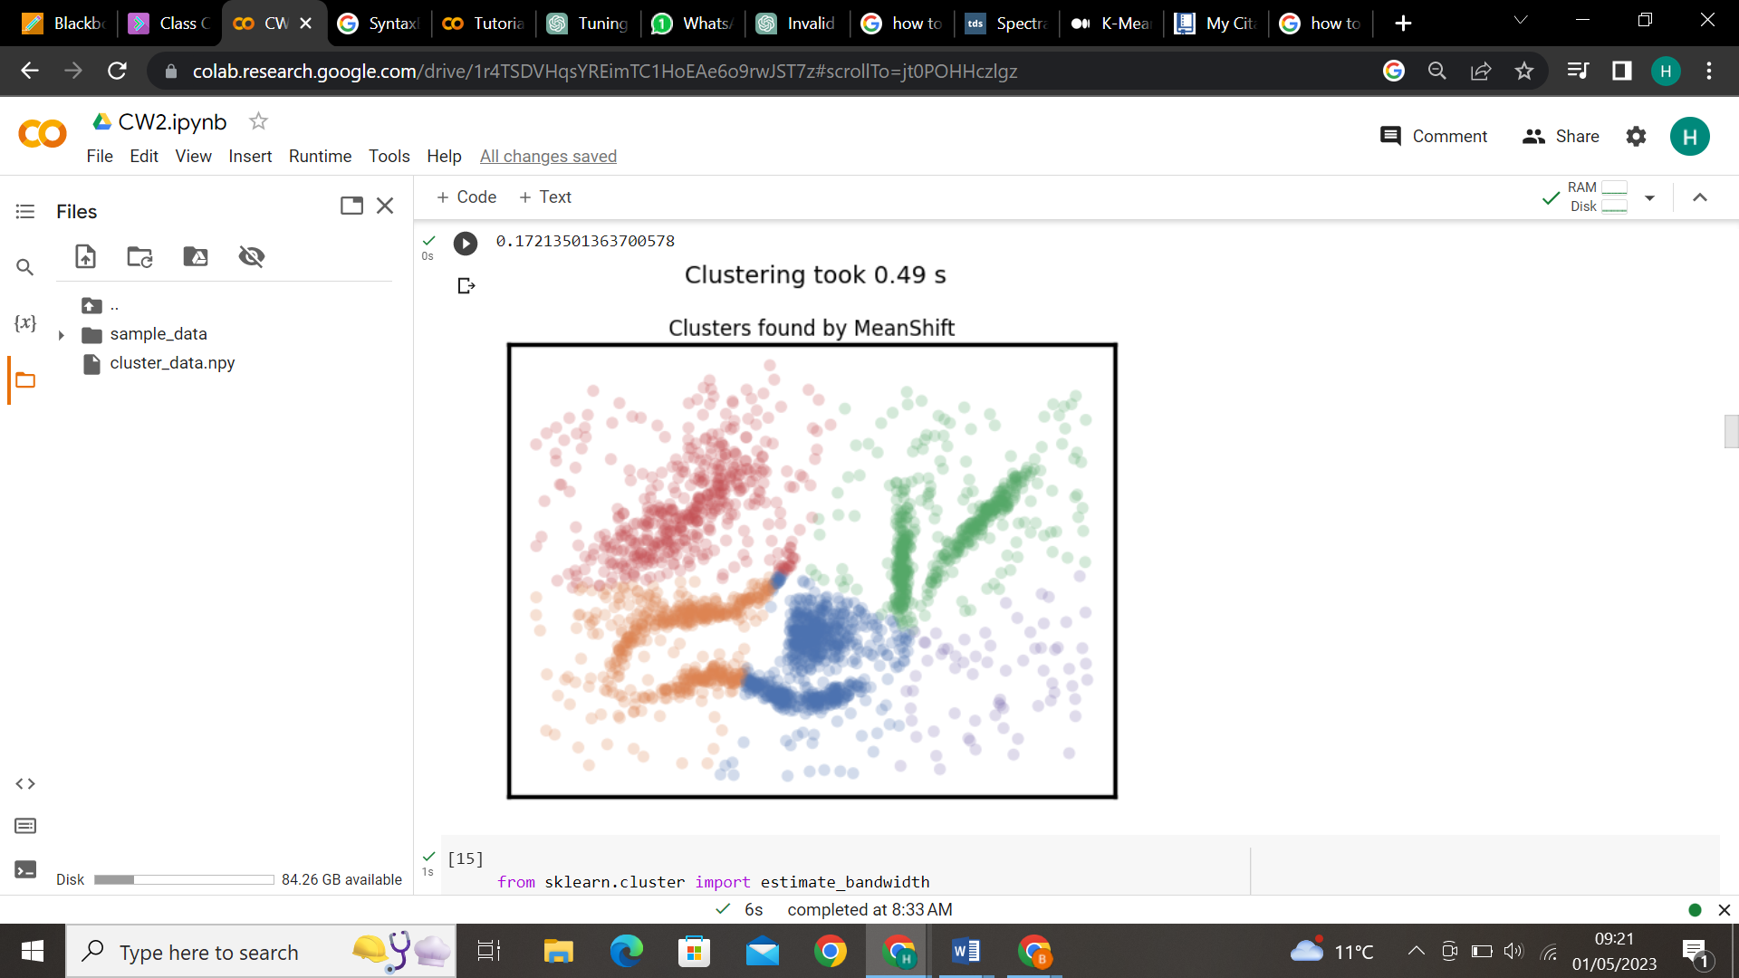
Case2:
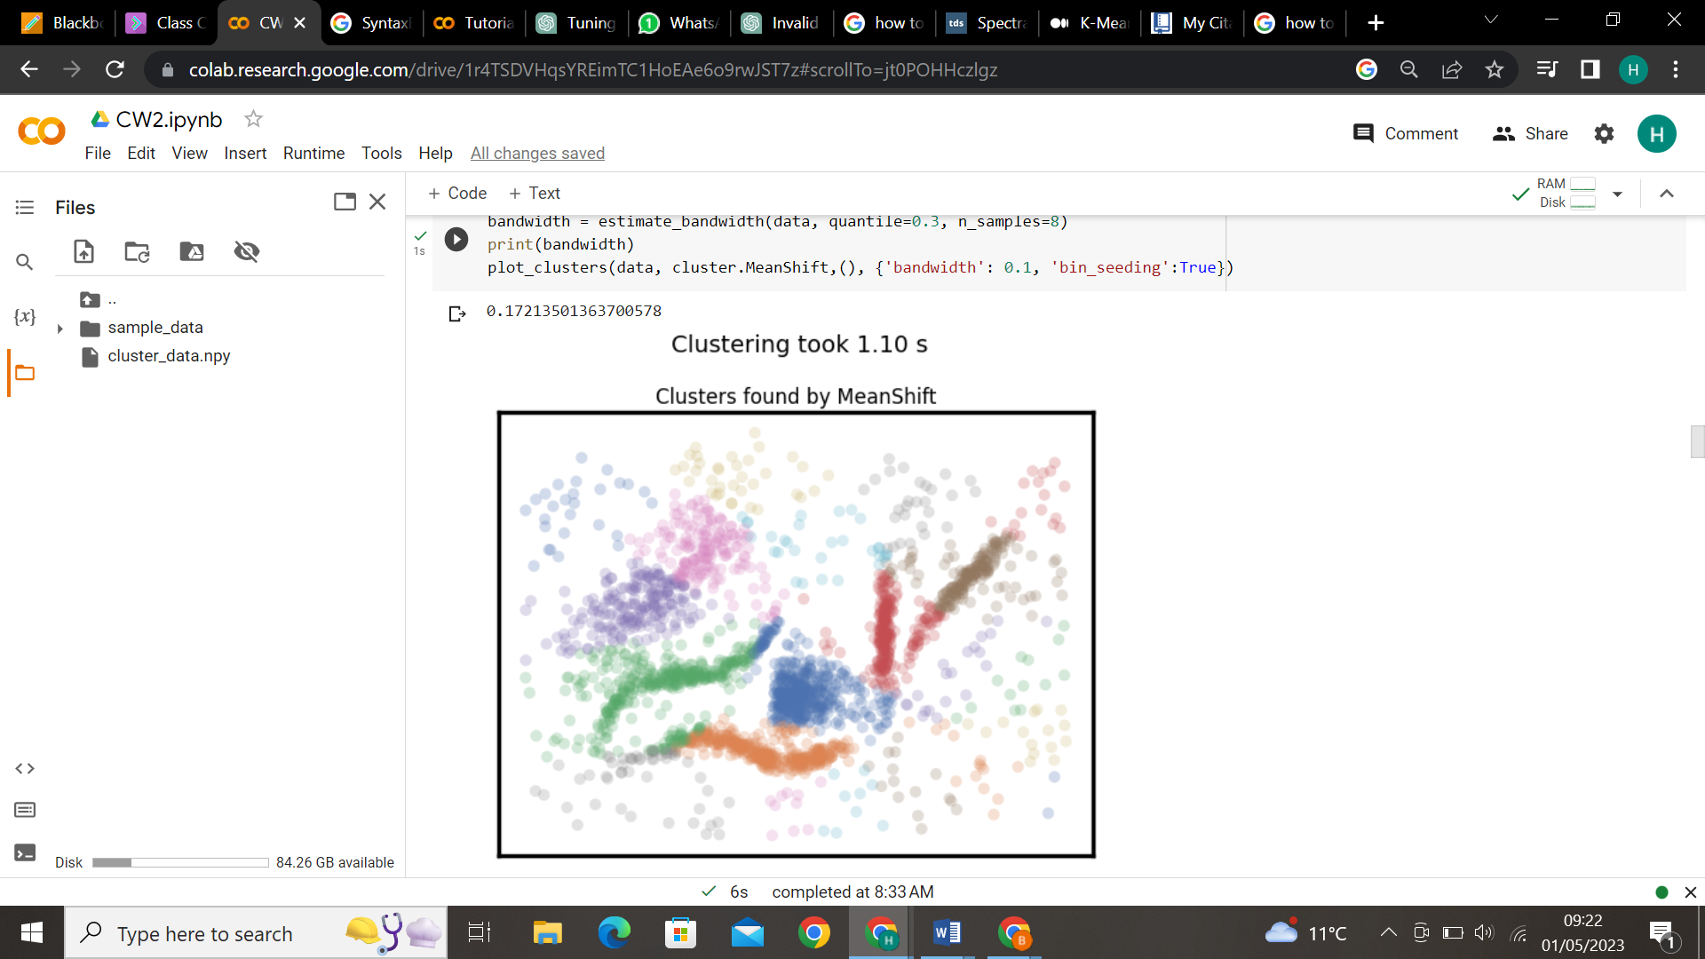
Case3:
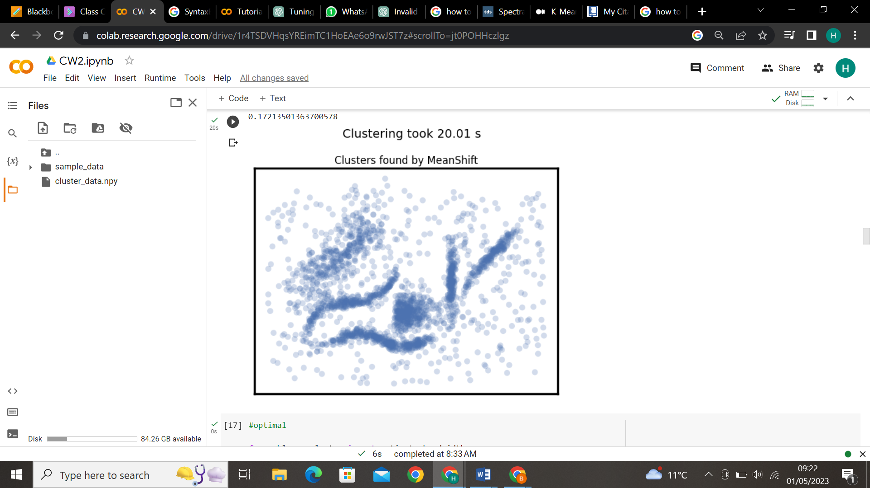
Case4:
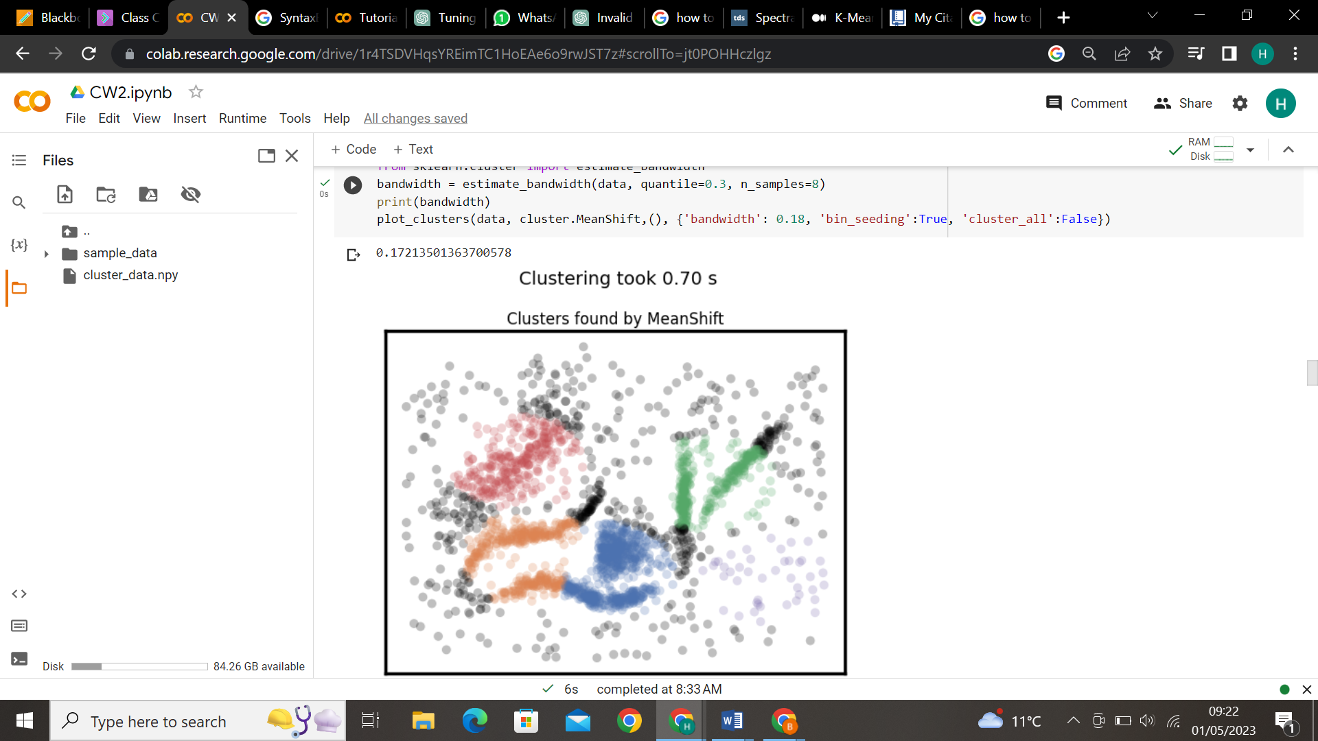

    - Spectral:
Cases | Parameters | Values
1 | N_clusters | 6
 | affinity | Rbf
2 | N_clusters | 6
 | Eigen_solver | Lobpcg
 | affinity | Rbf
3 | N_clusters | 6
 | Eigen_solver | Amg
 | affinity | Rbf
4 | N_clusters | 6
 | Eigen_solver | Arpack
 | affinity | Nearest_neighbors
5 | N_clusters | 6
 | Eigen_solver | Lobpcg
 | affinity | Nearest_neighbors
6 | N_clusters | 6
 | Eigen_solver | Amg
 | affinity | Nearest_neighbors

Case1:
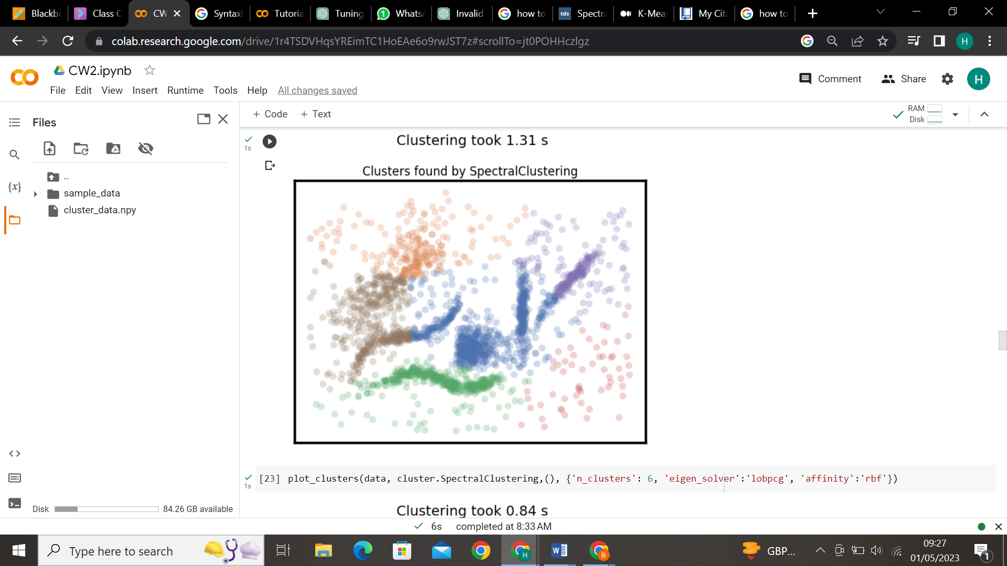
Case2:
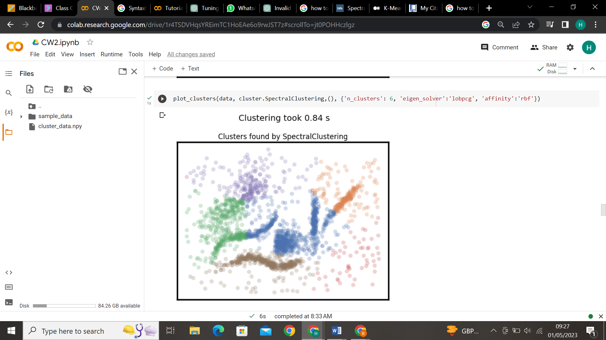
Case3:
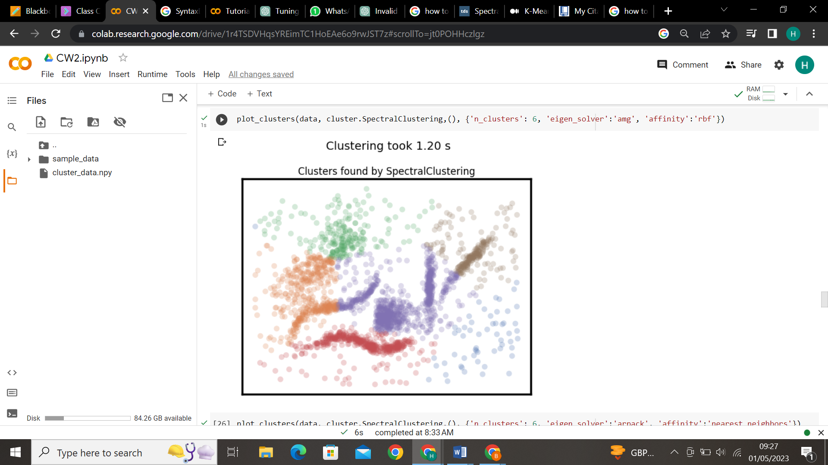
Case4:
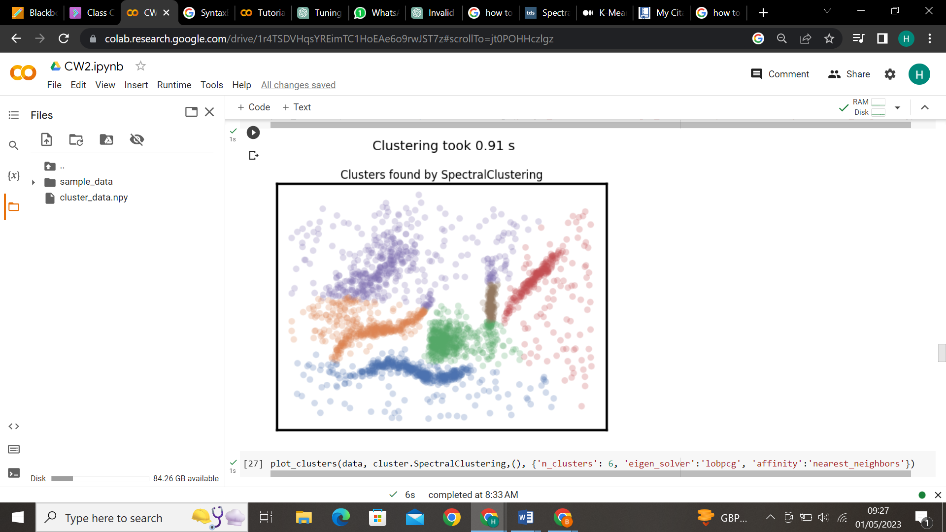
Case5:
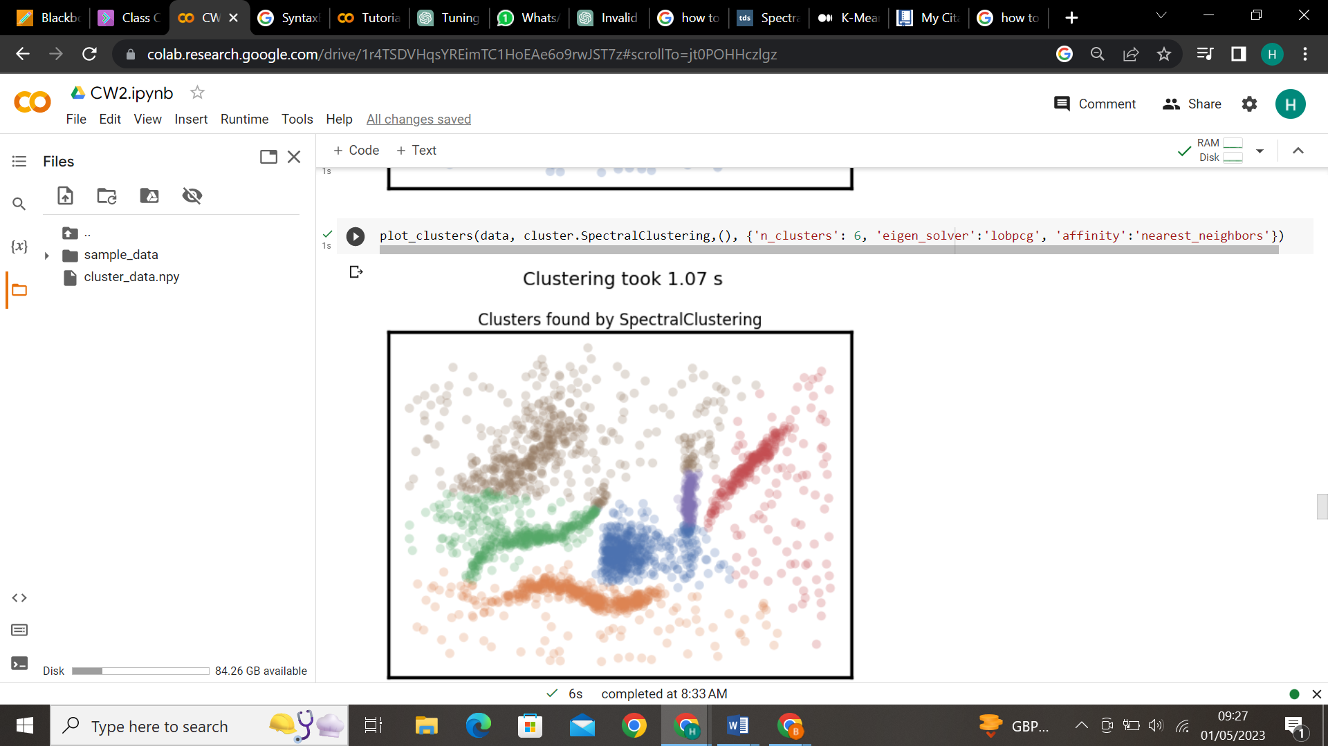
Case6:
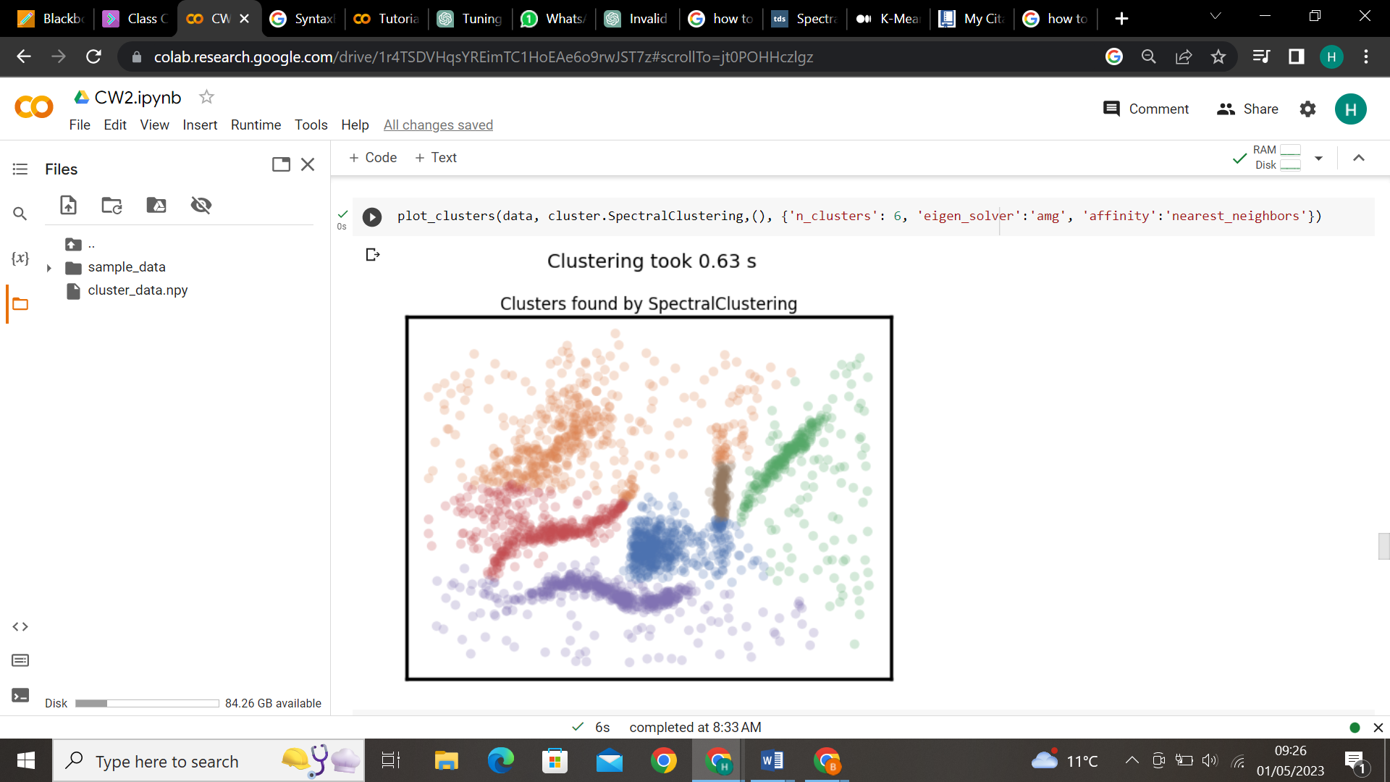

    - Agglomerative:
Cases | Parameters | Values
1 | N_clusters | 6
 | linkage | single
2 | N_clusters | 6
 | linkage | complete
3 | N_clusters | 6
 | linkage | average
4 | N_clusters | 6
 | linkage | ward

Case1:
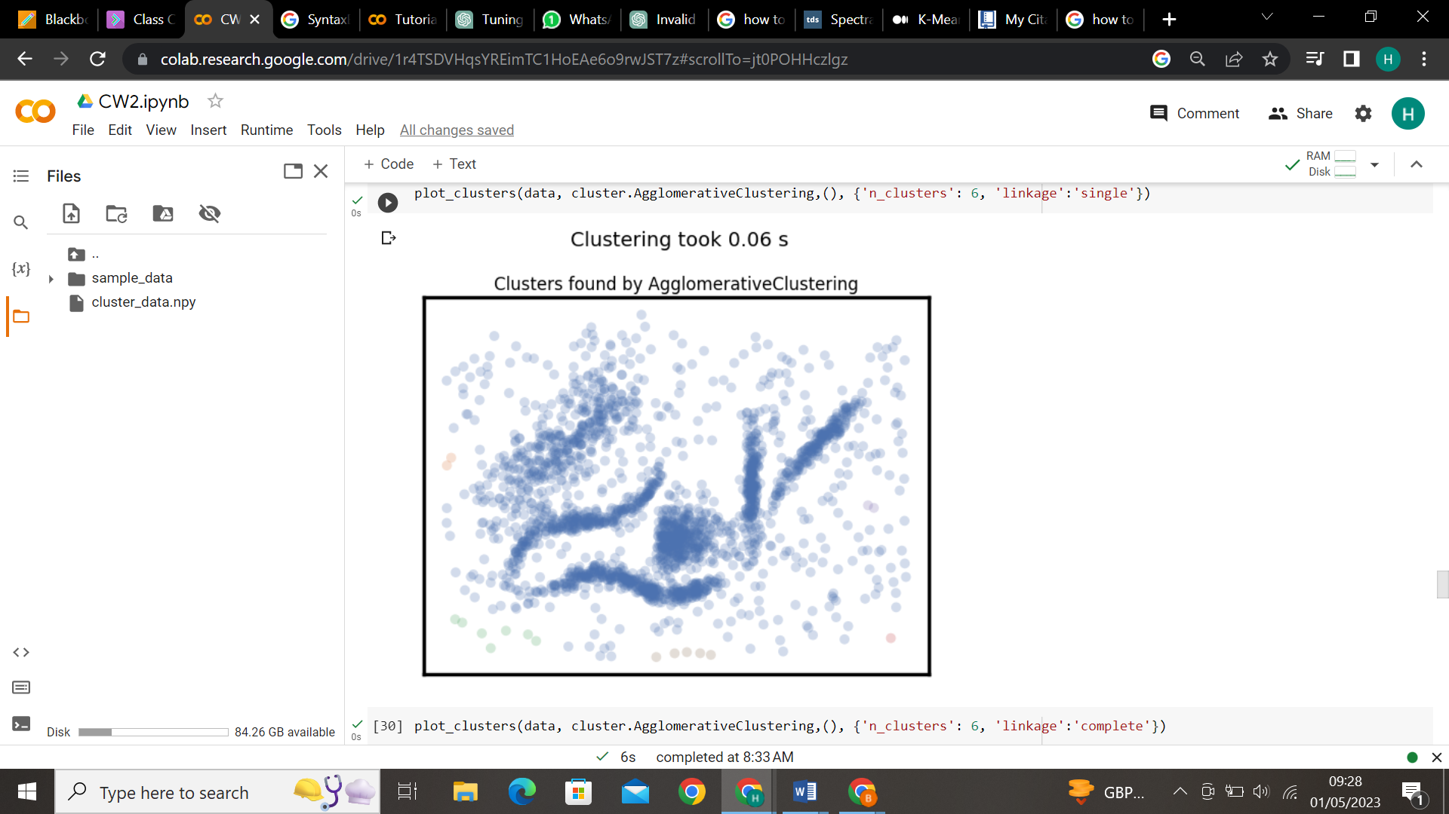
Case2:
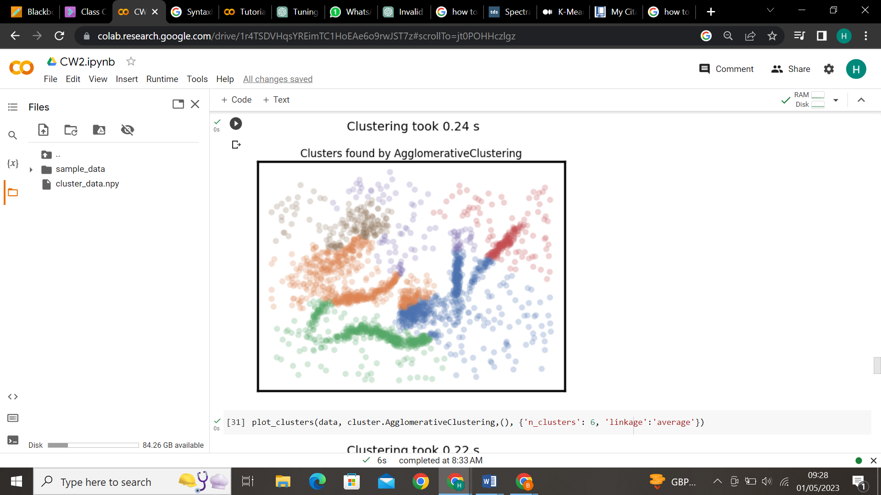
Case3:
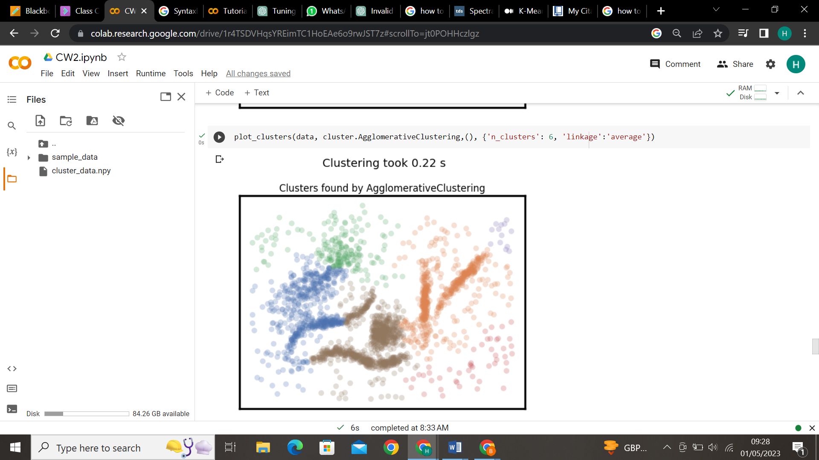
Case4:
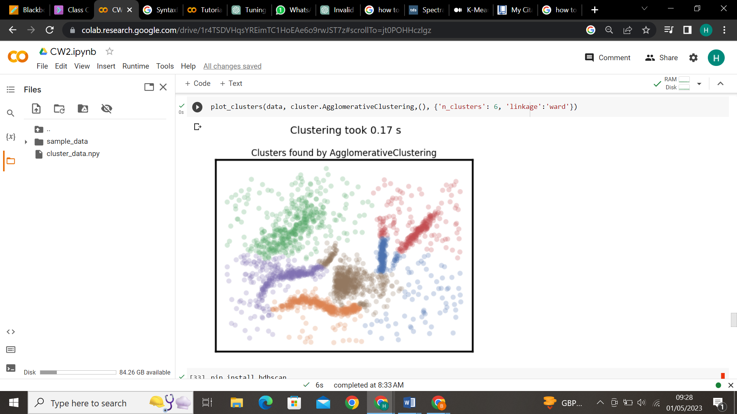
    - HDBSCAN:
Cases | Parameters | Values
1 | min_cluster_size | 5
2 | min_cluster_size | 15
3 | min_cluster_size | 30
4 | min_cluster_size | 90
5 | min_cluster_size | 90
 | min_samples | 15
5 | min_cluster_size | 90
 | min_samples | 1
Case1:
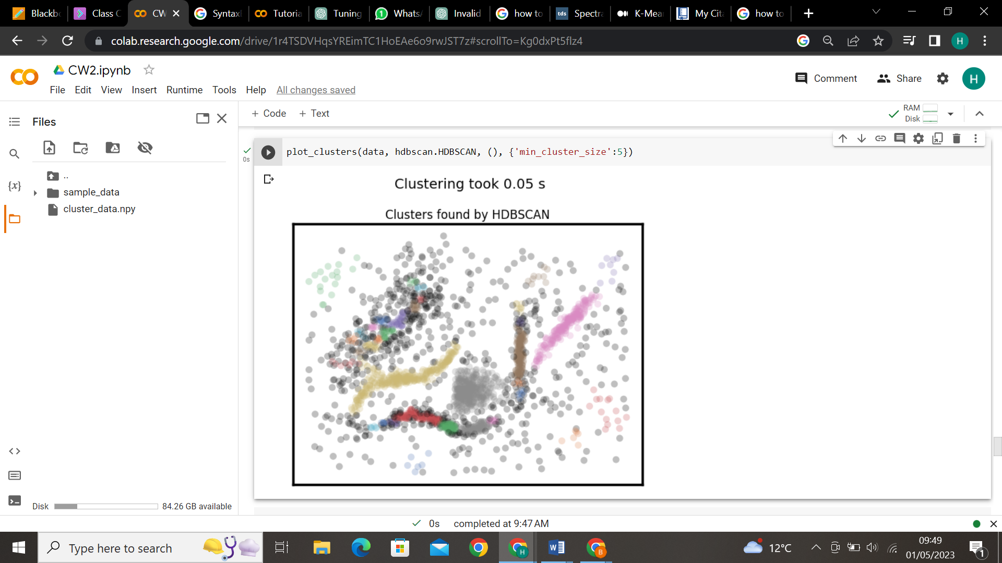
Case2:
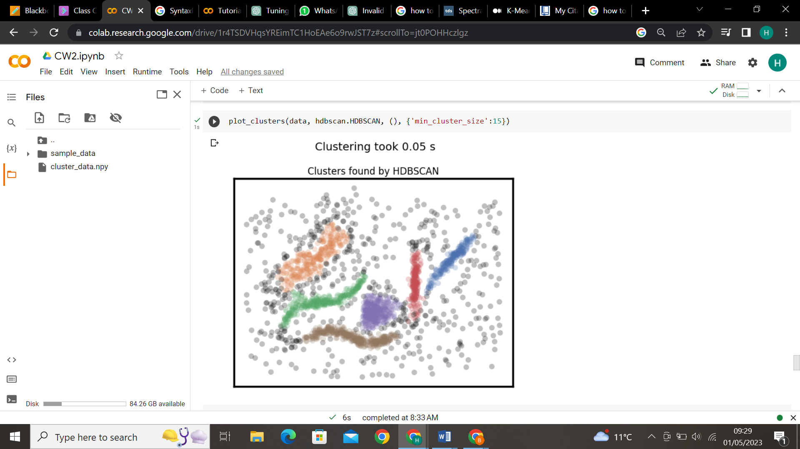
Case3:
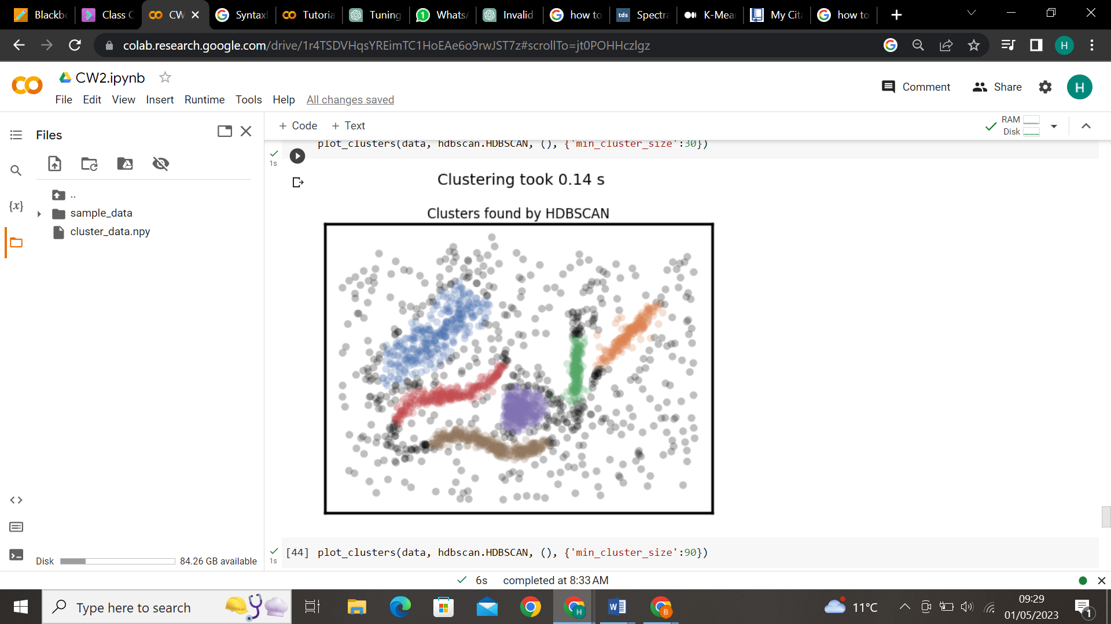
Case4:
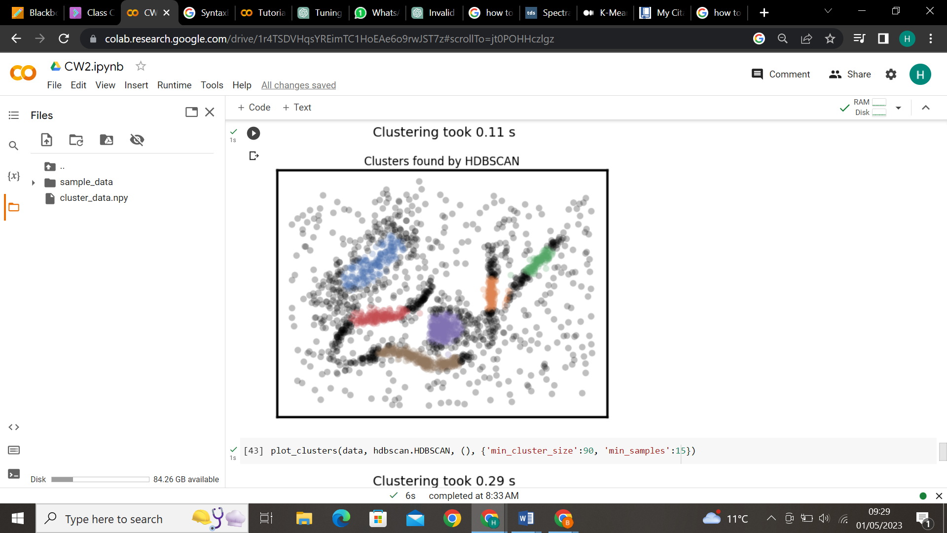
Case5:
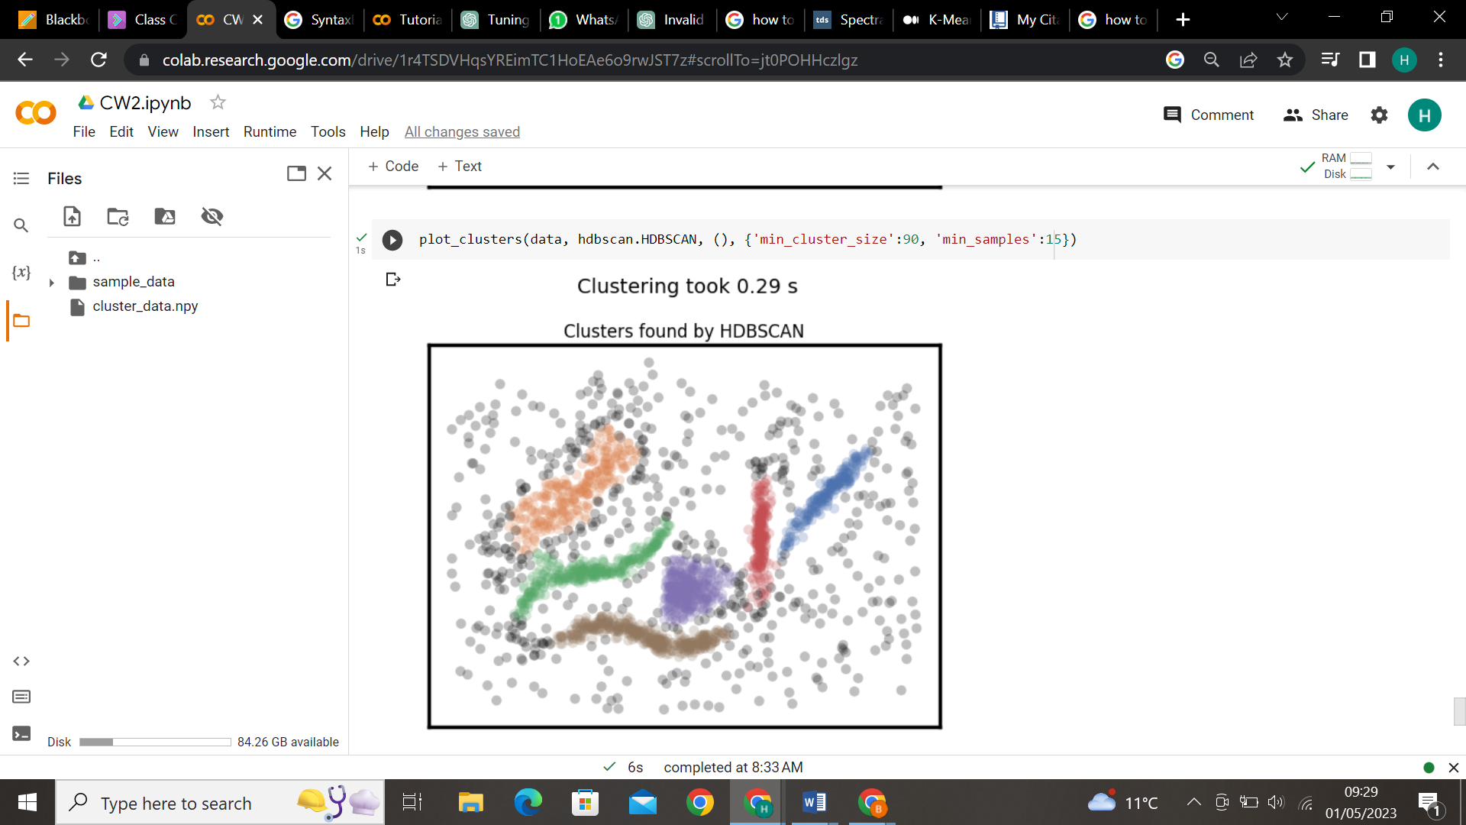
Case6:
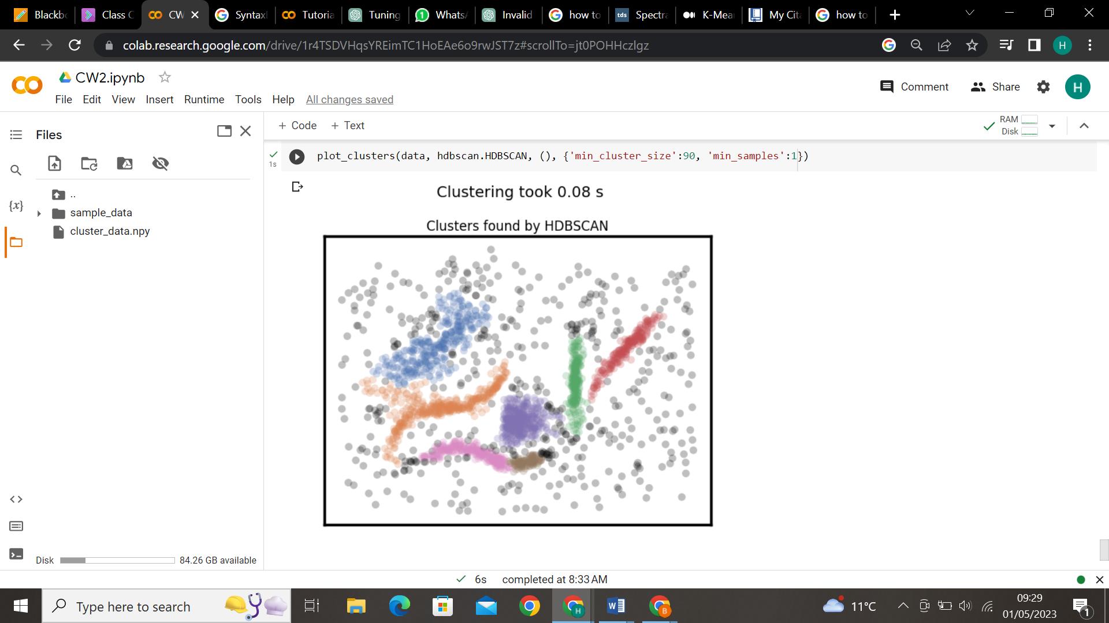

Task 4
Some ground rules of what we need a good EDA clustering algorithm to do, then we can set about seeing how the algorithms available stack up.
    - Don’t be wrong!: If you are doing EDA you are trying to learn and gain intuitions about your data. In that case it is far better to get no result at all than a result that is wrong. Bad results lead to false intuitions which in turn send you down completely the wrong path. Not only do you not understand your data, you misunderstand your data.
    - Intuitive Parameters: All clustering algorithms have parameters; you need some knobs to adjust things. The question is: how do you pick settings for those parameters? If you know little about your data it can be hard to determine what value or setting a parameter should have. This means parameters need to be intuitive enough that you can hopefully set them without having to know a lot about your data.
    - Stable Clusters: If you run the algorithm twice with a different random initialization, you should expect to get roughly the same clusters back. If you vary the clustering algorithm parameters you want the clustering to change in a somewhat stable predictable fashion.
    - Performance: Data sets are only getting bigger. Ultimately you need a clustering algorithm that can scale to large data sizes.

    - With reference to the given domain:

After plotting the given data, we are able to identify 6 clusters, therefore we need to trust our eyes and make decision whether the algorithms are doing well or not.
The base is that we don’t know the locations or the indices of the clusters, we can only check whether the algorithms are able to identify clusters as in the way we are able to see.
We can see that the data has different types of clusters such as anisotropic and unequal variances.

  - K-Means:
    - From the above tests we can see that using this algorithm we did not get the same clusters as we can identify, therefore it is not doing well. Anisotropic and unequal variances are real limitations of the k-means algorithm, and assumes that the clusters are spherical I shape. [1]
    - It is a stable clustering algorithm.
    - It is computationally efficient and can scale to large datasets.

    - Affinity Propagation:
    - It has the same issues as K-means, it assumes the clusters are spherical and takes data points whether they actually belong or not.
    - It has two main intuitive parameters which are preference and damping factor.
    - It is not completely a stable clustering algorithm; it is relatively stable compared to K-means.
    - It can be computationally expensive and may not scale well to very large data sets, it might depend on the choice of similarity metric, damping factor and other parameters to achieve optimal performance.

    - Mean Shift:
    - From the tests we can see that this algorithm is not able to cluster as we are able to see them, it is not doing well identifying it, also this algorithm does not assume the number of clusters or any other structure of the data and identifies number of clusters itself, therefore we need to adjust few parameters to get the right number of clusters.
    - It has a main intuitive parameter that is bandwidth which determines the number of clusters automatically.
    - It is a stable algorithm which produces similar results for different random initializations.
    - It is computationally expensive, especially for large datasets as a mean-shift iteration initialized at every data point and then to have each mode define one cluster, with all the points that converged to the same mode belonging to the same cluster. [6]

    - Spectral:
    - From the above tests we can that this algorithm is able to identify well than other algorithms.
    - The intuitive parameters are the number of clusters and kernel function to measure similarity.
    - It is a stable algorithm which produces similar results for different random initializations.
    - It can be scaled to large datasets by parallelization techniques.

    - Agglomerative:
    - From the tests we can see that it is not able to identify the same clusters as we are able to see.
    - The main intuitive parameters are number of clusters, linkage and metric used to calculate distances between data points.
    - In terms of stability, it is sensitive to the choice of parameters such as number of clusters and the linkage criteria for small datasets. However, for larger datasets, with approximate tuning, it can be stable and produce unvarying results.
    - It is computationally expensive as has to calculate distance between clusters. For small to medium datasets, it can be effective and efficient algorithm by appropriate parameter tuning, for larger data sets it is not scalable and also it depends on the linkage used. [7]

    - HDBSCAN:
    - It has all benefits of DBSCAN, DBSCAN could not find clusters with different variance and take the dense areas and take others as noise, this has been overcome in this algorithm, and this becomes the optimal algorithm which can identify all clusters if they are of spherical or varying densities or anisotropic.
    - It has two intuitive parameters; minimum cluster size and minimum samples to recover original clusters. [8]
    - It is stable over multiple runs with parameter choices.
    - It is used to scale to large datasets, also it has a condensed tree representation which reduces the memory.

- The specified (algorithm, args, kwds) values as part of the plot_clusters(data, algorithm, args, kwds) employed function.
  - K-Means:
- There is not much difference between the random and k-means++ initialization as well as using auto or default value as 10 for n_init, max_iter would be helpful to cover more feature space when we large datasets.
- But for this dataset there is not much difference, and from all of these combination, we did not get the required clustering.
  - Affinity Propagation:
- As we increase the preference we can see that the number of clusters are increasing, by changing this we can get obtain the required number of clusters – in case2 I got the required number of clusters i.e., 6.
- By changing the damping factor, we can let the algorithm to converge, in this case as 0.9.
- It is deterministic over runs, also we did not get the required clustering.
  - Mean Shift:
- For this dataset we used estimate_bandwidth for this case it is 0.172, but for larger datasets it is not a good estimator, we can use gridsearchCV which would give better results, as we increase the bandwidth we will decrease the number of clusters as you can see when we increased the bandwidth to 0.3, all the data points were clustered as 1.
- bin_seeding has helped us to speed up the algorithm by setting it as True.
- Cluster_all it is used to cluster those data points that are close to the mode, we can see this in case4.
  - Spectral Clustering:
  - Affinity parameter value having nearest_neighbors has clustered better than the rbf, as we can see in last 3 cases.
  - There is not much difference in clustering between the eigen_solver values having arpack or lobpcg or amg.
  - This algorithm has identified 3 clusters properly from 6 clusters than other algorithms.
  - Agglomerative Clustering:
      - Linkage parameter of value ward has done well better than other linkage as we can see that case4 was better than other cases.
  - HDBSCAN:
      - Min_cluster_size having value 15 has done the best clustering, and also another case i.e., case5 has done the best.

- Intra-cluster versus inter-cluster distance
  - K-Means:
- Intra-cluster: The average distance between the centroids of the cluster
- Inter-cluster: Distance between the centroids of the clusters
  - Affinity Propagation:
  - Intra-cluster: The average similarity between each point and its exemplar
  - Inter-cluster: The negative squared distance between the exemplars of two clusters
  - Mean Shift:
    - Intra-cluster: The average distance between the data points in a cluster and its mode
    - Inter-cluster: The distance between the modes of the kernel density estimate of the clusters
  - Spectral Clustering:
    - Intra-cluster: The average distance between the data points in a cluster and its centroid of transformed space
    - Inter-cluster: The distance between the centroids of the clusters in a transformed space
  - Agglomerative Clustering:
    - Intra-cluster: The average distance between the data points in a cluster and its centroid
    - Inter-cluster: The distance between the two clusters being merged, having a common metric of distance such as Euclidean distance
  - HDBSCAN:
    - Intra-cluster: The average distance between the data points of a cluster and its core points i.e., the points having the minimum number of neighbouring points with a certain radius.
    - Inter-cluster: The distance minimized by the spanning tree is the distance between the two clusters being merged.

- Taken scatter plots after applying each clustering algorithm which were best among the cases.
K-means:


Affinity Propagation:


Mean shift:


Spectral:


Agglomerative:


HDBSCAN:


Recommendation:
HDBSCAN is the best clustering algorithm than other clustering algorithms for the dataset that we have according to the domain.

References:
[1] Sklearn.cluster.kmeans (no date) scikit. Available at: https://scikit-learn.org/stable/modules/generated/sklearn.cluster.KMeans.html
[2] K-means optimization & parameters (2021) HolyPython.com. Available at: https://holypython.com/k-means/k-means-optimization-parameters/?utm_content=cmp-true
[3] Sklearn.cluster.MeanShift (no date) scikit. Available at: https://scikit-learn.org/stable/modules/generated/sklearn.cluster.MeanShift.html
[4] Tanner, G. (no date) Mean shift, Machine Learning Explained. Available at: https://ml-explained.com/blog/mean-shift-explained
[5] Sklearn.cluster.AffinityPropagation (no date) scikit. Available at: https://scikit-learn.org/stable/modules/generated/sklearn.cluster.AffinityPropagation.html
[6] Carreira-Perpiñán, M.Á. (2015) A review of mean-shift algorithms for clustering, arXiv.org. Available at: https://arxiv.org/pdf/1503.00687.pdf
[7] Clustering Analysis - Computer Science | Western Michigan University (no date). Available at: https://cs.wmich.edu/alfuqaha/summer14/cs6530/lectures/ClusteringAnalysis.pdf
[8] Parameter selection for HDBSCAN*¶ (no date) Parameter Selection for HDBSCAN* - hdbscan 0.8.1 documentation. Available at: https://hdbscan.readthedocs.io/en/latest/parameter_selection.html)
[9] Sklearn.cluster.SpectralClustering (no date) scikit. Available at: https://scikit-learn.org/stable/modules/generated/sklearn.cluster.SpectralClustering.html
[10] Sklearn.cluster.AgglomerativeClustering (no date) scikit. Available at: https://scikit-learn.org/stable/modules/generated/sklearn.cluster.AgglomerativeClustering.html
[11] Parameter selection for HDBSCAN*¶ (no date) Parameter Selection for HDBSCAN* - hdbscan 0.8.1 documentation. Available at: https://hdbscan.readthedocs.io/en/latest/parameter_selection.html

