CASE STUDY:

Food Wholesales

Group Work (Food Wholesales)
Ashwin Karthik B S
Hari Priya Bondili
Alishba Tahir
Parisa Saffar Zadeh
Pooja Chhabra

Table of Contents
PHASE I 2
a) Food Wholesales Entity Details 2
b) Relationships 8
Original Entity Relationship Diagram 9
Enhanced Entity Relationship Diagram 11
PHASE II: 11
Logical Entity Relationship Diagram 11
Relational Schema 11
Assumptions 12

PHASE I

Food Wholesales Entity Details
- Customer:
SNo. | Attribute | Data Type | Constraint
1 | customerID | varchar (10) | PK
2 | customerName | string | Not null
3 | customerAddress | varchar | Not null
4 | customerPostcode | varchar (7) | Not null
5 | customerPhoneNo | numeric (14) | Not null
6 | customerEmail | varchar
7 | customerCredit | numeric | Not null

- SalesOrder:
SNo. | Attribute | Data Type | Constraint
1 | salesOrderID | varchar (10) | PK
2 | productID | varchar (10) | FK
3 | customerID | varchar (10) | FK
4 | salesOrderDate | datetime | Not null
5 | salesOrderStatus | enum{new, validated, approved, pending, completed}
6 | salesOrderQuantity | numeric | Not null

- Product:
SNo. | Attribute | Data Type | Constraint
1 | productID | varchar (10) | PK
2 | supplierID | varchar (10) | FK
3 | productName | varchar | Not null
4 | productDescription | varchar
5 | productPrice | numeric | Not null

- Supplier:
SNo. | Attribute | Data Type | Constraint
1 | supplierID | varchar (10) | PK
2 | supplierName | varchar | Not null
3 | supplierPrice | numeric | Not null
4 | supplierAddress | varchar | Not null
5 | supplierPostcode | varchar (7)
6 | supplierPhoneNo | numeric (14) | Not null
7 | supplierEmail | varchar | Not null

- Depot:
SNo. | Attribute | Data Type | Constraint
1 | depotID | varchar (10) | PK
2 | productID | varchar (10) | FK
3 | productQuantity | numeric | Not null
4 | depotName | varchar | Not null
5 | depotPostcode | varchar (7) | Not null
6 | depotAddress | varchar | Not null
7 | depotPhoneNo | numeric (14) | Not null
8 | depotEmail | varchar
9 | reorderLevel | numeric

- PickingList:
SNo. | Attribute | Data Type | Constraint
1 | pickingListID | varchar(10) | PK
2 | depotID | varchar(10) | FK
3 | pickingListQuantity | numeric | Not null

- CustomerInvoice:
SNo. | Attribute | Data Type | Constraint
1 | customerInvoiceID | varchar(10) | PK
2 | customerDeliveryNoteID | varchar(10) | FK
3 | depotID | varchar(10) | FK
4 | productID | varchar(10) | FK
5 | salesOrderID | varchar(10) | FK
6 | customerInvoiceDate | dateTime | Not null
7 | customerInvoiceTotalAmount | numeric | Not null

- CustomerDeliveryNote:
SNo. | Attribute | Data Type | Constraint
1 | customerDeliveryNoteID | varchar(10) | PK
2 | customerDeliveryDispatchDate | datetime | Not null
3 | customerDeliveryQuantity | numeric | Not null
4 | customerDeliveryNotes | varchar | Not null
5 | customerDeliveryDicrepencyNotes | string

PurchaseOrder:
SNo. | Attribute | Data Type | Constraint
1 | purchaseOrderID | varchar(10) | PK
2 | productID | varchar(10) | FK
3 | depotID | varchar(10) | FK
4 | purchaseOrderDate | datetime | Not null
5 | purchaseOrderStatus | enum{new, validated, approved, pending, completed}
6 | purchaseOrderQuantity | numeric | Not null

- SupplierInvoice:
SNo. | Attribute | Data Type | Constraint
1 | supplierInvoiceID | varchar(10) | PK
2 | supplierDeliveryNoteID | varchar(10) | FK
3 | purchaseOrderID | varchar(10) | FK
4 | supplierInvoiceDate | dateTime | Not null
5 | supplierInvoiceTotalAmount | numeric | Not null

- SupplierDeliveryNote:
SNo. | Attribute | Data Type | Constraint
1 | supplierDeliveryNoteID | varchar(10) | PK
2 | supplierDeliveryDispatchDate | datetime | Not null
3 | supplierDeliveryQuantity | numeric | Not null
4 | supplierDeliveryNotes | varchar | Not null
5 | supplierDeliveryDicrepencyNotes | string

Relationships
SNo | Entity Name | Relationship Name | Entity Name | Relationship Type | Constraint
1.1 | Customer | places | SalesOrder | Binary | 1:*
1.2 | SalesOrder | of | Customer | Binary | 1:1
2.1 | SalesOrder | produces | CustomerInvoice | Ternary | 1:1
2.2 | SalesOrder | has | Product | Ternary | 1:*
2.3 | Product | In | SalesOrder | Ternary | 1:1
3.1 | Depot | prints | CustomerInvoice | Binary | 1:*
3.2 | CustomerInvoice | of | Depot | Binary | 1:1
4.1 | Depot | has | PickingList | Binary | 1:*
4.2 | PickingList | for | Depot | Binary | 1:1
5.1 | Depot | places | PurchaseOrder | Ternary | 1:*
5.2 | PurchaseOrder | of | Depot | Ternary | 1:1
5.3 | PurchaseOrder | has | Product | Ternary | 1:*
6.1 | PurchaseOrder | produces | SupplierInvoice | Binary | 1:1
6.2 | SupplierInvoice | of | PurchaseOrder | Binary | 1:1
7.1 | SupplierDeliveryNote | updates | SupplierInvoice | Binary | 1:1
7.2 | SupplierInvoice | has | SupplierDeliveryNote | Binary | 1:*
8.1 | Supplier | has | Product | Binary | 1:*
8.2 | Product | has | Supplier | Binary | 1:*

Original Entity Relationship Diagram

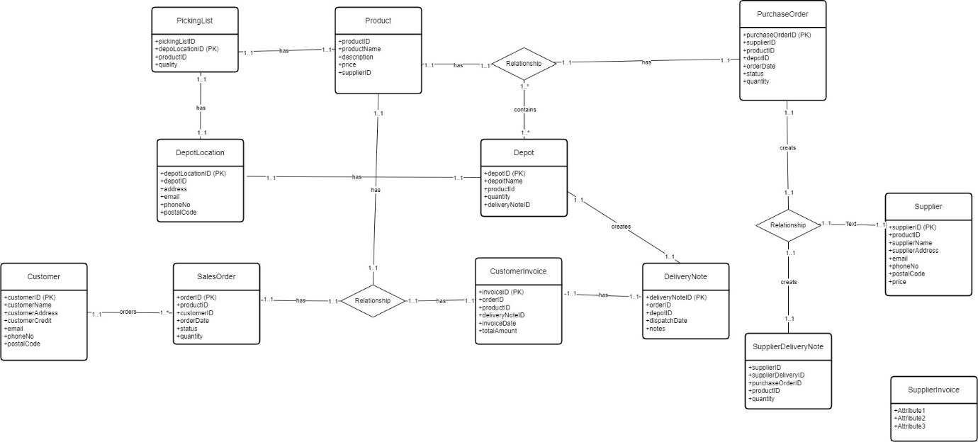
This was the initial Entity Relationship Diagram that we had given to the professor Dr Hamzah Alzubi for evaluation, we considered the professor's observations into consideration and made the modifications that were needed.
- Given that there was a one-to-one relationship between the Depot Location and the Depot entities, we added the location details to the Depot and eliminated the Depot Location table, reducing the need to maintain two entities for the Depot.
- Recommended establishing a direct link with the invoice rather than the Delivery Note entity
- Was advised to provide distinct and particular names for the relationships in order to provide a better understanding.
- The primary function of the relationship or the reason for connecting should determine the cardinality in ternary connections.
- Ensure that all the naming conventions to be consistent.

We implemented additional modifications based on the case study and group discussions, which are listed below. The final changes can be seen in the below Enhanced Entity Relationship Diagram.
- We connected Depot with Picking List entity
  - As per the case study for each depot, a picking list covering all products by location within a depot is produced.
- Connected Supplier to Product entity
  - Information regarding which Supplier is supplying which product should to be provided.
- Connected Purchase Order to Supplier Invoice
  - The order and invoice should be linked so the supplier's invoice and the orders placed with them are related.

Enhanced Entity Relationship Diagram

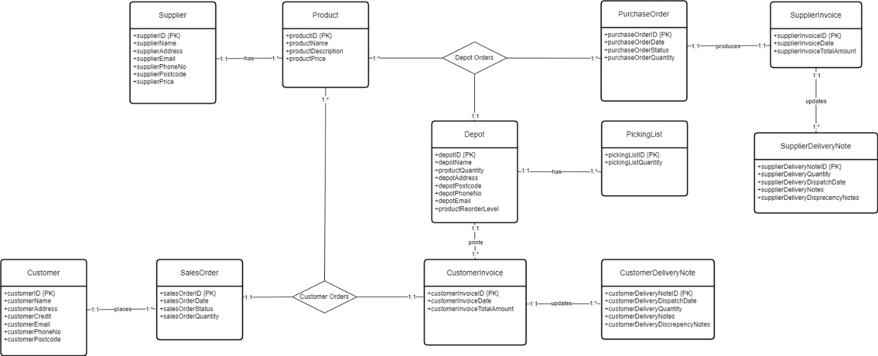

PHASE II:

Logical Entity Relationship Diagram

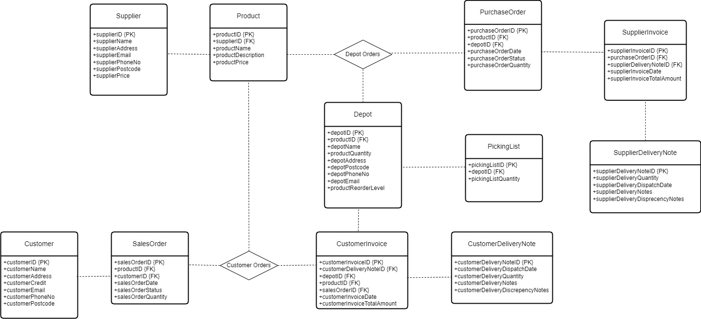

Relational Schema

SalesOrder (salesOrderID, productID, customerID, salesOrderDate, salesOrderStatus, salesOrderQuantity)

Customer (customerID, customerName, customerAddress, customerPostcode, customerPhoneNo, customerEmail,customerCredit)

Product (productID, supplierID, productName, productDescription, productPrice)

Depot (depotID, productID, productQuantity, depotName, depotPostcode, depotAddress,depotPhoneNo, depotEmail, reorderLevel)

CustomerInvoice (customerInvoiceID, salesOrderID, customerDeliveryNoteID,depotID, customerInvoiceDate,customerInvoiceTotalAmount)

PurchaseOrder (purchaseOrderID, productID, depotID, purchaseOrderDate, purchaseOrderStatus,purchaseOrderQuantity)

CustomerDeliveryNote (customerDeliveryNoteID, customerDeliveryDispatchDate,customerDeliveryQuantity, customerDeliveryNotes, customerDeliveryDiscrepencyNotes)

PickingList (pickingListID, depotID, pickingListQuantity)

Supplier (supplierID, supplierName, supplierPrice, supplierAddress, supplierPostcode, supplierPhoneNo,supplierEmail)

SupplierInvoice (supplierInvoiceID,supplierDeliveryNoteID, purchaseOrderID, supplierInvoiceDate,supplierInvoiceTotalAmount)

SupplierDeliveryNote (supplierDeliveryNoteID, supplierDeliveryDispatchDate,supplierDeliveryQuantity, supplierDeliveryNotes, supplierDeliveryDicrepencyNotes)

Assumptions
- The default constraint configuration for primary keys and foreign keys promotes data consistency and prevents anomalies by enforcing non-nullability and uniqueness.
- The pre-condition for this analysis is that all product information is populated in the table before any store entry events.
- To facilitate seamless data analysis across multiple tables, we're implementing field prefixes for clear identification and association.
- The wholesale price differs from the retail price.
- Sales orders generate delivery notes and invoices.
- To enhance order tracking and ensure compliance with SLAs, we're introducing an enum with distinct states: New, Validated, Approved, Pending, Completed, and Cancelled.
  - New - This clearly describes the status assigned when an order is created.
  - Validated - This focuses on the positive result of the product meeting defined standards.
  - Approved - This highlights the next step in the workflow after successful credit approval.
  - Pending - The pending state serves as a checkpoint for robust error handling and data integrity checks (Did not pass-through b and c).
  - Completed - This simply denotes the end of the transaction lifecycle
  - Cancelled – This focuses on the outcome, indicating the order cannot be executed due to exceeding the Service Level Agreement (SLA) timeframe.
- To streamline the purchase process, front-end developers will participate in integrated credit validation checks against defined limits
- To ensure accuracy and efficiency, invoice updates are closely coupled with customer delivery notes. In case of missing products due to damage or other factors, a separate discrepancy note will be utilized for detailed documentation. If no discrepancies are found, the discrepancy note will remain unused.
- The depot table maintains information about individual product reorder levels, flagging products requiring new orders as their inventory dips below designated thresholds.
- To streamline supplier deliveries, we've adopted the same structure as for customer deliveries. Upon receiving supplies, we reconcile purchase orders and delivery notes to ensure accuracy. Any discrepancies will prompt adjustments to the supplier invoice, a process undertaken by the development team.
- Assuming that a single Supplier supplies a single Product and that a Supplier supplies several Products.

