**AI-Based Greeting and BMI Calculator**

**Problem Identification:**

The real-world problem that the AI-powered BMI (Body Mass Index) calculator seeks to answer is assisting individuals in properly assessing their body weight and health condition. Based on weight and height, BMI is a regularly used statistic to evaluate whether a person is underweight, normal weight, overweight, or obese. This data is critical for understanding the health hazards linked with body weight and making educated decisions to live a healthy lifestyle.

**Importance of the Problem:**

**Health Awareness:** Accurate BMI calculation is essential for individuals to be aware of their health status. Being underweight or overweight can have serious health implications, including cardiovascular diseases, diabetes, and other chronic conditions.

**Prevention and Early Intervention:** Regularly monitoring BMI can help identify potential health risks at an early stage. Individuals with a high BMI can take preventive measures to avoid the development of obesity-related health problems.

**Nutrition and Fitness:** Understanding BMI can guide individuals in making healthier dietary and exercise choices. It can motivate them to pursue weight loss or gain goals that align with their health objectives.

**Medical Decision-Making:** Healthcare professionals use BMI as an initial assessment tool for patients. Accurate BMI information assists doctors in recommending appropriate treatment plans, interventions, and lifestyle modifications.

**Benefits of AI in Addressing the Problem:**

**Precision and Automation:** AI can quickly and accurately calculate BMI based on weight and height inputs. It eliminates manual calculations, reducing the risk of human errors.

**Personalized Recommendations:** AI-powered BMI calculators can provide personalized health recommendations based on the calculated BMI. This can include suggestions for exercise routines, dietary changes, and potential health risks.

**Quick Accessibility:** With an AI-powered calculator, individuals can access BMI information instantly, making it easier to track changes over time and make informed decisions on the spot.

**Education and Awareness:** The AI calculator can educate users about the significance of BMI, its implications on health, and the importance of maintaining a healthy weight.

**Integration with Health Platforms:** AI-powered BMI calculators can seamlessly integrate with health and fitness apps, wearable devices, and telemedicine platforms, enhancing the overall health monitoring experience.

**Scalability**: AI can handle a large volume of calculations simultaneously, making it suitable for organizations, healthcare providers, and wellness programs aiming to offer BMI assessment services to a wide audience.

**Technical Explanation:**

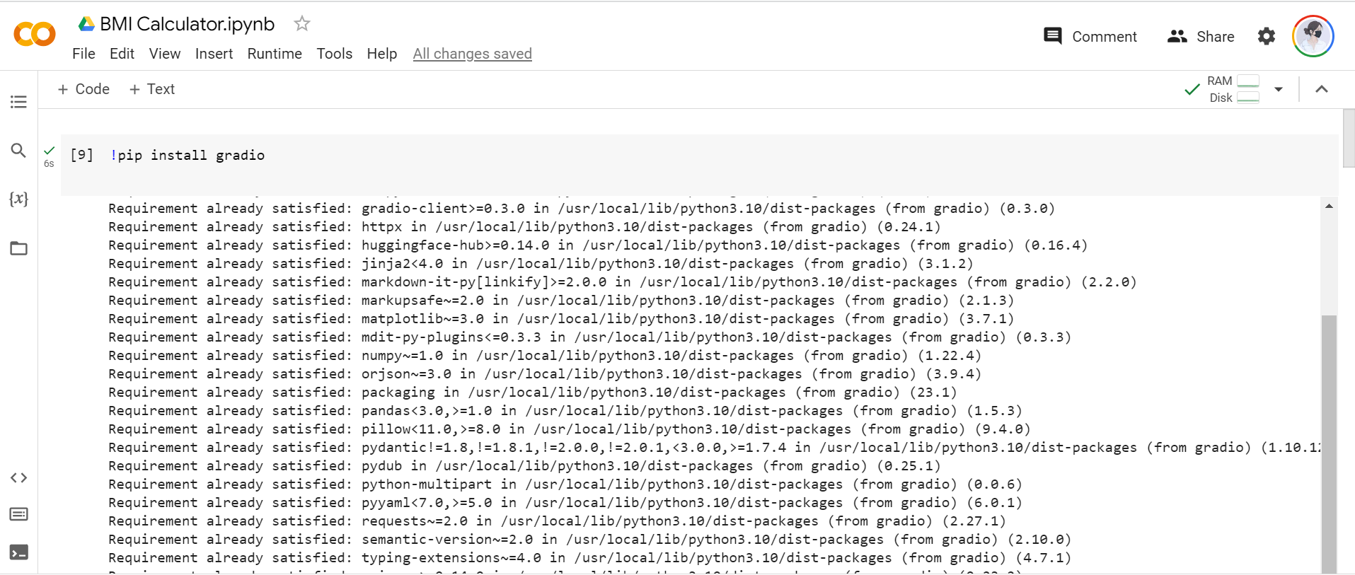

**a. Greeting Module:**

The greeting module is a simple function called "greet" that takes a single input "text" (user's name) and returns a personalized greeting message.

The function concatenates the input text with the greeting message "Hello," resulting in a personalized greeting for the user.

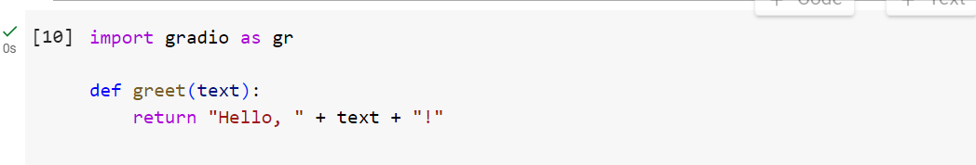

**b. BMI Calculator:**

The BMI calculator function, "calculate_bmi," takes three inputs: "name" (user's name), "height_in_cm" (user's height in centimeters), and "weight" (user's weight in kilograms).

It calculates the BMI using the formula: BMI = weight / (height_in_cm / 100) ** 2

Based on the calculated BMI, the function determines the BMI category and returns it along with a personalized BMI message to the user.

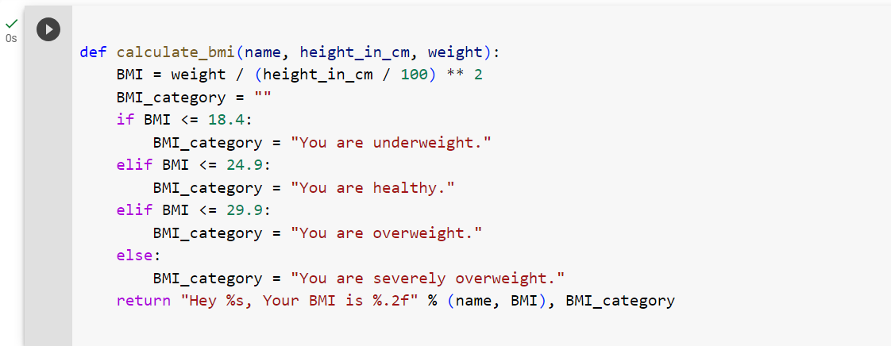

**c. Gradio Interface:**

Gradio is used to create a user-friendly front-end for the AI product.

Two Gradio interfaces are defined:

Interface 1 (iface_greet): It takes a user's name as input and displays a greeting message.

Interface 2 (bmi_cal): It takes a user's name, height, and weight as inputs, and returns a BMI message along with the BMI category.

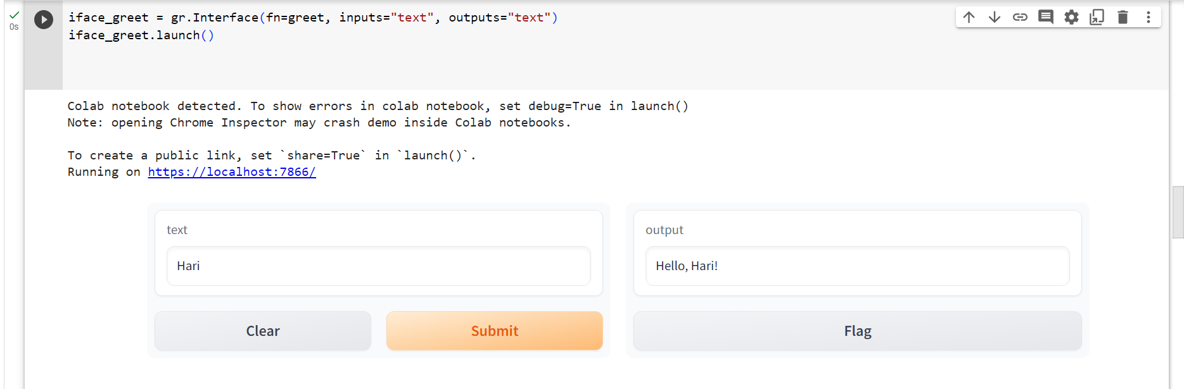

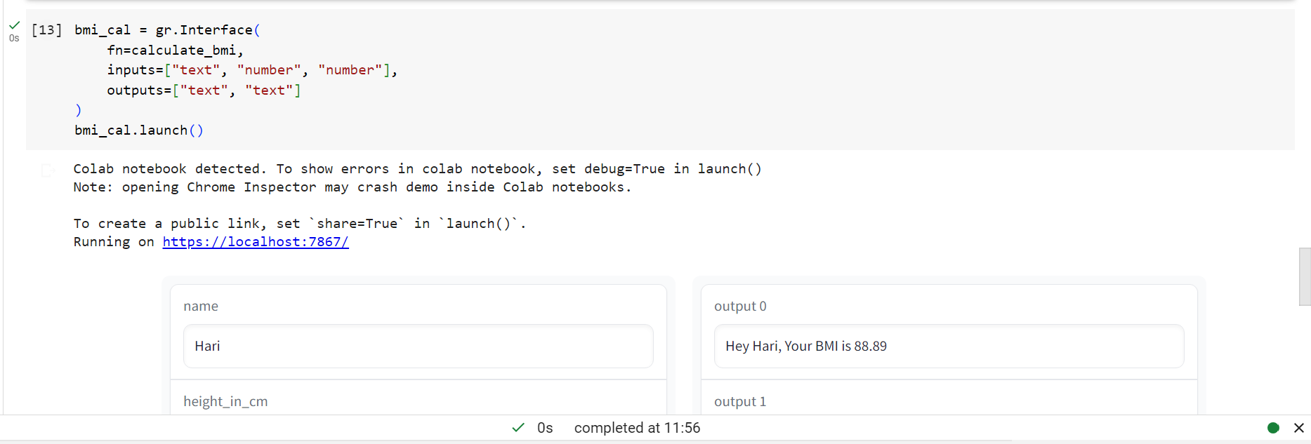

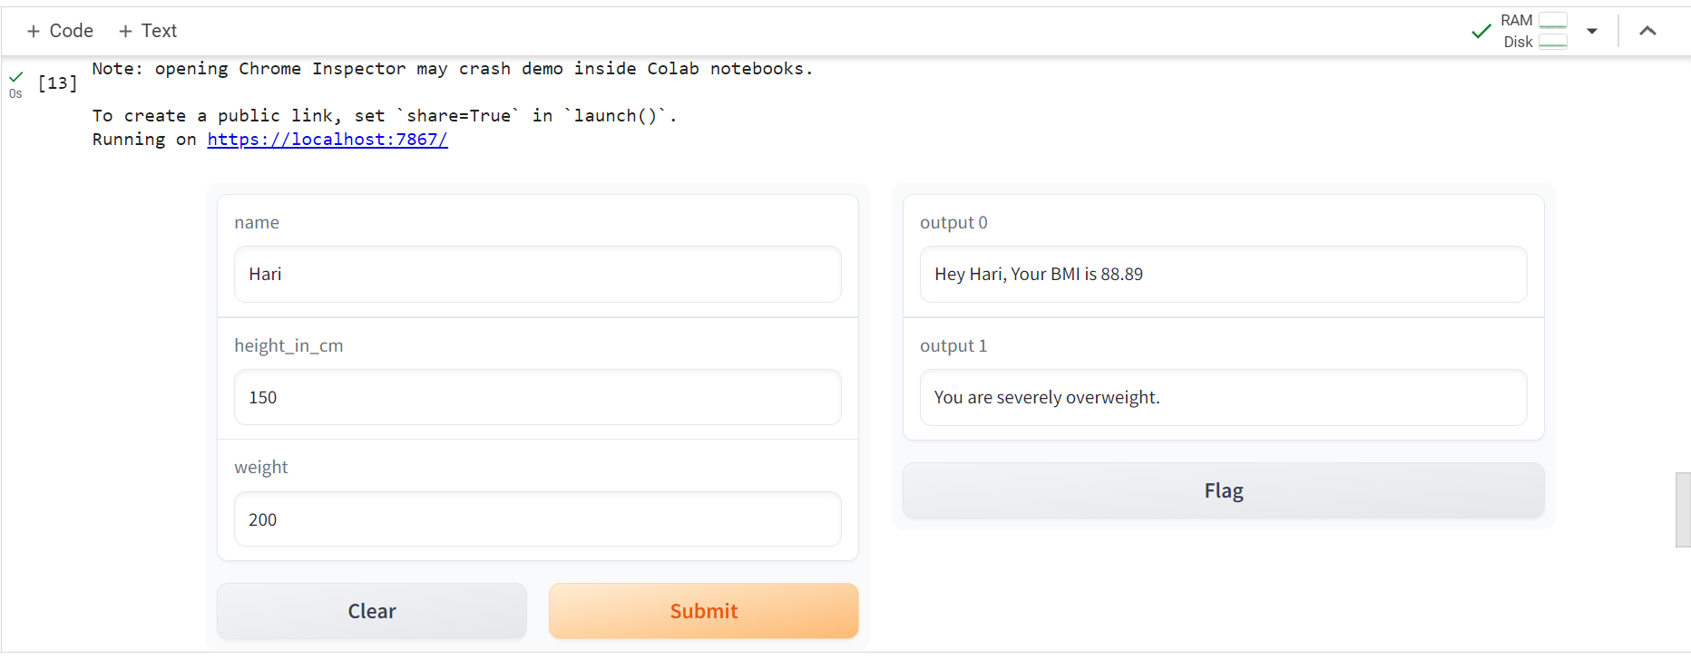

**3. Evaluation Metrics:**

As this AI product primarily focuses on user interaction and BMI calculations, there are no strict quantitative evaluation metrics. However, we can measure its effectiveness based on the following criteria:

User Satisfaction: Gather user feedback to determine how well the product meets user expectations.

Accuracy of BMI Calculations: Compare the BMI calculated by the product with manual calculations to ensure accuracy.

Responsiveness: Evaluate the response time of the product to ensure real-time user interaction.

**4. Limitations:**

The BMI calculator only provides a rough estimate of a person's body mass index. It does not consider factors such as body composition, muscle mass, and individual variations, which could affect the accuracy of the results.

The product may not handle misspellings or input errors gracefully, potentially leading to incorrect greetings or BMI calculations.

The GPT-3 model for the greeting module might not handle all types of text inputs or context accurately, leading to ambiguous or incorrect greetings in some cases.

**5. Ethical Considerations:**

Data Privacy: The AI product should not store or misuse user input data (e.g., names, height, weight) and must adhere to data privacy regulations.

Bias: The BMI calculator's predefined BMI categories may not consider individual differences or cultural variations, potentially leading to bias in health assessments.

Transparency: The product should be transparent about its limitations, use of language models, and the information it collects from users.

Consent: Users must be informed about the data collection and usage policies, and their explicit consent should be obtained before collecting any information.