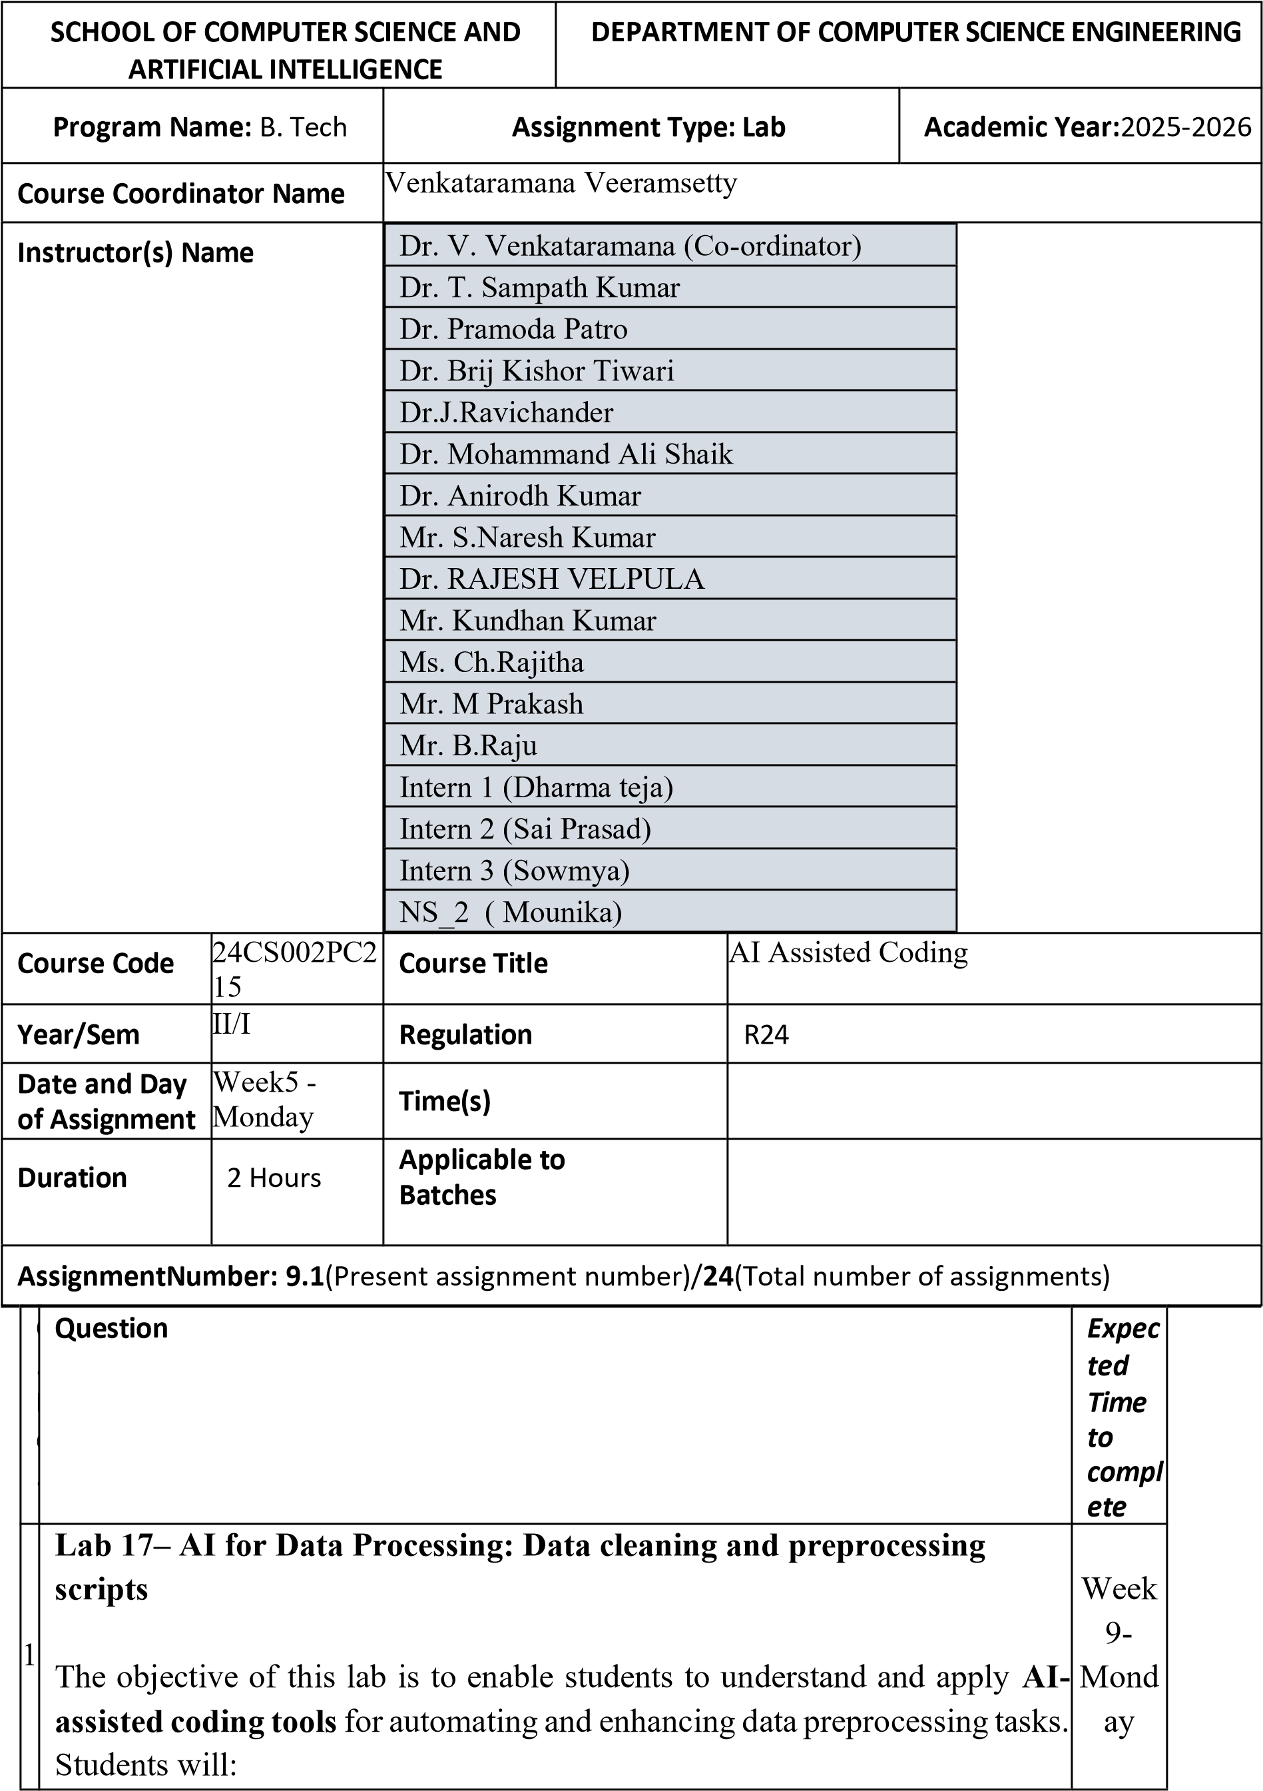
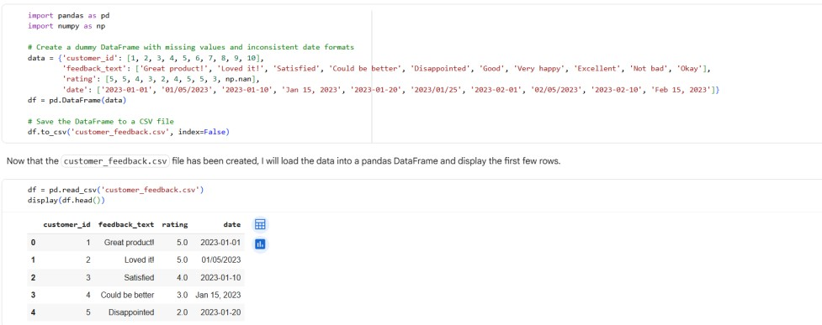
1.

Gain practical experience in
cleaning, transforming, and
standardizing real
-
world datasets

with issues such as missing
values, duplicates, outliers, inconsistent formats, and noisy text.

2.

Learn to
leverage AI coding assistants

to generate preprocessing
scripts, while critically evaluating and refining the AI
-
generated code

for accuracy, efficiency, and best practices.

3.

Develop the ability to design
end
-
to
-
end preprocessing pipelines

that prepare raw data for downstream machine learning and analytics
applications.

4.

Build confidence in
combining human expertise with AI
assistance
, ensuring data quality and integrity in diverse domains
such as customer feedback, healthcare, and finance.

Lab Question 1: Customer Feedback Dataset

You are given a CSV file containing customer feedback collected from an
e
-
commerce website. The dataset includes columns: customer_id,
feedback_text, rating, and date. However, the file has many missing values,
typos, and inconsistent date formats.

•

Task 1:

Use an AI
-
assisted coding tool to generate a script that
detects and fills missing rating values with the column’s median and
standardizes the date column into YYYY
-
MM
-
DD format.

•

Task 2:

Clean the feedback_text column by removing stopwords,
correcting common spelling mistakes, and converting text to
lowercase using AI suggestions. Compare the AI
-
generated
preprocessing code with your manually written version.

TASK 1 OUTPUT :

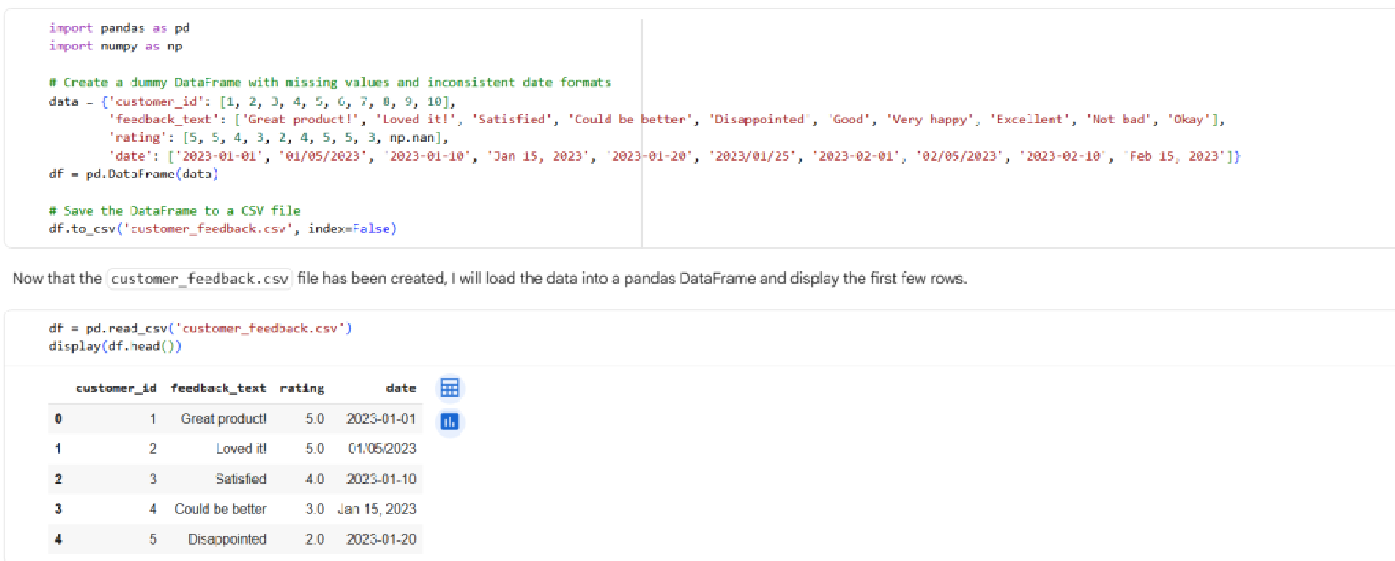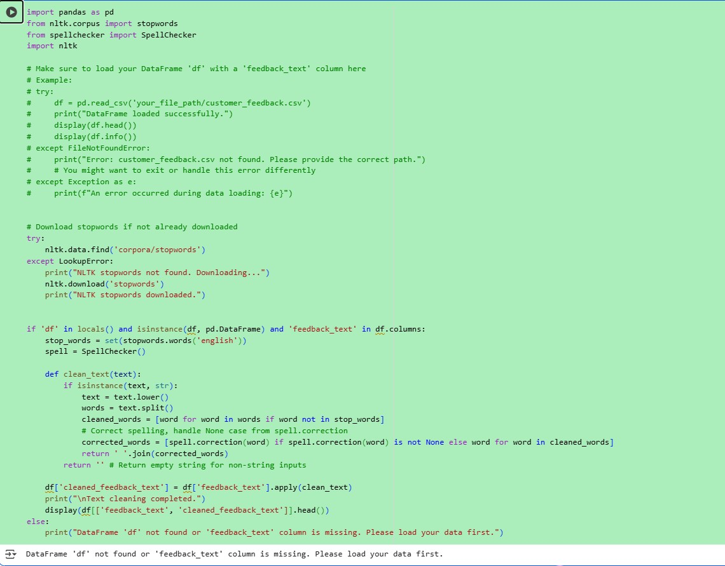
TASK 2 OUTPUT:

COMPARING MANUAL CODE AND AI CODE:

Consistency:

Check if the AI
-
cleaned text consistently applies the cleaning rules
lowercase, stopwords removal, spelling correction) across all feedback entries,
(
compared to your manual process.

Accuracy of Spelling Corrections:

Evaluate the accuracy of the spelling corrections
made by the AI's spellchecker against your manual corrections. Are there instances
where the AI corrected a word incorrectly or missed a typo that you caught
manually?

Effectiveness of Stopword Removal:

See if the AI successfully removed common
English stopwords as intended. Compare this to how you handled stopwords

manually.
- Handling of Edge Cases: Look at how both approaches handled unusual or complex feedback entries, such as those with special characters, emojis, or unconventional phrasing.
- Subjectivity: Text cleaning can sometimes involve subjective decisions (e.g., how to handle slang or informal language). Note any differences in how these were handled.
- Efficiency: While not directly visible in the output, consider the time and effort it took for each approach. AI can automate and speed up the process significantly for large datasets.
Lab Question 2: Medical Records Dataset
A hospital provides you with a dataset of anonymized medical records containing attributes like patient_id, age, gender, blood_pressure, and cholesterol. Some columns include outliers and inconsistent categorical labels (e.g., Male, M, male).
- Task 1: Write a script (with AI assistance) to detect and handle outliers in the blood_pressure column using statistical methods (e.g., IQR or z-score).

- Task 2: Standardize categorical values in the gender column and encode them into numeric form. Let the AI-assisted coding tool propose the preprocessing pipeline, then refine the pipeline manually based on your understanding
TASK 1 OUTPUT :

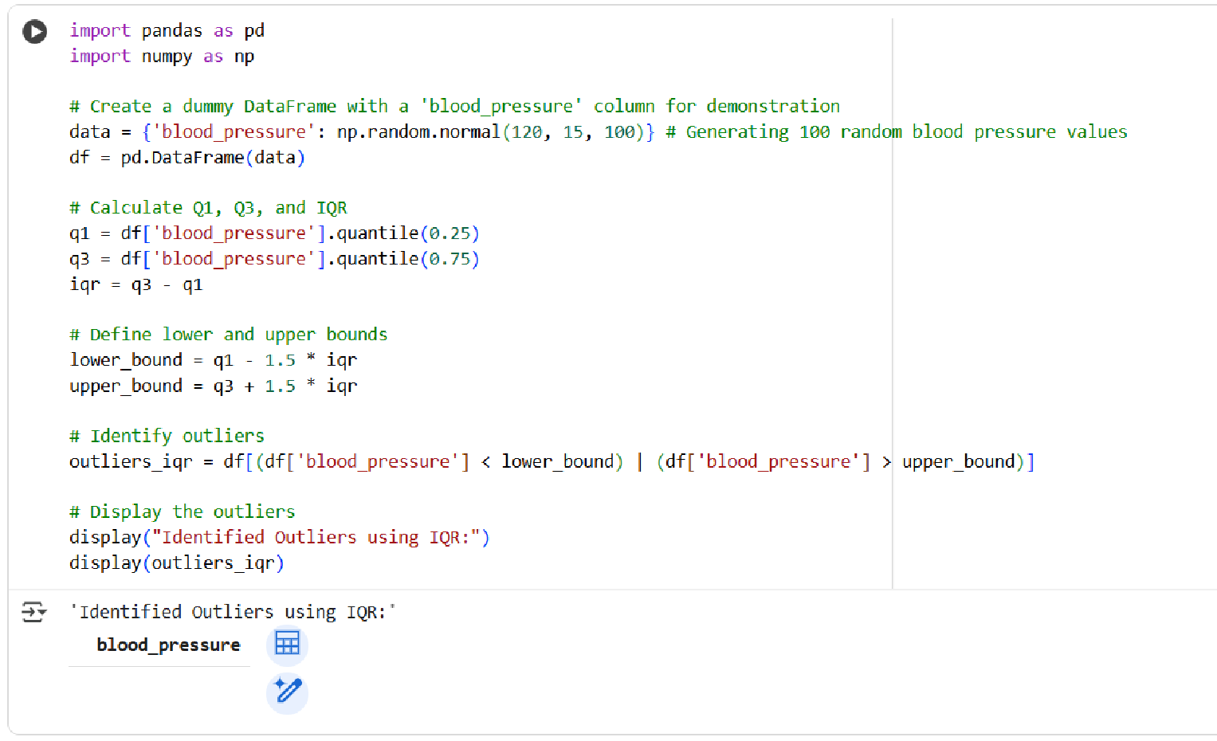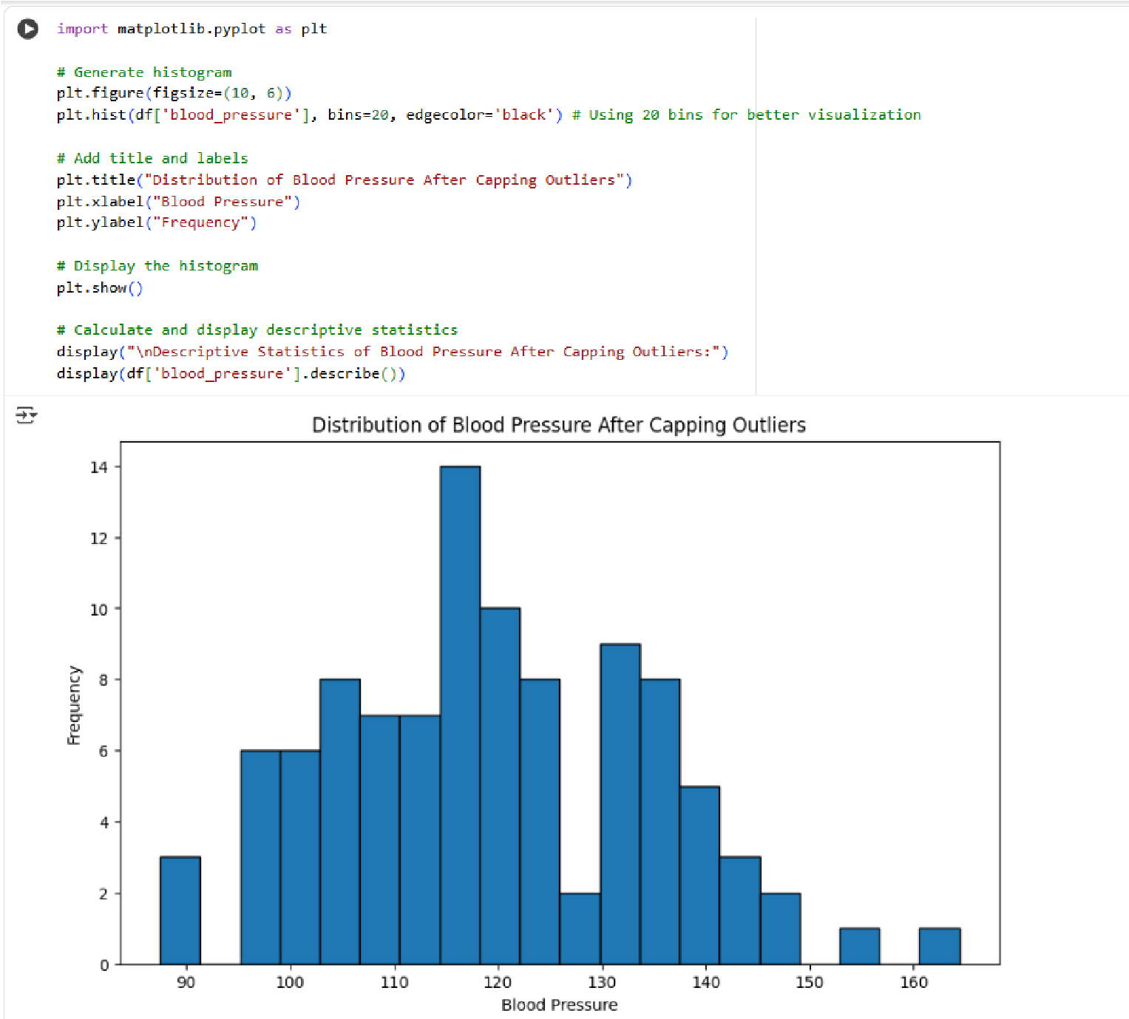

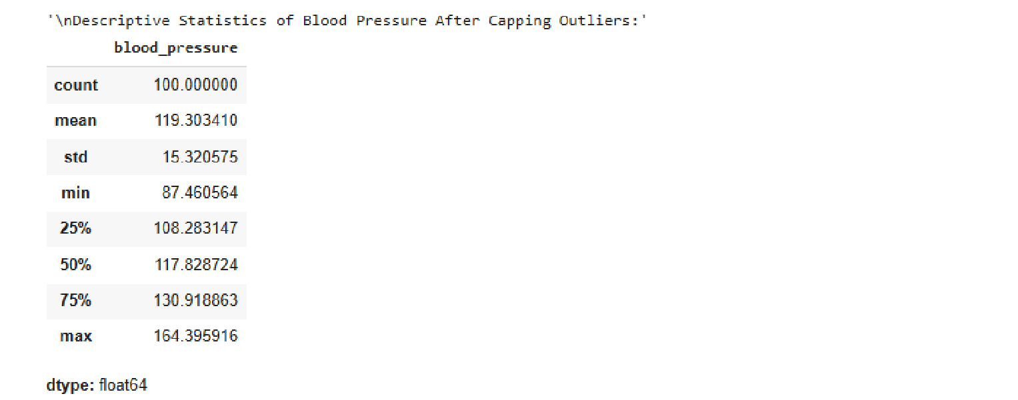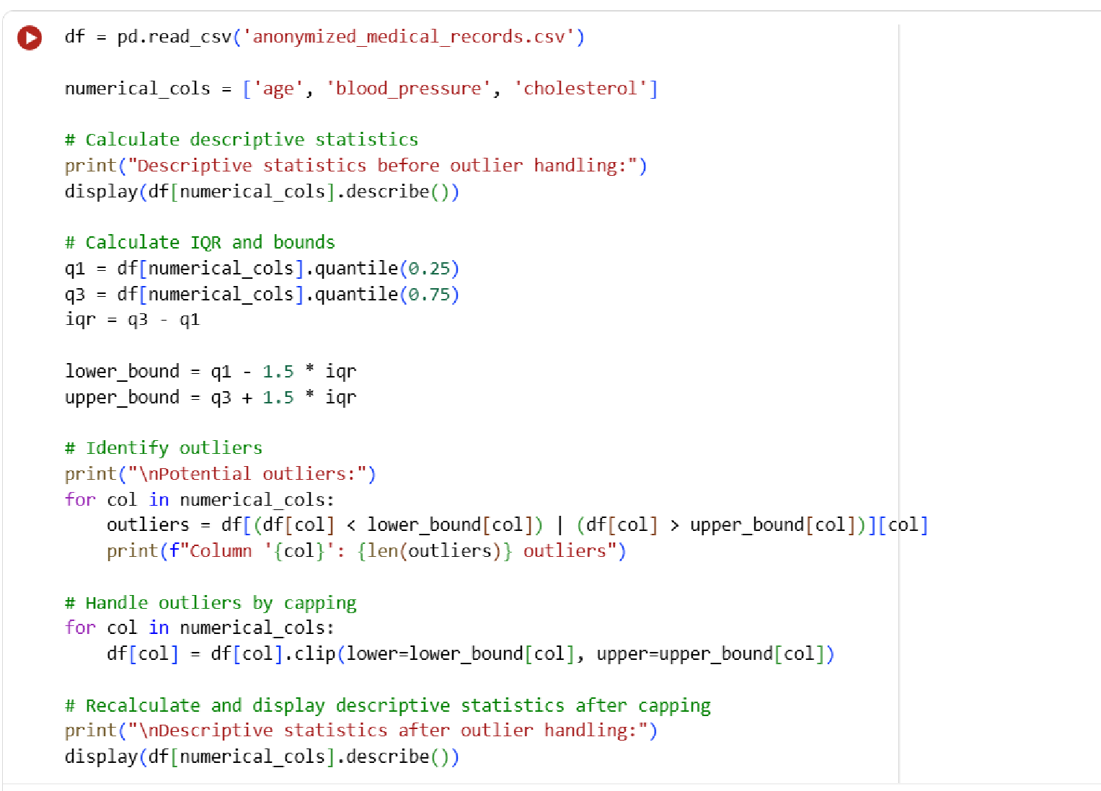

TASK 2 OUTPUT :

Lab Question 3: Financial Transactions Dataset

A bank gives you transaction data with columns: transaction_id, amount,

currency, timestamp, and merchant. The dataset contains multiple issues:
different currency units (USD, INR, EUR), timestamps in various time zones,

and duplicated rows.

•

Task 1:

Use AI
-

assisted coding to write a script that removes duplicate

transactions and converts all amount values into a single currency (e.g.,
USD) using a provided conversion dictionary.

•

Task 2:

Normalize the timestamp column into UTC format and create
a new column transaction_hour for downstream time
-

series analysis.

Compare the AI’s preprocessing code against your own optimized version.

TASK 1 OUTPUT:

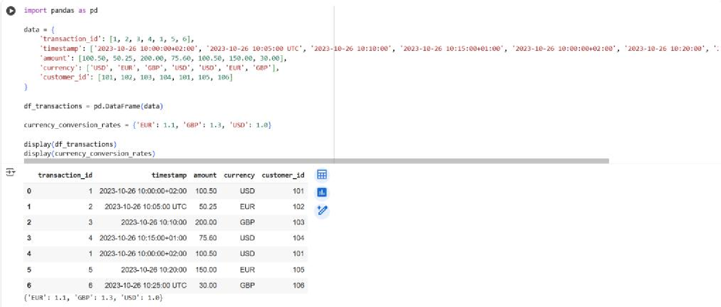
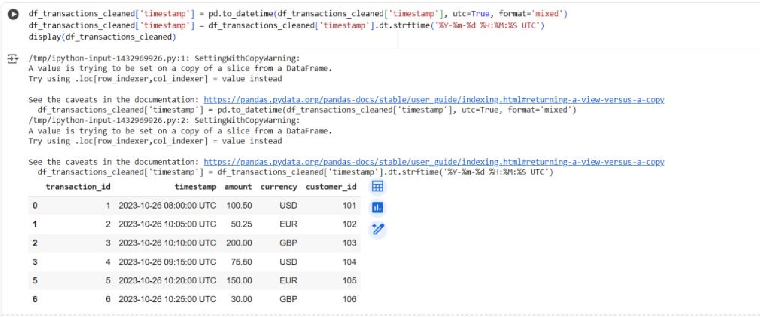
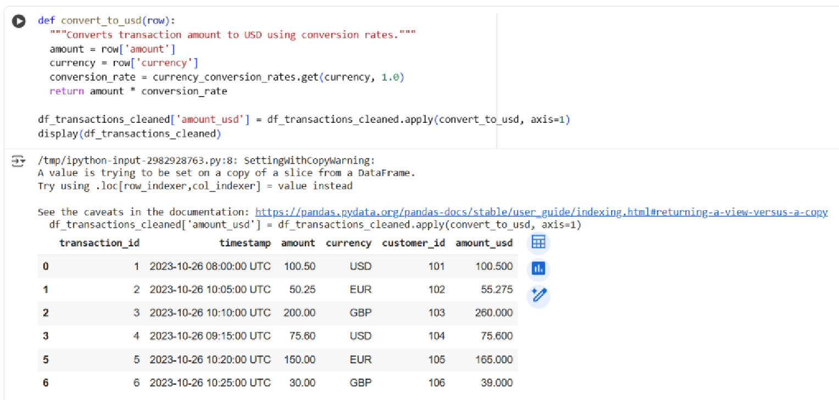
TASK 2 OUTPUT:

